%作业1

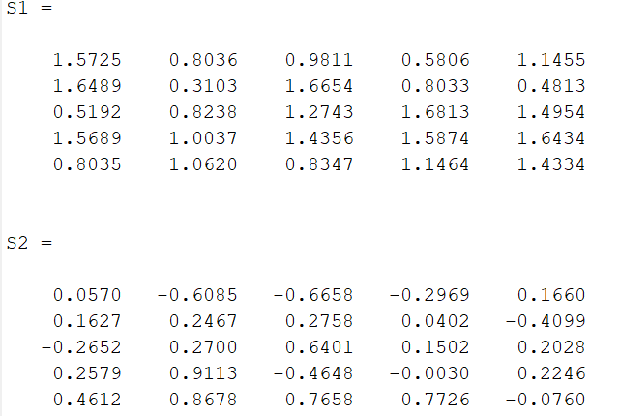A=rand(5,5)

B=rand(5,5)

C=rand(5,5)

b=rand(5,1)

%T1

S1=A+B

S2=A-B

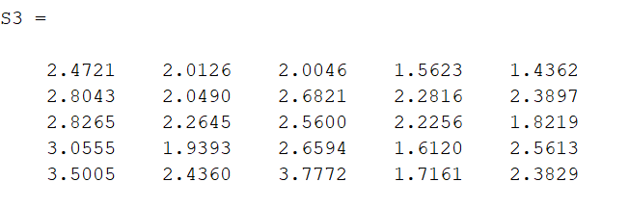%T2

S3=A\*B+B\*A

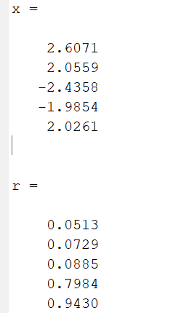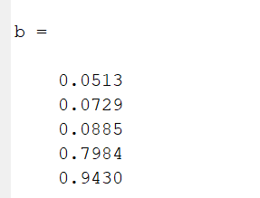%T3

x=A\b

r=A\*x

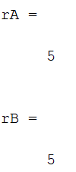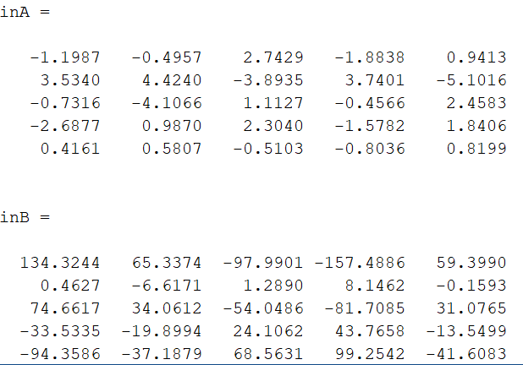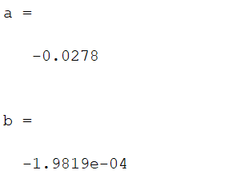%T4

a=det(A)

b=det(B)

inA=inv(A)

inB=inv(B)

rA=rank(A)

rB=rank(B)

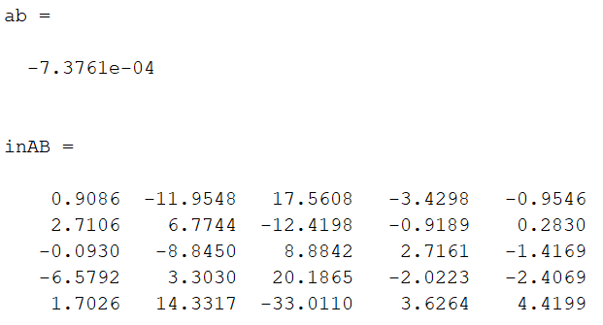%T5

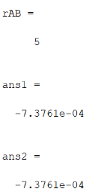ab=det(A\*B)

inAB=inv(A\*B)

rAB=rank(A\*B)

ans1=det(A\*B)

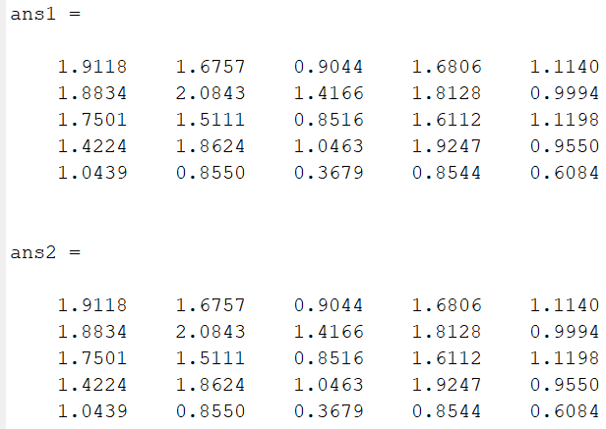ans2=det(A)\*det(B)

%T6

ans1=(A\*B)'

ans2=B'\*A'

%T7

X=(A\C)/B

ans=A\*X\*B

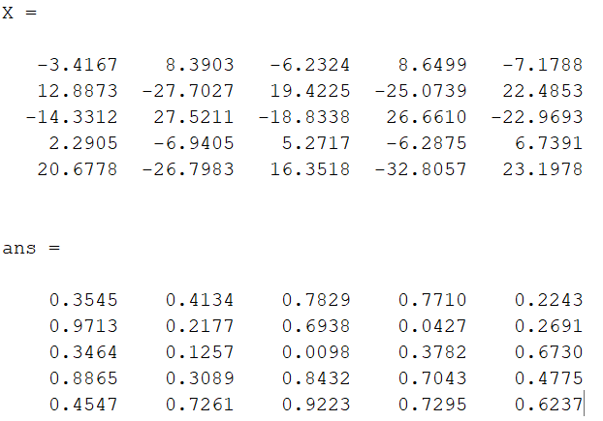

%上机作业二

%Q1

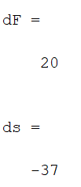F=[1 2 3 4;

3 2 1 5;

2 3 4 5;

1 7 9 6];

A=[1 2;3 2];

B=[3 4;1 5];

C=[2 3;1 7];

D=[4 5;9 6];

dF=det(F)

ds=det(A)\*det(D)-det(B)\*det(C)

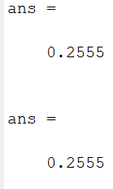%Q2

A=diag([1 1 1 1],0);

C=diag([2 2 2 2],0);

B=rand(4,4);

D=rand(4,4);

E=[A B;C D];

det(E)

det(A\*D-C\*B)

%上机作业三----------------------

A=rand(4,4)

ra=A(1,:)

rb=A(2,:)

rc=A(3,:)

B=[ra;rb;rc]

la=A(:,1)

lb=A(:,2)

C=[la lb]

d1=A(2:4,3:4)

E=B\*C

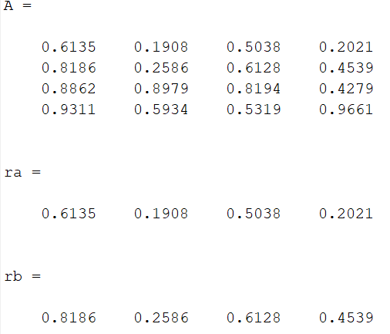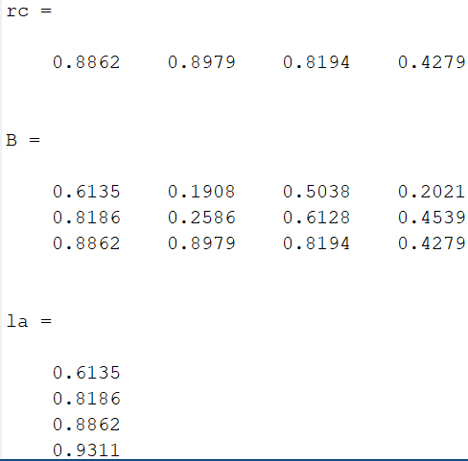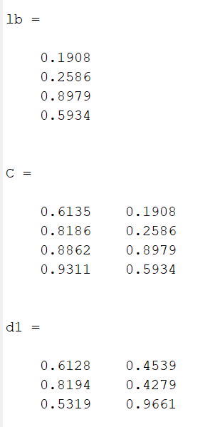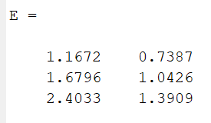

%上机作业4------------

a=83;b=86;c=50;d=88;e=28;f=63;g=83;h=60;

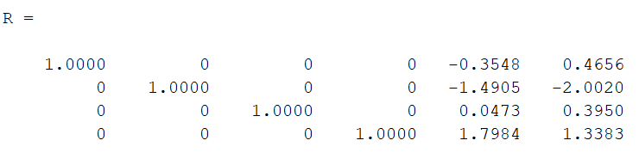A=[a b c d 3 4;

1 2 3 4 4 3;

12 15 22 17 5 7;

e f g h 8 0];

R=rref(A)

%上机作业5

%T1

A=rand(5,5);

b=rand(5,1);

x=A\b

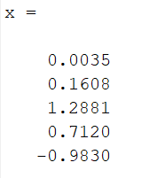

%T2

A=rand(3,2);

j1=rank(A\*A')%求阶

j2=rank(A'\*A)

