When War Strikes, Hunger Follows
New research across 22 conflict-affected countries shows that armed violence triggers food crises that persist long after the fighting—and that food aid alone is not the answer.
In 2024, more than 343 million people across 74 countries faced acute food insecurity — roughly 10 million more than the year before and nearly 200 million more than before the COVID-19 pandemic. Behind these numbers lies a pattern that humanitarian workers have long recognized but economists have struggled to measure: wherever conflict goes, hunger tends to follow. In 2024, roughly 65 percent of the world's acutely food-insecure people lived in fragile and conflict-affected states (FCS). Every country classified by the World Bank as fragile and conflict-affected recorded a food security rating of 'in crisis' or worse.
The connection seems intuitive. Conflict destroys crops, displaces farmers, closes markets, disrupts supply chains, and drives away investment and trade. But how large is the causal effect, exactly? How long does it last? And which specific channels translate bullets into empty plates? These are surprisingly hard questions to answer rigorously. I this paper, I examine these issues using the most detailed cross-country dataset yet assembled on the conflict–food insecurity relationship.
Why measuring this is hard
Conflict and food insecurity have historically been measured at very different scales: national-level conflict statistics matched with infrequent, coarsely aggregated food security surveys. That combination makes it nearly impossible to study local dynamics, timing, or the persistence of shocks.
Another problem is the difficulty identifying the link between conflict and food insecurity. Conflict typically clusters in places already battered by poverty, drought, and weak institutions — the same conditions that drive hunger independently of violence. Any simple comparison of conflict and non-conflict areas will therefore mix the effect of violence with the underlying vulnerabilities that came before it. Meanwhile, hunger can itself fuel conflict: desperate populations are more likely to join armed groups or resort to violence over resources. Disentangling cause from effect requires both better data and a credible identification strategy.
A new dataset and a cleaner identification strategy
This study builds a harmonized district-by-quarter panel linking two leading global data systems. The first is the Armed Conflict Location and Event Data (ACLED), which geocodes the timing and location of every recorded conflict event worldwide. The second is the Famine Early Warning Systems Network (FEWS NET), which classifies district-level food insecurity using the internationally recognized Integrated Phase Classification (IPC). IPC Phase 3 or above — 'Crisis' or worse — is used as the threshold for a food crisis.
The resulting dataset covers 1,159 districts across 22 developing and fragile countries from 2010 to 2025. It is the most spatially and temporally granular multi-country dataset of its kind. Tracking individual districts over time removes fixed differences across places — geography, chronic poverty, local institutions — as well as global shocks such as food price spikes or the COVID-19 pandemic that affected all countries simultaneously.
To address the problem of reverse causality, the study uses an instrumental variable based on how conflict spreads. When fighting intensifies in a country, it tends to diffuse outward in waves to neighboring districts. The jihadist movements in the Sahel region provide a compelling illustration of how conflict can spread beyond local districts. A district’s exposure to the nationwide wave of conflict—excluding violence within the district itself—provides a source of external pressure on local conflict dynamics that is largely independent of local food security and economic conditions. This instrument allows the study to isolate the direction of causation: from conflict to hunger, not the reverse.
Food insecurity around conflict onset
Figure 1 provides a striking illustration of the dynamics at work. It shows how food insecurity changes in the quarters before and after a district experiences its first major conflict event (the dashed vertical line at k = 0). The sample covers 154 districts across 14 countries that underwent a clean first conflict onset, compared with 1,020 districts that never experienced lethal violence during the sample period.
Figure 1: Food insecurity around conflict onset
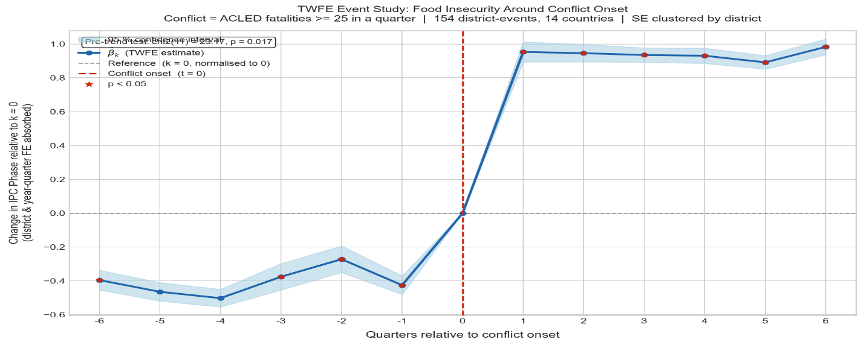
Three features stand out. First, food insecurity was already trending upward before conflict onset — visible in the rising pre-period estimates. This is consistent with reverse causality: districts that become conflict-prone are often already under economic stress, and that stress was already worsening food security. This pattern is precisely why a naive regression comparison will overstate the causal effect of conflict unless the endogeneity is properly addressed.
Second, food insecurity jumps sharply at the moment of conflict onset — by roughly 0.35 IPC phases on average — and the jump is highly statistically significant (p < 0.001). Third, and most important for policy, there is no evidence of recovery. The food insecurity effect does not fade over the three years of post-conflict observation. At two years after onset (k = 8), the effect remains as large as in the first quarter of conflict. Hunger, once entrenched, does not heal itself.
How large is the causal effect and how does conflict cause hunger?
Instrumental-variables estimates reveal that conflict raises the probability of food crisis by 5-7 percentage points in the affected quarter. Against a baseline crisis rate of roughly 40–50 percent in fragile states, this is a relative increase of 10–15 percent. The long-run effect — which accounts for the fact that food insecurity in one period directly raises the likelihood of crisis in the next — is roughly twice as large as the contemporaneous impact. Because food insecurity is persistent, a shock that increases it today compounds over subsequent quarters, amplifying the total damage well beyond what a snapshot would capture.
The paper also identifies three reinforcing transmission channels:
• Food prices: Conflict raises the local price of staple foods, reducing the purchasing power of households that depend on markets — which is nearly all households in conflict-affected areas. Market disruptions, the flight of traders, and trade blockades restrict supply, while fear and precautionary hoarding drive up demand, placing additional pressure on prices.
• Agricultural production: Conflict depresses local food output. Farmers abandon fields under threat. Livestock is often destroyed or stolen, while access to seeds, fertilizers, and credit becomes increasingly constrained.
• Forced displacement: Conflict drives people from their homes and communities, shattering local economic and social networks. Displaced populations face acute hunger while simultaneously straining the resources of the communities they enter.
These channels reinforce each other in ways that help explain the persistence seen in Figure 1. Markets that collapse during conflict do not automatically reopen when the fighting stops. Displaced populations do not return overnight.
What this means for humanitarian response
The findings carry a clear and sobering message for policy. Food insecurity induced by conflict is not a temporary disruption that resolves as violence subsides. It compounds through persistence: each quarter of elevated crisis risk raises the probability of crisis in the next quarter, creating a trap that emergency food distributions alone cannot break.
Effective responses must therefore address all three transmission channels simultaneously. Stabilizing local food markets — through trader guarantees, cash transfers, or temporary price supports — is as important as distributing food. Supporting agricultural recovery between conflict episodes, rather than waiting for full peace, can prevent the seasonal production losses that become structural. And addressing the economic and social needs of displaced populations must be treated as a core food security intervention, not an afterthought.

