Project Title: Design of an Integrated Circuit (IC) for a 2-bit Binary Comparator
1. Introduction
Digital comparators are important combinational circuits used in processors, arithmetic units, memory systems, communication devices, and digital controllers. Their function is to compare two binary numbers and determine whether one number is greater than, less than, or equal to the other.
In this project, a transistor-level 2-bit comparator was designed and simulated using LTspice with PTM 180 nm CMOS technology. The comparator receives two 2-bit inputs, A(A1A0) and B(B1B0), and produces three outputs: A > B, A = B and A < B.
The project initially aimed to implement the comparator using Static CMOS, Complex CMOS and Dynamic CMOS design techniques for diversification. However, despite multiple design and simulation attempts, the Dynamic CMOS implementation did not produce the expected output behavior and could not be successfully verified. So, the final working design was designed using Static CMOS and Complex CMOS logic techniques, which provided correct functionality along with low power consumption, high noise immunity and reliable operation.
2. Project Requirements
2.1. Inputs
- 2-bit input $A=A_{1}A_{0}$
- 2-bit input $B=B_{1}B_{0}$
2.2. Outputs
- A > B | - A = B | - A < B
2.3. Design Constraints
- Transistor-level implementation
- Utilization of Static CMOS and Complex CMOS logic
- Stable one-hot output behavior
- Verification through transient simulation
2.4. Technology Specifications
- PTM 180 nm MOSFET model
- Supply Voltage = 1.8 V
- PMOS dimensions = 180 nm / 400 nm
- NMOS dimensions = 180 nm / 400 nm
3. Working Principle of a 2-Bit Comparator
A 2-bit comparator is a combinational digital circuit used to compare two binary numbers and determine their relative magnitudes. In this project, two 2-bit inputs, $A(A_{1}A_{0})$ and $B(B_{1}B_{0})$ are compared to generate three outputs: $A>B$, $A=B$ and $A<B$. The comparison process begins with the Most Significant Bit (MSB) because it carries the highest weight. If the MSBs differ, the comparison result is immediately determined.
However, if the MSBs are equal, the Least Significant Bits (LSBs) are compared to obtain the final result. The circuit is designed such that only one output remains HIGH at a time, ensuring correct one-hot operation.
3.1. Equal Condition ($A=B$)
For the equality output to become HIGH, both corresponding bits of the two numbers must be identical. The comparator first checks whether $A_{1}$ $=B_{1}$and then whether $A_{0}=$ $B_{0}$. Only when both conditions are satisfied does the equality output become HIGH. Therefore, the output $A=B$ is asserted for the combinations: 00 = 00, 01 = 01, 10 = 10 and 11 = 11.
3.2. Greater-Than Condition ($A>B$)
The output $A>B$ becomes HIGH whenever the binary value represented by A is greater than that represented by B. If the MSB of A is greater than the MSB of B, the comparator immediately declares A greater than B. If the MSBs are equal, the LSBs are compared to obtain the final result. Examples: 01 > 00, 10 > 01 and 11 > 10.
3.3. Less-Than Condition ($A<B$)
The output $A<B$becomes HIGH whenever the binary value represented by A is smaller than that represented by B. If the MSB of A is smaller than the MSB of B, the comparator immediately declares A smaller than B. If the MSBs are equal, the LSBs are compared to obtain the final result. Examples: 00 < 01, 01 < 10 and 10 < 11.
4. Logical Expressions and Truth Table
4.1. Logical Expressions
The logical expression for equality condition is:
$$A=B=\left(A_{0}⊙B_{0}\right)⋅\left(A_{1}⊙B_{1}\right)$$
$$A=B=\left(\overline{{\overline{A}}_{0}B_{0}+A_{0}{\overline{B}}_{0}}\right)⋅\left(\overline{{\overline{A}}_{1}B_{1}+A_{1}{\overline{B}}_{1}}\right)$$
$$A=B=\overline{\overline{\left(\overline{{\overline{A}}_{0}B_{0}+A_{0}{\overline{B}}_{0}}\right)⋅\left(\overline{{\overline{A}}_{1}B_{1}+A_{1}{\overline{B}}_{1}}\right)}}$$
$$A=B=\overline{{\overline{A}}_{0}B_{0}+A_{0}{\overline{B}}_{0}+{\overline{A}}_{1}B_{1}+A_{1}{\overline{B}}_{1}}$$
The logical expression for greater-than condition is:
$$A>B=A_{1}{\overline{B}}_{1}+A_{0}{\overline{B}}_{0} (A_{1}⊙B_{1}) \\ A>B=\overline{\overline{A_{1}{\overline{B}}_{1}+A_{0}{\overline{B}}_{0}\left(\overline{{\overline{A}}_{1}B_{1}+A_{1}{\overline{B}}_{1}}\right)}}$$
$$A>B=\overline{\overline{A_{1}{\overline{B}}_{1}}⋅\overline{A_{0}{\overline{B}}_{0}\left(\overline{{\overline{A}}_{1}B_{1}+A_{1}{\overline{B}}_{1}}\right)}}$$
$$A>B=\overline{\left({\overline{A}}_{1}+B_{1}\right)⋅\left(\overline{A_{0}{\overline{B}}_{0}}+{\overline{A}}_{1}B_{1}+A_{1}{\overline{B}}_{1}\right)}$$
$$A>B=\overline{\left({\overline{A}}_{1}+B_{1}\right)⋅\left({\overline{A}}_{0}+B_{0}+{\overline{A}}_{1}B_{1}+A_{1}{\overline{B}}_{1}\right)}$$
The logical expression for less-than condition is:
$$A<B={\overline{A}}_{1}B_{1}+{\overline{A}}_{0}B_{0} (A_{1}⊙B_{1})$$
$$A<B=\overline{\overline{{\overline{A}}_{1}B_{1}+{\overline{A}}_{0}B_{0}\left(\overline{{\overline{A}}_{1}B_{1}+A_{1}{\overline{B}}_{1}}\right)}}$$
$$A<B=\overline{\overline{{\overline{A}}_{1}B_{1}}⋅\overline{{\overline{A}}_{0}B_{0}\left(\overline{{\overline{A}}_{1}B_{1}+A_{1}{\overline{B}}_{1}}\right)}}$$
$$A<B=\overline{\left(A_{1}+{\overline{B}}_{1}\right)⋅\left(A_{0}+{\overline{B}}_{0}+{\overline{A}}_{1}B_{1}+A_{1}⋅{\overline{B}}_{1}\right)}$$
4.2. Truth Table
A1 | A0 | B1 | B0 | A>B | A=B | A<B
0 | 0 | 0 | 0 | 0 | 1 | 0
0 | 0 | 0 | 1 | 0 | 0 | 1
0 | 0 | 1 | 0 | 0 | 0 | 1
0 | 0 | 1 | 1 | 0 | 0 | 1
0 | 1 | 0 | 0 | 1 | 0 | 0
0 | 1 | 0 | 1 | 0 | 1 | 0
0 | 1 | 1 | 0 | 0 | 0 | 1
0 | 1 | 1 | 1 | 0 | 0 | 1
1 | 0 | 0 | 0 | 1 | 0 | 0
1 | 0 | 0 | 1 | 1 | 0 | 0
1 | 0 | 1 | 0 | 0 | 1 | 0
1 | 0 | 1 | 1 | 0 | 0 | 1
1 | 1 | 0 | 0 | 1 | 0 | 0
1 | 1 | 0 | 1 | 1 | 0 | 0
1 | 1 | 1 | 0 | 1 | 0 | 0
1 | 1 | 1 | 1 | 0 | 1 | 0

5. Schematic Diagram
Figure 1 shows the complete transistor-level schematic of the implemented 2-bit comparator in LTspice.
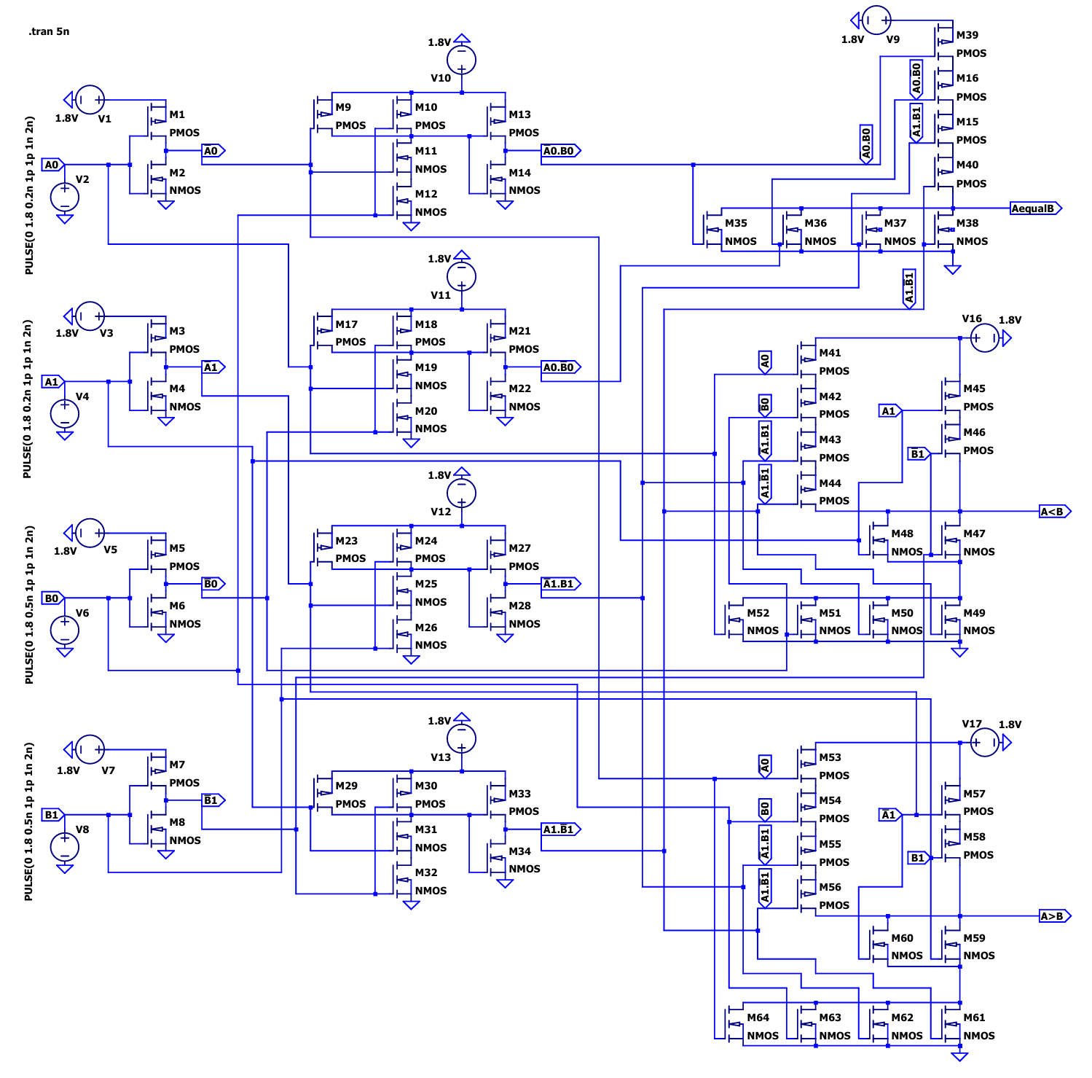
Figure 1: Transistor-level schematic of the 2-bit comparator using PTM 180 nm CMOS technology.
6. Simulation Results
The transient simulation verified all possible combinations of the 2-bit inputs.
6.1. Case 1: A = B
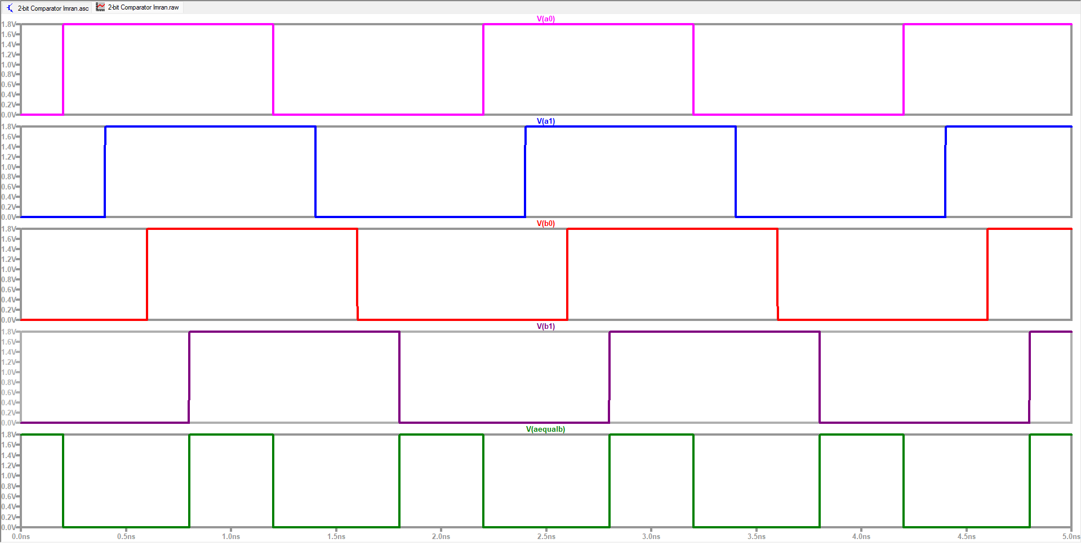
Figure 2: Output Waveform for A=B
Result Analysis: The waveform confirms that the A = B output becomes HIGH whenever both 2-bit inputs are identical. During these intervals, the outputs A > B and A < B remain LOW, indicating correct equality detection and proper one-hot operation of the comparator.
6.2. Case 2: A > B
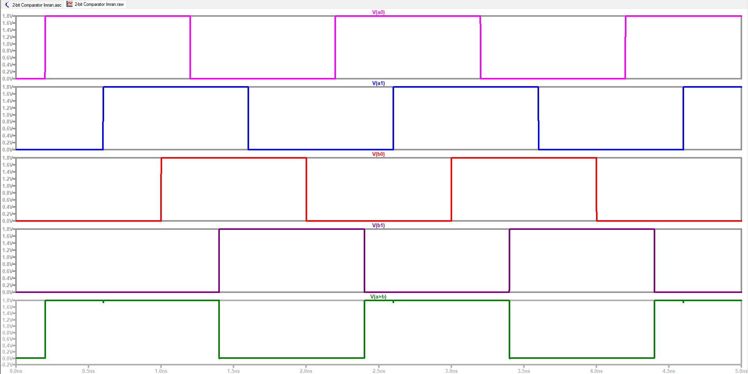
Figure 3: Output Waveform for A>B
Result Analysis: The simulation results show that the A > B output becomes HIGH whenever the binary value of input A exceeds that of input B. At the same time, the A = B and A < B outputs remain LOW, verifying accurate greater-than comparison and exclusive output behavior.
6.3. Case 3: A < B
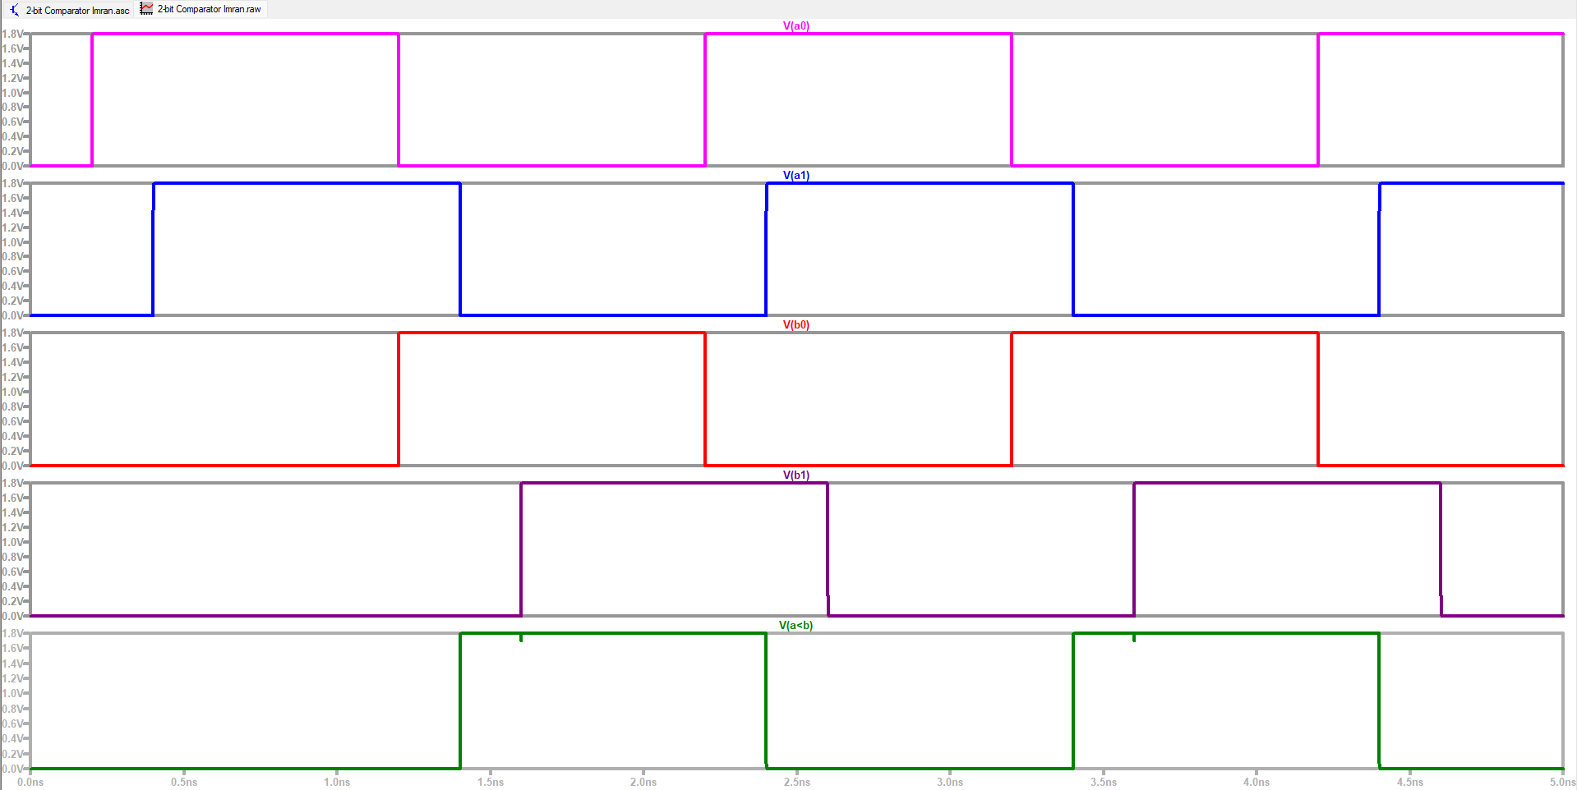
Figure 4: Output Waveform for A<B
Result Analysis: The waveform demonstrates that the A < B output is asserted HIGH whenever the binary value of input A is less than that of input B. The other outputs remain LOW during these periods, confirming correct less-than detection and reliable one-hot output generation.
7. Conclusion
A transistor-level 2-bit digital comparator was successfully designed and simulated in LTspice using PTM 180 nm CMOS technology. A total of 64 transistors were used in this design. The circuit employed Static CMOS and Complex CMOS logic to compare two 2-bit binary numbers and generate the outputs A>B, A=B, and A<B. All sixteen possible input combinations were verified through transient analysis, and the results matched the theoretical truth table. The design demonstrated correct functionality, full voltage swing, low static power consumption, and reliable one-hot output behavior, making it suitable for integration into larger digital systems.
8. Individual Contribution
Sl. | Metric ID | Name | Contribution
1. | ET231033 | Md. Abdullah Al Muntasir | Report Writing, Proofreading
2. | ET231034 | Md. Minhaj Uddin Raiyyan | Report Writing, Proofreading
3. | ET231035 | Imran Yakub | LTspice Design, Report Writing

