Smart Incubation System
Imran Yakub (ET231035)
Md. Sayem Ur Rahman (ET231037)

Course Code: EEE 3506  Course Title: Microprocessor & Interfacing sessional  Course Teacher: Dr. Sikder Sunbeam Islam  Department: EEE  Section: 5AM  Date of Submission: 16/06/2025 | Remarks:

Items | Remarks (by teacher) | Items for Report | Remarks (by teacher)
- Used Arduino Uno or PIC Microcontroller. |  | (i)Front page,
- Used Sensor (it is must). |  | (ii)Title
- Proper sensing operation. |  | (iii)Pointed features of the design
- Properly alerted the owner. |  | (iv) circuit diagram
- Proper Simulation output shown. |  | (v)Description ofprogram/codes,
- Hardware implemented properly. |  | (vi) Proteous (simulation) output snap shot,
 |  | (vii) hardware working snap shots,
 |  | (viii) Assessment of issues relevant to this work
 |  | (ix)Proof of CEP
 |  | (x) contribution of members.

- Title: Smart Incubation System.
- Pointed Features of the proposed work:
- This device can measure temperature and humidity.
- The result is accurate and reliable.
- It is used to gather environmental data inside an incubator.
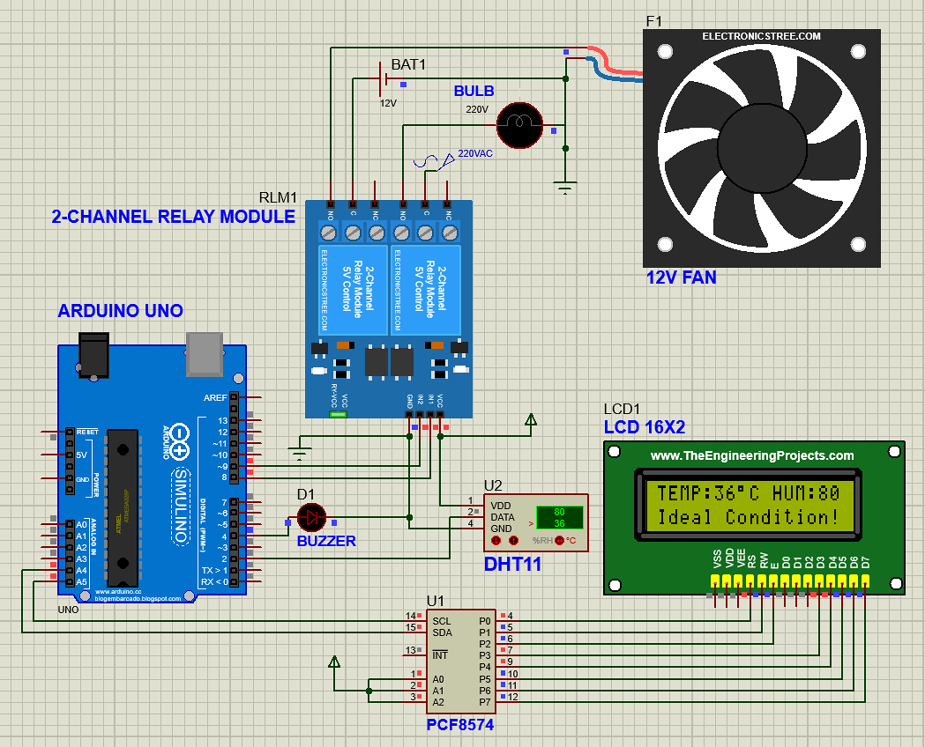
- Circuit Diagram & Operation:
Fig-1: Circuit Diagram of the Project
Operation:
In this circuit one sensor were used: DHT11 which is a temperature and humidity sensor.
Temperature Sensing: A thermistor (temperature-sensitive resistor) is used. Its resistance decreases as temperature increases. The DHT11 measures this resistance and converts it into a digital temperature value using its internal analog-to-digital converter.
Humidity Sensing: It uses a capacitive humidity sensor made of two electrodes with a moisture-holding dielectric material in between. As the humidity in the air changes, the dielectric constant of the material changes, which alters the capacitance. This change is converted into a digital humidity reading using an internal ADC.
- The Smart Incubation System automatically monitors and controls the internal temperature and humidity using a DHT11 sensor. Based on real-time temperature readings, it activates a bulb (via relay) to increase heat when the temperature drops below a set threshold, and a fan to cool when it rises above the safe limit. An LCD displays current temperature, humidity, and system status, while a buzzer alerts when the bulb is turned on. The system ensures stable incubation conditions with minimal human intervention, making it ideal for poultry or lab incubation setups.
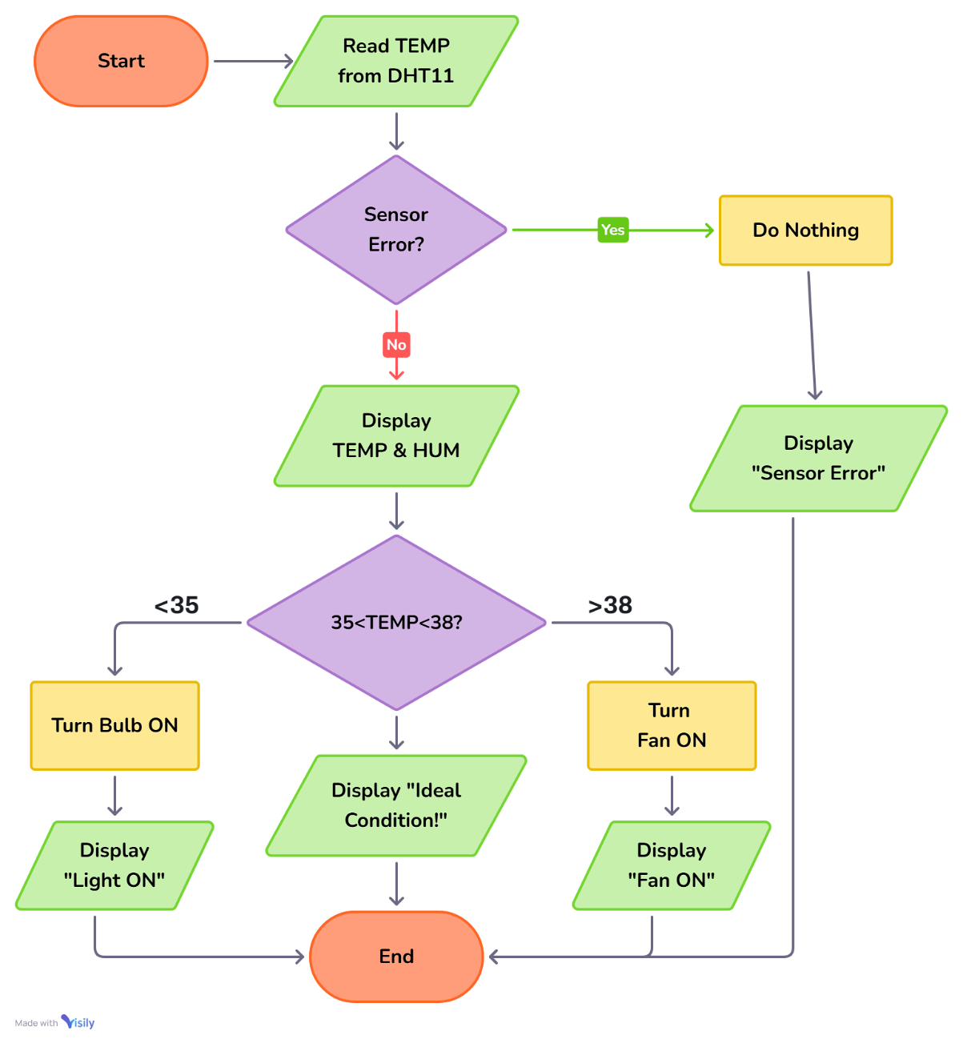
To better understand the operation, a flowchart has been provided.

Fig-2: Flow Chart of the System
- Description of program/codes:

Program | Description
#include <Wire.h> | Enables I2C communication (used by LCD and other I2C devices)
#include <LiquidCrystal_I2C.h> | control a 16x2 LCD display over I2C with simple functions
#include <DFRobot_DHT11.h> | Provides tools to read temperature and humidity from a DHT11 sensor easily
LiquidCrystal_I2C lcd(0x27, 16, 2); | Initializes the LCD at I2C address 0x27 with 16 columns and 2 rows.
#define DHT11_PIN 2 | Assigns digital pin 2 to the DHT11 sensor.
DFRobot_DHT11 DHT; | Creates an instance of the DHT11 sensor object.
#define BUZZER_PIN 4  #define BULB_RELAY_PIN 8  #define FAN_RELAY_PIN 9 | Defines pins for the buzzer, bulb relay, and fan relay.
#define BULB_ON_TEMP 34.5  #define BULB_OFF_TEMP 35  #define FAN_ON_TEMP 38.5  #define FAN_OFF_TEMP 37 | Defines temperature thresholds for turning bulb and fan on/off using hysteresis control.
bool bulbOn = false;  bool fanOn = false; | Tracks the current states of the bulb and fan.
void setup() {  lcd.init();  lcd.backlight(); | Initializes the LCD and turns on its backlight.
pinMode(BULB_RELAY_PIN, OUTPUT);  pinMode(FAN_RELAY_PIN, OUTPUT);  pinMode(BUZZER_PIN, OUTPUT); | Sets the relay and buzzer pins as output
digitalWrite(BULB_RELAY_PIN, HIGH);  digitalWrite(FAN_RELAY_PIN, HIGH);  digitalWrite(BUZZER_PIN, LOW); | Turns off the bulb and fan (active LOW relays) and ensures the buzzer is off.
lcd.setCursor(0, 0);  lcd.print("Initializing...");  delay(1000); | Displays “Initializing…” message for 1 second
lcd.clear();  lcd.setCursor(0, 0);  lcd.print("Smart Incubation");  lcd.setCursor(0, 1);  lcd.print(" System ");  delay(2000); | Clears the display and displays project title on LCD for 2 seconds.
lcd.clear();  lcd.setCursor(0, 0);  lcd.print("By, ET231035 ");  lcd.setCursor(0, 1);  lcd.print(" & ET231037 ");  delay(2000); | Shows contributor IDs on LCD for 2 seconds.
void loop() {  DHT.read(DHT11_PIN);  lcd.clear(); | Reads temperature and humidity; clears LCD for fresh data.
if (DHT.temperature == 255 || DHT.humidity == -1) { | Checks for sensor failure (255 = error from DHT11).
lcd.setCursor(0, 0);  lcd.print(" Sensor Error");  digitalWrite(BULB_RELAY_PIN, HIGH);  digitalWrite(FAN_RELAY_PIN, HIGH);  bulbOn = false;  fanOn = false; | Displays “Sensor Error”, turns off both devices.
} else {  lcd.setCursor(0, 0);  lcd.print("TEMP:");  lcd.print(DHT.temperature);  lcd.print((char)223); // degree symbol  lcd.print("C HUM:");  lcd.print(DHT.humidity);  lcd.print("%"); | Displays real-time temperature and humidity on the LCD.
if (DHT.temperature <= BULB_ON_TEMP && !bulbOn) {  digitalWrite(BULB_RELAY_PIN, LOW);  bulbOn = true; | Turns on bulb if temperature is below threshold.
digitalWrite(4, HIGH); delay(200);  digitalWrite(4, LOW); delay(200);  digitalWrite(4, HIGH); delay(200);  digitalWrite(4, LOW); | Buzzer beeps twice when bulb turns on.
} else if (DHT.temperature >= BULB_OFF_TEMP && bulbOn) {  digitalWrite(BULB_RELAY_PIN, HIGH);  bulbOn = false; | Turns off bulb if temperature reaches upper limit.
if (DHT.temperature > FAN_ON_TEMP && !fanOn) {  digitalWrite(FAN_RELAY_PIN, LOW);  fanOn = true; | Turns on fan when temperature exceeds threshold.
digitalWrite(4, HIGH); delay(200);  digitalWrite(4, LOW); delay(200);  digitalWrite(4, HIGH); delay(200);  digitalWrite(4, LOW); delay(200);  digitalWrite(4, HIGH); delay(200);  digitalWrite(4, LOW); | Buzzer beeps three times when fan turns on.
} else if (DHT.temperature <= FAN_OFF_TEMP && fanOn) {  digitalWrite(FAN_RELAY_PIN, HIGH);  fanOn = false; | Turns off fan when temperature cools down.
lcd.setCursor(0, 1);  if (DHT.temperature > FAN_ON_TEMP && fanOn) {  lcd.print(" Fan ON");  } else if (DHT.temperature <= BULB_ON_TEMP && bulbOn) {  lcd.print(" Light ON");  } else {  lcd.print("Ideal Condition!");  } | Shows the current system status (Light ON, Fan ON or Ideal Condition!) on the second LCD line.
delay(2000);  } | Delays 2 seconds before repeating the loop.

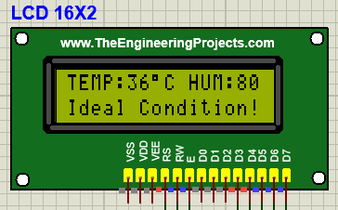
- Proteus Simulation Snap Shot:
Fig-3: Snap shot of Proteus output – Ideal Condition!
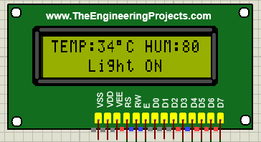
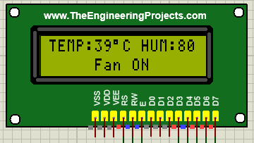
Fig-4: Snap shot of Proteus output – Light ON
Fig-5: Snap shot of Proteus output – Fan ON
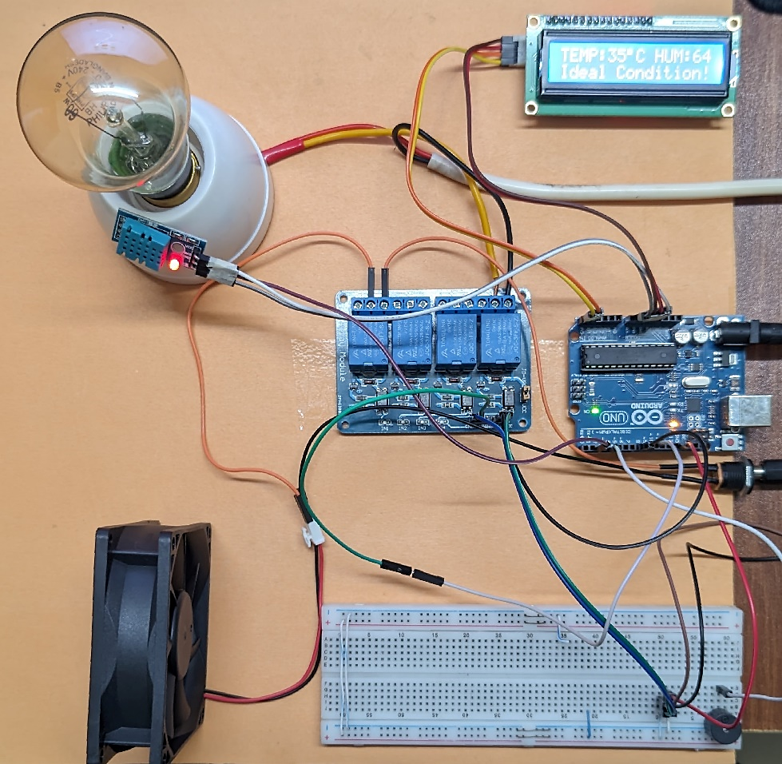
- Hardware working snap shots :
Fig-6: Snap shot of hardware output – Ideal Condition!
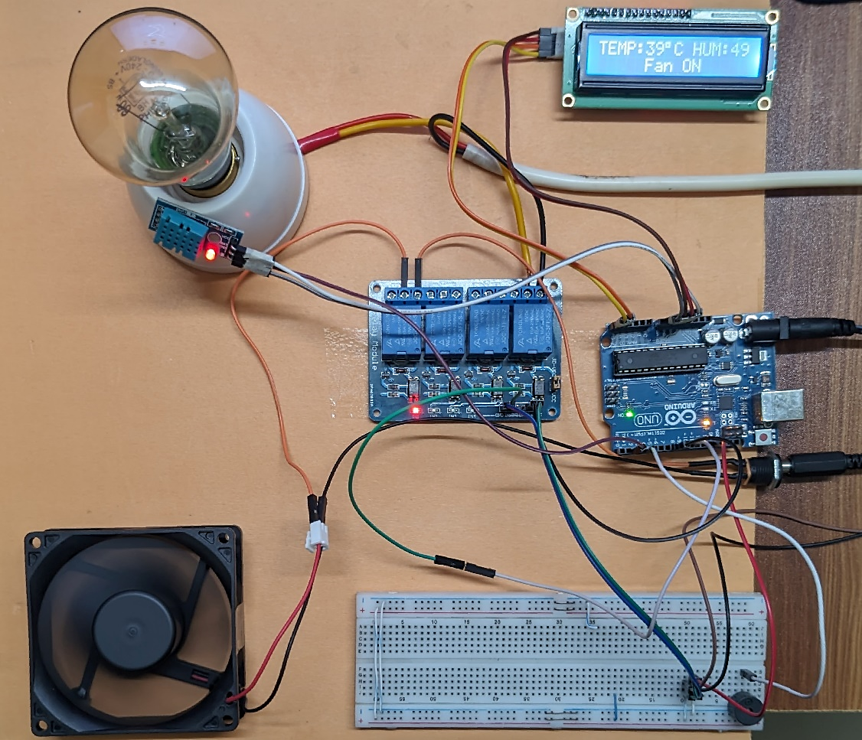
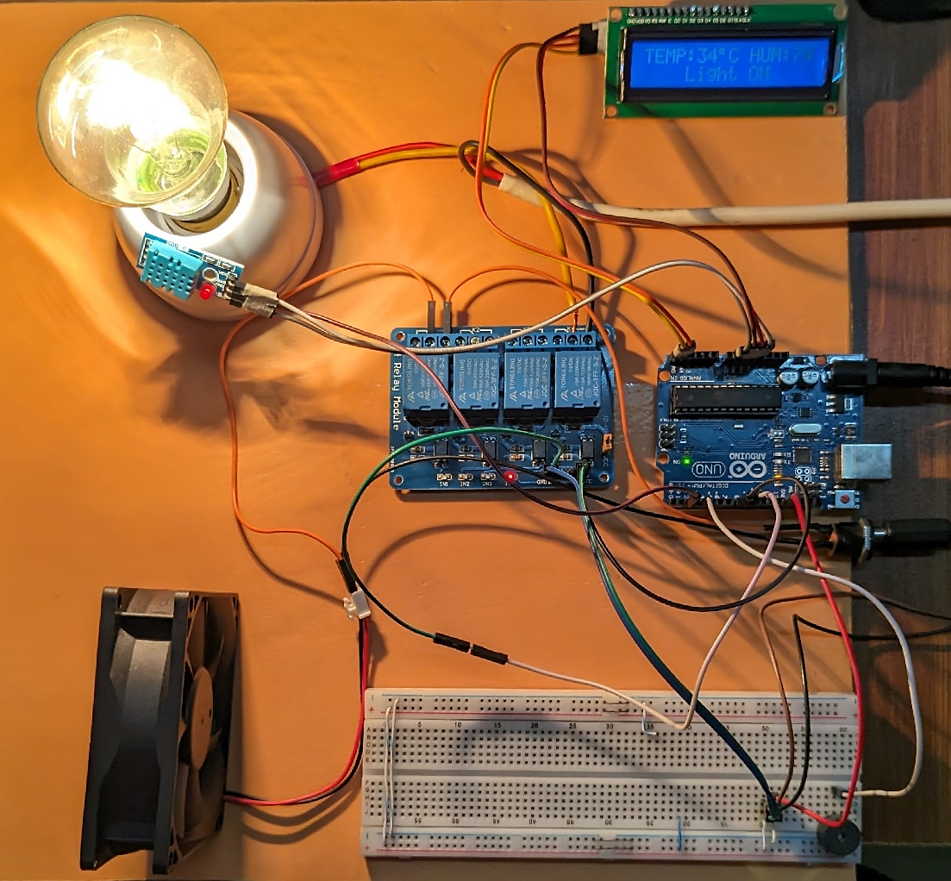
Fig-7: Snap shot of hardware output – Light ON
Fig-8: Snap shot of hardware output – Fan ON

- Assessment of Considered Issues:
- Public health issue: The system promotes public health by ensuring optimal incubation temperatures, which can be critical in hatching disease-free poultry or for biomedical applications. Proper regulation prevents harmful bacterial growth due to incorrect humidity or temperature levels.
- Safety issue: Malfunctioning of the sensor or IC used in the system may cause wrong reading at user end.
- Cultural issue: This project supports agricultural and traditional practices like poultry farming, which are culturally significant in many rural communities. Automating such processes respects cultural traditions while introducing modern efficiency.
- Societal issue: The smart system can empower small-scale farmers and educational institutions, contributing to local economies and food security. It also serves as an example of affordable technology addressing community-level needs.
- Legal issue: As an electronic device, it must comply with national electrical safety standards and, if commercialized, be certified under regulatory bodies like BSTI or CE. Data privacy is not directly involved, but safe hardware practices must be followed.
- Environmental & Sustainability issue: The system supports sustainability by using only the necessary power for temperature regulation, minimizing energy waste. If powered by renewables like solar, it becomes a fully green solution for off-grid areas.
- Sustainability assessment:
- Open-source hardware makes components reusable in other projects.
- Can be repaired or upgraded easily (modular design).
- Extremely low power consumption (milliwatt range).
- Can be powered by USB, solar, or rechargeable batteries.
- Very affordable: <$20 for complete setup.
- Promotes innovation in low-resource settings (e.g., rural animal husbandry).
- Encourages local assembly, reducing dependency on imports.
- Easy to repair and maintain.
- Can be mass-produced or adapted for specific community needs.

- Justification of CEP (Complex Engineering Problem):

We are claiming the project as CEP (Complex Engineering Problem) for the following attainment of WK, WP, WA:
WK3: Knowledge of Electronics, microcontroller was used.
WK4: Specialized knowledge on sensor was used.
WK5: Circuit design knowledge was applied.
WK6: Simulation and Hardware tools were used.
WK7: Societal issue was considered.

WP1: WK3-WK6 are addressed.
WP3: Multiple ways of design and microcontroller coding is possible.
WP4: The project work is involved with infrequently encountered issues as animal husbandry related matters that is not studied in electrical engineering discipline.

WA1: The project involves diverse resources (People, money, equipment etc)
- Contribution of the members:
Students ID | Name | Role | Contribution | Signature
ET231035 | Imran Yakub | Team Leader | - Planned the total work steps,  - Bought the equipment,  - Contributed to design,  - Hardware implementation,  - Report Writing. **
ET231037 | Md. Sayem Ur Rahman | Member | - Bought the equipment,  - Contributed to design,  - Hardware implementation,  - Simulation,  - Data Collection. **

