**User document**  
  
This is the bigger version of TicTacToe game.  
The board is 6 by 6 so you have 36 places to place the stone.  
To win this game, you have to make a 4 consecutive line of the stones in either vertical, horizontal or diagonal.  
  
Except for the first movement, you can’t place the stone where it doesn’t have any neighbour that already has a stone.

Once the game is started, you will see the board like this  
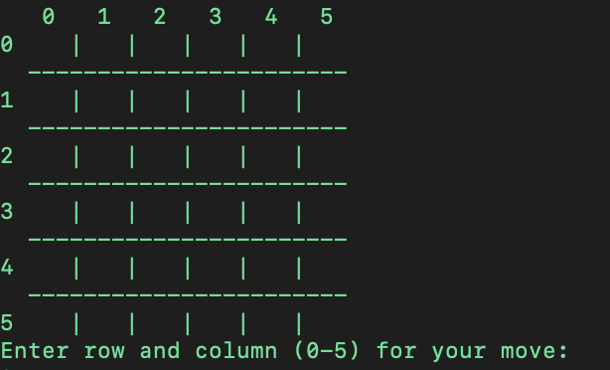

So please enter 2 numbers from 0 to 5, the first one is for the row and the second one is for the column where you want to place the stone.

After entering your movement, it shows your stone which you just placed.  
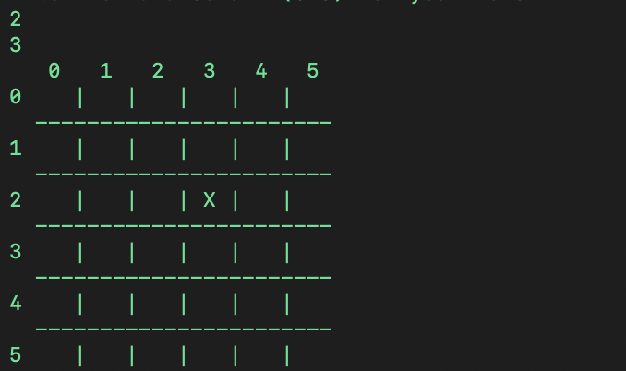

Right after that, AI will make his movement and shows where he placed the stone.  
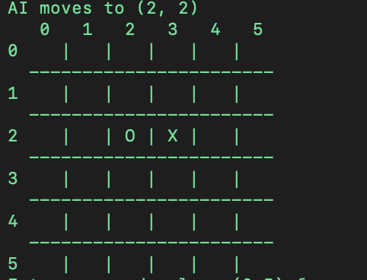

Then it is your turn again, so you can place your stone wherever you want.

Once you or the AI Player wins, it shows the result.  
  
