Internship Report: BF541
Koga, Yusuke
U74281846
The following is an internship status report summarizing the work I have accomplished under the guidance of my advisor, Dr. Joshua Campbell, starting from January 2018.
Background about the lab/work:
- The Spira-Lenburg laboratory is focused on research of lung biology and disease using post-genomic technologies and computational tools. Two of the major causes of deaths in United States, lung cancer and chronic obstructive pulmonary disease (COPD), are studied intensively in this lab, in which one of the major undertakings has been the development and validation of genomic biomarkers, which could then be used to create medicines that can target the disease. Through computational data analysis, I was tasked with finding patterns that may or may not be correlational to the occurrence to the disease.
Note about position: I have been working as a computational analyst at the Spira-Lenburg Laboratory since February 2017, and plan to continue working there for the very near future.

Projects worked on:
- CELDA – CELDA stands for CEllular Latent Dirichlet Allocation, which is a single-cell RNA-sequencing data analysis R package that my advisor has been working on. The purpose of the package is to perform gene and cell clustering on scRNA-seq datasets to be able to discern hidden cell subpopulations by grouping together cells and genes into clusters. I have been working on multiple facets of the package, which I will detail below.
  - Analysis of human nasal samples – CELDA was used to analyze a recently obtained nasal single-cell dataset, to test whether CELDA can identify the cell subpopulations. Upon running CELDA, the data was clustered with tSNE and classified with specific marker genes (Figure A), which was compared with a tSNE plot labeled with CELDA cluster labels (Figure B). Additionally, a heatmap was created with the top25 genes of each gene cluster, which is determined by the contribution of each gene to the expression of the gene cluster. (Figure C). Based off of these figures, several cell populations could be discerned. For instance, cell cluster 1 has high expression of gene cluster 9, which contained several immune cell marker genes. Thus, cells in cluster 1 were annotated to be immune cells. However, there were several clusters that have broad expression of many genes, making it difficult to annotate all clusters. Also, since cluster 1 contained multiple subclusters, CELDA was run on only the 120 cells that were labeled as immune cells to determine subpopulations within the immune cell population. A heatmap was created from the clustering results (Figure D), in which expression patterns for specific types of cells, such as MHC class I, class II, and NK cells can be seen. Overall, CELDA has been able to successfully cluster cell subpopulations based off of gene expression.
  - Determining the number of clusters – One of the primary issues with using the CELDA package has been that it requires users to choose how many cell and gene clusters to detect, which is unknown a priori. I have been attempting to devise methods to determine the “true” number of cell clusters in a CELDA model. For our analysis, a public PBMC (peripheral blood mononuclear cell) dataset was used, in which we have a rough understanding of what type of cells are present. Our first approach was to plot the perplexity of a model – how well the model predicts the sample – against the number of cell clusters, and try to see if there is an “elbow” in which added clusters does not cause a decrease in perplexity. However, when plotted (Figure E), an “elbow” was not observed; the perplexity would keep dropping at a steady rate when the number of cell clusters was increased. The next approach to determine the best cluster was to treat each gene cluster as a pseudogene, and run a pairwise t-test for all cell clusters. The underlying idea was that if all cell clusters are indeed novel, each cell cluster will have at least one pseudogene that is differentially expressed to another cell cluster. Once there is an “extra” cluster, that cluster should have a similar expression pattern to an existing cluster, and there should be no differentially expressed pseudogene. When the t-test is run between two the average expression in the cell clusters, the lowest p-value was stored. This is done for all cell cluster combinations, in which the negative log of the highest stored p-value was then plotted against the number of cell clusters. (Figure F) The issue with this strategy was that this was highly affected by the smallest cluster present in the model. When a t-test is conducted with an extremely small cell cluster, the p-value is going to end up being relatively high. (Figure G) As seen in the figure, when 17 cell clusters were used, there was one cell cluster that contained only 2 cells. When the t-test approach was conducted with this model, the resulting negative-log of the p-value was very low, due to the low degrees of freedom. To combat this issue, we first converted the counts matrix to a factorized matrix, which combined the expression of all genes within the same gene cluster, and combined the expression of all cells within the same cell cluster. The expression value was converted into a proportion, in which the expression of all gene clusters would total to 1. This “proportion” for each cell cluster was then fed into the rmultinom function to convert the proportion into a simulated cell cluster with equal number of cells. With an equal number of cells, degrees of freedom when performing t-test was not an issue, and we were able to see an elbow, which may indicate the number of cell clusters within the dataset. (Figure H) We are currently performing additional analysis to confirm the number of “true” cell clusters in the dataset.

- Development of RNA-seq pre-processing pipeline – To streamline the processing of RNA-Seq samples, a pipeline software has been developed which aligns RNA-seq data using STAR aligner (Dobin, 2013), creates the counts matrix from the outputted BAM files using RSEM (Li, 2011), conducts variant calling based on the GATK Best Practices for RNA-Seq Preprocessing, runs quality control on the aforementioned processes, and combines all of the information together in a SummarizedExperiment object. This pipeline has been in development since the last report (Spring 2017), and is now able to take in multiple paired-end reads per sample, and has cleared up many of the issues in regards to storage/memory allocations.

Impact of the experience on my professional development:
- From this job opportunity, I feel that I have gotten a glimpse at how I would function in a data analyst position, as well as a researcher. In addition to working on the aforementioned projects, as a lab member for over a year, I have also been involved in mentoring/helping other colleagues who needed assistance, such as debugging code, getting through command errors, producing data for others to analyze, and offering other help. The daily communication with my colleagues has brought to light the importance of communicating knowledge to others.

Figures:

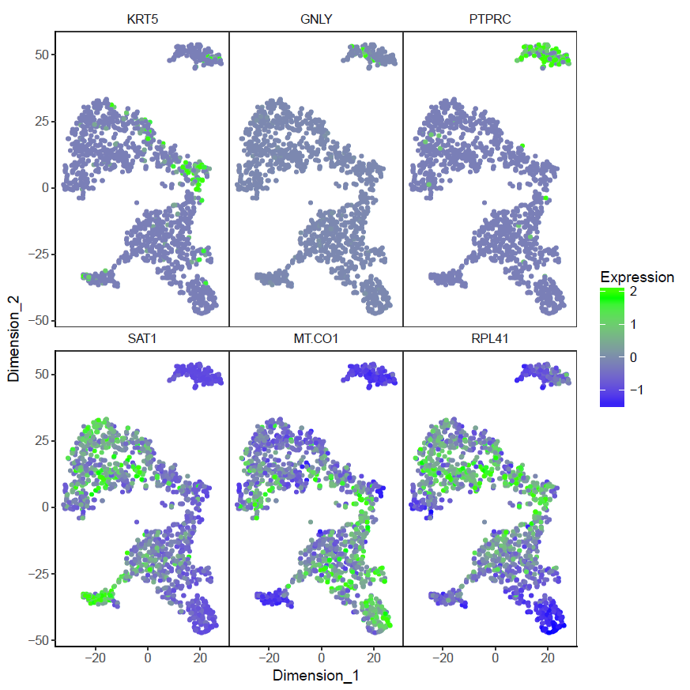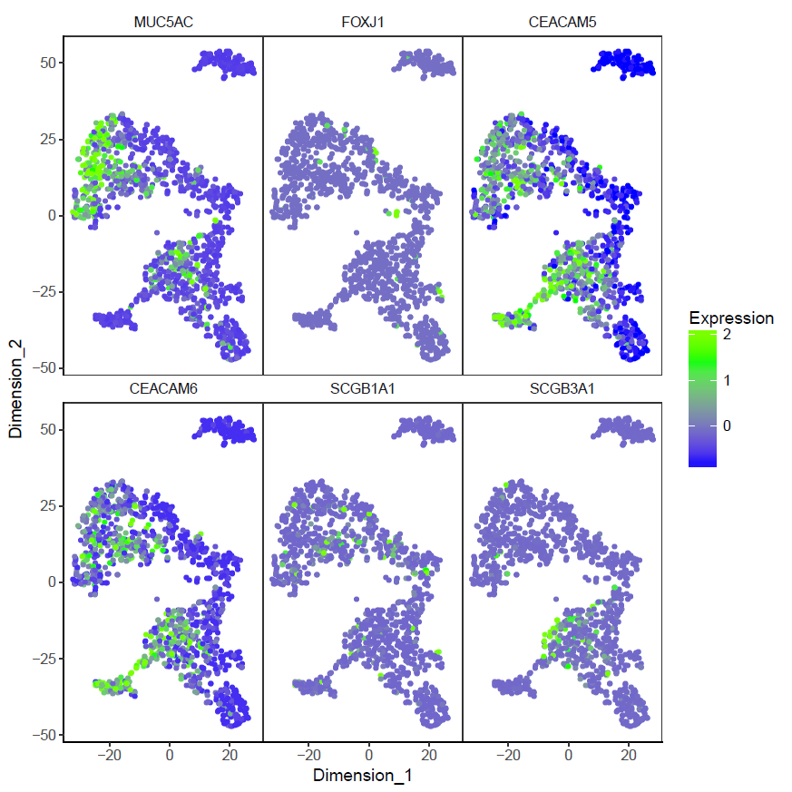
Figure A. tSNE clustering was conducted on the counts matrix that was analyzed via CELDA, in which each dot represents a cell, colored by the expression of a specific marker gene.
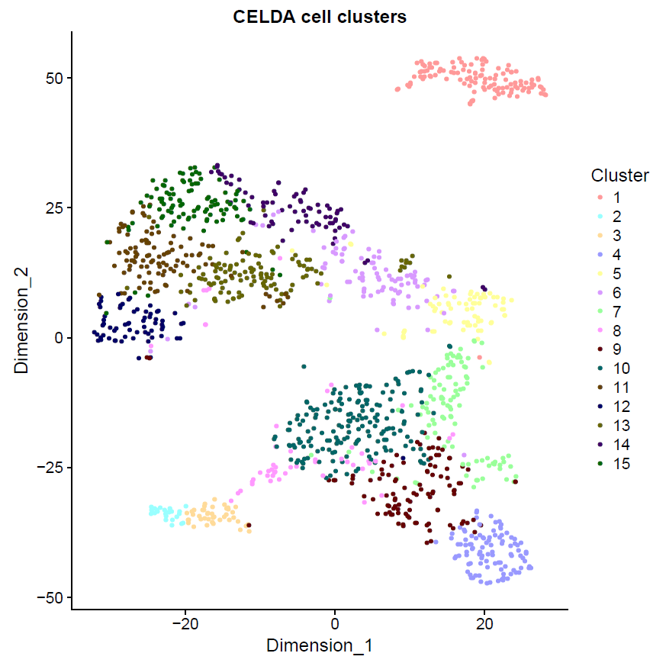
Figure B. tSNE clustering was conducted on the counts matrix that was analyzed by CELDA, in which cells were colored by the CELDA cell cluster labels.
Figure C. A heatmap was created from the nasal scRNA data, in which cells were clustered by the CELDA cluster labels. The top 25 genes for each gene cluster was used. If a prominent marker gene was included within the top 25 genes, they were annotated to the side.

Figure D. A heatmap was created from the 120 cells that were labeled as immune cells in the previous analysis.

Figure E. The perplexity of the model was plotted against the number of defined cell clusters (K). Each line corresponds to the set number of gene clusters (L).
Figure F. The negative log of the p-value when pairwise t-test was conducted, was plotted against the number of cell clusters in the model.
Figure G. The number of cells in the smallest cluster in each model was plotted against the number of cell clusters in the model.
Figure H. The negative log of the p-value when pairwise t-test was conducted between simulated cell clusters, was plotted against the number of cell clusters in the model.

