- AwareAds WordPress Memo

General setting:
General under Settings at Left Navigation bar

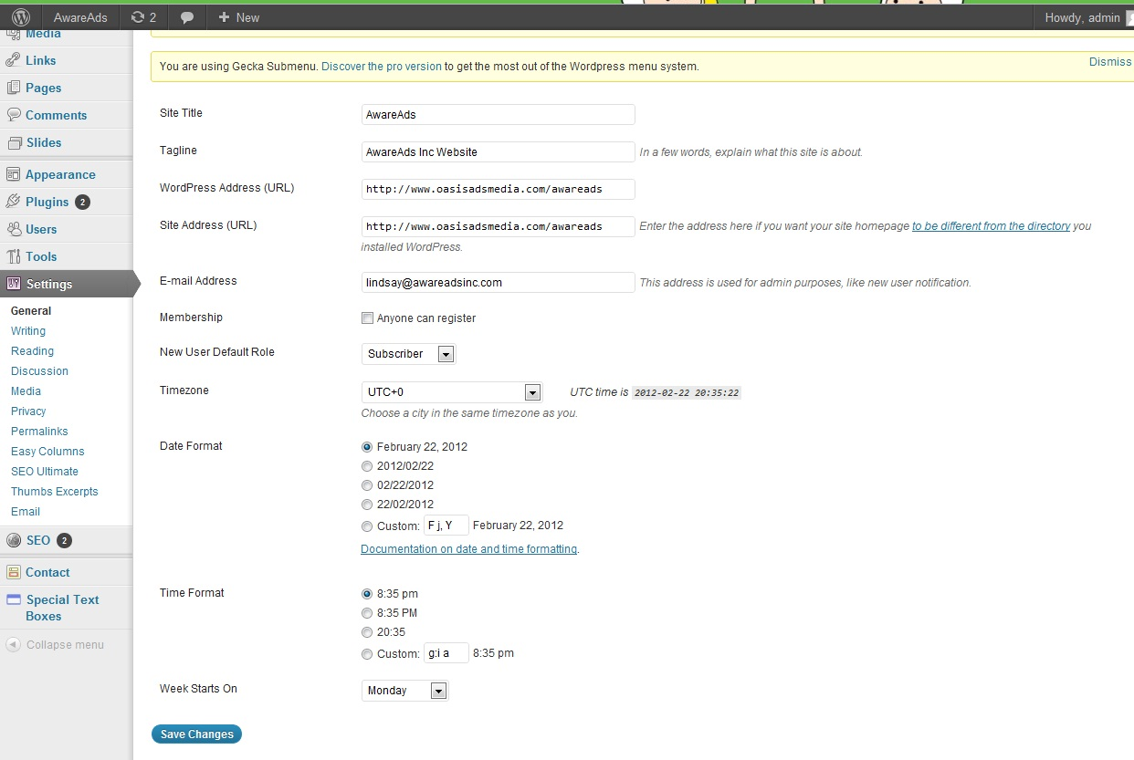

- SubMenu:
Add submenu
- Add new page at Pages from Left Navigation bar
- Select Parent page at Page Attributes
- Go to Menus under Appearance, and make sure the “Automatically populate with child pages” are selected at parents pages

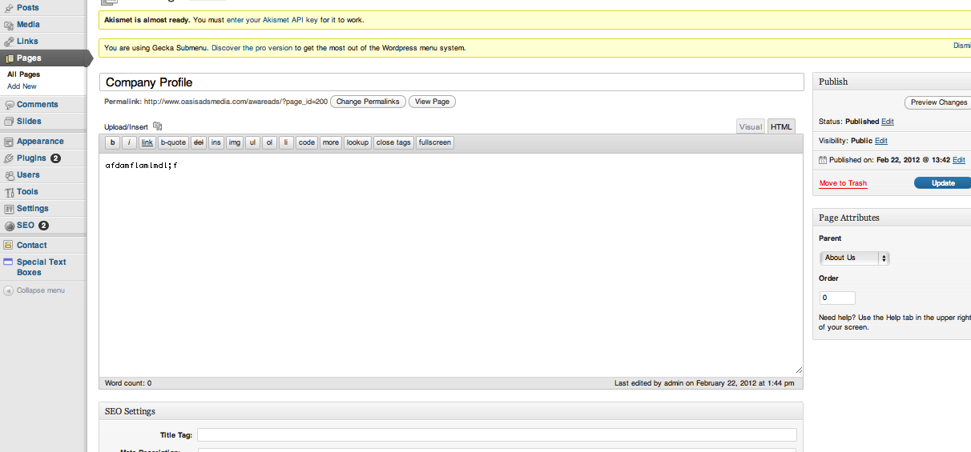
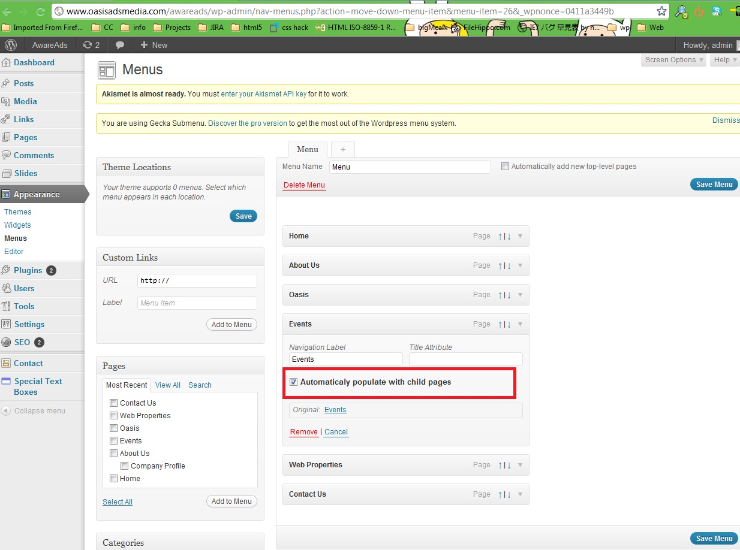
- Slides:
(Each Slide image has to be 845 x 320px)

- Go to Slides at Left Nav
- Click Add New
- Click “Set featured image” under Slide Image tag
- Select image (Select “Use as feature image )
- Slide Link
If you want to link to another URL from the image, you can add URL at “Slide Link”
- Click “Publish”
- Settings
You can change number of slideshow, transition style, duration and speed (but don't change the slide size)

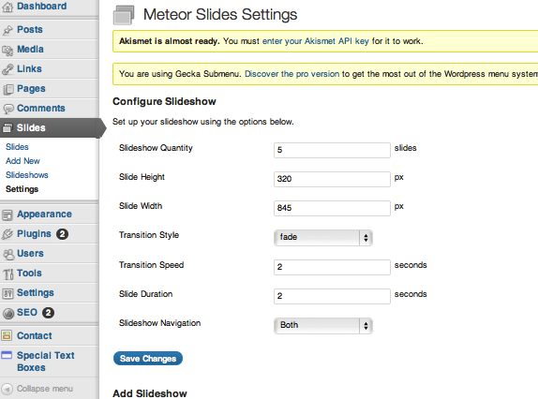
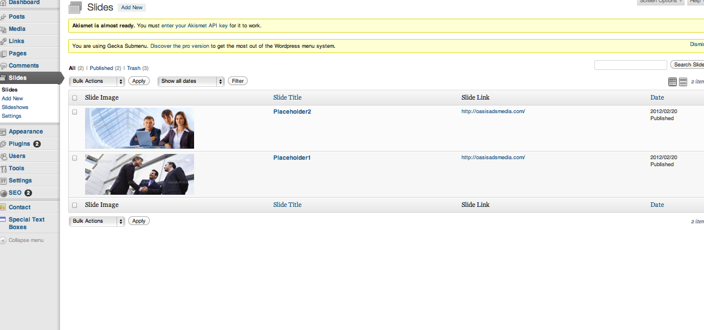
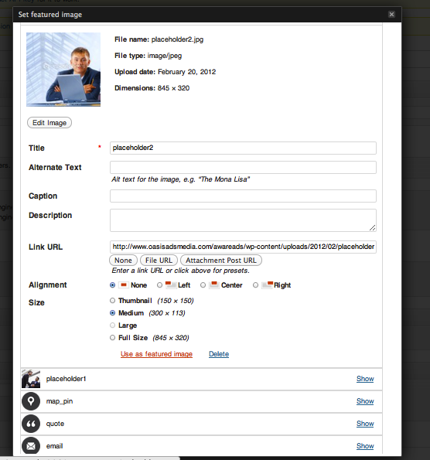

- Oasis Page:
(There are two columns in the content)
Please add your content between these following tags, so the website can recognize to each column.
*button link: you can change text and also add link that you want

[wpcol_1half id="" class="" style=""]

Test1 message

[button link="http://oasisadsmedia.com/"]Read More[/button]

[/wpcol_1half][wpcol_1half_end id="" class="" style=""]

Test2 message

[button link="http://oasisadsmedia.com/"]Read More......[/button]
[/wpcol_1half_end]

- Event Page with Special text box:

Please add text/image between the tags. Each tag displays with different design.

[stextbox id="custom" color="000000" bgcolor="e5e5e5" bcolor="e5e5e5"]Maecenas viverra, diam blandit faucibus consectetur, eros elit euismod eros, non faucibus risus mauris ut dolor. Nunc ac blandit mi. Suspendisse potenti. Class aptent taciti sociosqu ad litora torquent per conubia nostra, per inceptos himenaeos. Cras eleifend elit interdum felis laoreet lobortis. Class aptent taciti sociosqu a[/stextbox]

[stextbox id="warning"]awoeuriaoweruajelkwajl[/stextbox]

[stextbox id="black"]awoeuriaoweruajelkwajl[/stextbox]
[stextbox id="grey" image=" "]awoeuriaoweruajelkwajl[/stextbox]
[stextbox id="grey" color="000000" bgcolor="ffffff" bcolor="e5e5e5" image=" "]

awoeuriaoweruajelkwajl[/stextbox]
[stextbox id="alert"]awoeuriaoweruajelkwajl[/stextbox]
[stextbox id="grey" caption="This is example" color="000000" ccolor="000000" bgcolor="e5e5e5" cbgcolor="ffffff" bcolor="e5e5e5" ]Lorem ipsum dolor sit amet, consectetur adipiscing elit. Proin sed mauris nec nisl porttitor accumsan. Aliquam iaculis vehicula lectus id semper. Nunc feugiat fermentum dolor, et ullamcorper dolor lacinia ac. Nullam vitae turpis est.[/stextbox]

[stextbox id="grey" color="000000" bgcolor="ffffff" bcolor="e5e5e5" image=" "]<a href="http://www.awareads.com"><img title="awareads_logo" src="http://www.oasisadsmedia.com/awareads/wp-content/uploads/2012/02/awareads_logo.jpg" alt="" width="223" height="97" /></a> awoeuriaoweruajelkwajl[/stextbox]

- Contact Us Page:

Change the link of Google map:

[googlemap width="400" height="400" src="http://maps.google.com/maps?q=600+fleet+street+toronto&hl=en&ie=UTF8&ll=43.638094,-79.40006&spn=0.007206,0.01929&sll=36.527295,136.40625&sspn=32.561265,79.013672&brcurrent=3,0x0:0x0,0&hnear=600+Fleet+St,+Toronto,+Ontario+M5V+1B7+%E3%82%AB%E3%83%8A%E3%83%80&t=m&z=16&iwloc=A"]

Go to google map and enter your address.
Get the link and replace the link above.

