MLPPI Wizard: An Automated Multi-level Partitioning Tool on Analytical Workloads

Young-Kyoon Suh¹, Alain Crolotte² and Pekka Kostamaa³
¹ School of Computer Science and Engineering,
Kyungpook National University
Daegu, 41566 – Republic of Korea
[e-mail: yksuh@knu.ac.kr]
² Teradata Corporation,
El Segundo, CA 90245, USA
[e-mail: {alain.crolotte}@teradata.com]
³ OpenX
West Los Angeles, CA 90232, USA
[e-mail: {pekkak@yahoo.com}]
*Corresponding author: Young-Kyoon Suh

Abstract

Typically, it is a daunting task for a database administrator (DBA) to figure out how to partition a huge fact table accessed by query workloads for better performance. To relieve such a burden, we introduce a novel recommendation system, termed MLPPI wizard, to produce a multi-level partitioning solution on a fact table in a star schema of a data warehouse. This system uses a greedy algorithm for search space enumeration. This space is driven by predicates of a given query workload. The system takes advantage of the cost model of a query optimizer to prune the search space. The system resides completely on a client and interacts with the optimizer via APIs over the network. Thus, there is no overhead to instrument the optimizer code as opposed to some previous works. Note that our predicate-driven method can be applied to any clustering or partitioning scheme in an arbitrary database management system (DBMS) that underlies information systems. We show that the system’s recommendation outperforms a human expert’s solution with respect to the total execution time of a given workload. We also demonstrate that the recommendation scales very well with an increasing workload over a growing fact table.

Keywords: Data warehousing, information systems, star schema, fact table, OLAP, analytical workloads, multi-level partitioning
1. Introduction
Over the past decades much attention has been paid to improve the performance on analytical workloads like OLAP in a data warehousing environment. A relational database management system (DBMS), which underlies information systems, has been exploited to process such analytical queries faster and assist customers to draw a timely business-decision in rapidly-changing enterprise data warehousing. Teradata DBMS has been positioned as leading one in this data warehousing marketplace getting more competitive than ever.
Background: To optimize the performance of analytical processing in the Teradata DBMS, tables and materialized views are “hash-distributed” based on a user-specified column or set of columns called primary index. Each virtual processor, a unit of parallelism called AMP in the Teradata DBMS, receives a subset of the data and stores it in hash order. Users typically choose primary index fields in the DBMS, so that the data is evenly distributed among the AMPs. The primary index fields are also chosen to reflect join fields in workloads to accomplish cheaper local joins that do not require data shuffling.
Partitioned Primary Index (PPI) [1] is an optional horizontal partitioning scheme applied locally on the data belonging to each AMP. In some other DBMSes, this type of partitioning is termed clustering, but hereafter we call the term partitioning only to avoid confusion. Database administrators (DBAs) usually choose the columns for PPI, based on join fields and single table predicates to optimize the queries included in the workload. The PPI columns are used to physically group data with the same values together in contiguous data blocks. This grouping enables “partition elimination” in scans and joins for performance enhancement. PPI can be specified as single or multiple levels. This type of partitioning scheme is known as Multi-Level PPI (MLPPI) [2].
By allowing non-qualified partitions to be eliminated,MLPPI can considerably reduce the amount of data to be scanned to answer a query. But a large number of partitions can create significant overhead, particularly in joins and table maintenance operations such as inserts and deletes, so that the selection of partitions can be usually a balancing act.
Fig. 1 exemplifies an MLPPI table with a defined partitioning option. This example is a subset of the LINEORDER table from the Star Schema Benchmark (SSB) [3]. (Note that the full table with modified data types was actually used in our experiments.)

CREATE TABLE LINEORDER (
LO_ORDERKEY INTEGER,
LO_QUANTITY INTEGER,
LO_DISCOUNT INTEGER)
PRIMARY INDEX ( LO_ORDERKEY )
PARTITION BY (
CASE_N(LO_DISCOUNT >= 7, NO CASE OR UNKNOWN),
CASE_N(
LO_QUANTITY < 25,
LO_QUANTITY >= 25 AND LO_QUANTITY <= 30,
LO_QUANTITY > 30 AND LO_QUANTITY <= 35,
NO CASE OR UNKNOWN)
);
Fig. 1. An Example of a LINEORDER Table with Multi-level Partitioned Primary Index

Tab. 1. Partitions by LO_DISCOUNT and LO_QUANTITY
Partition Number | Condition
1 | LO_DISCOUNT >= 7 && LO_QUANTITY < 25
2 | LO_DISCOUNT >= 7 && 25 <= LO_QUANTITY <= 30
3 | LO_DISCOUNT >= 7 && 30 < LO_QUANTITY <= 35
4 | LO_DISCOUNT >= 7 && LO_QUANTITY no case
5 | LO_DISCOUNT no case && LO_QUANTITY < 25
6 | LO_DISCOUNT no case && 25 <= LO_QUANTITY < 30
7 | LO_DISCOUNT no case && 30 < LO_QUANTITY <= 35
8 | LO_DISCOUNT no case && LO_QUANTITY no case
shown in Table 1.
Whatever partition is chosen, the selection must be semantically correct; namely, the mapping of rows to partitions must be an injection. In other words, the constraints must form a covering of the entire range, so that a row will belong to exactly one and one partition. The optimizer then applies partition elimination for queries that specify conditions on LO_DISCOUNT and/or LO_QUANTITY. For example, only partitions 1 and 2 are needed for the query ‘SELECT * FROM LINEORDER WHERE LO_DISCOUNT >= 7 AND LO_QUANTITY <= 30.’ Similarly, partitions 1 and 5 are sufficient to answer the query ‘SELECT * FROM LINEORDER WHERE LO_QUANTITY < 25.’

Challenge: Consider the below query set Q with two queries q1 and q2 on the SSB as illustrated in Tab. 2.
Tab. 2. Example of a Given Star Schema Query Workload (Q)
Query ID | Query String
q1 | SELECT SUM(l.LO_EXTENDEDPRICE * l.LO_DISCOUNT)  FROM LINEORDER l, DDATE d  WHERE l.LO_ORDERDATE = d.D_DATEKEY  AND d.D_YEAR = ‘1993’  AND l.LO_DISCOUNT IN (1, 4, 5)  AND l.LO_QUANTITY <= 30
q2 | SELECT c.C_NATION, SUM(l.LO_REVENUE)  FROM CUSTOMER c, LINEORDER l  WHERE l.LO_CUSTKEY = c.LO_CUSTKEY  AND c.C_REGION = ‘EUROPE’  AND l.LO_DISCOUNT >= 7  AND l.LO_QUANTITY >= 25 AND l.LO_QUANTITY <= 35  GROUP BY c.C_NATION ORDER BY revenue desc

A DBA may focus on the LINEORDER fact table and the predicates involving LINEORDER fields only. The DBA can figure out the following five constraints, identified by the query number and the sequence number of predicates in each query as shown in Tab. 3.
Tab. 3. Extracted Query Predicates for Each of the Two Queries in Q
q1.1 | LO_DISCOUNT IN (1, 4, 5)
q1.2 | LO_QUANTITY <= 30
q2.1 | LO_DISCOUNT >= 7
q2.2 | LO_QUANTITY >= 25
q2.3 | LO_QUANTITY <= 35

CASE_N(
LO_DISCOUNT = 1,
LO_DISCOUNT = 4,
LO_DISCOUNT = 5,
LO_DISCOUNT >= 7,
NO CASE OR UNKNOWN)
Fig. 2. A Partitioning Candidate Based on LO_DISCOUNT

CASE_N(
LO_DISCOUNT >= 1 AND LO_DISCOUNT <= 5,
LO_DISCOUNT >= 7,
NO CASE OR UNKNOWN
)
Fig. 3. Another Partitioning Candidate Based on LO_DISCOUNT.

At this point the DBA needs to take into account options based only on two fields and the five constraints. There are many other possibilities from a “fine-grained” partition set to a “coarser-grained” definition.

Given for the time being the column LO_DISCOUNT, one solution is to identify each value for the IN predicate in q1.1 and use q2.1 as is. This yields the partitioning expression for LO_DISCOUNT as illustrated in Fig. 2.

This expression minimizes the size of the partitions by focusing exactly on the values required to satisfy the constraints but creates a large number of small partitions.
Another is to look at the maximum and minimum values in the IN set and to build an AND clause equivalent to a between clause yielding another candidate as described in Fig. 3.

The above partitioning solution decreases the number of partitions, compared to the previous solution but still focuses sharply on the constraints with still relatively small partitions.
Similar considerations apply to the partitioning associated with LO_QUANTITY. The resulting partitioning definition for the table includes both LO_DISCOUNT and LO_QUANTITY, and thus the number of possible combinations is the product of the potential combinations for each field.
Furthermore, given two queries one partitioning scheme may be favorable for one query but not for the other, or vice versa. Consequently, the DBA is faced with a daunting combinatorial search problem and no clear basis to decide on which combination is the best. This state of affairs begs for a “tool” for the DBA.
Solution: To ease a burden of such a partitioning decision, in this article we introduce a novel recommendation system (hereafter, tool or wizard), termed MLPPI wizard, designed to recommend an effective partitioning solution customized for a given star schema workload. This system uses a greedy algorithm for search space enumeration. The tool is based on a general framework allowing general expressions, ranges and case expressions for partition definitions. Note that the predicate-driven algorithm used by the tool can be applied to any clustering or partitioning scheme based on simple fields and expressions or complex SQL predicates in an “arbitrary” DBMS. The wizard also borrows the optimizer’s cost model to prune the search space and reach a final solution.
Contribution: The article provides the following contributions.
– We propose a novel recommendation tool to yield a multi-level partitioning definition for minimizing the execution cost of a given query workload on a star schema of a data warehouse.

– This tool is totally outside the database server, thereby incurring no overhead of instrumenting query optimizer’s code.
– We empirically show that a partitioning recommendation of our tool outperforms those of a human expert and no partitioning over increasing workload size and growing fact table.
This manuscript is a substantial extension of an earlier work [4]. The rest of the manuscript is organized as follows. In the subsequent section, we propose a multi-level partitioning algorithm—consisting of a series of phases—used by our MLPPI wizard, which is applicable to any clustering or partitioning scheme in an arbitrary database system. In turn, we conduct a detailed analysis of the complexity of the algorithms. Next, we report the performance evaluation results. We then elaborate on how our wizard is distinguished from several existing tools proposed by other DBMSes. We conclude this article by summarizing our discussion.
2. Related Work
Physical database design [9–11] has been discussed in academic research and industrial communities in the past decades. The major DBMS vendors have led much of the work. Their specific interests have been around automating the physical design for table partitioning [5–7, 12–14], indexes/materialized views [15–21], and integration [22].
Some of the tools in IBM DB2 [6], Oracle [12], and MS SQL Server [5] appear to be similar to our MLPPI wizard. With respect to problem scope and approach, however, the wizard is fundamentally different from the existing tools, except Oracle Partitioning Advisor [15] that provides no published technical details.
First, DB2 MDC Advisor [6] actually tackles a different problem of automatically recommending the most well suited MDC keys for a given workload. Agrawal’s work [5] discusses another problem of merging single-level range partitionings on objects such as tables and indexes. On the other hand, we address the multi-level partitioning problem. Hence, the existing solutions cannot be directly applied to our MLPPI wizard.
Regarding the approach, DB2 MDC Advisor [6] uses the search space driven by fields. In contrast, our search space is driven by query-predicates, of which the use is superior to that of the fields, as utilizing predicates can be more customized and specific to a given workload.
Agrawal’s horizontal partitioning scheme [5] also uses the search space driven by simple range predicates, but his technique has a shortcoming. Specifically, his work produces a solution for each individual query and attempt to merge the solutions. However, this approach cannot reach an optimized solution in a global perspective. We generate the whole search space upfront and in turn merge partitions, leading to a globally optimized solution. While his work considers a single column only, our wizard deals with multiple fields.
As addressed in Section 1, implementations of previous tools [5–7] required instrumentation for optimizer code. These instrumentations are needed to facilitate the required information for the physical design tools API calls. The instrumentation code need to be enhanced and tested for new database releases that add complexity and additional cost for software upgrades. But our algorithm is based existing APIs supported by an optimizer, which requires no code change in the optimizer.
In addition, Nehme’s work [7], deeply integrated with optimizer, reveals a concern about the quality of the recommendations made by some tools, shallowly integrated with optimizer. However, we observed in our experiments that the quality of the wizard’s solutions was much superior to that of the base solutions. In addition, some might argue that in our loosely coupled approach the cost to invoke the optimizer might be significant. But the measured call counts were much fewer than the theoretical bound, since most calls were made only when queries were affected by a merge.
Some previous work [7, 14, 20] tackles table partitioning in multi-node systems, but our problem is discussed in the context of a single node system, as in the existing work [23]. Database cracking [24] assumes a single node environment, but it does not address our multi-level partitioning problem.
There exists also some other recent work proposing a multi-level algorithm or a recommendation system. Wang et al. [24] aim at improving online service under hybrid deployment, using an effective multi-level scheduling algorithm. Yuan’s work [25] proposes a top-k recommendation system for OLAP sessions for better user assistance. Even though these works and our work seem to have something in common in terms of multi-level and recommendation, the existing works were discussed in a different domain from ours, mainly focusing on “partitioning” a fact table for better performance of a star schema workload.
Finally yet importantly, there are several recent works [27, 28] addressing the problems of exploiting analytical workloads from the real scenarios. Those works have something in common with our work in terms of utilizing analytical workloads. Each of these two camps, however, focuses on fundamentally different problems. In our work, a given star schema analytical workload is exploited to produce a possible partitioning recommendation for a huge fact table, but the authors’ works appear interested in exploiting analytical workloads from the real studies in order to propose algorithms for efficient job and task scheduling in grid computing.
3. The MLPPI wizard
In this section, we propose our MLPPI tool and describe the major algorithms of the tool.
Fig. 2 shows the overall architecture of the wizard. As shown in Fig. 2, our tool recommends the final MLPPI customized for a given workload consisting of a set of queries and corresponding weights while passing through a series of phases—Preprocessing, Initial, and Optimized Phases. Throughout this section, we elaborate in detail on each of the three phases, using the running query set Q comprised of q1 and q2 provided in Section 1, for better exposition. As seen in Fig. 2, the wizard resides completely on the client side, as opposed to several previous tools [5–7] that require optimizer code instrumentation. This loosely coupled approach makes the wizard extensible and portable to different releases of the DBMS server. Our tool simply invokes the server’s existing APIs used to simplify the queries, capture fact table predicates, and estimate processing costs. To the best of our knowledge, our wizard is the very first physical database design tool to address such a multi-level partitioning problem.
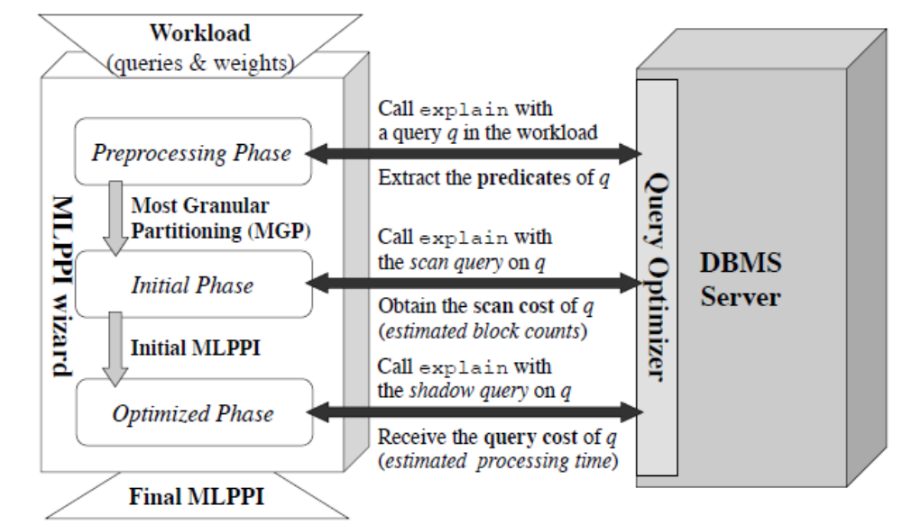
Fig. 2. The MLPPI Wizard Architecture
3.1 The Preprocessing Phase
The first phase is intended to extract query predicates and check any constraint in partitioning. This phase consists of six steps, as shown in Alg. 1.

input: Q (input query set)
output: R (non-overlapping range set), M (query-to-range-set map)
1 Query Simplification (on Q)
2 Range Extraction (from Q)
3 Non-Overlapping Range (R) Construction
4 Field Count Limit Check (on R)
5 Query-to-Range-Set Map (M) Construction
6 Partition Count Limit Check (on R)
Alg. 1. The Preprocessing Phase

Query Simplification: The first step is to simplify the predicates of queries in a given workload. In other words, we remove redundant conditions among the queries. For in- stance, if a query predicate has the condition of ‘LO_DISCOUNT IN (1, 4, 5) AND LO_DISCOUNT IN (2, 3, 4, 5)’, then the predicate can be simplified as ‘LO_DISCOUNT IN (4, 5).’ This simplification can be performed via an API call to the database server. This simplification is not required for the running example.

Range Extraction: In the subsequent step, we gather the simplified predicates and then extract ranges from the collected predicates. This task can also be finished through an API call to the server. The query predicate is of the form,
⟨variable⟩ ⟨op⟩ ⟨constant⟩,
where ⟨variable⟩ is a field from LINEORDER, ⟨op⟩ is in {= , <, <=, >=, >, IN}, and ⟨constant⟩ represents a constant value(s). All ⟨op⟩s are self-explanatory. In particular, ‘IN’ is a list predicate implying ‘OR’ operator. In the running example, we can collect a set of predicates P = {p1, p2, p3, p4} from Q as shown in Tab. 4.
Tab. 4. Collected Predicates from Q
Predicate ID | Predicate
p1 | l.LO_DISCOUNT IN (1, 4, 5)
p2 | l.LO_DISCOUNT >= 7
p3 | l.LO_QUANTITY <= 30
p4 | l.LO_QUANTITY >= 25 AND l.LO QUANTITY <= 35.

Next, we construct a bidirectional map between a query and associated predicates, so that for each query the corresponding predicate(s) can be found directly in the map, and vice versa. In the example, we get a map, called M1, which is built between Q and P. M1 gets filled with the following entries:
M1:
⟨q1, {p1, p3}⟩
⟨q2, {p2, p4}⟩.
Now we build a set of distinct ranges for each field referenced by the predicates. Specifically, we gather fields referenced by predicates in P, extract ranges from the predicates, and group the ranges of each of the referenced fields. Suppose L to be a list of fact table fields referenced by P. In the workload Q, we add in L the following two fields: LO_DISCOUNT and LO_QUANTITY used by P. The whole range of the gathered predicates can be represented by a kind of two-dimensional array, called R.
Each entry under a field in R represents a pair of (start and end) values forming the range. When it comes to range representation for an entry, ‘[’ and ‘]’ are used for closed ranges while ‘(’ and ‘)’ for open ranges. Also, infinity (∞) and -infinity (-∞) can be used for unbounded ranges. In particular, IN predicate is represented by multiple ranges. The above p1, for example, can be represented by the following three ranges [1, 1], [4, 4], [5, 5]; however, the last two consecutive ranges can be consolidated as [4, 5]. In the continuing example, the per-field distinct range set (R) is comprised of the entries below.
R:
LO_DISCOUNT = {[1, 1], [4, 5], [7, ∞)}
LO_QUANTITY = {(∞, 30], [25, 35]}.
In turn, we build another map, called M2, between P and R. That is, we associate each predicate in P with a corresponding range in R. Let R[i, j] denote the interval value for the i-th field and j-th range in R. For instance, R[1, 3] indicates range [7, ∞) under LO_DISCOUNT. In the running example, M2 is constructed as follows:
M2:
⟨p1, {R[1, 1], R[1, 2]}⟩
⟨p2, {R[1 ,3]}⟩
⟨p3, {R[2, 1]}⟩
⟨p4, {R[2, 2]}⟩.

Non-Overlapping Range Construction: Since there may be multiple predicates on the same field across queries, extracted ranges for the field may overlap each other. The overlapping ranges must be broken without any common portion, in order that we can consider a pair of consecutive, non-overlapping ranges for a merge in subsequent phases.
Alg. 2 describes the way of breaking the overlap of ranges. For each field, the algorithm gets associated ranges of each field and sorts them by start value. We then check whether adjacent ranges overlap each other or not. If that is the case, we make a split between the ranges. In the example, the split is applied on the overlapping ranges, (∞, 30] and [25, 35] in
input: R having overlapping ranges
output: R with consecutive, non-overlapping ranges
1 foreach field i ∈ R do
2 L ← Get the range set of i from R and sort by start value.
3 j=0;
4 while j < |L|-1 do
5 r_{j}, r_{j+1} ← Adjacent ranges in L
6 if r_{j+1}.end ≥ r_{j+1}.start then
7 Make a split by modifying values of r_{j} and r_{j+1}.
8 Insert into L an intermediate range if any.
9 Re-sort ranges in L and reset j to 0.
10 end
11 else j++;
12 end
13 Update R with the final L.
14 end

Alg. 2. Splitting Overlapping Ranges
LO_QUANTITY. Subsequently, we then create a common (or intermediate) range ([25, 30]) and insert into the range set belonging to the LO_QUANTITY field, in order to fill the gap. R includes the following ranges.

R:
LO_DISCOUNT = {[1, 1], [4, 5], [7, ∞)}
LO_QUANTITY = {(∞, 25), [25, 30], [31, 35]}.

The update of R affects the existing map M2. In the running example, p3 and p4, influenced by the split, are mapped to new range sets, {R[2, 1], R[2, 2]} and {R[2, 2], R[2, 3]}, respectively. Of course, the range sets corresponding to p1 and p2 referencing LO_DISCOUNT remains unchanged. As a result, in the running example we obtain the updated M2 in the following.

M2:
⟨p1, {R[1, 1], R[1, 2]}⟩
⟨p2, {R[1, 3]}⟩
⟨p3, {R[2, 1], R[2, 2]}⟩
⟨p4, {R[2, 2], R[2, 3]}⟩.

Field Count Limit Check: One question that occurs is what if a DBMS has a limit of fields that can be used for a partitioning definition. (In the case of Teradata DBMS, up to 64 fields can be allowed for an MLPPI definition.) If the number of fields present in R exceeds the field count limit, we determine which field(s) should be thrown away to satisfy the limit. (The fact table we use has much fewer fields than the limit, and thus, this step will not be executed.) To choose victim fields, our tool computes the weighted sum of query cost, which is discussed in Section 2.3, of queries regarding each field. The sum can be obtained by adding up every query cost on an MLPPI using only the ranges under the field. We incrementally discard a field with the largest sum of query cost until reaching the limit. Accordingly, we can update the existing M2. One might say that such an MLPPI definition may not be exploited if too many ranges over a partition count limit (65,536 in the case of Teradata DBMS) are found in one field. However, we assume that such an extreme case is not expected. Even if such a case happens, the merges of consecutive ranges can make the MLPPI feasible.

Query-to-Range-Set Map Construction: Using the existing maps M1 and M2, the tool can create the final bi-directional query-to-range-set map, say M, between Q and R. To construct M, we leverage a transitive property from M1 to M2. Once we compute M, there is no need to keep the intermediate maps (M1 to M2) for the subsequent phases. In the running example, we can build M in the following.
M:
⟨q1, {R[1, 1], R[1, 2], R[2, 1], R[2, 2]}⟩
⟨q2, {R[1, 3], R[2, 2], R[2, 3]}⟩.
In the subsequent phases, we use for cost computation and then update M in accordance with a merge of ranges; R is refined for an MLPPI recommendation.

Partition Count Limit Check: The range set R can be used to define an MLPPI using each field as one level. However, if the current number of partitions by R is greater than the aforementioned partition count limit, then it is not possible to make a feasible MLPPI based on the ranges in R.
The actual partition count limit is ample enough to pass the running example, but to continue our discussion, assume that in our discussion the limit is 15. From R in the running example, we obtain a total of (number of ranges in LO_DISCOUNT) × (number of ranges in LO_QUANTITY) = (3+1) × (3+1) = 16 partitions. Note here that one reserved range covering the rest but the identified is added by default to each field in the calculation, and the default range is equivalent to the ‘NO CASE OR UNKNOWN)’ case in Fig. 1. Since the total partitions surpass the limit, the tool should go through the initial phase in which we make fewer partitions than the limit. (Otherwise, the wizard can bypass the initial phase and then immediately proceed to the optimized phase.)
The tool is now ready to proceed to the next phases, with R (i.e., an input range set, or MGP) and the prepared M (i.e., a query-to-range-set map).
3.2 The Initial Phase
This phase incrementally merges a range pair in R to reduce partitions. The merge continues until the number of ongoing partitions drops below the partition count limit. After finishing the merge, the tool can derive a feasible MLPPI with the remaining partitions.
Overall, the merge may increase I/O cost, in that the full scan on a partition should be carried out to retrieve all the rows potentially matching a given query. In the case of a merged partition, we may read the non-qualifying rows that would not be seen before the merge, thereby paying more I/O to answer the query. To minimize the merge overhead, we pick up the range pair incurring the least I/O increase in a heuristic fashion. To choose a range pair for a merge, we calculate the scan cost of a query on the merged range pair.
Alg. 3 represents how the scan cost can be computed on the range pair that influences a given query. The scan cost represents the I/O cost to answer the query when the range pair is merged; it is defined as the number of blocks that are to be read for the given query. To compute the scan cost of a query q, we write a corresponding scan cost query, denoted by s, which can be constructed as follows:

s: SELECT *
FROM F
WHERE CP,
where F is a fact table such as LINE_ORDER, and CP indicates the predicates restored from the ranges mapped to q from M.
If q turns out to be affected by the merge of a range pair then the range set associated with q in M is temporarily updated by removing the parent ranges and adding the merged range.
Tab. 5. The Constructed Scan Cost Queries
Scan Cost Query ID | Query String
s1 | SELECT *  FROM LINEORDER l  WHERE ((l.LO_DISCOUNT = 1) OR  (l.LO_DISCOUNT >= 4 AND  l.LO_DISCOUNT <= 5))AND  l.LO_QUANTITY <= 35
s2 | SELECT *  FROM LINEORDER l  WHERE l.LO_DISCOUNT >= 7 AND  l.LO_QUANTITY >= 25 AND  l.LO_QUANTITY <= 35)
The altered range set is remapped to q in M and then translated to the equivalent predicates. Then CP for s can be built based on the predicates. Unless the merge range pair influences q, we can simply derive CP from the existing ranges mapped to q.
To see in Alg. 3 how a scan cost query is built, consider a range pair (rp) of R[2, 2] and R[2, 3] in the running example. rp produces the merged range, [25, 35], under LO_QUANTITY. The merge by rp affects both q1 and q2 in the workload. Thus, the range sets of q1 and q2 on LO_QUANTITY are correspondingly altered to {(∞, 25), [25, 35]} and {[25, 35]}, respectively. Certainly, no change is made to the existing range sets of the queries on LO_DISCOUNT. Therefore, the corresponding scan cost queries for q1 and q2 can be built as shown in Tab. 5.

Since the altered ranges {(∞, 25), [25, 35]} of q1 are consecutive, we can simply build the merged, single predicate (l.LO_QUANTITY <= 35) for s1.

In turn, the wizard sends each scan cost query to the server through an API call. The tool extracts from the server’s response the spool size (in bytes), which is the result size of the sent scan cost query, and then calculates as scan cost the block counts (denoted by blc) using the spool size. If the merge of a range pair does not influence any query in the workload, the existing (previously computed) scan cost of queries is reused for the range pair. In other words, the wizard only re-computes the scan cost of a query only if the query is affected by the merge of two consecutive ranges. The weighted sum of scan cost of queries, T_{s} can be computed for each range pair. T_{s} can be defined as follows:
_{n}
T_{s} = Σ (sc_{i} · w_{i}),
^{i =1}
where n is the number of queries in Q, sc_{i} is the scan cost of query q_{i} in Q, and w_{i} denotes the (non-negative) weight associated with q_{i}.

Once all range pairs are examined, the tool chooses the range pair with the least T_{s} for a merge. If several range pairs end up with the same least T_{s}, then the tool applies the heuristic of favoring the range pair that produces the fewer number of partitions when merged, to make it faster to reach the partition count limit. In the example, suppose that the running range pair, rp, produces the least T_{s}, and thus, the tool merges rp. Thus, we can update both R and M as follows.
R:
LO_DISCOUNT = {[1, 1], [4, 5], [7, ∞)}
LO_QUANTITY = {(∞, 25), [25, 35]}

input: q (query), rp (range pair), and M (query-to-range-set map)
output: Scan cost for answering q when considering a merge of rp
1 r_{m} ← Consolidate rp
2 L ← Copy the range set mapped to q from M;
3 Delete ranges in rp from and insert r_{m} into L.
4 s ← “SELECT * FROM LINE_ORDER WHERE ” ;
5 foreach range r ∈ L do
6 Restore a predicate p from r.
7 Add p to WHERE clause of s.
8 end
9 Make an API call with s to the server.
10 Extract the spool size (in bytes) from the result.
11 blc ← Calculate the block counts from the spool size.
12 Update q’s scan cost to blc.
13 return blc;

Alg. 3. Computing Scan Cost

M:
⟨q1, {R[1, 1], R[1, 2], R[2, 1], R[2, 2]}⟩
⟨q2, {R[1, 3], R[2, 2]}⟩

Note that we see that q2 may have the most customized partition based on the updated M. Only the single partition formed by (R[1, 3] ∩ R[2, 2]) is sufficient to retrieve all the qualifying rows for q2; thus, the other partitions can be simply eliminated. In the meantime, to answer q1, we need to read the four partitions formed by the top two ranges of each field. As the partitions formed by ((R[1, 1]∪R[1, 2])∩(R[2, 2])) contain the non-qualifying rows for q1, unfortunately, R cannot provide q1 with as much benefit as q2. R, however, can be a good compromise to satisfy both queries, in that the MLPPI derived by R can potentially minimize the total execution cost of Q.
Alg. 4 describes the initial phase. Given a query-to-range set map (M) and an input range set (R), the algorithm determines which range pair to yield the least total execution cost (T_{s}) and updates M and R using the chosen range pair, until the number of the partitions by R falls below a pre-defined partition limit count. Finally, the algorithm produces the final recommendation based on R.
In the running example the total partition counts (or 4 × 3=12) by R is under the assumed limit (or 15), which meets the partitioning limit. Hence, the wizard can enter the optimized phase with R, without repeating the initial phase.
3.3 The Optimized Phase
After passing the initial phase, we now have an initial MLPPI recommendation based on R, for the LINEORDER fact table. Certainly, we can sufficiently use the initial recommendation. However, our emphasis is on the fact that additional merges may make fewer partitions, which actually can enhance the overall workload performance for the following reasons. First, multiple file contexts by many partitions can incur huge overhead that affects the query optimizer. There also exists an operational threshold that the optimizer can handle the maximum number of the partitions at a time. Thus, further reducing partitions greatly helps the optimizer to manage these partitions.
input: M (query-to-range-set map) and R (input range set)
output: R with # partitions, fewer than or equal to a specified partition limit
1 W ← Query weights
2 while ← (# partitions by R > partition limit) do
3 foreach range pair, rp ∈ R do
4 T_{s} ← 0;
5 foreach q ∈ M do
6 w ← Get q’s weight from W
7 L ← Get the range set mapped to q in M
8 if ((rp ∩ L) ≠ ∅) then
9 T_{s} += w·(getSC(q, rp, M)); // Influenced
10 else T_{s} += w·(q’s existing scan cost) // See Alg. 3 regarding getSC()
11 end
12 Associate T_{s} with rp.
13 end
14 Find rp(s) with the least T_{s} .
15 If a tie occurs, then choose the rp to make fewer partitions when being consolidated.
16 Update M and R by the chosen rp.
17 end
18 return R;
Alg. 4. The Initial Phase
A similar algorithm, as suggested in the initial phase, is applied. Namely, this phase uses query cost, which is analogous to scan cost; we can obtain the query cost via a feasible MLPPI. The query cost is defined as the estimated processing time of a query on a so-called “faked” fact table applying the MLPPI definition that reflects the merge of a range pair. This cost estimation technique is similar to the “what-if” approach [8].

Alg. 5 illustrates the steps for computing the query cost of a query q. Given a range pair (rp) affecting q when merged, we first create an empty shadow table H with the same definition as F, including all indexes and constraints such as check and referential integrity ones. Next, we propagate all statistics of F to H. This covers field and index statistics. If F has materialized views (MVs), then we create the equivalent MVs on H and subsequently, propagate the statistics of the MVs on F to the new MVs on H. After that, we alter H by an MLPPI with the updated R (now say R’), applying the merge of rp. We then build a shadow query h that is equivalent to the input query q and replaces F in q with H. In turn, we make an API call to the EXPLAIN tool with h. Eventually, the algorithm extracts from the result and returns the estimated elapsed time of h as the query cost associated with q. As in the initial phase, the query cost of a query (like q) is recomputed only if the merge affects the query.
Alg. 6 proposes the algorithm of the optimized phase. W indicates a set of weights assigned to individual queries in a given workload. T_{p} keeps track of the existing least query cost sum, and initially is computed on an initial MLPPI. For each range pair, the algorithm computes T_{q}, the respective weighted sum of query costs of the queries in a given workload. (T_{q} can be similarly defined as T_{s}, described in Section 2.2, and thus the definition of T_{q} is omitted here.) Let the current least T_{q} be T. If T <= T_{p} (or the existing least), then for the next iteration T_{p} is set to T. We perform the merge on the range pair that produces that T and update M and R along with the merge. The algorithm repeats until (i) there are no more ranges in R left, or (ii) the number of specified iterations is reached. If T > T_{p}, then this optimization process is over.
input: q (query), rp (range pair), M (query-to-range-set map), and R (input range set)
output: Query cost to answer q when a merge of rp is considered
1 Create an empty shadow table H having the same definition as the fact table F,
including indexes and all constraints (check and referential integrity constraints).
2 Propagate all (field and index) statistics of F to H.
3 if F has materialized views (MVs) then
4 Create the equivalent MVs on H.
5 Propagate the statistics of the MVs on F to those of H.
6 end
7 r_{m} ←Merge rp;
8 L ← Copy ranges associated with q from M;
9 Remove ranges in rp from and add r_{m} to L.
10 R’ ← Update R with L
11 Alter H using a fictitious MLPPI with R’.
12 Construct and send to the server an H-based shadow query h equivalent to q.
13 ept ← Estimated processing time of h extracted from the server response;
14 Update q’s query cost to ept.
15 return ept
Alg. 5. Computing Query Cost
input: M (a query-to-range-set map) and R (an input range set)
output: an MLPPI solution to produce the minimum total query cost
1 W ← Query weights
2 T_{q} ← Total query cost sum on an initial MLPPI by R;
3 while ← (Pre-defined iterations || R ≠ ∅) do
4 foreach range pair, rp ∈ R do
5 T_{q} ← 0;
6 foreach q ∈ M do
7 w ← Get q’s weight from W
8 L ← Get the range set mapped to q in M
9 if ((rp ∩ L) ≠ ∅) then
10 T_{q} += w·(getQC(q, rp, M, R)); // Influenced
11 else T_{q} += w·(q’s existing query cost) // See Alg.5 on getQC()
12 end
13 Map T_{q} to rp.
14 end
15 T ← The least T_{q} that has been so far seen.
16 if T > T_{p} then break;
17 else
18 T_{p} ← T;
19 Find rp(s) with T.
20 If a tie occurs, then choose the rp to make fewer partitions when being consolidated.
21 Update M and R by the chosen rp.
22 end
23 end
24 return an MLPPI by R;
Alg. 6. The Optimized Phase

ALTER TABLE LINEORDER MODIFY PRIMARY INDEX PARTITION BY
(
CASE_N(
LO_DISCOUNT ≥ 1 AND
LO_DISCOUNT ≤ 5,
LO DISCOUNT ≥ 7,
NO CASE OR UNKNOWN
),
CASE_N(
LO_QUANTITY < 25,
LO_QUANTITY ≥ 25 AND
LO_QUANTITY ≤ 35,
NO CASE OR UNKNOWN
)
);
Fig. 3. The final MLPPI Definition Recommended for the Given Workload Q
Note that to break a tie between range pairs; we apply the same heuristic to favor one of the range pairs with fewer partitions. The order of the different partitioning levels may have some impact on the execution time. A range condition on lower levels like the query in Section 1 ‘SELECT * FROM LINEORDER WHERE LO QUANTITY < 25’ requires scanning non-consecutive partitions. This may incur some overhead at run time. To reduce this effect, we sort the partition levels based on the number of partitions in descending order before making the final recommendation. The solution in Fig. 1 follows this heuristic making the two-partition case in the first level followed by the four-partition case in the second level. The order in Fig. 3 can go either way since both levels have the same number of partitions.
In the running example, suppose that in the first round, for instance, a range pair of R[1, 1] and R[1, 2] are chosen for a merge. If so, then the wizard produces a merged range, or [1, 5] under LO_DISCOUNT; it proceeds to the next round. If a range pair selected for the subsequent merge fails to improve T_{p}, then, the tool exits the optimized phase and produces the final MLPPI recommendation for the given workload Q as shown in Fig. 3.

4. Complexity Analysis
In this section, we analyze the time complexity of the proposed algorithms: preprocessing, initial, and optimized phases. We use as the metric on each phase the logical running time of the wizard, which is equivalent to the number of API calls made to the database server during that phase.
4.1 The Preprocessing Phase
The following Lemma is the analysis on the running time of the preprocessing phase.
Lemma 1. The running time complexity for building a query-to-range map is O(N·C·V), where N is the number of queries in a workload, C is the total number of fields in the fact table, and V is the max number of values in a field.
Proof. Consider the worst case such that given a workload of N queries, each query references all the fields of the fact table, and each field is associated with at most V values by the predicates of the queries. Each query may have a single-value range. A range consisting of only one value per field can be mapped to each query. Thus, the running time complexity for the map construction is is O(N·C·V). □
But our experiments demonstrate that the bound of O(N·C·V) is overly pessimistic.

4.2 The Initial and Optimized Phases
The following is the running time complexity on each of the initial and optimized phases.
Lemma 2. The running time complexity for the initial (or optimized) phase is O(M2·N), where M is the number of range pairs, and N is the number of queries in a workload.
Proof. Suppose that the merge of every range pair influences all the queries. Every iteration either the scan or query costs need to be recomputed for each query. In the first round, we pay the re-computation cost of M·N and merge a victim range pair. In the subsequent round, (M-1) range pairs remain, so the cost amounts to (M-1)·N. In the worst case, we end up consolidating all range pairs, thus having no partition on the target table. The total calls made to the server can be added up to
_{M}
M·N + (M-1)·N + ··· + N = ( Σ i)·N = (M (M - 1) / 2) ·N
^{i=1}
Hence, the running time complexity is O(M2·N). □
Our experiments also showed that the above running time complexity was overly pessimistic. Specifically, the number of calls made in our experiments was by far fewer than that bound. That was because it was very rare for a range pair to involve all queries in a given workload (as seen in Table 1).
5. Experiments
In this section we evaluate the performance of our wizard using the proposed algorithms. We first describe our environment settings. We then report the statistics measured dur ing our experiments. Finally, we compare the performance of the recommendation by the MLPPI wizard (WIZARD) with (1) that of no partitioning (NO PPI) and (2) the partitioning of a human expert (EXP) under different setups.
5.1 Environment Settings
Development: We implemented our MLPPI wizard as a prototype on top of the Teradata DBMS server. We developed our wizard in Java. We evaluated the performance of the wizard on the Teradata DBMS server machine running UNIX.
Workload: When it comes to workload generation, we took advantage of our simple star schema query generator. The generator assumes that (i) available operators, (ii) fields, and (iii) the minimum and maximum values of the fields are already known. For each query, the generator first randomly selects the number of single-table predicates to create. The generator then arbitrarily chooses a field and a specific operator for each predicate. If IN operator on a chosen field is picked up, the query generator determines the number of values to add to the IN list and then chooses random values within the min-max value range of the field. In this way, the generator makes a query involving the generated predicates.
Table 2. The Runtime Statistics Obtained on Used Workloads
Item | The Initial Phase |  | The Optimized Phase
Item | 10Q | 20Q | 10Q | 20Q
1. The number of input partitions | 1,008,000 | 110,739,200 | 51,840 | 59,520
2. The number of input range pairs | 441 | 4,180 | 24 | 48
3. The number of total API calls  (The number of worst calls by Lemma 2) | 1,305 (1,944,810) | 31,915  (349,448,000) | 78  (5,760) | 388  (46,080)
4. The number of average API calls per range pair | 3 | 8 | 3 | 8
5. The number of average range pairs compared per iteration | 32 | 76 | 24 | 48
6. The maximum # of range pairs compared per an iteration | 38 | 103 | 24 | 48
7. The minimum # of range pairs compared per an iteration | 25 | 49 | 24 | 48
8. The number of average API calls made per iteration | 93 | 580 | 78 | 388
9. The maximum # of API calls made per an iteration | 123 | 791 | 78 | 388
10. The minimum # of API calls made per an iteration | 73 | 381 | 78 | 388
A generated query is based on a template that joins LINEORDER and DDATE with constraints defined by the predicates. This template is common in customer cases like reports and form templates. Using the query generator we generated two workloads consisting of 10 queries (10Q) and 20 queries (20Q).
For the query workloads we populated the fact table with a scale factor of 1TByte (1TB) and 3TBytes (3TB).

5.2 Statistics Report
Table 1 summarizes the execution statistics obtained while the recommendations for the workloads were produced. The statistics includes input partitions, range pairs, the number of API calls made, and total iterations observed in each phase.
Almost 1 million partitions were initially derived for 10Q and roughly 0.11 billion partitions for 20Q (Item #1). The workload size doubled from 10Q to 20Q, but surprisingly the total number of partitions increased exponentially. A lot more predicates with different bindings produced about 110x more ranges in 20Q than those of 10Q. While a huge number of input partitions were made, the number of range pairs collected per field was relatively small (Item #2).
The total number of iterations in the initial phase tended to be proportional to the input partitions generated from the 10Q and 20Q workloads. Note that the optimized phase ran only once for those two workloads. Since the partitions produced by the initial phase were customized enough, there was no need to iterate for further optimization.
As mentioned in Section 3, for each workload the number of the total calls to the server was extremely small, compared to that of the theoretical worst calls shown in the parentheses (Item #3). The worst call counts were calculated regarding the number of queries and range pairs observed in each phase. Furthermore, the average number of calls per range pair was limited within 10 across the workloads and phases (Item #4).
Finally, the per-iteration numbers of the average, minimum, and maximum range pairs proportionally increased along with the growing workload size (Items #5-#7), while the per-iteration numbers of the average, minimum, and maximum API calls increased more than the scale factor (of 2x) (Items #8-#10). Nevertheless, empirically the number of invoked API calls was much fewer than that of the theoretical bound.

5.3 Performance Evaluation
The focus of our experiments is to see the performance (or quality) of MLPPI recommendations made by the MLPPI wizard (WIZARD), compared with those of no partitioning (NO PPI) and partitioning by a human expert (EXP).
Figs. 4 and 5 exhibit our evaluation results. Fig. 4 shows the times taken to run the 10Q and 20Q workloads over the 1TB and 3TB fact tables that we populated into the database server. Based on the experiment results, Fig. 5 shows how much improvement was gained by the EXP and WIZARD solutions, compared with that of NO PPI.
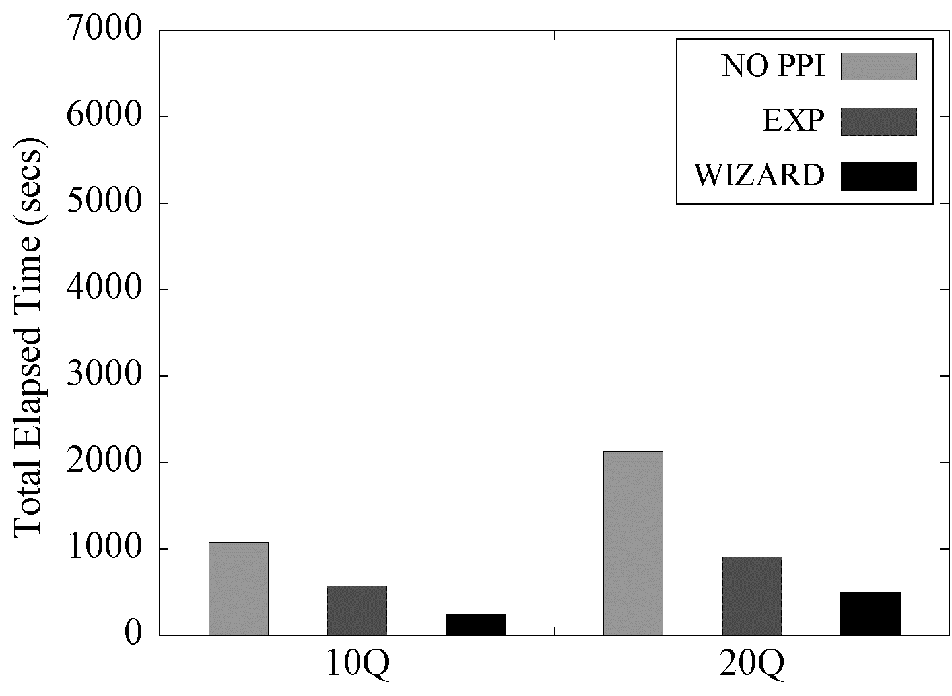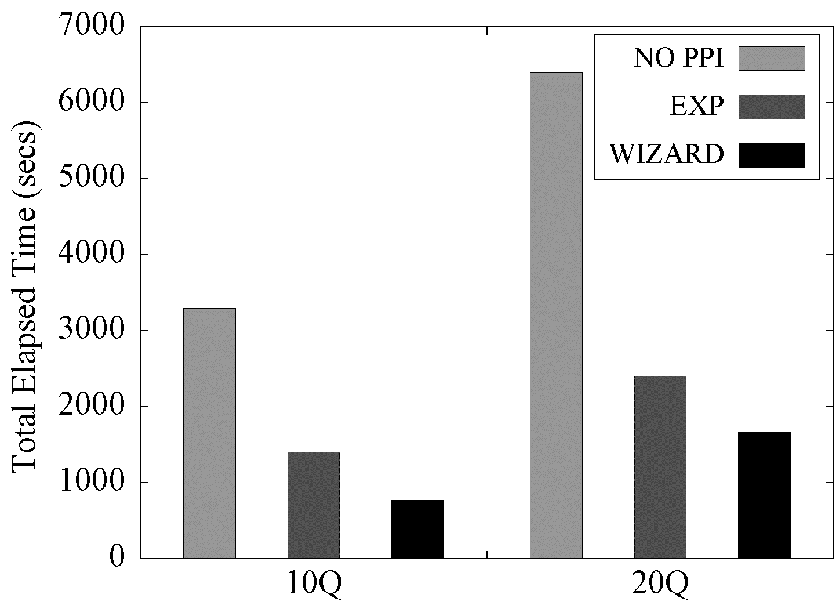
- 1TB (b) 3TB
Fig. 4. Comparison of the Total Elapsed Time
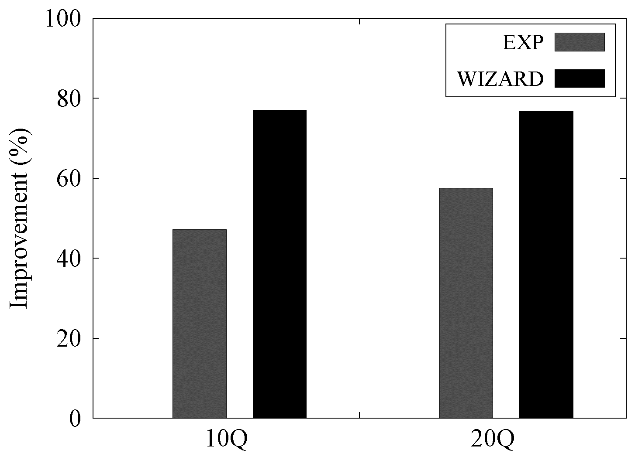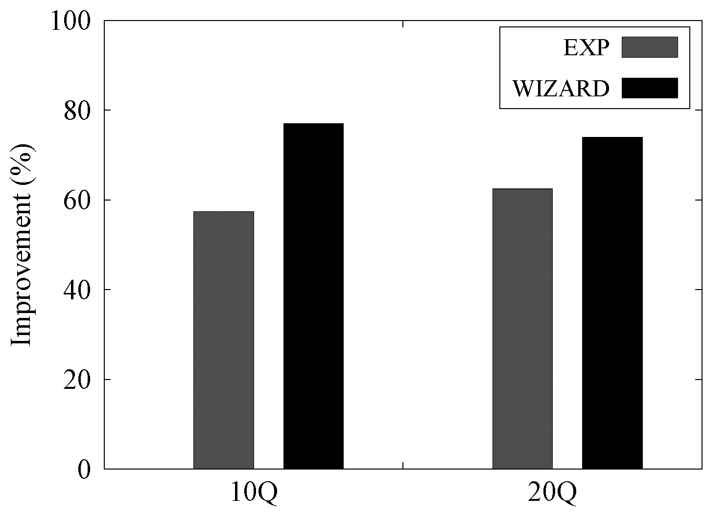
- 1TB (b) 3TB
Fig. 5. Comparison of Recommendation Quality
Overall, the WIZARD recommendations were very effective at partitioning the fact table via the predicates in the given workloads. First, regarding the total execution time for the 10Q workload on the 1TB table, our wizard outperformed NO PPI and EXP by about 4x and 2x, respectively, as illustrated in Fig. 4(a). Such a performance gain was retained even when we doubled the workload size to 20Q. As seen in in Fig. 4(b), the proposed tool bettered the total execution time on the 3TB table by almost a factor of four and two, compared with NO PPI and EXP, respectively, regardless of 10Q or 20Q.
Next, the WIZARD recommendations scaled very well with a combination of growing workload and table size, as illustrated in Fig. 5. Even though we doubly increased the workload size from 10Q to 20Q, the performance improvement of our solution retained the same in Fig. 5 (a). Furthermore, for the 3T table the performance gain of WIZARD was almost unchanged (at around 80%) as illustrated in Fig. 5 (b). This result showed that our WIZARD solution was scalable over increasing workload size.
When we increased the table scale from 1TByte to 3TBbytes, the performance improvement (about 77%) of our wizard for 10Q was almost the same in spite of the increased table scale. In the case of 20Q, the gain was somewhat reduced to 74% for the 3TB table, compared with 77% for the 1TB table, but it was almost negligible. Hence, the WIZARD partitioning recommendation scaled well with the increasing table size.
In sum, our experiment results confirm the effectiveness of the proposed algorithms for WIZARD and demonstrate the superiority of the recommendations of WIZARD.

6. Conclusion
Given query workloads, it is difficult for DBAs to select appropriate fields in partitioning a fact table in a star schema, due to huge search space. DBAs cannot easily determine how granular partitions should be made. In addition, it is hard to figure out which partitioning option would be the most optimal for executing the workloads with the minimum cost.
To address this concern, we presented the MLPPI wizard to recommend a fact table partitioning for a given star schema workload. Since query-predicates can be exploited to capture necessary ranges for fields and define partitions, a recommended MLPPI definition can be much optimized, customized to the workload.
We proposed the wizard’s algorithms consisting of the three phases. The wizard could reduce its search space by incrementally merging the range pair with the least scan or query cost at the respective phases, and eventually produced an MLPPI recommendation. We also analyzed the running complexity for the initial and optimized phases. Despite the theoretically high bound, the wizard in practice invoked much fewer calls in those two phases.
Using generated query workloads, we evaluated the performance of recommendations produced by the wizard. We demonstrated that the produced MLPPI solutions by the wizard reduced the total elapsed time up to by more than a factor of four, compared with those of no partitioning approach and partitioning done by a human expert. We observed that the recommendation quality also scaled very well with a combination of growing workload and fact table size.
References
- Sinclair, P., “Using PPIs to Improve Performance,” http://www.teradata.com/tdmo/v08n03/pdf/ AR5731.pdf (viewed on August 31, 2015)
- Klindt, J., “Single-level and Multilevel Partitioned Primary Indexes,” http://www.teradata.com/white-papers/Single-level-and-Multilevel-Partitioned-Primary-Indexes-eb1889/ (viewed on July 15, 2015)
- O’Neil, P., O’Neil, B., and Chen, X., “The Star Schema Benchmark (SSB),” http://www.cs.umb.edu/poneil/StarSchemaB.PDF (viewed on July 15, 2017)
- Suh, Y.K., Ghazal, A., Crolotte, A., and Kostamaa, P., “A New Tool for Multi-level Partitioning in Teradata,” in CIKM, pp. 2214–2218, 2012.
- Agrawal, S., Narasayya, V., and Yang, B., “Integrating Vertical and Horizontal Partitioning into Automated Physical Database Design,” in SIGMOD, pp. 359–370, 2004.
- Lightstone, S.S. and Bhattacharjee, B., “Automated Design of Multi-dimensional Clustering Tables for Relational Databases,” in VLDB, pp. 1170–1181, 2004.
- Nehme, R. and Bruno, N., “Automated Partitioning Design in Parallel Database Systems,” in SIGMOD, pp. 1137–1148, 2011.
- Chaudhuri, S. and Narasayya, V., “AutoAdmin ‘What-If’ Index Analysis Utility,” SIGMOD Record, vol. 27, no. 2, pp. 367–378, 1998.
- Finkelstein, S., Schkolnick, M., and Tiberio, P., “Physical Database Design for Relational Databases,” in ACM Trans. on Databas. Syst. vol. 13, no. 1, pp. 91–128, 1988.
- Labio,W., Quass, D., and Adelberg, B., “Physical Database Design for Data Warehouses,” in ICDE, pp. 277–288, 1997.
- Rozen, S. and Shasha, D., “A Framework for Automating Physical Database Design,” in VLDB, pp. 401–411, 1991.
- Oracle Corp., “Partitioning Advisor,” http://www.oracle.com/technetwork/database /options/partitioning/twp-partitioning-11gr2-2009-09-130569.pdf (viewed on February 2, 2017).
- Oracle Corp., “SQL Access Advisor,” http://docs.oracle.com/cd/B1930601/ser ver.102/b14211/advisor.htm (current March 2012)
- Rao, J., Zhang, C., Megiddo, N., and Lohman, G., “Automating Physical Database Design in a Parallel Database,” in SIGMOD, pp. 558–569, 2002.
- Agrawal, S., Chaudhuri, S., Kollar, L., Marathe, A., Narasayya, and V., Syamala, M., “Database
Tuning Advisor for Microsoft SQL Server 2005,” in SIGMOD, pp. 930–932, 2005.
- Agrawal, S., Chaudhuri, S., and Narasayya, V.R., “Automated Selection of Materialized Views and Indexes in SQL Databases,” in VLDB, pp. 496–505, 2000.
- Dash, D., Polyzotis, N., and Ailamaki, A., “CoPhy: A Scalable, Portable, and Interactive Index Advisor for Large Workloads,” PVLDB vol. 4, no. 6, pp. 362–372, 2011.
- Kimura, H., Narasayya, and V., Syamala, M., “Compression Aware Physical Database Design,” in PVLDB, vol. 4, no. 10, pp. 657–668, 2011.
- Microsoft Corp. “Microsoft SQL Server 2000: Index Tuning Wizard SQL Server 2000,” http://technet.microsoft.com/en-us/library/cc966541.aspx (viewed on March 1, 2012).
- Valentin, G., Zuliani, M., Zilio, D.C., Lohman, G., and Skelley, A., “DB2 Advisor: An Optimizer
Smart Enough to Recommend Its Own Indexes,” in ICDE, pp. 101–110, 2000.
- Zilio, D.C., Zuzarte, C., Lohman, G.M., Pirahesh, H., Gryz, J., Alton, E., Liang, D., and Valentin,
G., “Recommending Materialized Views and Indexes with the IBM DB2 Design Advisor,” in Proc. of the Int’l Conf. on Autonomic Computing, pp. 180–188, 2004.
- Zilio, D.C., Rao, J., Lightstone, S., Lohman, G., Storm, A., Garcia-Arellano, C., and Fadden, S.
“DB2 Design Advisor: Integrated Automatic Physical Database,” in VLDB, pp. 1087–1097, 2004.
- Tatarowicz, A.L., Curino, C., Jones, E.P.C., and Madden, S., “Lookup Tables: Fine-grained Partitioning for Distributed Databases,” in ICDE, pp. 102–113, 2012.
- Idreos, S., Kersten, M.L., and Manegold, S., “Database Cracking,” in CIDR, pp. 68–78, 2007.
- Wang, J., Hang, S., Liu, J., Chen, W., and Hou, G., “Multi-level Scheduling Algorithm Based on Storm,” in TIIS, vol. 10, no.3, 2016.
- Yuan, Y., Chen, W., Han, G., Jia, G., “OLAP4R: A Top-K Recommendation System for OLAP Sessions,” in TIIS, vol. 11, no.6, 2017.
- Zahra Pooranian, Mohammad Shojafar, Bahman Javadi, Ajith Abraham, “Using Imperialist Competition algorithm for Independent Task Scheduling in Grid Computing,” Journal of Intelligent and Fuzzy Systems 27(1): 187-199, 2014.
- Zahra Pooranian, Mohammad Shojafar, Reza Tavoli, Mukesh Singhal, Ajith Abraham, “Hybrid Metaheuristic Algorithm for Job Scheduling on Computational Grids,” Informatica (Slovenia) 37(2): 157-164, 2013.

