MLPPI Wizard: An Automated Multi-Level Table Partitioning Tool

ABSTRACT
We introduce a new tool recommending an optimized partitioning solution called Multi-Level Partitioned Primary Index (MLPPI) for a fact table accessed by a query workload. The tool uses a novel greedy algorithm for search space enumeration. The space is driven by query predicates. The tool uses the Teradata optimizer’s cost model to prune the search space for reaching a final recommendation. The tool resides completely on the client and interacts with the optimizer through APIs used to simplify the workload queries, to extract the predicates, and to estimate the workload execution cost on a candidate recommendation. The predicate-driven method can be applied to any clustering or partitioning schemes, based on simple field expressions or complex SQL predicates. Experimental results demonstrate that the recommendation from the tool outperforms a human expert. The experiments also show that the recommendation is scalable with the workload complexity and the size of the fact table.

Keywords: Star Schema, Fact Table, and Multi-Level Partitioning

Introduction
Tables and materialized views in Teradata are hash distributed based on a user-specified column or set of columns called primary index. Each virtual processor, which is a unit of parallelism called AMP in the Teradata relational DBMS, receives a subset of the data and stores it in hash order. Teradata users typically choose primary index fields, so that the data is evenly distributed among the AMPs. The primary index fields are also chosen to reflect join fields in workloads to accomplish cheaper local joins that do not require data shuffling. PPI (Partitioned Primary Index) [Sinclair, 2012] is an optional horizontal partitioning scheme applied locally on each AMP’s data. Note that in other database products, this type of partitioning would most likely be called clustering. For the rest article, we only use the term partitioning, not clustering. Database Administrators (DBAs) usually choose the columns for PPI, based on join fields and single table predicates to optimize the queries in the workload. The PPI columns are used to physically cluster data with the same values together in contiguous data blocks. This allows “partition elimination” in scans and joins, which improve query performance. PPI can be specified as single or multiple (or nested) levels. This type of partitioning scheme is referred to as Multi-Level PPI or MLPPI [Klindt, 2012]. By allowing non-qualified partitions to be eliminated, MLPPI can reduce significantly the amount of data to be scanned to answer a query. However, a large number of partitions can create significant overhead especially in joins and table maintenance operations such as inserts or deletes, so that the selection of partitions is usually a balancing act.

Figure 1 provides an example of MLPPI table with potential partitioning schemes. This example is a subset of the LINEORDER table from the Star Schema Benchmark (SSB) [O’Neil et al., 2012]. The full table with modified data types was actually used in our experiments.

Figure 1: An Example of MLPPI Table

CREATE TABLE LINEORDER
LO_ORDERKEY INTEGER,
LO_QUANTITY INTEGER,
LO_DISCOUNT INTEGER
)
PRIMARY INDEX (LO_ORDERKEY) PARTITION BY (
CASE_N(
LO_DISCOUNT >= 7,
NO CASE OR UNKNOWN
),
CASE_N(
LO_QUANTITY < 25,
LO_QUANTITY >= 25 AND
LO_QUANTITY <= 30,
LO_QUANTITY > 30 AND
LO_QUANTITY <= 35,
NO CASE OR UNKNOWN
)
);

In the definition of LINEORDER in the figure, the primary index is LO_ORDERKEY. The primary index dictates the AMP on which a row will be located, while the partitioning of data will be dictated by the values and ranges associated with LO_DISCOUNT and LO_QUANTITY. LO_DISCOUNT, for example, has two ranges one for values larger than or equal to 7 and one (NO CASE OR UNKNOWN) for all the other values, while LO_QUANTITY has four ranges. As a result, the relational table will have a total of 2 × 4 = 8 partitions as follows.

Partition | Condition
1 | LO_DISCOUNT >= 7 && LO_QUANTITY < 25
2 | LO_DISCOUNT >= 7 && 25 <= LO_QUANTITY <= 30
3 | LO_DISCOUNT >= 7 && 30 < LO_QUANTITY <= 35
4 | LO_DISCOUNT >= 7 && LO_QUANTITY no case
5 | LO_DISCOUNT no case && LO_QUANTITY < 25
6 | LO_DISCOUNT no case && 25 <= LO_QUANTITY < 30
7 | LO DISCOUNT no case && 30 < LO QUANTITY <= 35
8 | LO DISCOUNT no case && LO QUANTITY no case

Whatever partition set is chosen, the selection must be semantically correct; namely, the mapping of rows to partitions must be an injection. In other words, the constraints must form a covering of the entire range, so that a row will belong to exactly one and one partition. The Teradata optimizer then applies partition elimination for queries that specify conditions on LO _DISCOUNT and/or LO_QUANTITY. For example, only partitions 1 and 2 are needed for the query “SELECT * FROM LINEORDER WHERE LO DISCOUNT >= 7 AND LO QUANTITY <= 30.” Similarly, partitions 1 and 5 are sufficient to answer the query “SELECT * FROM LINEORDER WHERE LO QUANTITY < 25.” The respective sizes of the partitions are a factor of the data distribution. For more details about MLPPI, see our references [Sinclair, 2012, Klindt, 2012].

Next, using the full version of LINEORDER as defined in SSB [O’Neil et al., 2012] we provide examples of partitioning schemes that a DBA could define based on a small query set. Consider a query set Q consisting of only two queries q1 and q2 from the SSB set [O’Neil et al., 2012], as shown below.

q1 | SELECT SUM (l.LO_EXTENDEDPRICE *l.LO_DISCOUNT)  FROM LINEORDER l, DDATE d WHERE l.LO_ORDERDATE = d.D_DATEKEY AND d.D_YEAR = ‘1993’ AND l.LO_DISCOUNT IN (1, 4, 5) AND  l.LO_QUANTITY <= 30
q2 | SELECT c.C NATION, SUM (l.LO_REVENUE) FROM CUSTOMER c, LINEORDER l WHERE l.LO_CUSTKEY = c.LO_CUSTKEY AND c.C_REGION=‘EUROPE’ AND l.LO_DISCOUNT >= 7 AND l.LO_QUANTITY >= 25 AND  l.LO_QUANTITY <= 35  GROUP BY c.C_NATION  ORDER BY revenue desc

We now focus on the LINEORDER fact table and the predicates involving LINEORDER fields only. There are five constraints identified by the query number and the sequence number of the constraint in each query, as shown below.

q1.1 | LO_DISCOUNT IN (1,4,5)
q1.2 | LO_QUANTITY <= 30
q2.1 | LO_DISCOUNT >= 7
q2.2 | LO_QUANTITY >= 25
q2.3 | LO_QUANTITY <= 35

At this point, the DBA needs to look at options based only on two fields and a total of five constraints. There are many possibilities from a fine-grained partition set to a loser definition.

Considering for the time being the column LO_DISCOUNT, one solution could be to identify each value for the IN predicate in q1.1 and use q2.1as is. This yields the following partitioning expression for LO_DISCOUNT:
CASE N(
LO_DISCOUNT = 1,
LO_DISCOUNT = 4,
LO_DISCOUNT = 5,
LO_DISCOUNT >= 7,
NO CASE OR UNKNOWN
).
The above expression minimizes the size of the partitions by focusing exactly on the values required to satisfy the constraints, but creates a large number of small partitions.

Another possibility would be to look at the maximum and minimum values in the IN set and to build an AND clause equivalent to a between clause yielding the following:
CASE N(
LO_DISCOUNT >= 1 AND
LO_DISCOUNT <= 5,
LO_DISCOUNT >= 7,
NO CASE OR UNKNOWN
).
The above partitioning solution decreases the number of partitions, compared to the previous one, but still focuses sharply on the constraints with still relatively small partitions. Another possibility would be to use the partitioning associated with LO_DISCOUNT shown in the beginning of this section with only two partitions.
Similar considerations apply to the partitioning associated with LO_QUANTITY this time with ranges and covering problems difficult to deal with. The resulting partitioning scheme for the table includes both LO_DISCOUNT and LO_QUANTITY, so that the number of possible combinations is the product of the potential combinations for each field. Also, there are two queries, and one partitioning scheme may be better for one query or the other. As a result, the DBA will be faced with a daunting combinatorial search problem and no clear basis to decide on which combination is the best. This state of affairs begs for a tool to assist the DBA.

In the sequel, we introduce an automated tool called MLPPI wizard. Indeed, the wizard is the first physical database design tool developed at Teradata. The tool is based on a novel technique using a greedy algorithm for search space enumeration. This tool based on a general framework allowing general expressions, ranges and case expressions for partition definitions is particularly well-suited for MLPPI definition. The predicate-driven technique used by the tool can be applied to any clustering or partitioning based on simple fields/expressions or complex SQL predicates. In addition, the wizard borrows the Teradata DBMS optimizer’s cost model to prune the search space and reach a final solution.

Figure 2 illustrates how our tool recommends the final MLPPI customized for a given workload consisting of a set of queries and corresponding weights. The wizard passes through a series of phases: Preprocessing, Initial, and Optimized Phases. An initial MLPPI is produced through the top two phases reflecting practical constraints by field or partition.
It is further optimized in the last phase.

In the preprocessing phase, for each query its predicate(s) is extracted via an API call (on explain) made to the server. Then, the wizard produces the most granular partitioning (MGP) based on the predicates collected from every query. If the MGP has too many fields over a field count limit, then the wizard incrementally throws away a field from the MGP until the limit.
In the initial phase, the passed MGP gets reduced if it includes more partitions than a partition count limit that can be created by an MLPPI. The refinement can be incrementally done by merging a pair of partitions with the least scan cost (as explained in Section 2.2), until the limit. After the phase, an initial (feasible) MLPPI is produced based on the refined partitions.

In the optimization phase, the tool makes a further attempt to optimize the initial MLPPI. Similar to the initial phase, more partitions can be reduced by merging ones with the least query cost (as described in Section 2.3). If the ongoing solution cannot be further improved, the tool makes the final MLPPI recommendation. We will provide more details about each phase later using the query set Q consisting of q1 and q2 in the rest of the article.

To the best of our knowledge, there is no existing industrial tool to solve the multi-level partitioning problem except our wizard. The wizard is contained completely on the client side, as opposed to previous work [Agrawal et al., 2004, Lightstone and Bhattacharjee, 2004, Nehme and Bruno, 2011] requiring optimizer code extension. Our tool simply uses existing APIs to simplify the queries, capture fact table predicates and costs, and uses these items to make a recommendation. This makes the wizard extensible and portable to different releases of the Teradata DBMS server.

The article is an extension of our prior work presented at a previous venue [Suh et al., 2012], and organized in the following way. Section 2 presents the multi-level partitioning algorithms for the wizard. In turn, Section 3 conducts an analysis of the complexity of the algorithms. Section 4 reports the performance evaluation results. Section 5 states how Teradata MLPPI
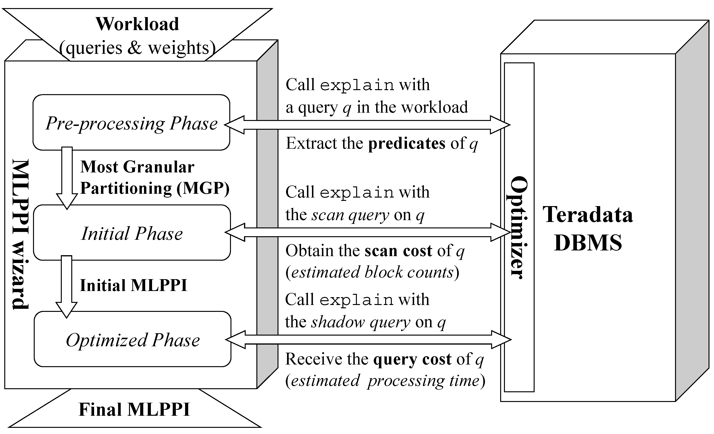
Figure 2: The MLPPI Wizard Architecture

wizard is different from some existing tools proposed by other vendors. Lastly, Section 6 summarizes our discussion.

THE MLPPI WIZARD
In this section, we describe each phase of the wizard in details, using the query set Q provided in Section 1.

The Preprocessing Phase
Algorithm 1 sketches the steps in the preprocessing phase. This phase consists of a total of six steps.

Algorithm 1: The Preprocessing Phase
input: Q (input query set)
output: R (non-overlapping range set),
M (query-to-range-set map)
1 Query Simplification (on Q)
2 Range Extraction (from Q)
3 Non-Overlapping Range (R)
Construction
4 Field Count Limit Check (on R)
5 Query-to-Range-Set Map (M)
Construction
6 Partition Count Limit Check (on R)

Query Simplification: The first step of this phase is to simplify the predicate(s) of each query by removing redundant conditions. For instance, if a query predicate has the condition of “LO_DISCOUNT IN (1, 4, 5) AND LO_DISCOUNT IN
(2, 3, 4, 5),” then the predicate can be simplified as “LO_DISCOUNT IN (4, 5).” This can be done via an API call to the DBMS server. In the example, this simplification is not required.

Range Extraction: The following step is to gather the simplified predicates and then obtain ranges from the collected predicates. This can also be done through an API call to the server. The query predicate is of the form
⟨variable⟩ ⟨op⟩ ⟨constant⟩,
where ⟨variable⟩ is a field from LINEORDER, ⟨op⟩ is in
{= , <, <=, >=, >, IN},
and ⟨constant⟩ represents a constant value(s). All ⟨op⟩s are self-explanatory. In particular, ‘IN’ is a list predicate implying ‘OR’ operator. In the running example, we can collect a set of predicates P = {p1, p2, p3, p4} from Q, where
p1: l.LO_DISCOUNT IN (1, 4, 5)
p2: l.LO_DISCOUNT >= 7
p3: l.LO_QUANTITY <= 30
p4: l.LO_QUANTITY >= 25 AND l.LO QUANTITY <= 35.

In turn, the wizard constructs a
bi-directional map between a query and associated predicates, so that for each query the corresponding predicate(s) can be found directly in the map, and vice versa. In the example, a map called M1 is built between Q and P, and M1 is filled with the following entries:
M1:
⟨q1, {p1, p3}⟩
⟨q2, {p2, p4}⟩.

Next, we gather fields referenced by predicates in P, extract ranges from the predicates, and group the ranges on each of the fields. Assume I to be the list of fact table fields referenced by P. In the workload Q, we can see that there are two fields used by P: LO_DISCOUNT, LO_QUANTITY. These are added to I. After that, we construct a set of distinct ranges on each field in I, using the predicates in P. Then, the whole range set becomes a kind of
two-dimensional array called R. The array R captures the range representation of the predicates. Each entry under a field in R represents a pair of (start and end) values forming the range. In the range representation, infinity (∞) or -infinity (-∞) can be used for unbounded ranges. “[” or “]” are used for closed ranges, and “(” or “)” for open ranges. In particular, IN predicate is represented by multiple ranges. For instance, the above p1 can be represented by the following three ranges [1, 1], [4, 4], [5, 5]; however, the last two consecutive ranges can be consolidated as [4, 5]. In the continuing example, the range set R is formed by the entries below.
R:
LO_DISCOUNT | LO_QUANTITY
[1, 1] | (∞, 30]
[4, 5] | [25, 35]
[7, ∞)

Then, each predicate can be mapped to its associated ranges in R. That is, we can have another map, called M2, between P and R. Let R[i, j] denote the interval value for the i-th field and j-th range in R. R[1, 3], for instance, indicates range [7, ∞) under LO_DISCOUNT. In the running example, M2 is constructed as follows:
M2:
⟨p1, {R[1, 1], R[1, 2]}⟩
⟨p2, {R[1 ,3]}⟩
⟨p3, {R[2, 1]}⟩
⟨p4, {R[2, 2]}⟩.

Non-Overlapping Range Construction:
Since there could be multiple predicates on the same field across queries, extracted ranges may overlap each other. The overlapping ranges must be broken without any common portion, so that a pair of consecutive, non-overlapping ranges can be considered for a merge in further phases.
Algorithm 2 describes the way of breaking the overlap of ranges. For each field, the tool gets its associated ranges and sorts them by start value. It then checks whether or not adjacent ranges overlap each other. If that is the case, then we make a split between the ranges. In the example, the split is applied on the overlapping ranges, (∞, 30] and [25, 35], under LO_QUANTITY. Subsequently, to fill the gap, a common, intermediate range ([25, 30]) is newly created and inserted into the range set belonging to the LO_QUANTITY field. Then, R in the example is shown as follows.
R:
LO_DISCOUNT | LO_QUANTITY
[1, 1] | (∞, 25)
[4, 5] | [25, 30]
[7, ∞) | [31, 35]

The update of R affects the existing map M2. In the running example, p3 and p4 influenced by the split get mapped to new range sets, {R[2, 1], R[2, 2]} and {R[2, 2], R[2, 3]}, respectively. Of course the range sets, mapped to p1 and p2 LO_DISCOUNT, remain unchanged. As a result, in the example we obtain the updated M2 as follows:
M2:
⟨p1, {R[1, 1], R[1, 2]}⟩
⟨p2, {R[1, 3]}⟩
⟨p3, {R[2, 1], R[2, 2]}⟩
⟨p4, {R[2, 2], R[2, 3]}⟩.

Field Count Limit Check: At present, the Teradata DBMS has a limit (64) of the fields that can be used in an MLPPI definition. If the number of fields present in R exceeds the field count limit, we determine which field(s) should be thrown away to meet the limit. (The star schema fact table we use has much fewer fields than the limit, and thus, this step will not be executed.) To choose victim fields, the tool computes the weighted sum of query cost of queries regarding each field. The sum can be obtained by adding up every query cost on an MLPPI using only the ranges under the field. (We will cover how to measure the query cost in Section 2.3.) We incrementally discard a field with the highest query cost sum until the limit is reached. Accordingly, we can update the existing M2. One might say that the MLPPI may not be exploited if too many ranges, exceeding a partition count limit (or 65,536 as of now) are found in one field. However, we assume that such an extreme case is not expected. Even if it happens, we would utilize the merges of consecutive ranges to make the MLPPI feasible.

Algorithm 2: Splitting Overlapping Ranges
input: R having overlapping ranges
output: R with consecutive,
non-overlapping ranges
1 foreach field i ∈ R do
2 L ← Get the range set of i from R and
sort by start value
3 j=0;
4 while j < |L|-1 do
5 r_{j}, r_{j+1} ← Adjacent ranges in L
6 if r_{j+1}.end ≥ r_{j+1}.start then
7 Make a split by modifying
values of r_{j} and r_{j+1}.
8 Insert into L an intermediate
range if any.
9 Re-sort ranges in L and
reset j to 0.
10 end
11 else j++;
12 end
13 Update R with the final L.
14 end

Query-to-Range-Set Map Construction:
Now, the tool can create a bi-directional query-to-range-set map, called M, between Q and R, using the existing maps M1 and M2. It leverages a transitive property from M1 to M2. Once M is constructed, the intermediate maps-M1 and M2-are not used in the rest of phases. M is shown as below:
M:
⟨q1, {R[1, 1], R[1, 2], R[2, 1], R[2, 2]}⟩
⟨q2, {R[1, 3], R[2, 2], R[2, 3]}⟩.
In the subsequent phases, M will be used for computing costs and get updated along with a merge of ranges. R will be evolving to an MLPPI recommendation.
Partition Count Limit Check:
In this regard, the range set R can be used to define an MLPPI using each field as one level. However, if the current number of partitions by R is greater than the partition count limit, then it is not possible to make a feasible MLPPI based on ranges in R.
The actual partition count limit is ample enough to pass the running example, but to continue our discussion, assume that in our discussion the limit is 15. From R in the running example, we can obtain a total of (number of ranges in LO_DISCOUNT) × (number of ranges in LO_QUANTITY) = (3+1) × (3+1) = 16 partitions. Because the total partitions surpass the limit, the tool should pass through the initial phase in which fewer partitions than the limit are made. (Otherwise, the wizard will proceed to the optimized phase immediately.) Note that one more range is counted per field in the calculation. The added range is equivalent to the “NO CASE OR UNKNOWN)” case in Figure 1.
The tool is now ready to proceed to the next phases, with R (input range set, or MGP) and the prepared M (query-to-range-set map).

The Initial Phase
In this phase, we incrementally merge a range pair in R to reduce partitions. The merge continues until the number of ongoing partitions drop below the partition count limit. Once reaching the limit, we can have a feasible MLPPI with the remaining partitions.

By and large, overall I/O cost may be increased by the merge. Since every row is hash-sorted in each AMP of the Teradata DBMS server, typically the full scan on a partition is done to retrieve all the rows matching a given query. In the case of a merged partition, we may read the non-qualifying rows that would not be seen before the merge, thereby paying more I/O to answer the query. To minimize the merge overhead, we pick up the range pair incurring the least I/O increase in a heuristic fashion.
To choose the desirable range pair for a merge, the tool leverages the scan cost of a query on a range pair. Algorithm 3 represents how the scan cost can be computed on the range pair that influences a query. The scan cost represents the I/O cost paid to answer the query when the range pair is merged. It is modeled as the number of blocks that are to be read for the target query.

Algorithm 3: Computing Scan Cost
input: q (query), rp (range pair), and
M (query-to-range-set map)
output: Scan cost for answering q
when considering a merge of rp
1 r_{m} ← Consolidate rp
2 L ← Copy the range set mapped to q
from M;
3 Delete ranges in rp from and insert r_{m}
into L.
4 s ← “SELECT *
FROM LINE_ORDER WHERE ” ;
5 foreach range r ∈ L do
6 Restore a predicate p from r.
7 Add p to WHERE clause of s.
8 end
9 Make an API call with s to the server.
10 Extract the spool size (in bytes) from
the result.
11 blc ← Calculate the block counts from
the spool size
12 Update q’s scan cost to blc.
13 return blc;

To compute the scan cost of a query q, we use a corresponding scan cost query (s), and it can be constructed as follows:
s: SELECT * FROM F WHERE CP,
where F is a fact table such as LINE_ORDER, and CP indicates the predicates restored from the ranges mapped to q from M.
If q turns out to be affected by the merge of a range pair, then the range set associated with q in M is temporarily updated by removing the parent ranges and adding the merged one. The altered range set is remapped to q in M, and it is translated to the equivalent predicates so that we can form CP for s based on the predicates. Unless the merge range pair influences q, CP can be simply built based on the predicates restored from the existing ranges mapped to q.
To help understand the scan cost construction, let us consider a range pair (rp) of R[2, 2] and R[2, 3] in the running example. rp produces the merged range, [25, 35], under LO_QUANTITY. The merge by rp affects q1 and q2 in the workload Q. Thus, the range sets of q1 and q2 on LO_QUANTITY are altered to {(∞, 25), [25, 35]} and {[25, 35]}, respectively. Of course, no change is made to the existing range sets of the queries on LO_DISCOUNT. Therefore, the corresponding scan cost queries for q1 and q2 can be built as below:

s1 | SELECT *  FROM LINEORDER l  WHERE  ((l.LO DISCOUNT = 1) OR (l.LO DISCOUNT >= 4 AND l.LO DISCOUNT <= 5)) AND l.LO QUANTITY <= 35
s2 | SELECT *  FROM LINEORDER l  WHERE  l.LO DISCOUNT >= 7 AND (l.LO QUANTITY >= 25 AND l.LO QUANTITY <= 35).

Note that it is possible to combine all the (consecutive) ranges in the (temporarily) altered set of q1, and therefore, a single predicate, “l.LO QUANTITY <= 35,” can be built.

The wizard sends such a scan cost query to the server via an API call, and it extracts the spool size (in bytes)-the size of scan query result-from the server’s response. Then, the tool computes as scan cost the number of blocks (block counts) using the spool size. If the merge of a range pair does not impact on any query in the workload, the existing (previously computed) scan cost of queries will be reused for the range pair. In other words, the wizard will only re-compute the scan cost of a query if the query is affected by the merge of two consecutive ranges.
In this way, the weighted sum of scan cost of queries, T_{s} can be computed for each range pair. T_{s} can be defined as follows:
_{n}
T_{s} = Σ (sc_{i} · w_{i}),
^{i =1}
where n is the number of queries in Q, sc_{i} is the scan cost of a query q_{i} in Q, and w_{i} denotes the (non-negative) weight associated with q_{i}.

Once all range pairs are examined, the tool chooses the range pair with the least Ts for a merge. If several range pairs end up with the same least Ts, then the tool applies the heuristic of favoring the range pair that produces the fewer number of partitions when merged, to make it faster to reach the partition count limit.

In the example, suppose that the running range pair rp produces the least Ts, and thus, the tool merges rp. Accordingly, we can update both R and M as follows.
R:
LO_DISCOUNT | LO_QUANTITY
[1, 1] | (∞, 25)
[4, 5] | [25, 35]
[7, ∞)

M:
⟨q1, {R[1, 1], R[1, 2], R[2, 1], R[2, 2]}⟩
⟨q2, {R[1, 3], R[2, 2]}⟩
Note that we see that q2 may have the most customized partition based on the updated M. Only the single partition formed by (R[1, 3] ∩ R[2, 2]) is sufficient to retrieve all the qualifying rows for q2; thus, the other partitions can be simply eliminated. In the meantime, to answer q1, we need to read the four partitions formed by the top two ranges of each field. Unfortunately, because the partitions formed by ((R[1, 1] ∪ R [1, 2]) ∩ R[2, 2]) contain the non-qualifying rows for q1, R cannot provide q1 with as much benefit as q2. However, R can be a good compromise to satisfy both queries, in that the MLPPI derived by R can potentially minimize the total execution cost of Q.

Algorithm 4 represents the initial phase that has been proposed so far.

Algorithm 4: The Initial Phase
input: M (query-to-range-set map),
R (the input range set)
output: R with # partitions fewer than or
equal to partition limit
1 W ← Query weights
2 while ← (# partitions by R > partition
limit) do
3 foreach range pair rp ∈ R do
4 T_{s} ← 0;
5 foreach q ∈ M do
6 w ← Get q’s weight from W
7 L ← Get the range set mapped
to q in M
8 if ((rp ∩ L) ≠ ∅) then
9 T_{s} += w·(getSC(q, rp, M));
// Affected
10 else T_{s} += w·(q’s existing scan
cost)
// See Algo.3
regarding getSC()
11 end
12 Associate T_{s} with rp.
13 end
14 Find rp(s) with the least Ts.
15 If a tie happens, select the rp to make
fewer partitions when consolidated.
16 Update M and R by the chosen rp.
17 end
18 return R;
The algorithm starts with a query-to-range set map (M) and an input range set (R). Until the number of the partitions in R falls below the partition limit threshold, the algorithm determines the range pair yielding the least total execution cost (T_{s}) and updates M and R. At the end, the algorithm produces a final recommendation based on R.

Now that the total partition counts (4 × 3 = 12) by R falls below the assumed limit (15), the wizard proceeds to the optimized phase with R, without repeating the initial phase.

The Optimized Phase
In this regard, we have an initial MLPPI recommendation for the LINEORDER fact table, using R. The recommendation can be used sufficiently, but having fewer partitions, induced by further merges, can enhance the overall workload performance for the following reasons. First, multiple file contexts by many partitions can incur huge overhead that impacts on the Teradata query optimizer.

In addition, there exists an operational threshold that the optimizer can handle the maximum number of the partitions at a time. Therefore, further reducing partitions greatly helps the optimizer to manage these partitions.

A similar algorithm, as suggested in the initial phase, can be applied to this optimized phase. Instead of the scan cost, the query cost can be used thanks to a feasible MLPPI. The query cost is modeled as the estimated processing time of a query on a “faked” fact table applying the MLPPI definition reflecting the merge of a range pair. This cost estimation technique is similar to the “what-if” approach [Chaudhuri and Narasayya, 1998].

Algorithm 5 illustrates the steps to compute the query cost of a query q for a given range pair (rp) affecting q when merged.

Algorithm 5: Computing Query Cost
input: q (query), rp (range pair),
M (query-to-range-set map),
R (input range set)
output: Query cost to answer q
when considering a merge of rp
1 Create an empty shadow table H
having the same definition as the fact
table F, including indexes and all
constraints (check and referential
integrity constraints).
2 Propagate all (field and index)
statistics of F to H.
3 if F has materialized views (MVs)
then
4 Create the equivalent MVs on H.
5 Propagate the statistics of the MVs
on F to those of H.
6 end
7 r_{m} ←Merge rp;
8 L ← Copy ranges associated with q
from M;
9 Remove ranges in rp from and add r_{m}
to L.
10 R’ ← Update R with L
11 Alter H using a fictitious MLPPI with
R’.
12 Construct and send to the server an
H-based shadow query h equivalent to
q.
13 ept ← Estimated processing time of h
extracted from the server
response;
14 Update q’s query cost to ept
15 return ept

First, we create an empty shadow table H with the same definition as F, including all indexes and constraints such as check and referential integrity ones. Next, we propagate all statistics of F to H. This covers field and index statistics. If F has MVs, then we create the equivalent MVs on H, and subsequently, propagate the statistics of the MVs on F to the new MVs on H. After that, we alter H by an MLPPI with R’ applying the merge of rp. The wizard then builds a shadow query h equivalent to the input query q, replaces F with H, and makes an API call to the EXPLAIN tool with h. Eventually, the tool extracts from the result and returns the estimated elapsed time of h as the query cost of q. As in the initial phase, the query cost re-computation of a query is done only if the merge affects the query.
Similarly, for each range pair the weighted sum (T_{q}) of query cost of queries is computed. As T_{q} can be equivalently defined as T_{s} shown in Section 2.2, the definition of T_{q} is omitted. Let the current least T_{q} be T and the existing least T_{q} be T_{p}. If T <= T_{p}, then for the next iteration T_{p} is updated to T.
In turn, the tool merges the range pair producing T, updates M and R along with the merge. The wizard repeats the process until no ranges in R remains or pre-defined iterations are reached. If T is greater than T_{p}, the optimized phase is finished.
In the running example, suppose that in the first round, ranges R[1, 1] and R[1, 2] are chosen for a merge. Then, the wizard produces a merged range [1, 5] under LO_DISCOUNT, and it proceeds to the next round. If a range pair selected for the subsequent merge fails to improve T_{p}, then, the tool exits the optimized phase and produces the final MLPPI recommendation for the given workload Q as shown in Figure 3.

Figure 3: The MLPPI Recommendation for
Workload Q
ALTER TABLE LINEORDER MODIFY PRIMARY INDEX PARTITION BY(
CASE_N(
LO_DISCOUNT ≥ 1 AND LO_DISCOUNT ≤ 5,
LO DISCOUNT ≥ 7,
NO CASE OR UNKNOWN),
CASE_N(
LO_QUANTITY < 25,
LO_QUANTITY ≥ 25 AND
LO_QUANTITY ≤ 35,
NO CASE OR UNKNOWN)
);

Algorithm 6 exhibits the proposed optimized phase.

Algorithm 6: The Optimized Phase
input: M (query-to-range-set map),
R (the input range set)
output: an MLPPI solution to produce the
minimum total query cost
1 W ← Query weights
2 T_{q} ← Total query cost sum on an initial MLPPI by R;
3 while ← (Pre-defined iterations ||
R ≠ ∅) do
4 foreach range pair rp ∈ R do
5 T_{q} ← 0;
6 foreach q ∈ M do
7 w ← Get q’s weight from W
8 L ← Get the range set mapped
to q in M
9 if ((rp ∩ L) ≠ ∅) then
10 T_{q} += w·(getQC(q, rp, M, R));
// Affected
11 else T_{q} += w·(q’s existing query
cost)
// See Algo.5
regarding getQC()
12 end
13 Map T_{q} to rp.
14 end
15 T ← The least T_{q} that has been so
far seen.
16 if T > T_{p} then break;
17 else
18 T_{p} ← T;
19 Find rp(s) with T.
20 If a tie happens, select the rp to
make fewer partitions when
consolidated.
21 Update M and R by the chosen rp.
22 end
23 end
24 return an MLPPI by R;

Note that it also applies the same heuristic to favor a range pair producing fewer partitions in breaking a tie.
The order of the different partitioning levels may have some impact on the execution time. A range condition on lower levels like the query in Section 1 “SELECT * FROM LINEORDER WHERE LO QUANTITY < 25” requires scanning non-consecutive partitions. This may incur some overhead at run time. To reduce this effect, we sort the partition levels based on number of partitions in descending order before making a final recommendation. The solution in Figure 1 follows this heuristic making the two-partition case in the first level followed by the four-partition case in the second level. The order in Figure 3 can go either way since both levels have the same number of partitions.
ANALYSIS
In this section, we analyze the time complexity of the proposed algorithms for the initial or optimized phases. We logically compute the running time of the wizard, using the number of API calls made to the server during the phases.
In this section the complexity of the proposed algorithms is analyzed.
The Preprocessing Phase
Lemma 1. The running time complexity for building a query-to-range map is O(N·C·V), where N is the number of queries in a workload, and C is the total number of fields in the fact table, and V is the max number of values in a field.
Proof. Let us consider a worst case such that given a workload of N queries, each query references all the fields of the fact table, and each field is associated with at most V values by the predicates of the queries. Each of the queries can have a range consisting of a single value. A range consisting of only a single value per field can be mapped to each query. Therefore, the running time complexity for the map construction is O (N · C · V). ☐
In practice, our experiments show that the bound O (N · C · V) is overly pessimistic.
The Initial and Optimized Phases
Lemma 2. The running time complexity for the initial or optimized phases is O(M²·N), where M is the number of range pairs, and N is the number of queries in a given workload.
Proof. Suppose that the merge of every range pair influences all the queries. Every iteration, either the scan or query cost needs to be recomputed for each query. In the first round, the re-computation cost is paid as much as M·N, and a chosen range pair is merged. Then, in the subsequent round, M-1 range pairs remain, and the following cost amounts to (M-1)·N. In the worst case, we may end up consolidating all range pairs, thereby having no partition on a target table. As a result, the total calls made to the server can be increased up to
M·N + (M-1)·N + ··· + N
_{M}
= Σ (i)· M) = (M (M-1) / 2) ·N. ☐
^{i =1}
Hence, the running time complexity is O(M²·N).
Our experiments showed that O(M²·N), the running time complexity, is overly pessimistic. In practice, the number of calls made was much fewer than the theoretic bound, since it was very rare for a range pair to be associated with all queries in a workload. In Section 4.2 we show how many API calls took place on the workloads used for evaluation.
EXPERIMENT
In this section, we describe our environment settings, report the statistics measured in our experiments, and demonstrate the performance of the WIZARD, compared with that of no partitioning and the partitioning by a human expert.
Environment Settings
The MLPPI WIZARD was implemented as a prototype on top of the Teradata DBMS. It was written in Java. The performance evaluation was conducted on the Teradata DBMS server machine running Unix.
Regarding workloads, we took advantage of our simple star schema query generator. The generator assumed that 1) available
Table 1: The Statistics Measured on the Used Workloads
 | The Initial Phase |  | The Optimized Phase
 | 10Q | 20Q | 10Q | 20Q
# Input Partitions | 1,008,000 | 110,739,200 | 51,840 | 59,520
# Input Range Pairs | 441 | 4,180 | 24 | 48
# Total Iterations | 14 | 55 | 1 | 1
# Total API Calls (Worst Calls by Lem. 2) | 1,305 (1,944,810) | 31,915 (349,448,000) | 78 (5,760) | 388 (46,080)
# Average API calls per Range Pair | 2.96 | 7.63 | 3.25 | 8.08

operators, 2) fields, and 3) the minimum and maximum values of the fields are already known. For each query, the generator first randomly selects the number of single-table predicates to create. Then, it arbitrarily chooses a field and a specific operator for each predicate. If IN operator on a chosen field is picked up, the query generator determines the number of values to add to the IN list, and in turn, chooses random values within the min-max value range of the field. In this way, the generator builds a query having the generated predicates.
The query is based on a template that joins the LINEORDER fact table and the DDATE dimension one with constraints defined by the predicates. This template is common in customer cases like reports and form templates. Based on the template, we generated two workloads consisting of 10 queries (10Q) or 20 queries (20Q).
Lastly, we populated the fact table with a scale of 1TByte (1TB) or 3TBytes (3TB).

Statistics Report
Table 1 summarizes the WIZARD’s statistics measured while the recommendations for the used workloads were produced. The statistics includes input partitions, range pairs, number of API calls made, and total iterations observed in each phase.
About 1 million partitions were derived initially from 10Q, whereas roughly 0.11 billion ones from 20Q. Although the workload size just doubled, the total number of partitions was increased exponentially. Because of much more predicates with different bindings, we observed two orders of magnitude more ranges in 10Q than in 20Q. The huge input partitions were made, but the number of collected range pairs per field was relatively small.
The total number of iterations in the initial phases tended to be proportional to the input partitions generated from the workloads. Note that there happened only one iteration in the optimized phase. That was because the partitions produced by the initial phase were customized enough, so no more iterations were necessary for further optimization.
As mentioned in Section 3, the total calls made to the server per workload were by far fewer than the theoretical bounds shown in parentheses. The worst calls were simply computed using number of queries and range pairs in each phase. The average number of API calls per range pair was limited within 10 across workloads and phases.
Performance Evaluation
The main focus of our demonstration is to see the performance (quality) of MLPPI recommendations made by the WIZARD (WIZARD), compared with those of no partitioning (NO PPI) and the partitioning (EXP) by a human expert.
Figures 4 and 5 exhibit our evaluation results. Figure 4 shows the times (in seconds) taken to run the 10Q or 20Q workloads over the 1TB or 3TB fact tables. Based on the run results, Figure 5 demonstrates how much improvement could be achieved by the EXP or the WIZARD recommendations against the NO PPI one.
Overall, the WIZARD recommendations were very effective at partitioning the fact tables by leveraging the predicates in the workloads. The total execution time of the workloads on the WIZARD solution was on average about 3.5 and 2 times faster than those of NO PPI or EXP, respectively; accordingly, we could see that the quality of the WIZARD solution outperformed that of EXP in any case, showing an average of about 77% improvement on the NO PPI case.
Furthermore, the WIZARD recommendations scaled very well with growing workload size or table size, as illustrated in Figure 5. Although we increased workloads from 10Q to 20Q on the fixed table scale, the performance improvement was preserved.
Also, we scaled up the table from 1TB to 3TB on the fixed workload, but the recommendation quality was not degraded at all. These results attest the effectiveness of our algorithms, and show the superiority of our recommendations.
RELATED WORK
Physical database design [Finkelstein et al., 1988, Labio et al., 1997, Rozen and Shasha, 1991, Zilio, 1998] has been discussed continued in academic research and industrial sectors over the past decades. The major DBMS vendors, such as IBM, Microsoft (MS) and Oracle, have driven much of the work. Their specific interests have been recently concentrated to automate the physical design for database-table partitioning [Agrawal et al., 2004, Lightstone and Bhattacharjee, 2004, Nehme and Bruno, 2011, Oracle, 2012a, Oracle, 2012b, Rao et al., 2002], indexes/materialized views [Agrawal et al., 2000, Agrawal et al., 2005, Dash et al., 2011, Kimura et al., 2011, Microsoft, 2012, Valentin et al., 2000, Zilio et al., 2004b], and their integration [Zilio et al., 2004a].
Some of the tools in IBM DB2 [Lightstone and Bhattacharjee, 2004], Oracle [Oracle, 2012a], and MS SQL Server [Agrawal et al., 2004] appear to be similar to our MLPPI wizard. However, in light of problem scope and approach, the wizard is fundamentally different from the existing tools excluding Oracle Partitioning Advisor [Oracle, 2012a] providing no published technical details.
Figure 4: The Total Elapsed Time
(a) 1TB
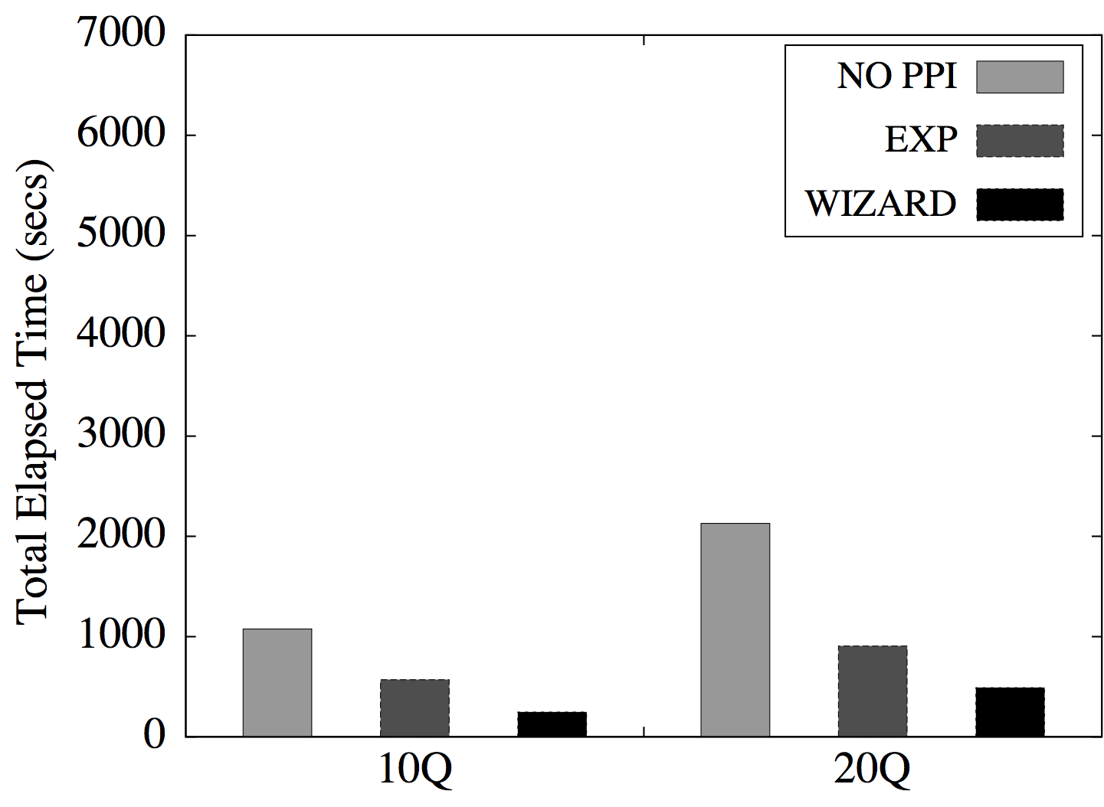
Figure 5: Recommendation Quality Comparison
(a) 1TB
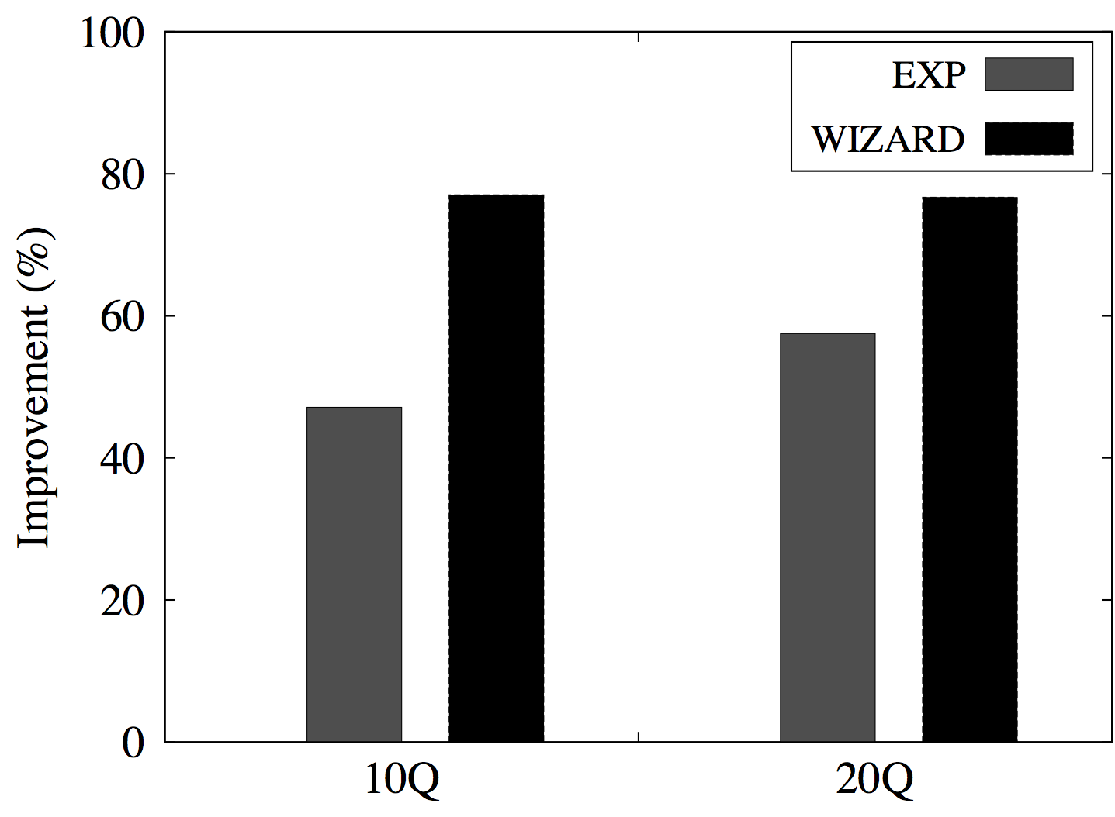
DB2 MDC Advisor [Lightstone and Bhattacharjee, 2004] actually tackles a different problem of automatically recommending the most well-suited MDC keys for a given workload. Agrawal’s work [Agrawal et al., 2004] discusses another problem of merging single-level range partitionings on objects such as tables or indexes. This article addresses the multi-level partitioning problem. Hence, the existing solutions cannot be directly applied to our MLPPI wizard.
Regarding the approach, DB2 MDC Advisor [Lightstone and Bhattacharjee, 2004] uses

(b) 3TB
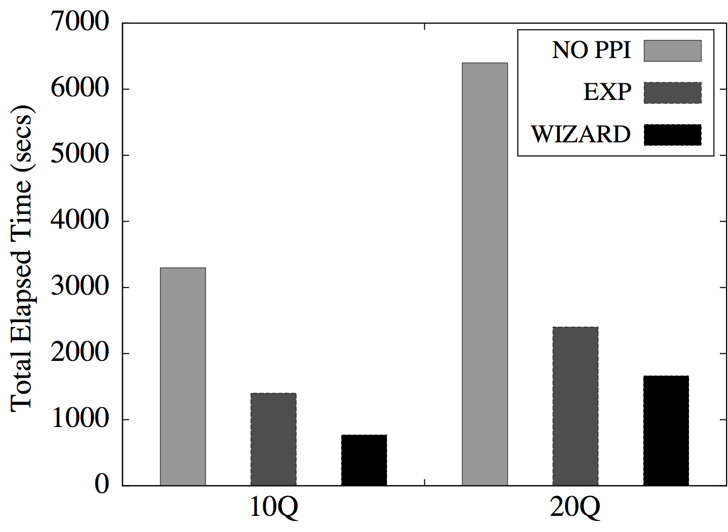

(b) 3TB
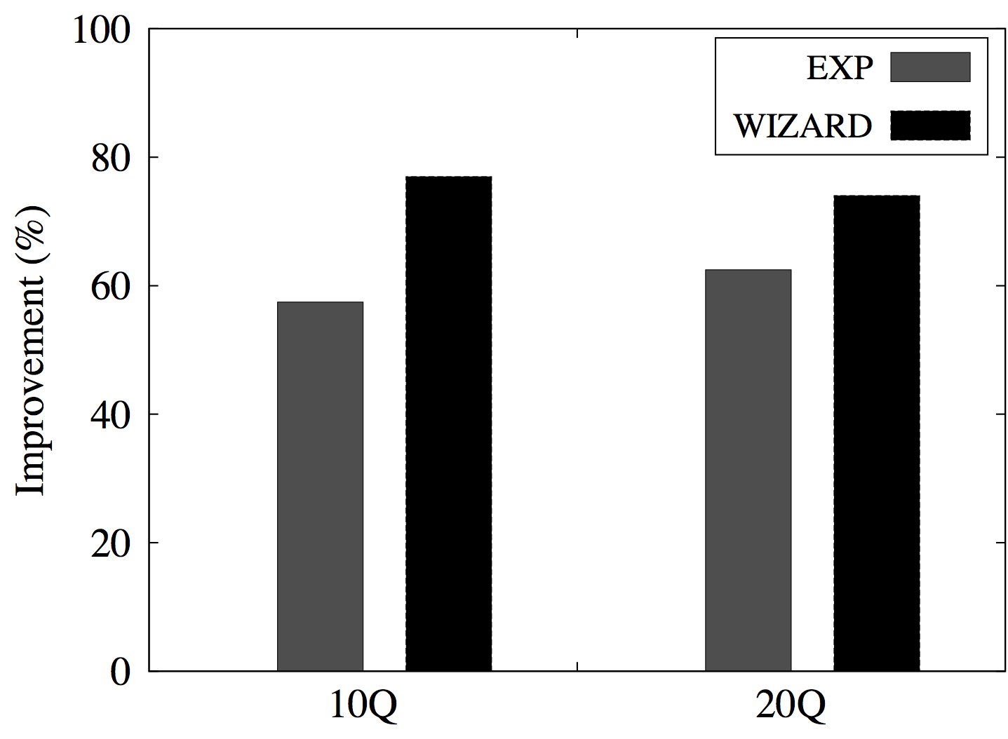
the search space driven by fields. Meanwhile, our search space is driven by query-predicates, which is superior because predicates are more customized and specific to a workload than fields. Agrawal’s horizontal partitioning scheme [Agrawal et al., 2004] also uses the search space driven by simple range predicates, but his technique has a shortcoming as follows. His work produces a solution for each individual query and attempt to merge the solutions, but this approach cannot reach an optimized solution in a global perspective. MLPPI wizard generates the whole search space upfront and subsequently merges partitions, leading to a globally optimized solution. Moreover, only a single column is considered in his work [Agrawal et al., 2004], whereas our tool deals with multiple fields.
Implementations of previous tools [Agrawal et al., 2004, Lightstone and Bhattacharjee, 2004, Nehme and Bruno, 2011] required instrumentation for optimizer code. These instrumentations are needed to facilitate the required information for the physical design tools API calls. The instrumentation code needs to be enhanced and tested for new database releases that add complexity and additional cost for software upgrades. The Teradata optimizer has a rich set of existing APIs originally coded for system and workload management tools. These APIs are sufficient for the MLPPI functionality helped us avoid the costly optimizer code change and instrumentation.
Also, Nehme’s work [Nehme and Bruno, 2011], deeply integrated with optimizer, reveals a concern about the quality of the recommendations made by some tools, shallowly integrated with optimizer. Nevertheless, we observed in our experiments that the quality of the wizard’s solutions was much superior to that of the compared base ones. In addition, some might argue that in our loosely coupled approach the cost of invoking the optimizer could be significant. However, the measured calls were much fewer than the theoretical bound as shown in Table 1, since the calls were mainly made only when queries were affected by a merge.
Lastly, there has been some previous work [Nehme and Bruno, 2011, Rao et al., 2002, Tatarowicz et al., 2012] regarding table partitioning in multi-node systems, but our problem is discussed in the context of a single node (that is, AMP) system, as in the existing work [Agrawal et al., 2004]. Database cracking [Idreos et al., 2007], self-reorganizing column values in accordance with query workload, also assumes a single node environment, but it does not address our multi-level partitioning problem.
SUMMARY
Given workloads, it is very hard for DBAs to select the appropriate fields in partitioning the fact table due to large search space. DBAs even cannot easily determine how granular partitions should be made for the workloads.
To help relieve this concern, we presented the Teradata MLPPI wizard that recommends a fact table partitioning solution suitable for a given star schema workload. Since query-predicates are exploited to capture necessary ranges for fields and define partitions, the MLPPI recommendation can be very optimized, customized to the workload.
We proposed the wizard’s algorithms consisting of the three phases. The wizard incrementally reduces its search space by merging the range pair with the least scan or query cost, and eventually reaches an MLPPI recommendation. In addition, we analyzed the running complexity for the initial and optimized phases. Despite the theoretically high bound, in practice, the wizard made much fewer calls in the phases.
We measured the performance of the recommendation by the wizard using our workloads. Our empirical results demonstrated that the produced MLPPI solutions by the wizard could reduce the total elapsed time by more than a factor of two, compared with those of no partitioning approach and partitioning done by a human expert.
REFERENCES
Agrawal, S., Chaudhuri, S., Kollar, L., Marathe, A., Narasayya, V., & Syamala, M. (2005). Database Tuning Advisor for Microsoft SQL Server 2005: Demo. In Proceedings of the 2005 ACM SIGMOD International Conference on Management of Data (pp. 930–932). ACM.

Agrawal, S., Chaudhuri, S., & Narasayya, V. R. (2000). Automated Selection of Materialized Views and Indexes in SQL Databases. In Proceedings of the 26th International Conference on Very Large Data Bases. (pp. 496–505). Morgan Kaufmann Publishers Inc.
Agrawal, S., Narasayya, V., & Yang, B. (2004). Integrating Vertical and Horizontal Partitioning into Automated Physical Database Design. In Proceedings of the 2004 ACM SIGMOD International Conference on Management of Data (pp. 359–370). ACM.
Chaudhuri, S. & Narasayya, V. (1998). AutoAdmin “What-If” Index Analysis Utility. In Proceedings of the 1998 ACM SIGMOD International Conference on Management of Data (pp. 367–378). ACM.
Dash, D., Polyzotis, N., & Ailamaki, A. (2011). CoPhy: A Scalable, Portable, and Interactive Index Advisor for Large Workloads. Proceedings of the VLDB Endowment, 4(6), 362–372.
Finkelstein, S., Schkolnick, M., & Tiberio, P. (1988). Physical Database Design for Relational Databases. ACM Transactions on Database Systems, 13(1), 91–128.
Idreos, S., Kersten, M. L., & Manegold, S. (2007). Database Cracking. In Proceedings of the Third Biennial Conference on Innovative Data Systems (pp. 68–78). ACM.
Kimura, H., Narasayya, V., and Syamala, M. (2011). Compression Aware Physical Database Design. Proceedings of the VLDB Endowment, 4(10), 657–668.
Klindt, J. (2012). Single-level and Multilevel Partitioned Primary Indexes. Retrieved March 31, 2012, from http://www.teradata.com/white-papers/Single-level-and-Multilevel-Partitioned-Primary-Indexes-eb1889/.
Labio, W., Quass, D., & Adelberg, B. (1997). Physical Database Design for Data Warehouses. In Proceedings of the Thirteenth International Conference on Data Engineering (pp. 277–288). IEEE Computer Society.
Lightstone, S. S. & Bhattacharjee, B. (2004). Automated Design of Multi-dimensional Clustering Tables for Relational Databases. In Proceedings of the Thirtieth International Conference on Very Large Data Bases (pp. 1170–1181). VLDB Endowment.
Microsoft (2012). Index Tuning Wizard SQL Server 2000. Retrieved February 21, 2012, from http://technet.microsoft.com/en-us/library/cc966541.aspx.
Nehme, R. & Bruno, N. (2011). Automated Partitioning Design in Parallel Database Systems. In Proceedings of the 2011 ACM SIGMOD International Conference on Management of Data (pp. 1137–1148). ACM.
O’Neil, P., O’Neil, B., & Chen, X. (2012). The Star Schema Benchmark (SSB), Retrieved March 31, 2012, from http://www.cs.umb.edu/~poneil/StarSchemaB.PDF.
Oracle. (2012a). Partitioning Advisor, Retrieved January 13, 2012a, from http://www.oracle.com/technetwork/database/options/partitioning/twp-partitioning-11gr2-2009-09-130569.pdf.
Oracle. (2012b). SQL Access Advisor, Retrieved March 31, 2012b, from http://docs.oracle.com/cd/B19306_01/server.102/b14211/advisor.htm.
Rao, J., Zhang, C., Megiddo, N., & Lohman, G. (2002). Automating Physical Database Design in A Parallel Database. In Proceedings of the 2002 ACM SIGMOD International Conference on Management of Data (pp. 558–569). ACM.
Rozen, S. and Shasha, D. (1991). A Framework for Automating Physical Database Design. In Proceedings of the 17th International Conference on Very Large Data Bases (pp. 401–411). Morgan Kaufmann Publishers Inc.
Sinclair, P. (2012). Using PPIs to Improve Performance, Retrieved March 31, 2012, from http://www.teradata.com/tdmo/v08n03/pdf/AR5731.pdf.
Suh, Y.-K., Ghazal, A., Crolotte, A., & Kostamaa, P. (2012). A New Tool for Multi-level Partitioning in Teradata. In Proceedings of the ACM International Conference on Information and Knowledge Management (pp. 2214–2218). ACM.
Tatarowicz, A., Curino, C., Jones, E., & Madden, S. (2012). Lookup Tables: Fine-grained Partitioning for Distributed Databases. In Proceedings of IEEE 28th International Conference on Data Engineering (pp. 102–113). IEEE Computer Society.
Valentin, G., Zuliani, M., Zilio, D. C., Lohman, G., & Skelley, A. (2000). DB2 Advisor: An Optimizer Smart Enough to Recommend Its Own Indexes. In Proceedings of the 16th International Conference on Data Engineering (pp. 101–101). IEEE Computer Society.
Zilio, D. C. (1998). Physical Database Design Decision Algorithms and Concurrent Reorganization for Parallel Database Systems. Doctoral dissertation, Department of Computer Science, University of Toronto.
Zilio, D. C., Rao, J., Lightstone, S., Lohman, G., Storm, A., Garcia-Arellano, C., & Fadden, S. (2004a). DB2 Design Advisor: Integrated Automatic Physical Database. In Proceedings of the International Conference on Very Large Data Bases (pp. 1087–1097). VLDB Endowment.
Zilio, D. C., Zuzarte, C., Lohman, G. M., Pirahesh, H., Gryz, J., Alton, E., Liang, D., and Valentin, G. (2004b). Recommending Materialized Views and Indexes with the IBM DB2 Design Advisor. In Proceedings of the First International Conference on Autonomic Computing (pp. 180–188). IEEE Computer Society.

SUBHEAD STYLE 1: Arial, Size 12, Bold, ALL CAPS) (SECTION TITLE, LEVEL 1)
Body Text 1st Para Style – used for first paragraph of main content under subheads
Body Text Style – used for main content under subheads

Caption Style. Used for block quotes

Caption Style. Used for image captions (for example, Table 1. This is a caption)

Subhead 2 Style (Section Title, Level 2)
Body Text 1st Para Style – used for first paragraph of main content under subheads
Body Text Style – used for main content under subheads

CONCLUSION (Subhead style 1: Arial, Size 12, Bold, ALL CAPS)
(Body Text, Times New Roman, 12 pt, left justified) Here, you should provide a discussion on the overall coverage of the paper and include your concluding remarks.

REFERENCES (Subhead style 1: Arial, Size 12, Bold, ALL CAPS)
(Body Text, Times New Roman, 12 pt, left justified) It is your responsibility to ensure that all information in your paper that is taken from another source is substantiated with an in-text reference citation. Please also note that your references must strictly follow APA (American Psychological Association) style NOTE: The publisher may return your chapter to you for correction if you do not properly format your references. Note that this will delay the production process, and ultimately, the release of the book. References should relate only to the material you actually cited within your chapter (this is not a bibliography), and they should be listed in alphabetical order. Please do not include any abbreviations.

While some examples of references in APA style are included below, it is highly recommended that you reference an actual APA style manual (5th edition). If you do not own an APA style manual, you may either 1) consult your library or 2) visit APA’s Web site to order your own copy: http://www.apastyle.org/pubmanual.html. It may also benefit you to consult the following pages of APA’s Web site for frequently asked questions and other tips: http://www.apastyle.org/faqs.html & http://www.apastyle.org/previoustips.html.

Book with one author:
Author, A. A. (2005). Title of work. Location/City, State: Publisher.

Book with two authors:
Author, A. A., & Author, B. B. (2005). Title of work. Location/City, State: Publisher.

Book with more than two authors:
Author, A. A., Author, B. B., & Author, C. C. (2005). Title of work. Location/City, State: Publisher.

Journal article:
Sawyer, S., & Tapia, A. (2005). The sociotechnical nature of mobile computing work: Evidence from a study of policing in the United States. International Journal of Technology and Human Interaction, 1(3), 1-14.

A publication in press:
Junho, S. (in press). Roadmap for e-commerce standardization in Korea. International Journal of IT Standards and Standardization Research.

Edited book:
Zhao, F. (Ed.). (2006). Maximize business profits through e-partnerships. Hershey, PA: IRM Press.

Chapter in an edited book:
Jaques, P. A., & Viccari, R. M. (2006). Considering students’ emotions in computer-mediated learning environments. In Z. Ma (Ed.), Web-based intelligent e-learning systems: Technologies and applications (pp. 122-138). Hershey, PA: Information Science Publishing.

Report from a university:
Broadhurst, R. G., & Maller, R. A. (1991). Sex offending and recidivism (Tech. Rep. No. 3). Nedlands, Western Australia: University of Western Australia, Crime Research Centre.

Published proceedings:
Deci, E. L., & Ryan, R. M. (1991). A motivational approach to self: Integration in personality. In R. Dienstbier (Ed.), Nebraska Symposium on Motivation: Vol. 38. Perspectives on motivation (pp. 237-288). Lincoln: University of Nebraska Press.

Unpublished doctoral dissertation or master’s thesis:
Wilfley, D. (1989). Interpersonal analyses of bulimia: Normal-weight and obese. Unpublished doctoral dissertation, University of Missouri, Columbia.

A presented paper:
Lanktree, C., & Briere, J. (1991, January). Early data on the Trauma Symptom Checklist for Children (TSC-C). Paper presented at the meeting of the American Professional Society on the Abuse of Children, San Diego, CA.

Web site:
VandenBos, G., Knapp, S., & Doe, J. (2001). Role of reference elements in the selection of resources by psychology undergraduates. Journal of Bibliographic Research, 5, 117-123. Retrieved October 13, 2001, from http://jbr.org/articles.html

