Classification of Traffic Flows into QoS Classes by Unsupervised Learning and KNN Clustering

Yi Zeng¹, Peter Jo¹ and Thomas M. Chen²
¹ San Diego Supercomputer Center, University of California
San Diego, CA 92093 - USA
[e-mail: yzeng@sdsc.edu]
² School of Engineering, Swansea University
Swansea, Wales SA2 8PP - UK
[e-mail: t.m.chen@swansea.ac.uk]
*Corresponding author: Thomas M. Chen

Abstract

Traffic classification seeks to assign packet flows to an appropriate quality of service (QoS) class based on flow statistics without the need to examine packet payloads. Classification proceeds in two steps. Classification rules are first built by analyzing traffic traces, and then the classification rules are evaluated using test data. In this paper, we use self-organizing map and K-means clustering as unsupervised machine learning methods to identify the inherent classes in traffic traces. Three clusters were discovered, corresponding to transactional, bulk data transfer, and interactive applications. The K-nearest neighbor classifier was found to be highly accurate for the traffic data and significantly better compared to a minimum mean distance classifier.

Keywords: Traffic classification, unsupervised learning, k-nearest neighbor, clustering
1. Introduction
Network operators and system administrators are interested in the mixture of traffic carried in their networks for several reasons. Knowledge about traffic composition is valuable for network planning, accounting, security, and traffic control. Traffic control includes packet scheduling and intelligent buffer management to provide the quality of service (QoS) needed by applications. It is necessary to determine to which applications packets belong, but traditional protocol layering principles restrict the network to processing only the IP packet header.
…
In Section 2, we review the previous work in traffic classification. Section 3 addresses the question of useful features and number of QoS classes. We describe experiments with unsupervised clustering of real traffic traces to build classification rules. Given the discovered QoS classes, Section 4 presents experimental evaluation of classification accuracy using k-nearest neighbor compared to minimum mean distance clustering.
2. Related Work
Research in traffic classification, which avoids payload inspection, has accelerated over the last five years. It is generally difficult to compare different approaches, because they vary in the selection of features (some requiring inspection of the packet payload), choice of supervised or unsupervised classification algorithms, and set of classified traffic classes. The wide range of previous approaches can be seen in the comprehensive survey by Nguyen and Armitage [1]. Further complicating comparisons between different studies is the fact that classification performance depends on how the classifier is trained and the test data used to evaluate accuracy. Unfortunately, a universal set of test traffic data does not exist to allow uniform comparisons of different classifiers.
A common approach is to classify traffic on the basis of flows instead of individual packets. Trussell et al. proposed the distribution of packet lengths as a useful feature [2]. McGregor et al. used a variety of features: packet length statistics, interarrival times, byte counts, connection duration [3]. Flows with similar features were grouped together using EM (expectation-maximization) clustering. Having found the clusters representing a set of traffic classes, the features contributing little were deleted to simplify classification and the clusters were recomputed with the reduced feature set. EM clustering was also studied by Zander, Nguyen, and Armitage [4]. Sequential forward selection (SFS) was used to reduce the feature set. The same authors also tried AutoClass, an unsupervised Bayesian classifier, for cluster formation and SFS for feature set reduction [5].….
3. Unsupervised Clustering
3.1 Self-Organizing Map
SOM is trained iteratively. In each training step, one sample vector x from the input data pool is chosen randomly, and the distances between it and all the SOM codebook vectors are calculated using some distance measure. The neuron whose codebook vector is closest to the input vector is called the best-matching unit (BMU), denoted by :

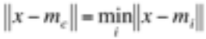 (1)

where  is the Euclidean distance, and 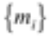 are the codebook vectors.
After finding BMU, the SOM codebook vectors are updated, such that the BMU is moved closer to the input vector. The topological neighbors of BMU are also treated this way. This procedure moves BMU and its topological neighbors towards the sample vectors. The update rule for the ith codebook vector is:

(2)

where n is the training iteration number, x(t) is an input vector randomly selected from the input data set at the nth training, 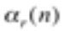 is the learning rate in the nth training, and 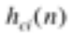 is the kernel function around BMU . The kernel function defines the region of influence that x has on the map.
…
Fig. 1 shows the U-matrix and the components planes for the feature variables. The U-matrix is a visualization of distance between neurons, where distance is color coded according to the spectrum shown next to the map. Blue areas represent codebook vectors close to each other in input space, i.e., clusters.
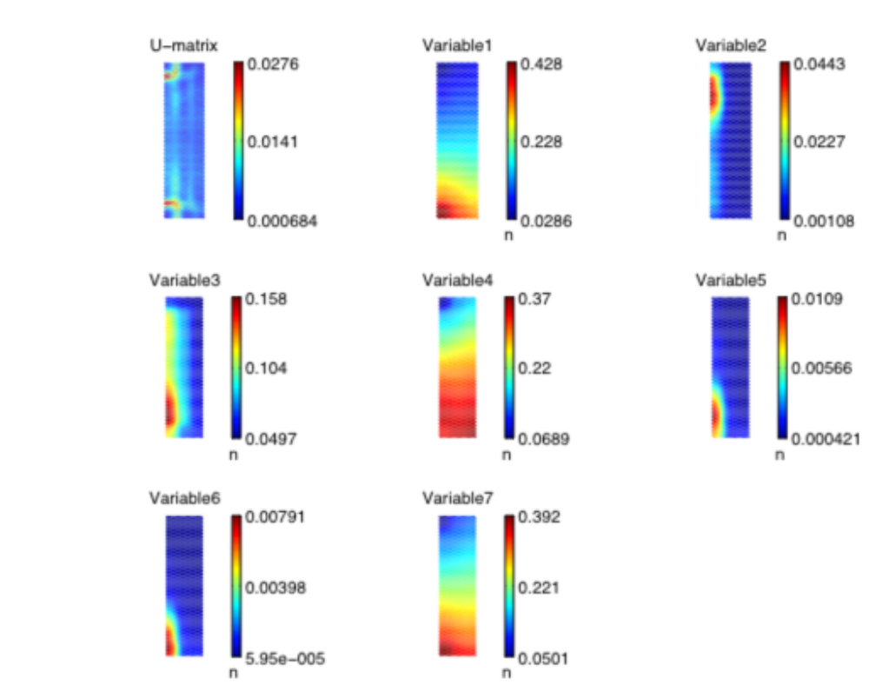
Fig. 1. U-matrix with 7 components scaled to [0,1]

...
3.2 K-Means Clustering
The K-means clustering algorithm starts with a training data set and a given number of clusters K. The samples in the training data set are assigned to a cluster based on a similarity measurement. Euclidean distance is generally used to measure the similarity. The K-means algorithm tries to find an optimal solution by minimizing the square error:

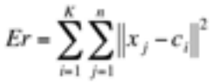 (3)

where K is the number of clusters and n is the number of training samples, is the center of the ith cluster, 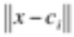 is the Euclidean distance between sample x and center of the ith cluster.
…
4. Experimental Classification Results and Analysis
The previous section identified three clusters for QoS classes and features to build up classification rules through unsupervised learning. In this section, the accuracy of the classification rules is evaluated experimentally. For classification, we chose the K-nearest neighbor (KNN) algorithm. Experimental results are compared with the minimum mean distance (MMD) classifier.
…

The selected application lists for each class and the number of applications in each class are shown in Table 1.

Table 1. Applications in each class
Class | Applications | Total number
Transactional | 53/TCP, 13/TCP, 111/TCP,… | 112
Interactive | 23/TCP, 21/TCP, 43/TCP, 513/TCP, 514/TCP, 540/TCP, 251/TCP, 1017/TCP, 1019/TCP, 1020/TCP, 1022/TCP,… | 77
Bulk data | 80/TCP, 20/TCP, 25/TCP, 70/TCP, 79/TCP, 81/TCP, 82/TCP, 83/TCP, 84/TCP, 119/TCP, 210/TCP, 8080/TCP,… | 1351
5. Conclusion
Traffic classification was carried out in two phases. In the first off-line phase, we started with no assumptions about traffic classes and used the unsupervised SOM and K-means clustering algorithms to find the structure in the traffic data. The data exploration procedure found three clusters corresponding to three QoS classes: transactional, interactive, and bulk data transfer. …
In the second classification phase, the accuracy of the KNN classifier was evaluated for test data. Leave-one-out cross-validation tests showed that this algorithm had a low error rate. The KNN classifier was found to have an error rate of about 2 percent for the test data, compared to an error rate of 7 percent for a MMD classifier. KNN is one of the simplest classification algorithms, but not necessarily the most accurate. Other supervised algorithms, such as back propagation (BP) and SVM, also have attractive features and should be compared in future work.
References
- Thuy Nguyen and Grenville Armitage, “A survey of techniques for Internet traffic classification using machine learning,” IEEE Communications Surveys and Tutorials, vol. 10, no. 4, pp. 56-76, November, 2008.
- H. Trussell, A. Nilsson, P. Patel and Y. Wang, “Estimation and detection of network traffic,” in Proc. of 11th Digital Signal Processing Workshop, pp. 246-248, January 12-16, 2004.
- Anthony McGregor, Mark Hall, Perry Lorier and James Brunskill, “Flow clustering using machine learning techniques,” in Proc. of 5th Int. Workshop on Passive and Active Network Measurement, pp.205-214, June 2-7, 2004.
- Sebastian Zander, Thuy Nguyen and Grenville Armitage, “Self-learning IP traffic classification based on statistical flow characteristics,” in Proc. of 6th Int. Workshop on Passive and Active Measurement, pp.325-328, March 23-27, 2005.
- Sebastian Zander, Thuy Nguyen and Grenville Armitage, “Automated traffic classification and application identification using machine learning,” in Proc. of IEEE Conf. on Local Computer Networks, pp.250-257, February 11-12, 2005.
[6] T. M. Cover and J. A. Thomas, Elements of Information Theory, 2nd Edition, Wiley, New York,
2009.

■ Important Requirements for Accepted Papers only
This is an important requirement for all of the accepted papers. Thus once your manuscript is finally accepted for publication in our journal, the authors should do the following requirement.

All the references in the manuscript should have its DOI link. Please follow the step-by-step procedures
to put the DOI link:

1) Register your e-mail ID in http://www.crossref.org/requestaccount/
2) Enter your registered e-mail ID and all the references in the boxes in http://www.crossref.org/SimpleTextQuery/

ex) Let’s enter the following two references together and then press “Submit” button. You will receive two DOIs in blue color below for them, respectively.

F. Hou, L. X. Cai, J. She, P. Ho, X. Shen and J. Zhang, “Cooperative multicast scheduling scheme for IPTV over IEEE 802.16 Networks,” IEEE Transactions on Wireless Communications, vol. 8, no. 3, pp. 1508-1519, Mar. 2009.
doi:10.1109/TWC.2009.080417
Thuy Nguyen and Grenville Armitage, “A survey of techniques for Internet traffic classification using machine learning,” IEEE Communications Surveys and Tutorials, vol. 10, no. 4, pp. 56-76, November, 2008.
doi:10.1109/SURV.2008.080406

Important: If any reference does not have its own DOI, no DOI will be returned. For that case, you don’t need to put a DOI for the reference. But almost all of journal papers have their DOI. Thus if the CrossRef’s automatic DOI searcher fails to find a DOI, you SHOULD google with the title of the journal paper. For instance, the DOIs of the following journal papers couldn’t be found by the CrossRef automatic DOI searcher but we could find the DOIs by googling with the title of the journal paper:

[1] Zabin. F, Misra. S, Woungang and I, Rashvand. H,F. Ma, N.-W, Ahsan Ali, M, “REEP:
data-centric, energy-efficient and reliable routing protocol for wireless sensor networks,” IET
Communications, vol. 2 , no 8, pp. 995-1008, 2008.
http://ieeexplore.ieee.org/Xplore/login.jsp?url=http%3A%2F%2Fieeexplore.ieee.org%2Fiel5%2F4105970%2F4607188%2F04607189.pdf%3Farnumber%3D4607189&authDecision=-203

[2] O. Powell, P. Leone and J. Rolim, “Energy Optimal Data Propagation in Wireless Sensor Networks,” J. Parallel and Distributed Computing, vol. 67, no. 3, pp. 02-317, 2007.
http://portal.acm.org/citation.cfm?id=1224643

3) Now you just add the DOIs link to the references in your paper. When you add the DOI in the
reference, you should attach a prfix, http://dx.doi.org/ to the front of each DOI.

ex) For the two examples,

F. Hou, L. X. Cai, J. She, P. Ho, X. Shen and J. Zhang, “Cooperative multicast
scheduling scheme for IPTV over IEEE 802.16 Networks,” IEEE Transactions on
Wireless Communications, vol. 8, no. 3, pp. 1508-1519, Mar. 2009.
http://dx.doi.org/doi:10.1109/TWC.2009.080417
Thuy Nguyen and Grenville Armitage, “A survey of techniques for Internet traffic
classification using machine learning,” IEEE Communications Surveys and Tutorials, vol. 10, no. 4, pp. 56-76, November, 2008.
http://dx.doi.org/doi:10.1109/SURV.2008.080406

4) Last, you should put a DOI link tag name, “Article (CrossRef Link)” as following:
You just place the cursor on the DOI link and click the right button of your mouse and then select the “Hyperlink Edit” menu. Enter the tag name “Article (CrossRef Link)” in the text box.

[1] F. Hou, L. X. Cai, J. She, P. Ho, X. Shen and J. Zhang, “Cooperative multicast scheduling scheme for IPTV over IEEE 802.16 Networks,” IEEE Transactions on Wireless Communications, vol. 8, no. 3, pp. 1508-1519, Mar. 2009. Article (CrossRef Link).

[2] Thuy Nguyen and Grenville Armitage, “A survey of techniques for Internet traffic classification using machine learning,” IEEE Communications Surveys and Tutorials, vol. 10, no. 4, pp. 56-76, November, 2008. Article (CrossRef Link).

-END-

