**Name:D.Yaswanth**

**RollNO:22491A05d7**

**CLASS:3cse2**

**Activity_main.xml**

*<?*xml version="1.0" encoding="utf-8"*?>*<androidx.constraintlayout.widget.ConstraintLayout xmlns:android="http://schemas.android.com/apk/res/android"  
 xmlns:app="http://schemas.android.com/apk/res-auto"  
 xmlns:tools="http://schemas.android.com/tools"  
 android:layout_width="match_parent"  
 android:layout_height="match_parent"  
 android:background="@drawable/img"  
  
 tools:context=".MainActivity">  
  
 <TextView  
 android:id="@+id/shakeText"  
 android:layout_width="wrap_content"  
 android:layout_height="wrap_content"  
 android:text="Shake your device!"  
 android:textSize="40dp"  
 android:textColor="@color/blue"  
 android:textStyle="bold"  
 app:layout_constraintBottom_toBottomOf="parent"  
 app:layout_constraintEnd_toEndOf="parent"  
 app:layout_constraintStart_toStartOf="parent"  
 app:layout_constraintTop_toTopOf="parent"  
 app:layout_constraintVertical_bias="0.023" />  
  
</androidx.constraintlayout.widget.ConstraintLayout>

**MainActivity.java**

package com.yeswanthdevarasetti.miniproject;  
  
import androidx.appcompat.app.AppCompatActivity;  
import android.hardware.Sensor;  
import android.hardware.SensorEvent;  
import android.hardware.SensorEventListener;  
import android.hardware.SensorManager;  
import android.os.Bundle;  
import android.widget.TextView;  
import android.widget.Toast;  
  
public class MainActivity extends AppCompatActivity implements SensorEventListener {  
  
 private SensorManager sensorManager;  
 private Sensor accelerometer;  
 private TextView shakeText;  
 private static final float *SHAKE_THRESHOLD* = 3.25f;  
 private static final int *MIN_TIME_BETWEEN_SHAKES* = 1000;  
 private long lastShakeTime;  
  
 @Override  
 protected void onCreate(Bundle savedInstanceState) {  
 super.onCreate(savedInstanceState);  
 setContentView(R.layout.*activity_main*);  
  
 shakeText = findViewById(R.id.*shakeText*);  
  
 sensorManager = (SensorManager) getSystemService(*SENSOR_SERVICE*);  
 if (sensorManager != null) {  
 accelerometer = sensorManager.getDefaultSensor(Sensor.*TYPE_ACCELEROMETER*);  
 }  
 }  
  
 @Override  
 protected void onResume() {  
 super.onResume();  
 if (accelerometer != null) {  
 sensorManager.registerListener(this, accelerometer, SensorManager.*SENSOR_DELAY_NORMAL*);  
 }  
 }  
  
 @Override  
 protected void onPause() {  
 super.onPause();  
 sensorManager.unregisterListener(this);  
 }  
  
 @Override  
 public void onSensorChanged(SensorEvent event) {  
 if (event.sensor.getType() == Sensor.*TYPE_ACCELEROMETER*) {  
 float x = event.values[0];  
 float y = event.values[1];  
 float z = event.values[2];  
  
 float acceleration = (float) Math.*sqrt*(x * x + y * y + z * z) - SensorManager.*GRAVITY_EARTH*;  
  
 if (acceleration > *SHAKE_THRESHOLD*) {  
 long currentTime = System.*currentTimeMillis*();  
 if (currentTime - lastShakeTime > *MIN_TIME_BETWEEN_SHAKES*) {  
 lastShakeTime = currentTime;  
 onShakeDetected();  
 }  
 }  
 }  
 }  
  
 @Override  
 public void onAccuracyChanged(Sensor sensor, int accuracy) {  
 *// Not used in this example* }  
  
 private void onShakeDetected() {  
 shakeText.setText("Device shaken!");  
 Toast.*makeText*(this, "Shake detected!", Toast.*LENGTH_SHORT*).show();  
 *// Add your custom action here* }  
}

**OUTPUT:**

1.Intial State

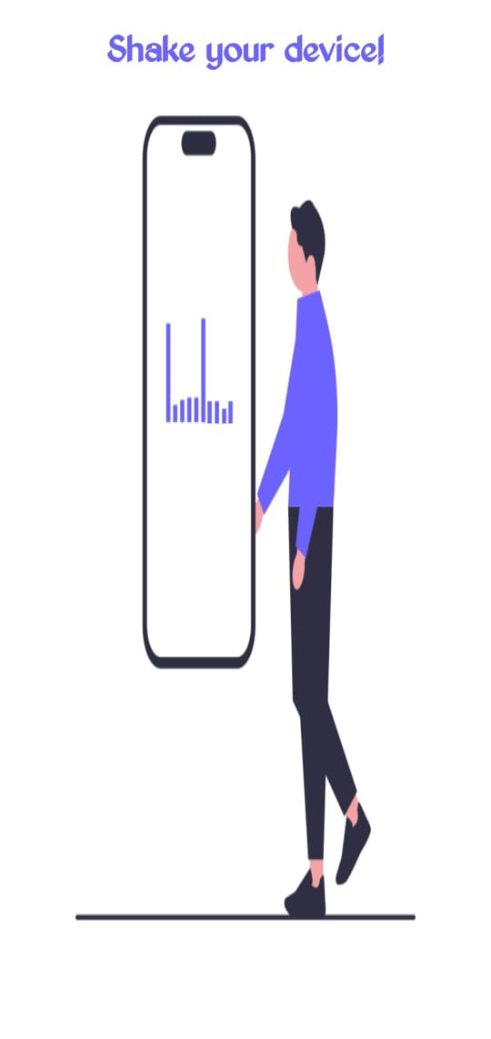

2.AFTER SHAKING

