**Final Report**

**SoloSphere: Travel Solo, Connect Together**

" SoloSphere is a social app for solo travelers to connect, share experiences, and create memories together. "

Avneet Kaur (300379014), Dan Do (300387931), Shubham Shubham(300352587)

Douglas College

CSIS 3375-001 UX Design in Web & Mobile App

Padmapriya Arasanipalai Kandhadai

April 8, 2025

**Overall Percentage contributions**

Avneet Kaur (300379014): 33.3%

Dan Do (300387931): 33.3%

Shubham Shubham(300352587): 33.3%

**App Idea for Prototype**

* Application Description
  + SoloSphere is designed for individuals who love traveling alone yet desire companionship and shared experiences on the road. The app connects like-minded solo travelers, enabling them to
    - Find travel companions
    - Plan trips together
    - Share experiences through posts and reviews
    - Access safety features such as real-time location sharing, emergency contacts, and host verification
* Novelty
  + Niche Focus: While many travel apps primarily offer limited functionalities such as selling travel products or planning itineraries, SoloSphere targets solo travelers who are eager to build genuine relationships alongside enjoying social networking features
  + Safety-Centric Design**:** Integrated safety features such as geolocation tracking, in-app emergency alerts, and verified profiles provide extra security for solo adventurers
  + Community-Driven: The app leverages community reviews, meet-ups, and localized events to foster a supportive network, differentiating it from traditional travel planning apps
* Transformative Experience for the User
  + SoloSphere transforms the solo travel experience by
    - Empowering Connection: Allowing travelers to meet new people who share similar interests, reducing feelings of isolation
    - Enhancing Safety: Providing built-in safety tools that give users peace of mind while exploring unfamiliar destinations
    - Simplifying Planning: Integrating trip planning, itinerary sharing, and real-time updates within one easy-to-use platform
    - Building a Community: Creating lasting relationships and memorable shared experiences among solo travelers

**Background Research**

* Market Competitor Apps
  + Travel Buddy: Matches travelers but lacks real-time safety features.
  + Couchsurfing Travel: Offers cultural exchange but no structured travel planning
  + Meetup: Organizes events but does not focus on solo travelers.
  + Tinder: Location-based matching but lacks safety & travel features
* Market Inspiration Apps
  + Airbnb Experiences: Inspires by offering local experiences that foster connection between visitors and locals
  + Meetup: Encourages community gatherings and events, inspiring SoloSphere’s community meet-up features
  + Instagram: The visual storytelling element inspires the sharing of travel experiences and user-generated content

**PACK Framework**

* People
  + Primary Users: Solo travelers seeking social connections, travel companions, and safety assurance
  + Secondary Users: Local hosts, travel bloggers, and local businesses (e.g., tour operators) who can provide services or participate in community events
* Activity
  + Creating and browsing profiles
  + Planning trips and itineraries
  + Connecting through Chat and Bulletin Boards
  + Sharing photos, reviews, and travel experiences
  + Accessing safety tools (e.g., location sharing, emergency alerts)
* Context
  + Physical Context: Mobile use in diverse environments—urban, rural, and international travel locations
  + Social Context: Engaging with a global community of like-minded travelers
  + Technological Context: Utilizes GPS, real-time data updates, secure messaging, and social media integration
* Technologies Needed
  + Mobile Platform: Designing with Android Material Design Guidelines.
  + Prototyping Tool: Figma (for wireframing, UI/UX design, and interactive prototypes)
  + Security Considerations in UX: Trust-building UI elements such as password visibility toggles, intuitive authentication UX, and clear error messaging

**Value Proposition**

* Based on the PACT framework and the novel aspects of SoloSphere, our value proposition is

“ SoloSphere connects solo travelers through a secure, community-driven app. With safety tools, AI-based travel matching, and trip planning, it ensures a stress-free and enriching solo travel experience.”

**Requirements Gathering**

* Purpose or objectives for Requirements Gathering
  + The objective of requirements gathering is to understand the needs, behaviors, and concerns of solo travelers regarding social travel experiences. Specifically, we aim to
    - Identify the key motivations of solo travelers for seeking companionship
    - Analyze the biggest challenges and risks associated with solo travel
    - Evaluate user preferences for travel matching, communication, and social features
    - Determine essential safety features that users expect in a solo travel app
    - Assess current methods of connecting with travel companions and the gaps in existing solutions
* User study and target sample
  + Methodology: Online survey and semi-structured interviews
  + Target audience
    - Primary Users
      * Young solo travelers (late teens to early 30s) who actively engage in solo travel for adventure, self-exploration, or flexibility
      * Married travelers in their 30s-40s who aspire to travel alone but face challenges due to family responsibilities
  + Dual Perspective Approach
    - The survey was conducted among both active solo travelers and individuals who want to travel alone but find it difficult
    - By considering both groups, we can identify what solo travelers truly need and how the app can support them
  + Survey Scope
    - The research focuses on understanding the essential needs of solo travelers and the features that would enhance their experience
    - Key areas of interest include safety, social interaction, trip planning, and overcoming barriers to solo travel
* Draft of user study survey
  + The user study survey consists of 25 questions categorized into
    - Demographics: Age, location, travel habits
    - Travel Behavior: Preferred travel styles, duration, and frequency
    - Challenges & Preferences: Solo travel struggles, travel companion compatibility
    - Safety & Security: Privacy concerns, emergency features, verification methods
    - Social & Community Features: How users interact with others while traveling
    - Technology & App Features: Current travel-related apps used, interest in SoloSphere
  + See Appendix A for full survey details
* Data Visualization & Analysis
  + To gain insights into the needs and preferences of solo travelers, we conducted a survey focusing on key areas such as safety, social interaction, trip planning, and challenges of solo travel. Below is an analysis of the collected data
  + Sample Size: 21 responses from target users
  + Data visualization & analysis
    - Respondent Demographics
      * The majority of respondents belong to the 25-34 age group, followed by the 18-24 category

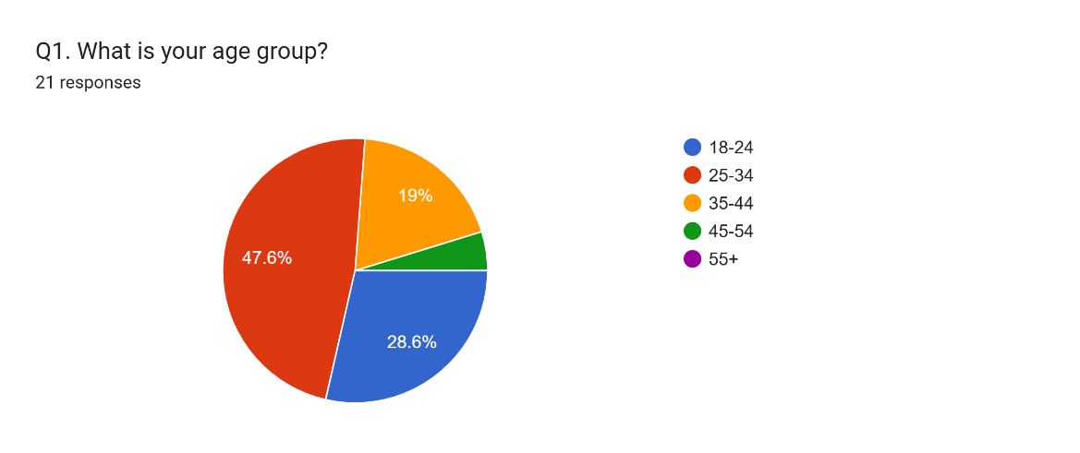

* + - * Most participants reside in North America

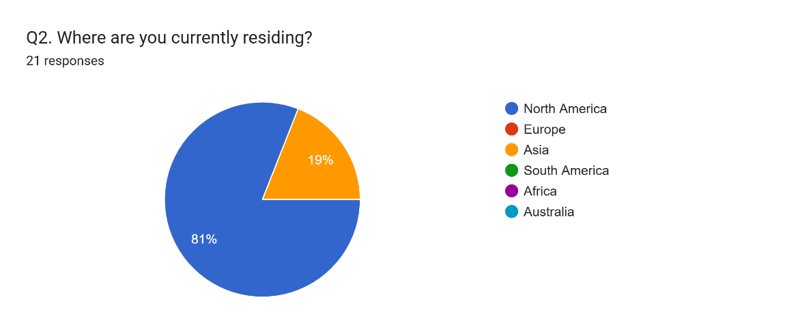

* + - Solo Travel Frequency
      * More than 60% of respondents travel solo at least once a year

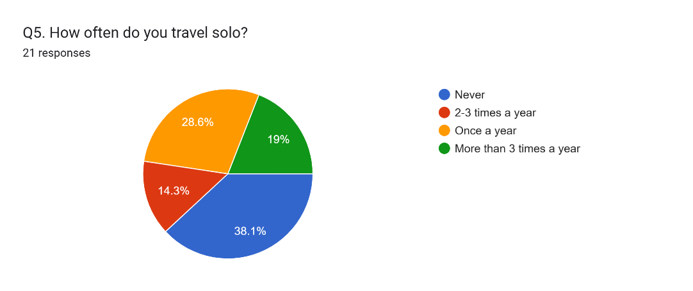

* + - Biggest Challenges of Solo Travel
      * Safety concerns ranked as the highest challenge

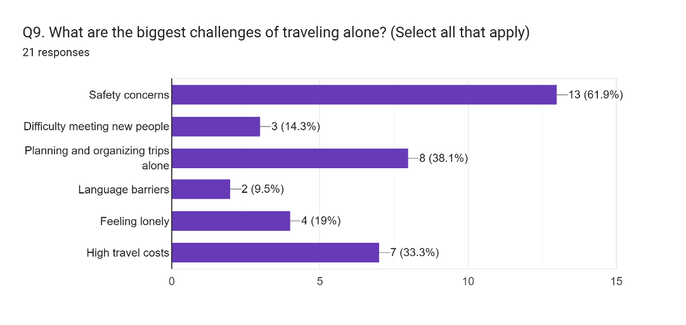

* + - Preferred Solo Travel Styles
      * Popular travel styles: Backpacking, Cultural & city exploration,

Adventure travel (hiking, diving, extreme sports)

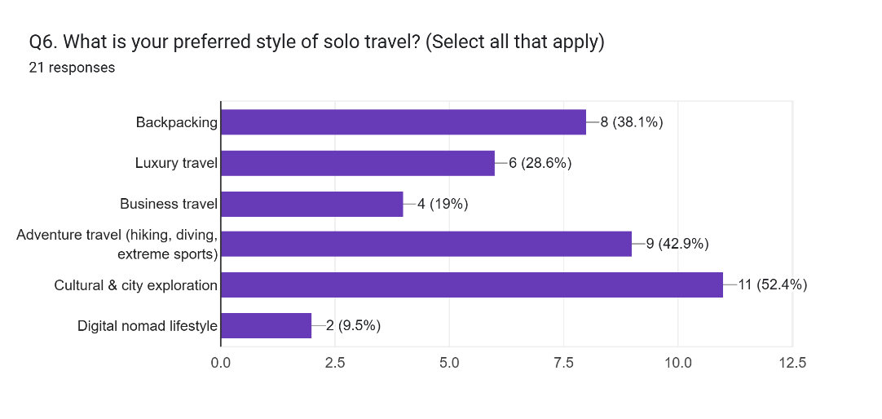

* + - Key Factors When Choosing a Travel Companion
      * Similar interests and activities ranked as the most critical factor
      * Compatible travel pace and style match also play a major role

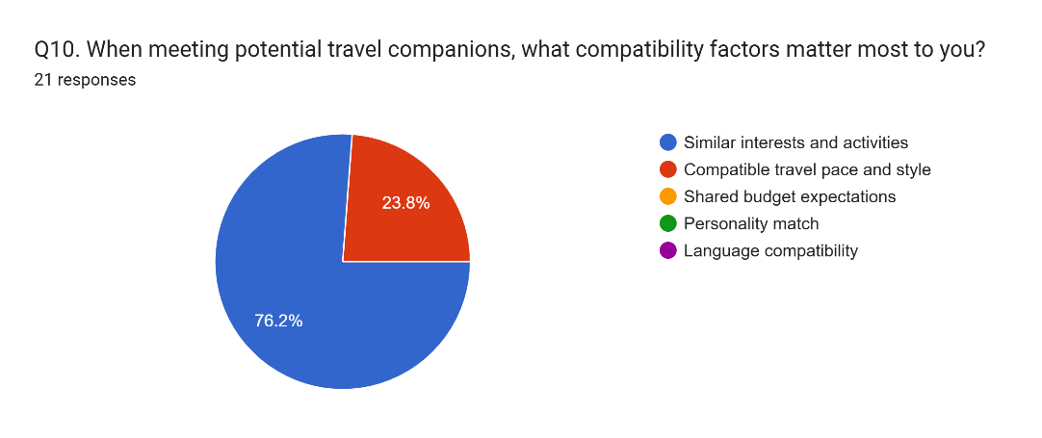

* + - Most Valued Emergency Assistance Features
      * One-touch emergency contact alert and local emergency services information are the top safety features users want

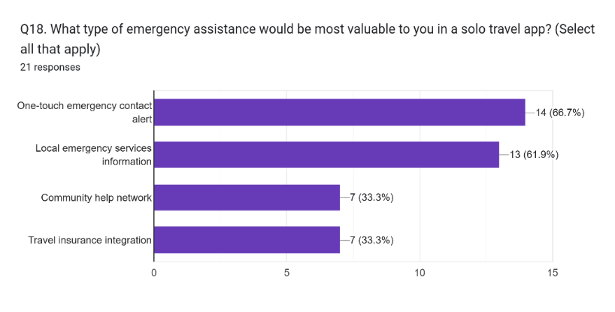

* + - Preferred Features in a Solo Travel App

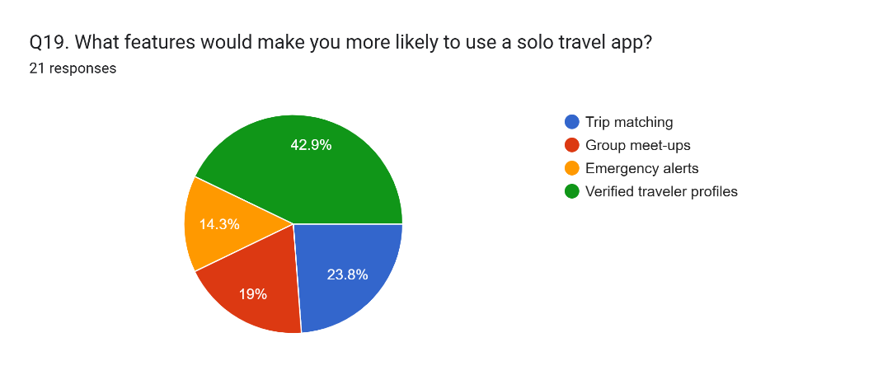

* Insights from the results
  + Safety and social interaction are the most critical factors for solo travelers
  + Users need structured trip planning tools to overcome travel planning difficulties
  + travel companion matching should prioritize compatibility in interests, travel pace, and personality
  + Emergency features like SOS alerts, local help, and verification systems are key to user trust

**Requirements Generation**

* Personas and scenarios
  + Community-Driven: The app leverages community reviews, meet-ups, and localized events to foster a supportive network, differentiating it from traditional travel planning apps
  + First personas and scenarios
    - Daniel Kim – The Cultural Explorer
      * Age: 35
      * Occupation: Senior Software Engineer (Multinational Corporation)
      * Marital Status: Engaged
      * Financial Status: Well-established, has saved a significant amount for travel
      * Travel Frequency: Travels multiple times a year, prefers long solo trips
      * Physical Activity Level: Very active – enjoys hiking, running, and outdoor adventures
      * Personality Traits: Open-minded, adventurous, organized planner
      * Preferred Travel Style: Solo travel with opportunities to meet compatible travelers
    - Scenario: Daniel’s Solo Trip to Japan
      * Daniel has always been passionate about exploring different cultures and landscapes. With his wedding approaching in six months, he wants to maximize his solo travel experiences before settling down
      * He decides to plan a two-week solo trip to Japan, focusing on Kyoto and Hokkaido
      * As a solo traveler, Daniel enjoys meeting new people, but past bad experiences with incompatible travel companions make him cautious. He wants to ensure compatibility before traveling with someone
      * He opens the SoloSphere app and sets up his travel profile, selecting his interests (hiking, cultural exploration, food experiences) and preferences for travel companions
      * The app suggests potential travel buddies based on shared interests, travel frequency, and personality traits
      * He finds Lisa, another solo traveler with similar preferences and good past reviews from other travelers
      * Before deciding to meet, Daniel reviews Lisa’s travel history, past trip experiences, and feedback from other users
      * They start chatting through the in-app secure messaging feature to discuss their travel plans
      * Using SoloSphere’s trip planning feature, they create an itinerary together, choosing local meetups, outdoor activities, and sightseeing spots
      * Daniel books separate accommodations but plans to meet Lisa for shared experiences like a tea ceremony in Kyoto and hiking Mount Fuji
      * Before departure, Daniel activates SoloSphere’s safety features, including
        + Real-time location sharing with his fiancée for safety
        + An emergency SOS button connected to local services
      * During his trip, he uses SoloSphere’s event discovery feature to join community meetups with other travelers
      * He documents his journey in SoloSphere’s travel journal feature, sharing insights and photos with the travel community
      * The trip turns out to be a great experience – Daniel meets like-minded people, avoids mismatched travel companions, and explores Japan stress-free
  + Second personas and scenarios
    - Sarah Patel – The Family-Oriented Solo Traveler
      * Age: 40
      * Occupation: Marketing Manager
      * Marital Status: Married with two children
      * Financial Status: Well-established, has a comfortable travel budget
      * Travel Frequency: Once a year
      * Physical Activity Level: Moderately active- enjoys sightseeing and cultural experiences
      * Personality Traits: Family-oriented, organized, and prefers structured travel plans
      * Preferred Travel Style: Cultural and city exploration
    - Scenario
      * Sarah has always loved art and history, and she dreams of discovering Europe's rich cultural heritage. As a hardworking marketing manager and a devoted mother of two, she struggles to juggle family duties with her desire to travel. Still, she is committed to taking a solo trip to Europe to pursue her passion for exploring different cultures
      * Sarah's Solo Trip to Europe

* + Third personas and scenarios
    - Emma Collins
      * Age: 26
      * Occupation: Marketing Consultant (Remote)
      * Location: New York, USA
      * Travel Style: Solo traveler, loves history, cultural experiences, and meeting new people safely
      * Pain Points
        + Struggles to find trustworthy travel companions
        + Concerned about safety when exploring unfamiliar places alone
        + Prefers local insights over generic tourist experiences
    - Scenario: Emma’s Solo Adventure in Egypt with Solosphere
      * Emma had always dreamed of visiting Egypt, but the thought of exploring alone made her hesitant. After landing in Cairo, she opened Solosphere and found a verified group planning a visit to the Pyramids of Giza. One of them, Youssef, a local history enthusiast, had great reviews for sharing unique insights beyond standard tours
      * Before joining, Emma used Solosphere’s in-app chat to introduce herself and discuss the plan with the group, making her feel more comfortable. Feeling reassured by SoloSphere’s safety features, she checked Youssef’s profile, shared her live location with a friend, and set a check-in reminder before heading out
      * As they explored the pyramids, she bonded with fellow travelers, learning hidden details about the site. Later, they continued their conversations over tea at a local café, exchanging travel tips and planning their next adventure together. For the first time, Emma truly felt that solo travel didn’t mean being alone
* Requirements Generation
  + User Authentication & Secure Profile Creation
  + Location-based Travel Companion Matching
  + AI-Based Smart Recommendations
  + Secure In-App Messaging (Private & Group Chat)
  + Emergency Assistance Features (One-touch SOS & Trusted Contacts)
  + Trip Planning & Itinerary Sharing
  + Community Meet-Ups & Verified Reviews
  + User Ratings & Reviews for Travel Companions
  + Multi-Language Support for International Travelers
  + Privacy & Safety-First Travel Experience
  + Group Travel & Social Networking Features
  + Verified Local Guides & Experts
  + Solo-Friendly Accommodation & Transport Suggestions
  + Offline Mode and Smart Itinerary Syncing
  + Expense Splitting and Group Budgeting tools
  + Verified Women’s Travel Network

**Synthesis of requirements gathering and generation**

* By combining insights from user surveys and the requirements generation process, we categorized and prioritized key requirements
  + Must-Have Features (Essential for Core Functionality)
    - Secure user authentication and verification (ID, social media linking, ratings)
    - AI-driven travel companion matching based on interests, travel style, and pace
    - Secure, encrypted in-app messaging system for private communication
    - Emergency assistance tools: one-touch SOS, real-time location sharing, local emergency contacts
    - Trip planning and itinerary-sharing tools for structured travel experiences
    - A dynamic trust score based on user activity, ratings, successful meet-ups, and safety reports
    - Dark Mode & Low-Light UI Optimization
    - Automatically adjusts trip details, event timings, and currency calculations based on the user's current location
    - Offline mode with pre-synced key data like itineraries, safety contacts, and chats for remote use
    - Verified Women’s Travel Network, offering women-only group options and added verification
  + Should-Have Features (Enhancing Usability & Safety)
    - User ratings and review system to assess trustworthiness
    - Community meet-up features for local and group activities
    - Multi-language support for global accessibility
    - Filter options to find travelers based on budget, fitness level, and travel goals
    - Expense splitting and budgeting tools for transparent cost sharing among companions
    - Converts expenses into the user’s preferred currency
    - Users can create visual travel boards with saved destinations, experiences, and itineraries
  + Could-Have Features (Additional Functionalities for Expansion)
    - Integration with third-party travel services (Airbnb, local guides, tour services)
    - Augmented reality (AR) meet-up discovery for real-world connections
    - AI-powered chat assistant for real-time trip recommendations
    - Syncs with smartwatches or fitness bands to provide real-time alerts on trip changes, safety warnings, or meeting reminders
    - Users earn badges for sustainable actions like avoiding plastic, using public transport, or engaging in conservation activities

**Design**

* Design Pattern
  + Bottom Navigation Bar: Enables quick access to core sections like Home, Buddies, Messages, Share, and Profile
  + Card-Based Layout: Used in user profiles, and travel reviews sharing features for visual clarity and easy interaction
  + Floating Action Button (FAB): Offers quick creation of new reviews
  + RecyclerView Pattern: Implemented for scrollable lists such as user profiles, and travel reviews, ensuring high performance and scalability
  + Chip UI Components: Used for displaying selectable tags such as interests, locations, or activity types, enabling quick filtering and interaction
  + Carousel View: Applied in nearby buddies and buddies' reviews screens, allowing users to horizontally swipe through profiles and feedback for a more intuitive and engaging experience.Tab Navigation: Helps organize related content, especially in Profile and Itinerary Planning
* Rationale for Design Choices
  + Familiar UI components reduce user learning curve and enhance usability
  + Card layouts create a modern, mobile-friendly experience and clearly present traveler profiles and reviews
  + FABs enable fast action while maintaining screen simplicity
  + RecyclerView structure helps in managing dynamic data efficiently while keeping UI smooth
  + Chips provide intuitive, touch-friendly filters for users to customize their browsing or preferences easily
  + Carousel view enhances browsing experiences by allowing horizontal swiping through profiles, reviews, and recommendations
* Overall Workflow on Figma
  + Implemented a bottom navigation bar to support seamless screen transitions between key sections. Card views were utilized alongside detail screens to provide users with both summarized and in-depth information depending on context. Throughout the development process, we conducted internal testing sessions and made iterative updates based on team feedback to continuously refine the design
  + Figma Link: <https://www.figma.com/design/BCT67dVhwfF2BuhTGc00ON/W25_S25_G7_SoloSphere?node-id=0-1&p=f&t=IBOMwrTI1lR03St5-0>
* Screenshots of all the screens

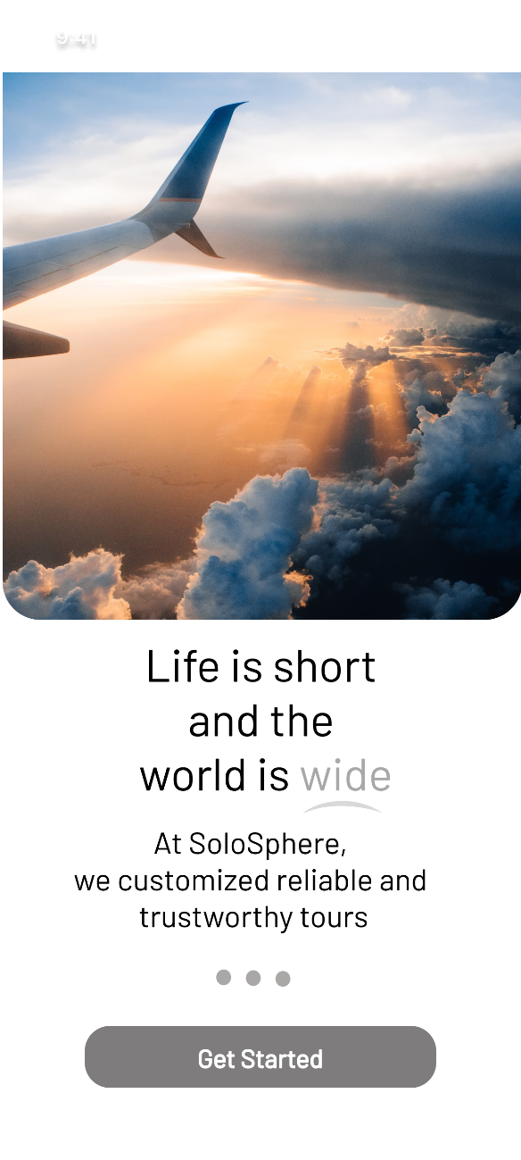 텍스트, 스크린샷, 소프트웨어, 멀티미디어 소프트웨어이(가) 표시된 사진

AI가 생성한 콘텐츠는 부정확할 수 있습니다.

Figure 1. Welcome Screen Figure 2. Main Screen

텍스트, 스크린샷, 소프트웨어, 멀티미디어이(가) 표시된 사진

AI가 생성한 콘텐츠는 부정확할 수 있습니다. 텍스트, 스크린샷, 소프트웨어, 운영 체제이(가) 표시된 사진

AI가 생성한 콘텐츠는 부정확할 수 있습니다.

Figure 3. Buddy Info Screen Figure 4. Buddies Screen

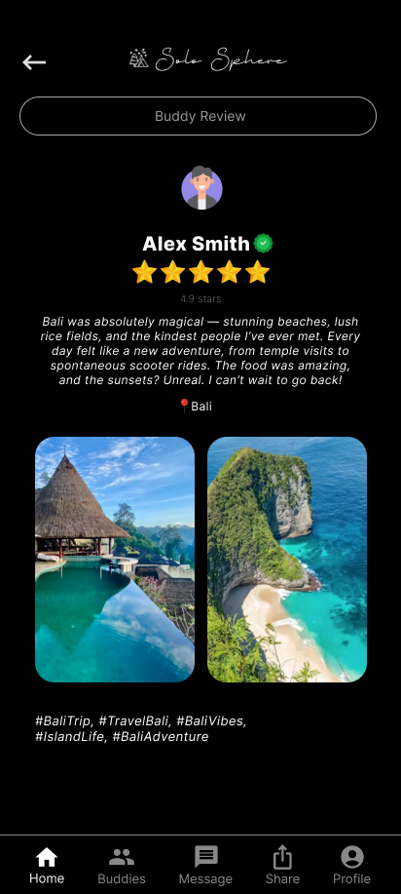 스크린샷, 텍스트, 하늘, 멀티미디어 소프트웨어이(가) 표시된 사진

AI가 생성한 콘텐츠는 부정확할 수 있습니다.

Figure 5. Buddy Review Screen Figure 6. Share Screen

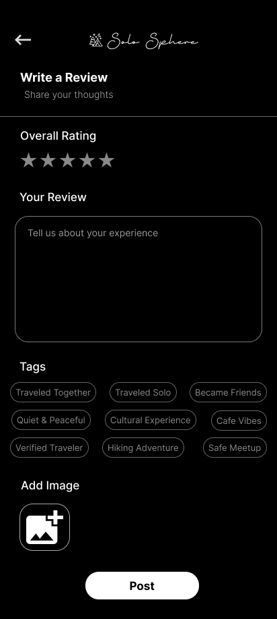 텍스트, 스크린샷, 폰트, 디자인이(가) 표시된 사진

AI가 생성한 콘텐츠는 부정확할 수 있습니다.

Figure 7. Add Review Screen Figure 8. SOS Screen

텍스트, 스크린샷, 멀티미디어, 소프트웨어이(가) 표시된 사진

AI가 생성한 콘텐츠는 부정확할 수 있습니다. 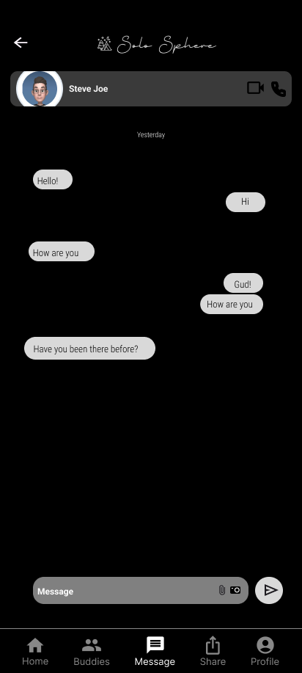

Figure 9. Message Screen Figure 10. Chat Screen

**Designer-Based Prototype Evaluation**

* To illustrate the typical journey of a SoloSphere user, we identified a 7-step process representing how a solo traveler engages with the app from onboarding to community interaction. Below is a structured version of the journey in text form
  + Step 1: Onboarding / Login: The user installs the app, signs up, and is introduced to key features through a short onboarding tutorial
  + Step 2: Profile Setup: The user enters personal travel preferences, styles, and destination interests. These inputs power the AI-based companion matching system
  + Step 3: Find Buddies: The user views companion suggestions via card-based and carousel UI components and reviews profiles to identify matches
  + Step 4: Chat & Plan: Once matched, the user starts a conversation and begins planning trips collaboratively using built-in tools
  + Step 5: Safety Tools: Before or during travel, the user activates safety features such as live location sharing, emergency contacts, and SOS
  + Step 6: Share Reviews: The user uploads travel experiences, shares trip reviews, and connects with others in the community through posts or comments

**User-based Prototype Evaluation**

* Purpose and Objectives
  + Evaluate user ability to navigate the prototype effectively
  + Assess ease of completing key tasks such as profile creation, companion matching, and user safety features
  + Gauge user perceptions of safety features including the SOS button and real-time location sharing
  + Collect user satisfaction feedback on visual design, interaction flow, and feature usefulness
  + Identify potential areas of confusion or design friction for new users
  + Determine which features are most valuable and where improvements are needed
* Choice of User Study and Sample
  + Methodology: Online usability survey conducted after interacting with a high-fidelity Figma prototype
  + Sample Size: 6 participants aged 20–40
  + Target audience
    - Primary Users
      * Young solo travelers (late teens to early 30s) who actively engage in solo travel for adventure, self-exploration, or flexibility
      * Married travelers in their 30s-40s who aspire to travel alone but face challenges due to family responsibilities
  + Dual Perspective Approach
    - The survey was conducted among both active solo travelers and individuals who want to travel alone but find it difficult
    - By considering both groups, we can identify what solo travelers truly need and how the app can support them
* Draft of user study survey
  + The user study survey consists of 10 questions categorized into the following sections
    - General Background: Solo travel experience, familiarity with companion apps
    - Task-Specific Evaluation: Profile creation, travel companion matching, emergency features, trip planning, and navigation
    - UI/UX Feedback: Visual satisfaction, confusion or frustration points
    - Feature Value & Suggestions: Most useful features and user improvement ideas
  + These categories help evaluate user interaction with the prototype and identify usability and design improvement opportunities
  + See Appendix B for the full survey details
* Data Visualization & Analysis
  + Sample Size: 6 participants
  + Data visualization & Analysis
    - General Information
      * Most participants (66.7%) have traveled solo before

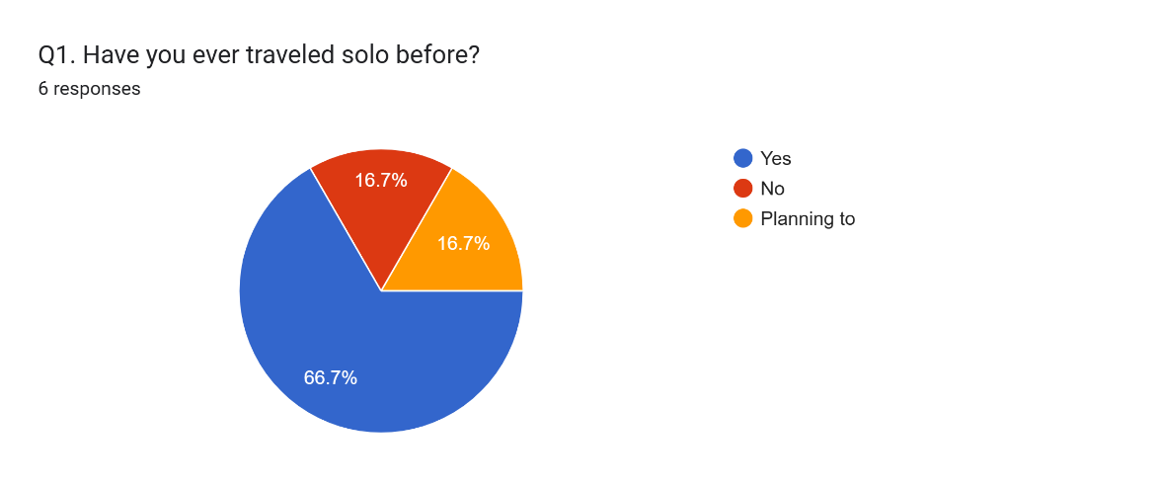

* + - * Most users (66.7%) are only somewhat familiar with travel companion apps, indicating a need for clear onboarding

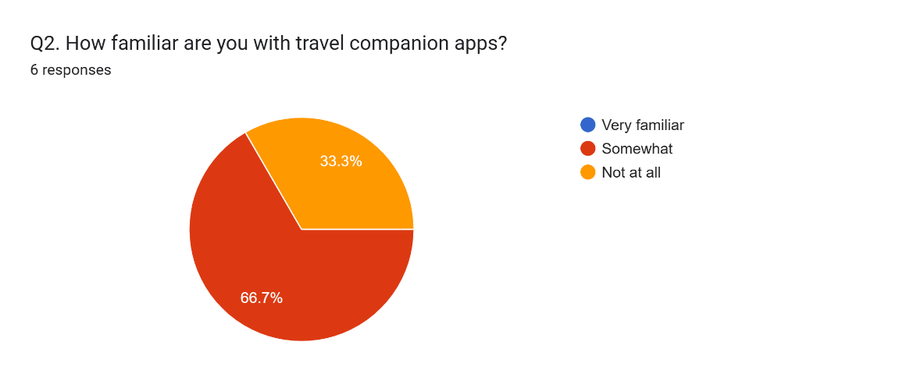

* + - * Responses were evenly split, suggesting mixed experiences with profile creation and room for improving clarity

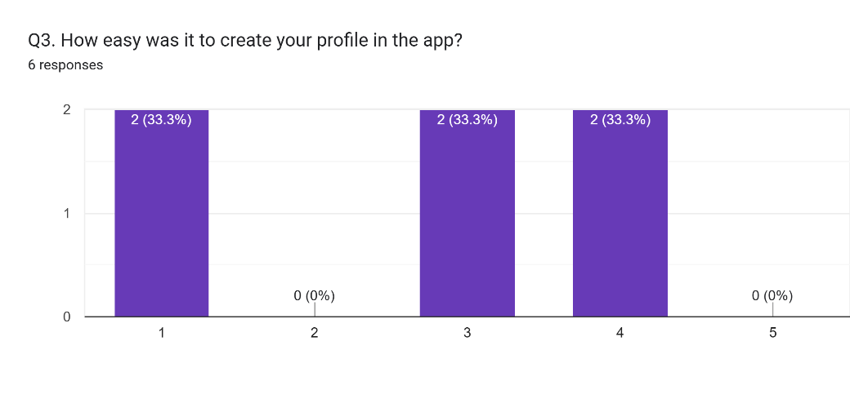

* + - * Half of the users found a suitable companion, but 33.3% didn’t

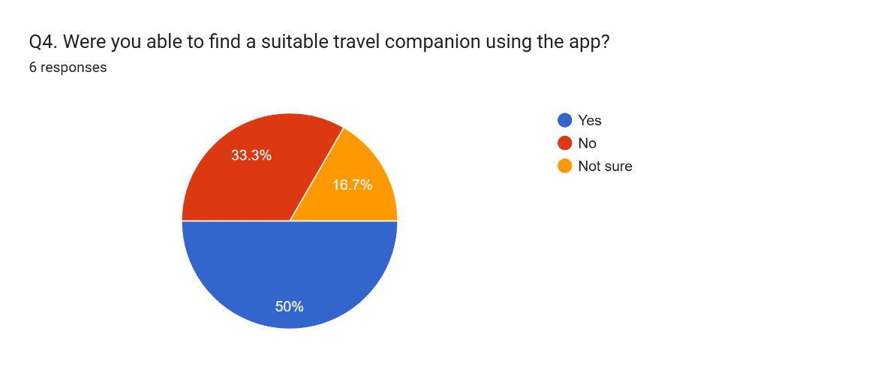

* + - * All users (100%) found the SOS button easy to locate and understand, confirming effective UI placement for safety features

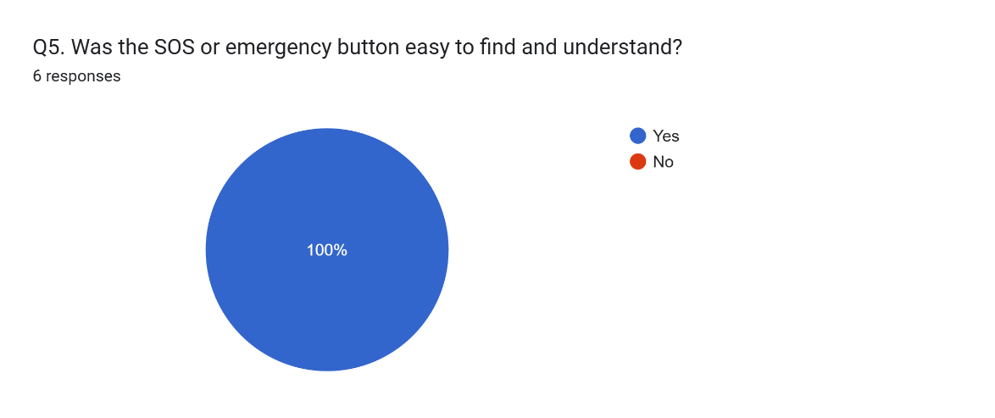

* + - * Most users rated navigation as Good or Excellent, indicating a generally positive experience with the app’s layout

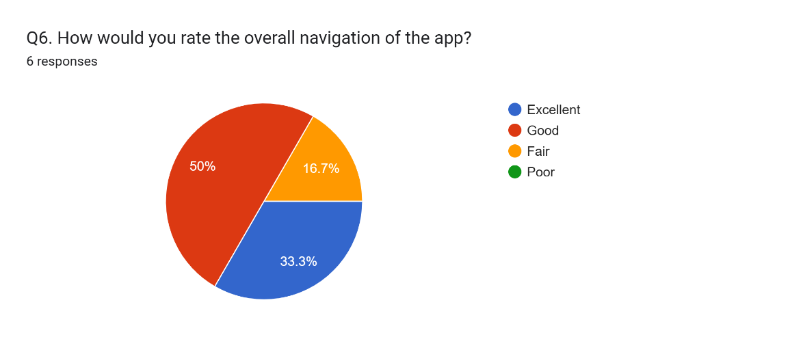

* + - * Two-thirds of users were satisfied or very satisfied with the visual design, though a small portion felt neutral or dissatisfied

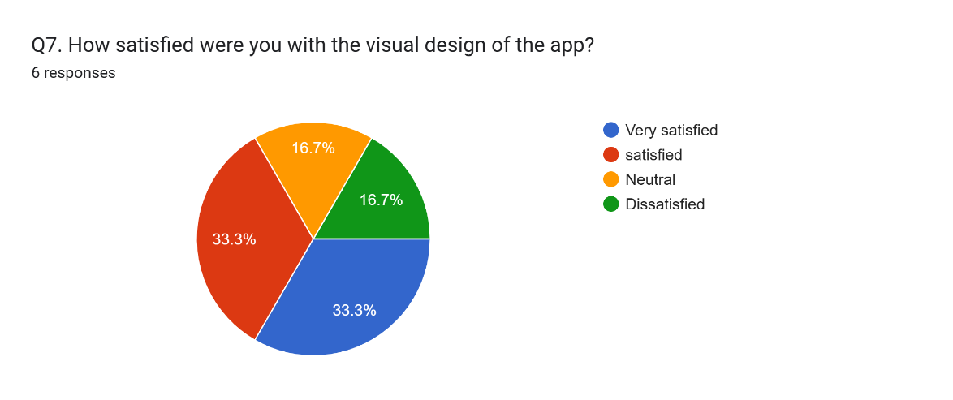

* Insights from the Results
  + The user evaluation of the SoloSphere prototype provided several key insights
    - User familiarity with travel companion apps is limited, with most users only somewhat aware of such platforms. This highlights the need for an intuitive onboarding experience
    - The profile creation process received mixed feedback, suggesting room for improvement in clarity and guidance
    - 50% of users were able to find a suitable travel companion, but 33.3% did not, indicating that the matching algorithm or explanation of results may need refinement
    - All participants (100%) easily located and understood the SOS/emergency feature, demonstrating successful design in safety-related UI elements
    - Most users rated the app’s navigation as Good or Excellent, confirming the effectiveness of the overall layout and screen flow
    - Visual design feedback was mostly positive, though a few participants expressed neutral or dissatisfied opinions, pointing to areas where aesthetics or clarity could be enhanced
    - The trip planning feature was appreciated but lacked guidance, such as tutorials or sample templates, making it harder for users to get started without prior knowledge

**Changes to the design based on Prototype Evaluation**

* Changes Needed
  + Implement a short onboarding tutorial that introduces key features, especially for first-time users unfamiliar with travel companion apps
  + Enhance visibility and guidance for the trip planning section, including templates or prompts to help users begin planning quickly
  + Add descriptive explanations or visual cues within the companion matching process to help users better understand match results
* Changes Implemented
  + Based on feedback, the UI elements related to safety features were reviewed and maintained as-is due to high user satisfaction

**Conclusion**

* SoloSphere transforms the solo travel experience by balancing connection and safety through well-integrated features. The user-centered design process—grounded in surveys, personas, and user testing—enabled us to build a prototype that feels purposeful, intuitive, and scalable. By combining community elements, real-time tools, and thoughtful interaction patterns, SoloSphere stands out as an empowering companion for modern solo travelers.

**References**

* Travel Buddy: <https://beatravelbuddy.com/>
* Couchsurfing Travel: <https://www.couchsurfing.com/>
* Meetup: <https://www.meetup.com/>
* Tinder: <https://www.dating.com/>
* Airbnb: <https://www.airbnb.ca/>
* Instagram: <https://www.instagram.com/>

**Work Date/Hours Logs**

* **Avneet Kaur**

|  |  |  |
| --- | --- | --- |
| **Date** | **Number of Hours** | **Description of work done** |
| Jan 25, 2025 | 2 | Searching for project ideas and finalizing |
| Jan 30, 2025 | 1 | An idea confirmation meeting |
| Jan 31, 2025 | 1.5 | Review GitHub repo |
| Feb 4, 2025 | 2 | Tried making changes to the README document, but I wasn’t able to. Then asked Dan for help |
| Feb 5, 2025 | 1 | Finalize proposal document |
| Feb 8, 2025 | 2.5 | Created a Figma account and completed an introductory exercise to understand the interface |
| Feb 12, 2025 | 4 | Designed a simple mobile app login screen in Figma to explore features like frames, text tools, and prototyping. |
| Feb 16, 2025 | 1.5 | Watched the "UserStudy_RequirementGathering" video and reviewed the accompanying slides |
| Mar 2, 2025 | 1 | Discuss with group members to decide whether to go with survey or interview, and we decided to take surveys of users |
| Mar 5, 2025 | 3 | Brainstormed different survey questions individually and then analyzed and finalized the questionnaire |
| Mar 6, 2025 | 1 | Talked to a few users and sent them the Google Form survey for responses. |
| Mar 11, 2025 | 0.5 | Review draft requirement gathering document |
| Mar 11, 2025 | 2 | Developed personas and scenarios for requirement generation |
| Mar 12, 2025 | 3 | Convert scenario into storyboard |
| Mar 15, 2025 | 3 | Conduct requirement generation based on personas and review team-created requirement generations |
| Mar 22, 2025 | 0.5 | Check the introduction document in the project details section on Blackboard to review updates and set personal deadlines to ensure I don't miss any submissions. |
| Mar 22, 2025 | 1 | Create a Logo for the app |
| Mar 23, 2025 | 3 | Create a profile screen |
| Mar 28, 2025 | 2 | Develop a login page and complete the profile screen. |
| Apr 02, 2025 | 4 | Develop a message and chat screen for users to connect with each other |
| Apr 05,2025 | 1.5 | Review the draft of the final report and discuss necessary revisions. |
| Apr 06,2025 | 1 | Distribute a user prototype evaluation survey and collect feedback. |

* **Dan Do**

|  |  |  |
| --- | --- | --- |
| **Date** | **Number of Hours** | **Description of work done** |
| Jan 24, 2025 | 3 | Project Idea Initiative |
| Jan 30, 2025 | 1 | An idea confirmation meeting |
| Jan 30, 2025 | 2 | Create GitHub repo |
| Jan 30, 2025 | 0.5 | Update README file |
| Feb 1, 2025 | 6 | Write Project Proposal draft version |
| Feb 5, 2025 | 1 | Finalize proposal document |
| Feb 18, 2025 | 2 | Explored Figma features, including design tools, prototyping, and collaboration functionalities |
| Feb 20, 2025 | 1 | Downloaded and explored apps such as TravelBuddy, Meetup, Tinder, and Couchsurfing to analyze their features and functionalities relevant to Solo Sphere |
| Feb 21, 2025 | 2 | Reviewed a Requirements Gathering video to ensure a clear understanding of the requirements gathering process |
| Mar 1, 2025 | 1 | Brainstormed ideas for requirements gathering |
| Mar 2, 2025 | 1 | Collaborated with team members to refine the survey structure, determine appropriate question formats (MCQs, rating scales, open-ended), and identify the best approach for gathering meaningful user feedback |
| Mar 5, 2025 | 3 | Collaboratively reviewed the survey questions proposed by each team member, eliminated duplicates, and categorized them based on key themes |
| Mar 6, 2025 | 3 | Created the survey form using Google Forms based on the finalized questions and distributed it to the target user group |
| Mar 10, 2025 | 2 | Developed personas and scenarios for requirements generation |
| Mar 11, 2025 | 3 | Drafted the initial requirements gathering document based on survey results |
| Mar 12, 2025 | 3 | Reviewed team-created personas and scenarios to prepare for requirements generation |
| Mar 13, 2025 | 3 | Conducted requirements generation based on three finalized personas and scenarios |
| Mar 14, 2025 | 2 | Created a Figma project and started building the prototype |
| Mar 16, 2025 | 2 | Finalized the requirements document, ensuring completeness and consistency |
| Mar 19, 2025 | 3 | Created seven core pages in Figma as the foundation for the prototype |
| Mar 20, 2025 | 1 | Assigned team members to different prototype pages based on a team meeting discussion |
| Mar 23, 2025 | 2 | Designed the official app logo to be incorporated into the prototype |
| Mar 27, 2025 | 4 | Developed the Share page, the review submission page, and the SOS page for emergency situations |
| Apr 3, 2025 | 2 | Drafted the Final Report |
| Apr 5, 2025 | 3 | Added app design screenshots and the Designer-based prototype evaluation section to the final report |
| Apr 6, 2025 | 3 | Created survey questions for the user-based prototype evaluation and conducted the survey using Google Forms |
| Apr 7, 2025 | 4 | Drafted the User-based prototype evaluation section based on survey results and completed the first full version of the final report |
| Apr 7, 2025 | 1 | Applied screen transition animations and implemented a consistent UI design across all prototype pages |

* **Shubham Shubham**

|  |  |  |
| --- | --- | --- |
| **Date** | **Number of Hours** | **Description of work done** |
| Jan 30, 2025 | 1 | An idea confirmation meeting |
| Feb 2, 2025 | 1.5 | Refined background research, expanded competitor analysis |
| Feb 3, 2025 | 1.5 | Improved "Technologies Needed" section, added Figma |
| Feb 3, 2025 | 0.5 | Enhanced value proposition and preliminary features list |
| Feb 3, 2025 | 0.5 | Formatting of Word Document |
| Feb 5, 2025 | 1 | Finalize proposal document |
| Feb 9, 2025 | 2 | Exploring Figma and its features (  wireframing, prototyping) |
| Feb 12, 2025 | 2.5 | Trying a small demo on Figma |
| Feb 16, 2025 | 2 | Reviewed the **Requirement Gathering** video and analyzed the key tasks needed for the survey. Identified best practices for designing effective surveys. |
| March 2, 2025 | 1 | Discussed with team members about the survey structure, types of questions to include (MCQs, rating scales, open-ended), and the best way to collect relevant user feedback. |
| March 3, 2025 | 3 | Created an independent set of questions to ensure coverage of all aspects of solo travel. Cross-checked against team inputs for completeness. |
| March 5, 2025 | 1.5 | Filtered and refined survey questions by removing duplicates, selecting the best ones, and ensuring clarity and logical flow. |
| March 5, 2025 | 1 | Continuing practicing Figma components (UI design principles) |
| March 7, 2025 | 1 | Monitored survey responses, collected initial data |
| March 9, 2025 | 2 | Drafted persona and Scenario for the requirement generation task |
| March 11, 2025 | 2 | Practicing the UI from different Mobile UI template from Figma resources |
| March 14, 2025 | 1.5 | Drafting the requirement generation from other member’s Persona and Scenario |
| March 16, 2025 | 0.5 | Started working on the App that is thinking of the style and color combinations |
| March 17, 2025 | 2 | Added First page that is Welcome Screen |
| March 19, 2025 | 0.5 | Divided the work among Team members |
| March 22, 2025 | 0.5 | Started the Buddy screen |
| March 28, 2025 | 4.5 | Tried to implement Carousal and faced difficulties with different card layout and dragging after trying, was able to make it happen. |
| March 29, 2025 | 3 | Worked on the Buddy Screen and finished with implementing all its contents  Also made review carousal and travel tip section in Main screen |
| March 31, 2025 | 0.5 | Added animations to the pages |
| April 03, 2025 | 4 | Worked on the 3 Screens (Buddy, Review and Info), I messed up the Buddy Screen so that took time to make it right |
| April 07, 2025 | 1 | Reviewed user evaluation survey and gathered its results. |

**Appendix A**

* SoloSphere User Survey
  + Thank you for participating in this survey! This survey aims to understand solo travelers' needs and preferences to design a better travel companion app.
  + Estimated time to complete: 10 minutes
    - Demographics - 3 Questions
      * Q1. What is your age group?
        + 18-24
        + 25-34

35-44

* + - * + 45-54
        + 55+
      * Q2. Where are you currently residing?
        + North America
        + Europe
        + Asia
        + South America
        + Africa
        + Australia
      * Q3. What is your gender?
        + Male
        + Female
        + Non-binary / Prefer not to say
    - Travel Behavior - 5 Questions
      * Q4. What is your preferred solo travel duration?
        + Weekend trips (1-3 days)
        + Short trips (4-7 days)
        + Medium trips (1-2 weeks)
        + Extended trips (more than 2 weeks)
      * Q5. How often do you travel solo?
        + Never
        + Once a year
        + 2-3 times a year
        + More than 3 times a year
      * Q6. What is your preferred style of solo travel? (Select all that apply)
        + Backpacking
        + Luxury travel
        + Business travel
        + Adventure travel (hiking, diving, extreme sports)
        + Cultural & city exploration
        + Digital nomad lifestyle
        + Other (please specify) _______
      * Q7. Why do you choose to travel alone? (Select all that apply)
        + Freedom to explore at my own pace
        + Opportunity to meet new people
        + Personal growth and self-discovery
        + Work or business-related travel
        + Couldn’t find travel partners
        + Other (please specify) _______
      * Q8. How do you currently find travel companions when traveling solo? (Select all that apply)
        + Friends
        + Social media
        + Travel companion apps/websites
        + I usually prefer to travel alone
        + Other (please specify) _______
    - Challenges & Preferences - 5 Questions
      * Q9. What are the biggest challenges of traveling alone? (Select all that apply)
        + Safety concerns
        + Difficulty meeting new people
        + Planning and organizing trips alone
        + Language barriers
        + Feeling lonely
        + High travel costs
        + Other (please specify) _______
      * Q10. When meeting potential travel companions, what compatibility factors matter most to you?
        + Similar interests and activities
        + Compatible travel pace and style
        + Shared budget expectations
        + Personality match
        + Language compatibility
      * Q11. What travel style best describes you?
        + Adventure seeker
        + Cultural explorer
        + Relaxation focused
        + Budget traveler
        + Luxury traveler
      * Q12. How important is having a shared travel itinerary feature in the app?
        + Not important
        + Somewhat important
        + Important
        + Very important
      * Q13. Would you be interested in location-based notifications about other solo travelers nearby?
        + Yes, always
        + Yes, but only after I approve them
        + Only in specific situations
        + No, I prefer to initiate all connections
    - Safety & Security - 5 Questions
      * Q14. What features do you look for in a travel app? (Select all that apply)
        + Navigation
        + Trip planning
        + Social networking
        + Safety features
        + Other (please specify) _______
      * Q15. Would you feel more secure and safe if the app had real-time location sharing with trusted contacts?
        + Yes
        + No
      * Q16. What is your biggest concern about using technology to meet travel companions?
        + Privacy of my personal data
        + Authenticity of other users
        + Ability to disconnect if needed
        + Technical reliability while traveling
        + Other (please specify) _______
      * Q17. How would you prefer to verify another traveler's identity?
        + Government ID verification
        + Social media profile linking
        + Video call verification
        + References from other travelers
        + Professional/educational verification
      * Q18. What type of emergency assistance would be most valuable to you in a solo travel app? (Select all that apply)
        + One-touch emergency contact alert
        + Local emergency services information
        + Community help network
        + Travel insurance integration
    - Social & Community Features - 4 Questions
      * Q19. What features would make you more likely to use a solo travel app?
        + Trip matching
        + Group meet-ups
        + Emergency alerts
        + Verified traveler profiles
        + Other (please specify) _______
      * Q20. How would you like to share your travel experiences within the app? (Select all that apply)
        + Photo galleries
        + Written travel journals
        + Short video clips
        + Interactive maps of places visited
        + I prefer not to share my experiences
      * Q21. How do you usually meet new people while traveling? (Select all that apply)
        + Join travel meet-up events
        + Use travel companion apps or websites
        + Stay in hostels / shared accommodations
        + Engage with locals through cultural experiences
        + Social media or online communities
        + I usually prefer to travel alone
      * Q22. How would you prefer to interact with other travelers through an app?
        + Private one-on-one chat
        + Public community forums / social feed
        + Group chat based on location or travel plans
        + Organized group meet-ups
        + I am not interested in connecting with other travelers
    - Technology & App Features - 3 Questions
      * Q23. Which travel-related apps do you currently use? (Select all that apply)
        + Google Maps
        + Airbnb
        + Couchsurfing
        + Meetup
        + Tinder
        + None of the above
        + Other (please specify) _______
      * Q24. If an app like SoloSphere existed, would you consider using it?
        + Yes
        + No
        + Not Sure
      * Q25. Do you have any additional comments or suggestions for SoloSphere? (Optional)
        + "What additional features would you like to see in a solo travel app like SoloSphere? Do you have any concerns, suggestions, or ideas to improve the app? Feel free to share your thoughts!"

**Appendix B**

* User-based Prototype Evaluation Survey
  + General Information
    - Q1. Have you ever traveled solo before?
      * Yes
      * No
      * Planning to
    - Q2. How familiar are you with travel companion apps?
      * Very familiar
      * Somewhat
      * Not at all
  + Task Feedback
    - Q3. How easy was it to create your profile in the app?
      * Very easy
      * Easy
      * Neutral
      * Difficult
      * Very difficult
    - Q4. Were you able to find a suitable travel companion using the app?
      * Yes
      * No
      * Not sure
    - Q5. Was the SOS or emergency button easy to find and understand?
      * Yes
      * No
    - Q6. How would you rate the overall navigation of the app?
      * Excellent
      * Good
      * Fair
      * Poor
  + UI/UX Evaluation
    - Q7. How satisfied were you with the visual design of the app?
      * Very satisfied
      * Satisfied
      * Neutral
      * Dissatisfied
    - Q8. Did you experience any confusion or frustration while using the app?
      * Yes (please specify): ____________
      * No
  + Feature Value & Suggestions
    - Q9. Which feature did you find most useful?
    - Q10. What would you improve or change in the app?