Crop Analysis Q3 2013
John Smith
May 3rd, 2014
x <- 1:50
plot(x, sin(x))
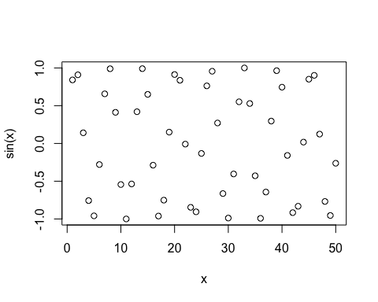
plot(x, sin(x), typ="l", col="purple", lwd=5)
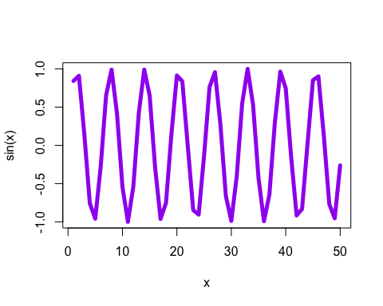
log(10, base=10)
## [1] 1

