KLogNG
Station profiles and what comes after
A proposal for KLog, in two stages
Arnis, YL3GBC
30 August 2026
github.com/yl3gbc/klog

1. Why I started this
Hello Jaime,
I have been using KLog for a while and I like how it is built. This document describes work I have done on top of it, why I started, and where I think it could go. Two pull requests are already open (#1134 and #1135); the rest is running locally and I can submit it in whatever shape suits you.
I should say up front that I am also one of the main developers of CQRLOG. That is not a conflict — it is the reason some of the ideas here look familiar. I have spent years watching what operators actually ask for in a logbook, and a few of those things are missing from every logger I know, including the two I work on.

The problem I hit first
I run three callsigns: YL3GBC, YL3AUG and YL3ARH. Each has its own locator, QSL address, equipment and LoTW certificate. KLog already stores several logs internally through the lognumber column, so the data model was almost there. But in daily use, switching between them meant opening Setup and retyping the station data every single time — and forgetting one field meant QSOs landed in the wrong log with the wrong grid.
That happened to me. Twice in one evening, while testing. It is the kind of mistake that is invisible until you try to upload to LoTW six months later.
The data model supported several logs. The workflow did not. That gap is what this work closes.

2. Stage one — what is running today
Everything in this section runs on a live log: 20,200 QSOs across three callsigns, used daily with JTDX over UDP, with uploads to LoTW and Club Log.

2.1 Station profiles
Each log becomes a full station profile. On startup a dialog lists the profiles with their QSO counts; choosing one switches the log and the whole station configuration in a single step. A checkbox opens the last profile directly for operators who only use one.
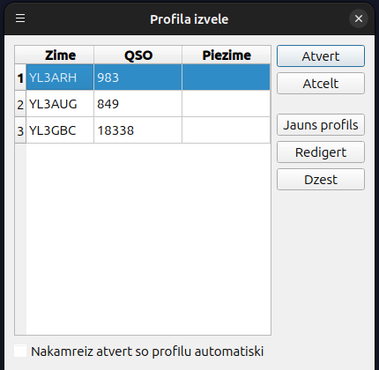
Figure 1 — Profile selection at startup
(The screenshots are in Latvian because that is my working language. All strings are English in the source and go through the normal .ts translation route.)
The profile editor groups the data into tabs: Station, Address, Equipment and Clubs. These are the same fields KLog already uses in Setup, so nothing is duplicated — what is typed here ends up in the KLog configuration.
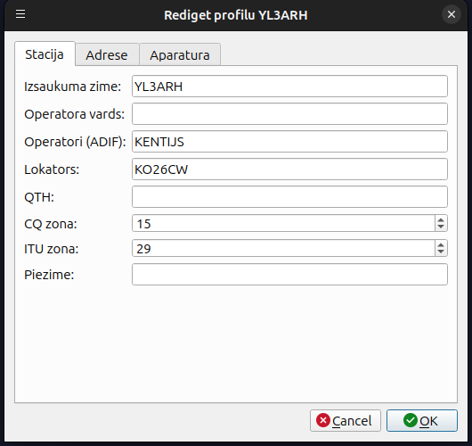
Figure 2 — Station data. Zones fill in by themselves
CQ and ITU zones and the DXCC entity are derived from the callsign prefix using the World class that already exists in KLog. Only empty fields are filled, so a value entered by hand is never overwritten. The /MM and /AM suffixes are deliberately excluded: a maritime or aeronautical mobile station belongs to no DXCC entity, and its locator changes constantly.
This is particularly useful for expeditions — creating an EA8/YL3GBC profile fills in the zones and entity from EA8 with no operator input.

2.2 One configuration file per profile
This was the second thing I built, and it came out of a bug I created myself. eLog credentials in KLog live in one global configuration: change the QRZ.com user while YL3ARH is open, and YL3AUG gets it too. I only noticed after uploads started failing.
Rather than move the eLog fields into the profile one by one, each profile now keeps its own configuration file:
~/.klogng/profiles/<CALLSIGN>/klogrc
Nothing is shared. LoTW, QRZ.com, eQSL and Club Log credentials belong to the callsign, and so does everything else — including settings neither of us has thought of yet. That is the point: the isolation holds by construction, not because someone remembered to add a field.

2.3 New QSOs
Profile assignment for new QSOs happens through an SQLite trigger rather than application code:
CREATE TRIGGER trg_log_profile AFTER INSERT ON log
WHEN NEW.profile_id IS NULL BEGIN ... END
That way manual entry, ADIF import and QSOs arriving over UDP from WSJT-X or JTDX all behave identically, without touching a single existing code path. It also means the assignment cannot be bypassed by a route we forgot about.

2.4 Propagation tools
Two small additions that turned out to matter more than I expected in daily operating.
A grayline map, available as a tab next to Info/Awards/Search and as a dockable panel that can be moved to a second monitor. The terminator is computed per pixel — the solar elevation is evaluated for each point rather than fitting a single curve — so it is correct in every season, including near the solstices where the simpler formula inverts. It redraws every ten seconds and shows the subsolar point.
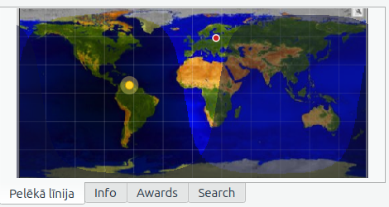
Figure 3 — Grayline map with terminator and subsolar point
When a correspondent is entered, a line is drawn from your station to theirs. If they give a locator it is used directly; if not, the DXCC entity coordinates are used instead, so the line still appears for the great majority of contacts.
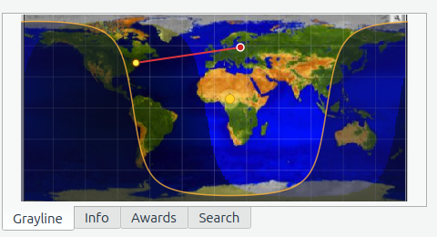
Figure 4 — Line to the current correspondent (KO26CW to FN32)
And solar indicators in the status bar: solar flux, A and K index, fetched hourly from hamqsl.com. Small, unobtrusive, and exactly what you want to glance at before deciding whether 40m is worth the effort tonight.
Figure 5 — Solar indicators in the status bar

2.5 Band panel
A small fix with a large effect once profiles exist: the band panel now shows the bands configured for the active profile instead of a fixed list of twelve. I noticed the commented-out longer list in dxccstatuswidget.cpp, so I suspect this was already on your mind.
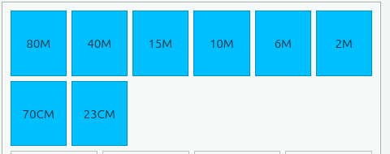
Figure 6 — Only the bands this station actually works

2.6 Guard against operator error
When a QSO arrives over UDP, its station callsign and locator are compared with the active profile. If they differ, a warning appears. This exists because I kept making the mistake myself: switching profiles in KLog while JTDX still had the previous callsign configured. The comparison is case-insensitive, since JTDX writes KO26cw and KLog writes KO26CW for the same square.

3. How it is built
The modification is deliberately non-invasive. I assumed from the start that you would want to read the diff, not take it on faith.

Item | Detail
New files | profilemanager.{h,cpp}, startprofiledialog.{h,cpp}, graylinewidget.{h,cpp}, solarindicator.{h,cpp}
New tables | profiles, profile_variants, profile_clubs
Added columns | log.profile_id, log.variant_id
main.cpp | 11 lines: create the manager, call the dialog, check the result
CMakeLists.txt | 2 lines
Migration | Automatic from the logs table on first run, idempotent

Existing data is preserved intact: the migration reads the logs table, creates one profile per base callsign and links each QSO through its lognumber. A callsign with a suffix such as YL3GBC/P does not become a separate profile but a variant of the base profile, because awards and DXCC count it as the same station. That distinction is stored in profile_variants and matters later, for the club module.
Pull request #1135 contains only the profile core: six files, 1,165 lines, additions only, and it builds cleanly against master without any of the rest.

4. Things I found along the way
Working through 20,000 QSOs turned up six issues. Each has a reproducible case; I am listing them here rather than opening six issues at once, so you can decide which are worth reporting properly.

Issue | Detail
Duplicate window ignores mode | The 600 s default discards genuine FT4/FT8 contacts made minutes apart with the same station. Example: ON4KBU, 2025-04-03, 14:58 and 15:01, 15m FT4 — the second is dropped. Digital modes need a shorter window (30-60 s) than SSB/CW.
Callsign validator too strict | 4JT3DJ (Azerbaijan, listed on QRZ with 35,192 lookups) is refused silently, both on ADIF import and manual entry. No error, the QSO simply does not appear.
Locator comparison case-sensitive | getStringQueryMyGrid() compares my_gridsquare literally, so KO26cw (the Maidenhead and JTDX form) and KO26CW count as different squares and QSOs drop out of the export filter. Fixed in my fork with UPPER() on both sides.
Empty LatestBackup crashes | FileManager::getDateTimeOfLastBackup() segfaults when the value is empty, taking the application down a few seconds after startup via recommendBackupIfNeeded(). This affects every new user who has not yet made a backup.
Dialogs show parent mode | The LoTW and ADIF export dialogs join on log.modeid, so every FT4 and FT8 QSO shows as MFSK, even though the log view itself was fixed. This is PR #1134.
FT8 exported without submode | ADIF export writes MODE=FT8 with no submode, where the standard expects MODE=MFSK SUBMODE=FT8. FT4 is written correctly. LoTW and Club Log both accept it, so this is cosmetic — but it is inconsistent.

5. Stage two — where this is heading
Everything above is finished and tested. What follows is designed but not built, and I am describing it because the shape of stage one was chosen with stage two in mind. If you dislike the direction, better to say so now.

5.1 Club membership
Club numbers are one of the most requested logbook features and one of the worst served. The CQRLOG membership format has become a de facto standard: around 120 club files maintained by volunteers, one file per club, plain text, callsign and member number.
The problem is upstream of the format. Clubs publish their official rosters as PDF, Excel, HTML tables, sometimes scanned images. Someone has to turn each of those into the standard format, by hand, every time the roster changes. That is why many club files are years out of date.
What I want to build is a pipeline: one recipe per club describing where its roster lives and how to read it, then a single shared path — normalise, validate, compare against the current file, add what is new, upload. The recipe is data, not code, so adding a club means writing a few lines, not patching the program.
There is a subtlety worth knowing about, because it catches everyone: the member number belongs to the operator, not the callsign. EU1EU, LY/EU1EU and YL/EU1EU are all member number 1. And when an operator changes callsign, the number follows: EW3LB and UC2LB are both number 8. This is why the profile_variants table exists in stage one — the distinction between a base callsign and its variants has to be in the data model before the club lookup can be correct.

5.2 Award engine
Every logger hard-codes DXCC and WAS, and then someone asks for a national award with slightly different rules and it cannot be done without a code change.
The alternative is to treat an award as three pieces of data: a list of targets, a rule for matching a QSO to a target, and a condition for when a target counts as confirmed. Written as YAML or JSON, DXCC and WAS become built-in definitions rather than special cases, and a club secretary can add a new award by writing a file. Progress in the main window, application generation, submission tracking — all of it then works for any award, not just the two we anticipated.

5.3 More propagation
The grayline map is a foundation, not a finished feature. Cluster spots on the map, a historical view with filters by band and period, and moon position with azimuth and elevation for EME operators on VHF and above. The last one has a real audience that no mainstream logger serves well.

6. The database question
This is the part I most want your opinion on, because it is the one decision that cannot be quietly reversed later.
SQLite is the right choice for what KLog does today: log a QSO, look one up, export a file. It is fast, it is everywhere, and it has never lost me a QSO.
It is the wrong choice for what I want stage two to do. Award progress across 20,000 QSOs, filtered by band and mode and period, recomputed while the operator watches — that is an analytical query, and row-oriented storage makes it slow enough to be annoying. Right now KLog avoids the problem by not offering those views. I would rather make them possible.
DuckDB is built for exactly this shape of work: columnar, embedded, no server, a single file, and an SQL dialect close enough to SQLite that most queries port unchanged. On a log of this size the difference on aggregate queries is roughly two orders of magnitude.

How I would do it, if you were open to it
- The schema and migration scripts are already written and tested against my log — this is not speculation.
- ADIF export as a safety net from day one: whatever happens to the database, the QSOs can always be recovered.
- All writes through a single database layer, so the storage engine is one substitution rather than a thousand.
- The sqlite_scanner extension built in statically, since development builds cannot always reach the extension server.
- Both engines behind the same interface during the transition, so a user who prefers SQLite keeps it.
I am not proposing this for KLog tomorrow. I am proposing it as the direction, so that stage one is built in a way that does not block it — which is why every write in my fork already goes through the data proxy rather than touching SQL directly.

7. One more thing
There are a couple of ideas I am keeping quiet about until they work, because describing an unbuilt feature is how projects acquire promises they cannot keep. What I will say is that they came from the same place as everything else here: watching what operators do, noticing where the logbook makes them do it twice, and asking why the program cannot do it for them.
One of them involves the club data above being useful for something other than filling in a field. Another involves the map. If either works out, you will see a pull request rather than a paragraph.

8. How I would like to proceed
I would rather ask than assume, so:
- Does turning logs into station profiles seem a reasonable approach to you? It touches the data model, and I would rather not build stage two on a foundation you dislike.
- Should the selection dialog be optional rather than always shown at startup? It already has a "remember my choice" checkbox, but the default could go either way.
- Do you want the rest as separate pull requests — grayline and solar, band panel, per-profile configuration — or does one larger one suit you better?
- Is the direction in sections 5 and 6 something you want in KLog at all, or does it belong in a separate project?
Whatever you decide, the code is available and I am happy to reshape, split or drop any part of it:
Repository: https://github.com/yl3gbc/klog/tree/klogng-main
Profiles PR: https://github.com/ea4k/klog/pull/1135
Submode fix: https://github.com/ea4k/klog/pull/1134
One practical note: all new dialog strings are in English in the source and already translated to Latvian through the normal .ts route, so nothing here blocks translators. A friend from Georgia starts on klog_ka.ts in September.

Thank you for KLog, and for the work you have put into it over the years.

73,
Arnis, YL3GBC

A Spanish version of this document is available on request.

