SQLyog连接mysql出现错误时
ALTER USER 'root'@'localhost' IDENTIFIED WITH mysql_native_password BY 'password';（引号里的password是自己设置的root密码）
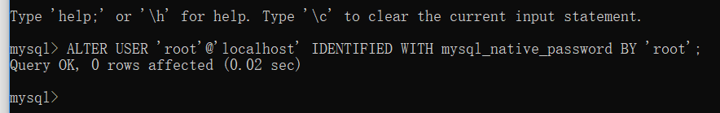

python manage.py runserver 0.0.0.0:80
python manage.py startapp myapp
python manage.py makemigrations myapp
python manage.py migrate
python manage.py createsuperuser

python manage.py shell
id自增长
ALTER TABLE common1_teachers AUTO_INCREMENT=0;

