Yunlu Li

STAT 5170

Homework 2

2. The left plot is the ACF plot for 10000 observations, and the right plot is the ACF plot for 200 observations.

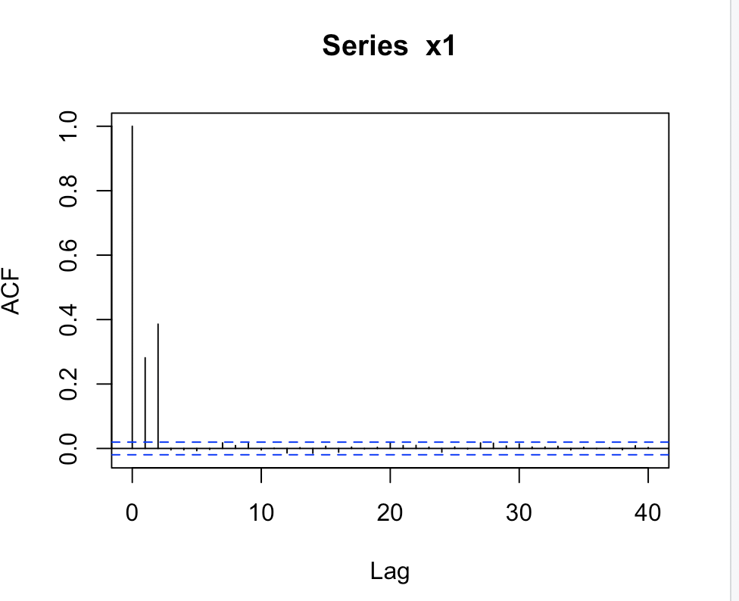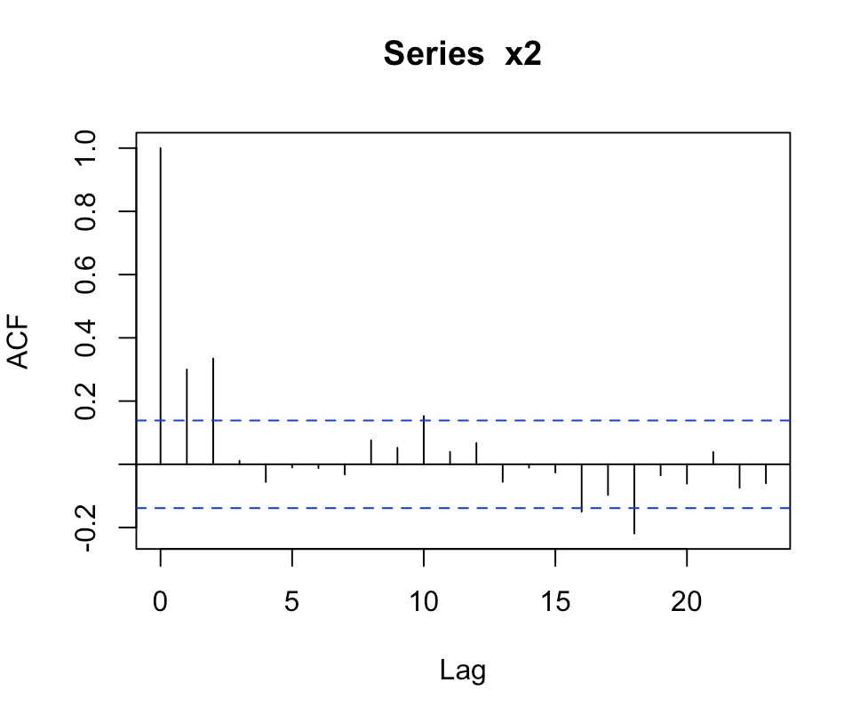

This is consistent with the model generated.

The bigger sample size gives narrower blue lines, whereas the smaller sample size has wider blue lines. Some correlations, which are nearly zero in the 10000-ACF, become non-zero or even outside the blue lines in the 200-ACF.