5.

(a) It is not stationary. The ACF plot is decaying very slowly and remains well above the dotted blue lines, and it is an indication of a non-stationary time series.

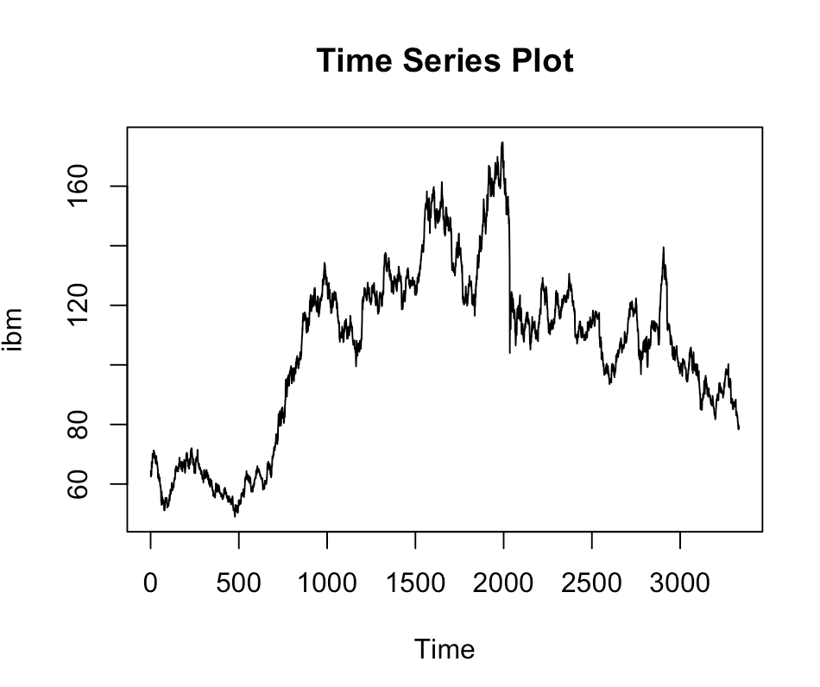 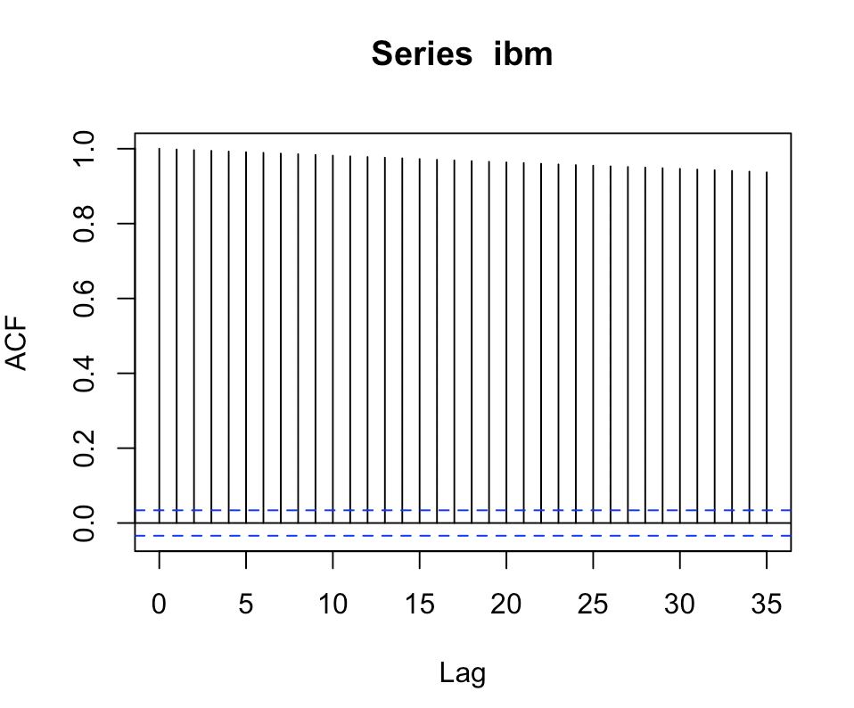

(b) The differenced time series is not stationary, because the variance is not stable.

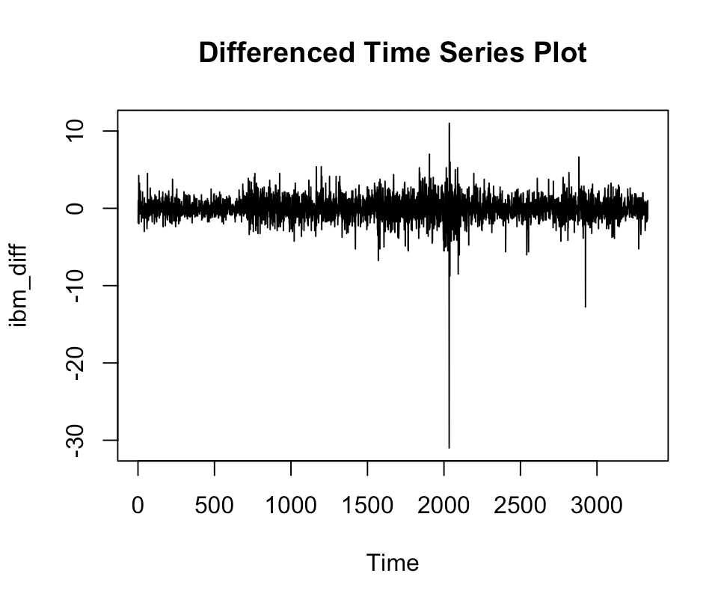 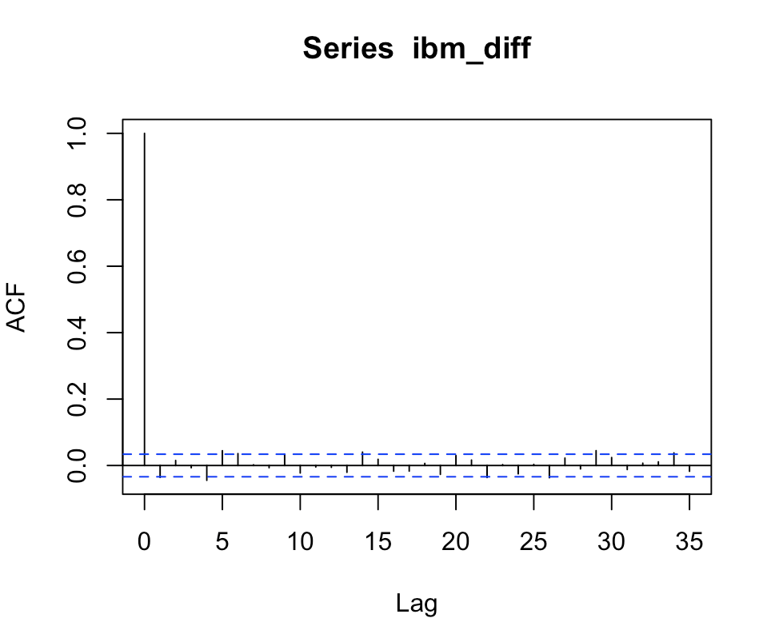

(c) The transformed data does not appear stationary. The ACF plot is still decaying very slowly and remains well above the dotted blue lines, so it is a non-stationary time series.

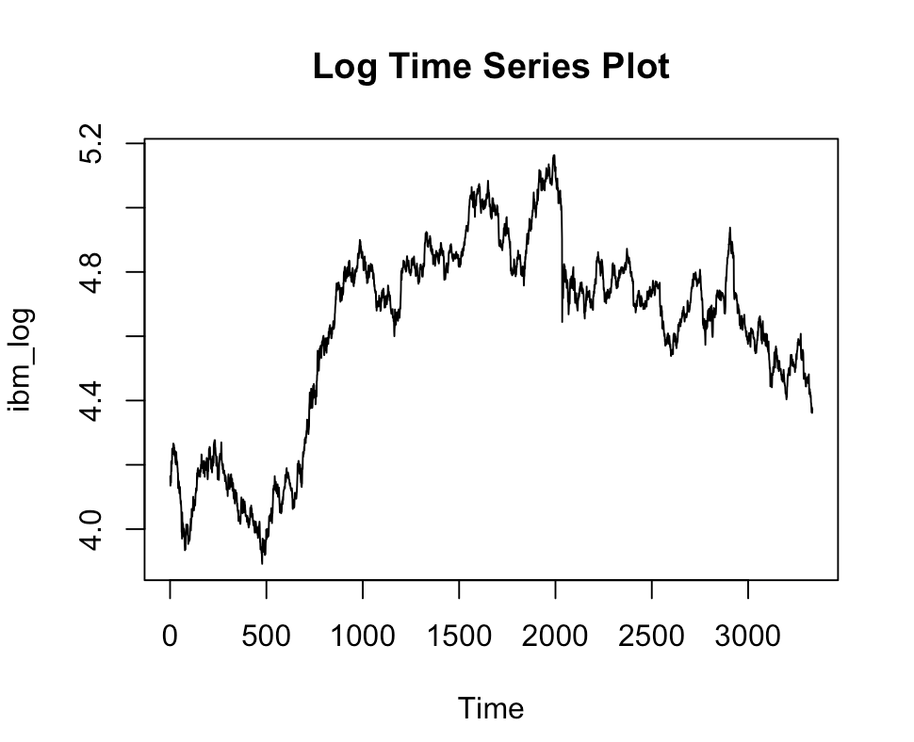 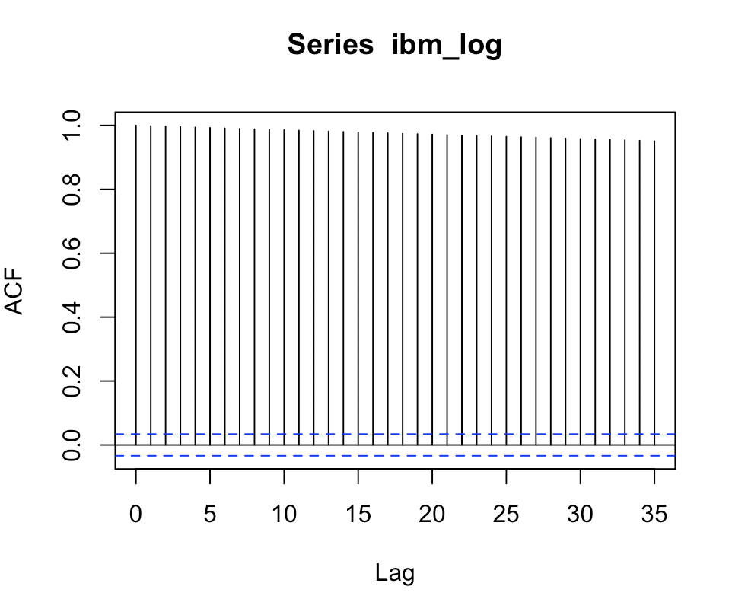

(d) log(diff(ibm)) is not a good idea because if we take difference first, we get some negative data and then log() does not work.

According to the ACF plot, this transformation succeed in creating stationary data.

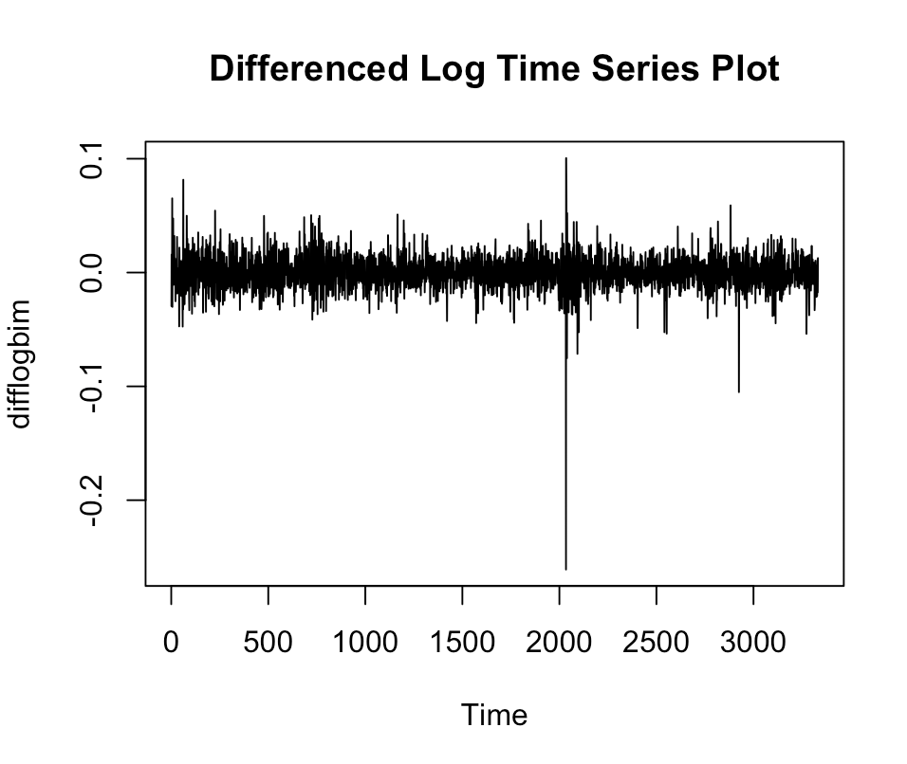 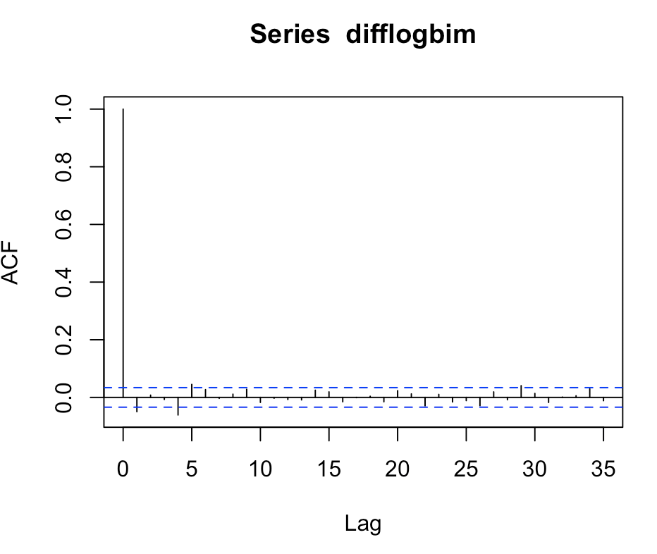

(e) The first section contains fewer observations than the second section. Smaller sample size lead to a wider area of dotted blue lines and more lags outside the area. Bigger sample size lead to a narrower area of dotted blue lines.

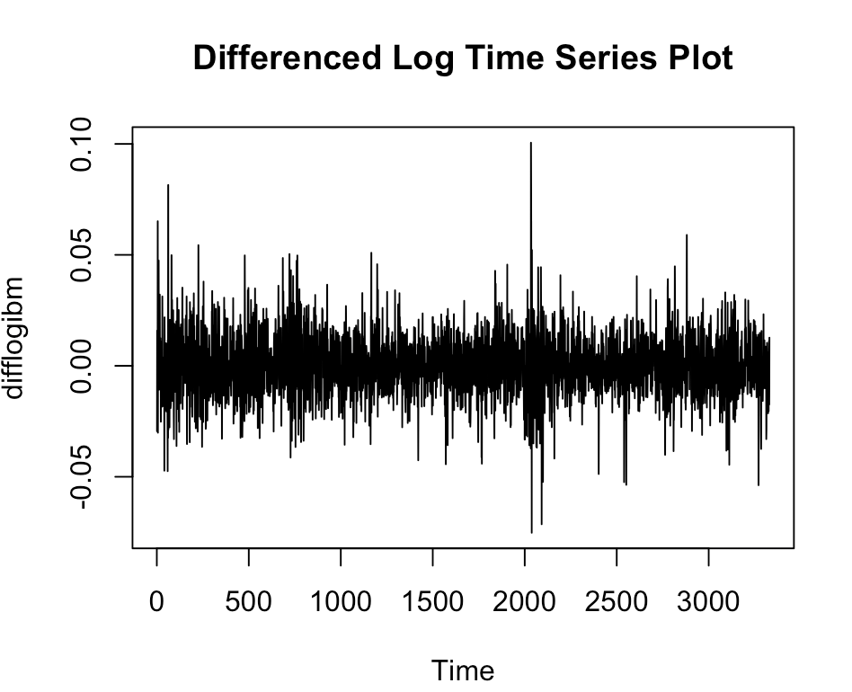 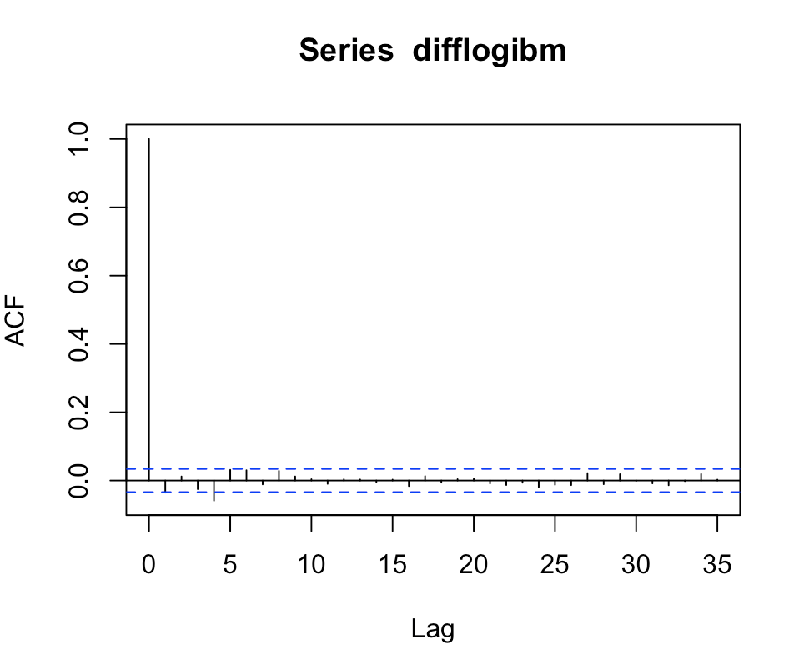

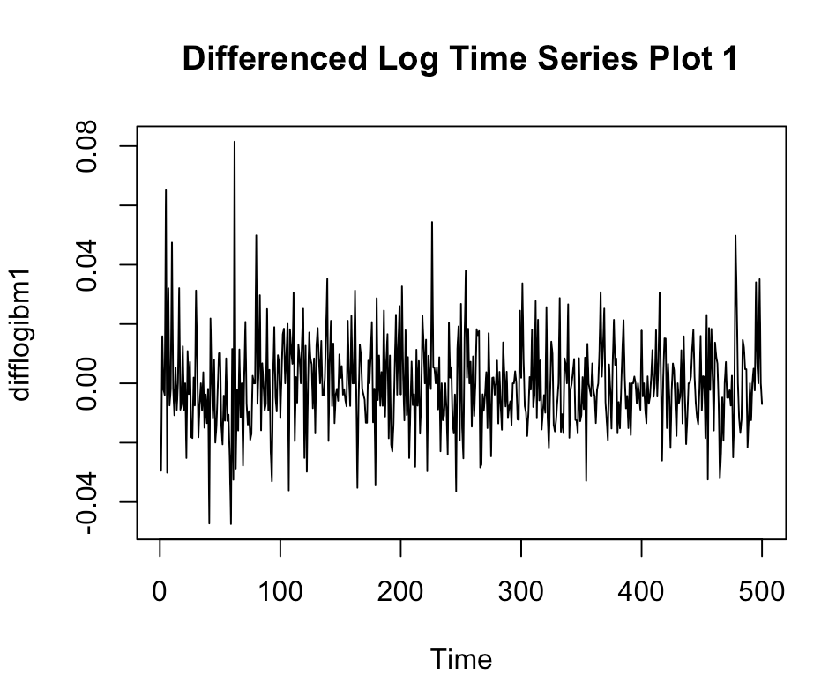 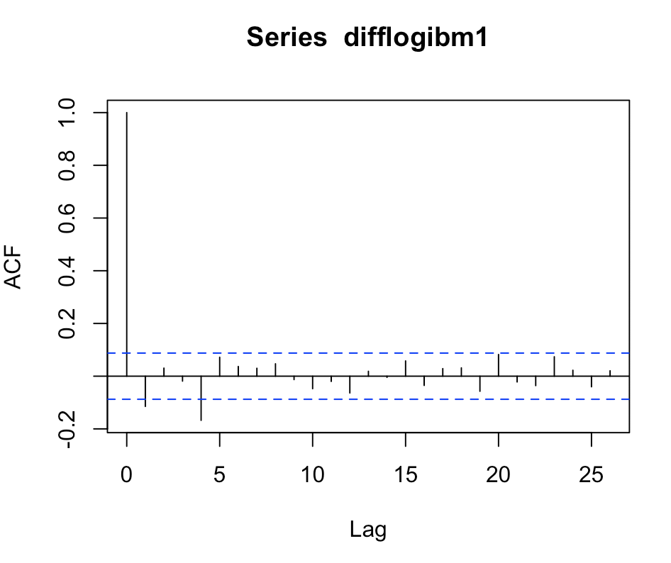

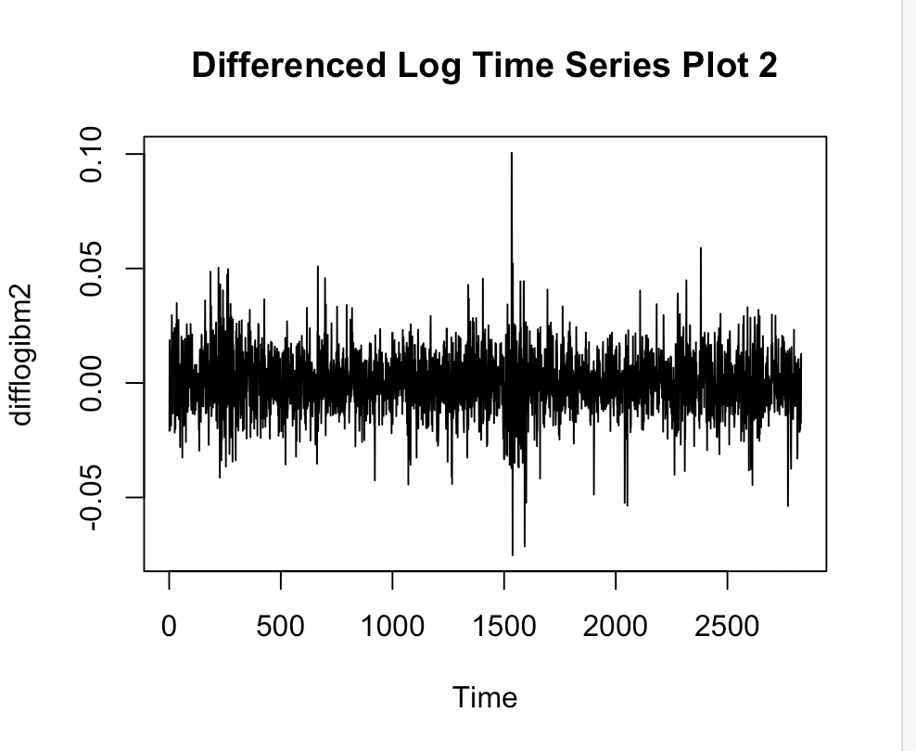 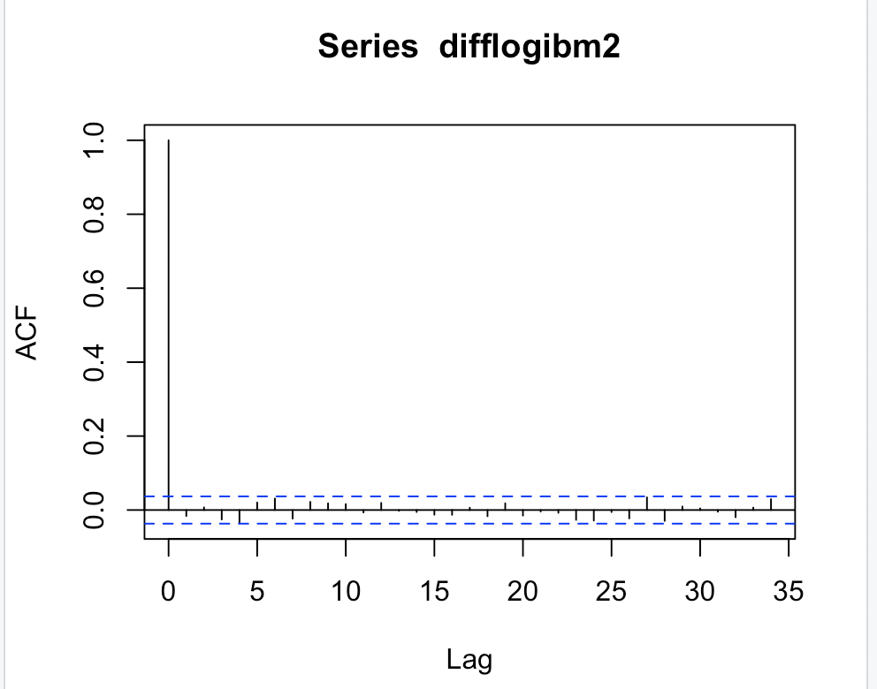

(f) It is reasonable, because the ACF plot for difflogibm2 is similar to the Sample ACF plot for Gaussian White Noise. We take the mean and variance of difflogibm2 to estimate and .

, so

, so