Preoperative Pulmonary Function, Overall Survival, and Postoperative Outcomes After Lung Cancer Resection
A Synthetic Applied-Biostatistics Technical Report
Prepared to mirror the structure and analytic requirements of the 2022 Ph.D. Applied Qualifying Examination
———————————————————————————————————
Data source | Synthetic lung-cancer resection cohort (N = 130)
Primary endpoint | Overall survival from surgery to death or last follow-up
Primary exposures | FEV1, FEV1 percent predicted, DLCO, and DLCO percent predicted
Practice-use notice: These data are synthetic and must not be interpreted as clinical evidence or used for publication.
Generated June 24, 2026

Abstract
Background: Preoperative pulmonary function tests quantify respiratory reserve and may be associated with postoperative outcomes and long-term survival after lung cancer resection. This synthetic practice analysis evaluated four pulmonary function measures in relation to overall survival, postoperative complications, and length of hospital stay.
Methods: A retrospective synthetic cohort of 130 adults undergoing lung cancer resection was analyzed. Overall survival was summarized using Kaplan-Meier methods and modeled using Cox proportional hazards regression. FEV1, FEV1 percent predicted, DLCO, and DLCO percent predicted were entered into separate models and scaled to clinically interpretable increments. Core adjusted models included age, sex, smoking status, type of surgery, pathologic stage, and tumor size. Secondary analyses used logistic regression for any postoperative complication and log-linear regression for length of stay. Model assumptions, sparse-event stability, and sensitivity analyses were evaluated.
Results: The cohort included 81 deaths (62.3%) over a median observed follow-up of 32.2 months. Median overall survival was 43.2 months; estimated survival was 77.7% at 12 months, 55.3% at 36 months, and 38.0% at 60 months. In separate adjusted Cox models, higher DLCO percent predicted was associated with lower mortality hazard (HR 0.78 per 10-percentage-point increase, 95% CI 0.64–0.96; P = 0.018). FEV1, FEV1 percent predicted, and absolute DLCO were not independently associated with survival. No interaction test met the conventional 0.05 threshold. None of the four PFT measures was associated with any postoperative complication in adjusted logistic models. Primary log-linear models did not identify a statistically significant association with length of stay; a Gamma log-link sensitivity model suggested shorter stay with higher DLCO percent predicted, but this finding was not consistent across model specifications.
Conclusions: In this synthetic practice cohort, DLCO percent predicted was the only pulmonary function measure independently associated with overall survival. Findings for postoperative complications and length of stay were inconclusive, in part because of sparse events and limited sample size. The analysis illustrates a complete applied-biostatistics workflow but does not support clinical inference.

Introduction
Patients undergoing surgical resection for lung cancer vary substantially in baseline pulmonary reserve, comorbidity burden, tumor characteristics, and operative extent. Preoperative pulmonary function tests (PFTs), including forced expiratory volume in one second (FEV1) and diffusing capacity of the lung for carbon monoxide (DLCO), provide complementary information about airway function and gas exchange. Both absolute values and percent-predicted measures may be considered in clinical assessment, but their associations with long-term survival and early postoperative outcomes require appropriate multivariable evaluation.
The primary objective of this synthetic applied-practice analysis was to determine whether FEV1, FEV1 percent predicted, DLCO, or DLCO percent predicted was associated with overall survival after lung cancer resection. Secondary objectives were to evaluate associations with postoperative complications and length of hospital stay and to explore whether survival associations differed across selected patient or disease characteristics. Because the four PFT measures are correlated and represent overlapping constructs, each was analyzed in a separate regression model.

Methods

Study design and analytic cohort
This report uses a synthetic retrospective cohort constructed to reproduce the variable structure and analytic tasks of the 2022 Ph.D. Applied Qualifying Examination. The cohort contained 130 adults who underwent surgical resection for lung cancer. Overall survival was measured in months from surgery to death or last follow-up. Patients alive at last follow-up were right-censored. All 130 records had valid positive survival time and known event status.

Variables and outcomes
The primary exposures were FEV1 in liters, FEV1 percent predicted, DLCO, and DLCO percent predicted. To improve interpretability, regression effects were reported per 0.5-L increase in FEV1, per 10-percentage-point increase in FEV1 percent predicted, per 5-unit increase in DLCO, and per 10-percentage-point increase in DLCO percent predicted. The four PFT variables were not entered together in the same model.
The primary outcome was overall survival. Secondary outcomes were any postoperative complication, respiratory complication, cardiac complication, infectious complication, postoperative death complication, and length of hospital stay. Candidate covariates included age, sex, smoking status, type of surgery, pathologic stage, histology, tumor size, hilar and mediastinal lymph-node involvement, and baseline comorbidities. Core adjusted models were prespecified to include age, sex, smoking status, type of surgery, pathologic stage, and tumor size to limit overfitting in this small cohort.

Statistical analysis
Continuous variables were summarized using mean and standard deviation and median with interquartile range. Categorical variables were summarized as frequency and percentage using nonmissing denominators. Missingness and cohort flow were documented. PFT distributions and length-of-stay distribution were inspected graphically. Pearson correlations were used to describe relationships among the four PFT measures.
Overall survival was estimated using the Kaplan-Meier method. Univariate Cox proportional hazards models were fit for baseline variables and each PFT measure. Four separate multivariable Cox models estimated the adjusted association of each PFT measure with mortality while controlling for the core covariates. Hazard ratios (HRs), 95% confidence intervals (CIs), and two-sided P values were reported. Potential effect modification by age, sex, smoking status, pathologic stage, and respiratory comorbidity was assessed using one PFT-by-modifier interaction at a time and likelihood-ratio tests comparing nested models. These interaction analyses were exploratory and were not adjusted for multiplicity.
For any postoperative complication, unadjusted PFT distributions were compared using Wilcoxon rank-sum tests, and four separate multivariable logistic models estimated adjusted odds ratios (ORs). Because only 25–26 events were available in each complete-case dataset, events-per-parameter calculations were used to characterize model stability. Secondary complication-specific models were fit only when the prespecified screening and event-count criteria were met.
Length of stay was treated as a continuous right-skewed outcome. Primary models used linear regression for log-transformed length of stay; exponentiated coefficients were interpreted as ratios of geometric mean length of stay. Gamma generalized linear models with a log link were used as sensitivity analyses. Model-specific complete-case analysis was used throughout. Full candidate Cox models were considered as sensitivity analyses but were not fit when the event-to-parameter ratio was below 5.
Proportional hazards were assessed using scaled Schoenfeld residual tests and plots. Martingale residual smooths were reviewed for the functional form of continuous PFT terms. Residual-versus-fitted, quantile-quantile, scale-location, and leverage plots were reviewed for the log-linear length-of-stay model. Statistical significance was assessed at a two-sided α of 0.05, while emphasizing effect estimates and uncertainty rather than P values alone. Analyses were performed in R; exact software and package versions should be inserted from sessionInfo() in a formal submission.

Results

Cohort characteristics and data completeness
All 130 synthetic records were included in the survival analysis. Missingness was concentrated in the PFT variables: 8 observations (6.2%) were missing FEV1, 7 (5.4%) were missing FEV1 percent predicted, 10 (7.7%) were missing DLCO, and 9 (6.9%) were missing DLCO percent predicted. Other covariates had no more than 2.3% missingness. Model-specific adjusted sample sizes therefore ranged from 115 to 118 for the primary PFT models.
The mean age was 65.5 years (SD 8.6), 60.0% of patients were male, and 60.8% underwent lobectomy. Stage I disease accounted for 54.6% of the cohort, while 18.5% had stage III disease. Adenocarcinoma was the most common histology among patients with nonmissing histology (67.2%). Median length of stay was 6 days (IQR 4–8). Baseline and pulmonary function characteristics are summarized in Table 1.
Table 1. Baseline characteristics and pulmonary function measures
Characteristic | Summary / level, n (%) | Median (Q1, Q3) | Missing, n
Age, years | 65.5 (8.6) | 66.0 (59.2, 71.0) | 0
Sex | Female: 52 (40.0%)
 | Male: 78 (60.0%)
Smoking status | Never: 25 (19.5%)
 | Former: 78 (60.9%)
 | Current: 25 (19.5%)
 | Missing: 2
Type of surgery | Wedge/segmentectomy: 21 (16.2%)
 | Lobectomy: 79 (60.8%)
 | Pneumonectomy: 30 (23.1%)
Pathologic stage | I: 71 (54.6%)
 | II: 35 (26.9%)
 | III: 24 (18.5%)
Histology | Adenocarcinoma: 86 (67.2%)
 | Squamous cell carcinoma: 26 (20.3%)
 | Other: 16 (12.5%)
 | Missing: 2
Tumor size, cm | 3.4 (2.0) | 3.0 (2.0, 4.4) | 3
Hilar lymph-node involvement | No: 96 (73.8%)
 | Yes: 34 (26.2%)
Mediastinal lymph-node involvement | No: 110 (84.6%)
 | Yes: 20 (15.4%)
Respiratory comorbidity | No: 105 (82.0%)
 | Yes: 23 (18.0%)
 | Missing: 2
Cardiac comorbidity | No: 104 (81.2%)
 | Yes: 24 (18.8%)
 | Missing: 2
Stroke | No: 123 (94.6%)
 | Yes: 7 (5.4%)
Chronic kidney disease | No: 127 (97.7%)
 | Yes: 3 (2.3%)
Diabetes | No: 119 (91.5%)
 | Yes: 11 (8.5%)
Other comorbidity | No: 105 (80.8%)
 | Yes: 25 (19.2%)
FEV1, L | 2.5 (0.5) | 2.6 (2.2, 2.9) | 8
FEV1 percent predicted | 82.2 (12.3) | 80.8 (75.4, 91.2) | 7
DLCO | 18.5 (3.8) | 18.6 (16.2, 21.3) | 10
DLCO percent predicted | 77.8 (13.4) | 78.6 (69.9, 87.3) | 9
Continuous variables are shown as mean (SD) in the second column and median (Q1, Q3) in the third column. Categorical percentages use nonmissing denominators. DLCO = diffusing capacity of the lung for carbon monoxide; FEV1 = forced expiratory volume in one second.

Overall survival
During follow-up, 81 patients died and 49 were censored. Median observed follow-up was 32.2 months (IQR 15.4–53.1). Kaplan-Meier median overall survival was 43.2 months. Estimated survival probabilities were 77.7% at 12 months, 66.7% at 24 months, 55.3% at 36 months, and 38.0% at 60 months (Figure 1).
Figure 1. Kaplan-Meier estimate of overall survival after lung cancer resection
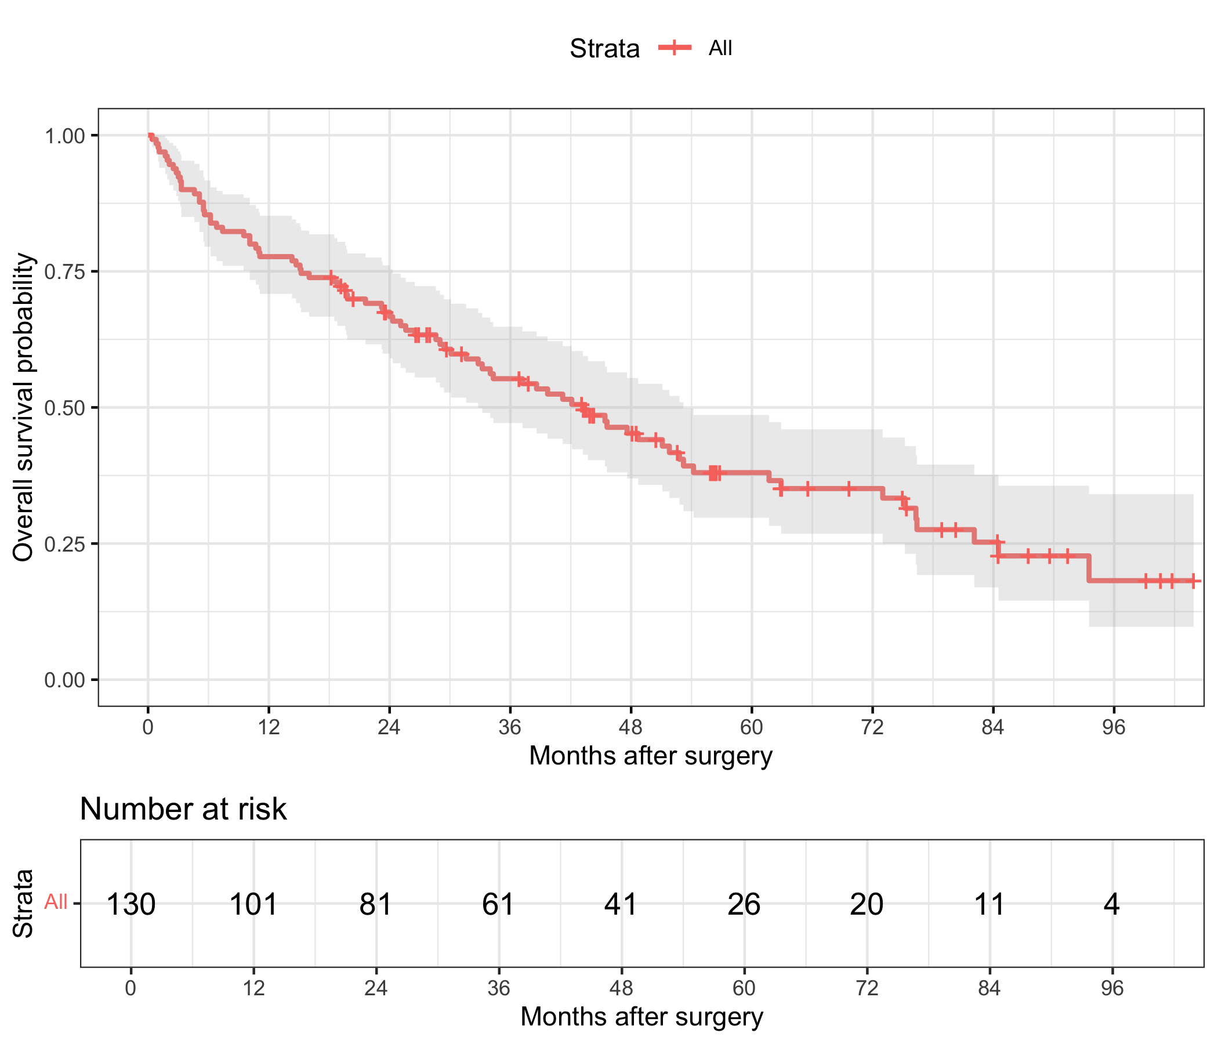
The shaded band represents the 95% confidence interval. Tick marks indicate censoring. The risk table gives the number of patients remaining under observation at each time point.

Pulmonary function and overall survival
In univariate analyses, higher DLCO percent predicted was associated with lower mortality hazard (HR 0.72 per 10-percentage-point increase; 95% CI 0.61–0.85; P < 0.001). FEV1 percent predicted and absolute DLCO showed inverse but nonsignificant univariate associations, while absolute FEV1 was not associated with survival. Several clinical covariates, including older age, male sex, former or current smoking, stage III disease, larger tumor size, and respiratory comorbidity, were associated with higher mortality hazard in univariate models.
After adjustment for age, sex, smoking status, type of surgery, pathologic stage, and tumor size, DLCO percent predicted remained associated with overall survival. Each 10-percentage-point increase was associated with a 22% lower instantaneous mortality hazard averaged over follow-up (adjusted HR 0.78; 95% CI 0.64–0.96; P = 0.018). The adjusted associations for FEV1, FEV1 percent predicted, and absolute DLCO were not statistically significant (Table 2 and Figure 2).
Table 2. Adjusted associations between pulmonary function and overall survival
Pulmonary function measure | Increment | N | Adjusted HR (95% CI) | P value
FEV1 | Per 0.5-L increase | 118 | 1.05 (0.78, 1.40) | 0.761
FEV1 percent predicted | Per 10-percentage-point increase | 118 | 1.06 (0.84, 1.35) | 0.624
DLCO | Per 5-unit increase | 115 | 0.73 (0.49, 1.09) | 0.128
DLCO percent predicted | Per 10-percentage-point increase | 117 | 0.78 (0.64, 0.96) | 0.018
Each row is from a separate Cox proportional hazards model adjusted for age, sex, smoking status, type of surgery, pathologic stage, and tumor size. HR < 1 indicates lower mortality hazard at higher PFT values. CI = confidence interval; HR = hazard ratio.
Figure 2. Adjusted hazard ratios for pulmonary function measures
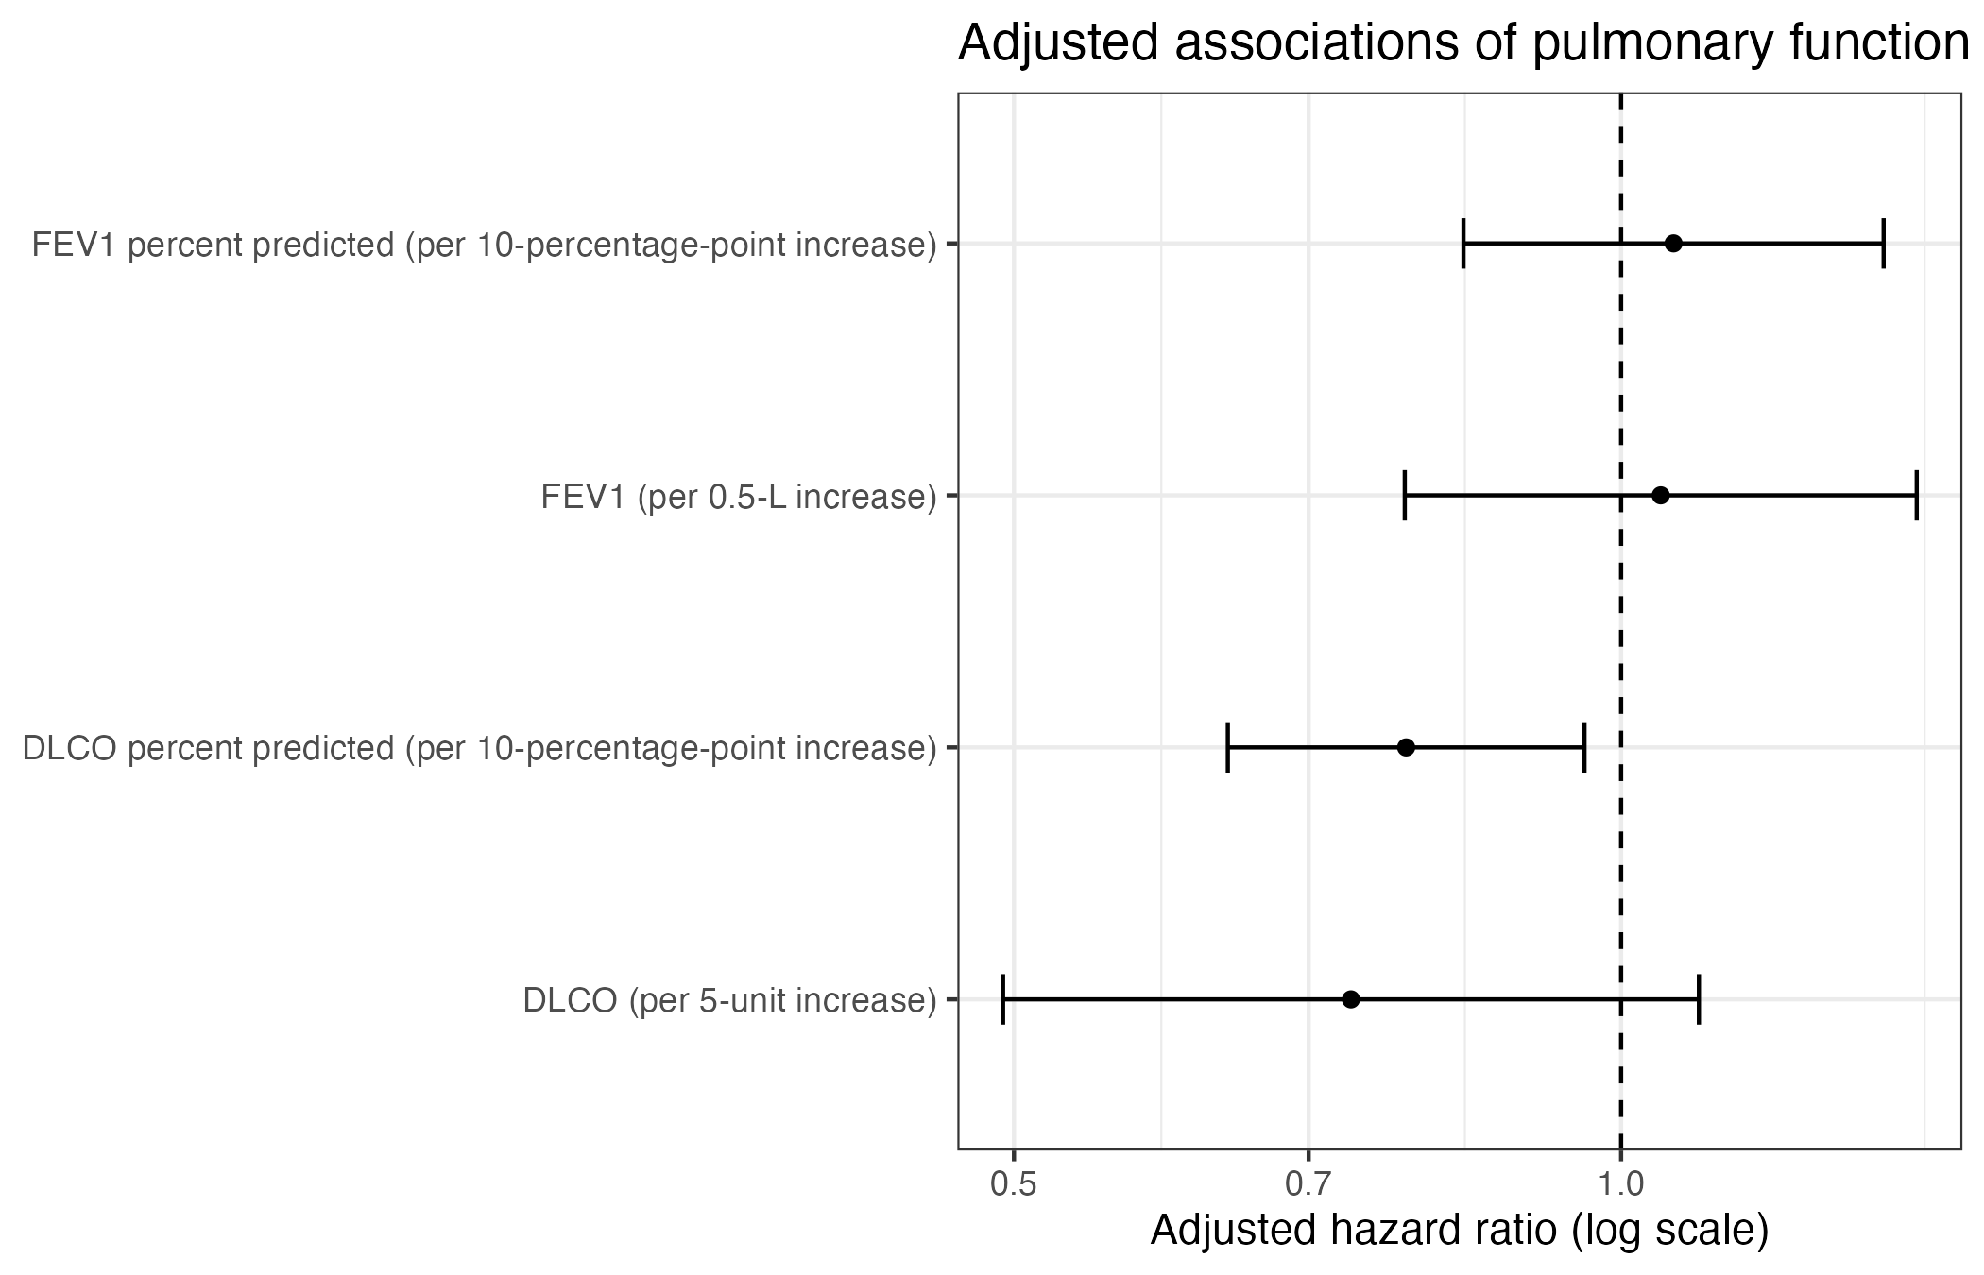
Points are adjusted hazard ratios; horizontal lines are 95% confidence intervals. The vertical line at 1.0 denotes no association. The x-axis is logarithmic.

Effect-modification analyses
No PFT-by-modifier interaction met the conventional 0.05 significance threshold. The smallest likelihood-ratio P values were observed for DLCO by pathologic stage (P = 0.053), FEV1 percent predicted by respiratory comorbidity (P = 0.054), and FEV1 by age (P = 0.064). These borderline findings were exploratory, arose from multiple interaction tests, and should not be interpreted as established heterogeneity. Detailed interaction screening results are provided in Appendix Table A3.

Postoperative complications
Any postoperative complication occurred in 30 patients (23.1%). Respiratory complications occurred in 12 patients (9.2%), cardiac complications in 6 (4.6%), infectious complications in 6 (4.6%), and postoperative death complications in 2 (1.5%). Unadjusted comparisons did not identify a statistically significant difference in any PFT measure between patients with and without any of the evaluated postoperative complications.
In separate adjusted logistic models for any postoperative complication, none of the four PFT measures was associated with the odds of complication (Table 3). However, complete-case models contained only 25–26 complication events and approximately 10 parameters, yielding 2.5–2.6 events per parameter. Although the models converged, the low event-to-parameter ratio and wide confidence intervals indicate substantial risk of overfitting and imprecision. Therefore, these analyses should be interpreted as inconclusive rather than evidence that no association exists.
Table 3. Adjusted logistic models for any postoperative complication
Pulmonary function measure | Increment | N | Adjusted OR (95% CI) | P value
FEV1 | Per 0.5-L increase | 118 | 0.94 (0.55, 1.61) | 0.829
FEV1 percent predicted | Per 10-percentage-point increase | 118 | 0.81 (0.50, 1.29) | 0.373
DLCO | Per 5-unit increase | 115 | 0.77 (0.37, 1.58) | 0.470
DLCO percent predicted | Per 10-percentage-point increase | 117 | 0.93 (0.62, 1.41) | 0.734
Each row is from a separate logistic regression model adjusted for age, sex, smoking status, type of surgery, pathologic stage, and tumor size. ORs are odds ratios and must not be interpreted as risk ratios.

Length of hospital stay
Length of stay was right-skewed, with a median of 6 days (IQR 4–8) and mean of 6.5 days (SD 3.1). In primary log-linear models, none of the four PFT measures was statistically significantly associated with length of stay. The strongest primary association was for DLCO percent predicted: each 10-percentage-point increase corresponded to an estimated 5% lower geometric mean length of stay, but the confidence interval included the null (ratio 0.95; 95% CI 0.89–1.01; P = 0.076).
In the Gamma log-link sensitivity model, the corresponding DLCO percent predicted estimate was 0.94 (95% CI 0.88–0.99; P = 0.037). Because statistical significance depended on model specification, this finding should be presented as sensitivity evidence rather than a definitive association. The other PFT measures were not associated with length of stay in either model family.
Table 4. Adjusted associations between pulmonary function and length of hospital stay
Pulmonary function measure | Increment | N | Log-linear geometric mean ratio (95% CI) | P value | Gamma mean ratio (95% CI) | P value
FEV1 | Per 0.5-L increase | 117 | 1.06 (0.97, 1.15) | 0.208 | 1.06 (0.97, 1.16) | 0.174
FEV1 percent predicted | Per 10-percentage-point increase | 115 | 1.00 (0.94, 1.07) | 0.916 | 1.00 (0.94, 1.07) | 0.933
DLCO | Per 5-unit increase | 112 | 0.92 (0.82, 1.04) | 0.177 | 0.90 (0.80, 1.01) | 0.079
DLCO percent predicted | Per 10-percentage-point increase | 115 | 0.95 (0.89, 1.01) | 0.076 | 0.94 (0.88, 0.99) | 0.037
Each row is from a separate model adjusted for age, sex, smoking status, type of surgery, pathologic stage, and tumor size. Ratios below 1 indicate shorter expected length of stay at higher PFT values.

Model diagnostics and sensitivity analyses
The PFT terms themselves did not show statistically significant evidence of nonproportional hazards in the adjusted Cox models. Global Schoenfeld tests were nonsignificant for the FEV1, FEV1 percent predicted, and absolute DLCO models and borderline for the DLCO percent predicted model (P = 0.050). Tumor size showed evidence of nonproportional hazards in all four models (P = 0.003–0.012). Accordingly, the reported Cox coefficients should be interpreted as average hazard ratios across follow-up rather than necessarily constant effects at every time point. In a real confirmatory analysis, a time-varying tumor-size effect or stratified sensitivity analysis would be considered.
Martingale residual smooths did not reveal a strong gross departure from linearity for the PFT terms, although the small sample produced uncertainty at the tails of the distributions. Full candidate Cox models containing the wider covariate set were not fit because events per parameter were below 5. This decision reduced overfitting risk and preserved the prespecified core models as the primary analyses.

Discussion

Principal findings
In this synthetic cohort of patients undergoing lung cancer resection, DLCO percent predicted was the only pulmonary function measure independently associated with overall survival after adjustment for core demographic, smoking, operative, and tumor-related covariates. A 10-percentage-point higher DLCO percent predicted was associated with a 22% lower mortality hazard averaged over follow-up. Absolute DLCO showed a directionally similar but less precise association, whereas FEV1 and FEV1 percent predicted were not associated with survival after adjustment.
The contrast between DLCO percent predicted and the other PFT measures illustrates why the estimand and scale of exposure must be specified before analysis. Percent-predicted DLCO incorporates expected variation related to patient characteristics and may capture physiologic impairment differently from the absolute measure. Nevertheless, the analysis does not establish that DLCO percent predicted is causally protective; it identifies an adjusted association within a small synthetic observational cohort.

Secondary outcomes
The complication analyses did not identify statistically significant adjusted associations between PFT and any postoperative complication. These findings were limited by sparse events and model complexity. The odds-ratio confidence intervals were wide, and the events-per-parameter ratio was substantially below commonly used stability benchmarks. Therefore, the appropriate interpretation is that the available data were insufficient to demonstrate an association, not that pulmonary function has no relationship with postoperative complications.
For length of stay, the primary log-linear analyses were nonsignificant. DLCO percent predicted reached statistical significance only in the Gamma sensitivity model. Because this result was sensitive to model specification and arose among several secondary analyses, it should be considered hypothesis-generating. A larger cohort would permit more robust assessment of distributional assumptions and potentially flexible nonlinear modeling.

Strengths and limitations
Strengths of the analysis include explicit separation of the four correlated PFT measures, clinically interpretable exposure increments, publication-style effect estimates with confidence intervals, documentation of model-specific sample size, and formal evaluation of proportional hazards, functional form, sparse-event stability, and sensitivity to alternative length-of-stay models.
Several limitations are important. First, the data are synthetic and cannot support clinical inference. Second, the cohort was small, and complete-case sample size varied across PFT models. Third, secondary logistic models were overparameterized relative to the number of complications. Fourth, multiple exploratory interaction and secondary-outcome analyses were performed without multiplicity adjustment. Fifth, tumor size showed evidence of a time-varying effect, making the standard Cox coefficients average effects over follow-up. Sixth, observational analyses remain susceptible to residual confounding, measurement error, and selection bias even when multivariable adjustment is used.

Conclusion
This synthetic applied-practice analysis identified an adjusted association between higher DLCO percent predicted and longer overall survival after lung cancer resection. Other PFT measures were not independently associated with survival, and evidence for postoperative complications or length of stay was inconclusive. The report demonstrates how to translate a multi-aim clinical question into separate survival, binary-outcome, and skewed-continuous-outcome analyses while explicitly addressing model assumptions, overfitting, and uncertainty.

References
Kaplan EL, Meier P. Nonparametric estimation from incomplete observations. Journal of the American Statistical Association. 1958;53:457–481.
Cox DR. Regression models and life-tables. Journal of the Royal Statistical Society: Series B. 1972;34:187–220.
Schoenfeld D. Partial residuals for the proportional hazards regression model. Biometrika. 1982;69:239–241.
Harrell FE Jr. Regression Modeling Strategies. 2nd ed. Springer; 2015.
Vittinghoff E, McCulloch CE. Relaxing the rule of ten events per variable in logistic and Cox regression. American Journal of Epidemiology. 2007;165:710–718.
von Elm E, Altman DG, Egger M, et al. The Strengthening the Reporting of Observational Studies in Epidemiology (STROBE) statement. PLoS Medicine. 2007;4:e296.
R Core Team. R: A Language and Environment for Statistical Computing. R Foundation for Statistical Computing.

Appendix: Supporting Analyses and Diagnostics
The appendix contains detailed univariate models, interaction screening, assumption checks, sparse-event diagnostics, and sensitivity analyses. These materials support the main conclusions but would generally be placed outside the main report body.
Appendix Table A1. Cohort flow and selected missingness summary
Item | N | Missing, n (%)
Raw records imported | 130
Positive nonmissing survival time | 130
Known event indicator | 130
Included in survival analysis | 130
FEV1 missing |  | 8 (6.2%)
FEV1 percent predicted missing |  | 7 (5.4%)
DLCO missing |  | 10 (7.7%)
DLCO percent predicted missing |  | 9 (6.9%)
Tumor size missing |  | 3 (2.3%)
Length of stay missing |  | 3 (2.3%)
All survival records had valid follow-up time and event status. Regression models used model-specific complete-case samples.
Appendix Table A2. Univariate Cox proportional hazards models
Predictor / contrast | HR (95% CI) | P value
Age, per year | 1.03 (1.00, 1.06) | 0.019
Male vs female | 1.82 (1.14, 2.92) | 0.012
Former vs never smoker | 3.24 (1.53, 6.84) | 0.002
Current vs never smoker | 3.13 (1.34, 7.27) | 0.008
Lobectomy vs wedge/segmentectomy | 1.01 (0.52, 1.96) | 0.973
Pneumonectomy vs wedge/segmentectomy | 1.65 (0.80, 3.40) | 0.176
Stage II vs I | 1.70 (1.00, 2.90) | 0.050
Stage III vs I | 3.64 (2.09, 6.34) | <0.001
Other histology vs adenocarcinoma | 0.86 (0.44, 1.70) | 0.667
Squamous vs adenocarcinoma | 0.86 (0.50, 1.49) | 0.601
Tumor size, per cm | 1.23 (1.11, 1.37) | <0.001
Hilar LN involvement | 1.56 (0.97, 2.53) | 0.067
Mediastinal LN involvement | 1.57 (0.88, 2.81) | 0.124
Respiratory comorbidity | 2.25 (1.34, 3.79) | 0.002
Cardiac comorbidity | 1.26 (0.72, 2.23) | 0.421
Stroke | 1.31 (0.53, 3.24) | 0.563
Chronic kidney disease | 0.78 (0.19, 3.16) | 0.724
Diabetes | 0.71 (0.29, 1.75) | 0.452
Other comorbidity | 0.74 (0.41, 1.35) | 0.329
FEV1, per 0.5 L | 0.91 (0.72, 1.15) | 0.423
FEV1 percent predicted, per 10 points | 0.86 (0.72, 1.02) | 0.090
DLCO, per 5 units | 0.76 (0.56, 1.03) | 0.080
DLCO percent predicted, per 10 points | 0.72 (0.61, 0.85) | <0.001
Each row is from a separate univariate Cox model. These analyses are descriptive and were not used as the sole basis for covariate selection.
Appendix Table A3. PFT effect-modification screening
PFT | Potential modifier | N | Likelihood-ratio P value
DLCO | Pathologic stage | 115 | 0.053
FEV1 percent predicted | Respiratory comorbidity | 116 | 0.054
FEV1 | Age | 118 | 0.064
FEV1 percent predicted | Age | 118 | 0.084
FEV1 percent predicted | Smoking | 118 | 0.085
DLCO | Sex | 115 | 0.098
DLCO percent predicted | Sex | 117 | 0.129
DLCO | Age | 115 | 0.209
DLCO percent predicted | Age | 117 | 0.252
DLCO percent predicted | Smoking | 117 | 0.336
DLCO percent predicted | Pathologic stage | 117 | 0.403
FEV1 percent predicted | Pathologic stage | 118 | 0.434
DLCO | Smoking | 115 | 0.503
FEV1 | Respiratory comorbidity | 116 | 0.527
DLCO percent predicted | Respiratory comorbidity | 115 | 0.529
DLCO | Respiratory comorbidity | 113 | 0.708
FEV1 | Smoking | 118 | 0.713
FEV1 | Sex | 118 | 0.747
FEV1 percent predicted | Sex | 118 | 0.904
FEV1 | Pathologic stage | 118 | 0.928
Each P value compares nested Cox models with and without the specified interaction. No multiplicity adjustment was applied.
Appendix Table A4. Key proportional-hazards diagnostic tests
Adjusted Cox model | Term | Schoenfeld test P value
FEV1 model | FEV1 term | 0.255
FEV1 model | Tumor size | 0.007
FEV1 model | Global | 0.263
FEV1 percent predicted model | PFT term | 0.485
FEV1 percent predicted model | Tumor size | 0.003
FEV1 percent predicted model | Global | 0.192
DLCO model | DLCO term | 0.226
DLCO model | Tumor size | 0.009
DLCO model | Global | 0.073
DLCO percent predicted model | PFT term | 0.078
DLCO percent predicted model | Tumor size | 0.012
DLCO percent predicted model | Global | 0.050
Tumor size showed evidence of nonproportional hazards in all four adjusted models. PFT-specific tests did not cross the 0.05 threshold.
Appendix Table A5. Unadjusted PFT comparisons by postoperative complication
Outcome | PFT | No complication, median (IQR) | Complication, median (IQR) | P value
Any complication | FEV1 | 2.6 (2.2, 2.9) | 2.5 (2.0, 3.0) | 0.831
Any complication | FEV1 % predicted | 81.9 (75.7, 91.4) | 79.4 (71.8, 84.3) | 0.217
Any complication | DLCO | 18.6 (16.5, 21.6) | 18.3 (14.7, 20.2) | 0.187
Any complication | DLCO % predicted | 79.3 (70.6, 87.4) | 75.3 (65.2, 82.9) | 0.250
Respiratory complication | FEV1 | 2.6 (2.2, 2.9) | 2.6 (2.1, 2.9) | 0.848
Respiratory complication | FEV1 % predicted | 81.4 (75.5, 91.3) | 79.4 (72.2, 83.8) | 0.383
Respiratory complication | DLCO | 18.6 (16.4, 21.3) | 18.4 (14.8, 20.4) | 0.713
Respiratory complication | DLCO % predicted | 79.2 (70.6, 87.4) | 73.0 (58.9, 81.0) | 0.226
Cardiac complication | FEV1 | 2.6 (2.2, 2.9) | 2.2 (2.1, 2.4) | 0.472
Cardiac complication | FEV1 % predicted | 81.4 (75.3, 91.5) | 78.7 (78.4, 80.2) | 0.377
Cardiac complication | DLCO | 18.4 (16.0, 21.3) | 18.9 (17.4, 19.1) | 1.000
Cardiac complication | DLCO % predicted | 78.6 (69.7, 87.3) | 77.8 (74.9, 81.8) | 0.995
Infectious complication | FEV1 | 2.6 (2.2, 2.9) | 2.8 (2.5, 3.1) | 0.201
Infectious complication | FEV1 % predicted | 80.9 (75.3, 90.9) | 80.0 (76.1, 98.0) | 0.673
Infectious complication | DLCO | 18.6 (16.4, 21.3) | 16.8 (14.9, 22.9) | 0.952
Infectious complication | DLCO % predicted | 78.5 (69.8, 87.3) | 79.2 (72.9, 82.3) | 0.815
Postoperative death complication | FEV1 | 2.6 (2.2, 2.9) | 2.1 (2.0, 2.3) | 0.226
Postoperative death complication | FEV1 % predicted | 80.8 (75.3, 91.3) | 79.2 (77.5, 81.0) | 0.704
Postoperative death complication | DLCO | 18.6 (16.0, 21.3) | 18.3 (18.3, 18.3) | 0.910
Postoperative death complication | DLCO % predicted | 78.5 (69.8, 87.3) | 84.6 (84.6, 84.6) | 0.557
P values are from Wilcoxon rank-sum tests and are descriptive. Very small event counts limit interpretability for cardiac, infectious, and postoperative death complications.
Appendix Table A6. Logistic model stability diagnostics
Model | N | Events | Parameters | Events per parameter | Converged
FEV1 model | 118 | 26 | 10 | 2.6 | Yes
FEV1 percent predicted model | 118 | 25 | 10 | 2.5 | Yes
DLCO model | 115 | 26 | 10 | 2.6 | Yes
DLCO percent predicted model | 117 | 26 | 10 | 2.6 | Yes
Convergence does not guarantee reliable inference. Events-per-parameter values near 2.5 indicate substantial overfitting risk.
Appendix Table A7. Full candidate Cox sensitivity-model feasibility
PFT | N | Events | Parameters | Events per parameter | Decision
FEV1 | 112 | 68 | 20 | 3.4 | Not fit
FEV1 percent predicted | 112 | 69 | 20 | 3.5 | Not fit
DLCO | 109 | 64 | 20 | 3.2 | Not fit
DLCO percent predicted | 111 | 68 | 20 | 3.4 | Not fit
The full candidate models were skipped because events per parameter were below 5. Core adjusted models were retained as the primary analyses.

Appendix Figure A1. Distributions of preoperative pulmonary function measures
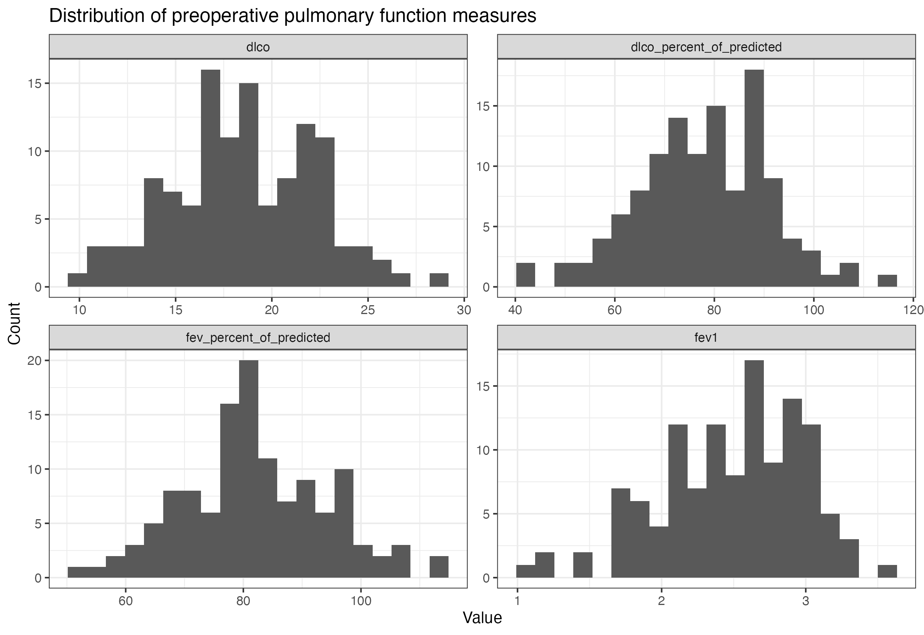
Histograms were reviewed to identify skewness, outliers, and scale differences. The four PFT measures were analyzed separately.
Appendix Figure A2. Distribution of length of hospital stay
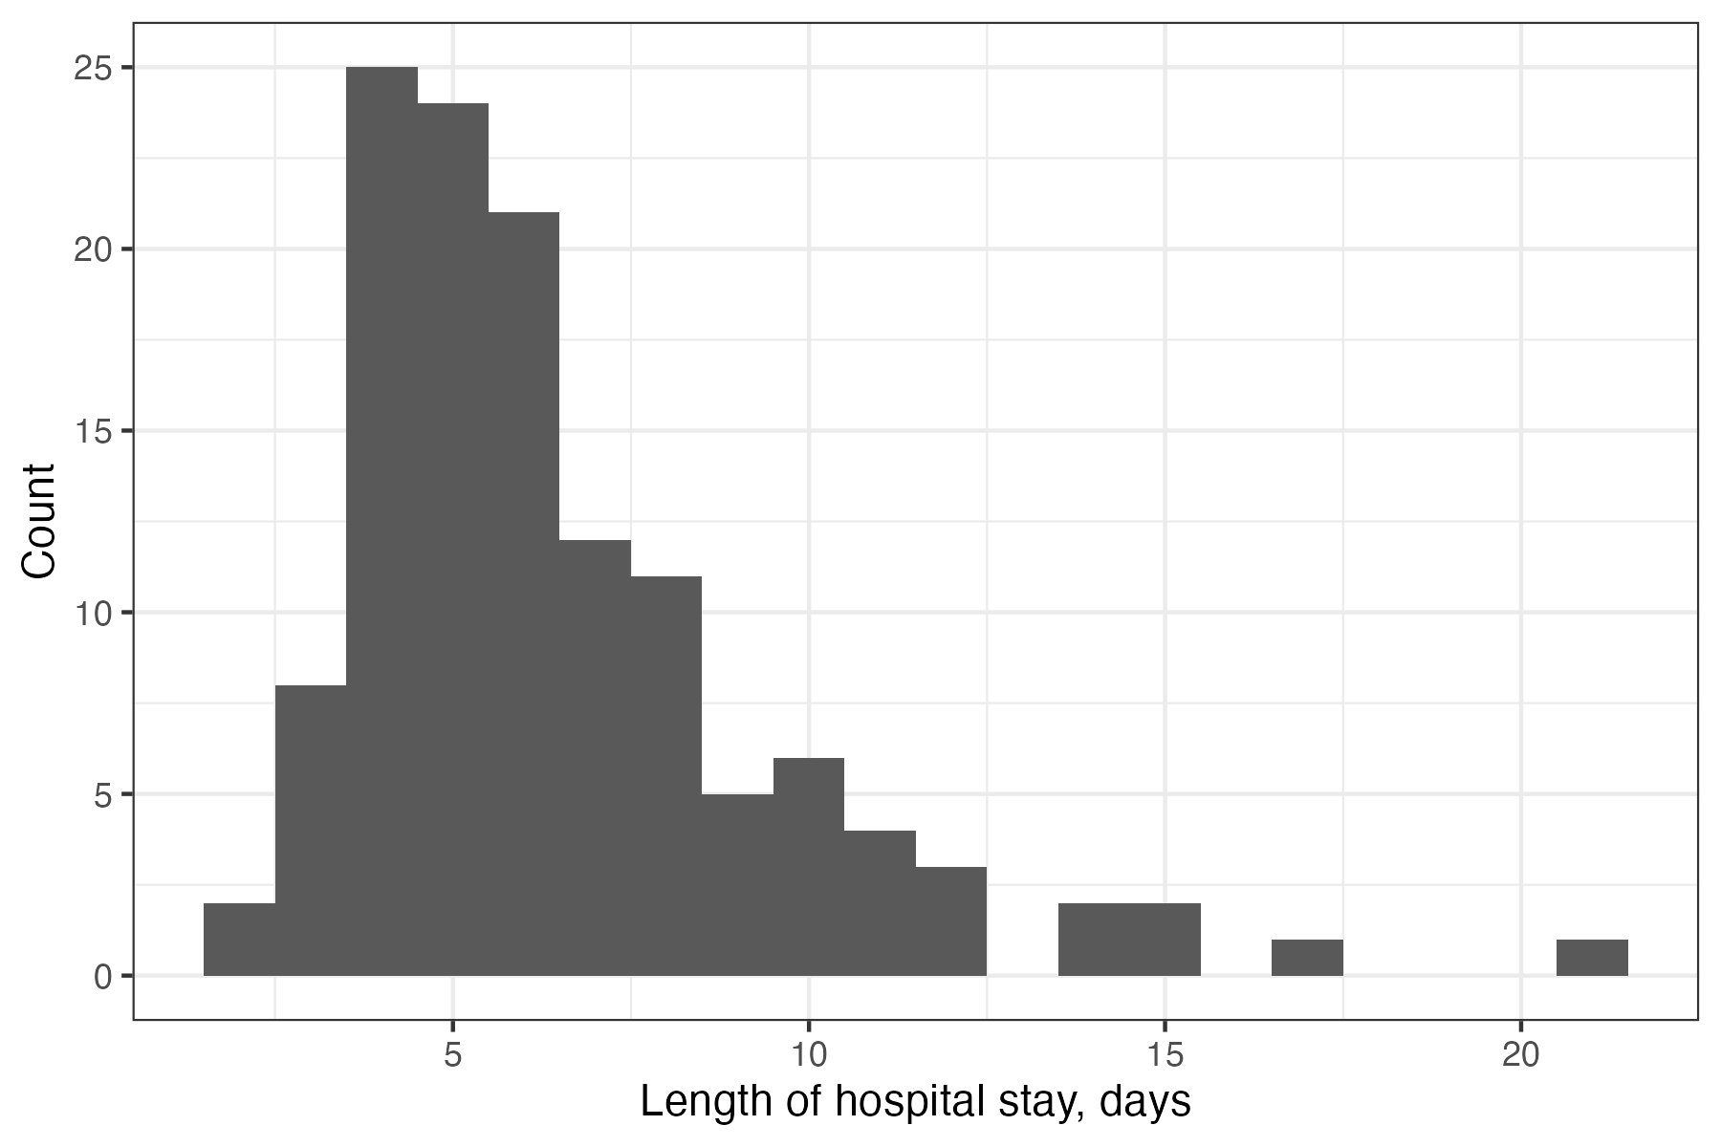
Length of stay was right-skewed, supporting the log-linear primary analysis and Gamma log-link sensitivity analysis.
Appendix Figure A3. Martingale residual functional-form check for DLCO percent predicted
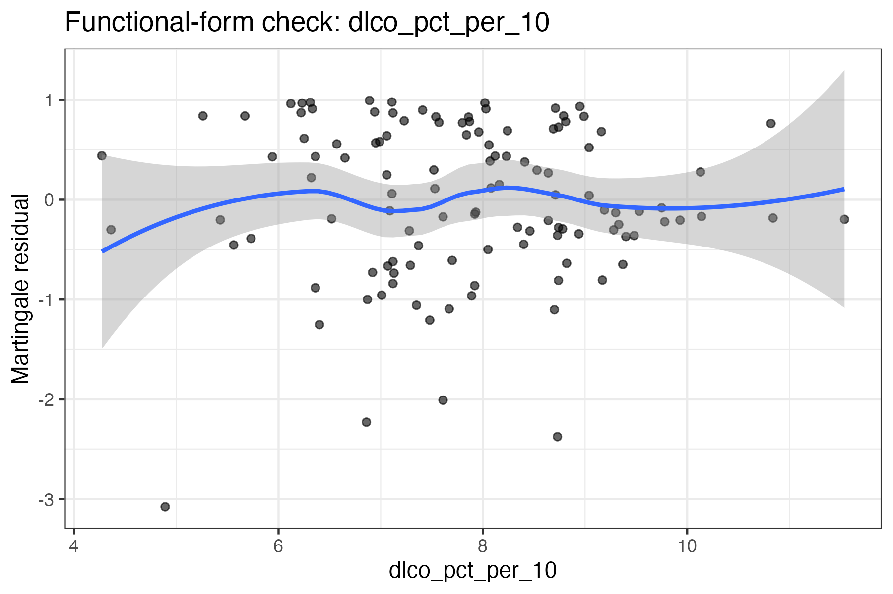
The smoothed residual pattern was inspected for marked nonlinearity. Tail uncertainty reflects limited observations at extreme PFT values.
Appendix Figure A4. Log-linear length-of-stay model diagnostics
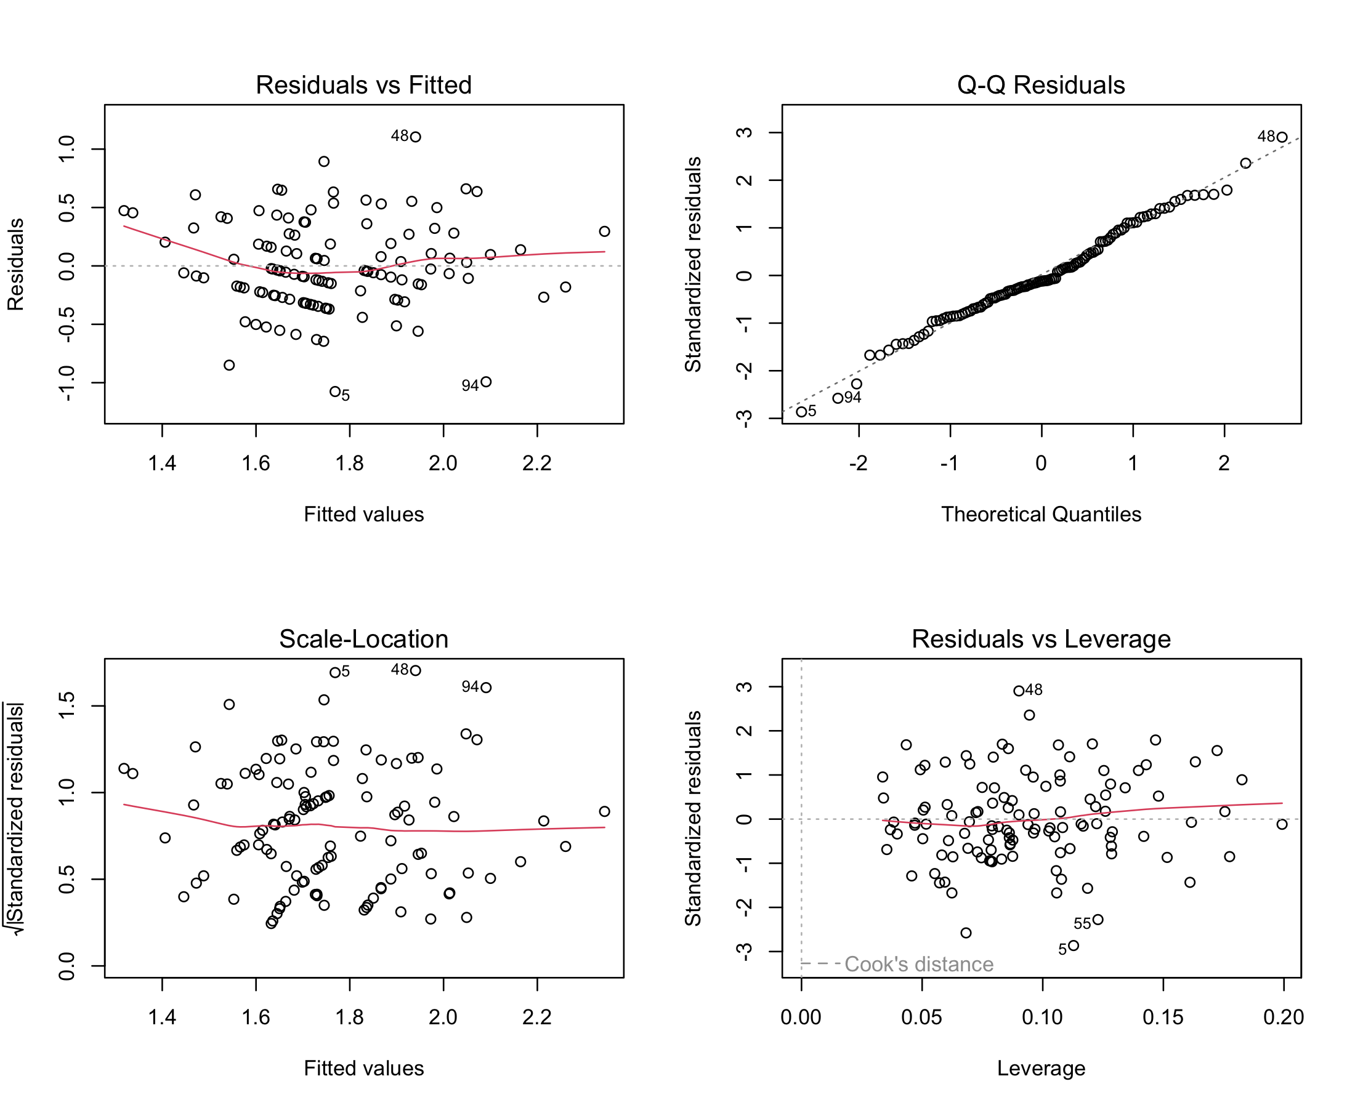
Residual-versus-fitted, normal Q-Q, scale-location, and leverage plots were reviewed. The analysis was supplemented with a Gamma log-link model because residual assumptions may be imperfect for skewed length-of-stay data.

