Appendix: Diagnostics and Sensitivity Analyses

Appendix Table A1. Cohort flow
Step | N
Raw records imported | 130
Positive nonmissing survival time | 130
Known event indicator | 130
Included in survival analysis | 130

Appendix Table A2. Missingness summary
Variable | Missing_N | Total_N | Missing_Percent
dlco | 10 | 130 | 7.7
dlco_percent_of_predicted | 9 | 130 | 6.9
fev1 | 8 | 130 | 6.2
fev_percent_of_predicted | 7 | 130 | 5.4
length_of_hospital_stay | 3 | 130 | 2.3
tumor_size_cm | 3 | 130 | 2.3
cardiac | 2 | 130 | 1.5
histology | 2 | 130 | 1.5
respiratory | 2 | 130 | 1.5
smoking | 2 | 130 | 1.5
age | 0 | 130 | 0.0
anycomp | 0 | 130 | 0.0
cardcomp | 0 | 130 | 0.0
ckd | 0 | 130 | 0.0
deathcomp | 0 | 130 | 0.0
dm | 0 | 130 | 0.0
event | 0 | 130 | 0.0
followup_months | 0 | 130 | 0.0
hilar_ln_involved | 0 | 130 | 0.0
infectcomp | 0 | 130 | 0.0
mediastinal_ln_involved | 0 | 130 | 0.0
othcomorb | 0 | 130 | 0.0
pathologic_stage | 0 | 130 | 0.0
respcomp | 0 | 130 | 0.0
sex | 0 | 130 | 0.0
stroke | 0 | 130 | 0.0
type_of_surgery | 0 | 130 | 0.0

Appendix Table A3. PFT correlation matrix
PFT | fev1 | fev_percent_of_predicted | dlco | dlco_percent_of_predicted
fev1 | 1.0000000 | 0.7741382 | 0.2180496 | 0.1576579
fev_percent_of_predicted | 0.7741382 | 1.0000000 | 0.2062826 | 0.3041018
dlco | 0.2180496 | 0.2062826 | 1.0000000 | 0.7594983
dlco_percent_of_predicted | 0.1576579 | 0.3041018 | 0.7594983 | 1.0000000
The PFT measures are related but are analyzed in separate regression models.

Appendix Table A4. Cox proportional hazards assumption tests
Model | Term | Chisq | df | P value
fev1_per_0_5l | fev1_per_0_5l | 1.298 | 1 | 0.255
fev1_per_0_5l | age | 0.310 | 1 | 0.578
fev1_per_0_5l | sex | 2.729 | 1 | 0.099
fev1_per_0_5l | smoking | 0.223 | 2 | 0.894
fev1_per_0_5l | type_of_surgery | 1.937 | 2 | 0.380
fev1_per_0_5l | pathologic_stage | 1.521 | 2 | 0.468
fev1_per_0_5l | tumor_size_cm | 7.387 | 1 | 0.007
fev1_per_0_5l | GLOBAL | 12.346 | 10 | 0.263
fev_pct_per_10 | fev_pct_per_10 | 0.488 | 1 | 0.485
fev_pct_per_10 | age | 0.488 | 1 | 0.485
fev_pct_per_10 | sex | 1.415 | 1 | 0.234
fev_pct_per_10 | smoking | 0.010 | 2 | 0.995
fev_pct_per_10 | type_of_surgery | 1.706 | 2 | 0.426
fev_pct_per_10 | pathologic_stage | 1.490 | 2 | 0.475
fev_pct_per_10 | tumor_size_cm | 8.920 | 1 | 0.003
fev_pct_per_10 | GLOBAL | 13.595 | 10 | 0.192
dlco_per_5 | dlco_per_5 | 1.463 | 1 | 0.226
dlco_per_5 | age | 0.084 | 1 | 0.771
dlco_per_5 | sex | 2.396 | 1 | 0.122
dlco_per_5 | smoking | 0.052 | 2 | 0.974
dlco_per_5 | type_of_surgery | 3.237 | 2 | 0.198
dlco_per_5 | pathologic_stage | 0.732 | 2 | 0.693
dlco_per_5 | tumor_size_cm | 6.857 | 1 | 0.009
dlco_per_5 | GLOBAL | 17.059 | 10 | 0.073
dlco_pct_per_10 | dlco_pct_per_10 | 3.106 | 1 | 0.078
dlco_pct_per_10 | age | 0.030 | 1 | 0.862
dlco_pct_per_10 | sex | 2.483 | 1 | 0.115
dlco_pct_per_10 | smoking | 0.034 | 2 | 0.983
dlco_pct_per_10 | type_of_surgery | 3.213 | 2 | 0.201
dlco_pct_per_10 | pathologic_stage | 1.995 | 2 | 0.369
dlco_pct_per_10 | tumor_size_cm | 6.365 | 1 | 0.012
dlco_pct_per_10 | GLOBAL | 18.285 | 10 | 0.050

Appendix Table A5. Logistic model stability diagnostics
Model | N | Events | Parameters | Events per parameter | Converged
fev1_per_0_5l | 118 | 26 | 10 | 2.6 | TRUE
fev_pct_per_10 | 118 | 25 | 10 | 2.5 | TRUE
dlco_per_5 | 115 | 26 | 10 | 2.6 | TRUE
dlco_pct_per_10 | 117 | 26 | 10 | 2.6 | TRUE

Appendix Table A6. Full candidate Cox sensitivity models
PFT | Increment | N | Events | Parameters | Events per parameter | Adjusted HR (95% CI) | P value | Note
FEV1 | per 0.5-L increase | 112 | 68 | 20 | 3.4 | Not fit |  | Skipped because events per parameter were <5.
FEV1 percent predicted | per 10-percentage-point increase | 112 | 69 | 20 | 3.5 | Not fit |  | Skipped because events per parameter were <5.
DLCO | per 5-unit increase | 109 | 64 | 20 | 3.2 | Not fit |  | Skipped because events per parameter were <5.
DLCO percent predicted | per 10-percentage-point increase | 111 | 68 | 20 | 3.4 | Not fit |  | Skipped because events per parameter were <5.
These models are secondary because the wider candidate set may be unstable in a small cohort.

Appendix Table A7. Selected secondary complication models
Outcome | PFT | N | Adjusted OR (95% CI) | P value | Note
None |  |  |  |  | No secondary complication/PFT pair met the prespecified screening criterion.

Appendix Table A8. Gamma log-link LOS sensitivity models
PFT | Increment | N | Adjusted mean ratio (95% CI) | P value
FEV1 | per 0.5-L increase | 117 | 1.06 (0.97, 1.16) | 0.174
FEV1 percent predicted | per 10-percentage-point increase | 115 | 1.00 (0.94, 1.07) | 0.933
DLCO | per 5-unit increase | 112 | 0.90 (0.80, 1.01) | 0.079
DLCO percent predicted | per 10-percentage-point increase | 115 | 0.94 (0.88, 0.99) | 0.037

Appendix_LOS_distribution
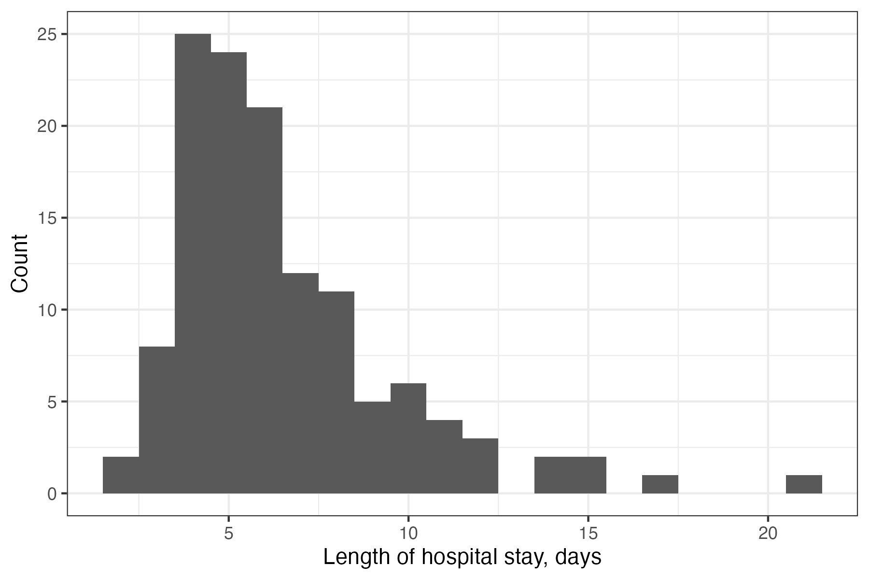

Appendix_LOS_residual_diagnostics
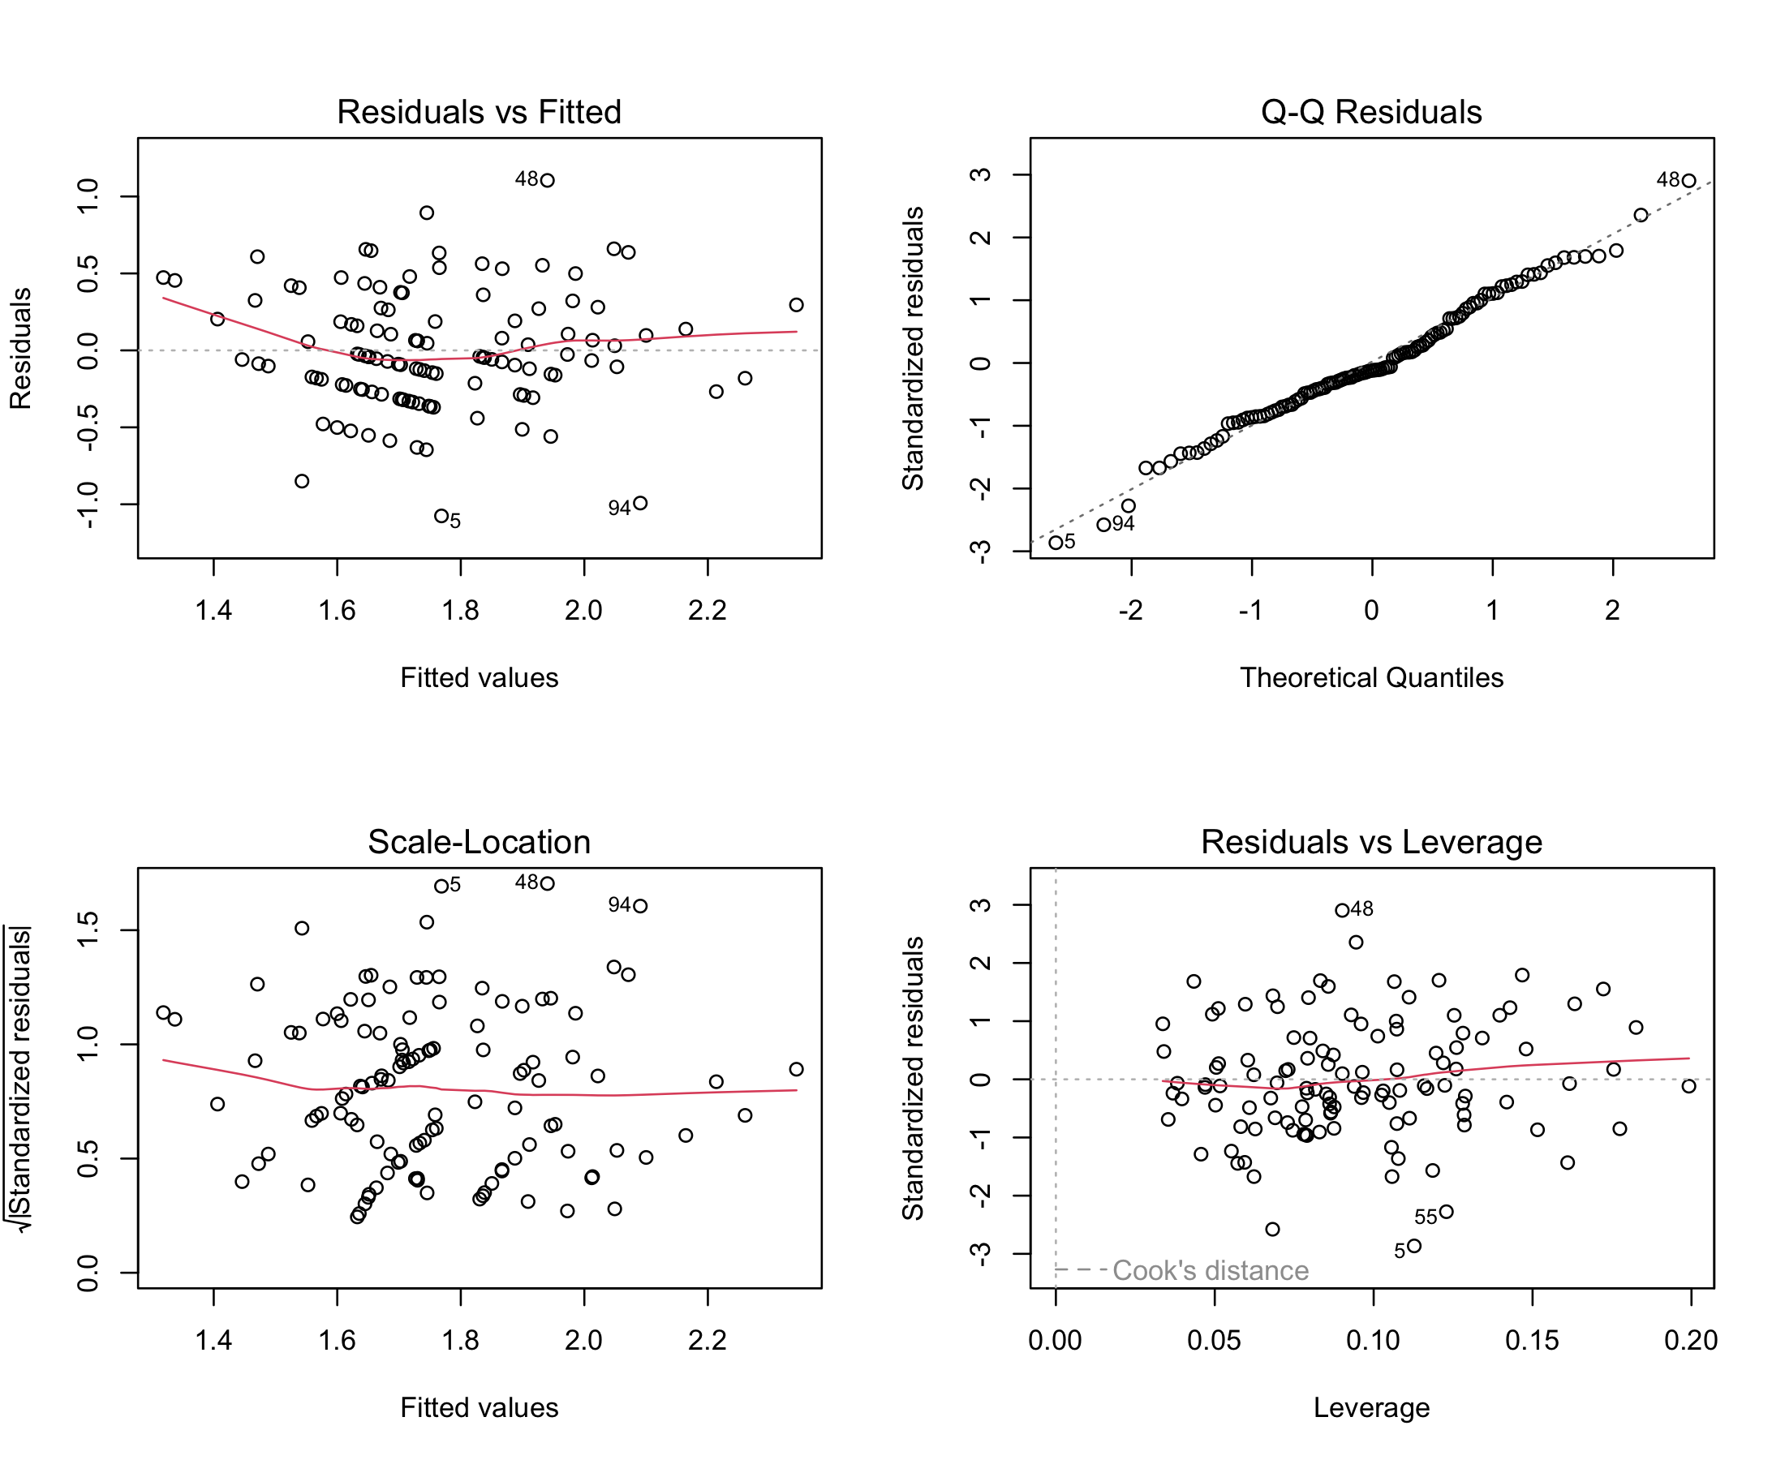

Appendix_Martingale_dlco_pct_per_10
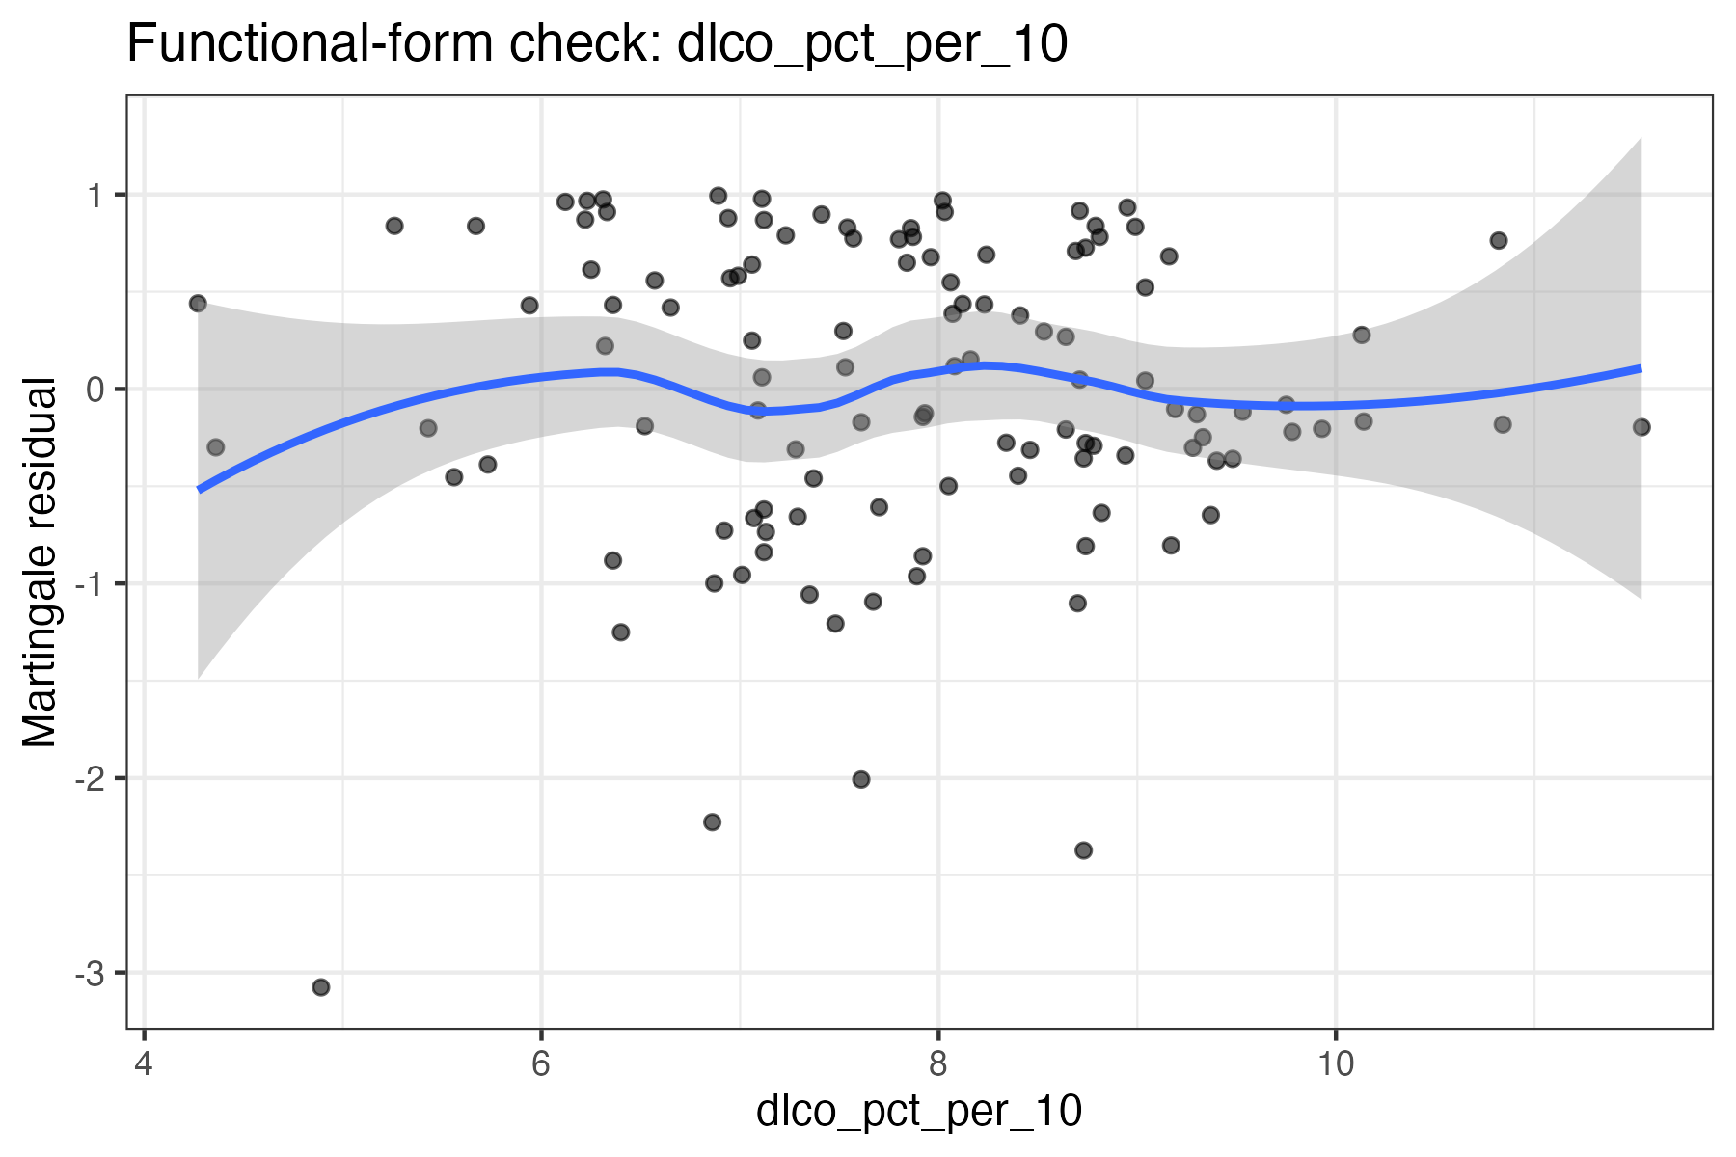

Appendix_Martingale_dlco_per_5
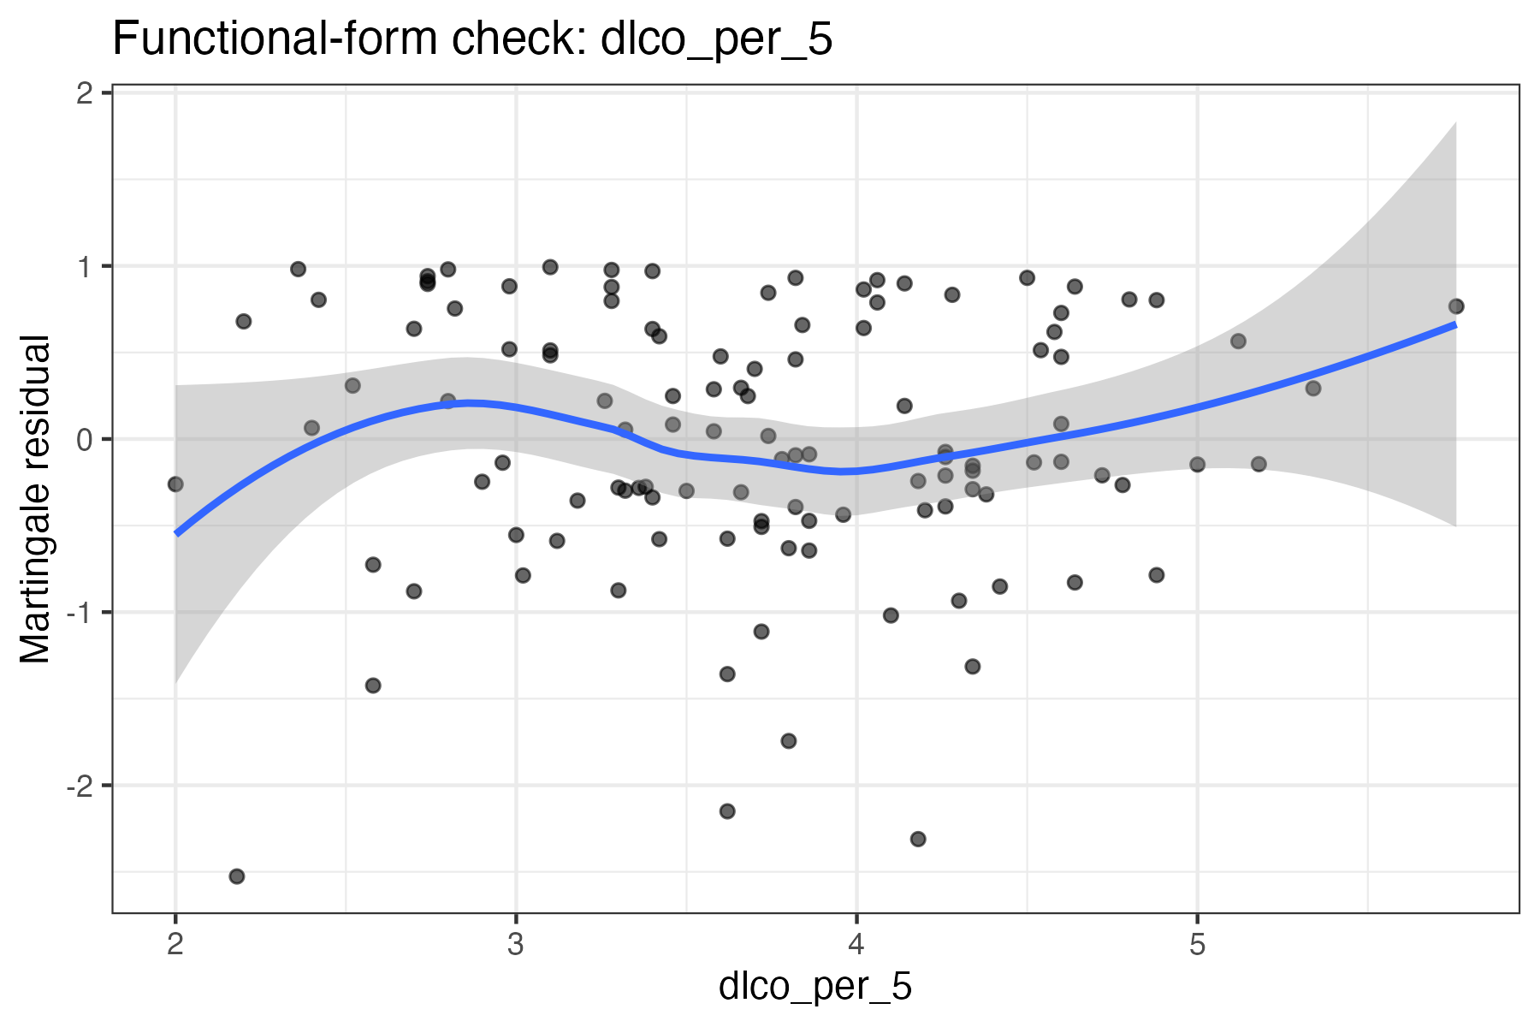

Appendix_Martingale_fev_pct_per_10
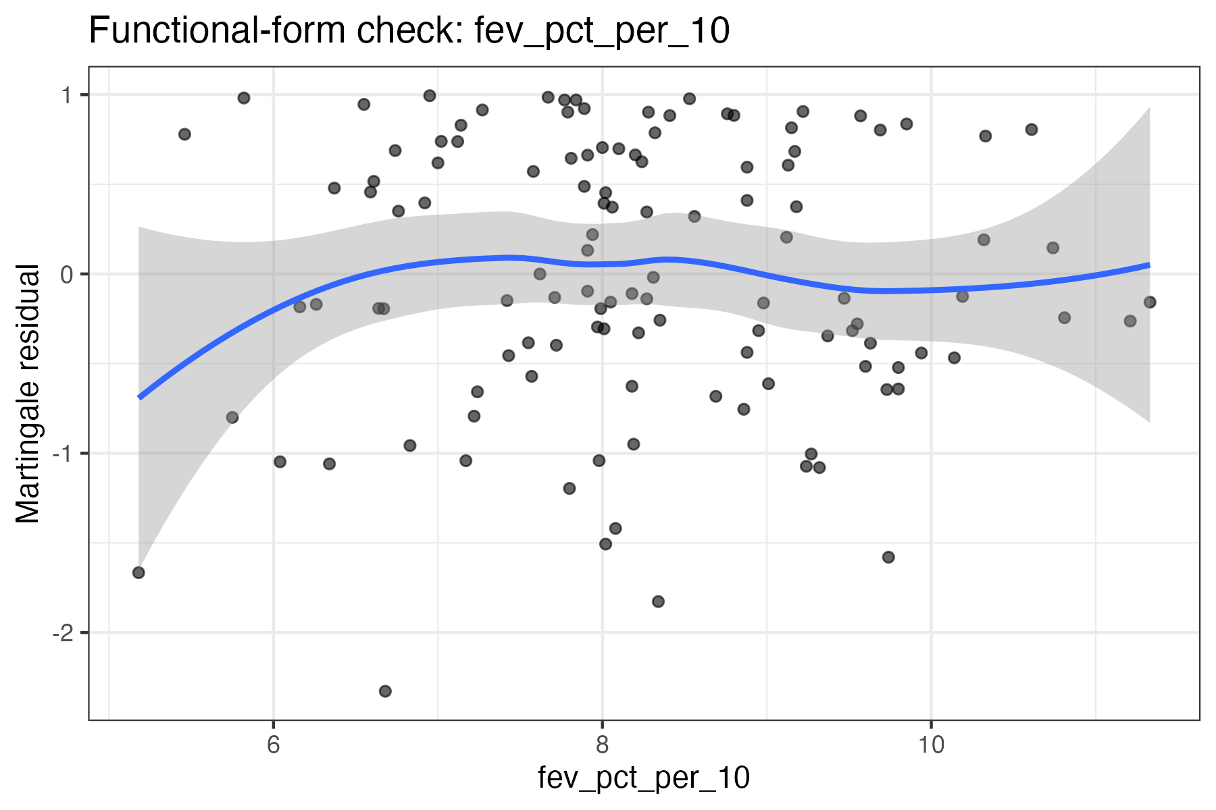

Appendix_Martingale_fev1_per_0_5l
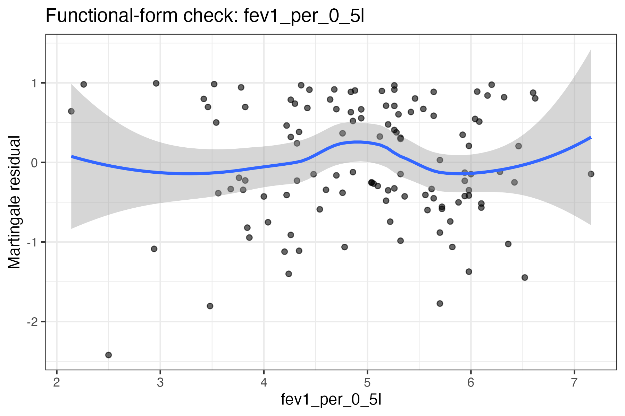

Appendix_PH_dlco_pct_per_10
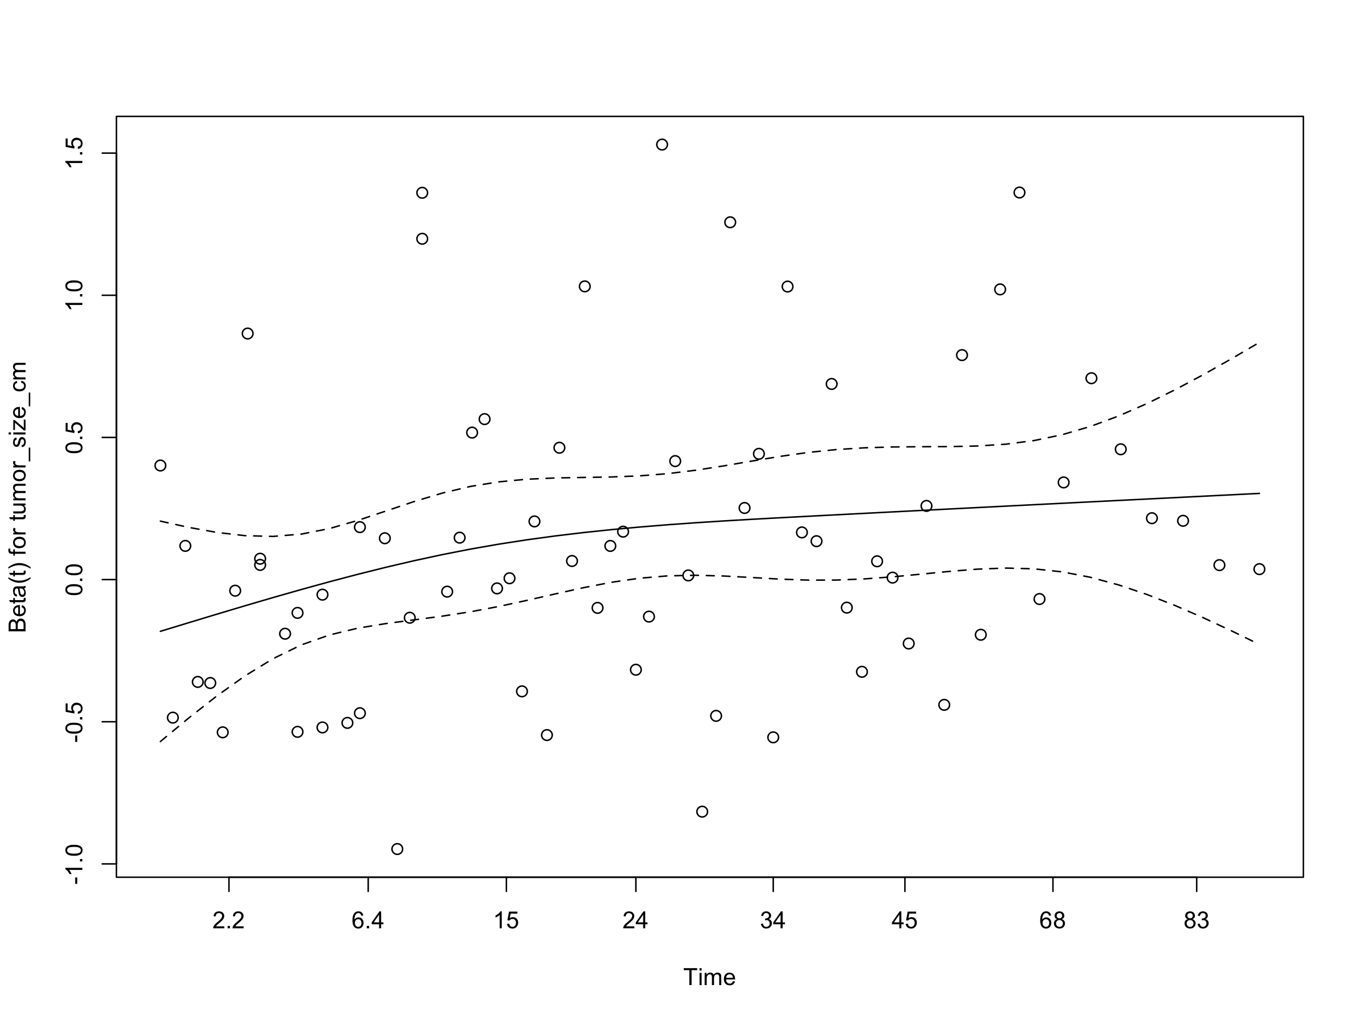

Appendix_PH_dlco_per_5
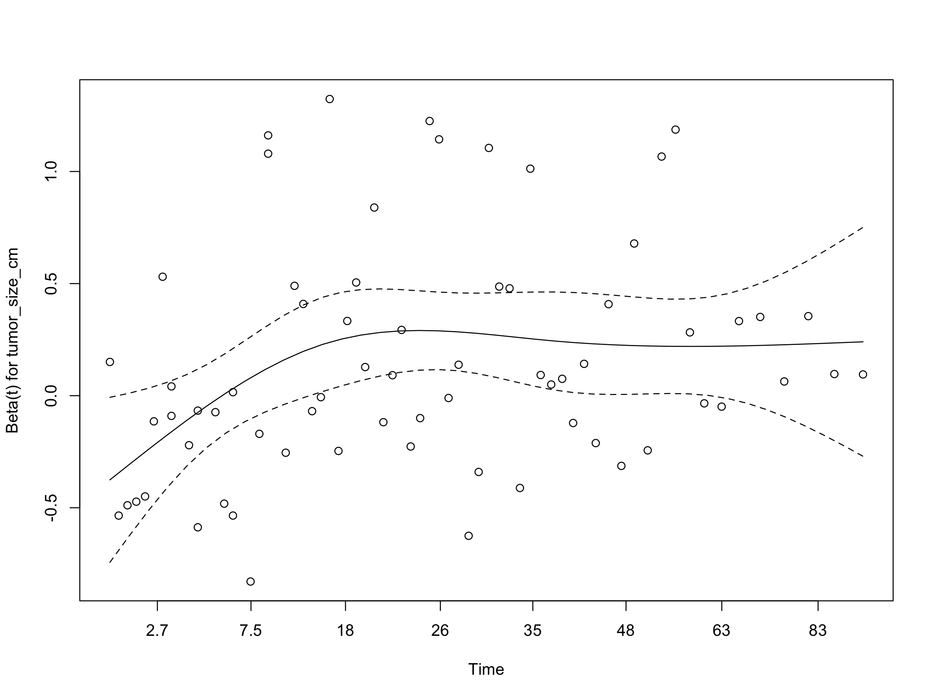

Appendix_PH_fev_pct_per_10
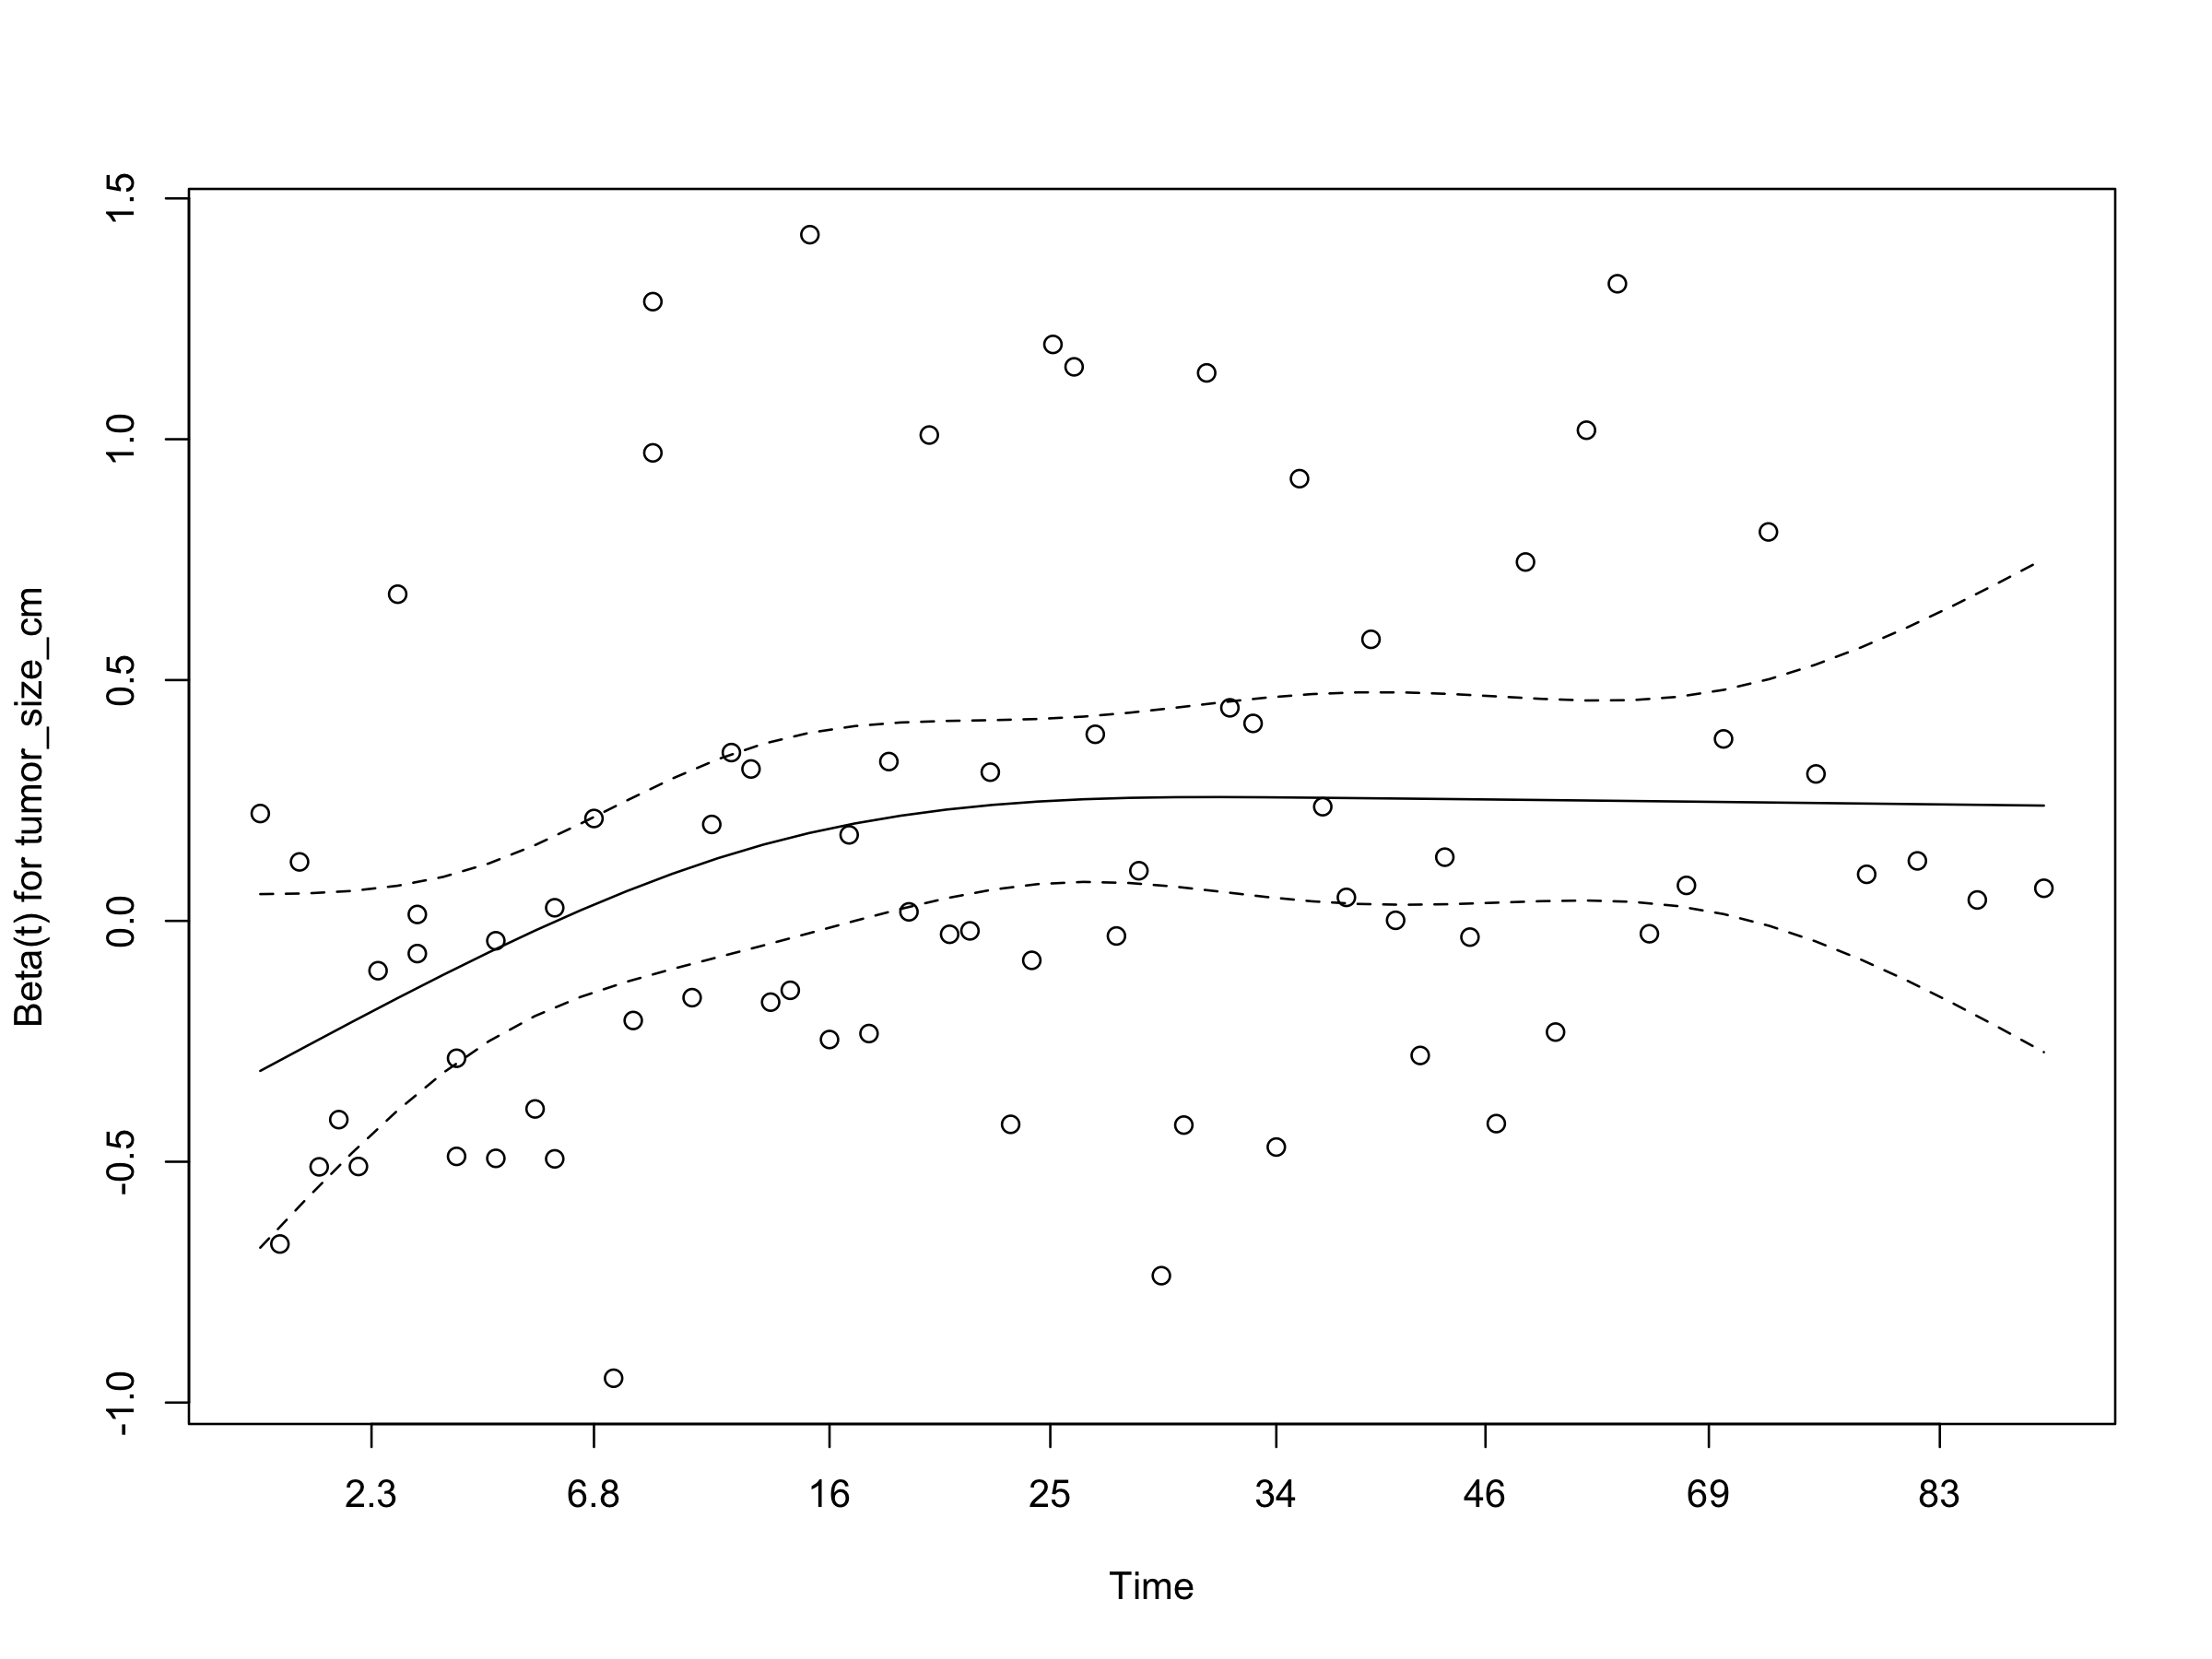

Appendix_PH_fev1_per_0_5l
