QE2022 Applied Practice: Pulmonary Function, Lung Cancer Outcomes, and Survival
Generated: 2026-06-24
Synthetic practice data only. Interpretations must be written from the actual final output.

Table 1A. Baseline continuous characteristics
Characteristic | N | Mean (SD) | Median (Q1, Q3) | Missing
Age, years | 130 | 65.5 (8.6) | 66.0 (59.2, 71.0) | 0
Tumor size, cm | 127 | 3.4 (2.0) | 3.0 (2.0, 4.4) | 3
Length of hospital stay, days | 127 | 6.5 (3.1) | 6.0 (4.0, 8.0) | 3

Table 1B. Baseline categorical characteristics
Characteristic | Level | Summary
Sex | Female | 52 (40.0%)
Sex | Male | 52 (40.0%)
Smoking status | Never | 25 (19.5%)
Smoking status | Former | 25 (19.5%)
Smoking status | Current | 25 (19.5%)
Type of surgery | Wedge/segmentectomy | 21 (16.2%)
Type of surgery | Lobectomy | 21 (16.2%)
Type of surgery | Pneumonectomy | 21 (16.2%)
Pathologic stage | I | 71 (54.6%)
Pathologic stage | II | 71 (54.6%)
Pathologic stage | III | 71 (54.6%)
Histology | Adenocarcinoma | 86 (67.2%)
Histology | Other | 86 (67.2%)
Histology | Squamous cell carcinoma | 86 (67.2%)
Respiratory comorbidity | No | 105 (82.0%)
Respiratory comorbidity | Yes | 105 (82.0%)
Cardiac comorbidity | No | 104 (81.2%)
Cardiac comorbidity | Yes | 104 (81.2%)
Diabetes | No | 119 (91.5%)
Diabetes | Yes | 119 (91.5%)

Table 2. Pulmonary function test summary
Characteristic | N | Mean (SD) | Median (Q1, Q3) | Missing
FEV1 | 122 | 2.5 (0.5) | 2.6 (2.2, 2.9) | 8
FEV1 percent predicted | 123 | 82.2 (12.3) | 80.8 (75.4, 91.2) | 7
DLCO | 120 | 18.5 (3.8) | 18.6 (16.2, 21.3) | 10
DLCO percent predicted | 121 | 77.8 (13.4) | 78.6 (69.9, 87.3) | 9
The four PFT measures should not be entered together in the same multivariable model.

Table 3. Outcome summary
Outcome | n (%)
Deaths | 81 (62.3%)
Censored | 49 (37.7%)
Any postoperative complication | 30 (23.1%)
Respiratory complication | 12 (9.2%)
Cardiac complication | 6 (4.6%)
Infectious complication | 6 (4.6%)
Postoperative death complication | 2 (1.5%)

Figure 1. Pulmonary function distributions
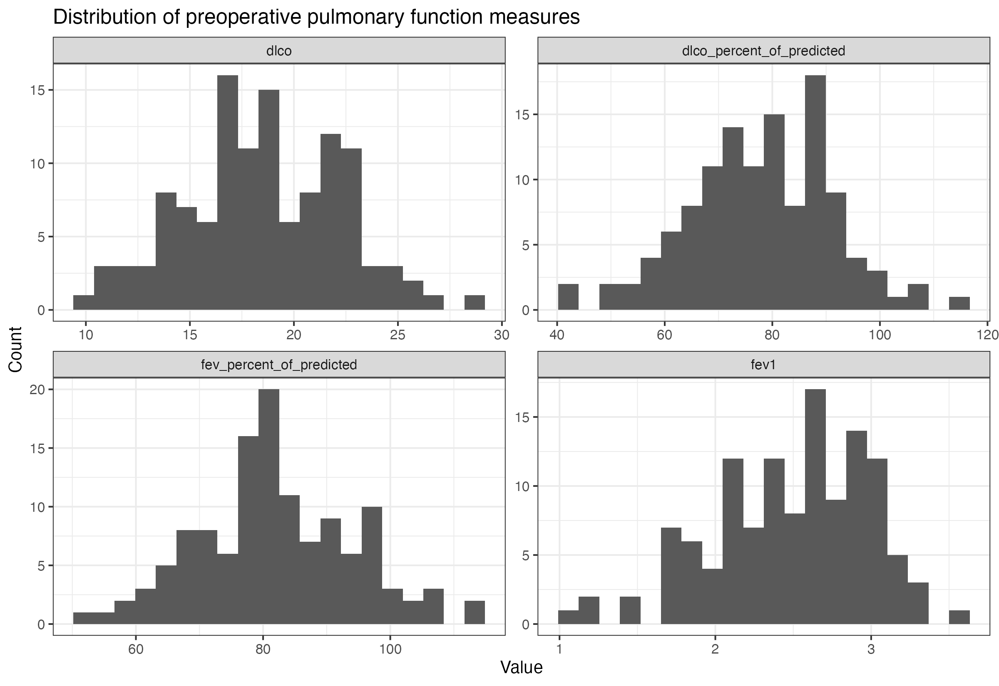

Figure 2. Overall Kaplan-Meier survival curve
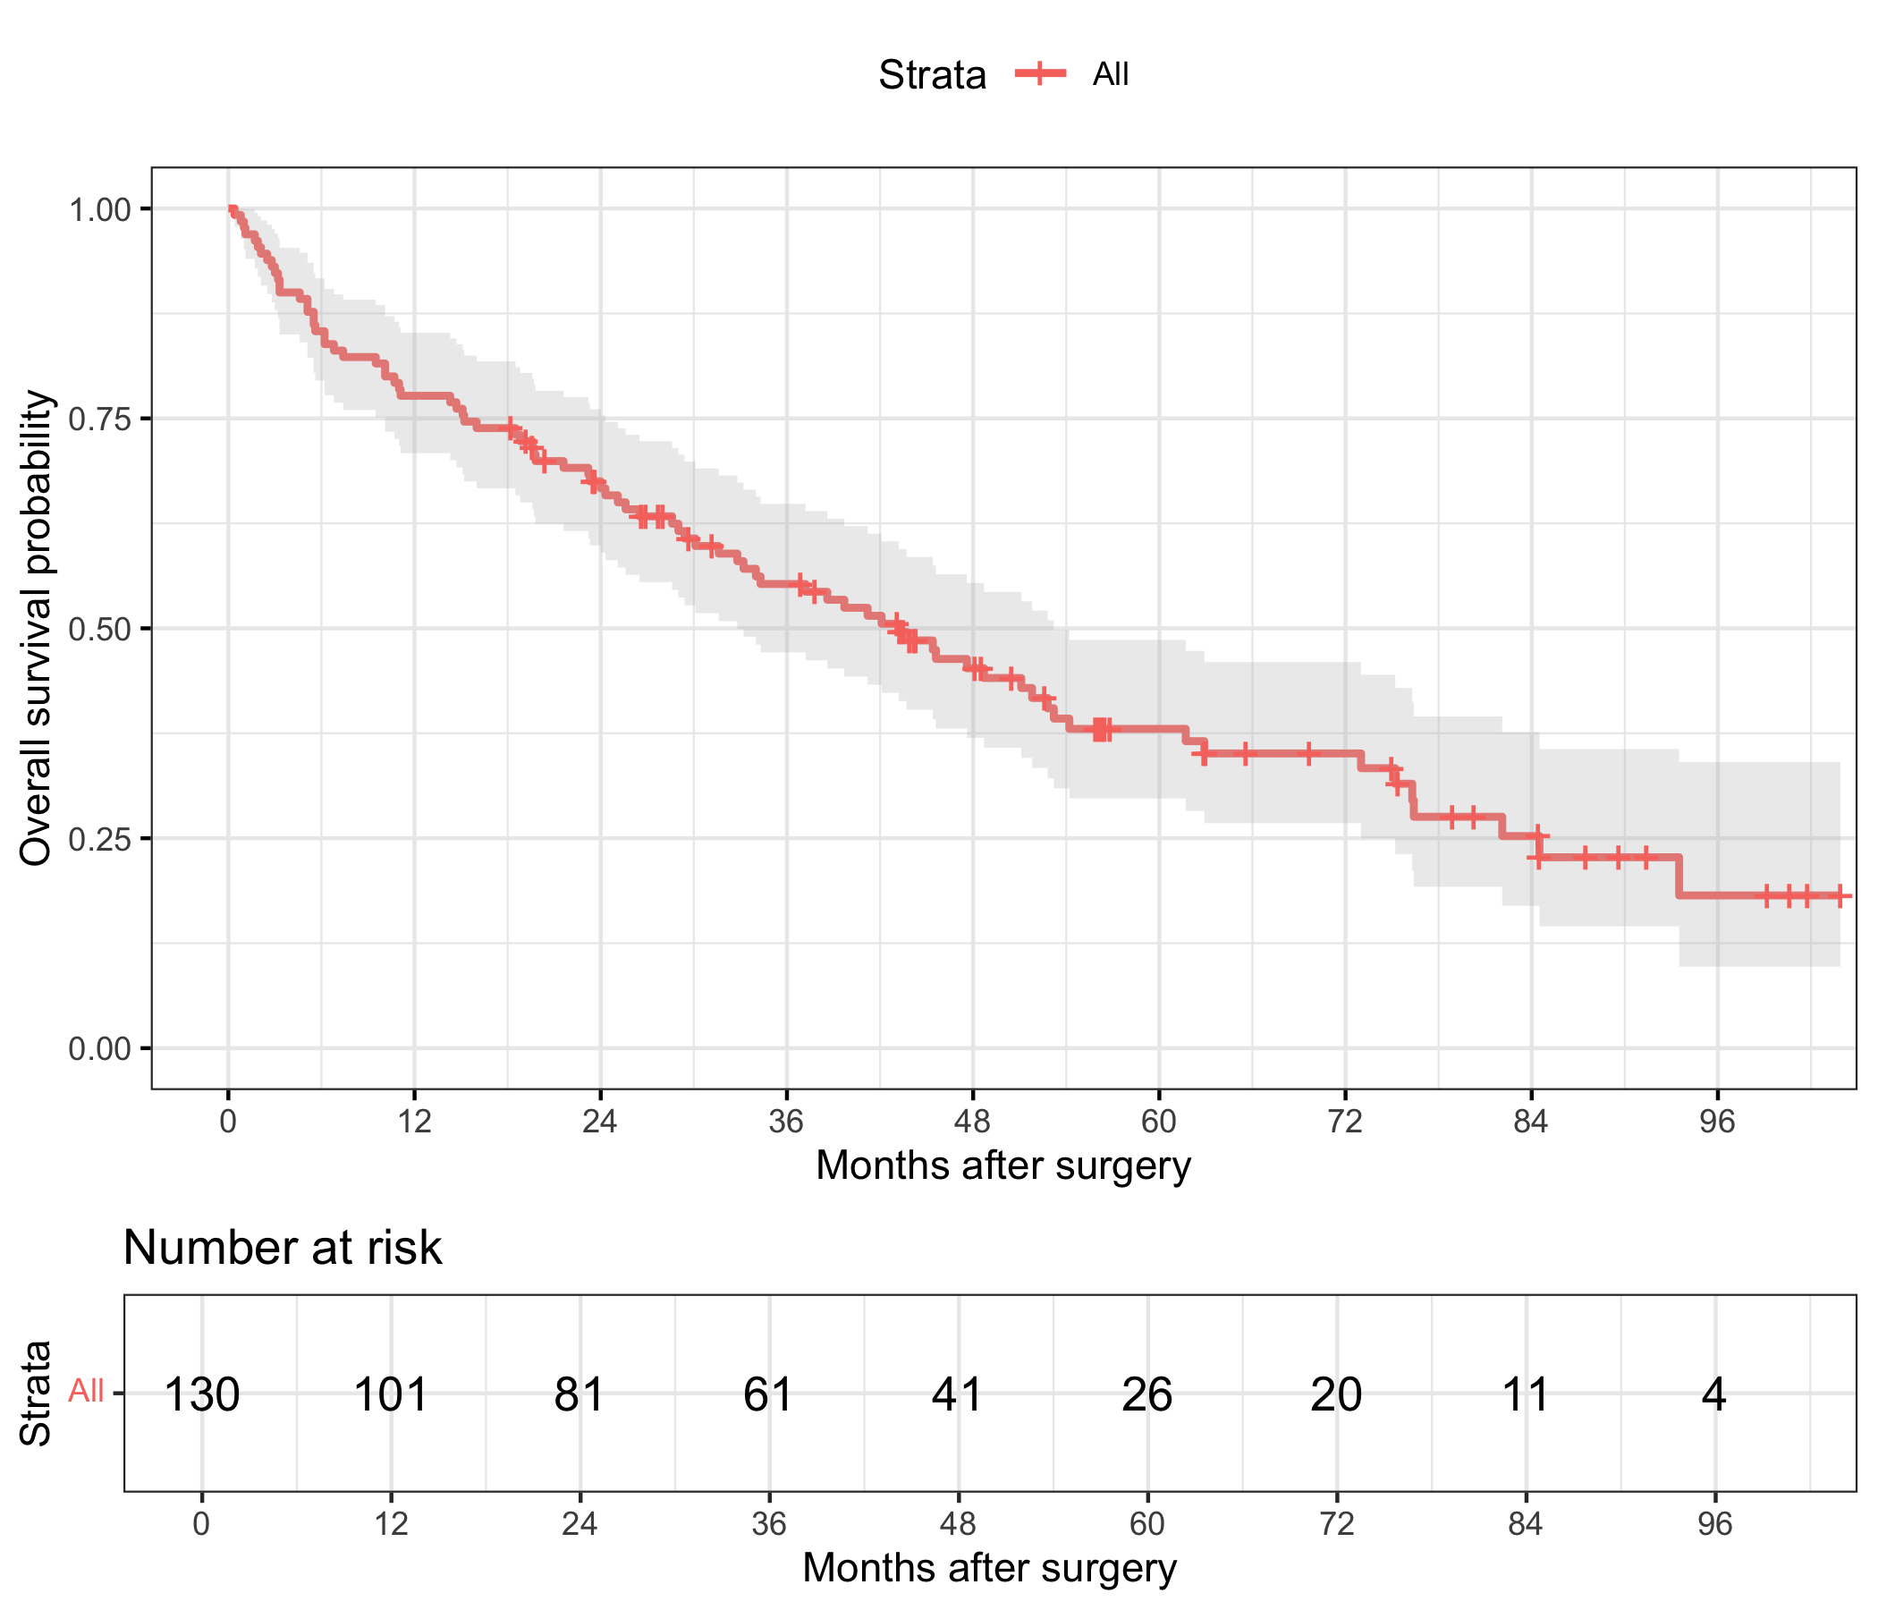

Figure 3. Adjusted associations of PFT with overall survival
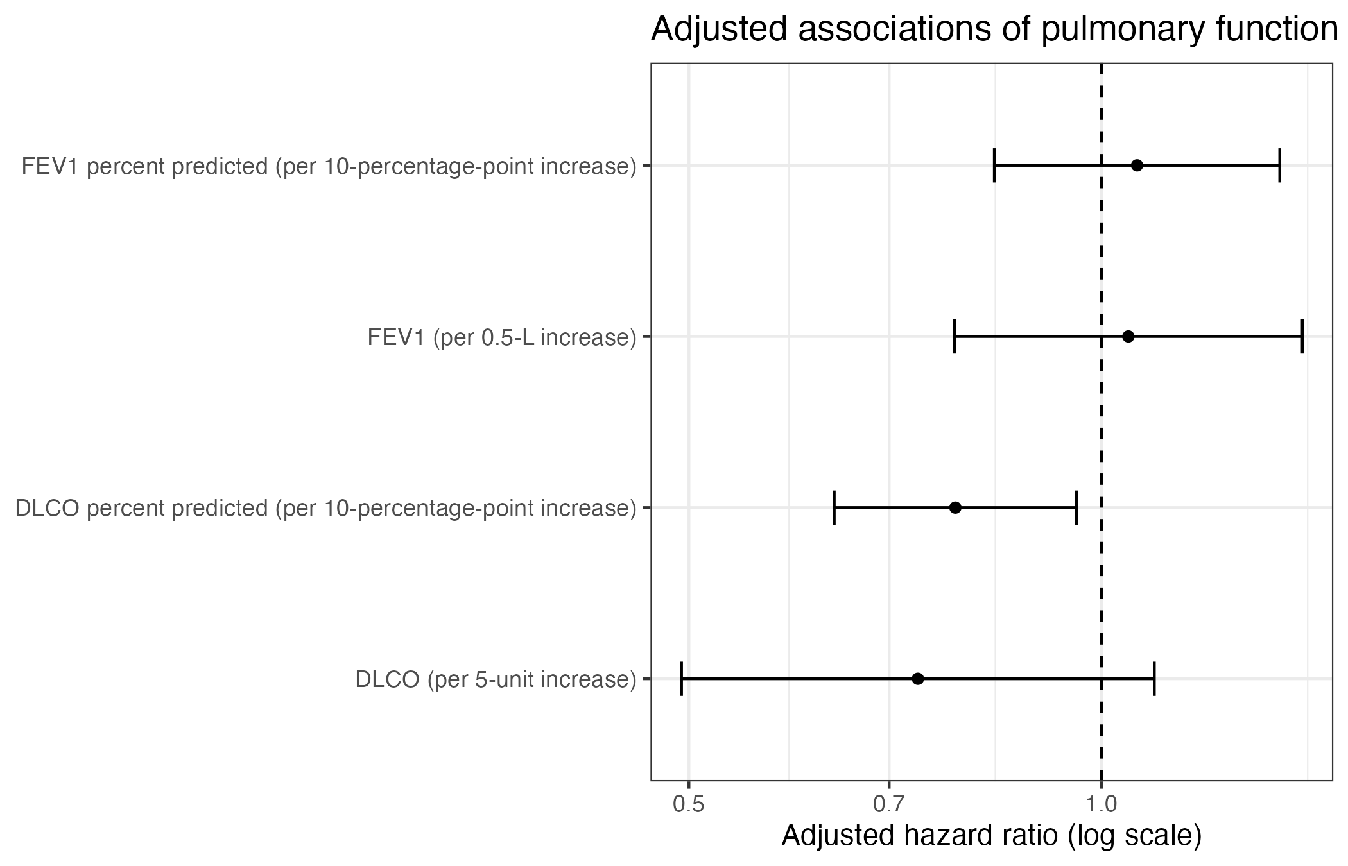

Table 4. Univariate Cox proportional hazards models
Model | term | HR (95% CI) | P value
Univariate: age | age | 1.03 (1.00, 1.06) | 0.019
Univariate: sex | sexMale | 1.82 (1.14, 2.92) | 0.012
Univariate: smoking | smokingFormer | 3.24 (1.53, 6.84) | 0.002
Univariate: smoking | smokingCurrent | 3.13 (1.34, 7.27) | 0.008
Univariate: type_of_surgery | type_of_surgeryLobectomy | 1.01 (0.52, 1.96) | 0.973
Univariate: type_of_surgery | type_of_surgeryPneumonectomy | 1.65 (0.80, 3.40) | 0.176
Univariate: pathologic_stage | pathologic_stageII | 1.70 (1.00, 2.90) | 0.050
Univariate: pathologic_stage | pathologic_stageIII | 3.64 (2.09, 6.34) | <0.001
Univariate: histology | histologyOther | 0.86 (0.44, 1.70) | 0.667
Univariate: histology | histologySquamous cell carcinoma | 0.86 (0.50, 1.49) | 0.601
Univariate: tumor_size_cm | tumor_size_cm | 1.23 (1.11, 1.37) | <0.001
Univariate: hilar_ln_involved | hilar_ln_involvedYes | 1.56 (0.97, 2.53) | 0.067
Univariate: mediastinal_ln_involved | mediastinal_ln_involvedYes | 1.57 (0.88, 2.81) | 0.124
Univariate: respiratory | respiratoryYes | 2.25 (1.34, 3.79) | 0.002
Univariate: cardiac | cardiacYes | 1.26 (0.72, 2.23) | 0.421
Univariate: stroke | strokeYes | 1.31 (0.53, 3.24) | 0.563
Univariate: ckd | ckdYes | 0.78 (0.19, 3.16) | 0.724
Univariate: dm | dmYes | 0.71 (0.29, 1.75) | 0.452
Univariate: othcomorb | othcomorbYes | 0.74 (0.41, 1.35) | 0.329
Univariate: fev1_per_0_5l | fev1_per_0_5l | 0.91 (0.72, 1.15) | 0.423
Univariate: fev_pct_per_10 | fev_pct_per_10 | 0.86 (0.72, 1.02) | 0.090
Univariate: dlco_per_5 | dlco_per_5 | 0.76 (0.56, 1.03) | 0.080
Univariate: dlco_pct_per_10 | dlco_pct_per_10 | 0.72 (0.61, 0.85) | <0.001

Table 5. Four separate adjusted Cox models for pulmonary function
PFT | Increment | N | Adjusted HR (95% CI) | P value
FEV1 | per 0.5-L increase | 118 | 1.05 (0.78, 1.40) | 0.761
FEV1 percent predicted | per 10-percentage-point increase | 118 | 1.06 (0.84, 1.35) | 0.624
DLCO | per 5-unit increase | 115 | 0.73 (0.49, 1.09) | 0.128
DLCO percent predicted | per 10-percentage-point increase | 117 | 0.78 (0.64, 0.96) | 0.018
Each row is from a separate adjusted Cox model. HRs are expressed per clinically interpretable PFT increment.

Table 6. PFT effect-modification screening
PFT | Modifier | N | LRT | df | P value
DLCO | pathologic_stage | 115 | 5.889 | 2 | 0.053
FEV1 percent predicted | respiratory | 116 | 3.723 | 1 | 0.054
FEV1 | age | 118 | 3.425 | 1 | 0.064
FEV1 percent predicted | age | 118 | 2.986 | 1 | 0.084
FEV1 percent predicted | smoking | 118 | 4.936 | 2 | 0.085
DLCO | sex | 115 | 2.742 | 1 | 0.098
DLCO percent predicted | sex | 117 | 2.299 | 1 | 0.129
DLCO | age | 115 | 1.581 | 1 | 0.209
DLCO percent predicted | age | 117 | 1.313 | 1 | 0.252
DLCO percent predicted | smoking | 117 | 2.184 | 2 | 0.336
DLCO percent predicted | pathologic_stage | 117 | 1.815 | 2 | 0.403
FEV1 percent predicted | pathologic_stage | 118 | 1.669 | 2 | 0.434
DLCO | smoking | 115 | 1.376 | 2 | 0.503
FEV1 | respiratory | 116 | 0.400 | 1 | 0.527
DLCO percent predicted | respiratory | 115 | 0.397 | 1 | 0.529
DLCO | respiratory | 113 | 0.140 | 1 | 0.708
FEV1 | smoking | 118 | 0.677 | 2 | 0.713
FEV1 | sex | 118 | 0.104 | 1 | 0.747
FEV1 percent predicted | sex | 118 | 0.014 | 1 | 0.904
FEV1 | pathologic_stage | 118 | 0.150 | 2 | 0.928
Likelihood-ratio tests compare models with and without the stated PFT-by-modifier interaction.

Table 7. Unadjusted PFT comparisons by postoperative complication
Outcome | PFT | N | No complication, median (IQR) | Complication, median (IQR) | P value
Any postoperative complication | FEV1 | 122 | 2.6 (2.2, 2.9) | 2.5 (2.0, 3.0) | 0.831
Any postoperative complication | FEV1 percent predicted | 123 | 81.9 (75.7, 91.4) | 79.4 (71.8, 84.3) | 0.217
Any postoperative complication | DLCO | 120 | 18.6 (16.5, 21.6) | 18.3 (14.7, 20.2) | 0.187
Any postoperative complication | DLCO percent predicted | 121 | 79.3 (70.6, 87.4) | 75.3 (65.2, 82.9) | 0.250
Respiratory complication | FEV1 | 122 | 2.6 (2.2, 2.9) | 2.6 (2.1, 2.9) | 0.848
Respiratory complication | FEV1 percent predicted | 123 | 81.4 (75.5, 91.3) | 79.4 (72.2, 83.8) | 0.383
Respiratory complication | DLCO | 120 | 18.6 (16.4, 21.3) | 18.4 (14.8, 20.4) | 0.713
Respiratory complication | DLCO percent predicted | 121 | 79.2 (70.6, 87.4) | 73.0 (58.9, 81.0) | 0.226
Cardiac complication | FEV1 | 122 | 2.6 (2.2, 2.9) | 2.2 (2.1, 2.4) | 0.472
Cardiac complication | FEV1 percent predicted | 123 | 81.4 (75.3, 91.5) | 78.7 (78.4, 80.2) | 0.377
Cardiac complication | DLCO | 120 | 18.4 (16.0, 21.3) | 18.9 (17.4, 19.1) | 1.000
Cardiac complication | DLCO percent predicted | 121 | 78.6 (69.7, 87.3) | 77.8 (74.9, 81.8) | 0.995
Infectious complication | FEV1 | 122 | 2.6 (2.2, 2.9) | 2.8 (2.5, 3.1) | 0.201
Infectious complication | FEV1 percent predicted | 123 | 80.9 (75.3, 90.9) | 80.0 (76.1, 98.0) | 0.673
Infectious complication | DLCO | 120 | 18.6 (16.4, 21.3) | 16.8 (14.9, 22.9) | 0.952
Infectious complication | DLCO percent predicted | 121 | 78.5 (69.8, 87.3) | 79.2 (72.9, 82.3) | 0.815
Postoperative death complication | FEV1 | 122 | 2.6 (2.2, 2.9) | 2.1 (2.0, 2.3) | 0.226
Postoperative death complication | FEV1 percent predicted | 123 | 80.8 (75.3, 91.3) | 79.2 (77.5, 81.0) | 0.704
Postoperative death complication | DLCO | 120 | 18.6 (16.0, 21.3) | 18.3 (18.3, 18.3) | 0.910
Postoperative death complication | DLCO percent predicted | 121 | 78.5 (69.8, 87.3) | 84.6 (84.6, 84.6) | 0.557

Table 8. Adjusted logistic models for any postoperative complication
PFT | Increment | N | Adjusted OR (95% CI) | P value
FEV1 | per 0.5-L increase | 118 | 0.94 (0.55, 1.61) | 0.829
FEV1 percent predicted | per 10-percentage-point increase | 118 | 0.81 (0.50, 1.29) | 0.373
DLCO | per 5-unit increase | 115 | 0.77 (0.37, 1.58) | 0.470
DLCO percent predicted | per 10-percentage-point increase | 117 | 0.93 (0.62, 1.41) | 0.734
Each row is from a separate multivariable logistic model; OR must not be described as a risk ratio.

Table 9. Adjusted log-linear models for length of stay
PFT | Increment | N | Adjusted geometric mean ratio (95% CI) | P value
FEV1 | per 0.5-L increase | 117 | 1.06 (0.97, 1.15) | 0.208
FEV1 percent predicted | per 10-percentage-point increase | 115 | 1.00 (0.94, 1.07) | 0.916
DLCO | per 5-unit increase | 112 | 0.92 (0.82, 1.04) | 0.177
DLCO percent predicted | per 10-percentage-point increase | 115 | 0.95 (0.89, 1.01) | 0.076
Exponentiated coefficients are ratios of geometric mean length of stay.

