Procedure Type and 30-Day Outcomes After Bariatric Surgery: A Synthetic NSQIP Applied-Practice Analysis
Technical Report, High-Journal-Standard Practice Version
Based on synthetic practice data generated to mimic the 2024 Ph.D. Applied Qualifying Exam structure
Generated for exam preparation, not for clinical inference or publication
Key finding in this synthetic analysis: gastric bypass was associated with higher unadjusted complication rates, higher complication counts, higher reoperation rates, and longer hospital stay than gastric banding. After covariate adjustment with age and BMI interaction terms, there was no evidence that the procedure effect on any complication or complication count varied by age or BMI. Severe ASA status remained associated with higher odds and rates of complications.
Report contents: Abstract; Introduction; Methods; Results; Discussion; References; Appendix.

Abstract
Background: Bariatric procedures differ in invasiveness and perioperative risk. This synthetic applied-practice analysis evaluates whether 30-day postoperative outcomes differ between laparoscopic adjustable gastric banding and laparoscopic Roux-en-Y gastric bypass, and whether procedure-associated differences vary by age or body mass index (BMI).
Methods: A synthetic NSQIP-like cohort of 2,400 adults undergoing bariatric surgery was analyzed. The primary outcome was any postoperative surgical complication, defined as the occurrence of at least one specified postoperative complication. Secondary outcomes included number of complications, mortality, reoperation, length of hospital stay, and individual complications. Baseline characteristics and outcomes were summarized by procedure type using Wilcoxon rank-sum and chi-square or Fisher exact tests as appropriate. Multivariable logistic regression was used for any complication, and Poisson regression was used for complication counts after evaluation of overdispersion. Procedure-by-age and procedure-by-BMI interactions were evaluated using likelihood-ratio tests.
Results: Among 2,400 synthetic patients, 890 underwent gastric banding and 1,510 underwent gastric bypass. Bypass patients were slightly older, had higher BMI, and more often had severe ASA status. The unadjusted complication rate was higher for bypass than banding (39% versus 23%), as were the mean number of complications (0.43 versus 0.25), reoperation (4.2% versus 2.4%), and median length of stay (3 versus 2 days). In univariate models, bypass was associated with higher odds of any complication (odds ratio [OR], 2.11; 95% confidence interval [CI], 1.75-2.55) and higher complication rate (incidence rate ratio [IRR], 1.73; 95% CI, 1.49-2.01). In adjusted models including interaction terms, neither procedure-by-age nor procedure-by-BMI interaction improved model fit for any complication (likelihood-ratio P = 0.641) or number of complications (P = 0.437).
Conclusions: In this synthetic practice analysis, gastric bypass showed a higher unadjusted burden of postoperative morbidity and longer hospitalization than gastric banding. The available evidence did not support effect modification by age or BMI. These findings are intended only to demonstrate applied-exam analysis and reporting workflow; they should not be interpreted as real clinical evidence.

Introduction
Bariatric surgery is commonly performed in patients with severe obesity, but perioperative risk may vary across procedure types. In this synthetic NSQIP-like practice dataset, two laparoscopic bariatric procedures were compared: laparoscopic adjustable gastric banding and laparoscopic Roux-en-Y gastric bypass. The applied statistical objective was to produce a complete, reproducible, manuscript-quality analysis addressing baseline comparability, postoperative outcomes, model-based associations, effect modification, and diagnostics.
The primary objective was to determine whether the rate of any postoperative surgical complication differed by procedure type. Secondary objectives were to compare number of complications, mortality, reoperation, length of hospital stay, and individual postoperative complications by procedure type. Additional objectives were to evaluate whether the association between procedure type and either complication rate or complication count differed by age or BMI.

Methods

Study design and analytic cohort
This report is based on synthetic practice data constructed to mirror the structure of the 2024 applied qualifying-exam NSQIP bariatric surgery problem. The analytic cohort included adults who underwent one of two bariatric procedures: gastric banding or gastric bypass. Eligibility criteria were assumed to have been applied before analysis, including age greater than 18 years, BMI at least 35 kg/m^2, and exclusion of emergency procedures, history of cancer, and combined procedures. Because the data are synthetic, all clinical statements are interpreted as practice results rather than real-world evidence.

Variables and outcome definitions
The primary exposure was procedure type. Baseline variables included age, sex, race/ethnicity, BMI, smoking status within one year, and ASA severity. ASA class was collapsed into mild versus severe according to the exam instructions. The primary outcome, any surgical complication, was defined as one or more listed postoperative complication indicators. The number of surgical complications was calculated as the count of listed complications. Secondary outcomes included mortality, reoperation, and length of total hospital stay. Missing codes such as -99 and NULL were recoded to missing before analysis.

Statistical analysis
Baseline characteristics were summarized by procedure type. Continuous variables were reported using median and interquartile range as well as mean and standard deviation to capture both distributional shape and conventional location-scale summaries. Categorical variables were summarized as counts and percentages. Wilcoxon rank-sum tests were used for continuous variables, and chi-square or Fisher exact tests were used for categorical variables as appropriate. All P values were two-sided and were interpreted descriptively because multiple outcomes and individual complications were examined.
Univariate model-based comparisons were performed for major outcomes. Logistic regression was used for binary outcomes and reported as odds ratios. Poisson regression was used for complication counts and reported as incidence rate ratios. Length of hospital stay was right-skewed and was modeled using log-transformed length of stay; exponentiated coefficients were interpreted as ratios of geometric mean length of stay.
For the primary multivariable model, logistic regression estimated the association between procedure type and any surgical complication while adjusting for age, BMI, sex, race/ethnicity, smoking status, and ASA severity. Procedure-by-age and procedure-by-BMI interaction terms were included to directly address effect modification. A likelihood-ratio test compared the main-effects model with the interaction model. For the count outcome, Poisson regression with the same interaction structure was used. The Pearson overdispersion ratio was examined, and negative binomial regression would be preferred if meaningful overdispersion were present. Model diagnostics included calibration assessment for the logistic model, Pearson residuals for the count model, and residual-versus-fitted plots for the log-linear length-of-stay model. Analyses used complete-case data for each model.

Results

Cohort and baseline characteristics
The synthetic dataset included 2,400 records, with 890 patients in the gastric banding group and 1,510 in the gastric bypass group. Procedure type and surgical complication status were known for all records. The complete-case sample for the primary logistic regression model contained 2,330 patients after excluding records with missing covariates.
Baseline characteristics differed by procedure type for age, BMI, and ASA severity. Patients undergoing gastric bypass were slightly older, had higher BMI, and were more likely to have severe ASA status. Sex, race/ethnicity, and smoking status were similar across procedure groups. These baseline differences justify covariate adjustment in the multivariable outcome models.
Table 1. Patient characteristics by procedure type
Characteristic | Overall (N = 2,400) | Gastric Banding (N = 890) | Gastric Bypass (N = 1,510) | P value
Age, years |  |  |  | <0.001
Median (Q1, Q3) | 46 (39, 52) | 44 (38, 51) | 46 (39, 53)
Mean (SD) | 46 (10) | 44 (10) | 46 (10)
Unknown | 6 | 3 | 3
Sex |  |  |  | 0.558
Female | 1,856 (78%) | 695 (78%) | 1,161 (77%)
Male | 538 (22%) | 194 (22%) | 344 (23%)
Unknown | 6 | 1 | 5
Race/ethnicity |  |  |  | 0.406
Hispanic | 284 (12%) | 111 (13%) | 173 (12%)
Non-Hispanic Black | 402 (17%) | 161 (18%) | 241 (16%)
Non-Hispanic White | 1,490 (63%) | 540 (61%) | 950 (63%)
Other/Unknown | 204 (8.6%) | 71 (8.0%) | 133 (8.9%)
Unknown | 20 | 7 | 13
BMI, kg/m^2 |  |  |  | <0.001
Median (Q1, Q3) | 46 (42, 51) | 45 (40, 49) | 47 (43, 51)
Mean (SD) | 46 (6) | 45 (6) | 47 (6)
Unknown | 14 | 7 | 7
Current smoker |  |  |  | 0.720
No | 2,028 (85%) | 756 (85%) | 1,272 (85%)
Yes | 361 (15%) | 131 (15%) | 230 (15%)
Unknown | 11 | 3 | 8
ASA severity |  |  |  | <0.001
Mild | 2,150 (90%) | 825 (93%) | 1,325 (88%)
Severe | 235 (9.9%) | 62 (7.0%) | 173 (12%)
Unknown | 15 | 3 | 12
Continuous variables are summarized as median (Q1, Q3) and mean (SD). Categorical variables are summarized as n (%). P values are from Wilcoxon rank-sum tests for continuous variables and chi-square tests for categorical variables.

Unadjusted postoperative outcomes
Unadjusted outcomes suggested a higher postoperative morbidity burden among patients undergoing gastric bypass. Any surgical complication occurred in 39% of bypass patients and 23% of banding patients. The mean number of complications was also higher in the bypass group. Mortality was rare and numerically higher after bypass, but the unadjusted comparison did not meet conventional statistical significance. Reoperation and length of stay were higher after bypass.
Table 2. Postoperative outcomes by procedure type
Characteristic | Overall (N = 2,400) | Gastric Banding (N = 890) | Gastric Bypass (N = 1,510) | P value
Any surgical complication |  |  |  | <0.001
No complication | 1,614 (67%) | 686 (77%) | 928 (61%)
Any complication | 786 (33%) | 204 (23%) | 582 (39%)
Number of surgical complications |  |  |  | <0.001
Median (Q1, Q3) | 0.00 (0.00, 1.00) | 0.00 (0.00, 0.00) | 0.00 (0.00, 1.00)
Mean (SD) | 0.37 (0.56) | 0.25 (0.48) | 0.43 (0.59)
Mortality |  |  |  | 0.071
No | 2,377 (99%) | 886 (100%) | 1,491 (99%)
Yes | 18 (0.8%) | 3 (0.3%) | 15 (1.0%)
Unknown | 5 | 1 | 4
Length of hospital stay, days |  |  |  | <0.001
Median (Q1, Q3) | 2.00 (1.00, 4.00) | 2.00 (1.00, 3.00) | 3.00 (2.00, 4.00)
Mean (SD) | 2.80 (1.95) | 2.19 (1.39) | 3.15 (2.14)
Unknown | 30 | 10 | 20
Reoperation |  |  |  | 0.017
No | 2,306 (96%) | 864 (98%) | 1,442 (96%)
Yes | 85 (3.6%) | 21 (2.4%) | 64 (4.2%)
Unknown | 9 | 5 | 4
Surgical complication is defined as any listed postoperative complication. Number of complications is the count of listed complications.
Figure 1. Observed postoperative outcome rates by procedure type
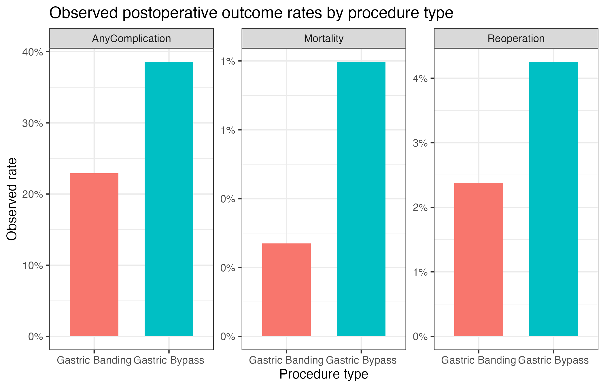
Observed rates are unadjusted proportions from the synthetic data. The figure visually summarizes any complication, mortality, and reoperation by procedure type.

Individual postoperative complications
Several individual complications were more frequent after gastric bypass in the synthetic data, including unplanned intubation, urinary tract infection, myocardial infarction, bleeding transfusions, DVT/thrombophlebitis, superficial surgical site infection, and wound disruption. Because many individual complications were tested, these P values should be interpreted as exploratory and descriptive rather than definitive multiplicity-adjusted inference.
Table 3. Individual postoperative complications by procedure type
Complication | Gastric Banding | Gastric Bypass | P value
Pneumonia | 30 (3.4%) | 67 (4.4%) | 0.199
Unplanned intubation | 9 (1%) | 32 (2.1%) | 0.043
Pulmonary embolism | 8 (0.9%) | 15 (1%) | 0.817
Ventilator > 48 hours | 10 (1.1%) | 17 (1.1%) | 0.996
Acute renal failure | 2 (0.2%) | 13 (0.9%) | 0.056
Progressive renal insufficiency | 4 (0.4%) | 8 (0.5%) | >0.999
Urinary tract infection | 20 (2.3%) | 63 (4.2%) | 0.013
Cardiac arrest requiring CPR | 3 (0.3%) | 6 (0.4%) | >0.999
Myocardial infarction | 4 (0.4%) | 25 (1.7%) | 0.009
Bleeding transfusions | 40 (4.5%) | 128 (8.5%) | <0.001
DVT/thrombophlebitis | 10 (1.1%) | 37 (2.5%) | 0.023
Neurologic deficit | 2 (0.2%) | 4 (0.3%) | >0.999
Coma > 24 hours | 3 (0.3%) | 3 (0.2%) | 0.676
Stroke/CVA | 1 (0.1%) | 5 (0.3%) | 0.422
Graft/prosthesis/flap failure | 2 (0.2%) | 6 (0.4%) | 0.718
Sepsis | 15 (1.7%) | 37 (2.5%) | 0.214
Septic shock | 2 (0.2%) | 8 (0.5%) | 0.340
Superficial surgical site infection | 33 (3.7%) | 110 (7.3%) | <0.001
Deep incisional SSI | 13 (1.5%) | 24 (1.6%) | 0.819
Organ space SSI | 10 (1.1%) | 26 (1.7%) | 0.242
Wound disruption | 2 (0.2%) | 19 (1.3%) | 0.009
Each individual complication is summarized as n (%) by procedure type. P values are descriptive and not adjusted for multiplicity.

Univariate model-based comparisons
In univariate model-based analyses, gastric bypass was associated with higher odds of any complication, a higher incidence rate of complications, higher odds of reoperation, and longer hospital stay. The mortality association was imprecise because mortality was rare.
Table 4. Univariate model summaries by procedure type
Model | Term | Estimate (95% CI) | P value
Any complication, logistic OR | Gastric Bypass vs Gastric Banding | 2.109 (1.751, 2.548) | <0.001
Number of complications, Poisson IRR | Gastric Bypass vs Gastric Banding | 1.726 (1.485, 2.013) | <0.001
Mortality, logistic OR | Gastric Bypass vs Gastric Banding | 2.971 (0.977, 12.854) | 0.086
Reoperation, logistic OR | Gastric Bypass vs Gastric Banding | 1.826 (1.127, 3.08) | 0.018
Length of stay, log-linear ratio | Gastric Bypass vs Gastric Banding | 1.384 (1.314, 1.458) | <0.001
Exponentiated estimates are odds ratios for binary outcomes, incidence rate ratios for count outcomes, and ratios of geometric means for log length of stay.

Primary adjusted model for any surgical complication
The multivariable logistic model included procedure type, age, BMI, sex, race/ethnicity, smoking status, ASA severity, and procedure-by-age and procedure-by-BMI interactions. The likelihood-ratio test comparing the interaction model with the main-effects model was not significant (P = 0.641), indicating no evidence that the procedure effect on any complication differed by age or BMI in this synthetic dataset. In the interaction model, severe ASA status was associated with higher odds of any complication. The procedure main-effect estimate in this model represents the contrast at the model reference values of the interacting covariates and should not be interpreted as the overall marginal procedure effect.
Table 5. Multivariable logistic regression for any surgical complication
Characteristic | OR | 95% CI | P value
Procedure type
Gastric Banding | — | —
Gastric Bypass | 2.62 | 0.485, 14.3 | 0.265
Age, years | 1.01 | 0.995, 1.03 | 0.171
BMI, kg/m^2 | 1.02 | 0.998, 1.05 | 0.072
Sex
Female | — | —
Male | 1.20 | 0.972, 1.47 | 0.089
Race/ethnicity
Hispanic | — | —
Non-Hispanic Black | 0.749 | 0.536, 1.05 | 0.092
Non-Hispanic White | 0.851 | 0.647, 1.12 | 0.250
Other/Unknown | 0.970 | 0.656, 1.43 | 0.879
Current smoker
No | — | —
Yes | 1.14 | 0.893, 1.46 | 0.284
ASA severity
Mild | — | —
Severe | 1.50 | 1.13, 2.00 | 0.005
Procedure type * Age, years
Gastric Bypass * Age, years | 1.01 | 0.986, 1.03 | 0.586
Procedure type * BMI
Gastric Bypass * BMI | 0.988 | 0.958, 1.02 | 0.443
The model includes procedure-by-age and procedure-by-BMI interactions and adjusts for sex, race/ethnicity, smoking status, and ASA severity. Odds ratios greater than 1 indicate higher odds of any complication.
Figure 2. Adjusted predicted probability of any complication by age and procedure type
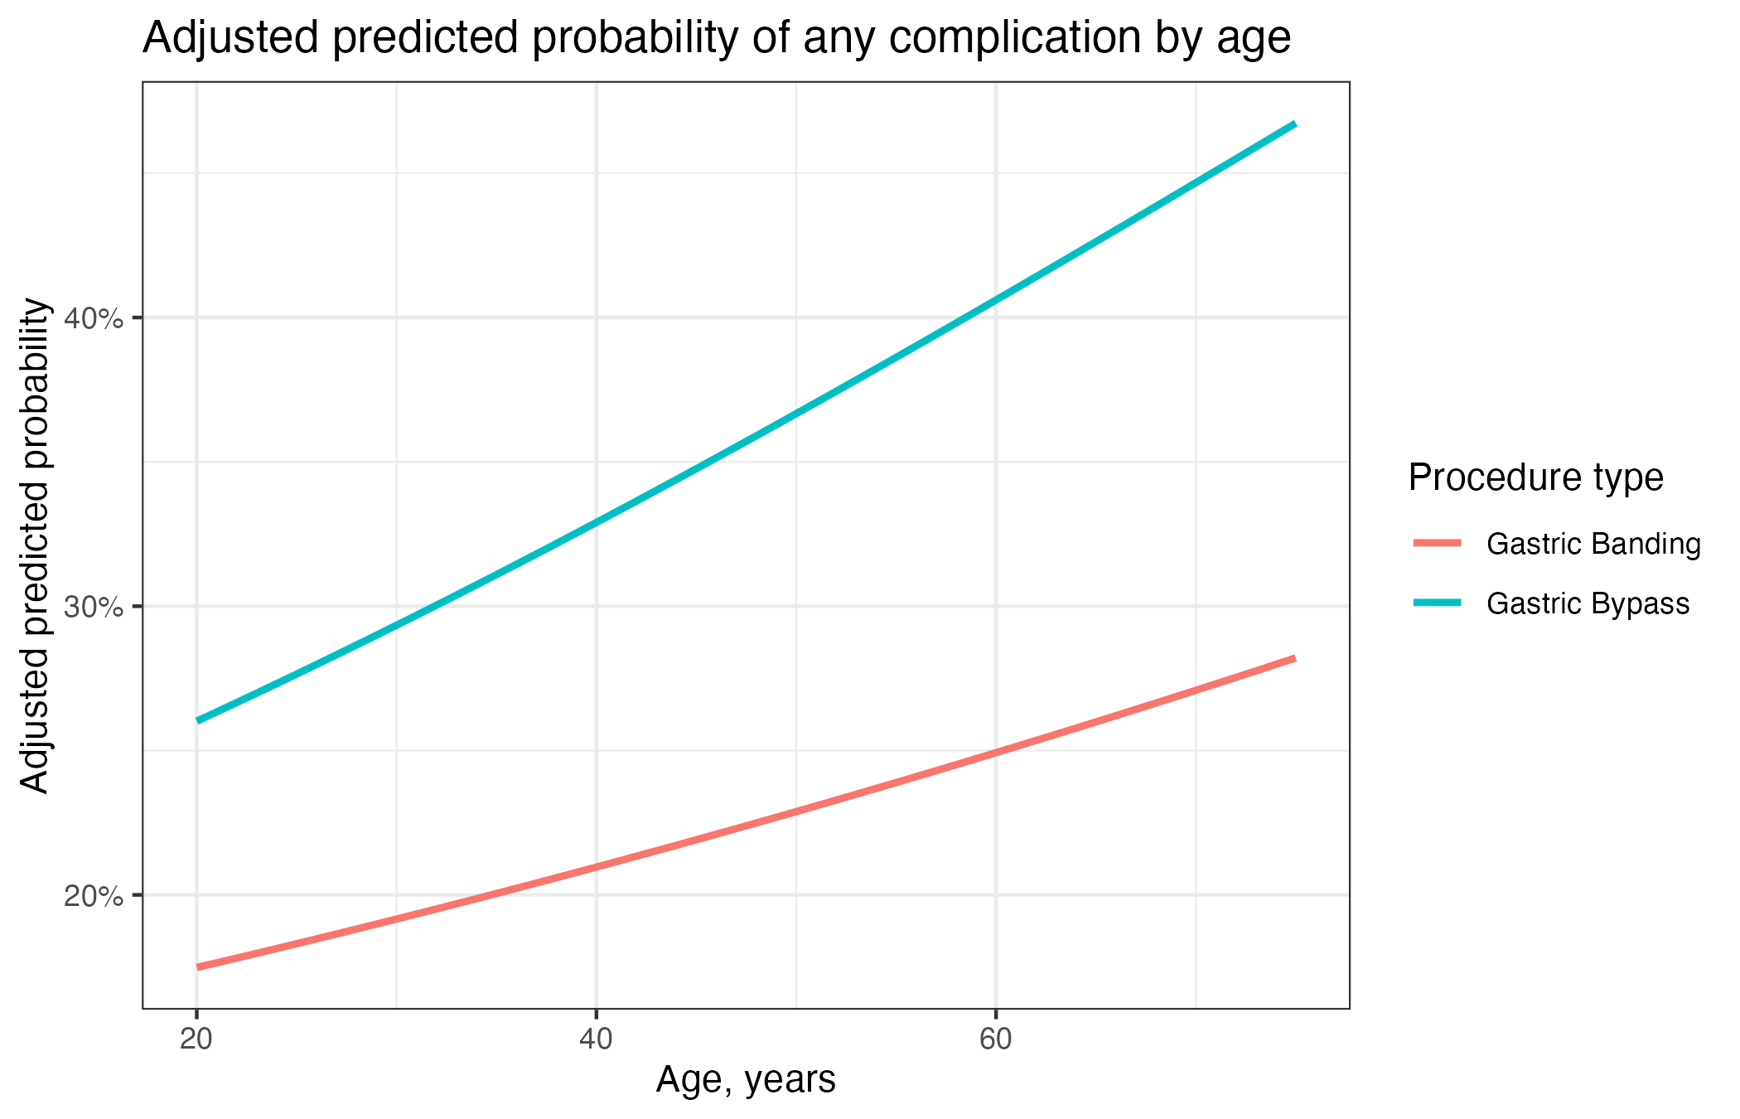
Curves are model-based predictions from the interaction logistic model. The likelihood-ratio test did not support age modification of the procedure effect.
Figure 3. Adjusted predicted probability of any complication by BMI and procedure type
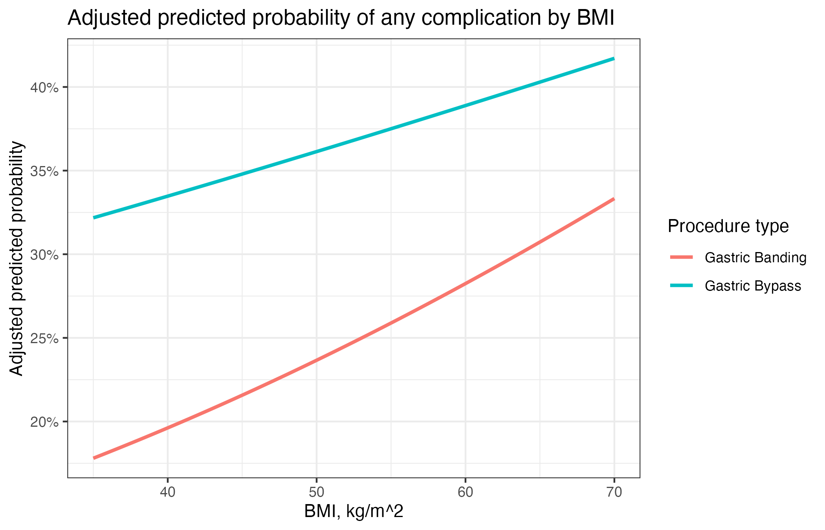
Curves are model-based predictions from the interaction logistic model. The likelihood-ratio test did not support BMI modification of the procedure effect.

Adjusted count model for number of complications
The Poisson overdispersion ratio was 0.852, which did not suggest meaningful overdispersion; therefore, Poisson regression was retained for the number of complications. The likelihood-ratio test for adding procedure-by-age and procedure-by-BMI interactions was not significant (P = 0.437). In the interaction model, older age, higher BMI, and severe ASA status were associated with higher complication counts. The bypass procedure contrast was large but imprecise when evaluated conditionally in the interaction model.
Table 6. Multivariable Poisson regression for number of surgical complications
Characteristic | IRR | 95% CI | P value
Procedure type
Gastric Banding | — | —
Gastric Bypass | 3.86 | 0.992, 15.2 | 0.052
Age, years | 1.01 | 1.00, 1.03 | 0.042
BMI, kg/m^2 | 1.02 | 1.00, 1.05 | 0.029
Sex
Female | — | —
Male | 1.13 | 0.964, 1.32 | 0.128
Race/ethnicity
Hispanic | — | —
Non-Hispanic Black | 0.867 | 0.675, 1.12 | 0.263
Non-Hispanic White | 0.883 | 0.723, 1.09 | 0.234
Other/Unknown | 0.930 | 0.691, 1.24 | 0.625
Current smoker
No | — | —
Yes | 1.11 | 0.921, 1.32 | 0.266
ASA severity
Mild | — | —
Severe | 1.34 | 1.09, 1.62 | 0.004
Procedure type * Age, years
Gastric Bypass * Age, years | 0.996 | 0.980, 1.01 | 0.585
Procedure type * BMI
Gastric Bypass * BMI | 0.985 | 0.961, 1.01 | 0.244
The final count model was Poisson regression. Incidence rate ratios greater than 1 indicate higher expected complication counts.
Table 7. Count model overdispersion diagnostic
Diagnostic | Value
Poisson overdispersion ratio | 0.852
Final count model selected | Poisson regression
A ratio meaningfully greater than 1 would suggest overdispersion and support negative binomial regression. Here, the ratio did not suggest overdispersion.

Length of hospital stay
Length of stay was right-skewed and was therefore analyzed using a log-linear model. In adjusted analysis, gastric bypass was associated with a 35.7% higher geometric mean length of stay compared with gastric banding. Higher BMI was also associated with slightly longer length of stay. Age, sex, race/ethnicity, smoking status, and ASA severity were not clearly associated with length of stay after adjustment in this synthetic dataset.
Table 8. Adjusted log-linear model for length of hospital stay
Term | Ratio of geometric mean LOS (95% CI) | P value
Procedure type: Gastric Bypass vs Gastric Banding | 1.357 (1.286, 1.432) | <0.001
Age, years | 1.001 (0.999, 1.004) | 0.411
BMI, kg/m^2 | 1.008 (1.004, 1.012) | <0.001
Sex: Male vs Female | 0.972 (0.915, 1.033) | 0.361
Race/ethnicity: Non-Hispanic Black | 0.966 (0.877, 1.064) | 0.486
Race/ethnicity: Non-Hispanic White | 0.972 (0.897, 1.054) | 0.490
Race/ethnicity: Other/Unknown | 0.894 (0.797, 1.003) | 0.055
Current smoker: Yes vs No | 1.05 (0.978, 1.128) | 0.176
ASA severity: Severe vs Mild | 0.994 (0.912, 1.084) | 0.894
Exponentiated coefficients are interpreted as ratios of geometric mean length of stay. Values greater than 1 indicate longer expected hospital stay.

Discussion
In this synthetic NSQIP-like applied-practice analysis, gastric bypass had a higher unadjusted burden of postoperative morbidity than gastric banding. The bypass group had a higher observed rate of any complication, more complications per patient, more reoperations, and longer length of stay. Several individual complications were also more frequent in the bypass group, especially bleeding transfusions and superficial surgical site infection. These descriptive findings are consistent with the practical expectation that a more invasive procedure may carry greater short-term perioperative morbidity, although the data here are synthetic and cannot be used for clinical inference.
The adjusted primary logistic model did not provide evidence that the procedure effect on any surgical complication varied by age or BMI. Similarly, the adjusted count model did not provide evidence that procedure-associated differences in complication counts varied by age or BMI. This distinction is important for reporting: the unadjusted procedure differences were large, but the formal interaction tests addressed a different question, namely whether the procedure-outcome association changed across age or BMI. The answer in this synthetic analysis was no.
ASA severity was consistently associated with higher postoperative morbidity in the adjusted models. This result is clinically plausible because ASA class is a broad marker of preoperative physiologic risk. BMI was associated with the count of complications and length of stay, suggesting that higher BMI may contribute to greater perioperative resource use or complication burden in this synthetic dataset.
The analysis has several limitations. First, these are synthetic data generated for exam preparation, so no real clinical conclusion should be drawn. Second, even with real NSQIP data, this would be an observational comparison and would be vulnerable to confounding by indication, surgeon selection, hospital practice patterns, and unmeasured comorbidity. Third, mortality and several individual complications were rare, leading to unstable estimates and wide confidence intervals. Fourth, multiple individual complication comparisons were conducted without multiplicity adjustment, so those results should be viewed as exploratory. Finally, complete-case modeling was used; although missingness was low, complete-case analysis can introduce bias if missingness is related to outcomes or treatment assignment.
Overall, this report demonstrates the applied-exam workflow expected for a clinical biostatistics analysis: clear variable definitions, clean recoding of missing values, publication-quality tables and figures, appropriate models by outcome type, interaction assessment aligned with the research questions, diagnostic checks, and cautious interpretation that separates descriptive findings from adjusted model-based inference.

References
American College of Surgeons National Surgical Quality Improvement Program (ACS NSQIP). User guide and participant use resources.
R Core Team. R: A language and environment for statistical computing. R Foundation for Statistical Computing.
Wickham H, et al. dplyr: A grammar of data manipulation. R package.
Sjoberg DD, et al. gtsummary: Presentation-ready data summary and analytic result tables. R package.
Fox J, Weisberg S. An R Companion to Applied Regression. Sage.
Venables WN, Ripley BD. Modern Applied Statistics with S. Springer. MASS package documentation.
Long JS, Freese J. Regression Models for Categorical Dependent Variables Using Stata. Reference for odds-ratio and count-model interpretation.

Appendix
The appendix contains supporting cohort flow, missingness, model-comparison tests, and diagnostic plots. These outputs support the analysis but would generally be placed outside the main manuscript body in a high-quality report.
Appendix Table A1. Cohort flow counts
Step | N
Raw records imported | 2,400
Records with known procedure type | 2,400
Records with nonmissing surgical complication status | 2,400
Records with nonmissing age and BMI | 2,380
Records available for primary logistic complete-case model | 2,330
These counts document the analytic sample used for descriptive analyses and complete-case modeling.
Appendix Table A2. Missingness summary
Variable | Missing_N | Total_N | Missing_Percent
operation_time_min | 33 | 2,400 | 1.4
los_days | 30 | 2,400 | 1.2
race_ethnicity | 20 | 2,400 | 0.8
asa_class | 15 | 2,400 | 0.6
asa_severity | 15 | 2,400 | 0.6
bmi | 14 | 2,400 | 0.6
smoking_status | 11 | 2,400 | 0.5
reoperation | 9 | 2,400 | 0.4
failwean_bin | 8 | 2,400 | 0.3
wndinfd_bin | 7 | 2,400 | 0.3
age_years | 6 | 2,400 | 0.2
cnscoma_bin | 6 | 2,400 | 0.2
orgspcssi_bin | 6 | 2,400 | 0.2
othbleed_bin | 6 | 2,400 | 0.2
othgrafl_bin | 6 | 2,400 | 0.2
othseshock_bin | 6 | 2,400 | 0.2
sex | 6 | 2,400 | 0.2
cdarrest_bin | 5 | 2,400 | 0.2
cnscva_bin | 5 | 2,400 | 0.2
mortality | 5 | 2,400 | 0.2
reintub_bin | 5 | 2,400 | 0.2
urninfec_bin | 5 | 2,400 | 0.2
neurodef_bin | 4 | 2,400 | 0.2
oupneumo_bin | 4 | 2,400 | 0.2
pulembol_bin | 4 | 2,400 | 0.2
supinfec_bin | 4 | 2,400 | 0.2
dehis_bin | 3 | 2,400 | 0.1
othdvt_bin | 3 | 2,400 | 0.1
othsysep_bin | 3 | 2,400 | 0.1
cdmi_bin | 2 | 2,400 | 0.1
oprenafl_bin | 2 | 2,400 | 0.1
renainsf_bin | 2 | 2,400 | 0.1
case_id | 0 | 2,400 | 0.0
number_complications | 0 | 2,400 | 0.0
procedure | 0 | 2,400 | 0.0
surgical_complication | 0 | 2,400 | 0.0
Missingness was low for all variables in the synthetic dataset. The primary complete-case logistic model used 2,330 patients.
Appendix Table A3. Logistic model interaction likelihood-ratio test
Model | Resid. Df | Resid. Dev | Df | Deviance | Pr(>Chi) | P value
1 | 2,320 | 2,856.342
2 | 2,318 | 2,855.453 | 2 | 0.8893797 | 0.641023 | 0.641
The likelihood-ratio test evaluates whether adding procedure-by-age and procedure-by-BMI interactions improves model fit for any complication.
Appendix Table A4. Count model interaction likelihood-ratio test
Model | Resid. Df | Resid. Dev | Df | Deviance | Pr(>Chi) | P value
1 | 2,320 | 1,895.144
2 | 2,318 | 1,893.488 | 2 | 1.655744 | 0.4369781 | 0.437
The likelihood-ratio test evaluates whether adding procedure-by-age and procedure-by-BMI interactions improves model fit for number of complications.
Appendix Figure A1. Distribution of length of hospital stay
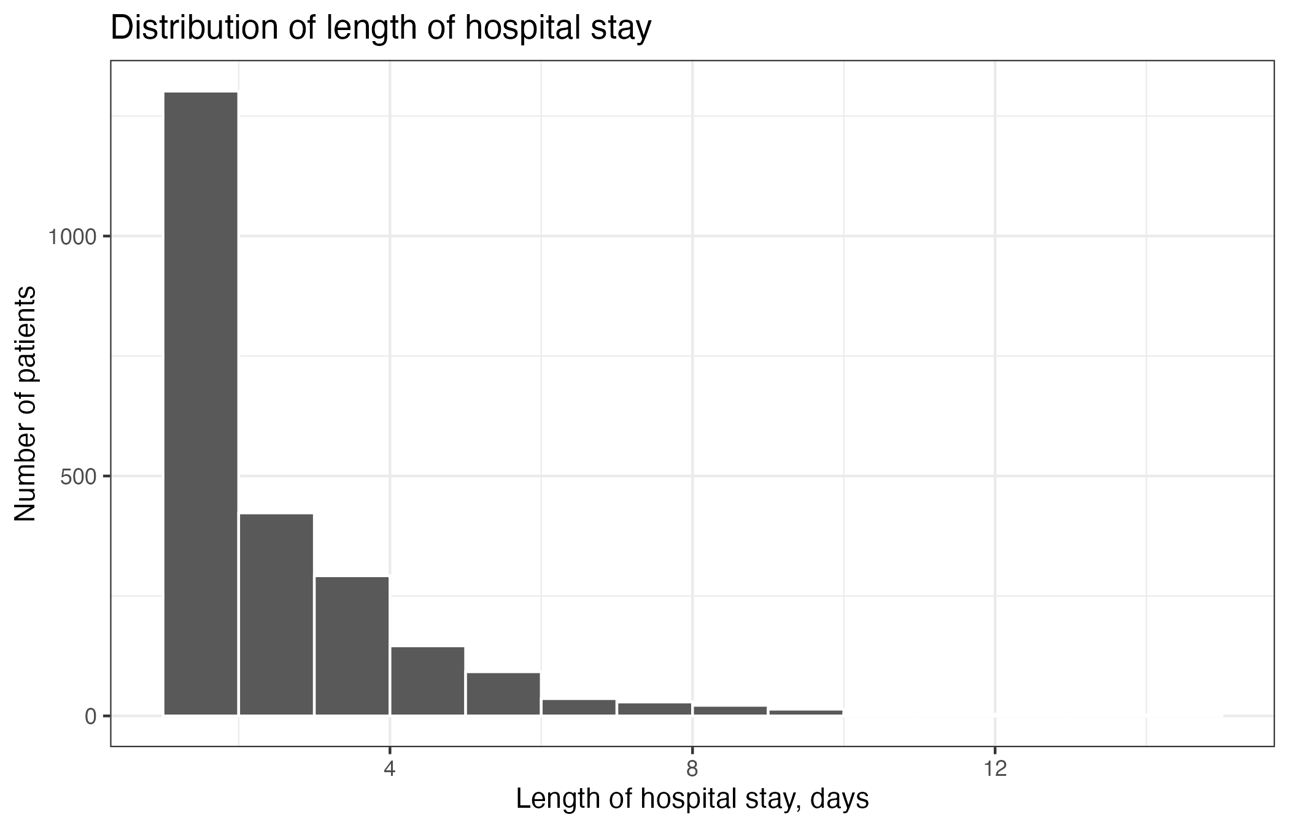
Length of stay was right-skewed, supporting the use of log-transformation for modeling.
Appendix Figure A2. Logistic model calibration by predicted-risk decile
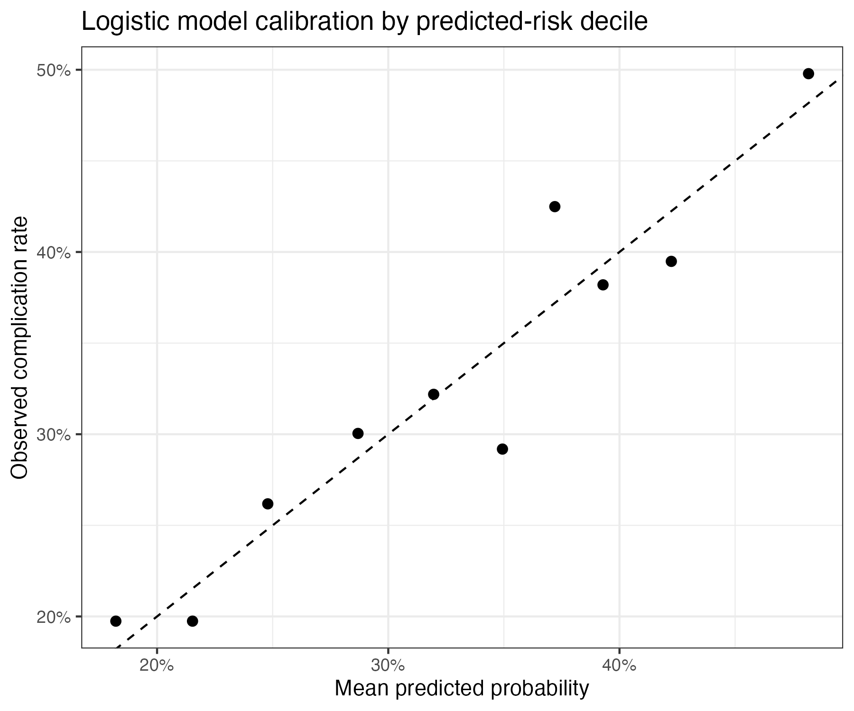
Observed complication rates are plotted against mean predicted probabilities across deciles.
Appendix Figure A3. Count model Pearson residuals versus fitted values
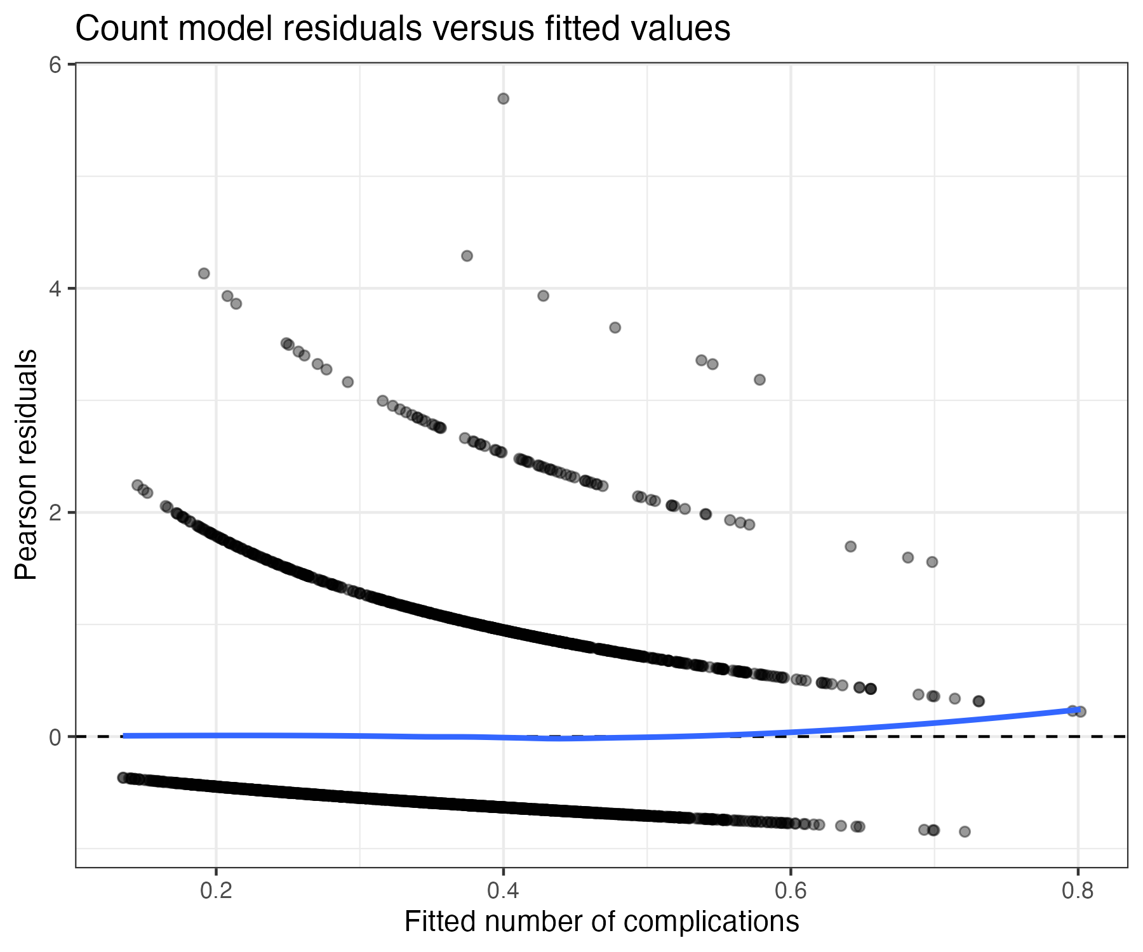
Residual patterns were reviewed as a diagnostic for the count model.
Appendix Figure A4. Log-linear length-of-stay residuals versus fitted values
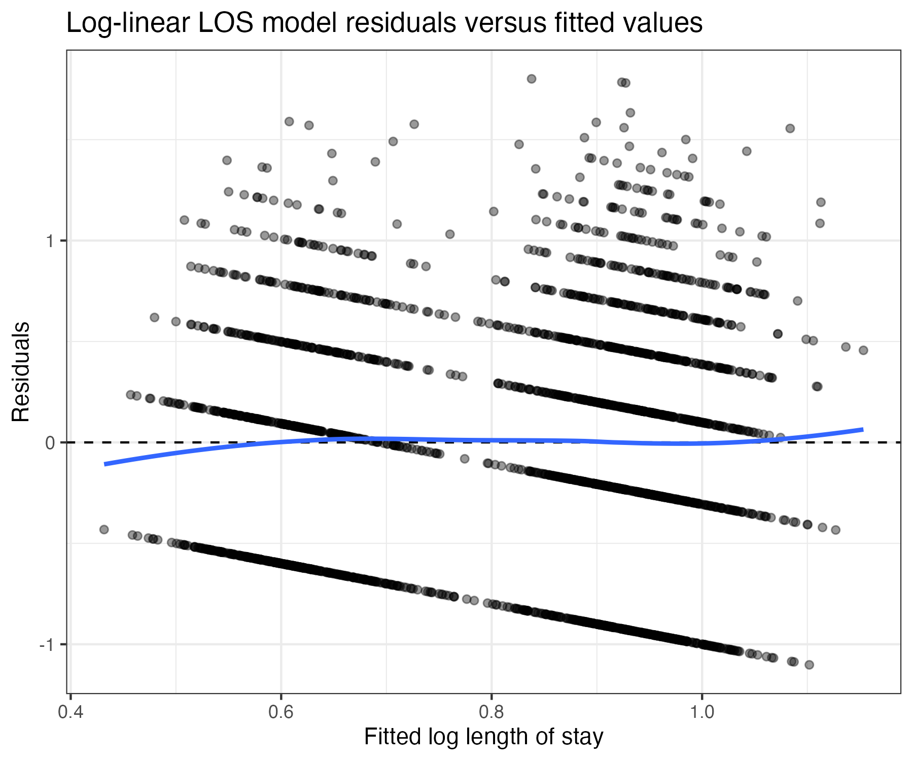
Residual patterns were reviewed as a diagnostic for the log-linear length-of-stay model.

