Appendix, Diagnostics and Supporting Analyses
Generated: 2026-06-10

Appendix Table A1. Cohort flow counts
Step | N
Raw records imported | 2,400
Records with known procedure type | 2,400
Records with nonmissing surgical complication status | 2,400
Records with nonmissing age and BMI | 2,380
Records available for primary logistic complete-case model | 2,330

Appendix Table A2. Missingness summary
Variable | Missing_N | Total_N | Missing_Percent
operation_time_min | 33 | 2,400 | 1.4
los_days | 30 | 2,400 | 1.2
race_ethnicity | 20 | 2,400 | 0.8
asa_class | 15 | 2,400 | 0.6
asa_severity | 15 | 2,400 | 0.6
bmi | 14 | 2,400 | 0.6
smoking_status | 11 | 2,400 | 0.5
reoperation | 9 | 2,400 | 0.4
failwean_bin | 8 | 2,400 | 0.3
wndinfd_bin | 7 | 2,400 | 0.3
age_years | 6 | 2,400 | 0.2
cnscoma_bin | 6 | 2,400 | 0.2
orgspcssi_bin | 6 | 2,400 | 0.2
othbleed_bin | 6 | 2,400 | 0.2
othgrafl_bin | 6 | 2,400 | 0.2
othseshock_bin | 6 | 2,400 | 0.2
sex | 6 | 2,400 | 0.2
cdarrest_bin | 5 | 2,400 | 0.2
cnscva_bin | 5 | 2,400 | 0.2
mortality | 5 | 2,400 | 0.2
reintub_bin | 5 | 2,400 | 0.2
urninfec_bin | 5 | 2,400 | 0.2
neurodef_bin | 4 | 2,400 | 0.2
oupneumo_bin | 4 | 2,400 | 0.2
pulembol_bin | 4 | 2,400 | 0.2
supinfec_bin | 4 | 2,400 | 0.2
dehis_bin | 3 | 2,400 | 0.1
othdvt_bin | 3 | 2,400 | 0.1
othsysep_bin | 3 | 2,400 | 0.1
cdmi_bin | 2 | 2,400 | 0.1
oprenafl_bin | 2 | 2,400 | 0.1
renainsf_bin | 2 | 2,400 | 0.1
case_id | 0 | 2,400 | 0.0
number_complications | 0 | 2,400 | 0.0
procedure | 0 | 2,400 | 0.0
surgical_complication | 0 | 2,400 | 0.0

Appendix Table A3. Logistic model interaction likelihood-ratio test
Model | Resid. Df | Resid. Dev | Df | Deviance | Pr(>Chi) | P value
1 | 2,320 | 2,856.342
2 | 2,318 | 2,855.453 | 2 | 0.8893797 | 0.641023 | 0.641

Appendix Table A4. Count model interaction likelihood-ratio test
Model | Resid. Df | Resid. Dev | Df | Deviance | Pr(>Chi) | P value
1 | 2,320 | 1,895.144
2 | 2,318 | 1,893.488 | 2 | 1.655744 | 0.4369781 | 0.437

Appendix Table A5. Log-linear model for length of hospital stay
Term | Ratio of geometric mean LOS (95% CI) | P value
Procedure type: Gastric Bypass vs Gastric Banding | 1.357 (1.286, 1.432) | <0.001
Age, years | 1.001 (0.999, 1.004) | 0.411
Body mass index, kg/m^2 | 1.008 (1.004, 1.012) | <0.001
sexMale | 0.972 (0.915, 1.033) | 0.361
Race/ethnicity: Non-Hispanic Black | 0.966 (0.877, 1.064) | 0.486
Race/ethnicity: Non-Hispanic White | 0.972 (0.897, 1.054) | 0.490
Race/ethnicity: Other/Unknown | 0.894 (0.797, 1.003) | 0.055
Current smoker: Yes vs No | 1.05 (0.978, 1.128) | 0.176
ASA severity: Severe vs Mild | 0.994 (0.912, 1.084) | 0.894

Appendix_LOS_Distribution
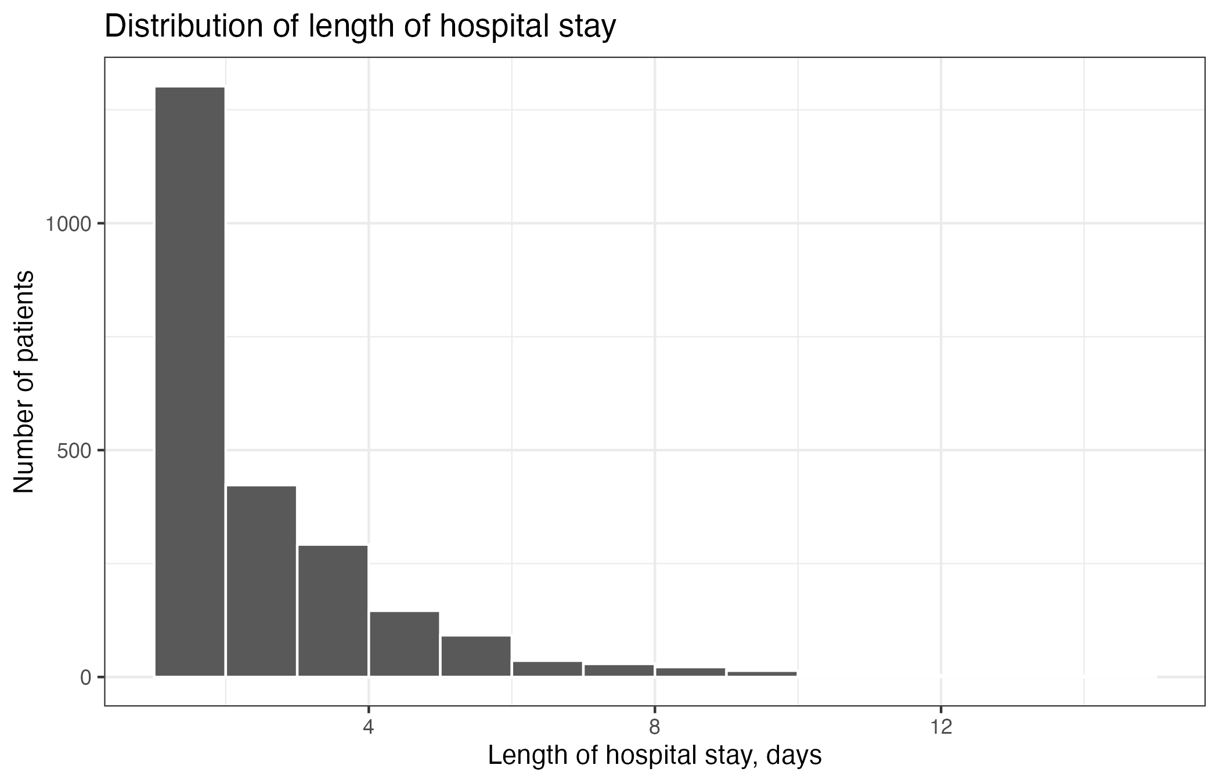

Appendix_Logistic_Calibration
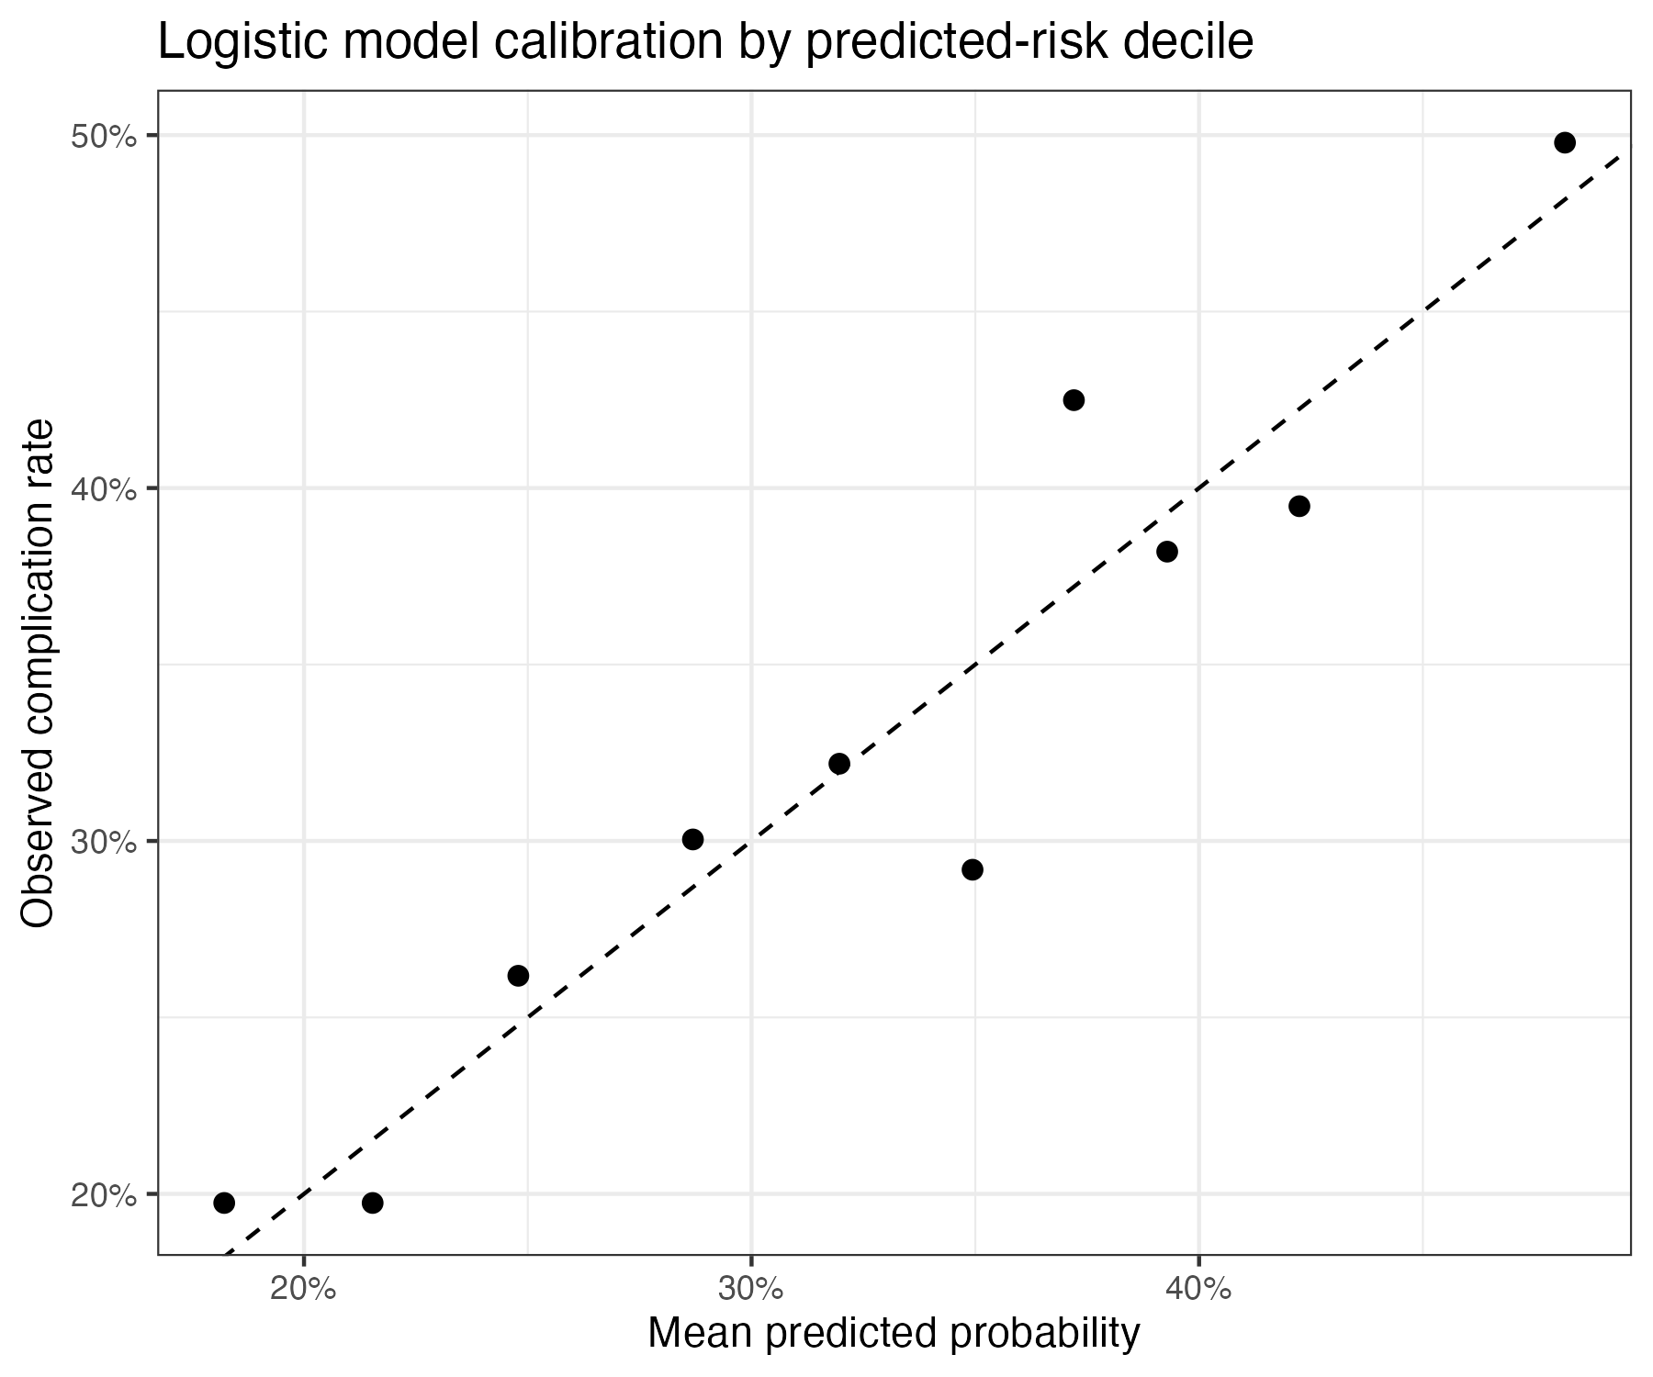

Appendix_Count_Residuals
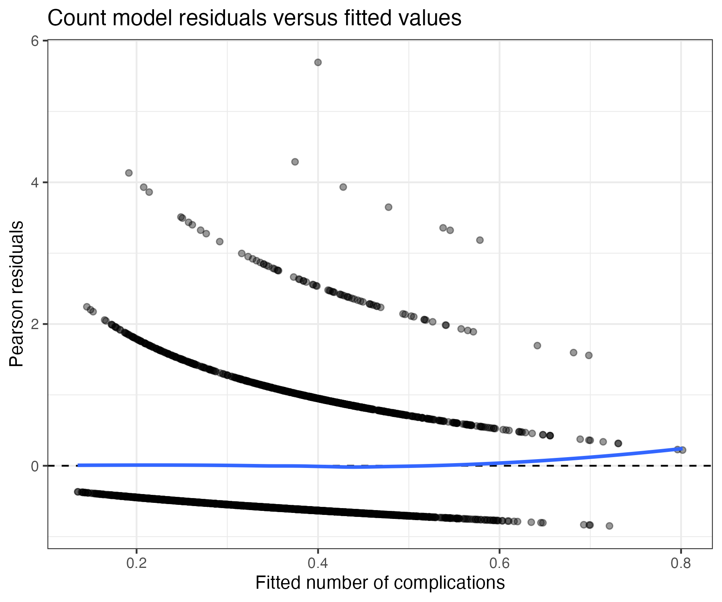

Appendix_LOS_Residuals
