QE2024 Applied Practice, NSQIP Bariatric Surgery Outcomes
Generated: 2026-06-10
This document contains formatted three-line tables and figures generated from the R analysis script. These outputs are based on synthetic practice data and should not be interpreted as real clinical findings.

Table 1. Patient characteristics by procedure type
Table 1. Patient characteristics by procedure type
Characteristic | Overall  N = 2,400¹ | Gastric Banding  N = 890¹ | Gastric Bypass  N = 1,510¹ | p-value²
Age, years |  |  |  | <0.001
Median (Q1, Q3) | 46 (39, 52) | 44 (38, 51) | 46 (39, 53)
Mean (SD) | 46 (10) | 44 (10) | 46 (10)
Unknown | 6 | 3 | 3
Sex |  |  |  | 0.558
Female | 1,856 (78%) | 695 (78%) | 1,161 (77%)
Male | 538 (22%) | 194 (22%) | 344 (23%)
Unknown | 6 | 1 | 5
Race/ethnicity |  |  |  | 0.406
Hispanic | 284 (12%) | 111 (13%) | 173 (12%)
Non-Hispanic Black | 402 (17%) | 161 (18%) | 241 (16%)
Non-Hispanic White | 1,490 (63%) | 540 (61%) | 950 (63%)
Other/Unknown | 204 (8.6%) | 71 (8.0%) | 133 (8.9%)
Unknown | 20 | 7 | 13
Body mass index, kg/m^2 |  |  |  | <0.001
Median (Q1, Q3) | 46 (42, 51) | 45 (40, 49) | 47 (43, 51)
Mean (SD) | 46 (6) | 45 (6) | 47 (6)
Unknown | 14 | 7 | 7
Current smoker within one year |  |  |  | 0.720
No | 2,028 (85%) | 756 (85%) | 1,272 (85%)
Yes | 361 (15%) | 131 (15%) | 230 (15%)
Unknown | 11 | 3 | 8
ASA severity |  |  |  | <0.001
Mild | 2,150 (90%) | 825 (93%) | 1,325 (88%)
Severe | 235 (9.9%) | 62 (7.0%) | 173 (12%)
Unknown | 15 | 3 | 12
¹n (%)
²Wilcoxon rank sum test; Pearson's Chi-squared test
Continuous variables are summarized as median (IQR) and mean (SD). Categorical variables are summarized as n (%). P values are from Wilcoxon rank-sum tests for continuous variables and chi-square tests for categorical variables.

Table 2. Outcomes by procedure type
Table 2. Outcomes by procedure type
Characteristic | Overall  N = 2,400¹ | Gastric Banding  N = 890¹ | Gastric Bypass  N = 1,510¹ | p-value²
Any surgical complication |  |  |  | <0.001
No complication | 1,614 (67%) | 686 (77%) | 928 (61%)
Any complication | 786 (33%) | 204 (23%) | 582 (39%)
Number of surgical complications |  |  |  | <0.001
Median (Q1, Q3) | 0.00 (0.00, 1.00) | 0.00 (0.00, 0.00) | 0.00 (0.00, 1.00)
Mean (SD) | 0.37 (0.56) | 0.25 (0.48) | 0.43 (0.59)
Mortality |  |  |  | 0.071
No | 2,377 (99%) | 886 (100%) | 1,491 (99%)
Yes | 18 (0.8%) | 3 (0.3%) | 15 (1.0%)
Unknown | 5 | 1 | 4
Length of hospital stay, days |  |  |  | <0.001
Median (Q1, Q3) | 2.00 (1.00, 4.00) | 2.00 (1.00, 3.00) | 3.00 (2.00, 4.00)
Mean (SD) | 2.80 (1.95) | 2.19 (1.39) | 3.15 (2.14)
Unknown | 30 | 10 | 20
Reoperation |  |  |  | 0.017
No | 2,306 (96%) | 864 (98%) | 1,442 (96%)
Yes | 85 (3.6%) | 21 (2.4%) | 64 (4.2%)
Unknown | 9 | 5 | 4
¹n (%)
²Pearson's Chi-squared test; Wilcoxon rank sum test
Surgical complication is defined as any listed postoperative complication. Number of complications is the count of listed complications.

Table 3. Individual postoperative complications by procedure type
Complication | Gastric Banding | Gastric Bypass | P value
Pneumonia | 30 (3.4%) | 67 (4.4%) | 0.199
Unplanned intubation | 9 (1%) | 32 (2.1%) | 0.043
Pulmonary embolism | 8 (0.9%) | 15 (1%) | 0.817
Ventilator > 48 hours | 10 (1.1%) | 17 (1.1%) | 0.996
Acute renal failure | 2 (0.2%) | 13 (0.9%) | 0.056
Progressive renal insufficiency | 4 (0.4%) | 8 (0.5%) | >0.999
Urinary tract infection | 20 (2.3%) | 63 (4.2%) | 0.013
Cardiac arrest requiring CPR | 3 (0.3%) | 6 (0.4%) | >0.999
Myocardial infarction | 4 (0.4%) | 25 (1.7%) | 0.009
Bleeding transfusions | 40 (4.5%) | 128 (8.5%) | <0.001
DVT/thrombophlebitis | 10 (1.1%) | 37 (2.5%) | 0.023
Neurologic deficit | 2 (0.2%) | 4 (0.3%) | >0.999
Coma > 24 hours | 3 (0.3%) | 3 (0.2%) | 0.676
Stroke/CVA | 1 (0.1%) | 5 (0.3%) | 0.422
Graft/prosthesis/flap failure | 2 (0.2%) | 6 (0.4%) | 0.718
Sepsis | 15 (1.7%) | 37 (2.5%) | 0.214
Septic shock | 2 (0.2%) | 8 (0.5%) | 0.340
Superficial surgical site infection | 33 (3.7%) | 110 (7.3%) | <0.001
Deep incisional SSI | 13 (1.5%) | 24 (1.6%) | 0.819
Organ space SSI | 10 (1.1%) | 26 (1.7%) | 0.242
Wound disruption | 2 (0.2%) | 19 (1.3%) | 0.009
Each individual complication is summarized as n (%) by procedure type.

Table 4. Univariate model summaries by procedure type
Model | Term | Estimate (95% CI) | P value
Any complication, logistic OR | procedureGastric Bypass | 2.109 (1.751, 2.548) | <0.001
Number of complications, Poisson IRR | procedureGastric Bypass | 1.726 (1.485, 2.013) | <0.001
Mortality, logistic OR | procedureGastric Bypass | 2.971 (0.977, 12.854) | 0.086
Reoperation, logistic OR | procedureGastric Bypass | 1.826 (1.127, 3.08) | 0.018
Length of stay, log-linear ratio | procedureGastric Bypass | 1.384 (1.314, 1.458) | <0.001
Exponentiated estimates are odds ratios for binary outcomes, incidence rate ratios for count outcomes, and ratios of geometric means for log length of stay.

Table 5. Multivariable logistic regression for any surgical complication
Table 4. Multivariable logistic regression model for any surgical complication
Characteristic | OR | 95% CI | p-value
Procedure type
Gastric Banding | — | —
Gastric Bypass | 2.62 | 0.485, 14.3 | 0.265
Age, years | 1.01 | 0.995, 1.03 | 0.171
Body mass index, kg/m^2 | 1.02 | 0.998, 1.05 | 0.072
Sex
Female | — | —
Male | 1.20 | 0.972, 1.47 | 0.089
Race/ethnicity
Hispanic | — | —
Non-Hispanic Black | 0.749 | 0.536, 1.05 | 0.092
Non-Hispanic White | 0.851 | 0.647, 1.12 | 0.250
Other/Unknown | 0.970 | 0.656, 1.43 | 0.879
Current smoker within one year
No | — | —
Yes | 1.14 | 0.893, 1.46 | 0.284
ASA severity
Mild | — | —
Severe | 1.50 | 1.13, 2.00 | 0.005
Procedure type * Age, years
Gastric Bypass * Age, years | 1.01 | 0.986, 1.03 | 0.586
Procedure type * Body mass index, kg/m^2
Gastric Bypass * Body mass index, kg/m^2 | 0.988 | 0.958, 1.02 | 0.443
Abbreviations: CI = Confidence Interval, OR = Odds Ratio
The model includes procedure-by-age and procedure-by-BMI interactions and adjusts for sex, race/ethnicity, smoking status, and ASA severity.

Table 6. Multivariable count model for number of surgical complications
Table 5. Poisson regression for number of surgical complications
Characteristic | IRR | 95% CI | p-value
Procedure type
Gastric Banding | — | —
Gastric Bypass | 3.86 | 0.992, 15.2 | 0.052
Age, years | 1.01 | 1.00, 1.03 | 0.042
Body mass index, kg/m^2 | 1.02 | 1.00, 1.05 | 0.029
Sex
Female | — | —
Male | 1.13 | 0.964, 1.32 | 0.128
Race/ethnicity
Hispanic | — | —
Non-Hispanic Black | 0.867 | 0.675, 1.12 | 0.263
Non-Hispanic White | 0.883 | 0.723, 1.09 | 0.234
Other/Unknown | 0.930 | 0.691, 1.24 | 0.625
Current smoker within one year
No | — | —
Yes | 1.11 | 0.921, 1.32 | 0.266
ASA severity
Mild | — | —
Severe | 1.34 | 1.09, 1.62 | 0.004
Procedure type * Age, years
Gastric Bypass * Age, years | 0.996 | 0.980, 1.01 | 0.585
Procedure type * Body mass index, kg/m^2
Gastric Bypass * Body mass index, kg/m^2 | 0.985 | 0.961, 1.01 | 0.244
Abbreviations: CI = Confidence Interval, IRR = Incidence Rate Ratio
The final count model was selected as: Poisson regression.

Table 7. Count model overdispersion diagnostic
Diagnostic | Value
Poisson overdispersion ratio | 0.852
Final count model selected | Poisson regression
If the Poisson overdispersion ratio is meaningfully greater than 1, a negative binomial model is usually preferred.

Figure_1_Observed_Outcome_Rates_by_Procedure
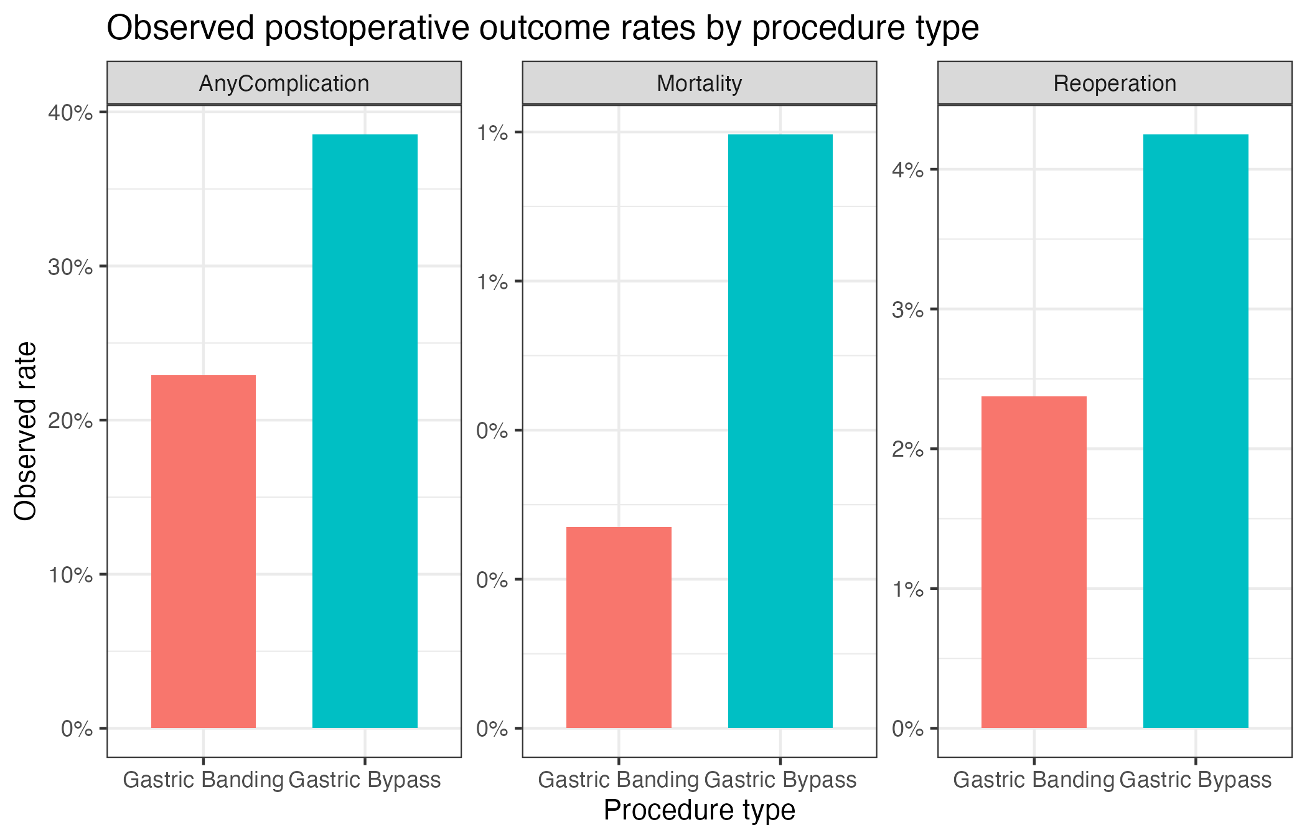

Figure_2_Logistic_Interaction_Age
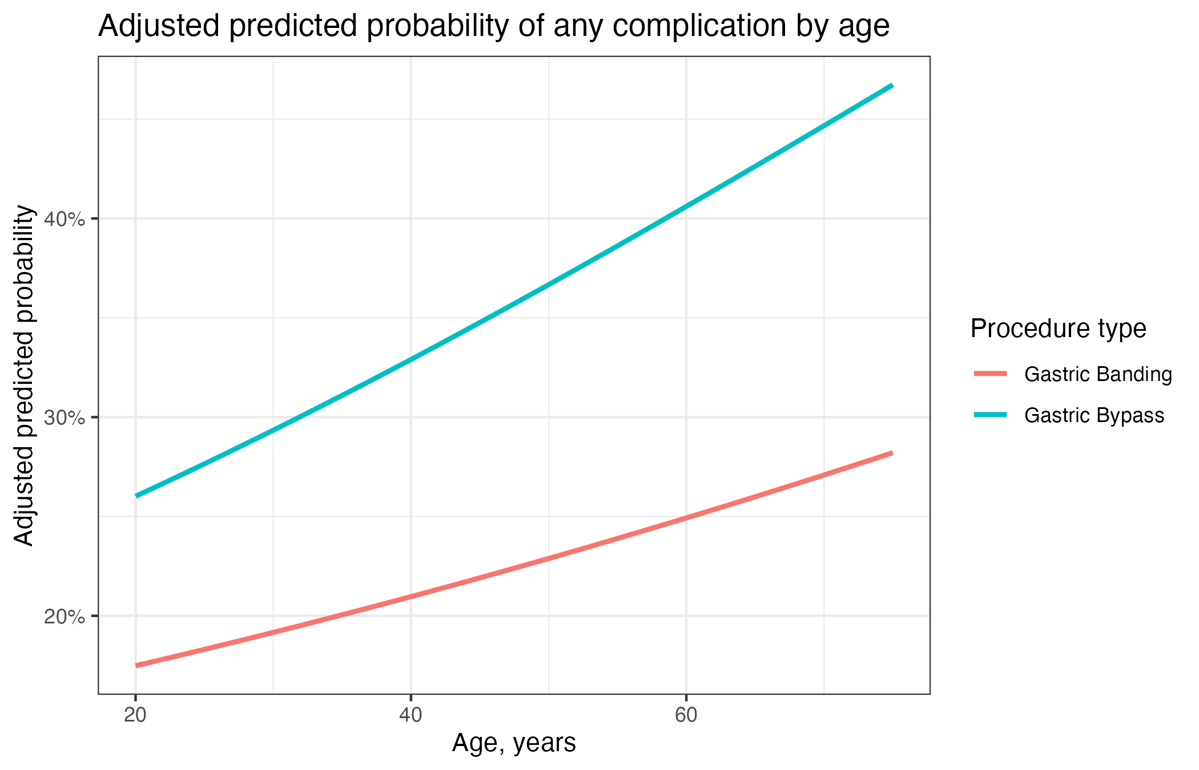

Figure_3_Logistic_Interaction_BMI
