Appendix, Diagnostics and Sensitivity Analyses
Generated: 2026-06-09

Appendix Table A1. Cohort flow counts
Step | N
Raw records imported | 469
Records with nonmissing positive follow-up time | 469
Records with nonmissing graft failure indicator | 469
Records included in survival analysis | 469
These counts document the analytic sample used for survival analysis.

Appendix Table A2. Missingness summary
Variable | Missing_N | Total_N | Missing_Percent
dialysis_days | 7 | 469 | 1.5
blood_units | 5 | 469 | 1.1
diabetes | 3 | 469 | 0.6
mismatch_score | 3 | 469 | 0.6
age_years | 2 | 469 | 0.4
prior_transplant_any | 2 | 469 | 0.4
prior_transplants_count | 2 | 469 | 0.4
sex | 2 | 469 | 0.4
alg_use | 0 | 469 | 0.0
followup_months | 0 | 469 | 0.0
graft_failure | 0 | 469 | 0.0
graft_failure_label | 0 | 469 | 0.0
invalid_event | 0 | 469 | 0.0
invalid_survival_time | 0 | 469 | 0.0
subject_id | 0 | 469 | 0.0
Missingness is calculated after excluding records that cannot contribute to survival analysis.

Appendix Table A3. Cox proportional hazards assumption tests
Model | Term | Chisq | df | P value
Full Cox model | alg_use | 0.109 | 1 | 0.741
Full Cox model | age_years | 4.422 | 1 | 0.035
Full Cox model | sex | 0.389 | 1 | 0.533
Full Cox model | dialysis_days | 0.360 | 1 | 0.549
Full Cox model | diabetes | 2.772 | 1 | 0.096
Full Cox model | prior_transplants_count | 2.257 | 1 | 0.133
Full Cox model | blood_units | 3.385 | 1 | 0.066
Full Cox model | mismatch_score | 2.254 | 1 | 0.133
Full Cox model | GLOBAL | 14.975 | 8 | 0.060
Selected Cox model | alg_use | 0.199 | 1 | 0.656
Selected Cox model | age_years | 4.301 | 1 | 0.038
Selected Cox model | diabetes | 2.898 | 1 | 0.089
Selected Cox model | prior_transplants_count | 2.258 | 1 | 0.133
Selected Cox model | mismatch_score | 2.400 | 1 | 0.121
Selected Cox model | GLOBAL | 10.680 | 5 | 0.058
Tests are based on scaled Schoenfeld residuals. A small p value suggests possible violation of the proportional hazards assumption.

Appendix Figure A1. Log-log survival plot by ALG use
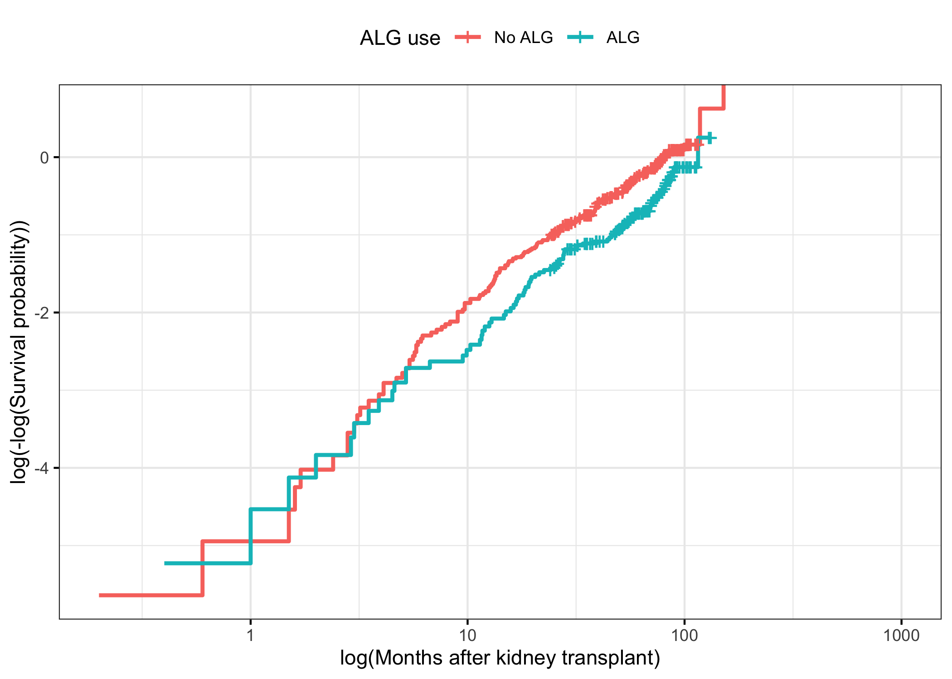

Appendix Figure A2. Scaled Schoenfeld residual plots for selected Cox model
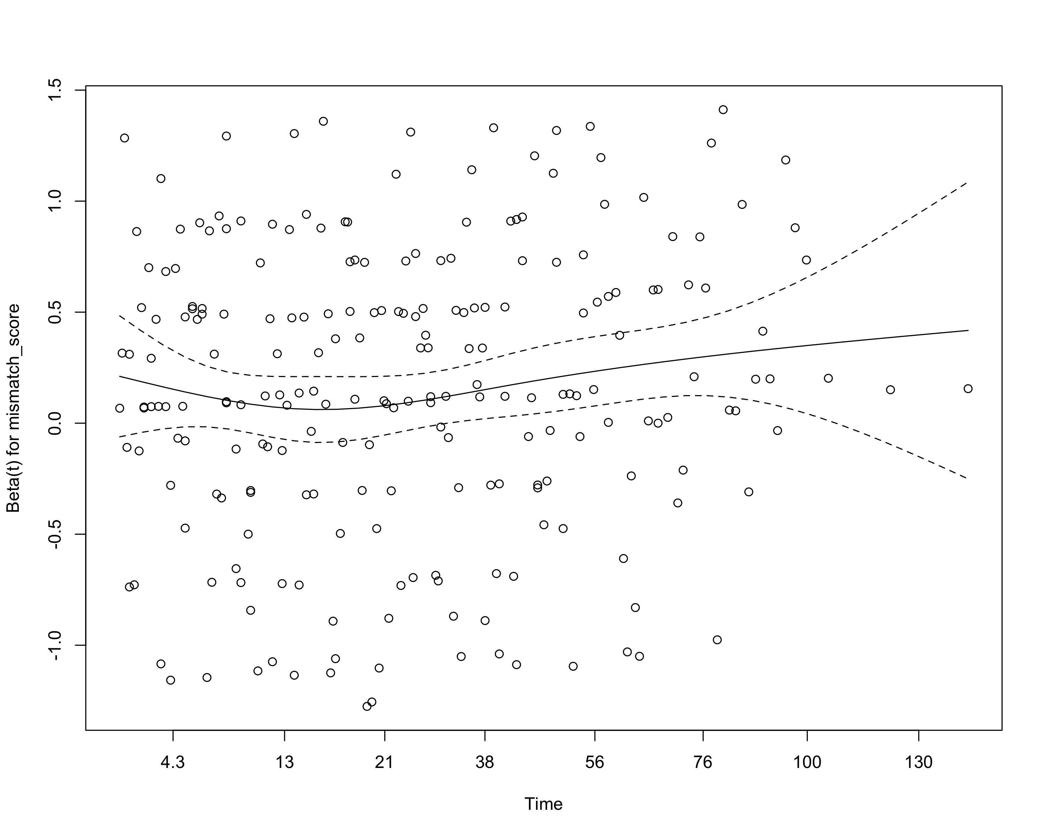

Appendix Table A4. Sensitivity model using prior transplant as binary
Sensitivity model using any prior transplant instead of prior transplant count
Characteristic | HR | 95% CI | p-value
ALG use
No ALG | — | —
ALG | 0.625 | 0.473, 0.825 | <0.001
Age at transplant, years | 1.03 | 1.02, 1.04 | <0.001
Biological sex
Male | — | —
Female | 0.953 | 0.729, 1.24 | 0.722
Duration of hemodialysis prior to transplant, days | 1.00 | 1.00, 1.00 | 0.567
Diabetes status
No | — | —
Yes | 1.94 | 1.36, 2.77 | <0.001
Any prior transplant
No | — | —
Yes | 1.21 | 0.910, 1.60 | 0.193
Amount of blood transfusion, blood units | 1.01 | 0.985, 1.04 | 0.407
Donor mismatch score | 1.17 | 1.07, 1.27 | <0.001
Abbreviations: CI = Confidence Interval, HR = Hazard Ratio
This sensitivity analysis uses any prior transplant instead of prior transplant count.

Appendix Table A5. Detailed interaction model for ALG by blood_units
Interaction model: ALG use by blood_units
Characteristic | HR | 95% CI | p-value
ALG use
No ALG | — | —
ALG | 0.434 | 0.287, 0.658 | <0.001
Amount of blood transfusion, blood units | 1.01 | 0.983, 1.03 | 0.625
Age at transplant, years | 1.03 | 1.02, 1.04 | <0.001
Biological sex
Male | — | —
Female | 0.976 | 0.746, 1.28 | 0.860
Duration of hemodialysis prior to transplant, days | 1.00 | 1.00, 1.00 | 0.552
Diabetes status
No | — | —
Yes | 2.02 | 1.41, 2.88 | <0.001
Number of prior transplants | 1.23 | 0.990, 1.52 | 0.061
Donor mismatch score | 1.15 | 1.06, 1.25 | 0.001
ALG use * Amount of blood transfusion, blood units
ALG * Amount of blood transfusion, blood units | 1.27 | 1.06, 1.51 | 0.009
Abbreviations: CI = Confidence Interval, HR = Hazard Ratio
This model is included to support interpretation of the corresponding interaction screening result.

Appendix Table A5. Detailed interaction model for ALG by sex
Interaction model: ALG use by sex
Characteristic | HR | 95% CI | p-value
ALG use
No ALG | — | —
ALG | 0.478 | 0.327, 0.698 | <0.001
Biological sex
Male | — | —
Female | 0.763 | 0.546, 1.07 | 0.112
Age at transplant, years | 1.03 | 1.02, 1.04 | <0.001
Duration of hemodialysis prior to transplant, days | 1.00 | 1.00, 1.00 | 0.504
Diabetes status
No | — | —
Yes | 1.89 | 1.32, 2.70 | <0.001
Number of prior transplants | 1.28 | 1.03, 1.59 | 0.025
Amount of blood transfusion, blood units | 1.01 | 0.986, 1.04 | 0.354
Donor mismatch score | 1.17 | 1.08, 1.27 | <0.001
ALG use * Biological sex
ALG * Female | 1.86 | 1.06, 3.27 | 0.030
Abbreviations: CI = Confidence Interval, HR = Hazard Ratio
This model is included to support interpretation of the corresponding interaction screening result.

Appendix Figure. Martingale residual functional-form check for age_years
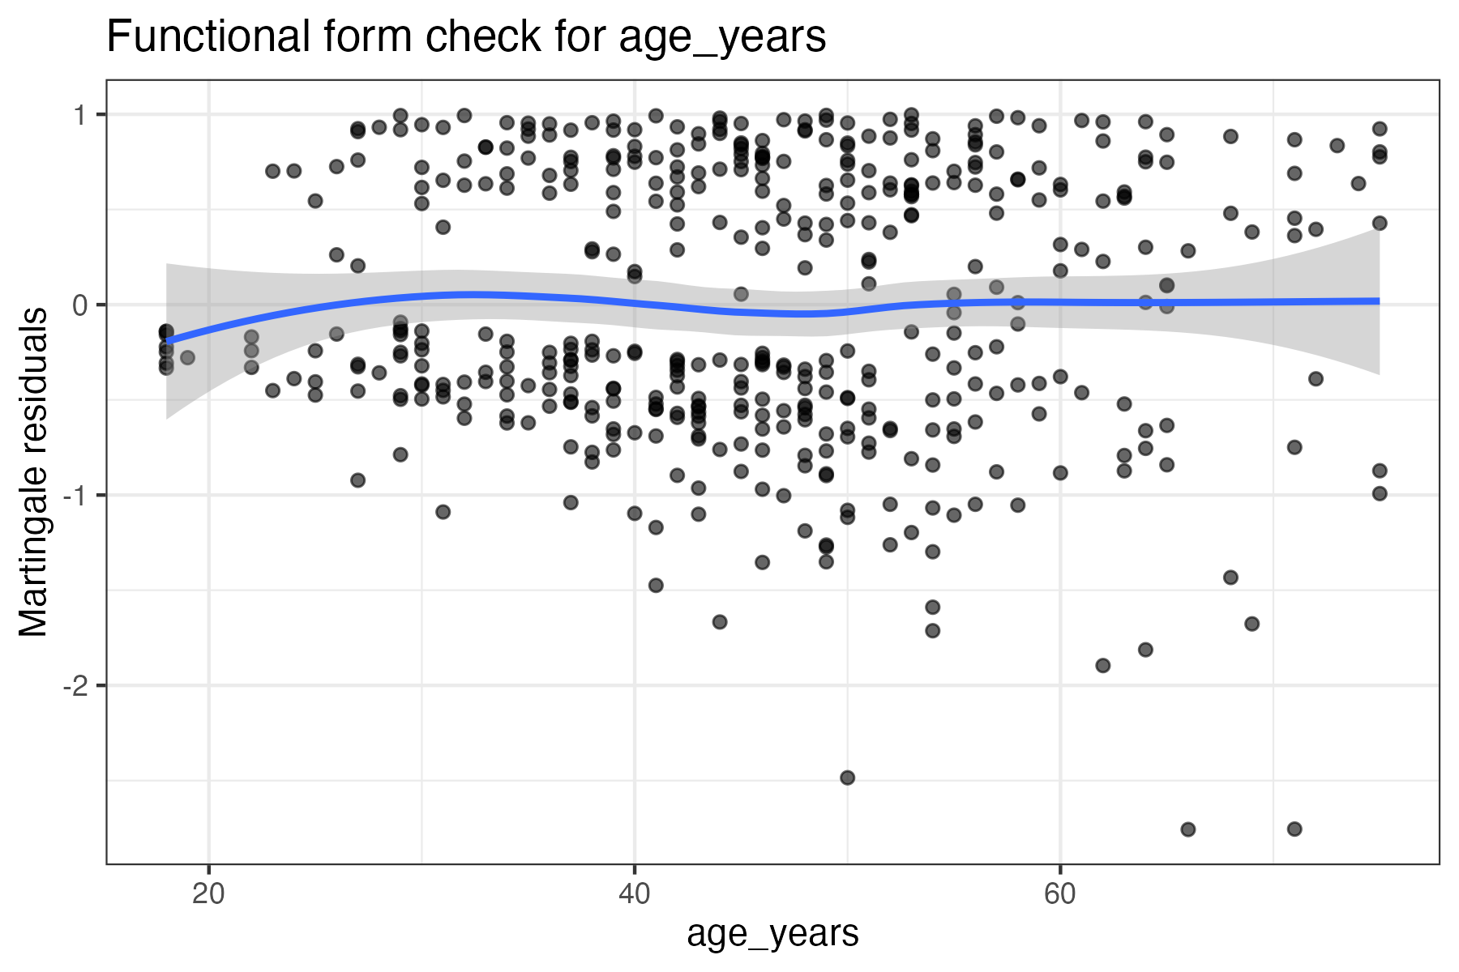

Appendix Figure. Martingale residual functional-form check for dialysis_days
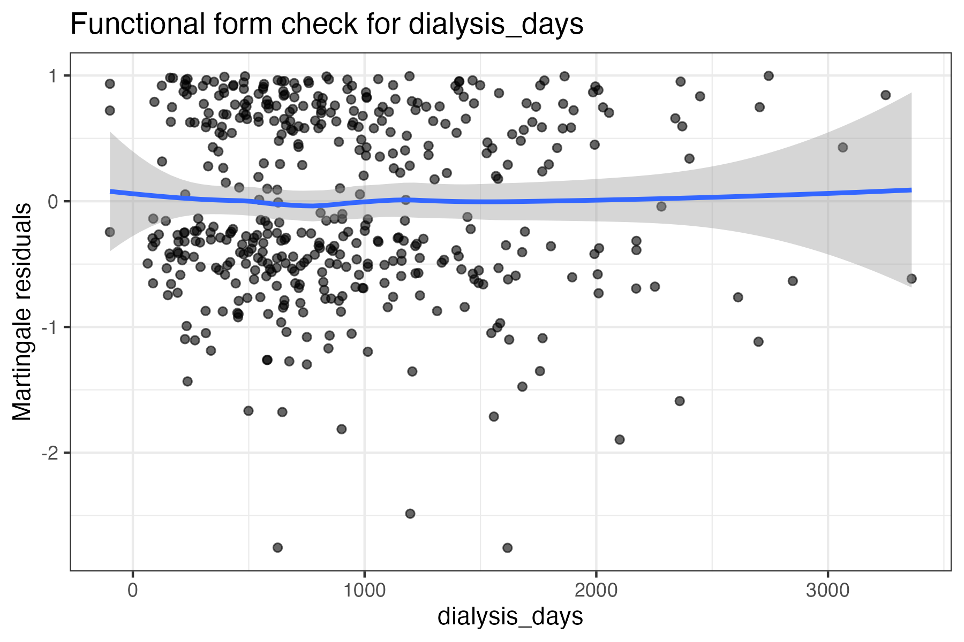

Appendix Figure. Martingale residual functional-form check for prior_transplants_count
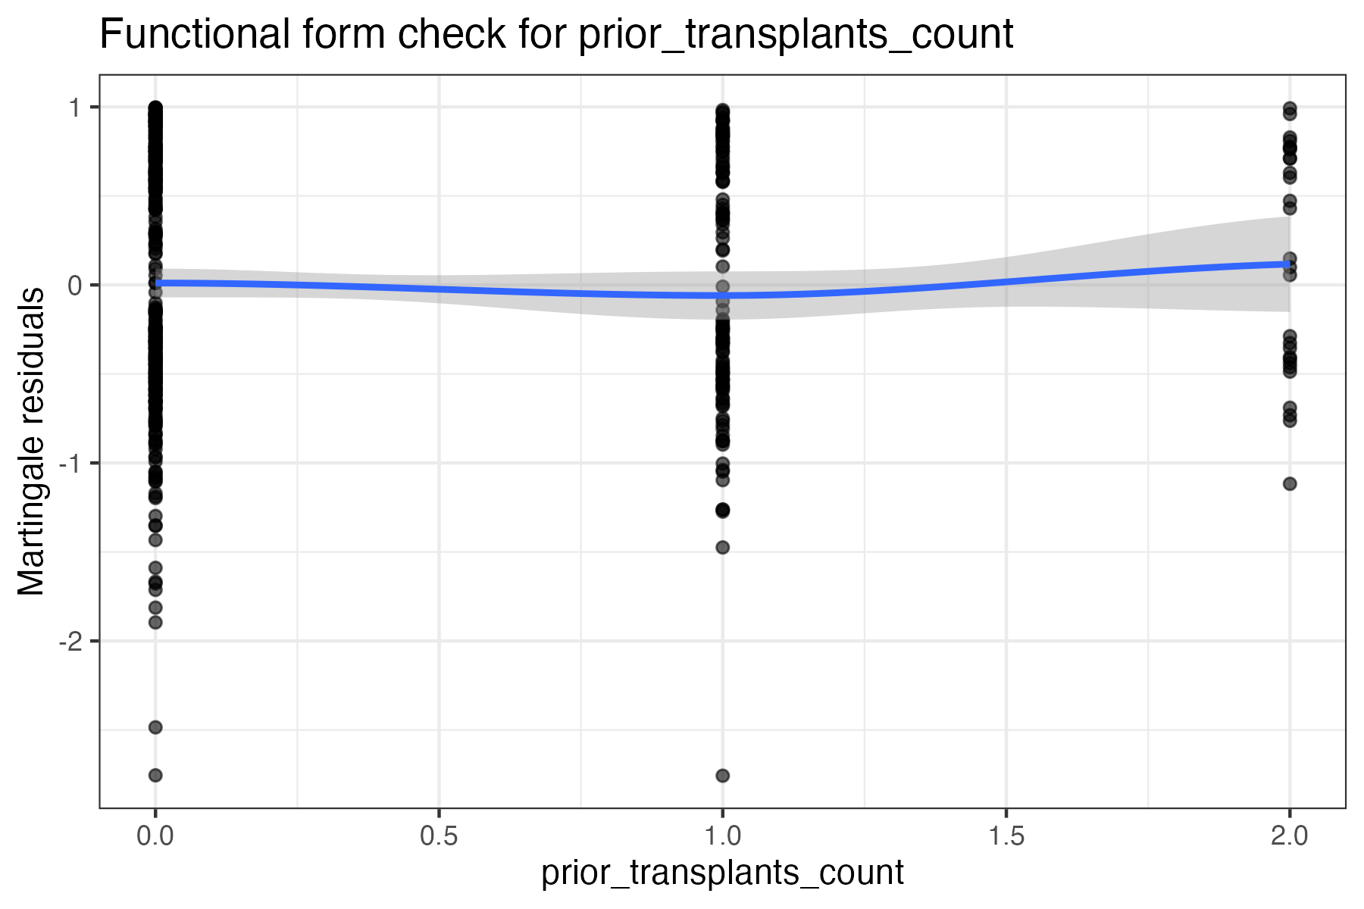

Appendix Figure. Martingale residual functional-form check for blood_units
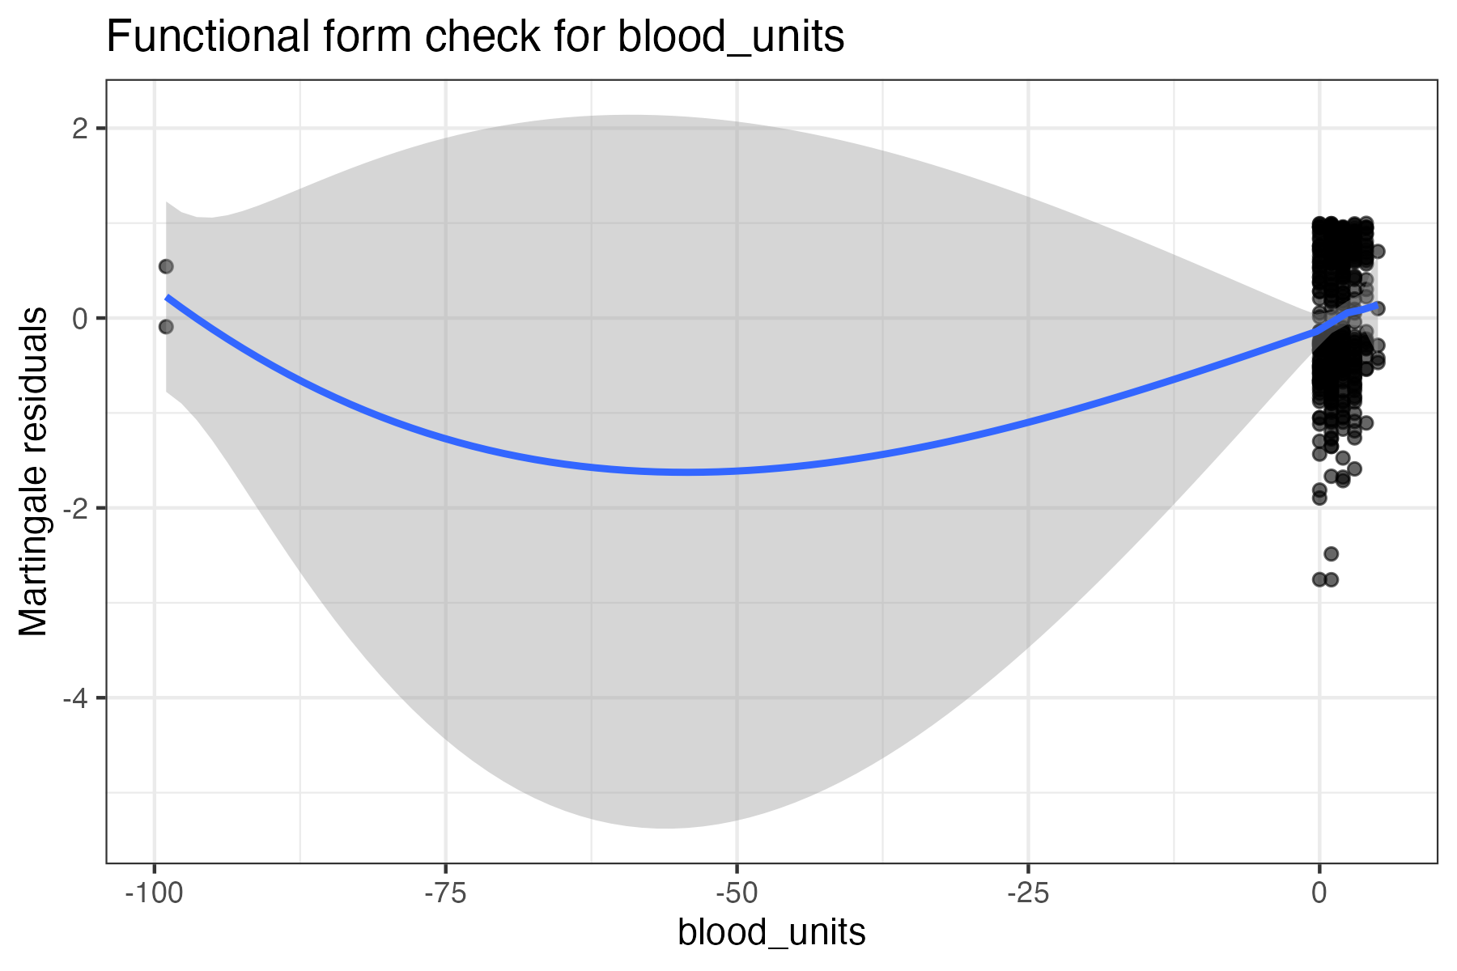

Appendix Figure. Martingale residual functional-form check for mismatch_score
