QE2025 Applied Practice, Kidney Transplant Graft Survival
Generated: 2026-06-09
This document contains formatted three-line tables and figures generated from the R analysis script. Replace this note with your own written interpretation before submitting any report.

Table 1. Patient characteristics by ALG use
Table 1. Patient characteristics by ALG use
Characteristic | Overall  N = 469¹ | No ALG  N = 282¹ | ALG  N = 187¹ | p-value²
Age at transplant, years |  |  |  | 0.206
Median (Q1, Q3) | 46.0 (37.0, 53.0) | 46.0 (38.0, 54.0) | 45.0 (37.0, 53.0)
Mean (SD) | 45.6 (12.1) | 46.2 (11.9) | 44.7 (12.4)
Missing | 2 | 2 | 0
Biological sex |  |  |  | 0.390
Male | 269 (57.6%) | 157 (55.9%) | 112 (60.2%)
Female | 198 (42.4%) | 124 (44.1%) | 74 (39.8%)
Missing | 2 | 1 | 1
Duration of hemodialysis prior to transplant, days |  |  |  | 0.922
Median (Q1, Q3) | 764.5 (479.0, 1,206.0) | 751.0 (478.0, 1,232.0) | 769.0 (482.0, 1,194.0)
Mean (SD) | 906.2 (593.4) | 914.2 (604.4) | 894.5 (578.3)
Missing | 7 | 7 | 0
Diabetes status |  |  |  | 1.000
No | 409 (87.8%) | 247 (87.9%) | 162 (87.6%)
Yes | 57 (12.2%) | 34 (12.1%) | 23 (12.4%)
Missing | 3 | 1 | 2
Number of prior transplants |  |  |  | 0.472
Median (Q1, Q3) | 0.0 (0.0, 1.0) | 0.0 (0.0, 1.0) | 0.0 (0.0, 1.0)
Mean (SD) | 0.4 (0.6) | 0.4 (0.6) | 0.4 (0.6)
Missing | 2 | 1 | 1
Amount of blood transfusion, blood units |  |  |  | 0.965
Median (Q1, Q3) | 1.0 (1.0, 2.0) | 1.0 (1.0, 2.0) | 1.0 (1.0, 2.0)
Mean (SD) | 1.2 (6.7) | 1.2 (6.1) | 1.0 (7.5)
Missing | 5 | 3 | 2
Donor mismatch score |  |  |  | 0.002
Median (Q1, Q3) | 3.0 (2.0, 4.0) | 3.0 (2.0, 4.0) | 3.0 (2.0, 4.0)
Mean (SD) | 3.0 (1.6) | 2.8 (1.7) | 3.3 (1.5)
Missing | 3 | 2 | 1
¹n (%)
²Wilcoxon rank sum test; Fisher's exact test
Continuous variables are summarized as median (IQR) and mean (SD); categorical variables are summarized as n (%). P values are from Wilcoxon rank-sum tests for continuous variables and Fisher exact tests for categorical variables.

Table 2. Graft failure and follow-up summary by ALG use
ALG use | N | Graft failures, n (%) | Censored/functioning graft, n (%) | Follow-up, median (IQR), months
No ALG | 282 | 157 (55.7%) | 125 (44.3%) | 38.8 (18.2, 64.8)
ALG | 187 | 83 (44.4%) | 104 (55.6%) | 52.1 (26.6, 74.6)
Events are graft failures. Patients without graft failure at last follow-up are treated as censored.

Log-rank test by ALG use
Test | Chisq | df | P value
Log-rank test comparing graft survival by ALG use | 8.49 | 1 | 0.004
The log-rank test compares unadjusted graft survival curves by ALG use.

Figure 1. Kaplan-Meier graft survival curve by ALG use
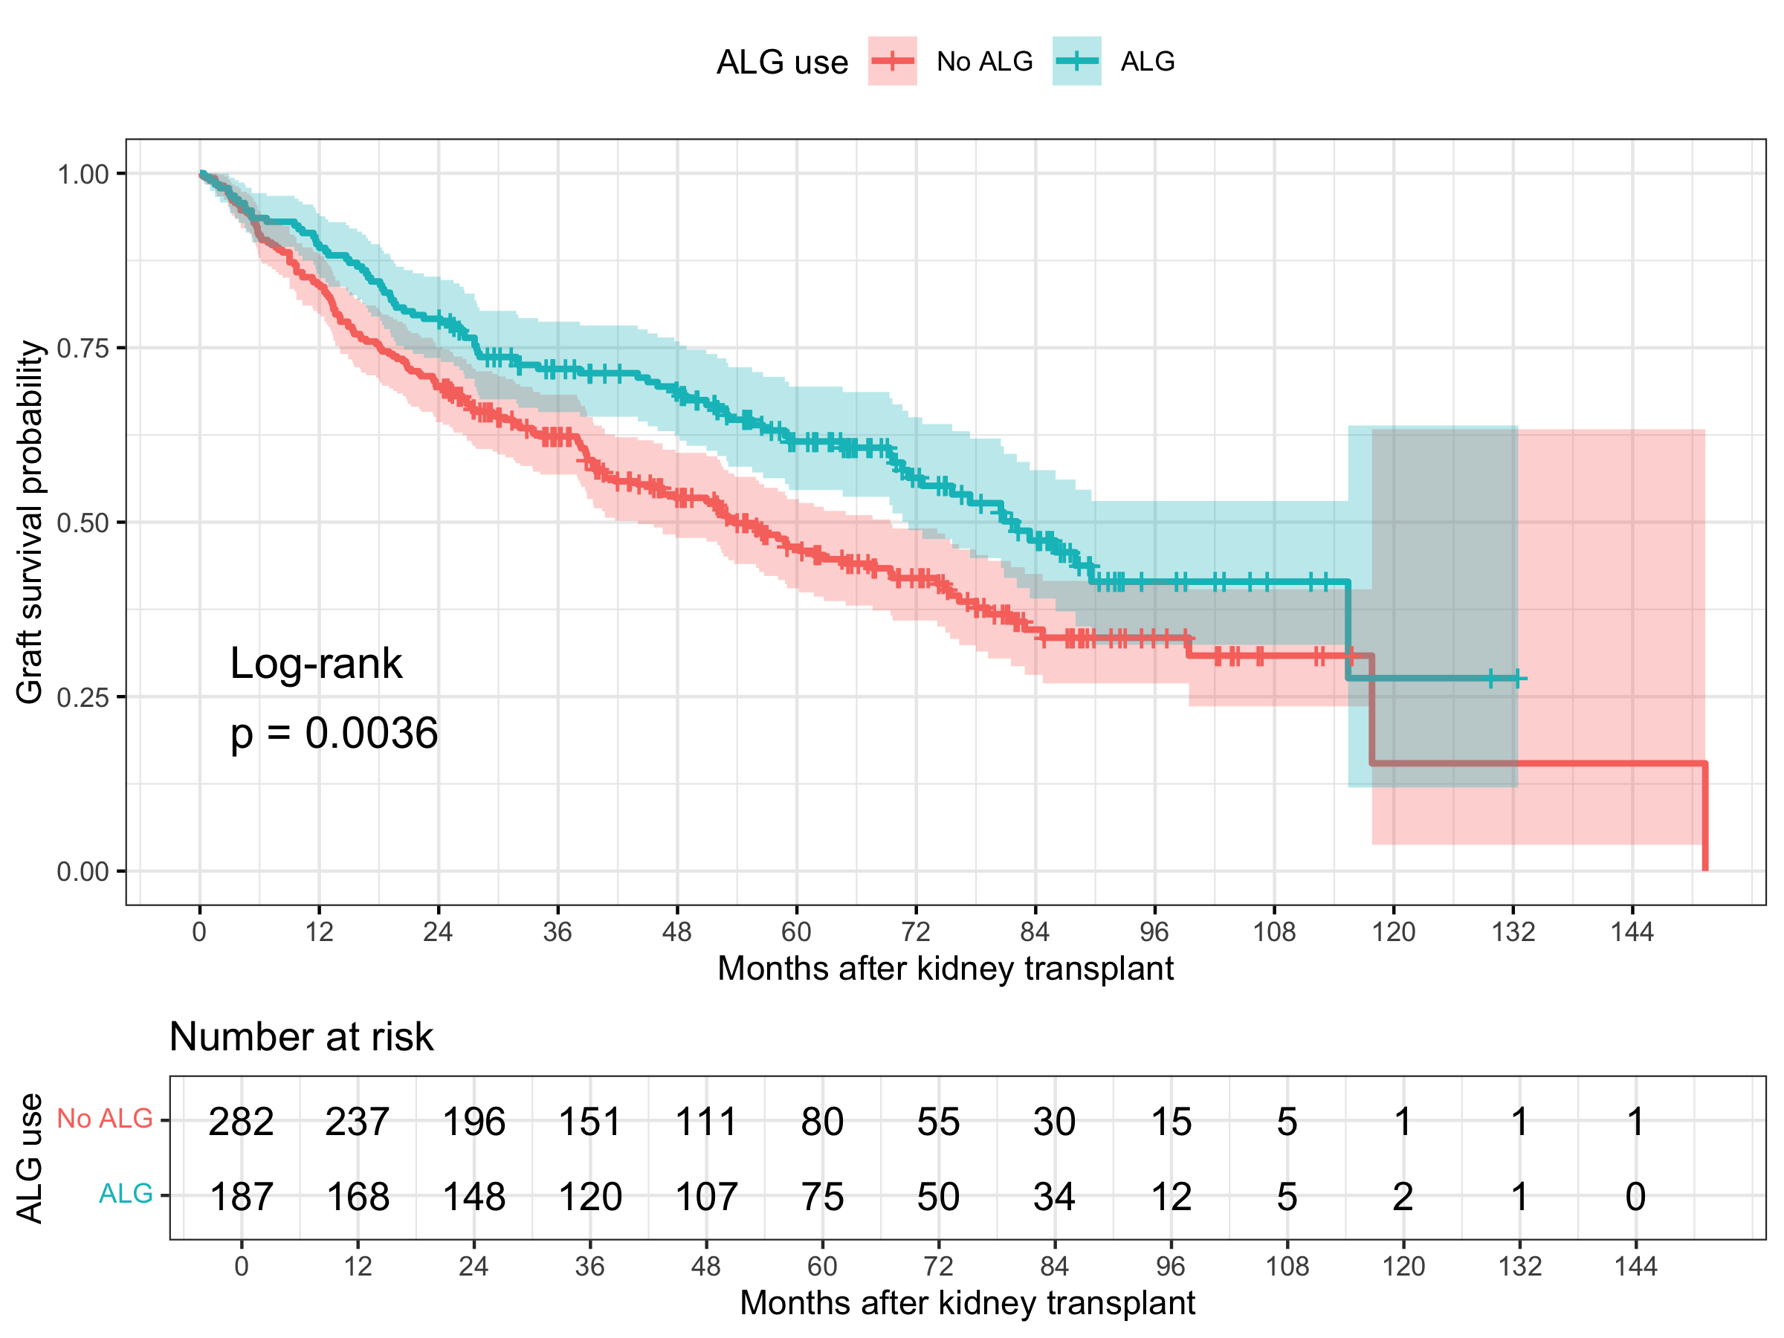

Table 3. Univariate Cox proportional hazards models
Variable | Model term | Hazard ratio (95% CI) | P value
ALG use | alg_useALG | 0.67 (0.52, 0.88) | 0.004
Age at transplant, years | age_years | 1.03 (1.02, 1.04) | <0.001
Biological sex | sexFemale | 1.02 (0.79, 1.32) | 0.894
Duration of hemodialysis prior to transplant, days | dialysis_days | 1.00 (1.00, 1.00) | 0.035
Diabetes status | diabetesYes | 2.14 (1.52, 3.01) | <0.001
Number of prior transplants | prior_transplants_count | 1.28 (1.04, 1.57) | 0.019
Amount of blood transfusion, blood units | blood_units | 1.01 (0.99, 1.04) | 0.296
Donor mismatch score | mismatch_score | 1.14 (1.05, 1.24) | 0.001
Each row comes from a separate univariate Cox proportional hazards model. Hazard ratios greater than 1 indicate higher hazard of graft failure.

Table 4. Full multivariable Cox proportional hazards model
Table 3. Full multivariable Cox proportional hazards model
Characteristic | HR | 95% CI | p-value
ALG use
No ALG | — | —
ALG | 0.628 | 0.475, 0.829 | 0.001
Age at transplant, years | 1.03 | 1.02, 1.04 | <0.001
Biological sex
Male | — | —
Female | 0.949 | 0.726, 1.24 | 0.702
Duration of hemodialysis prior to transplant, days | 1.00 | 1.00, 1.00 | 0.596
Diabetes status
No | — | —
Yes | 1.96 | 1.37, 2.80 | <0.001
Number of prior transplants | 1.24 | 1.00, 1.53 | 0.050
Amount of blood transfusion, blood units | 1.01 | 0.985, 1.04 | 0.417
Donor mismatch score | 1.16 | 1.07, 1.27 | <0.001
Abbreviations: CI = Confidence Interval, HR = Hazard Ratio
The full model includes ALG use and all prespecified covariates. Hazard ratios greater than 1 indicate higher hazard of graft failure.

Table 5. Selected Cox proportional hazards model with ALG forced
Table 4. Selected Cox proportional hazards model with ALG forced
Characteristic | HR | 95% CI | p-value
ALG use
No ALG | — | —
ALG | 0.635 | 0.481, 0.837 | 0.001
Age at transplant, years | 1.03 | 1.02, 1.04 | <0.001
Diabetes status
No | — | —
Yes | 1.97 | 1.39, 2.80 | <0.001
Number of prior transplants | 1.25 | 1.01, 1.55 | 0.040
Donor mismatch score | 1.17 | 1.08, 1.27 | <0.001
Abbreviations: CI = Confidence Interval, HR = Hazard Ratio
Model selection used AIC with ALG forced into the model because ALG is the main exposure of scientific interest.

Table 6. Screening tests for ALG effect modification
Potential effect modifier | LRT chi-square | df | P value
blood_units | 6.736 | 1 | 0.009
sex | 4.667 | 1 | 0.031
diabetes | 2.032 | 1 | 0.154
dialysis_days | 0.936 | 1 | 0.333
prior_transplants_count | 0.231 | 1 | 0.631
mismatch_score | 0.227 | 1 | 0.633
age_years | 0.108 | 1 | 0.743
Each row compares a model with an ALG-by-modifier interaction against the corresponding model without the interaction using a likelihood ratio test. These results should be interpreted as effect modification screening.

