Kidney Transplant Graft Survival and ALG Use
Technical Report, Practice Version Based on Synthetic Data
Course: Ph.D. Qualifying Exam Applied Practice
Dataset structure: 2025 Kidney Transplant Applied Exam

Introduction
Kidney graft failure is a clinically important time-to-event endpoint after kidney transplantation. This practice analysis evaluated a synthetic cohort of 469 transplant recipients to examine whether measured baseline covariates were associated with graft survival and whether the association between anti-lymphocyte globulin (ALG) use and graft survival differed across patient characteristics. The primary outcome was time from transplant to graft failure or last follow-up, with functioning grafts at last follow-up treated as censored observations. The primary exposure of interest was ALG use. Covariates considered in the analysis included age at transplant, biological sex, duration of hemodialysis before transplant, diabetes status, number of prior transplants, amount of blood transfusion, and donor mismatch score.

Statistical Methods
The analytic dataset included patients with a positive follow-up time and a nonmissing graft failure indicator. Categorical variables were summarized using counts and percentages, and continuous variables were summarized using median with interquartile range and mean with standard deviation. Baseline characteristics were compared by ALG use using Fisher exact tests for categorical variables and Wilcoxon rank-sum tests for continuous variables. Missing values were retained in descriptive summaries and excluded from complete-case regression models as required by each model.
Graft survival was summarized by ALG use using Kaplan-Meier curves and compared using a log-rank test. Univariate Cox proportional hazards models were fit separately for ALG use and each candidate covariate. The primary multivariable model was a Cox proportional hazards model including ALG use and the prespecified covariates. Model selection was performed using Akaike information criterion with ALG forced to remain in the model because it was the main exposure of scientific interest. Hazard ratios (HRs), 95% confidence intervals (CIs), and p values were reported. HRs greater than 1 indicate higher instantaneous risk of graft failure, and HRs less than 1 indicate lower instantaneous risk of graft failure.
Effect modification of the ALG association was examined by fitting one ALG-by-covariate interaction at a time and comparing the interaction model with the corresponding no-interaction model using a likelihood ratio test. These interaction analyses were treated as screening analyses because multiple interactions were examined. The proportional hazards assumption was assessed using scaled Schoenfeld residual tests and diagnostic plots. Visual diagnostics included log-log survival plots, scaled Schoenfeld residual plots, and Martingale residual plots for continuous covariates. A sensitivity analysis replaced the count of prior transplants with a binary indicator for any prior transplant. Analyses were implemented in R using survival, survminer, gtsummary, flextable, officer, broom, dplyr, and related packages. For an actual exam submission, the R version and package versions should be inserted from sessionInfo().

Results

Study population and baseline characteristics
The synthetic dataset contained 469 transplant recipients, including 282 patients without ALG use and 187 patients with ALG use. Baseline characteristics were generally similar between ALG groups for age, biological sex, duration of hemodialysis, diabetes status, prior transplant count, and blood transfusion amount. Donor mismatch score differed by ALG use, with a higher mean mismatch score in the ALG group than in the no-ALG group, 3.3 versus 2.8, p = 0.002. This imbalance is clinically relevant because higher mismatch score was later associated with higher graft failure hazard.

Table 1. Patient characteristics by ALG use.
Characteristic | Overall N = 469 | No ALG N = 282 | ALG N = 187 | p-value
Age at transplant, years |  |  |  | 0.206
Median (Q1, Q3) | 46.0 (37.0, 53.0) | 46.0 (38.0, 54.0) | 45.0 (37.0, 53.0)
Mean (SD) | 45.6 (12.1) | 46.2 (11.9) | 44.7 (12.4)
Missing | 2 | 2 | 0
Biological sex |  |  |  | 0.390
Male | 269 (57.6%) | 157 (55.9%) | 112 (60.2%)
Female | 198 (42.4%) | 124 (44.1%) | 74 (39.8%)
Missing | 2 | 1 | 1
Duration of hemodialysis prior to transplant, days |  |  |  | 0.922
Median (Q1, Q3) | 764.5 (479.0, 1,206.0) | 751.0 (478.0, 1,232.0) | 769.0 (482.0, 1,194.0)
Mean (SD) | 906.2 (593.4) | 914.2 (604.4) | 894.5 (578.3)
Missing | 7 | 7 | 0
Diabetes status |  |  |  | 1.000
No | 409 (87.8%) | 247 (87.9%) | 162 (87.6%)
Yes | 57 (12.2%) | 34 (12.1%) | 23 (12.4%)
Missing | 3 | 1 | 2
Number of prior transplants |  |  |  | 0.472
Median (Q1, Q3) | 0.0 (0.0, 1.0) | 0.0 (0.0, 1.0) | 0.0 (0.0, 1.0)
Mean (SD) | 0.4 (0.6) | 0.4 (0.6) | 0.4 (0.6)
Missing | 2 | 1 | 1
Amount of blood transfusion, blood units |  |  |  | 0.965
Median (Q1, Q3) | 1.0 (1.0, 2.0) | 1.0 (1.0, 2.0) | 1.0 (1.0, 2.0)
Mean (SD) | 1.2 (6.7) | 1.2 (6.1) | 1.0 (7.5)
Missing | 5 | 3 | 2
Donor mismatch score |  |  |  | 0.002
Median (Q1, Q3) | 3.0 (2.0, 4.0) | 3.0 (2.0, 4.0) | 3.0 (2.0, 4.0)
Mean (SD) | 3.0 (1.6) | 2.8 (1.7) | 3.3 (1.5)
Missing | 3 | 2 | 1
Continuous variables are summarized as median (Q1, Q3) and mean (SD). Categorical variables are summarized as n (%). P values are from Wilcoxon rank-sum tests for continuous variables and Fisher exact tests for categorical variables.

Unadjusted graft survival by ALG use
Overall, graft failure occurred in 157 of 282 patients without ALG use, 55.7%, and 83 of 187 patients with ALG use, 44.4%. Median follow-up was longer in the ALG group than in the no-ALG group, 52.1 months versus 38.8 months. The Kaplan-Meier curves suggested better graft survival among patients with ALG use, and the log-rank test showed a statistically significant difference in unadjusted graft survival by ALG use, chi-square = 8.49, p = 0.004.
Table 2. Graft failure and follow-up summary by ALG use.
ALG use | N | Graft failures, n (%) | Censored/functioning graft, n (%) | Follow-up, median (IQR), months
No ALG | 282 | 157 (55.7%) | 125 (44.3%) | 38.8 (18.2, 64.8)
ALG | 187 | 83 (44.4%) | 104 (55.6%) | 52.1 (26.6, 74.6)
Events are graft failures. Patients without graft failure at last follow-up are treated as censored.
Table 3. Log-rank test comparing graft survival by ALG use.
Test | Chi-square | df | p-value
Log-rank test comparing graft survival by ALG use | 8.49 | 1 | 0.004
The log-rank test compares unadjusted graft survival curves by ALG use.
Figure 1. Kaplan-Meier graft survival curve by ALG use.
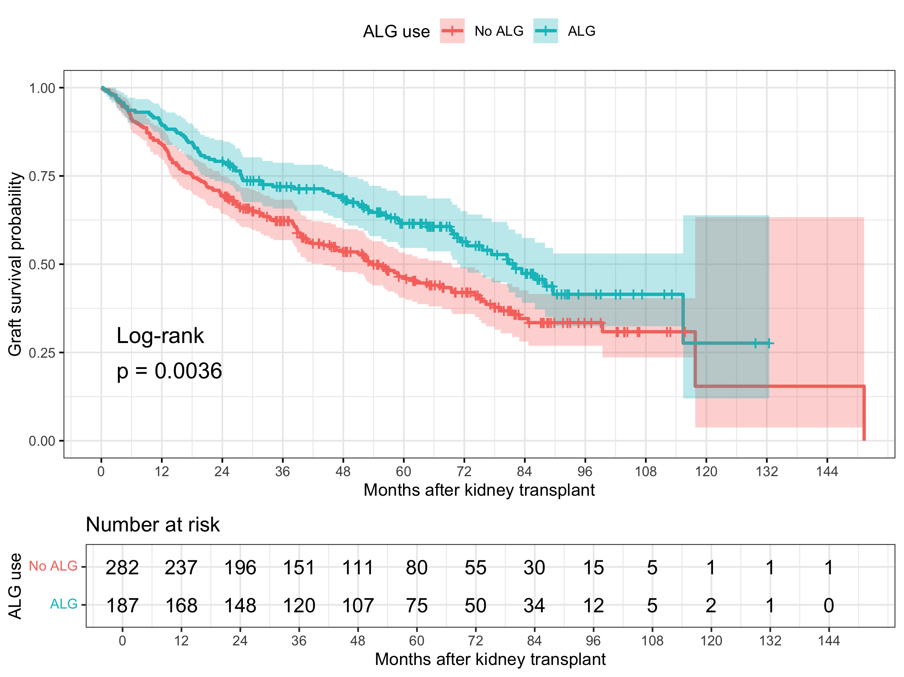
The curve for the ALG group is generally above the curve for the no-ALG group, consistent with lower unadjusted graft failure risk among ALG users in this synthetic dataset.

Univariate Cox proportional hazards models
In univariate Cox models, ALG use was associated with lower graft failure hazard, HR = 0.67, 95% CI 0.52 to 0.88, p = 0.004. Older age, longer dialysis duration, diabetes, greater number of prior transplants, and higher donor mismatch score were each associated with higher graft failure hazard in univariate analyses. Biological sex and blood transfusion amount were not statistically significant in the univariate models.
Table 4. Univariate Cox proportional hazards models.
Variable | HR (95% CI) | p-value
ALG use | 0.67 (0.52, 0.88) | 0.004
Age at transplant, years | 1.03 (1.02, 1.04) | <0.001
Biological sex, Female vs Male | 1.02 (0.79, 1.32) | 0.894
Duration of hemodialysis prior to transplant, days | 1.00 (1.00, 1.00) | 0.035
Diabetes status, Yes vs No | 2.14 (1.52, 3.01) | <0.001
Number of prior transplants | 1.28 (1.04, 1.57) | 0.019
Amount of blood transfusion, blood units | 1.01 (0.99, 1.04) | 0.296
Donor mismatch score | 1.14 (1.05, 1.24) | 0.001
Each row comes from a separate univariate Cox proportional hazards model. HR = hazard ratio; CI = confidence interval.

Multivariable Cox proportional hazards models
In the full multivariable Cox model, ALG use remained associated with lower graft failure hazard after adjustment for prespecified covariates, HR = 0.628, 95% CI 0.475 to 0.829, p = 0.001. The selected Cox model with ALG forced retained ALG use, age, diabetes status, number of prior transplants, and donor mismatch score. In the selected model, ALG use was associated with a 36.5% lower hazard of graft failure, HR = 0.635, 95% CI 0.481 to 0.837, p = 0.001. Older age, diabetes, more prior transplants, and higher mismatch score were independently associated with higher graft failure hazard.
Table 5. Selected Cox proportional hazards model with ALG forced.
Characteristic | HR | 95% CI | p-value
ALG use, ALG vs No ALG | 0.635 | 0.481, 0.837 | 0.001
Age at transplant, years | 1.03 | 1.02, 1.04 | <0.001
Diabetes status, Yes vs No | 1.97 | 1.39, 2.80 | <0.001
Number of prior transplants | 1.25 | 1.01, 1.55 | 0.040
Donor mismatch score | 1.17 | 1.08, 1.27 | <0.001
Model selection used AIC with ALG forced into the model. HRs greater than 1 indicate higher hazard of graft failure; HRs less than 1 indicate lower hazard of graft failure.

Effect modification of the ALG association
Likelihood ratio tests suggested potential heterogeneity of the ALG association by blood transfusion amount, p = 0.009, and biological sex, p = 0.031. The detailed interaction model for blood transfusion showed an ALG-by-blood-units interaction HR of 1.27, 95% CI 1.06 to 1.51, p = 0.009, indicating that the apparent protective association of ALG was attenuated as blood transfusion units increased. The detailed interaction model for sex showed an ALG-by-female interaction HR of 1.86, 95% CI 1.06 to 3.27, p = 0.030, suggesting that the lower graft failure hazard associated with ALG may be stronger among males than females in this synthetic dataset. Because multiple interactions were screened, these findings should be interpreted as hypothesis-generating rather than definitive evidence of effect modification.
Table 6. Screening tests for ALG effect modification.
Potential effect modifier | LRT chi-square | df | p-value
Amount of blood transfusion, blood units | 6.736 | 1 | 0.009
Biological sex | 4.667 | 1 | 0.031
Diabetes status | 2.032 | 1 | 0.154
Duration of hemodialysis prior to transplant, days | 0.936 | 1 | 0.333
Number of prior transplants | 0.231 | 1 | 0.631
Donor mismatch score | 0.227 | 1 | 0.633
Age at transplant, years | 0.108 | 1 | 0.743
Each row compares a model with an ALG-by-modifier interaction against the corresponding model without the interaction using a likelihood ratio test. LRT = likelihood ratio test.

Model diagnostics
The global proportional hazards test was borderline in both the full Cox model, p = 0.060, and the selected Cox model, p = 0.058. The ALG term did not show evidence of non-proportionality in either model, p = 0.741 in the full model and p = 0.656 in the selected model. Age showed evidence of possible non-proportionality in both models, p = 0.035 in the full model and p = 0.038 in the selected model. Therefore, the primary interpretation of ALG appears reasonably supported by the diagnostics, but the age effect should be interpreted with caution. In a final applied report using real data, a time-dependent age effect, stratification, or sensitivity analysis should be considered if age non-proportionality persists.

Discussion
In this synthetic practice analysis of kidney transplant recipients, ALG use was associated with better graft survival in unadjusted Kaplan-Meier analysis and remained associated with lower graft failure hazard after adjustment for key clinical covariates. Age at transplant, diabetes status, prior transplant burden, and donor mismatch score were consistently associated with worse graft survival. Interaction screening suggested possible heterogeneity of the ALG association by blood transfusion amount and biological sex, but these findings require cautious interpretation because they were based on multiple exploratory interaction tests.
This analysis has several limitations. First, the dataset used for this practice report was randomly generated and does not represent real kidney transplant outcomes. Second, the study structure is observational, so estimated ALG associations should not be interpreted as causal without stronger design assumptions and confounding control. Third, model selection can produce unstable results, especially when candidate predictors are correlated or event counts are limited. Fourth, the proportional hazards diagnostics suggested possible non-proportionality for age, and further modeling would be needed in a real analysis. Finally, the interaction findings should be considered exploratory and would require external validation. Despite these limitations, the analysis demonstrates a complete applied workflow for descriptive summaries, survival modeling, interaction assessment, model diagnostics, publication-style tables, and technical reporting.

References
R Core Team. R: A language and environment for statistical computing. R Foundation for Statistical Computing. https://www.r-project.org/
Therneau TM. A Package for Survival Analysis in R. survival package documentation. https://cran.r-project.org/package=survival
Kassambara A, Kosinski M, Biecek P. survminer: Drawing Survival Curves using ggplot2. https://cran.r-project.org/package=survminer
Sjoberg DD, Whiting K, Curry M, Lavery JA, Larmarange J. gtsummary: Presentation-ready data summary and analytic result tables. https://www.danieldsjoberg.com/gtsummary/
Gohel D. officer and flextable package documentation. https://davidgohel.github.io/officer/ and https://davidgohel.github.io/flextable/

Appendix
The appendix contains supporting tables and figures used to assess the analytic dataset, model assumptions, and sensitivity analyses. These materials are intended to support the main report but would not usually all be included in the main text.
Appendix Table A1. Cohort flow counts.
Step | N
Raw records imported | 469
Records with nonmissing positive follow-up time | 469
Records with nonmissing graft failure indicator | 469
Records included in survival analysis | 469
All 469 synthetic records had nonmissing positive follow-up time and nonmissing graft failure status.
Appendix Table A2. Missingness summary.
Variable | Missing N | Total N | Missing percent
dialysis_days | 7 | 469 | 1.5
blood_units | 5 | 469 | 1.1
diabetes | 3 | 469 | 0.6
mismatch_score | 3 | 469 | 0.6
age_years | 2 | 469 | 0.4
prior_transplants_count | 2 | 469 | 0.4
sex | 2 | 469 | 0.4
alg_use | 0 | 469 | 0.0
followup_months | 0 | 469 | 0.0
graft_failure | 0 | 469 | 0.0
Missingness was low across covariates. Regression models used complete-case records for variables included in each model.
Appendix Table A3. Full multivariable Cox proportional hazards model.
Characteristic | HR | 95% CI | p-value
ALG use, ALG vs No ALG | 0.628 | 0.475, 0.829 | 0.001
Age at transplant, years | 1.03 | 1.02, 1.04 | <0.001
Biological sex, Female vs Male | 0.949 | 0.726, 1.24 | 0.702
Duration of hemodialysis prior to transplant, days | 1.00 | 1.00, 1.00 | 0.596
Diabetes status, Yes vs No | 1.96 | 1.37, 2.80 | <0.001
Number of prior transplants | 1.24 | 1.00, 1.53 | 0.050
Amount of blood transfusion, blood units | 1.01 | 0.985, 1.04 | 0.417
Donor mismatch score | 1.16 | 1.07, 1.27 | <0.001
The full model includes ALG use and all prespecified covariates.
Appendix Table A4. Cox proportional hazards assumption tests.
Model | Term | Chi-square | df | p-value
Full Cox model | alg_use | 0.109 | 1 | 0.741
Full Cox model | age_years | 4.422 | 1 | 0.035
Full Cox model | sex | 0.389 | 1 | 0.533
Full Cox model | dialysis_days | 0.360 | 1 | 0.549
Full Cox model | diabetes | 2.772 | 1 | 0.096
Full Cox model | prior_transplants_count | 2.257 | 1 | 0.133
Full Cox model | blood_units | 3.385 | 1 | 0.066
Full Cox model | mismatch_score | 2.254 | 1 | 0.133
Full Cox model | GLOBAL | 14.975 | 8 | 0.060
Selected Cox model | alg_use | 0.199 | 1 | 0.656
Selected Cox model | age_years | 4.301 | 1 | 0.038
Selected Cox model | diabetes | 2.898 | 1 | 0.089
Selected Cox model | prior_transplants_count | 2.258 | 1 | 0.133
Selected Cox model | mismatch_score | 2.400 | 1 | 0.121
Selected Cox model | GLOBAL | 10.680 | 5 | 0.058
Tests are based on scaled Schoenfeld residuals. A small p value suggests possible violation of the proportional hazards assumption.
Appendix Figure A1. Log-log survival plot by ALG use.
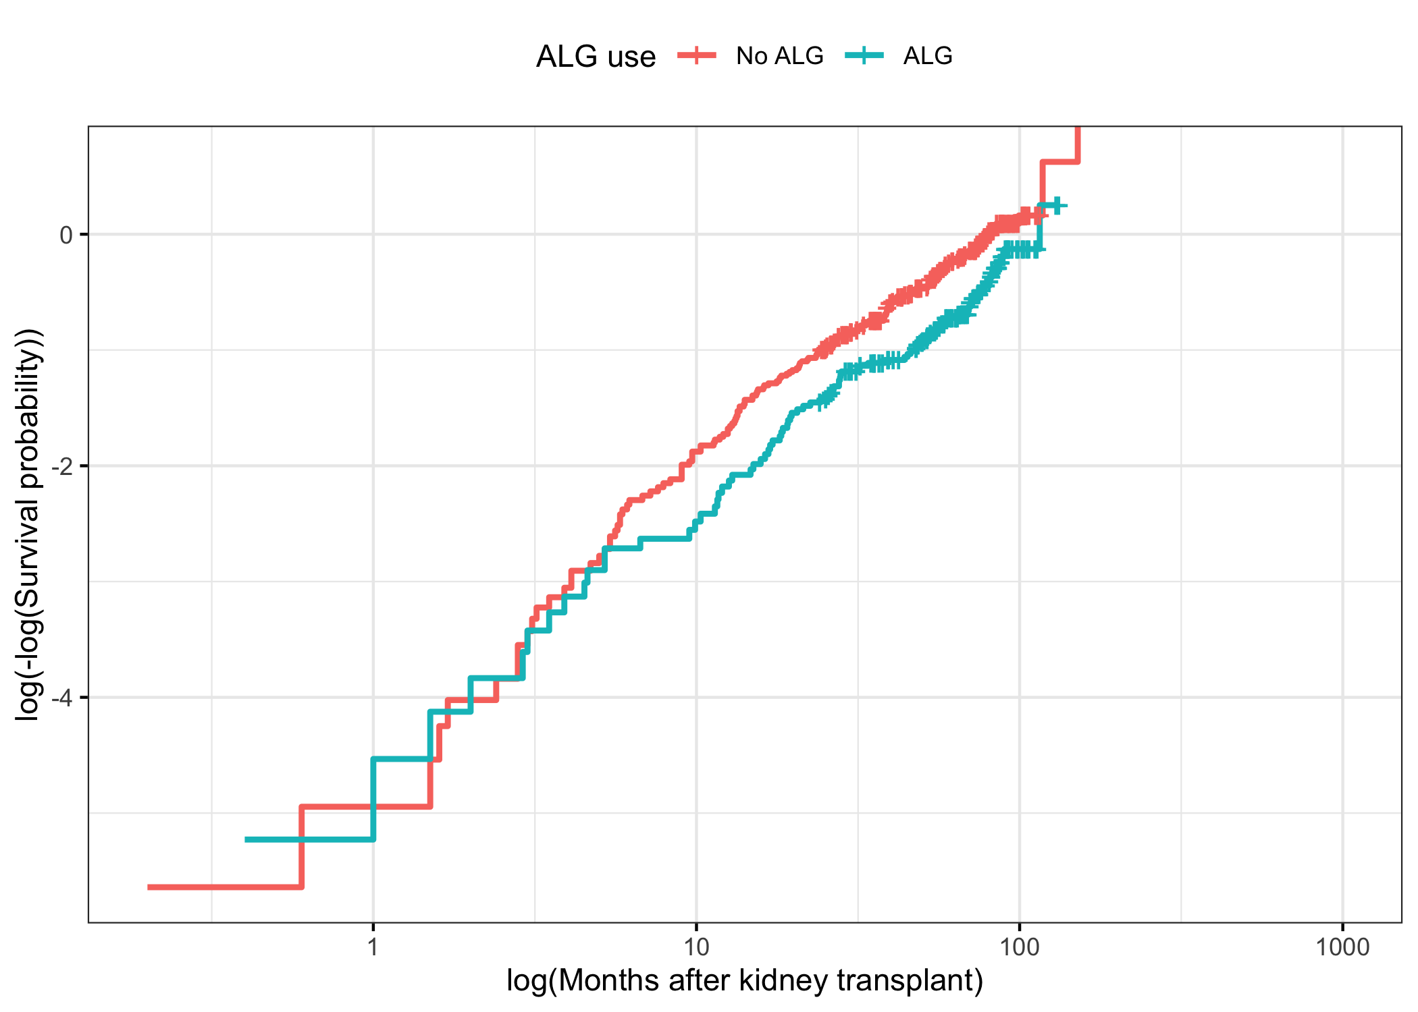
Appendix Figure A2. Scaled Schoenfeld residual plots for selected Cox model.
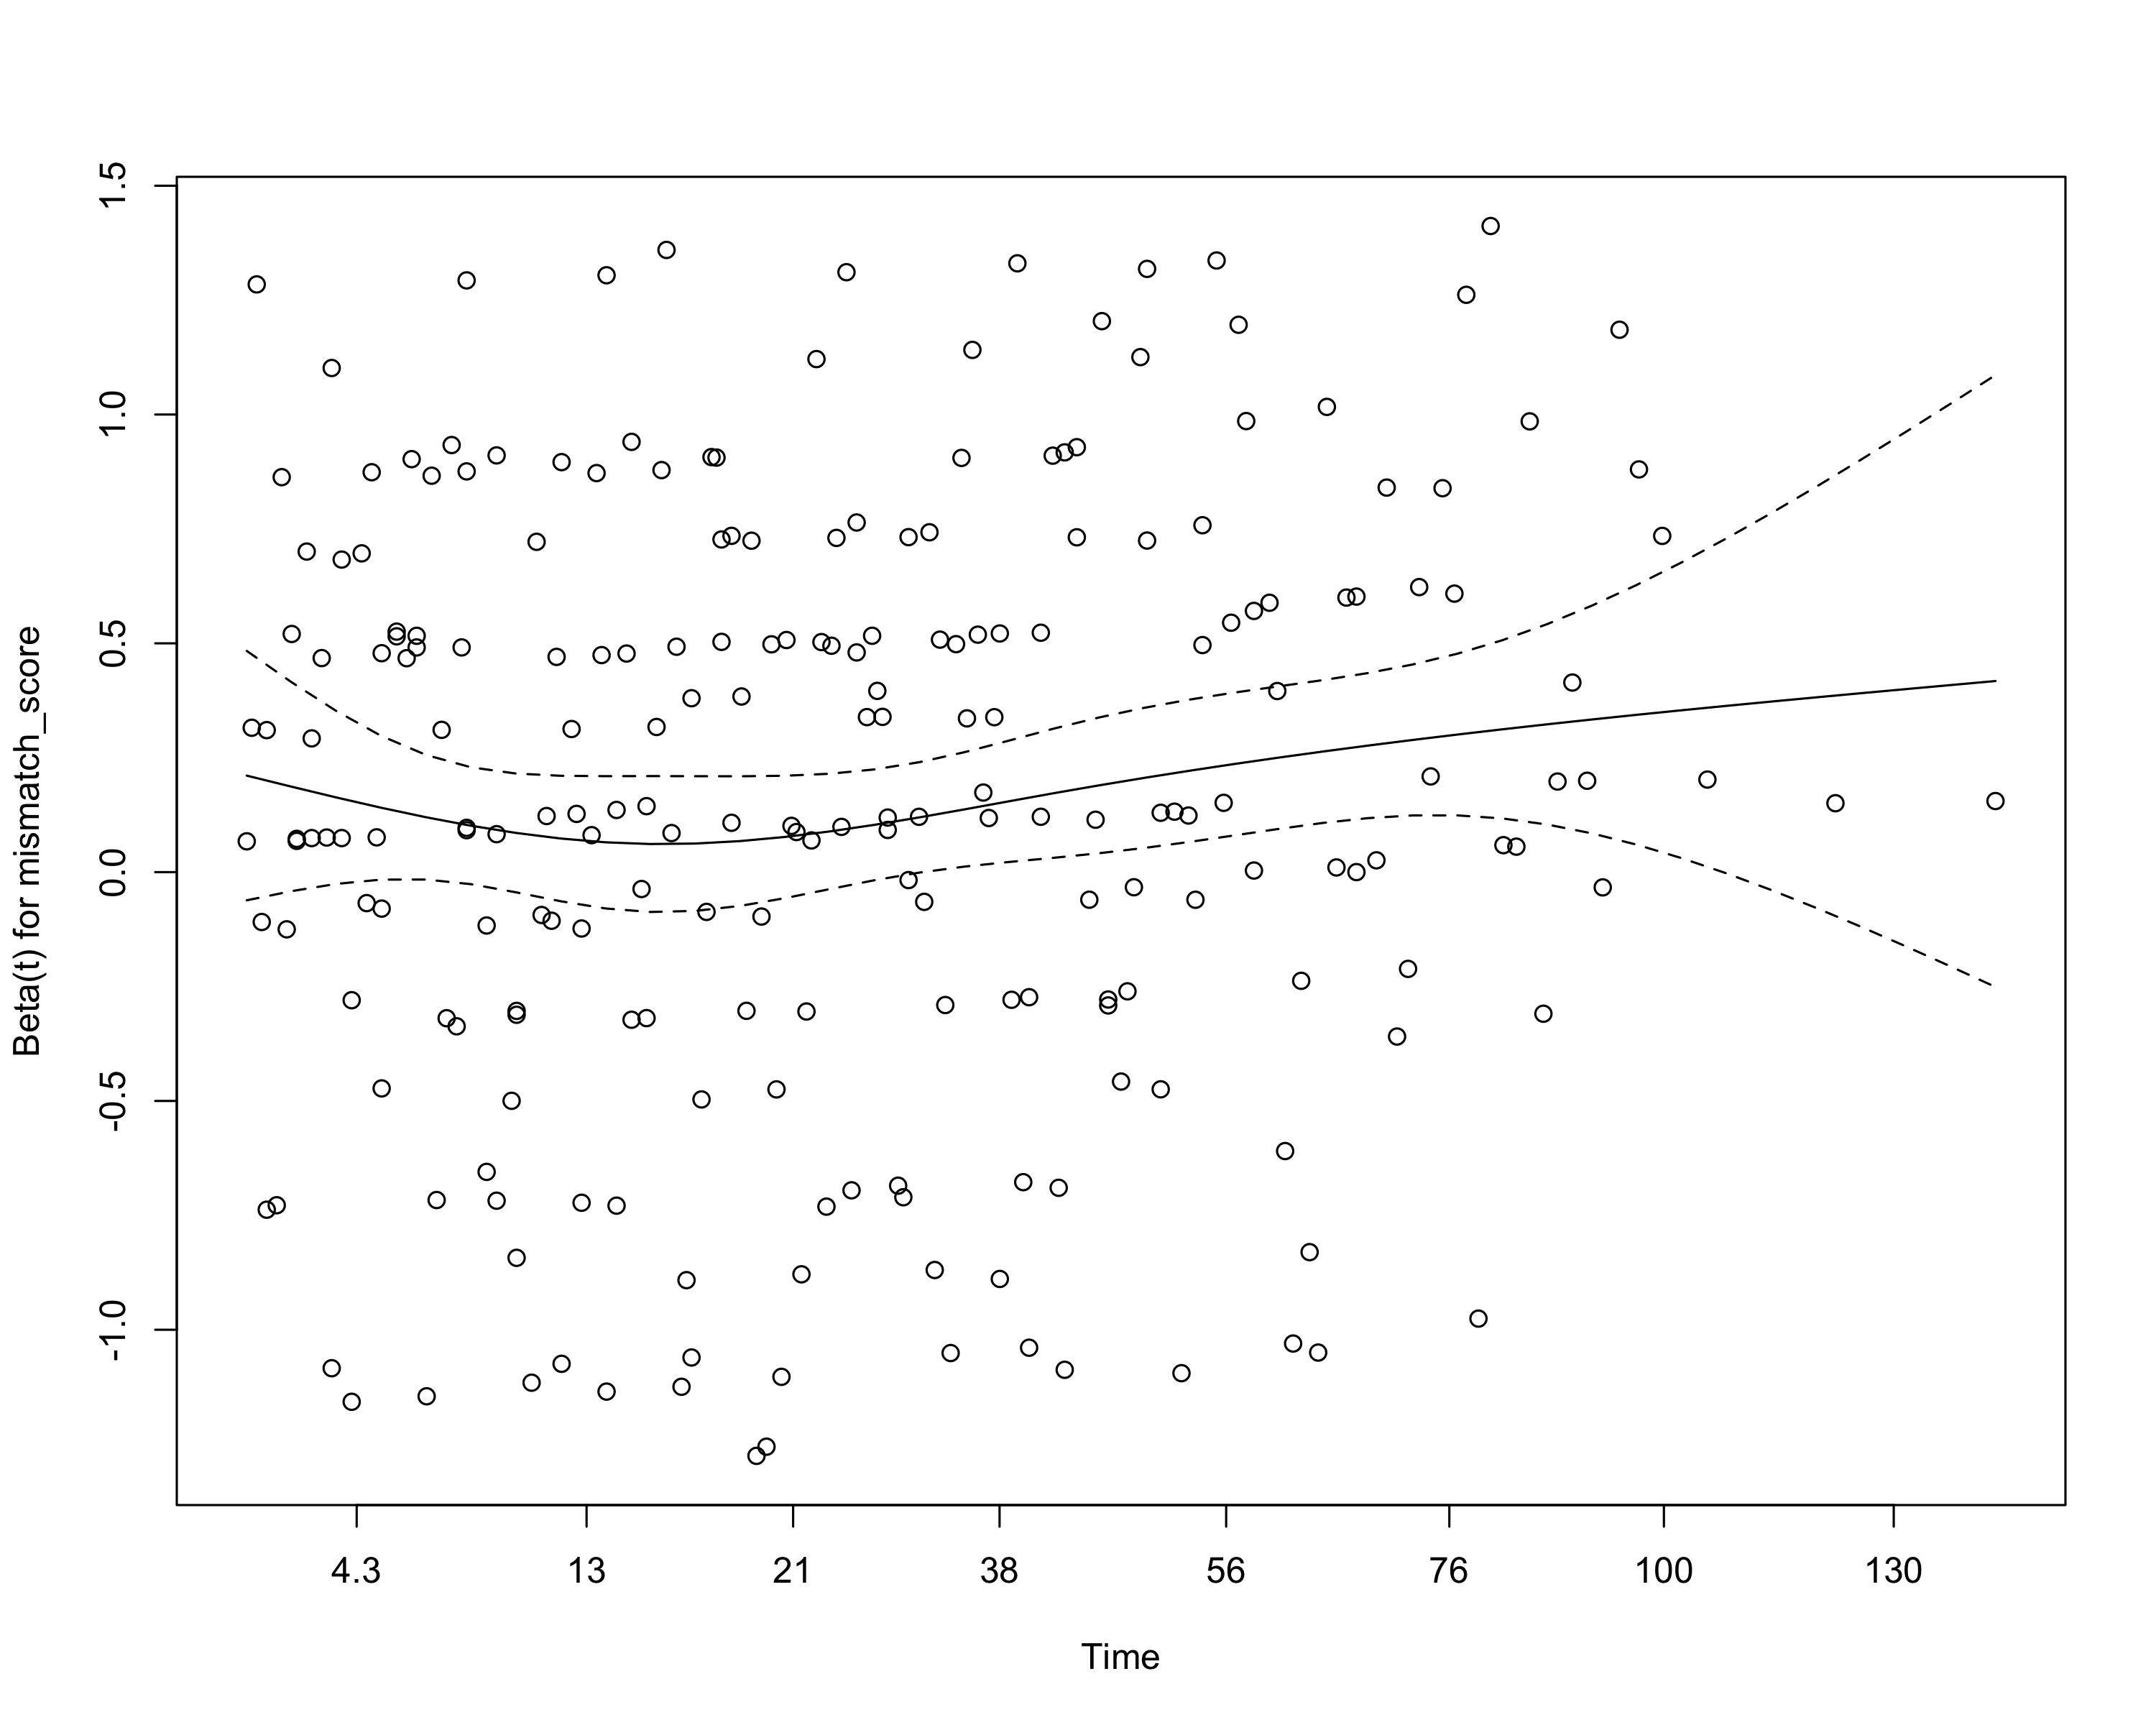

Appendix Table A5. Sensitivity model using any prior transplant instead of prior transplant count.
Characteristic | HR | 95% CI | p-value
ALG use, ALG vs No ALG | 0.625 | 0.473, 0.825 | <0.001
Age at transplant, years | 1.03 | 1.02, 1.04 | <0.001
Biological sex, Female vs Male | 0.953 | 0.729, 1.24 | 0.722
Duration of hemodialysis prior to transplant, days | 1.00 | 1.00, 1.00 | 0.567
Diabetes status, Yes vs No | 1.94 | 1.36, 2.77 | <0.001
Any prior transplant, Yes vs No | 1.21 | 0.910, 1.60 | 0.193
Amount of blood transfusion, blood units | 1.01 | 0.985, 1.04 | 0.407
Donor mismatch score | 1.17 | 1.07, 1.27 | <0.001
The sensitivity analysis retained the main interpretation for ALG, age, diabetes, and donor mismatch score.
Appendix Figure A3. Martingale residual functional-form check for age at transplant.
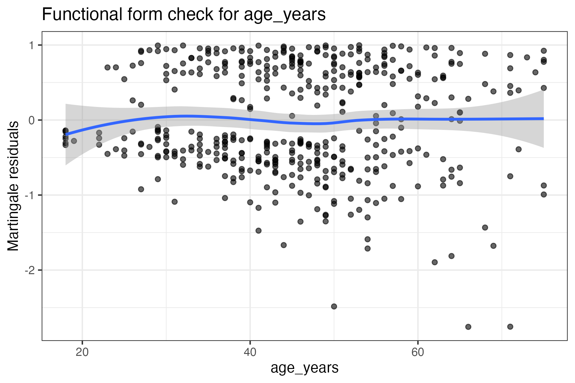
Appendix Figure A4. Martingale residual functional-form check for dialysis duration.
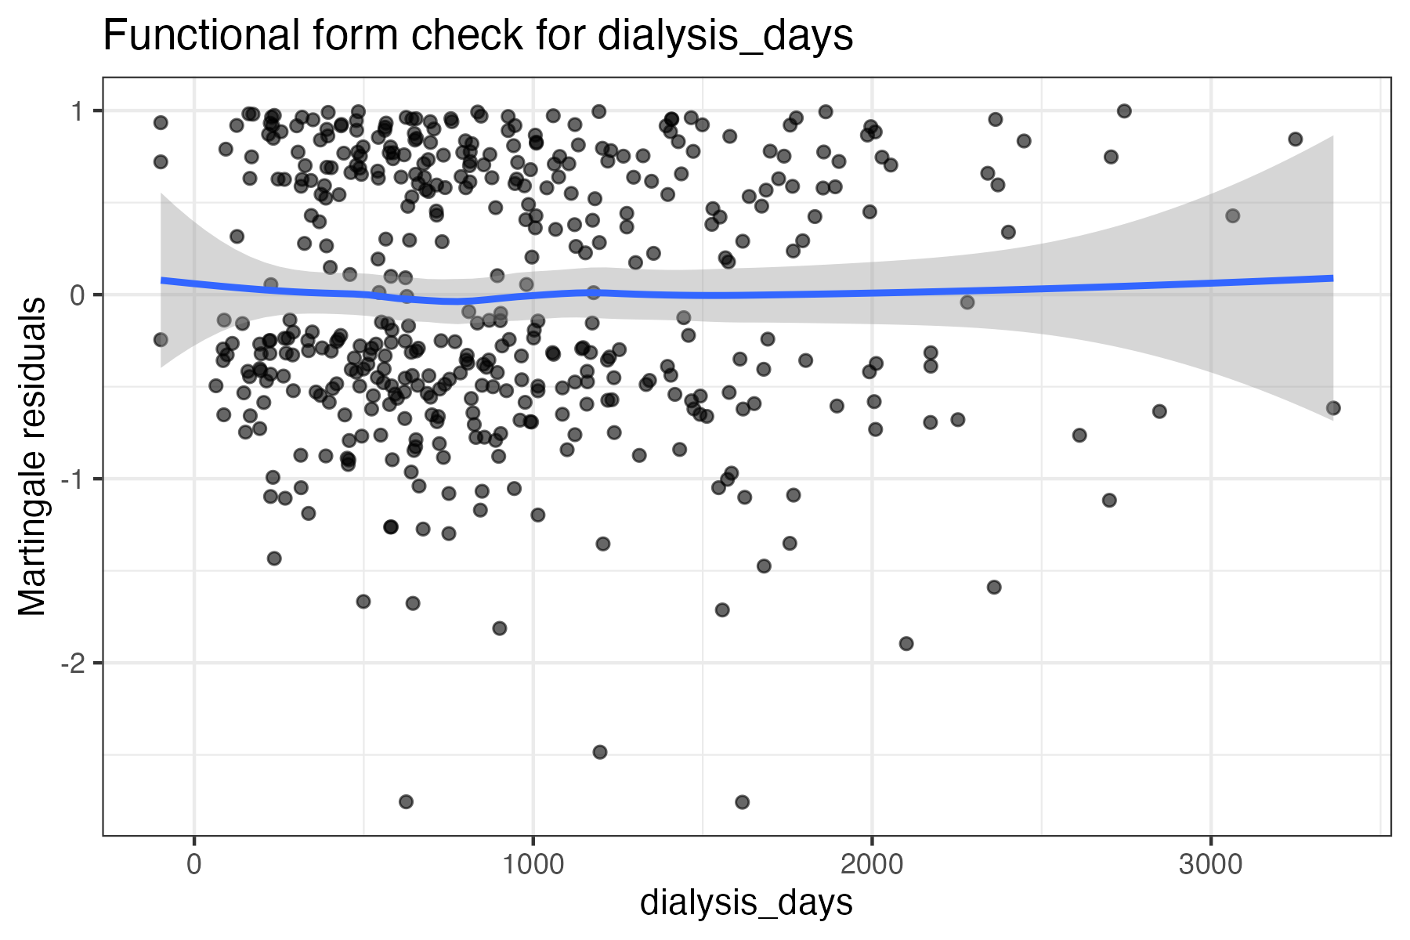

Appendix Figure A5. Martingale residual functional-form check for prior transplant count.
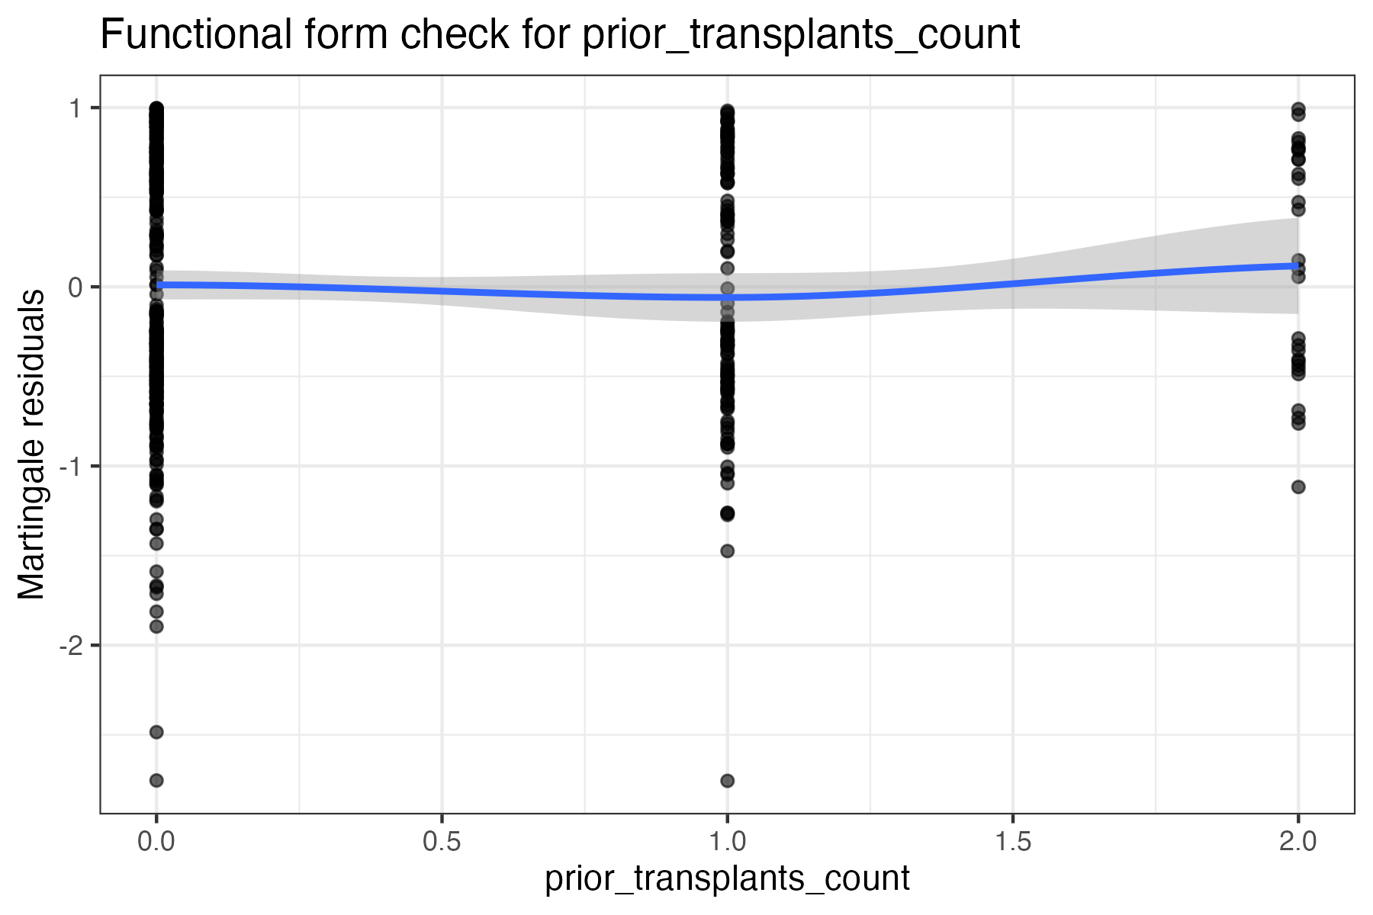
Appendix Figure A6. Martingale residual functional-form check for blood transfusion amount.
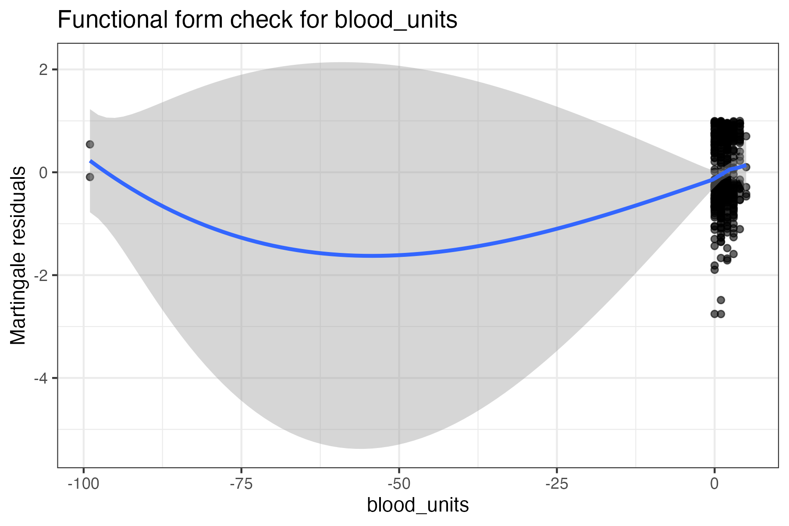

Appendix Figure A7. Martingale residual functional-form check for donor mismatch score.
