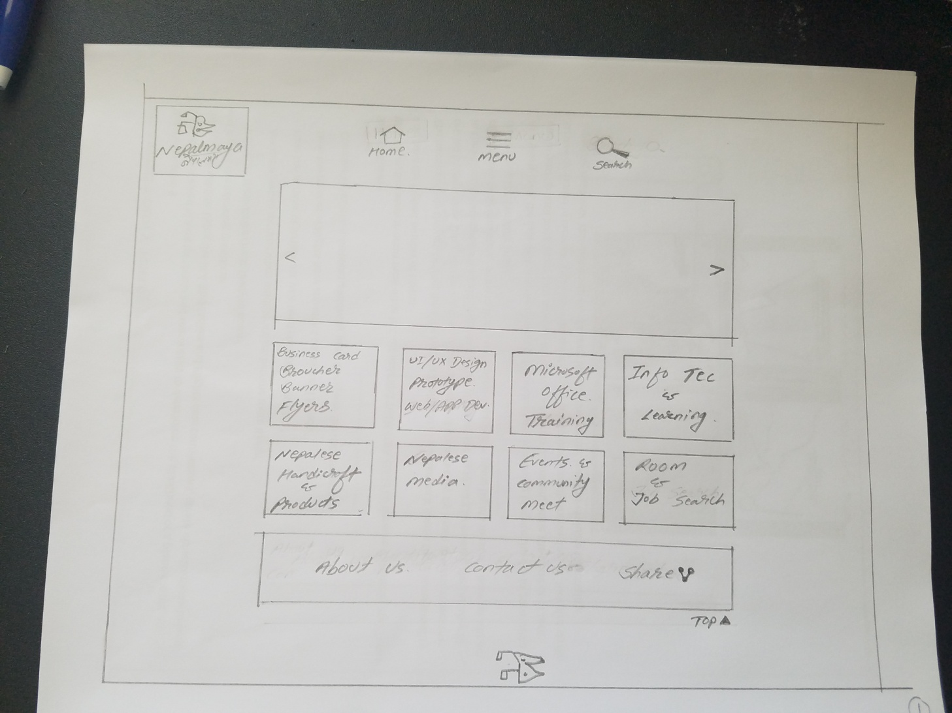
- This is the First Screen ( Home), which also has Icons such as : Menu, Search, About Us, Contact, Share and the Product itself
- User Can see almost all the product, it doesn’t have next page
- User can easily navigate by clicking each icons seen in the screen as provided
Th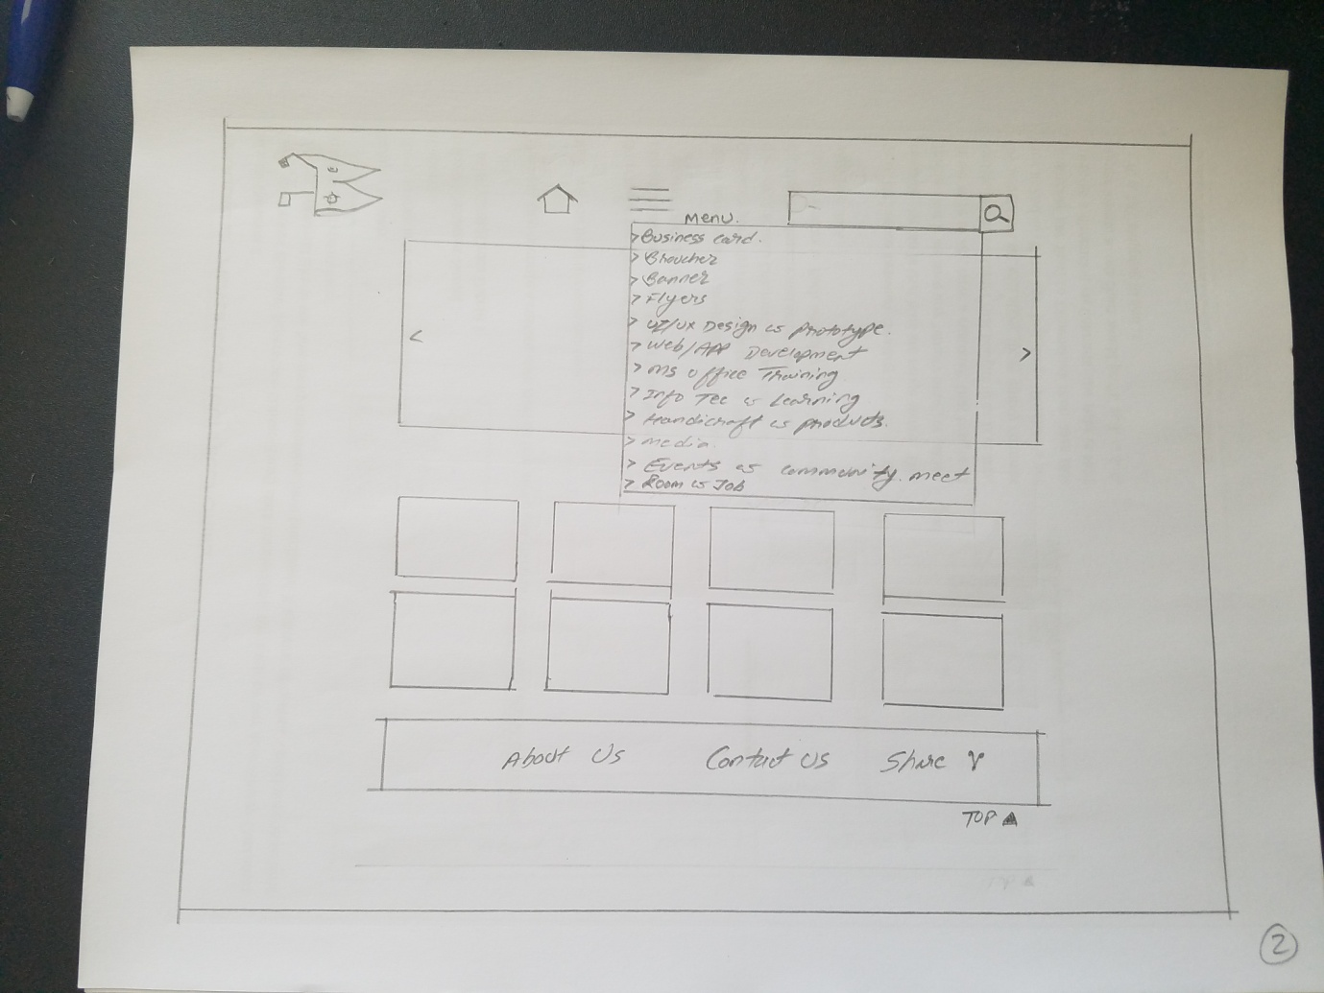

- This screen shows the Icon (Menu) and (Search) are clicked and its activities
- Below these Icon, that is Dynamic Slide View , that will continually shows the Ads. Or the Product Information.
-The White space in the Right and the Left side of the screen is kept for Advertisements , if any 3rd party is interested to keep their Ads.

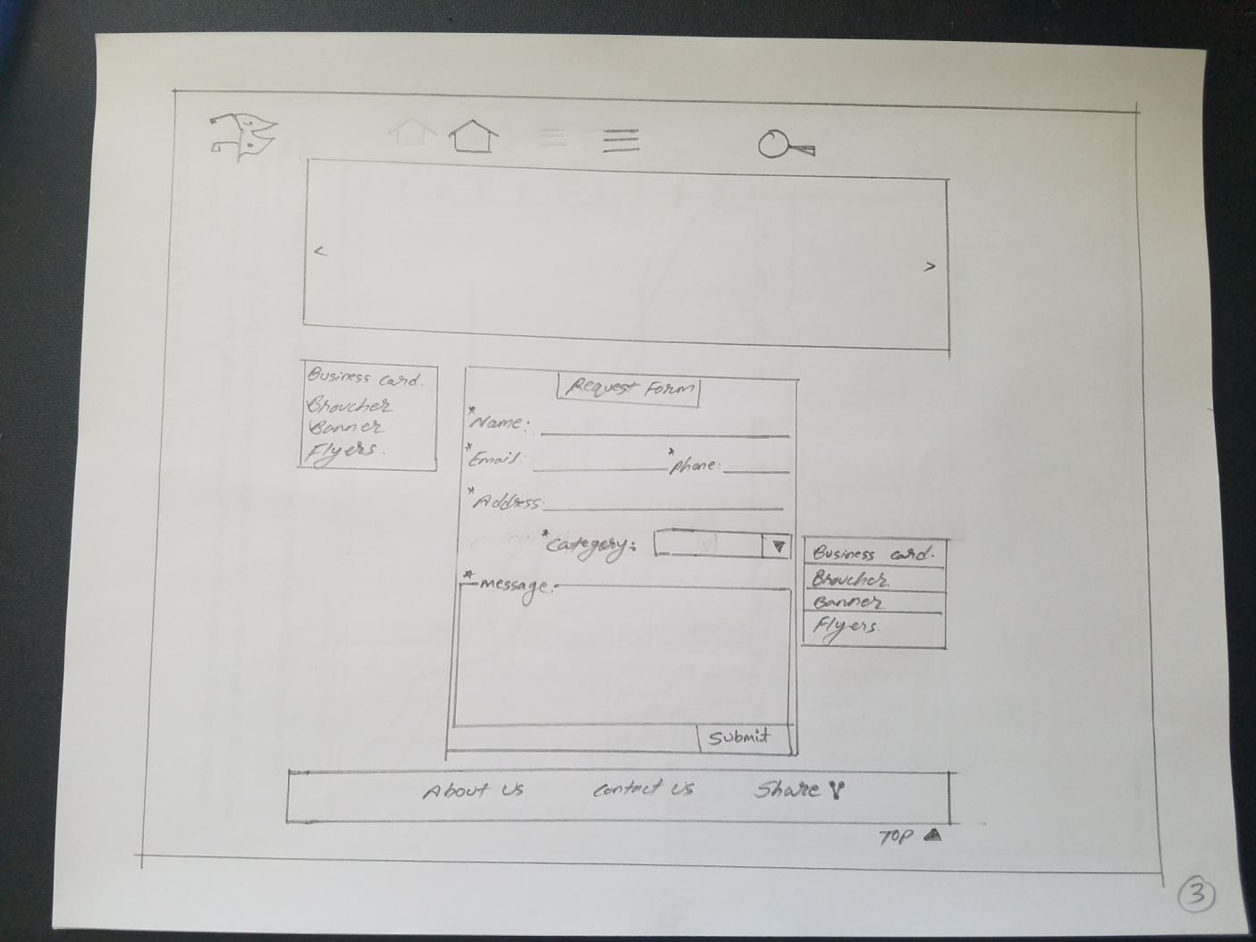
- This screen shows the activities after a click to a product, as you can see in the screen.
- Once the User click to a product, only that Product will be visible and other will go blur. and once the user click to any where besides the particular Product Icon, it will come back to the main page . and all other 8 icons will be visible as Home Page .
- User can submit a simple Form to get in touch and get our service
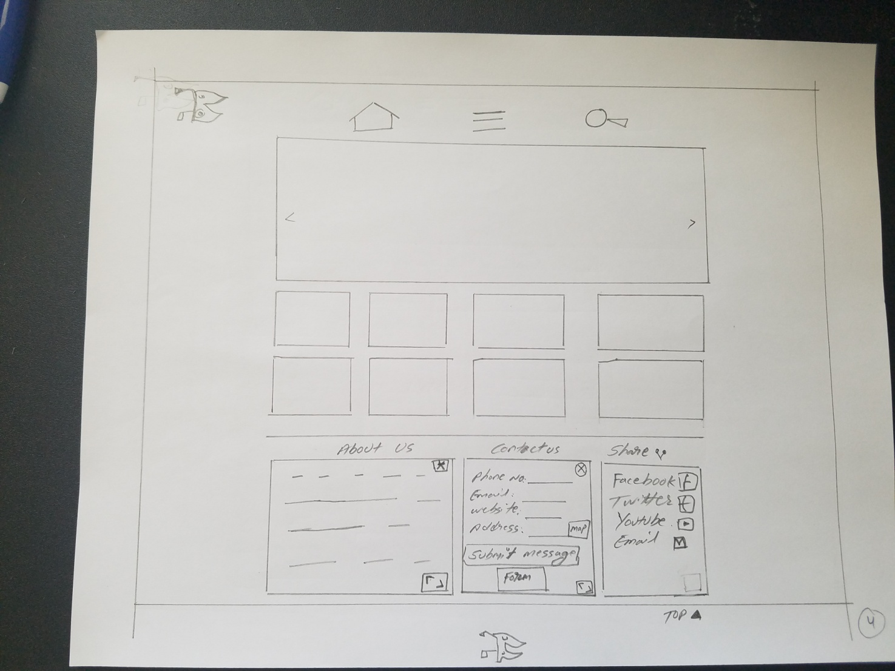

- This screen shows the activities in About, Contact and Share
- Once the User Click About US , the small box will appear , which can me cancelled or can make its view larger by clicking the small icons inside the same small box , this page will give all the information about Nepalmaya .
- Once the user click into the Contact Us, the small box will appear with some information with small request form , that page will help user to fill the form if they want us to contact them , otherwise user can directly get into touch . and as About us, this page also can be cancelled and make it bigger . ( the message box is also as similar as Request message as previous page )
- Once the user click to Share Inco, all the provided social media will appear, user can choose anyone of them and take its benefits to direct link to the page or email box.

