**January**

16

**Modeling and Simulating Social Systemswith MATLAB (and other tools)**

TEAM RESCUE

Ylenia Casali and Nazli Yonca Aydin

08

**Fall**

TABLE OF CONTENT

1 Abstract 3

2 Individual contributions 3

3 Introduction and Motivations 3

3.1 Fundamental questions 3

3.2 Expected results 4

4 Description of the Model 4

4.1 System 4

4.2 Modelling the behaviour of rescuers 5

5 Implementation 6

5.1 Simulation RESULTS 7

6 RESULTS 12

LIST OF FIGURES AND TABLEs

Table 1 Description of nodes 4

Table 2 Mean and Standard deviation results for simulation of 100 times 9

Table 3 Mean and Standard deviation results for simulation of 500 times 9

Table 4 Mean and Standard deviation results for simulation of 1000 times 12

Figure 1 Model Flow 6

Figure 2 Network topology 7

Figure 3 Simulation result for each strategy – 100 times simulation 8

Figure 4 Simulation results that show the number of rescued and dead people–100 times simulation 8

Figure 5 The number of rescued people in each strategy – 100 times simulation 9

Figure 6 Simulation result for each strategy – 500 times simulation 10

Figure 7 Simulation results that show the number of rescued and dead people – 500 times simulation 10

Figure 8 The number of rescued people in each strategy – 500 times simulation 10

Figure 9 Simulation results that show the number of rescued and dead people – 1000 times simulation 12

Figure 10 Simulation result for each strategy – 1000 times simulation 13

Figure 11 The number of rescued people in each strategy – 1000 times simulation 13

Figure 12 Comparison of strategies and mean values of each simulation result 14

Figure 13 Comparison of strategies and standard deviation values of each simulation result 14

# Abstract

In this report, an Agent-based Model is developed for a random transportation network in order to assist decision makers in emergency and/or disaster management activities. More specifically, the proposed model consists of 3 main strategies. First strategy is based on random rescue operations on a given network. Second strategy is developed to understand if using the shortest path *“Dijkstra”* method would assist in rescuing more people. Finally, the third strategy, which is similar to the second strategy, is focusing on the using the shortest path *“Breadth-first search”* method. The behavior of agents is implemented by strategies on MATLAB software. In the developed model, each decision maker should decide the way to save injured people located at certain node of the network by choosing one strategy. The problem takes in account a limit range of time during which people could be found a saved. As a result we expect that strategies under less uncertainty condition should provide a better response saving people.

# Individual contributions

All team members of this project worked actively and contributed to implementation and the conceptual design phases. A MATLAB code is developed in order to model transportation network using Agent Based Modeling approach.

# Introduction and Motivations

In the developed and developing countries, emergency plans are developed in order to minimize damages and risks on population as well as on critical infrastructures such as transportation network, water resources, telecommunication etc. Mitigation, preparedness, response and recovery are the components of emergency management plans, which are prepared at different administrative and geographic scales (Kunwar et al. 2014[1]). In order to implement these plans effectively, stakeholders and decision makers also need to take into account the uncertainty of human behavior under disaster condition. In this regard, the agent based modeling could assist in simulating human and stakeholder behavior and providing guidance for decision makers to implement effective emergency management plans.

## Fundamental questions

This research project aims to model disaster response specifically we would like to simulate rescuers behaviors on a network system. First, strategies to rescue injured people are developed assuming that ambulance drivers are rescuers and injured people need ambulance service to reach hospitals. Another assumption of this project is that the transportation network will be disturbed due to the damage caused by earthquake. This means that edges (i.e. roads, links) on the transportation network will have different weights representing the level of disruption on the corresponding edges.

Damages on transportation network due to earthquake hazards are taken into account in order to simulate real-world conditions. Damages on transportation network would affect the accessibility to hospitals or might cause time delays, which is important under emergency situations where injured people need immediate assistance. Fundamental questions of this research are:

* What kind of rescue action would be the best strategy in the recovery phase of disaster management plans?
* Would any strategy stand out in terms of number of injured people who were able to reach hospitals?

## Expected results

We expect that systematic rescue such as using different shortest path algorithms would save more injured people than random saving operations in chaotic environment.

# Description of the Model

In this section, the model is described in two segments. First, system details are given including network topology and components of the network. Second, behaviors of agents are described including developed strategies and model flow.

## System

In order to implement the model, a conceptual network is created. Nodes are defined as all possible locations of agents and edges (i.e. links, roads) are identified as routes that agents can move from one location to another. In this model, there are two different types of agents: rescuers and injured people. It is assumed that rescuers always start the operation from a selected location (e.g. hospital). However, locations of the injured people are disaster-depending meaning that locations of the injured people, and so their positions on the network, change randomly in each simulation of the system. A brief description of nodes is given in Table1.

Table 1 Description of nodes

|  |  |
| --- | --- |
| Function of nodes | Description |
| Hospital location | Starting location for every rescuer |
| Nodes with injured people | The injured people are located randomly at some nodes of the network with probability 50%. |
| Empty nodes | Nodes are part of the network without any incidents |

The network is assumed to be a static network since it represents a system after a calamity occurred. In other words, the network topology is not time depending. Agents can navigate throughout the network without counting any change in the connection links. Orientation of edges is modeled as a directed graph which represents a constraint in the searching method: rescuers can navigate to reach a specific location and have to take into account specific directions of edges (i.e. constraints).

## Modelling the behaviour of rescuers

The Agent Based Model is developed considering rescuers as agents. All agents have to select a target node to reach the injured people. The model takes into count a specific time range that rescuers have to save injured people in this specific time interval, all the injured people that are not saved within this time interval are considered deceased. The selection of target nodes depends on the specific strategy that rescuers decide to adopt. In the developed model, agents can choose between three different strategies:

*Strategy 1: The target node is selected by a random selection process.* Injured people are rescued by random selection, meaning that rescuers do not follow a specific method to select a target node.

*Strategy 2: Rescuers have already known where injured people are located.* The information of the network is used in order to reach the nodes where injured people are. The target nodes are selected by saving first the injured with minimum distance from the location of the rescuers (e.g. the hospital). The shortest path *“Dijkstra”* method is used. Distance parameter is set which is represented as the weights on the network edges. This weight parameter represents a distance but can also be considered as congestion, time delays and/or accessibility degree of the nodes.

*Strategy 3:* Rescuers already know where the injured people are located as in strategy 2. However, this time target nodes are selected by using a different shortest path algorithm *“Breadth-first search”* method which assumes all weights in the edges are equal. In other words, target nodes are selected based on their proximity to the location of rescuers by counting the number of nodes and agents try to save injured people in a hierarchical way.

The logistic flow of the model is given in Figure 1. After the selection of a strategy, rescuers travel in the network to reach their target node according the shortest path method. When an injured is found, a route is calculated from the injured location to the hospital. In this model, each rescuer can only save one injured person at a time. The strategy is selected when the rescuer is at the hospital (i.e. starting point). The target is selected:

* When the rescuer starts to search for the injured people at time 0.
* When an injured is already found and saved in the hospital.

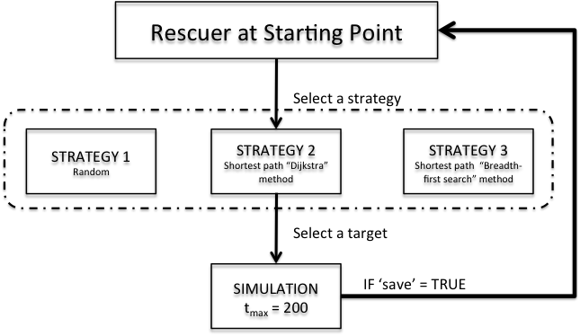

Figure 1 Model Flow

# implementation

Implementation of the model using MATLAB consists of two parts: an initialization part and a simulation part. In the initialization part, data structures and all parameters of the model are set up. A directed network of 11 nodes and 18 edges is built from scratch, as displayed in Figure 2. The number of rescuers is set to 10, whereas the number of injured people and the injured node locations are randomly arranged in the network. The simulation starts with a “for loop” that runs the simulation for a set maximum number of rounds. This represents a maximum time steps that injured people can be saved. In this simulation, this parameter is set to 200 numbers of rounds (i.e. tmax = 200).

The implementation of the model follows these steps for each rescuer:

* The selection of the strategy
* The strategy implementation
* The simulation of the travel in the network

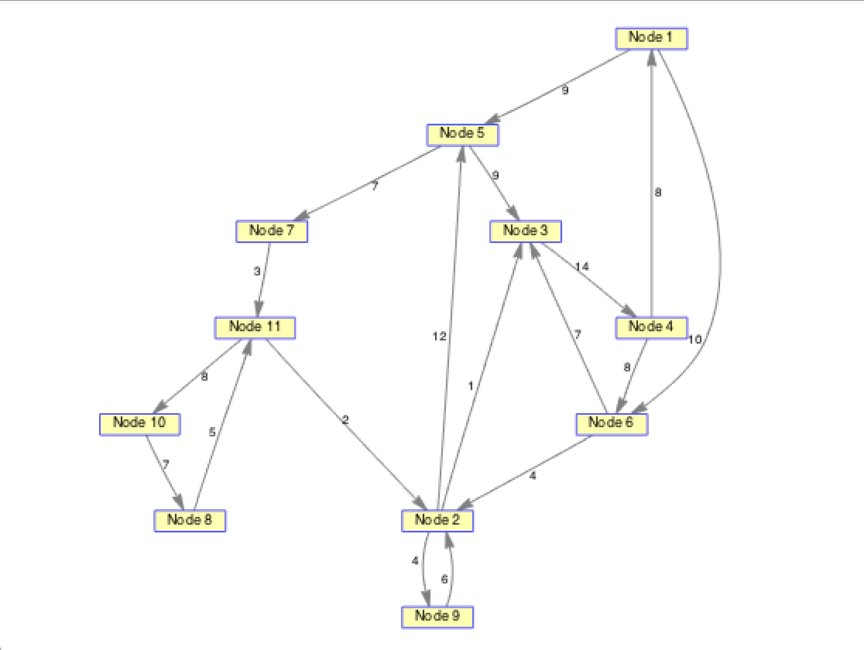

Figure 2 Network topology

## Simulation RESULTS

In order to compare and interpret strategies, the proposed model is run multiple times for 3 different times: 100 times, 500 times and 1000 times.

The result for ***100 simulations*** showed that the implementing Strategy 1 is the most favorable approach in term of rescuing people in a given directed network. In other words, Strategy 1 was the main strategy that allowed saving the maximum number of people with a mean of 7.3 and standard deviation of 3.7. Figure 3 and 4 illustrate the simulation results for each strategy and the simulation results that show the number of rescued and dead people, respectively.

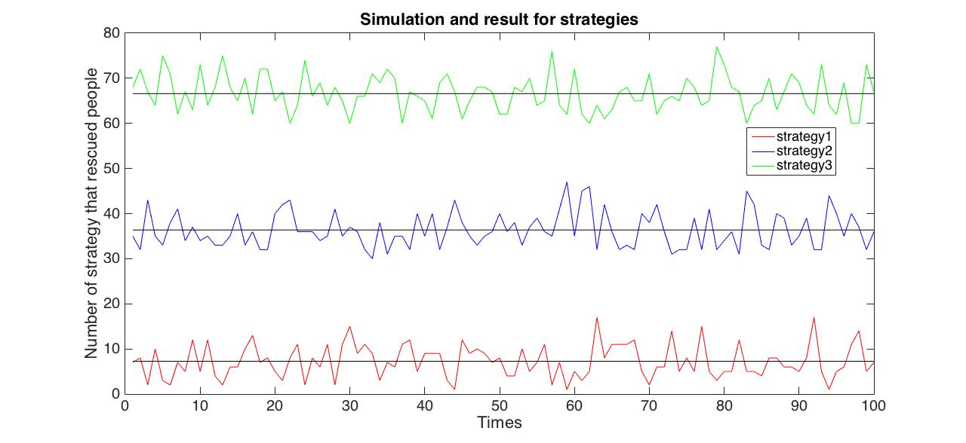

Figure 3 Simulation result for each strategy – 100 times simulation

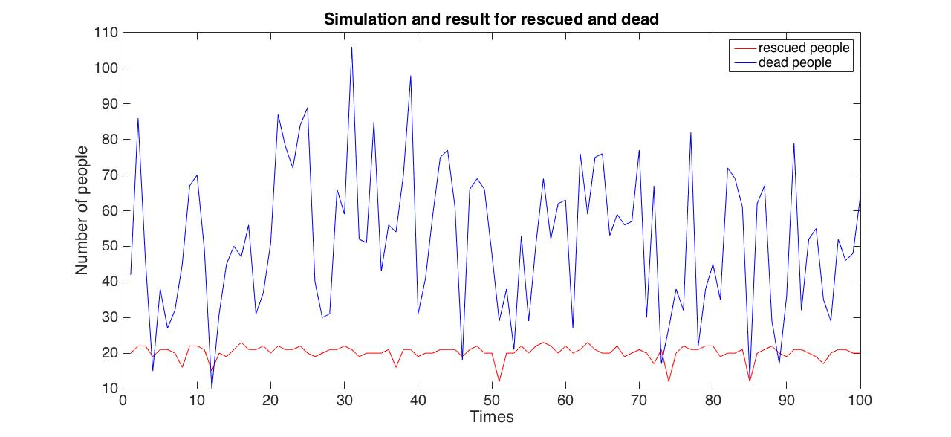

Figure 4 Simulation results that show the number of rescued and dead people – 100 times simulation

As can be seen from Figure 4, the number of deceased people fluctuates significantly in each simulation while the rescued people rarely shows drastic change when the model simulated 100 times. In addition, Figure 5 illustrates the number of rescued people in each simulation for each strategy. Mean and Standard deviation results for simulation of 100 times are given in Table 2.

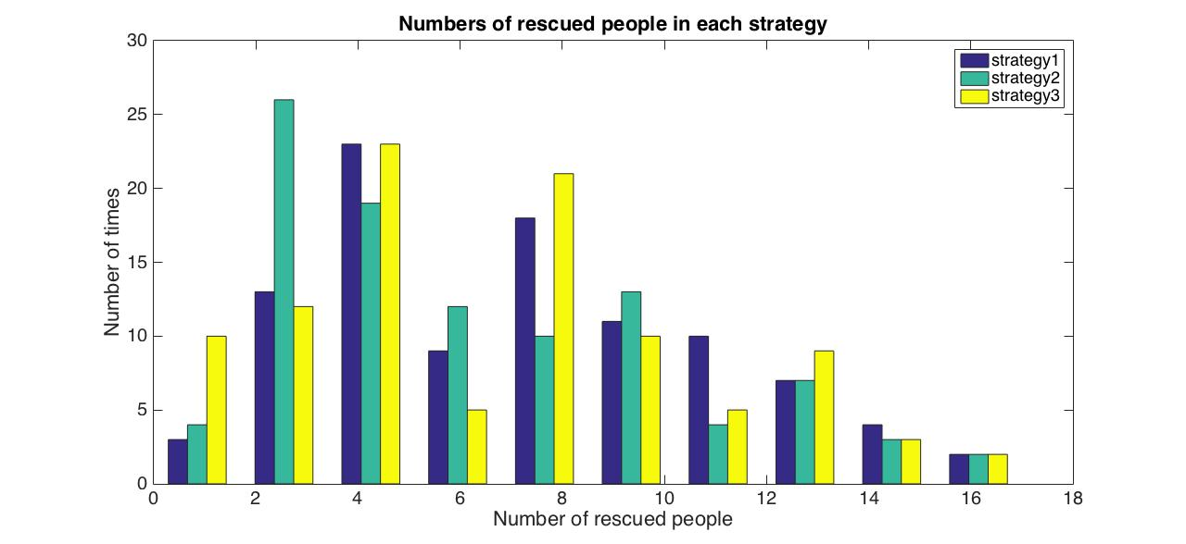

Figure 5 The number of rescued people in each strategy – 100 times simulation

Table 2 Mean and Standard deviation results for simulation of 100 times

|  |  |  |
| --- | --- | --- |
| STRATEGY | MEAN | STANDARD DEVIATION |
| Strategy 1 | 7.2600 | 3.6780 |
| Strategy 2 | 6.3600 | 3.9248 |
| Strategy 3 | 6.6000 | 4.0726 |

***Simulation: 500 times***

After the 100 times of simulation, the proposed Agent-Based Model is run for *500 times* in order to observe if there are any changes in the results of previous simulation. Simulating multiple times will also let us understand if the Strategy 1 is indeed the best strategy among all. Simulating 500 times showed that the most favorable result changes when the simulation time increases. This time, the Strategy 2 has the most number of people rescued in the given network. As can be seen from Table 3, Strategy 2 allows saving the maximum number of people with a mean of 10.8 and standard deviation of 4.8, when the simulation is applied for 500 times.

Table 3 Mean and Standard deviation results for simulation of 500 times

|  |  |  |
| --- | --- | --- |
| STRATEGY | MEAN | STANDARD DEVIATION |
| Strategy 1 | 10.5220 | 4.9931 |
| Strategy 2 | 10.7960 | 4.8101 |
| Strategy 3 | 10.1240 | 4.6849 |

Figures 6 and 7 illustrate the simulation results for each strategy for 500 times of simulation and the simulation results that show the number of rescued and dead people for 500 times of simulation, respectively. Comparing with the 100 times simulation, the number of rescued people increased. In addition, Figure 8 illustrates the number of rescued people in each simulation for each strategy. The histogram shows that the number of people between 5 and 15 is saved more frequently. Comparing Figure 5 with Figure 8, we realized that the increasing number of simulations changed the distribution of the number of rescued people in the given network.

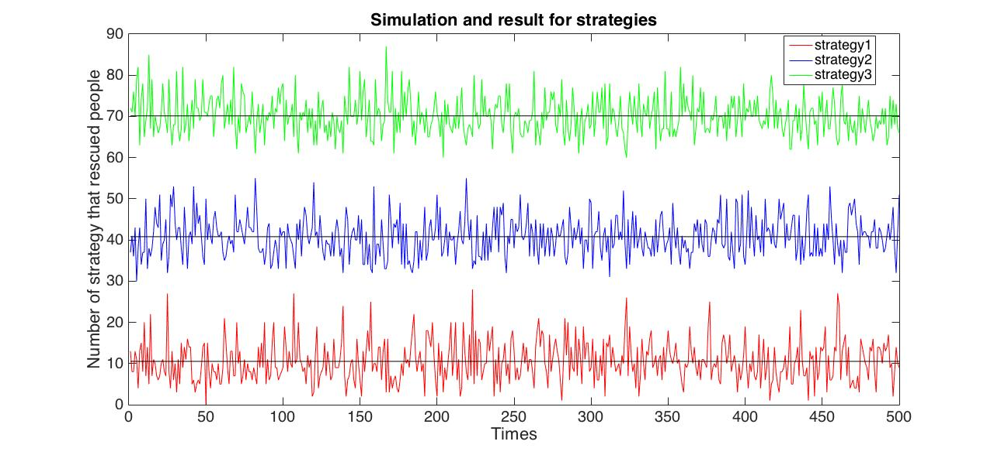

Figure 6 Simulation result for each strategy – 500 times simulation

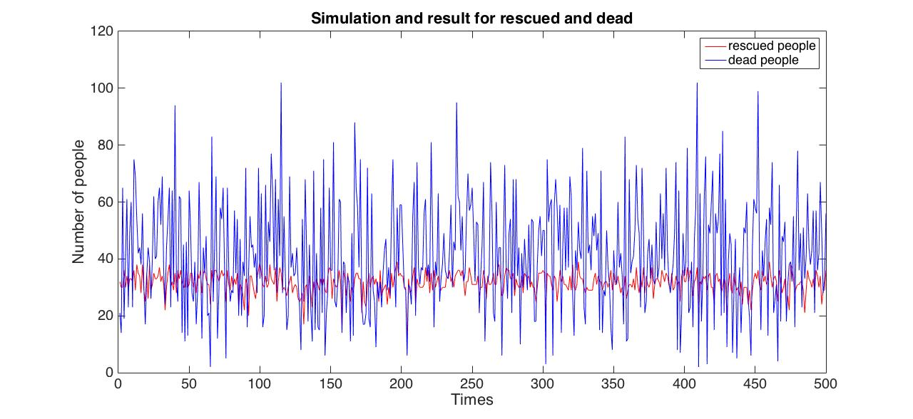

Figure 7 Simulation results that show the number of rescued and dead people – 500 times simulation

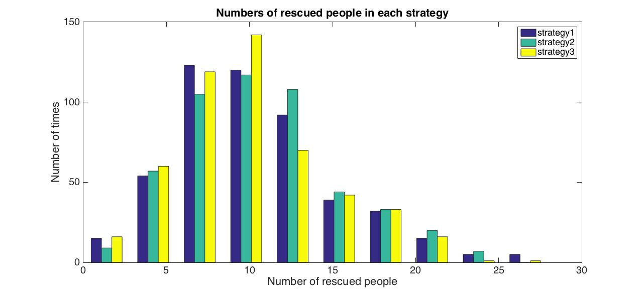

Figure 8 The number of rescued people in each strategy – 500 times simulation

***Simulation: 1000 times***

Finally, simulation numbers increased to 1000 to be able to see major differences and to understand if the most favorable strategy would change when the number of simulation increases. Simulating the proposed model for 1000 times showed consistent results with the 500 times of simulation meaning that Strategy 2 allows saving the maximum number of people with a mean of 6.69 and standard deviation of 4.2. Results for all the strategies are given in Table 4. In addition, simulation results for each strategy for 1000 times of simulation is given in Figure 9 and the simulation results that show the number of rescued and dead people for 1000 times of simulation is given in Figure 10. Figure 11 illustrates the distribution of number of rescued people for each strategy. It easy to observe that in this simulation, numbers of people between 1 and 11 are saved more frequently.

Table 4 Mean and Standard deviation results for simulation of 1000 times

|  |  |  |
| --- | --- | --- |
| STRATEGY | MEAN | STANDARD DEVIATION |
| Strategy 1 | 6.5720 | 4.2314 |
| Strategy 2 | 6.6930 | 4.2119 |
| Strategy 3 | 6.2470 | 4.1450 |

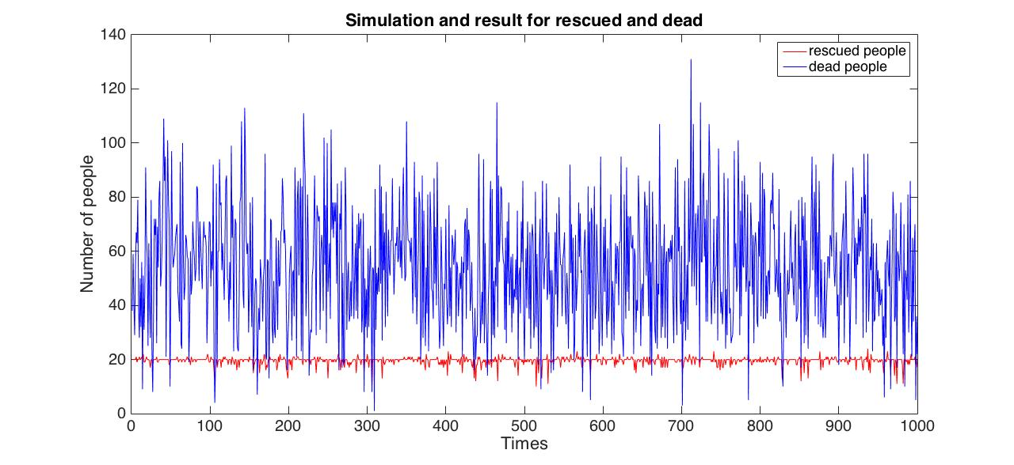

Figure 9 Simulation results that show the number of rescued and dead people – 1000 times simulation

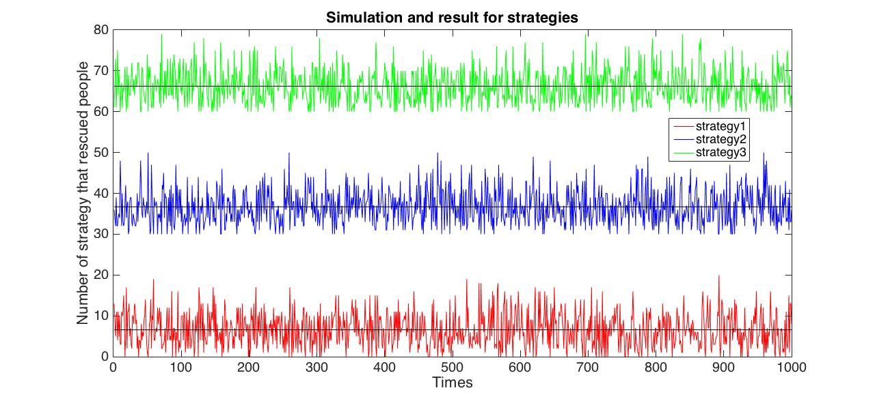

Figure 10 Simulation result for each strategy – 1000 times simulation

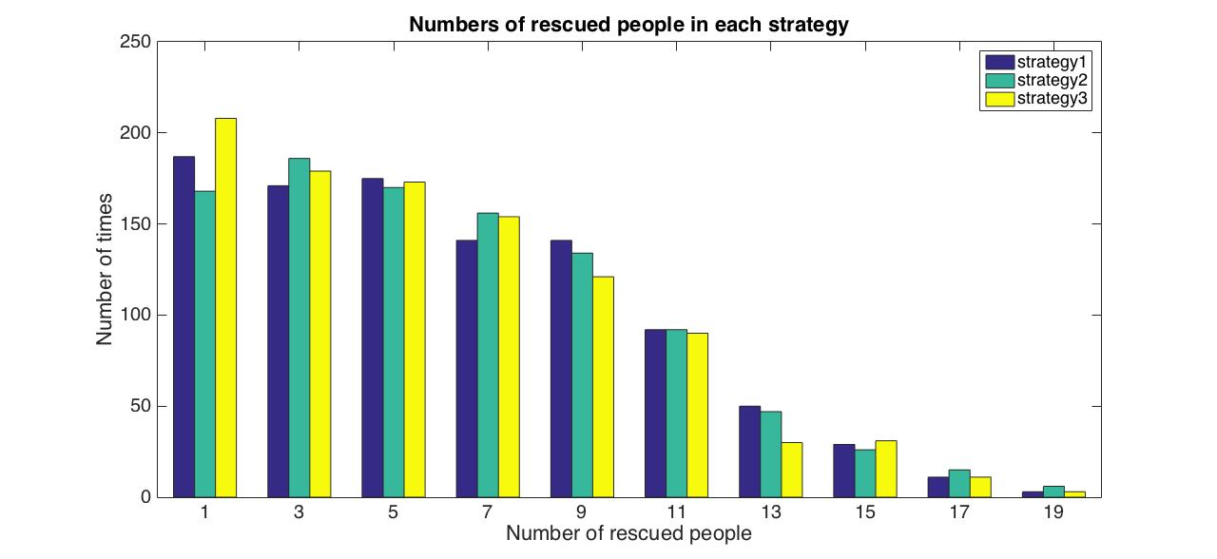

Figure 11 The number of rescued people in each strategy – 1000 times simulation

# RESULTS

In order to observe/visualize the results of each Strategy in each simulation, mean and standard deviations are plotted. Figures 12 and 13 illustrate “Comparison of strategies and mean values of each simulation result” and “Comparison of strategies and standard deviation values of each simulation result”, respectively.

The results showed that the Strategy 2 (i.e. Rescuers have already known where injured people are located and rescuers use the shortest path “Dijkstra” method to circulate in the network) provides the best results in terms of saving injured people’s lives. Although the number of times injured people saved was the highest in Strategy 1 when the proposed model is simulated 100 times, increased number of simulations is found more reliable and sensible. Considering a real-life situation, having knowledge of the injured people’s locations would allow saving time of searching for the injured people. In addition, using the shortest path algorithm considering the edge weights assist to perform more rescue operations in the network.

It is also observed that the difference between mean and standard deviation values of all strategies are not as fluctuating as much when the number of simulation increases.

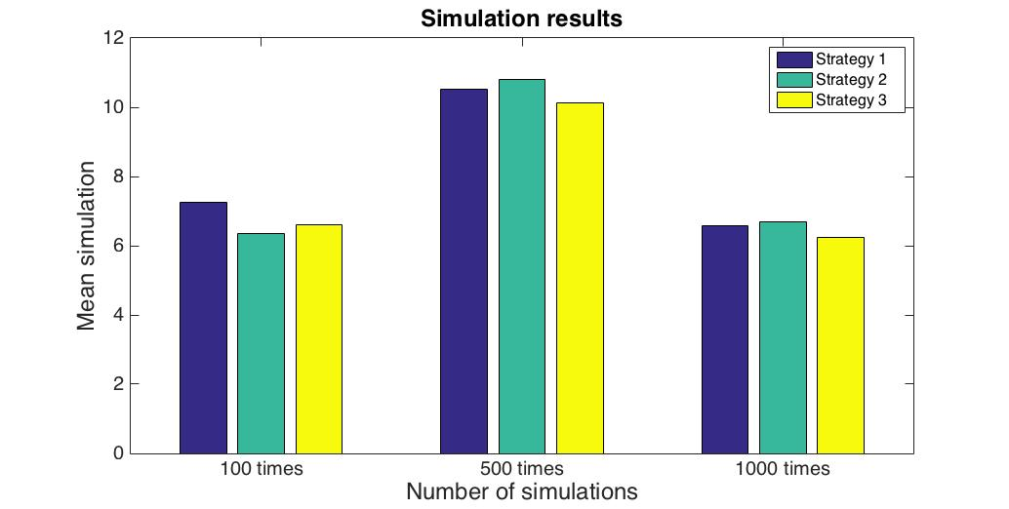

Figure 12 Comparison of strategies and mean values of each simulation result

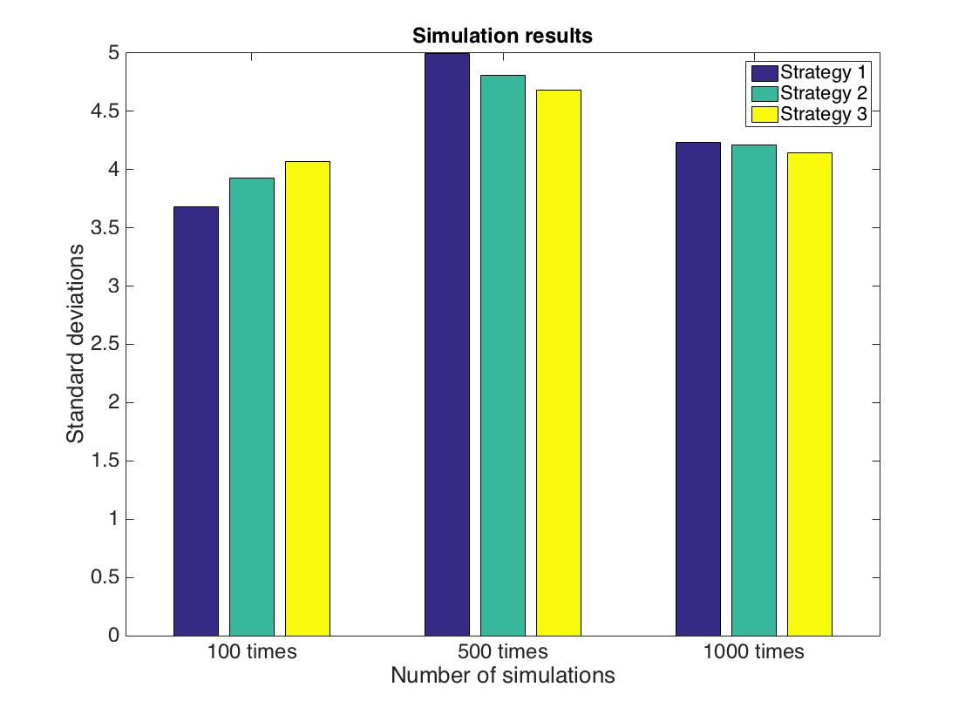

Figure 13 Comparison of strategies and standard deviation values of each simulation result

In this study, we have done the following assumptions, which would change the results significantly.

* The developed directed network has only 11 nodes and connections. The proposed network is rather small and directed. Changing properties of the network would change the results.
* The weights for the edges are created randomly. Changing the weights might change the way shortest path algorithm works. Therefore, results might differentiate.
* The number of simulations applied to the proposed model. In this study, we only applied 100-times, 500-times and 1000-times of simulations to our model and observed that number of simulations changes the result of agent based modeling significantly. Increased number of simulations would assist in obtaining more reliable results.

1. Kunwar, B., Simini, F., Johansson, A. (2014). “Large scale pedestrian evacuation modeling framework using volunteered geographical information.” *Transportation Research Procedia*, 2, 813 – 818.