CNS 1400: Worksheet for Lab Seven

Your name: ________________________ Section:_______

Consider the following function:
int doubleValue( int n )
{
return (n * 2);
}
Let's look closely at the first line of the function:
int doubleValue( int n )
This line declares that the function doubleValue takes an integer parameter, which we will refer to as n inside of the function, and that it will return an integer value. The body of the function is written between the curly braces. To call this function, we could write something like
int m = doubleValue( 5 );
This statement would pass the value of 5 as the argument to the function, and the return value of the function, 10, will be stored in the variable m. Values are passed to functions on what is called the run-time stack. The function also uses the run-time stack to return a value to the caller. If a function does not return a value, we denote this by using the keyword void.
The following code illustrates they way that we write and call functions in a program. In particular, note that the function must be declared before it is called. To do this, we often times write what is called the function prototype someplace before the beginning of main( ). The function prototype is basically the first line from the function, providing the function name, any parameters, and the return type. In the function prototype, we usually do not give the parameters any names, we just show the types. When a function is called, the compiler checks to make sure that the parameters that are passed match the types shown in the prototype.
In the following example, the parameter n is passed by value. Consider the first time that the function is called. At that moment, the variable i contains the value of 0. The compiler makes a copy of this value and places it on the run-time stack. Inside the function, the value is taken from the stack and stored in the local variable n. When we double n, it only affects the variable n that is defined local to the function. The original variable i is not changed.

#include <iostream>
using namespace std;
// The function prototype
int doubleValue( int );
const int SIZE = 5;
int main( )
{ for (int i = 0; i < SIZE; i++)
{
cout << doubleValue( i );
}
return 0;
}
// The actual implementation of the function
int doubleValue( int n )
{
return (n * 2);
}
Data can also be passed to a function by reference. When an argument is passed by reference, the compiler puts the address of the argument on the run-time stack, not a copy of its value. Now, when the function uses the argument, it uses the actual variable whose address was passed on the stack, not a copy of the variable. We denote a pass by reference by using an & symbol after the type name in the function prototype. For example
// The function prototype
int doubleValue( int& );
Because we have given the function the address of a variable declared somewhere outside of the function, the function is free to change the value of that variable. Oftentimes, this is not a desirable thing to do. Changing the value of a variable declared outside of a function is called a side effect. In general, we do not like to have side effects in our code. To be more precise, a fucntion should only change the values of variables that are declared inside of the function.

When passing parameters, use the following rules of thumb:
- If you are passing primitive data, pass by value. There can be no side effects when passing by value.
- When passing objects, pass by reference. This is because objects can be rather large. Passing an object by value requires that the entire object be copied onto the stack. This takes more time than passing by reference, when just the address of the object is placed on the stack. Putting very large objects on the stack could also result in the program running out of stack space.
- In most cases, since we don't want the object modified, pass the object by constant reference. This prevents side effects. Passing by constant reference looks like
// The function prototype
int doubleValue( const carObject& );

Learning Exercise 1
Type in the following program:
#include <iostream>
using namespace std;
// The function prototype
int doubleValue( int );
int main( )
{
int number = 7;
cout << "\nThe value of number is " << number;
cout << "\nCalling the function doubleValue( )";
int newNumber = doubleValue( number );
cout << "\nAfter function return the value of number is " << number;
cout << "\nand the value of newNumber is " << newNumber;

system(“PAUSE”);
return 0;
}
// The implementation of the function
int doubleValue( int n )
{
cout << "\nInside the function doubleValue( )";
cout << "\nThe value of n is " << n;
n = n * 2;
return n;
}
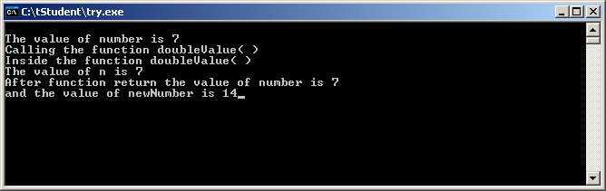
Compile and execute the program. The output should look something like this:
Thought Question 1 (3 points): The value of n is shown as being equal to 7. Where did the value that is stored in n come from? That is, how did n come to have the value of 7? Where was the variable n declared in the function doubleValue( )?
Thought question 2 (1 point): In the function doubleValue( ), is the parameter passed by value or by reference?

Change this program so that it looks like the following. The lines that have been changed are marked.
#include <iostream>
using namespace std;
// The function prototype
int doubleValue( int& );
int main( )
{
int number = 7;
cout << "\nThe value of number is " << number;
cout << "\nCalling the function doubleValue( )";
int newNumber = doubleValue( number );
cout << "\nAfter function return the value of number is " << number;
cout << "\nand the value of newNumber is " << newNumber;
return 0;
}
// The implementation of the function
// This function doubles the value of n
int doubleValue( int& n )
{
cout << "\nInside the function doubleValue( )";
cout << "\nThe value of n is " << n;
n = n * 2;
return n;
}
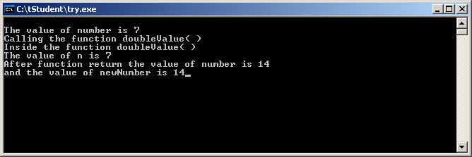
Compile and execute the program. The output should look something like
Thought Question 3 (3 points): Compare the output of this program with the output of the first one. What difference do you see? How do you account for this difference? Explain clearly and in some detail what is happening in both sets of code that accounts for the difference in what you see.
Thought question 4 (1 point): This time, in the function doubleValue( ), is the parameter passed by value or by reference?
Modify the function so that it looks like the following. Don't forget to also modify the function prototype.
// The implementation of the function
// This function doubles the value of n
int doubleValue( const int& n )
{
cout << "\nInside the function doubleValue( )";
cout << "\nThe value of n is " << n;
n = n * 2;
return n;
}
Compile the program.
Thought Question 5 (2 points): What happened when the program was compiled? Can you explain why? Without changing the function prototype, fix the code so that it compiles. What change did you make? Show your code in the space below.

