CNS 1400: Worksheet for Lab Ten

Your name: ________________________ Section:_______

In this exercise, you will practice the design of a simple class. Then in the associated programming exercise, you will develop and test the code for your class. In the reading material for this lab, you were introduced to two classes, a Point class, and a Line class. In this exercise, you will design, code, and test a Rectangle class.

The Rectangle Class
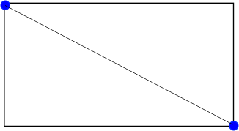
With its sides parallel to the coordinate axes, a rectangle in 2-dimensional space can be uniquely defined by two points on opposite ends of one of the diagonals of the rectangle. For your rectangle class, use the upper left corner of the rectangle and the lower right corner of the rectangle, as shown in the drawing to the left.
Question 1 (2 pts)
Review the reading assignment for this lab. The first step in designing a class is to figure out what the important properties of a rectangle are. Some of the properties of a Rectangle are intrinsic and must be stored as data members of the class. Some properties, however, can be calculated from the others, and need not be stored as data members. In the space below, write down the most important properties of a rectangle that cannot be calculated. These will become data members of your class. Note that there may be more than one way to do this.

Question 2 (2 pts)
For each data member, write down how you would represent this data in the computer. Think about how you might represent this data in terms of other classes that you have seen in the reading assignment. In the space below, write down a declaration for each data member of your class.

Question 3 (2 pts)
For each data member in your class, write down the function prototype for a getter and a setter for that data member.

Question 4 (2 pts)
In question 1 you may have considered some properties of a rectangle that can be computed. In the space below, write down those computed properties of a rectangle.

Question 5 (2 points)
For these computed properties, you will need a member function to calculate them. In the space below, write down the function prototypes required to calculate the values for any computed properties. Do not write the implementation code for these functions, only the prototypes.

Question 6 (5 points)
In the space below draw the UML class diagram for your Rectangle class. Include the data members and functions you considered in this worksheet, as well as a non-parameterized and a parameterized constructor.

