CNS 1410 Object-oriented Programming II

Programming Project 2: Linked List

Due Date:
Must be submitted no later than 11:59pm on Sunday.
Programs received prior to 11:59pm on Saturday will receive 5 bonus points, if the program completely meets the specifications and executes correctly.

Objectives:
- To learn how Linked Lists are constructed and used
- To gain experience using pointers in C++

Project:
This week you learned about linked lists. In this project you will need to create two classes. Refer to the slides on Linked Lists if you need some help remembering what a linked list looks like.
The Node class: Objects of the node class represent items you might want to have on your grocery list. This class has three data members:
- A string to contain a description of a grocery item, for example, "bread".
- A string to contain a quantity for this item, for example "2 loaves".
- A pointer to the next Node in the list. Initially this pointer should be NULL.
You should provide a constructor and getters and setters for each of the data members in your Node class.
The List class: You need an object of this class to head the list. This class also has three data members:
- A Node* that points to the first node in the list. Initially this pointer should be NULL.
- A Node* that points to the last node in the list. Initially this pointer should be NULL.
- An integer that contains the number of nodes in the list.
You should provide the following functions in your List class:
- A constructor that creates an empty list object.
- A push_back(Node*) function that takes a Node* as a parameter and adds the node pointed to by the pointer to the end of the list.
- A push_front(Node*) function that takes a Node* as a parameter and adds the node pointed to by the pointer to the front of the list.
- A pop_back( ) function that removes the last node from the list, and returns a pointer to this node. Important, do not delete the node in this function. Simply unlink it from the list.
- A pop_front( ) function that removes the first node from the list, and returns a pointer to this node. Important, do not delete the node in this function. Simply unlink it from the list.
- A getFirst( ) function that returns a pointer to the first node in the list.
You will also need to create a stand-alone function printList(LinkedList) that takes a LinekdList object as it's parameter and prints out each node in the list. Print each node's data members in the form
2 loaves bread
i.e. the quantity followed by the description. Print the contents of each node on a separate line.
Now, create a driver that tests your Linked list as follows:
- Create an empty list. Add to the end of the list the following:
1 gallon of milk
2 loaves of bread
1 dozen eggs
1 package bacon
- Print the contents of the list.
- Add to the front of the list the following:
2 pounds hamburger
1 dozen hamburger buns
- Print the contents of the list.
- Delete the front node from the list.
- Delete the last node from the list.
- Print the contents of the list.
Format and document your code in accordance with the course style guidelines. Include a file prologue identifying you as the author. Submit your project using the instructions outlined in the Course Syllabus, Programming Projects section.

File(s) to Submit:
All source code files and an executable file.

Grading
Review the grade sheet for this project to see how this project will be graded. Be sure that your program meets all of the specifications. In this program a significant part of your grade will be based on your understanding and use of Programming by Contract.
The Grade sheet for this program is here

Sample Output:
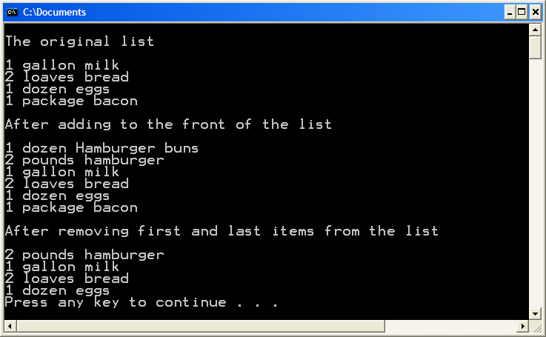

Sample Executable:
A sample executable for this program is located here.

