ASSERT
Assert statements are a great way of checking something that should be true. The format is
Assert assertion : error code;
Examples:
assert x < y : “subarray x must be < y”
assert x==3: x // x must always be 3
switch (x){
case -1: return LESS;
case 0: return EQUAL;
case 1 : return GREATER;
default: assert false:x // throw AssertError if x is not -1, 0, or 1
}
You enable this via a command line argument to Java. In Eclipse you can do this in the Run item settings or you can make it the default in Window > Preferences > Java > Installed JREs > Edit… > Default VM Arguments: -ea

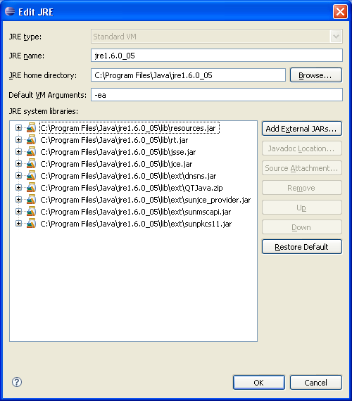

Getting Started with Java under Windows Questions and Answers
What software do I need? You need a Java compiler and an IDE.
What is a compiler? A compiler translates Java code into bytecodes.
Where do I get it?
There is essentially only one Java compiler. It is part of JDK (Java Development Kit) and it is available free for downloading from Sun Microsystems's web site. The latest version, as of August 2008 is Java SE Development Kit 6u7
What is an IDE?
An IDE (Integrated Development Environment) includes an editor for writing Java code, a project maker, sometimes a debugger, all conveniently packaged into one program with a graphical user interface. Several free IDEs are available for downloading. One, called NetBeans, is available from Sun in a "cobundle" with the JDK. Other semesters, we have used JCreator LE from Xinox software. This semester we will use Eclipse.

Downloading JDK, Docs, and Eclipse
- To download JDK, go to the link specified above.
Scroll down to the orange bar:
Download Selected with Sun Download Manager
Make sure to choose JDK (not JRE).
Accept the license agreement. Click on the Windows Offline Installation and download the file to the desktop or a folder of your choice.
- Now download the documentation. To do that, return to the download page
http://java.sun.com/javase/downloads/index.jsp
Java(TM) SE Development Kit Documentation 6
Accept the license agreement. Download the zipped documentation file jdk-6-doc.zip (about 44 MB) to the desktop or a folder of your choice. Unzipping the file will create a docs directory (with LOTS of files). Click on docs/api/index.html. That will get you to an interface like that below:
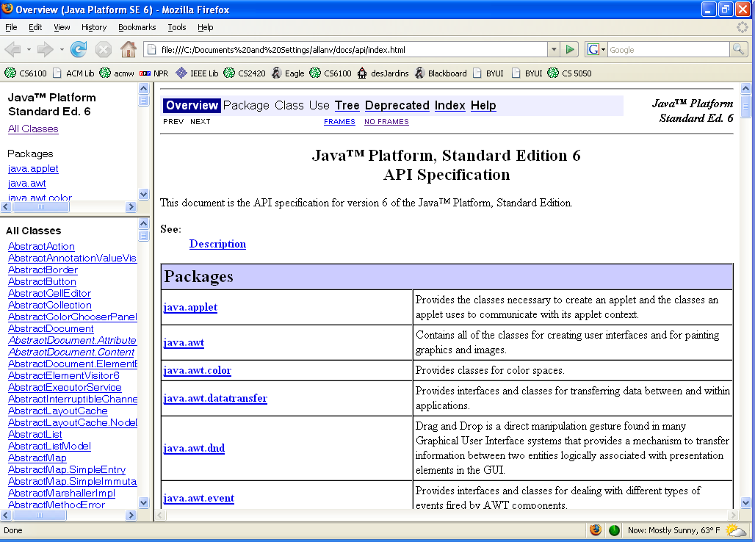
Now download Eclipse from here. Eclipse IDE for Java Developers (85 MB)
- After you download Eclipse, you will want to unzip the folder to right under your C drive (or main hard drive). However, you can install Eclipse in what ever directory you want. The file is over 85MG. Eclipse is run by clicking on the eclipse.exe executable which is at the top level of the Eclipse directory. It doesn’t automatically give you a shortcut, but you will want to create one. Use Windows Explorer to locate eclipse.exe. Right click on it and create a shortcut (or drag it to the desktop).
The Eclipse Workbench
The first time you open Eclipse, you will be asked to pick a workspace. I like to create a directly under the class name for this. Then, you see the welcome page, which exists inside the workbench (see Figure 1). As an Eclipse user, you'll be given a few options of going to an overview page, which I recommend (see Figure 2). See what's new, explore some samples, or go through some tutorials.
Figure 1. Eclipse Welcome Page
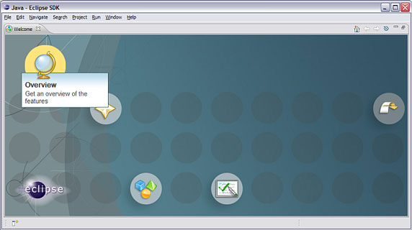
Figure 2. Eclipse Overview Page
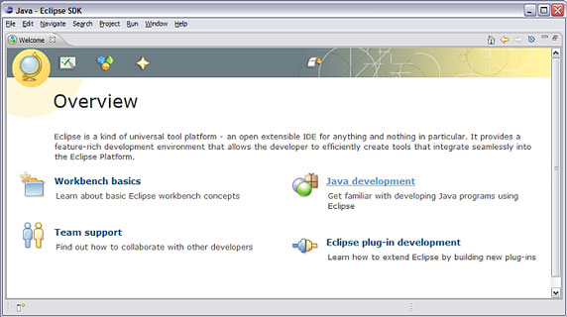
The Eclipse workbench consists of several panels known as views, such as the navigator or outline views. A collection of these views is called a perspective. One of the most common perspectives is the Resource perspective, which is a basic set of views for managing projects and viewing and editing files in a project.
I recommend most novice users start with the Overview page featured in Figure 2 and learn about Eclipse. The workbench basics section contains a lot of good starter information about the various pieces of Eclipse and how they interact. Spend a few minutes reading the material, then let's dive directly into the Java Development Tools (JDT) in Eclipse. There's no better way to learn than doing it hands-on. You can always get back to the welcome page by selecting Help>Welcome. Click on the X by the word Welcome to exit this screen.
To continue this short tour of Eclipse, we'll create a new Java project. Select File > New > Java Project and enter Hello when prompted for the project name, then click Finish.
Next, we'll take a look at the Java perspective (if you aren't already there). The word Java in the upper right hand corner indicates the Java perspective. Depending on how you like to manage your screen, you can change the perspective in the current window by selecting Window > Open Perspective > Java or you can open a new window by selecting Window > New Window and selecting the new perspective.
The Java perspective, as you might expect, has a set of views that are better suited for Java development. One of these includes, as the top-left view, a hierarchy containing various Java packages, classes, JARs, and miscellaneous files. If you click on the plus sign next to “Hello” you will see the jar files. This view is the called the Package Explorer. Also notice that the main menu has expanded to include two new menu items (after File and Edit): Source and Refactor.
The Java Development Tools (JDT)
To try out the Java development environment, we'll create and run a Hello World application. Using the Java perspective, right-click on the Hello project's source folder (src) and select New > Class, as shown in Figure 3. In the dialog box that appears, type Hello as the class name. Under Which method stubs would you like to create? check public static void main(String[] args), then Finish.
Figure 3. Creating a new class in the Java perspective
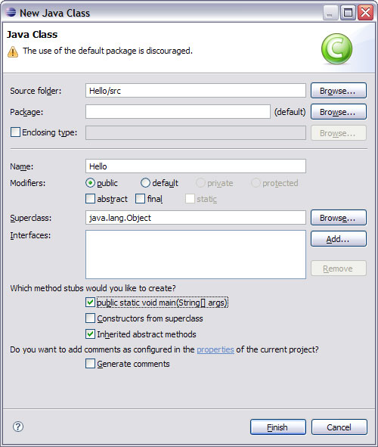
This will create a .java file with a Hello class and an empty main() method in the editor area, as shown in Figure 4. Add the following code to the method (note that the declaration for i has been omitted deliberately).
Figure 4. The Hello class in the Java editor
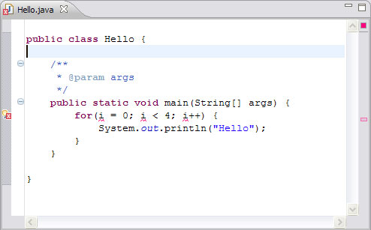
You'll notice some of the Eclipse editor's features as you type, including syntax checking and code completion. Also, when you type an open parenthesis or double quote, Eclipse will provide its partner automatically and place the cursor inside the pair.
In other cases, you can invoke code completion by using Ctrl+space. Code completion provides a context-sensitive list of suggestions selectable by keyboard or mouse. The suggestions can be a list of methods specific to a particular object or a code snippet to expand, based on various keywords such as for or while.
Syntax checking depends on incremental compilation. As you save your code, it is compiled in the background and checked for syntax errors. By default, syntax errors are underlined in red, and a red dot with a white X appears in the left margin. Other errors are indicated with a lightbulb in the editor's left margin; these are problems that the editor might be able to fix for you (a feature called Quick Fix). If you want to browse through the errors, select the “Next Annotation” button (cntl+.)
The code above has a lightbulb next to the for statement because the declaration for i has been omitted. Double-left clicking on the lightbulb will bring up a list of suggested fixes. In this case, it will offer to create a class field i, a local variable i, or a method parameter i; clicking each of these suggestions will display the code that would be generated. Figure 5 shows the list of suggestions and the code it suggests for a local variable.
Figure 5. Quick Fix suggestions
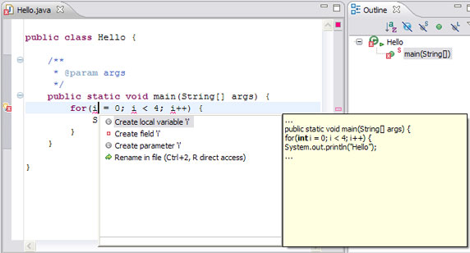
Double-clicking on the suggestion inserts the code in the proper location in the code.
Once the code compiles without error, you can execute the program by selecting Run from the Eclipse menu. (Note that there is no separate compilation step because compilation takes place as you save the code. If your code has no syntax errors, it's ready to run. It will ask you to save the file before it runs.) A Launch Configurations dialog box appears, with appropriate defaults; click Run at the bottom right. A new tabbed panel appears in the lower panel (the Console), displaying the program's output, as shown below.
Figure 6. Output from the program
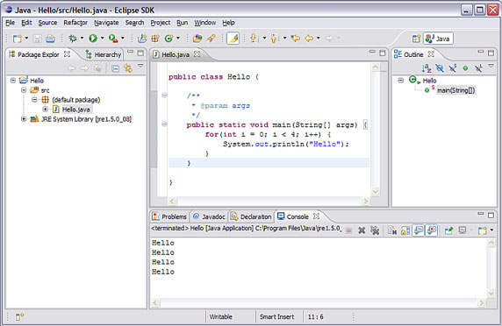

What if the files you want to compile already exist?
The best way to do bring your pre-existing Java files into eclipse is to create a Java project and copy your files into the project. You can copy the files into the project using a number of methods. You can:
- Use the import facility, File->Import...
- Copy the files into the project folder in the src. Then right click on the project and select Refresh
- (Win32 only) Drag the files from the desktop, a folder, or an Explorer window into the project.
If you do not want to copy the files, you can create a Java project that is located at the folder that contains your Java source. For example, let's say you have 5000 source files in directory tree under c:\work. You can create a Java project and set its location to c:\work. To do this, uncheck the "Use default location" check box in the new project wizard to specify the location.
Debugging
You can also run the program in the Java debugger. First, set a breakpoint in main() System.out.println() by double-clicking in the gray margin on the left side of the editor view, next to the call to System.out.println(). A blue dot will appear. From the Run menu, select Debug. As described, a Launch Configurations dialog will appear. Select Run. The perspective will change to the Debug perspective automatically (after the first time when it asks you if you want to switch to the Debug perspective when debugging), with a number of interesting new views, as shown below.
Figure 7. The Debug perspective
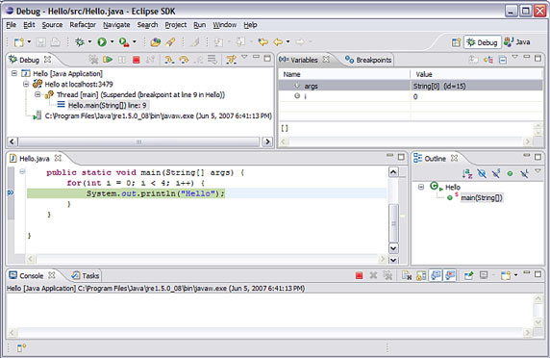
Notice the Debug view at the top left of the perspective. This view shows the call stack and has a toolbar in the title bar that allows you to control the execution of the program, including buttons to resume, suspend, or terminate the program, step into the next statement, step over the next statement or return from a method. The panel at the top right contains a number of tabbed views, including Variables, Breakpoints, Expressions, and Display. I've clicked Variables so we can see the current value of i.
You can obtain more information about any of the views with the context-sensitive help; click on the title of the view and press F1. To get back to the familiar Java perspective, you can click on the white Java perspective button in the upper right hand corner.
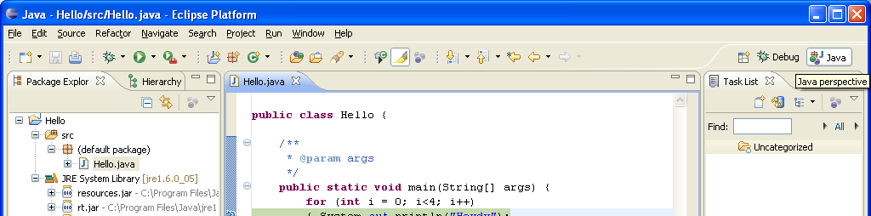

More Info:
Depending on the type of file that is being edited, the appropriate editor is displayed in the editor area. For example, if a .TXT file is being edited, a text editor is displayed in the editor area. The figure below shows an editor open on the file file1.txt. The name of the file appears in the tab of the editor. An asterisk (*) appearing at the left side of the tab indicates that the editor has unsaved changes. If an attempt is made to close the editor or exit the Workbench with unsaved changes, a prompt to save the editor's changes will appear.
. 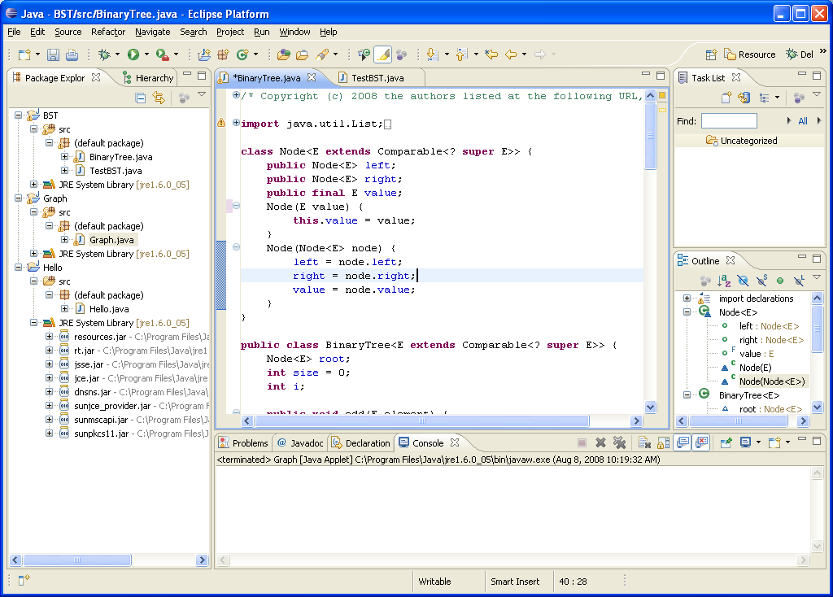
To activate a view that is part of a tabbed notebook simply click its tab.
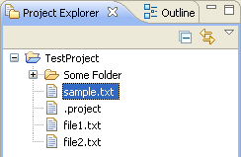

The editors can be stacked in the editor area and individual editors can be activated by clicking the tab for the editor. Editors can also be tiled side-by-side in the editor area so their content can be viewed simultaneously.

Through the normal course of using the Workbench you will open, move, resize, and close views. If you'd like to restore the perspective back to its original state, you can select the Window > Reset Perspective menu operation.
Editing
- Notice the syntax highlighting. Different kinds of elements in the Java source are rendered in unique colors. Examples of Java source elements that are rendered differently are:
  - Regular comments
  - Javadoc comments
  - Keywords
  - Strings
- Look at the Outline view on the right hand side. It displays an outline of the Java file including the package declaration, import declarations, fields, types and methods. The Outline view uses icons to annotate Java elements. For example, icons indicate whether a Java element is static (), abstract (), or final (). Different icons show you whether a method overrides a method from a base class ( ) or when it implements a method from an interface ( ). Clicking on a method, moves the editor to that method
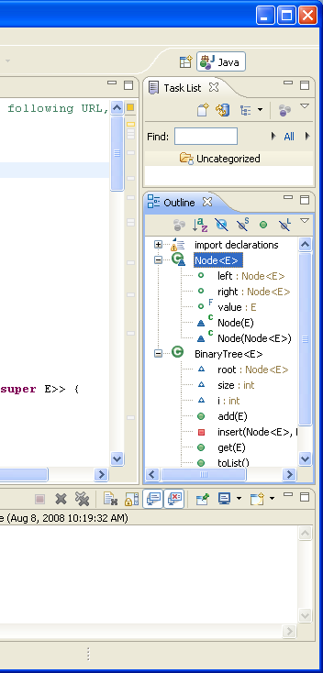
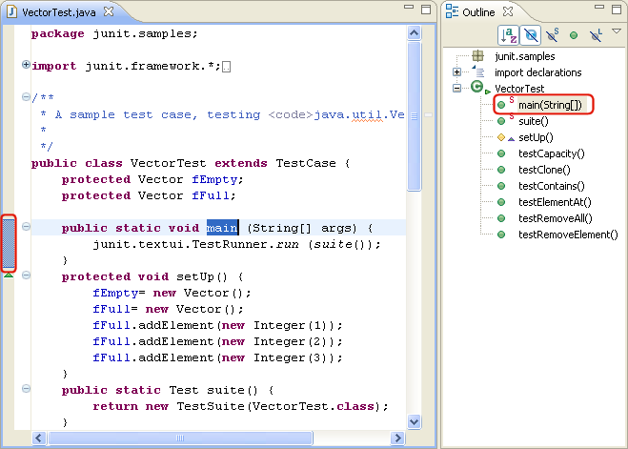
In the outline view, select different elements and note that they are again displayed in a whole file view in the editor. The Outline view selection now contains a range indicator on the vertical ruler on the left border of the Java editor that indicates the range of the selected element.

- Content assist provides you with a list of suggested completions for partially entered strings. In the Java editor press Ctrl+Space or use Edit > Content Assist.
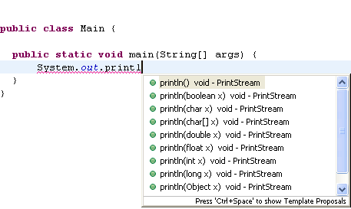

- To create getter and setter methods for a field, select the field's declaration and invoke Source > Generate Getter and Setter.
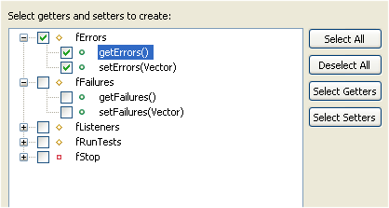

If you use a name prefix or suffix be sure to specify this in the Java > Code Style preference page.

- A quick assist (Ctrl+1) is available on fields to create getters and setters. It also replaces all uses of the variable with a getter.
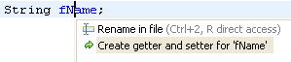

When you delete a field from within a view, Eclipse can propose deleting its Getter and Setter methods. If you use a name prefix or suffix for fields, be sure to specify this in the Java > Code Style preference page.

- Start with the method invocation and use Quick Fix (Ctrl+1) to create the method.
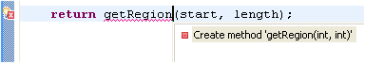
- Add an argument to a method invocation at a call site. Then use Quick Fix (Ctrl+1) to add the required parameter in the method declaration.
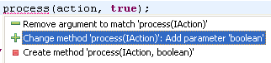
- To implement a new interface, add the 'implements' declaration first to the type. Even without saving or building, the Java editor will underline the type to signal that methods are missing and will show the Quick Fix light bulb. Click on the light bulb or press Ctrl+1 (Edit > Quick Fix) to choose between adding the unimplemented methods or making your class abstract.
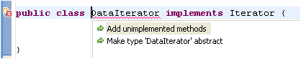
- When you add a new method to an interface or an abstract method to an abstract class, Eclipse can generate method stubs in all concrete subclasses at once. Invoke Source > Clean Up... on a set of Java elements, use a custom profile, and select on the Configure... dialog to Add unimplemented methods on the Missing Code tab.
- Dealing with thrown exceptions is easy. Unhandled exceptions are detected while typing and marked with a red line in the editor.
- Click on the light bulb or press Ctrl+1 to surround the call with a try catch block. If you want to include more statements in the try block, select the statements and use Source > Surround With > Try/catch Block. You can also select individual statements by using Edit > Expand Selection To and selecting Enclosing, Next or Previous.
- If the call is already surrounded with a try block, Quick Fix will suggest adding the catch block to the existing block.
- If you don't want to handle the exception, let Quick Fix add a new thrown exception to the enclosing method declaration
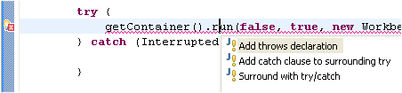
At any time, you can convert a catch block to a thrown exception. Use Ctrl+1 (Edit > Quick Fix) on a catch block.
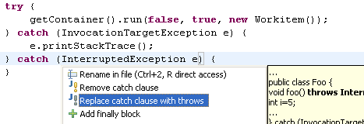
- The following Clean Ups have been added:
- Correct indentation: Corrects the indentation of your source code.
- Add unimplemented methods: Adds code stubs for all unimplemented methods.
Add unimplemented methods is most useful after adding a new method to an interface. Correct indentation is also available as save action. (The first time you must select “Use Custom Profile” and Configure. Then select Code Organizing under the Custom CleanUps view. Check “Correct Indentation”.)
To clean up your code select a set of Java elements and invoke Source > Clean Up.

Quick Outline
To use the quick outline view in the Java editor:
- Open java file in the Java editor if you do not already have it open.
- Press Ctrl+O or select Navigate > Quick Outline and you will see an in-place outline of the current source file.
- Press Ctrl+O a second time and all inherited fields, types and methods are shown as well. Inherited members are shown in grey.
- Start typing while the quick outline view is shown to filter the list of displayed elements. Further, use the arrow keys to navigate in the outline view and press Enter to reveal the selected element in the Java editor

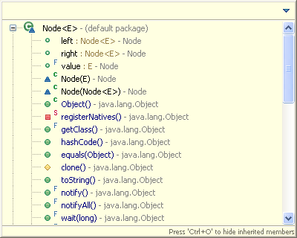
Renaming
In this section, you will rename a Java element using refactoring. Refactoring actions change the structure of your code without changing its semantics (behavior).
- Select a variable name. Select Refactor > Rename.
- Type in the new name. All instances will be replaced with the new name. Note, the names are replaced based on context rather than a global replace.
You have seen that a refactoring action can cause many changes in different compilation units. These changes can be undone as a group.
- In the menu bar, select Edit > Undo

Performing a Java search from the workbench
- In the Java perspective, click the Search () button in the workbench toolbar or use Search > Java... from the menu bar.
- If it is not already selected, select the Java Search tab.
- In the Search string field, type insert In the Search For area, select Method, and in the Limit To area, select References.
Verify that the Scope is set to Workspace.

- Then click Search. While searching you may click Cancel at any time to stop the search. Partial results will be shown.
- In the Java perspective, the Search view shows the search results. Use the Show Next Match () and Show Previous Match () buttons to navigate to each match. If the file in which the match was found is not currently open, it is opened in an editor. When you navigate to a search match using the Search view buttons, the file opens in the editor at the position of the match. Search matches are tagged with a search marker in the rulers.

Running your Program
- To specify arguments, use the drop-down Run menu in the toolbar and select Run Configurations....
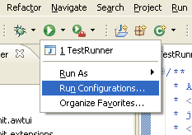

Debugging your programs
In this section, you will debug a Java program.
- In the Package Explorer view in the Java perspective, double-click junit.samples/VectorTest.java to open it in an editor.
- Place your cursor on the vertical ruler along the left edge of the editor area on the following line in the setUp() method:
fFull.addElement (new Integer(1));
and double-click on the ruler to set a breakpoint.
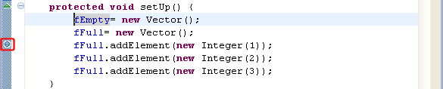
The breakpoint icon indicates the status of the breakpoint. The plain blue breakpoint icon indicates that the breakpoint has been set, but not yet installed.
Note: Once the class is loaded by the Java VM, the breakpoint will be installed and a checkmark overlay will be displayed on the breakpoint icon.
- In the Package Explorer view, select the junit.samples package and select Debug As, and then Java Application. When you run a program from a package, you will be prompted to choose a type from all classes in the package that define a main method.
- Select the VectorTest item in the dialog, then click OK.
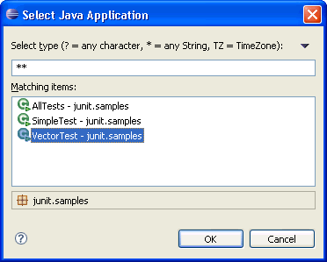
Note: You can also simply hit the debug button which will launch the currently selected resource or active editor. Select Java Application when you are prompted to select a way to debug VectorTest.
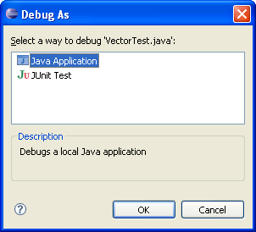
- The program will run until the breakpoint is reached. When the breakpoint is hit, execution is suspended, and you are asked whether to open the Debug perspective. Click Yes. Notice that the process is still active (not terminated) in the Debug view. Other threads might still be running.
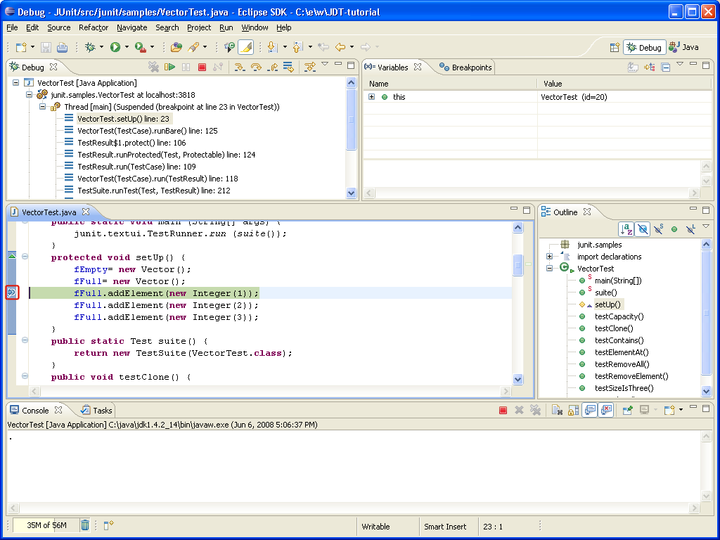
Note: The breakpoint now has a checkmark overlay since the class VectorTest was loaded in the Java VM.
- In the editor in the Debug perspective, select new Vector() from the line above where the breakpoint is set, and from its context menu, select Inspect.
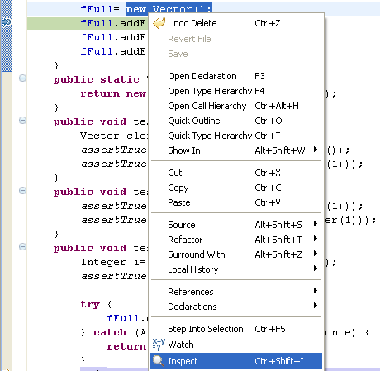
- The expression is evaluated in the context of the current stack frame, and a pop-up appears which displays the results. You can send a result to the Expressions view by pressing the key binding displayed in the pop-up.
- Expressions that you evaluate while debugging a program will be listed in this view. To delete an expression after working with it, select the expression and choose Remove from its context menu.
- The Variables view (available on a tab along with the Expressions view) displays the values of the variables in the selected stack frame. Expand the this.fFull tree in the Variables view until you can see elementCount.
- The variables (e.g., elementCount) in the Variables view will change when you step through VectorTest in the Debug view. To step through the code, click the Step Over () button. Execution will continue at the next line in the same method (or, if you are at the end of a method, it will continue in the method from which the current method was called).
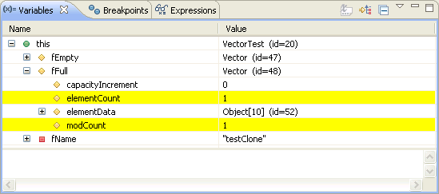
- In the variables view you can choose to see certain types as logical structures. This hides the implementation details of a type and simply shows it as arrays or fields. You can define logical structures by yourself in the preference page Java > Debug > Logical Structures.
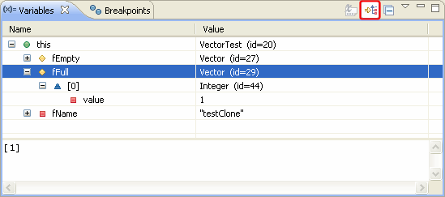
- Try some other step buttons (Step Into , Step Return ) to step through the code. Note the differences in stepping techniques.
- You can end a debugging session by allowing the program to run to completion or by terminating it.
  - You can continue to step over the code with the Step buttons until the program completes.
  - You can click the Resume () button to allow the program to run until the next breakpoint is encountered or until the program is completed.
  - You can select Terminate from the context menu of the program's process in the Debug view to terminate the program

Assert

Assert statements are a great way of checking something that should be true. The format is
Assert assertion : error code;
Examples:
assert x < y : “subarray x must be < y”

assert x==3: x // x must always be 3

switch (x){
case -1: return LESS;
case 0: return EQUAL;
case 1 : return GREATER;
default: assert false:x // throw AssertError if x is not -1, 0, or 1
}

You enable this via a command line argument to Java. In Eclipse you can do this in the Run item settings or you can make it the default in Window > Preferences > Java > Installed JREs > Edit… > Default VM Arguments: -ea

