

Back to Basics® Cocoa Latte™
Hot Drink Maker

Instruction Manual

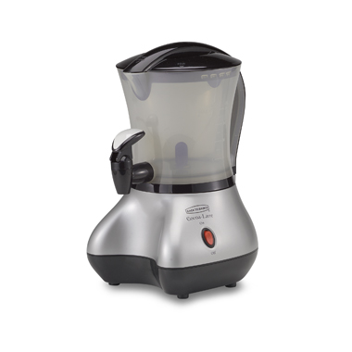

General Overview:

The Cocoa Latte™ Hot Drink Maker is designed to make delicious, frothy, hot drinks. The Cocoa Latte™ stands approximately 12 inches tall and is roughly 7 inches in diameter. The basic machine consists of the base which controls the entire hot drink maker when plugged into an electrical outlet. The mixing container holds up to 32 ounces of drink and contains a stirring paddle which enables the machine to create specialized, frothy drinks. A dispensing valve, attached to the mixing container, allows for drinks to be released directly into a cup. A lid attaches to the top of the container, ensuring the containment of the mixture.
Ingredients for the hot drink and an electrical outlet are all that is needed to make the Cocoa Latte™ Hot Drink Maker work. Coffee, tea, chai, cappuccino, hot chocolate, hot toddies, espresso, and lattes are just a few of the gourmet quality products that the Cocoa Latte™ will make. Beverages are warmed automatically during mixing and the auto reheat feature assures that they stay warm.

How it Works:

The Cocoa Latte™ Hot Drink Maker uses electric coils in the base to gently heat your instant beverage as it mixes. When you turn the switch to “ON,” the stirring paddles begin mixing the beverage while it is also begins heating. The froth function enables the high speed motor to whip your drink at 5,000 RPM to create a tasty foamy professional beverage. Within 4-8 minutes, depending on the amount of mixture, the Cocoa Latte™ will create a gourmet hot drink for you and your family.

Introduction:

Congratulations on your purchase of the Cocoa Latte™ Hot Drink Maker! With this product you will now be able to make frothy hot chocolate, tea, or coffee heated to the perfect temperature. The Hot Drink Maker mixes, heats, and whips any instant hot beverage into a ready to serve foamy, hot drink.

The following information is a step-by-step set of instructions for assembling the Cocoa Latte™ Hot Drink Maker. Carefully follow these instructions before use. After completing assembly you will be ready to make any instant hot beverage of your choice. A company favorite recipe is included after the assembly instructions. To maintain your Cocoa Latte™ please follow the detailed cleaning instructions at the end of the instruction manual. By following these directions you will ensure the long life and durability of your product.

List of Equipment and Materials Required:

- Base
- Container
- Lid
- Dispensing Valve
- Instructions
- Ingredients

Assembly of the Cocoa Latte Machine

- Gather together the items listed in the parts section of the Manual.
- Place the base (#1.1) on a flat level surface close to a wall outlet.

 Warning: To prevent electrocution do not immerse the plug, cord, or base in water.

- Place the mixing container (#1.3) on the base with the pour spout, located on the rim at the top of the mixing container, pointing to the front of the base as shown in image 2.1. The rectangular part under the handle should fit into the rectangular groove on the base.

Danger: Assure that On/Off switch is in off position and that power cord is not connected.
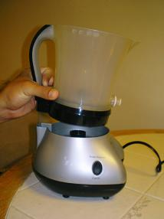
#2.1 Connecting the Mixing Container
 Caution: Make sure that the mixing container is properly seated on the base

- Take the dispensing spout (#1.4) and carefully twist it clockwise onto the small spout at the bottom of the mixing container as shown in image 2.2.
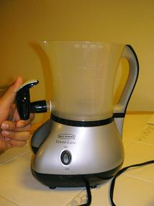

#2.2 Connecting the Spout
Caution: Make sure that spout is secure to avoid leaking.

- Place lid on container.

Caution: To avoid spilling, do not operate the Cocoa Latte™ without the lid properly placed on top of the container.

- Insert the plug into a wall socket.

Your Cocoa Latte™ is now ready for use and should appear as shown in Figure #2.3

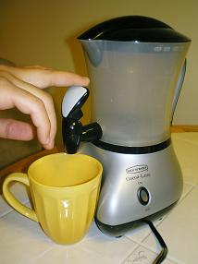
#2.3 Fully Assembled Cocoa Latte™

Back to Basics’ Hot Wassail recipe:

Step 1- Gather all ingredients:

- 2 cups apple juice
- 1 cup orange juice
- 1 cup cranberry juice cocktail
- 3 tablespoons lemon juice
- ¼ teaspoon ground cinnamon
- ¼ teaspoon ground ginger
- ¼ teaspoon ground nutmeg
- ¼ teaspoon ground cloves

Step 2- Combine all ingredients in Cocoa Latte™

- Add juices first
- More or less cinnamon can be added according to desire
- Note: Container can be removed from the base for easy filling in a more convenient location.

Step 3- Make sure the lid is securely closed before you turn on the Cocoa Latte™

Step 4- Turn Switch to on position

- Cocoa Latte™ will automatically shut off when beverage has been heated and mixed to perfection.

- Note: The Cocoa Latte™ will automatically begin re-heating the mixture if the drink lowers from the ideal temperature.

- Note: If the froth button is set to “froth/dispense” the machine will continue running even after it has completed making the drink. Be sure the froth button is set to “cancel” until you are ready to serve the beverage.

Step 5- Serve Beverage

  - Press the Froth button to “froth/dispense” to ensure the beverage is frothy.
  - Set cup underneath dispensing spout
  - Press down on dispensing spout and fill cup to desired level
  - Serves about 4

Step 6- Enjoy

- Your perfectly heated frothy wassail is now ready to be served!

Danger: Beverage will be hot, handle with care.
Cleaning Instructions:

It is important to clean the Cocoa Latte® Hot Drink Machine after each use. When the machine has completely cooled down, you may begin cleaning.

Warning: Do not wash any part of the Cocoa Latte® machine in a dishwasher.

Warning: Do not completely submerge the base or container completely in water!

- Be sure the “ON/OFF” switch is turned to “OFF.”
- Unplug the Cocoa Latte® machine from the wall.
- Take the container off of the base.
- Empty the remaining drink from the container.
- Add a small amount of warm water and liquid dishwashing soap to the inside of the container. Be sure not to immerse the entire container into water.
- Wipe the inside and outside of the container clean using a soft, wet cloth.
Caution: If you use a rough, abrasive washing utensil it will scratch the container.
- With soapy water still inside the container, open the dispensing valve and let the soapy water move through the valve.
- Carefully rinse the container with warm, clean water, allowing it to flow through the dispensing valve.
- The lid may be submerged completely in water. Wash with dishwashing soap and water.
- Wipe down the base with a clean cloth. Do not immerse the base in water.
- Dry the machine with a clean, dry cloth.

