IT 252 HW 1 text

Name: Lehi Alcantara

HomeWork Problems answered is followed bellow:

2.64:

y=2863311530 this is the number that by and’ing with will give us the answer we are looking for to find out if the number passed in has any odd bits in odd positions.

int any_odd_one(unsigned int x)

{

unsigned int y = 2863311530;

if ((x & y) > 0)

{

return 1;

}

else { return 0; }

}

HW 2.65

int odd_ones(unsigned x)

{

unsigned int y=1;

unsigned int count=0;

By looping through the number passed in and shifting once per loop and and’ing with 1 to x, will give us all the 1’s contained in x, then compare with count to determine right return value.

int i=0;

for (;i<32;i++)

{

count+=(x&y);

x=x>>1;

}

if(count%2==0)

{

return 0;

}

else { return 1;}

}

Screenshots of HW 2.64 debug mode:

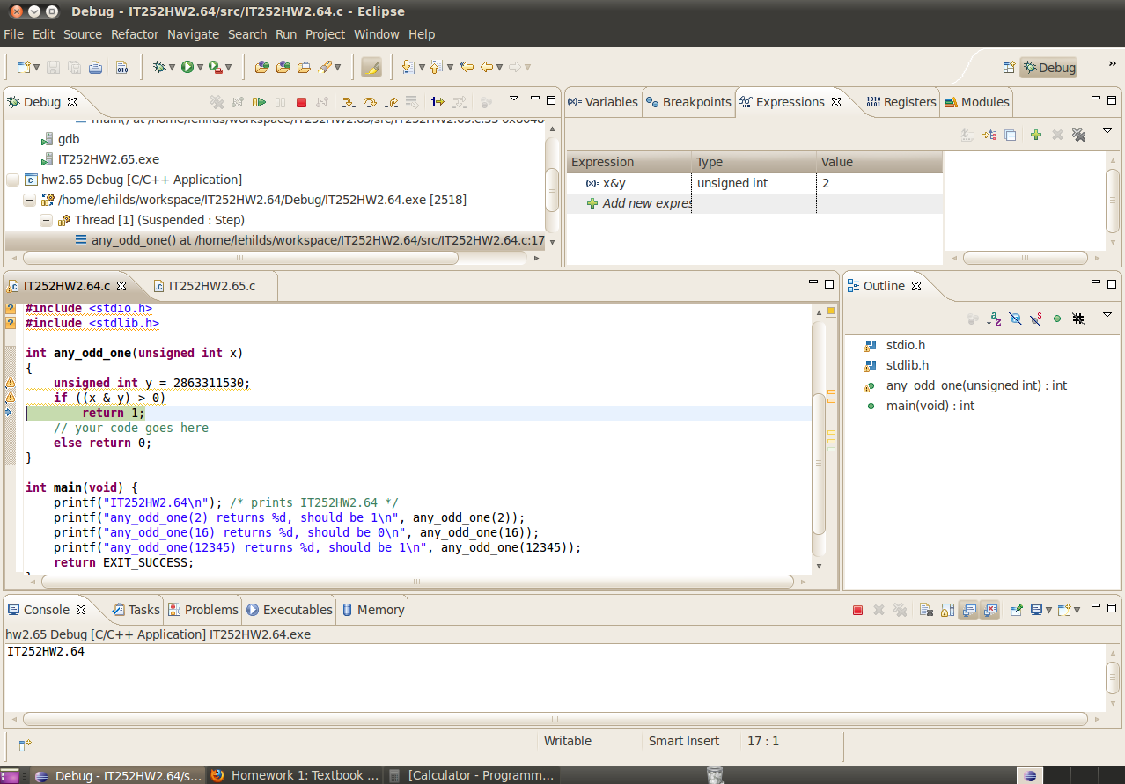

Screenshots of HW 2.64 showing right results:

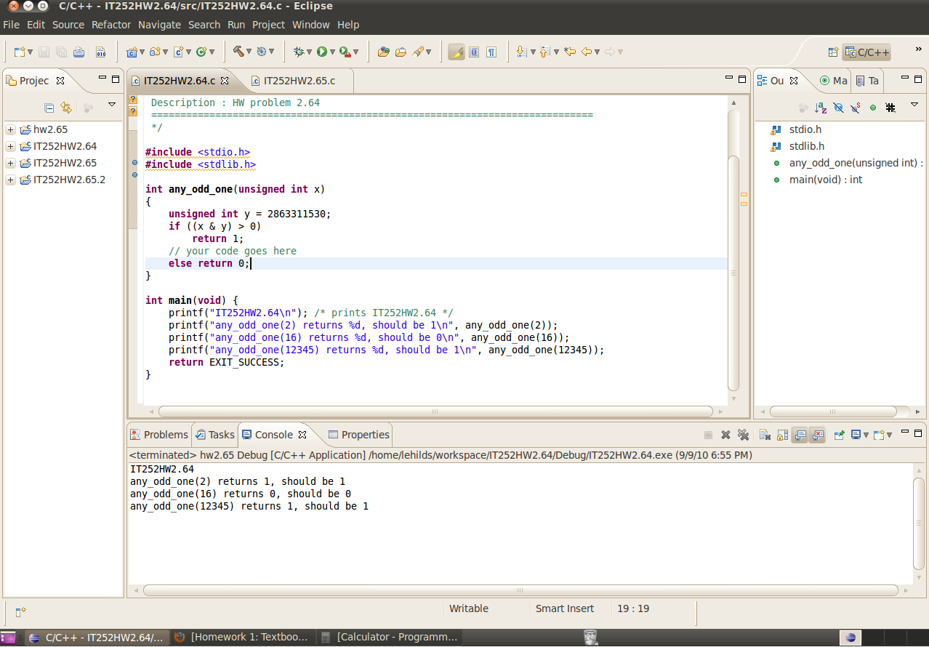

Screenshot of HW 2.65 debug mode:

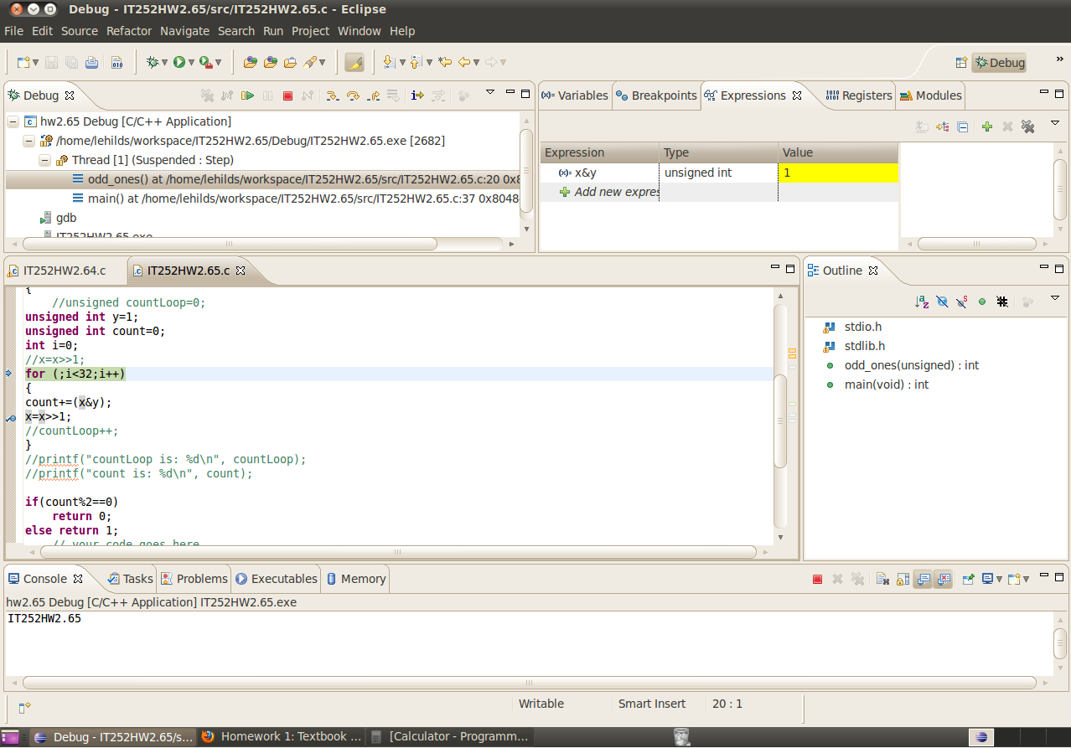

Screenshot of HW 2.65 showing right results:

