**IT 327 - Lab #3**

**Inductors and Transformers**

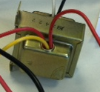

# Objective

To experience some applications of transformers and how to measure transformers output.

# Procedures

Step 1

I set the function generator to sine wave output to 60 Hz and maximum amplitude. I measured the amplitude with the oscilloscope which I obtained 16.92 Vpp. The following are the results:

|  |  |
| --- | --- |
| **Vpp/** | **16.92 Vpp** |
| **Vp** | **8.46Vp** |
| **Frequency** | **60.3 Hz** |

**Screenshot showing the measurements from above instructions.**

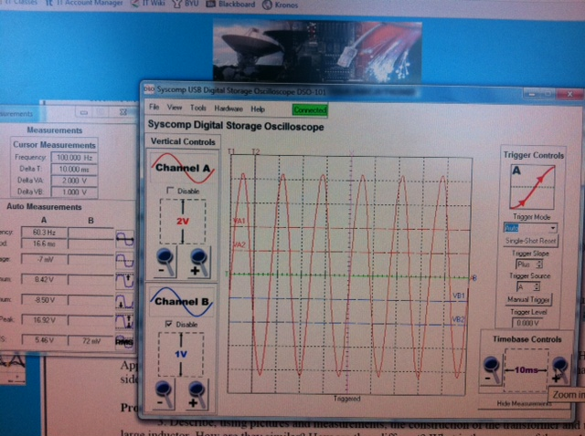

I applied this signal to the primary side of the transformer and measure the voltage out of the secondary side. **Make sure to get a lot of peaks to get the right Vrms.** The input ampacity is 15 Amps; the following are the results:

|  |  |
| --- | --- |
| **Vpp** | **6.59 Vpp** |
| **Vp** | **3.295 Vp** |
| **Vrms** | **2.94 Vrms** |

**Screenshot showing the above measurements, look at channel B.**

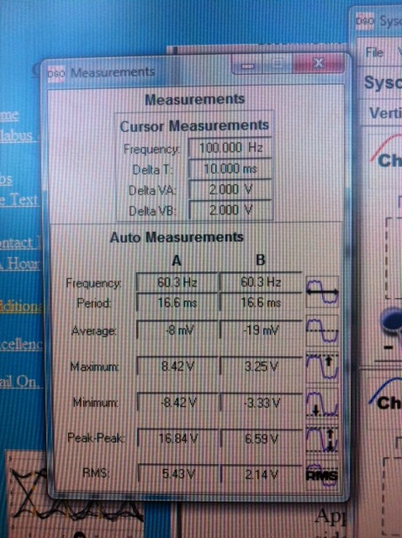

Calculate the output ampacity found by this formula: I2 = I1 E1/E2. You should find it to be I2 = **38.51 A.**

Step 2

I set the function generator output amplitude to 5 Vp-p, set it to sine wave; frequency is 60 Hz. I applied this signal to the secondary transformer and measured the voltage out of the primary side. Assume input ampacity to be 15 Amps. Calculated the output ampacity with this formula: I2 = I1 E1/E2 which should be **6.12 A.** The following are the results:

|  |  |
| --- | --- |
| **Vpp** | **2.04 Vpp** |
| **Vp** | **1.02 Vp** |
| **Frequency** | **60.1 Hz** |
| **Vrms** | **0.675 Vrms** |

Screenshot showing the measurements above, look at channel B.

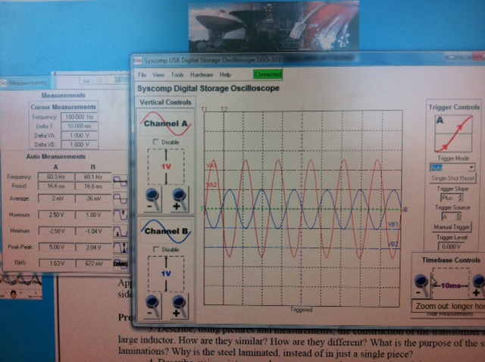

Below is a screenshot showing the right connections to measure the transformer output.

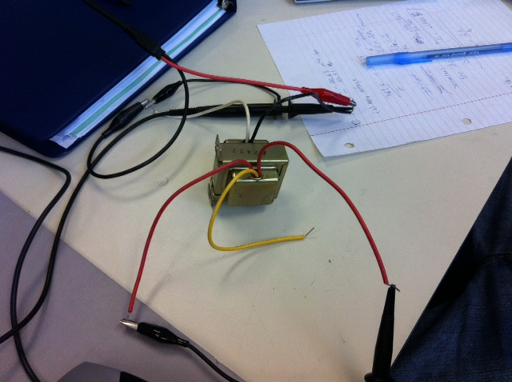

# Equipment Used

* Oscilloscope: Syscomp Computer Controlled Instruments.
* Function generator
* Transformer
* Alligator clips

# Report

Comparing my results against expected was mostly accurate. I had some trouble following the lab instructions and did the lab oscilloscope connections to transformer quite a few times, because of some confusion from lab instructor, but eventually with a few trial and errors I figured out the right oscilloscope connections with the transformer.

Measuring the Amplitude, Vrms, Vpp, Vp with the oscilloscope was very educational, because I could then see in practice what I had learned in class. Learning how to measure the voltage from primary and secondary and observe the differences between the 2 helped me to understand what the transformer does depending on which side of the transformer I’m measuring.

The lab was educational and it was important to me to see the relationships of the measured voltage from primary and secondary side on the transformer and compare with the expected calculations.

# Conclusion

This lab has reinforced me some of the applications of transformer. Measuring the Amplitude, Vrms, Vpp, Vp on each side of the transformer, primary and secondary sides, helped me to see how transformer works.

This lab also taught me the importance of setting up the right connections in order to get the right readings. If by observing one measure does not compare with the expected then there is something wrong with the connections set-up. This happened quite a few times with me but eventually I got the right cable connections to the transformer, connecting the oscilloscope to both ends of the transformer to measure the transformer output.

This lab also taught me to design well the connections to the transformer, as I said before we had a hard time on the connections step, with better cable connection design I would have been more successful, but in the end it worked out. Learning how to use the oscilloscope was also beneficial as to measure the output of transformers.

**Name: Lehi Alcantara**

**Completion Date: 09/19/2011**