**IT 327 - Lab #2**

**Parallel Circuits & the Power Formula; Electronic Measuring Equipment**

# Objective

**Objective 1:** To experience basic relationships loads in parallel and its relationship described by the power formula. **Objective 2**: Also experience some of the issues associated with using electronic test and measuring equipment.

# Procedures

## Objective 1

The first step on this lab is to measure all the resistors using DMM. Determine how close each resistor is to its rated value and make sure whether the resistor is within rated tolerance.

Table describing the resistors measured:

|  |  |  |
| --- | --- | --- |
| Resistors | DMM resistance measurement | Within Tolerance |
| 33 Ω | 34 Ω | 2.94% |
| 100 Ω | 99.83 Ω | 0.17% |
| 330 Ω | 331 Ω | 0.30% |

All resistors above were within its rated tolerance. Next step is to understand the effects of combining resistors in parallel. To do this set the power supply to +5V, and connect 330 Ω resistor and then measure the current. The current measured is 0.016 A.

Table showing the calculated and measured current

|  |  |  |  |
| --- | --- | --- | --- |
| Resistors | DMM current measurement | Expected current | % difference |
| 330 Ω | 0.016 A | 0.015 | 6.25% |

Add 100 Ω resistor in parallel with the 330 Ω resistor and then measure its current which should be 0.051 A. The current went up as expected, the expected calculation gives me this current 0.065152 A.

Table showing the calculated and measured current

|  |  |  |  |
| --- | --- | --- | --- |
| Resistors in parallel | DMM current measurement | Expected current | % difference |
| 330 Ω + 100 Ω | 0.051 A | 0.065 | 21.54% |

Remember that to measure current with parallel resistors you have to first insert the DMM connectors before the parallel resistors to read the right current through the breadboard. Also to get Resistance total use formula: RT = 1/(1/R1 + 1/R2). Now add 33 Ω resistor in parallel with 100 Ω and 330 Ω then measure the current which measured is 0.191 A and the predicted was 0.216667 A. The current went up as expected.

Table showing the calculated and measured current

|  |  |  |  |
| --- | --- | --- | --- |
| Resistors in parallel | DMM current measurement | Expected current | % difference |
| 330 Ω + 100Ω + 33 Ω | 0.191 A | 0.217 | 11.98% |

Picture showing measuring current in parallel.

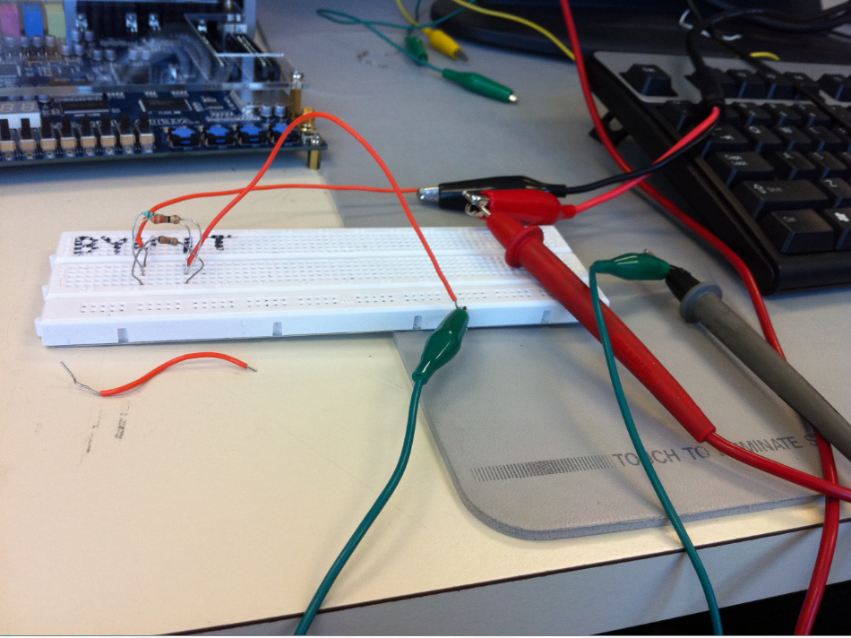

Next calculate the expected current in each of the 3 branches of the above circuit, using the current divider or ohm’s law, measuring branches current and comparing to calculated values. I have used the current divider formula and obtained the following table:

|  |  |  |  |
| --- | --- | --- | --- |
| Resistors | DMM current measurement | Calculated current | Current difference |
| 33 Ω | 0.145 A | 0.151515 A | 4.29 % |
| 100 Ω | 0.05 A | 0.05 A | 0% |
| 330 Ω | 0.016 A | 0.015152 A | 5.3 % |

The above table shows the current on each resistor, calculated method as well as DMM current measurement, the measured and calculated were close in numbers.

Next is to observe the relationship described by the power formula, to do this calculate the power dissipated by each resistor and make sure it agrees with what is expected for each resistor. Power formula is P =V2/R.

Table showing the power for each resistor:

|  |  |  |
| --- | --- | --- |
| Resistors | Calculated Power | Temperature measurement |
| 33 Ω | 0.76 W | hottest |
| 100 Ω | 0.25 W | middle |
| 330 Ω | 0.076 W | coolest |

Table showing its power measurement

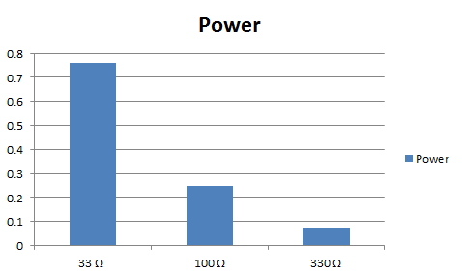

## Objective 2

Measure the actual resistor values of each 10 M Ω. Below is a table of resistance measured on each resistor.

|  |  |
| --- | --- |
| Resistors | DMM resistance measurement |
| 1st 10 M Ω | 9.89 m Ω |
| 2nd 10 M Ω | 10.16 m Ω |

Next set the voltage supplied to +10 V and apply it to both 10 M Ω resistor in series. Calculate the expected voltage and measure the voltage on each resistor using DMM device. Then compare the percent difference from measure and calculated resistance rate, the following table shows the difference and the reason for the difference is because the DMM device has some impedance, precisely 10 M Ω resistance, this resistance becomes in parallel to resistor being measured .which makes it so that the reading is wrong, approximately for resistor 1 is 19.92% difference compared to expected and for resistor 2 is 25.48 difference compared to expected.

|  |  |  |  |
| --- | --- | --- | --- |
| Resistors | DMM voltage measurement | Expected Resistance | % difference |
| 1st 10 M Ω | 3.08 V | 2.47 V | 19.92% |
| 2nd 10 M Ω | 3.04 V | 2.53 V | 25.48% |

|  |
| --- |
|  |
|  |
|  |

# Equipment Used

* Fluke 45 Dual Display Multimeter: 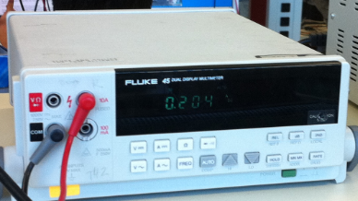
* Sorensen LT 30-3 Laboratory DC power Supply:

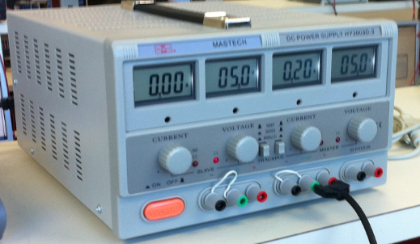

* Resistors: 33 Ω, 100 Ω, 330 Ω, 10M Ω, 10M Ω.

# Report

Comparing my results against expected was mostly accurate. I had some trouble measuring the current on a parallel resistor circuit, but once I have discovered that I needed to make the DMM device to read the current in series with the parallel resistors i was able to read the right current passing through those resistors.

Measuring the voltage measurement across each 10 M Ω resistor with the DMM device helped me to realize that there is an impedance on the DMM device where because of it, it reads the wrong voltage measurement across each resistor, therefore it is important to take into consideration the resistance of the voltage reader as to avoid the wrong reading.

The lab was educational and it was important to me to see the relationships of the measured voltage and current, and compare with the expected calculations using power formula, voltage drop formula and ohm’s law formula.

# Conclusion

This lab has reinforced me the importance of reading current of resistors in parallel system is done by actually making the reader device in series with the parallel resistors; that way the device will have an accurate reading of the current. It was also important to see the relation of formulas and device readers, they co-relate very well, as expected.

Power formula and the device reading of the power on each resistor was also very accurate, the lowest resistor ended up being the one resistor that had the most power and therefore ended up being the hottest resistor, meaning there was some heat dissipation more on that resistor as compared to the others. Therefore the lowest the resistor the more power it will have and the more heat dissipation produced.

**Name: Lehi Alcantara**

**Completion Date: 09/13/2011**