# Confidential Cover Letter

Lehi Alcantara

1106 W 590 N

Provo, UT 84601

March 24, 2011

CIO of MyDoggy Pedigree Pet Company

IT344 – Operating Systems

BYU

Provo, UT

Dear CIO:

As an IT support manager for MyDoggy Pedigree Pet Company I have been trying to make our employees have a better experience as they contribute to the company and as they are getting new computers, I have designed a more efficient way to make sure their work is not lost in case there is a computer problem.

As employees receive their new computer, I have set up new computers tasks that will auto generate a back-up of their work files that will either back-up files in their network home directory or back files up at an external hard drive in case network home directory is not available. They will be asked to leave computer on all the time so that back up will be happening on a daily basis. A hard disk defragment tool will also be running in a daily basis as to make sure computers are running in their optimum performance.

Please let me know if there is anything else I can do to influence your decision in my favor of implementing these new strategies of improving employees’ experience, save company’s money. And improve IT department by working on other tasks as they need.

Sincerely,

Lehi Alcantara

Table of Contents

Confidential Cover Letter 1

Registry, Scripts Description & How-To Instructions 3

Scripts Table: 3

Instructions for help desk to complete process from start to finish 3

1. Backup data to network (or external drive) Instructions using terminal: 3

2. Restore data on a computer from terminal: 3

3. Task Scheduler configuration 3

4. Registry changes that have to be made 4

Instructions for the end user on how to do the following tasks: 9

Analysis 9

Conclusion 10

Appendix 10

# Registry, Scripts Description & How-To Instructions

## Scripts Table:

|  |  |
| --- | --- |
| changes.reg | File that will set-up O.S. description of each of them is under this table |
| defrag.py | Defragment hard drive |
| mountScript.py | Python script to mount network drive |
| restore.py | To restore user home directory from network drive back-up |
| backup.py | To back up user home directory into network drive |

## Instructions for help desk to complete process from start to finish

### Backup data to network (or external drive) Instructions using terminal:

* 1. Click start button
  2. Click on run
  3. Then type cd c:\scripts
  4. Then run script: python mountScript.py
  5. Then run back-up script: assuming you are in folder c:\scripts, type python backup.py
  6. Done

### Restore data on a computer from terminal:

* 1. Click start button
  2. Click on run
  3. Then type cd c:\scripts
  4. Then run script: python mountScript.py
  5. Then run back-up script: assuming you are in folder c:\scripts, type python restore.py
  6. Done

### Task Scheduler configuration

* 1. Click Start button
  2. Click on Control Panel
  3. Click on Schedule Tasks
  4. To add a task click on Add Scheduled Task
  5. Click Next
  6. Click on browse and go to location c:\scripts the find script desired to run (for instance restore.py) in the scheduled task.
  7. Type a name for the task
  8. Click next
  9. Indicate how often the task is supposed to happen for the user.
  10. Click Next
  11. Indicate date, time, and frequency to start this task.
  12. Click Next
  13. Enter username and password of the user, since system may need them to run tasks.
  14. Click Next
  15. Click Finish

Below are screenshots of scheduled tasks:

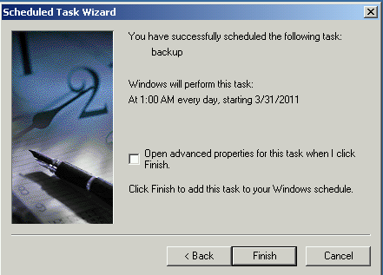 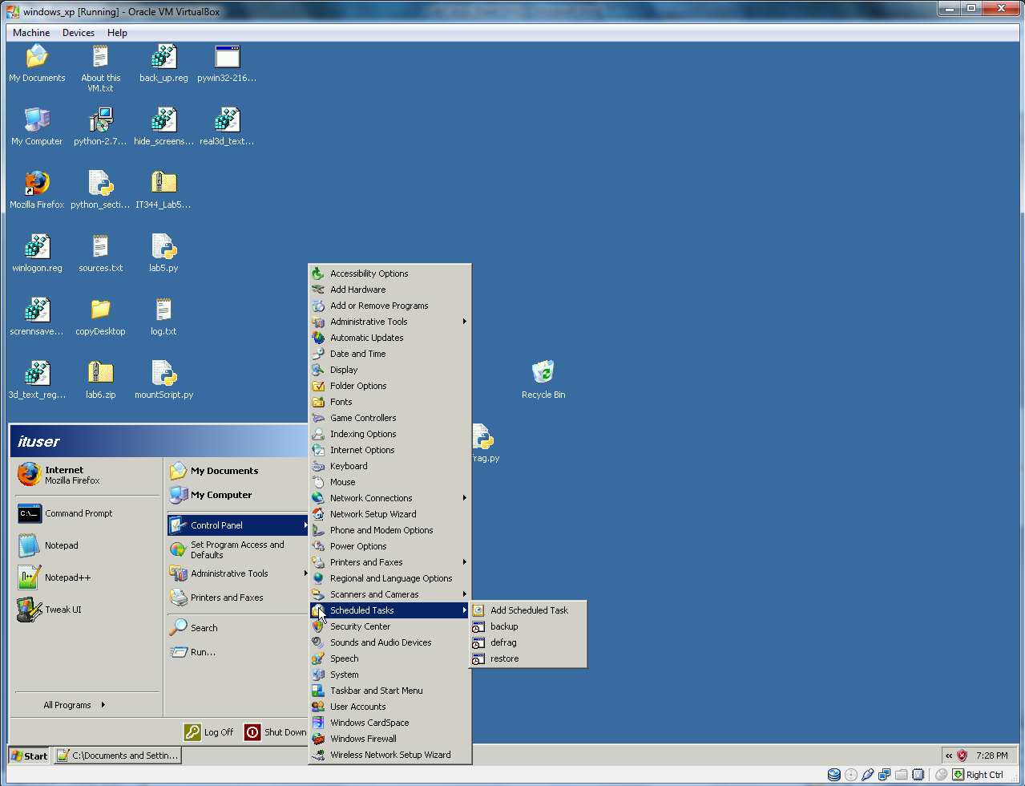

### Registry changes that have to be made

#### To Enable the CTRL+ALT+DEL requirement for logon

[HKEY_LOCAL_MACHINE\SOFTWARE\Microsoft\Windows NT\CurrentVersion\Winlogon]

"DisableCAD"=dword:00000000

"LogonType"=dword:00000000

This script will make it so that anytime user starts up computer, it will force user to press CTRL+ALT+DEL and log into the machine, see figure below:

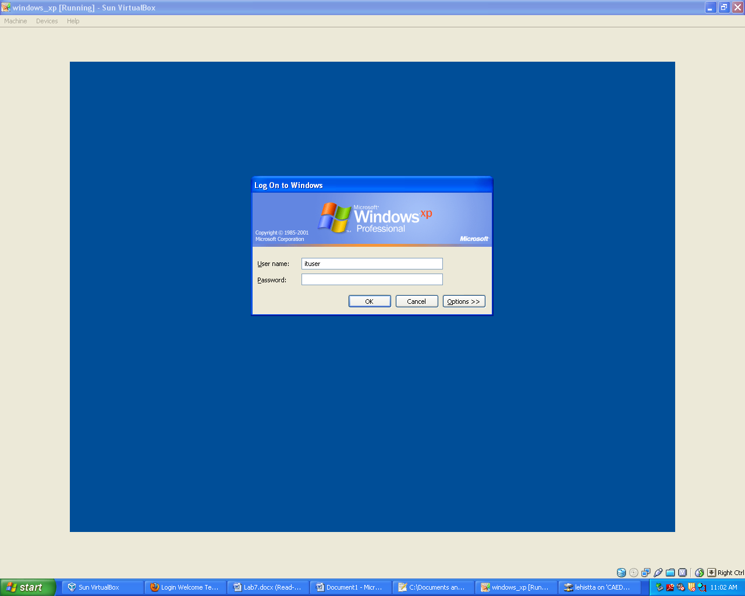

#### Pop-up Message text for users attempting to log on & company title on pop up box.

[HKEY_LOCAL_MACHINE\SOFTWARE\Microsoft\Windows NT\CurrentVersion\Winlogon]

"LegalNoticeCaption"="MyDoggy Pedigree Pet Company"

"LegalNoticeText"="this is my Message text for users attempting to log on"

This script will make it so that anytime users attempt to log into the computer it will pop up a message to the user with name of company as title. See figure below:

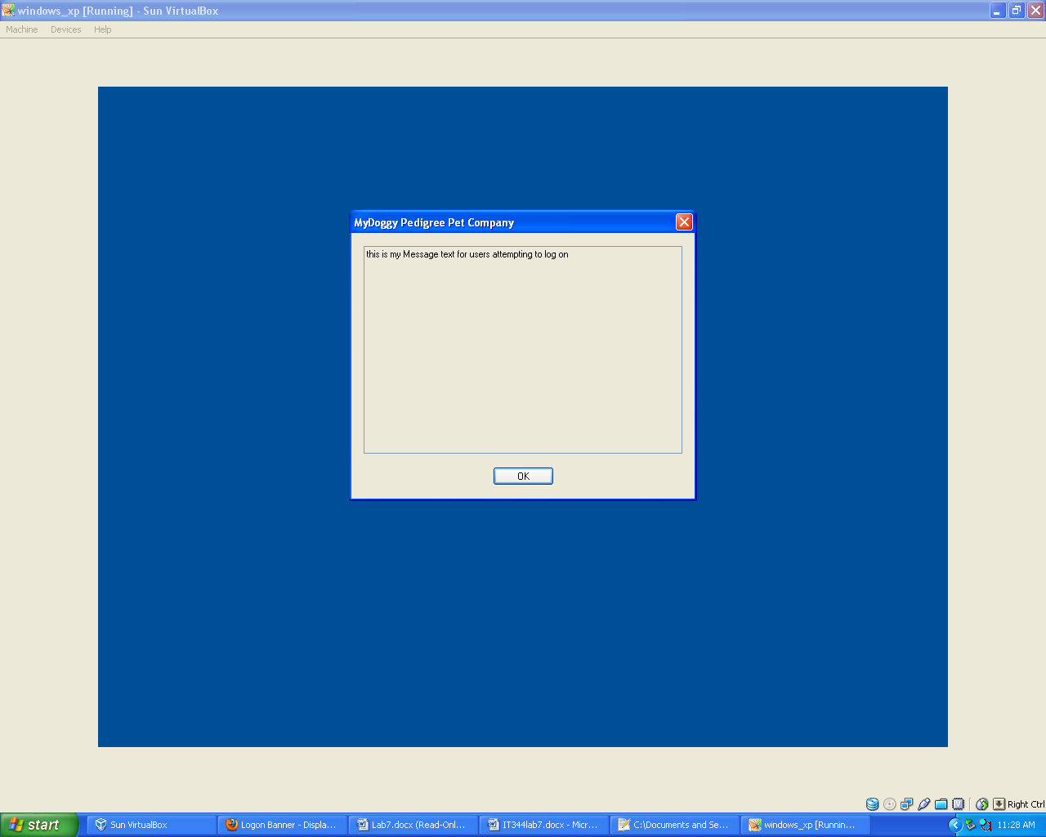

#### Screen Lock:

#### Screen-saver comes on automatically after 1 minute.

[HKEY_CURRENT_USER\Control Panel\Desktop]

"ScreenSaveTimeOut"="60"

See figure below:

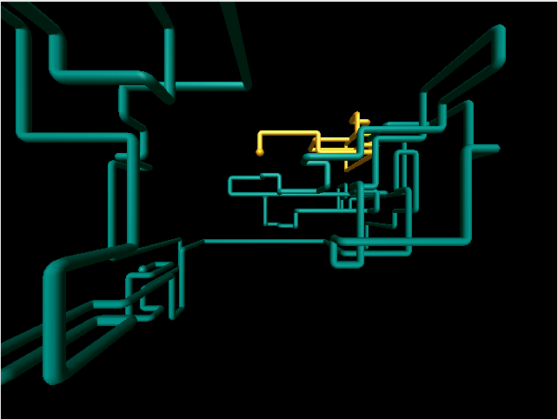

#### Screen-saver Lock

[HKEY_CURRENT_USER\Control Panel\Desktop]

"ScreenSaverIsSecure"="1"

"SCRNSAVE.EXE"="C:\\WINDOWS\\system32\\sstext3d.scr"

See figure below:

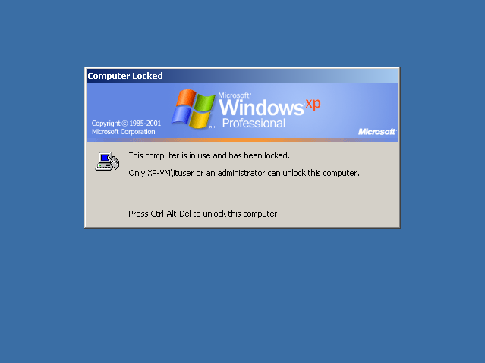

After screen-saver comes up this will force user to log in again for security purposes.

#### Screen-saver to be 3D Text with name of the company.

[HKEY_CURRENT_USER\Software\Microsoft\Screensavers\Text3D]

"DisplayString"="MyDoggy Company"

See figure below:

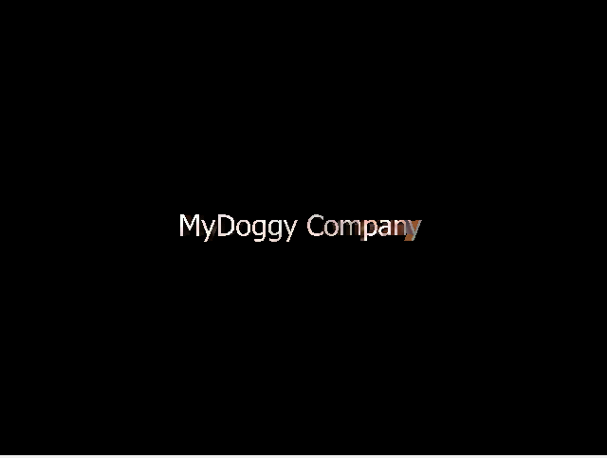

#### Hide Screen-saver tab in Display Properties so that the user cannot change their screen saver.

[HKEY_CURRENT_USER\Software\Microsoft\Windows\CurrentVersion\Policies\System]

"NoDispScrSavPage"=dword:00000001

See figure below:

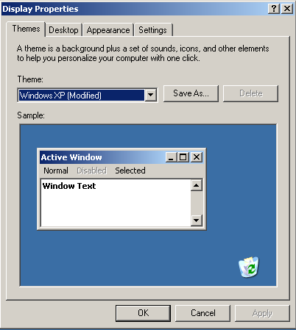

## Instructions for the end user on how to do the following tasks:

1. Manual Defrag:
   1. Click Start button
   2. Click on Control Panel
   3. Click on Schedule Tasks
   4. Click on defrag
2. Manual full data backup:
   1. Click Start button
   2. Click on Control Panel
   3. Click on Schedule Tasks
   4. Click on backup
3. Manual full data restore:
   1. Click Start button
   2. Click on Control Panel
   3. Click on Schedule Tasks
   4. Click on restore
4. Individual file restore:
   1. Click Start button
   2. Click on Control Panel
   3. Click on Schedule Tasks
   4. Click on restore
   5. Then go to C:\Documents and Settings\ituser
   6. Find the desired file.

# Analysis

I have learned many things about customizing windows operating system via registry. I find it amazing how much one can do with the use of registry and I see the importance of no letting users having access to it, so hiding certain tabs or programs from user is a valuable skill to have as a system administrator. Python is a great scripting language that I will definitely be using a lot; it made the tasks to be done so much more enjoyable because python does so much for the programmer. Attaching a network drive, which at first I thought would be a big obstacle, with python, it was not bad. Learning how to use registry and scripting programming is key to be successful as a system administrator. Robocopy tool in windows is great for copying directories and log purposes as to know what was backed up or copied.

# Conclusion

This back-up and restore strategy would be important for a company because it will make employees more efficient, if they messed up their system and have no back-ups to restore from then employer will lose a lot of money since employee is not working on new tasks, but reworking old tasks. Company loses money if they don’t have a back-up system and restore system tool in their computers. Documentation for a big move like this is important so that company knows their system and how to operate them in case they need a back-up or restore and new administrator system was just hired for the job, therefore it is important to have every single change made on system or features of the system in case there is a new hired. With these changes the IT department will have a less load and therefore able to fulfill their other tasks within the company.

# Appendix

*changes.reg*

*defrag.py*

*restore.py*

*backup.py*

*mountScript.py*