Modeling and Analyzing Electronic Imaging Devices
Yuval Levental
IMGS 613

Introduction

This project focuses on computer simulations of the limitations of electronic imaging devices. To perform this task, the Detective Quantum Efficiency (DQE) is calculate for several properties of these devices. The simulations were performed using the MATLAB R2019b programming language.

In an ideal array of photon detectors, each element acts as an individual photon detector and each photon can be read out individually. However, each detector has an upper limit of distinguishable output states, after which the detector saturates and has become ineffective. It is assumed that the number of photons incident on a detector follows Poisson statistics with mean q and actual number of photons k:
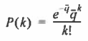

The mean count level is important in studying the imaging process. It is given by the following equation:

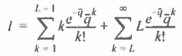

The first term averages detectors that have not reached saturation, and the second term averages detectors that have reached saturation. Based on the properties of the detector, the equation can be rewritten as follows for further analysis:

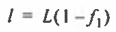

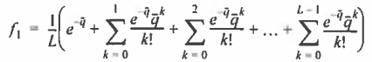

After this, the gain G is evaluated, which is equal to dl/dq. We get the equation G = Lf₂, where f₂ will be used for further analysis.
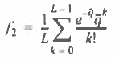

Next, to find the variance of the noise, the second moment is calculated using:

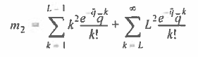
After rearranging the equation, we get the following:
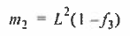

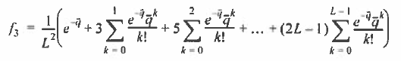

The variance is equal to:
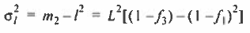
This will be used in computing the Detective Quantum Efficiency.

Detective Quantum Efficiency (DQE) is defined as the ratio of the squared output signal-to-noise ratio (SNR_{o})² to the squared input signal-to-noise ratio (SNR_{i})² of an imaging detector. The ratios are squared since DQE is derived from the ratios of the mean photon noise variances, which are part of SNR_{o} and SNR_{i} (Hailstone, Section 8.4). The main purpose of this project is to model a detector using DQE.

The DQE is derived by taking SNR_{i} as Δq/σ_{q} and SNR_{o} as Δl/σ_{l}:

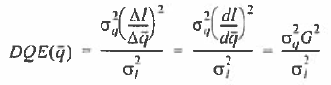
According to Poisson statistics, σ_{q}² = q, meaning that:

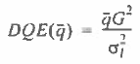

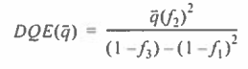

Electronic Noise is also an important part of electronic imaging devices. The two main types of noise are read noise and quantization (A-D) noise. Read noise is the “noise floor” of the system, which serves as a limit for the ability to discriminate between different exposure levels. Quantization noise is the noise which results from analog-to-digital conversion. The total system output noise variance is added in quadrature as σ_{tot}² = σ_{l}² + σ_{read}² + σ_{A-D}². After the additional noise sources are inserted into the denominator, the DQE will no longer start out at 1 at very low photon exposures, but will start out at very low values and level at its maximum value.

The A-D converter maps a random voltage coming out the amplifier to a set of 2^{b} representation values. These values are the values seen in displayed pixel images.

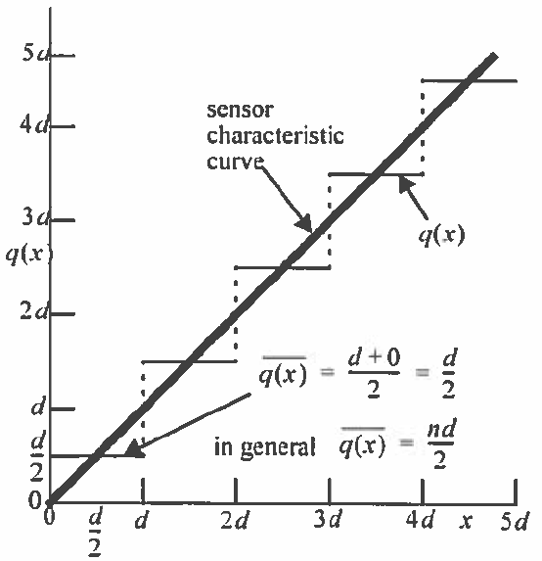

Quantization noise arises because the A-D conversion introduces an error that is between –d/2 and d/2. The error is zero-mean and uniform. Therefore, the variance of the error distribution is:
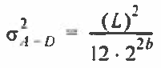
Not all incident photons are recorded by the array of photon detectors, so η is used to define the primary quantum efficiency of the detector. Since a Poisson process with a binomial filter yields a Poisson process, the relation is described as follows:
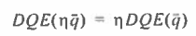

All simulations focus on a detector array. The first simulations involve plotting the DQE at various efficiencies at different levels of read noise and A-D noise. Then, the fraction of saturated pixels, l/L, is measured at different pixel diameters as a function of E, the number of photons per unit area. Then, the noise variance is plotted against the normalized count level for all three pixel sizes, and is also plotted as a function of E. Finally, the DQE is calculated for all pixel sizes.

Simulation Method

For this project, MATLAB Online R2019b was the programming language used for all graphs. All simulations focus on a detector array. Continuous lines for every simulation were plotted.

For the first part of Problem 1, the DQE was calculated at the efficiencies η = 0.125, 0.25, 0.5, and 1.0. DQE vs q was plotted for those efficiencies. The graph must be scaled properly, so the q value plotted should actually be equal to q / η. The POISSCDF function was used to help calculate the value of f₁, f₂, and f₃. To get the graph to scale properly, the mean values were set to qη in all of my equations. Since η is multiplied by DQE(q), there are two values of η in the numerator. As a result, the numerator contains the term qη². The value of L was set to 1024 electrons. For f₂, POISSCDF was simply used for the value of L – 1 and qη. POISSCDF allows the creation of an array for the values A:B, which can be implemented in the equation. For f₁ and f₃, 0:L-1 was the range of values used. All the values of the array were summed up using the sum(A) function, and were inputted into the main DQE equation. Additionally, to fulfill the requirements of the equations, f₁ and f₂ were divided by L. Additionally, f₃ was also divided by L².

Additionally, the array [(1:2:2L-1)] was multiplied using the dot product (.*) with the POISSCDF array for f₃ before summing the values. This is so that the required coefficients for f₃ could be obtained. When the graphs were initially plotted, gray discontinuity lines appeared at values where the denominator was equal to zero. Eventually, those lines were removed by plotting each graph for only a certain range.

Finally, the y-axis was properly scaled, the graph was properly labeled, and markers and a legend were placed at the best location.

In the second part of Problem 1, a read noise of 10 e⁻ and a 4-bit quantizer were added to the output noise. This was done by adding the term [1/(12*2^{(2*4)})] + 100/(L²) to the denominator of the DQE, where the read noise was squared and divided by L² for proportional consistency. The graphs were then plotted again.

For Problem 2, the efficiency of the DQE was set to η = 0.5, using the equations from Problem 1. For the first part of Problem 2, the A-D noise was set to zero, and the read noise was set to values of 1, 3, and 10. This was done by adding the term (read/L)² to the denominator of the DQE for each instance in a loop. For the second part of Problem 2, the read noise was set to zero, and the A-D noise was set to the values of 2, 4, and 8 bits. This was done by adding the term [1/(12*2^{(2*bit)})] to the denominator of the DQE. The loop was ran again with these values.

For Problem 3, the normalized count level l/L is plotted vs E, the number of photons per unit area. The graphs are plotted for square pixels with side lengths 5, 10, and 20 µm. Since the unit area is equal to 400 µm², E = q for the 20 µm pixel. E = q/4 for the 10 µm pixel, and E = q/16 for the 5 µm pixel, as the sizes are smaller. The graph is logarithmically scaled on the x-axis. The saturation value is not corrected for a change in size in this simulation. Compared to problems 1 and 2, only the value l = 1 - f₁ is plotted.

For the first part of Problem 4, the variance is plotted vs the normalized count level for the pixel values of 5, 10, and 20 µm. Both the count level and variance are scaled with respect to the pixel value; however, the variance is a function of l² so the y-values are scaled again by the same factor for each pixel value. For 20 µm, the x- and y-values of the plot are not scaled at all. For 10 µm, the y-values were scaled by 1/4 and for 5 µm, they were scaled by 1/16. The x-range is from 0 to 1, as all normalized values are from 0 to 1.
For the second part of Problem 4, the variance is plotted vs E, the number of photons per unit area. Since only the variance is scaled in this problem, the y-values and x-values both have be scaled. For 20 µm, the x- and y-values of the plot are not scaled at all. For 10 µm, both the x- and y-values were scaled by 1/4 and for 5 µm, they were scaled by 1/16. The graph is then logarithmically scaled on the x-axis.

For the first part of Problem 5, the DQE is plotted vs E for the same pixel values. Only the x-values are scaled as before, since both the signal and noise are both scaled. The x-axis is logarithmically scaled. For the second part of Problem 5, I compared the DQE and normalized count value on opposite y-axes for each pixel size vs E. To do this, I used the yyaxis right command to create an additional right y-axis for the normalized count.

Results

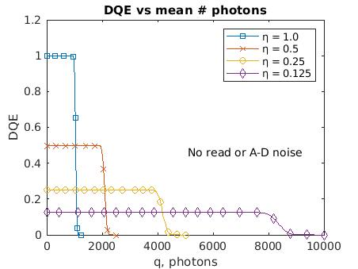 | 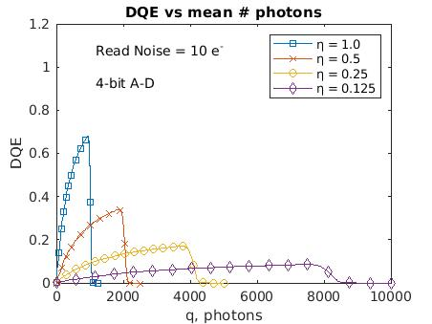

For Problem 1, Part 1, as the quantum efficiency decreased, the maximum DQE proportionally decreased. Since there is no noise, the DQE is at a uniform value until saturation. Additionally, the number of photons required to saturate the detectors also proportionally increased, as more photons are needed for saturation. Before the saturation threshold, the DQE value is a constant, equal to σ_{l}². After the threshold, the DQE drops to zero as saturated detectors cannot detect photons. The DQE drop is fastest for DQE = 1 as the detectors saturate the most quickly due to unitary efficiency.

For Problem 1, Part 2, the noise causes the value of the DQE to start at zero at low photon values. This is because when there are a small amount of photons, the output noise measurement is far greater than the input noise. The effect of the noise is mitigated as more photons are added, until the saturation threshold is reached.

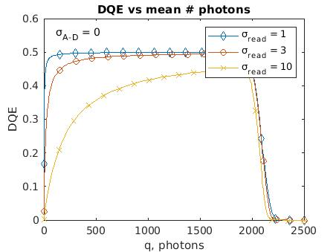 | 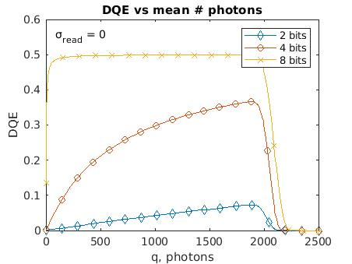

For Problem 2, Part 1, the DQE decreases as the read noise increases. The DQE decreases the most in the lower range of photons, as that when it has the greatest visibility. The read noise has a relatively small impact, as it is only the “noise floor” for the system, below which it is impossible to detect noise from the data.

For Problem 2, Part 2, the DQE increases as the A-D bit noise increases, with a maximum DQE of 1. The impact of the A-D noise is the largest at low photon values. Additionally, as the number of bits increases, the DQE is less affected as there are exponentially more possible output values.

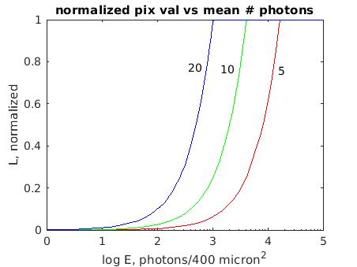

For Problem 3, as the pixel area decreases, more photons are needed to create a larger mean value. This is because for smaller pixels, more photons are needed to attain the same mean value. The graph is logarithmically proportional with respect to area, which is why the spacing is the same.

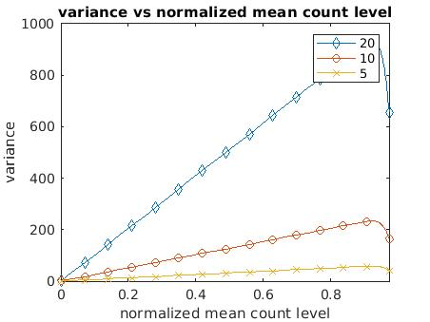 | 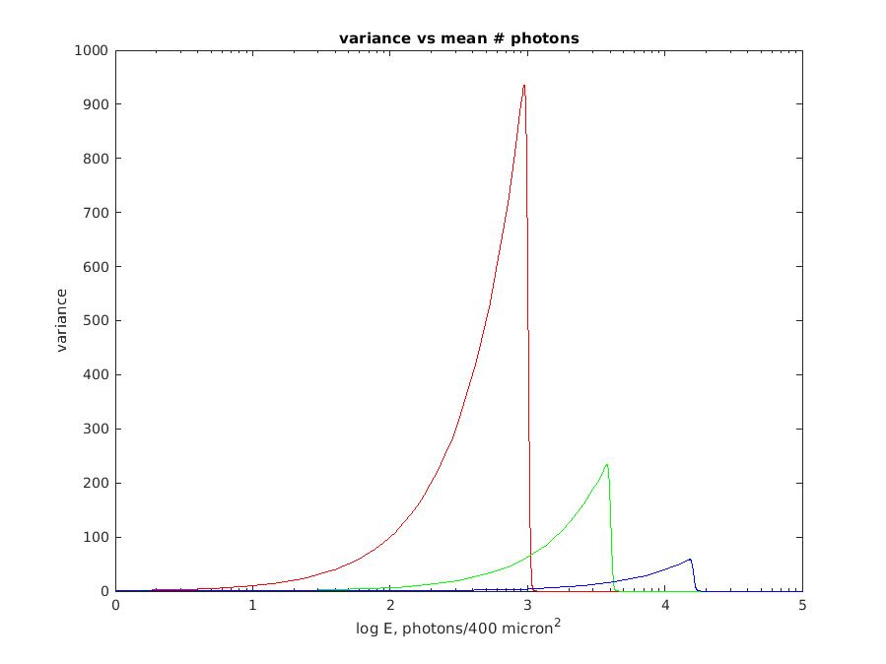

For Problem 4, Part 1, the relationship between noise variance and mean count value changes proportionally based on the area of the pixel. This is because variance is proportional to area. Before saturation, the variance linearly increases as the mean count increases due to the detector obeying Poisson statistics, where σ_{l}² = q. As the detector becomes more saturated, the variance decreases since there is no noise in saturated detectors.

For Problem 4, Part 2, the variance is proportional to the area, both horizontally and vertically. The variance exponentially increases at first, since it is exponentially proportional to E, but as the detectors get saturated, the variance quickly falls back to zero.

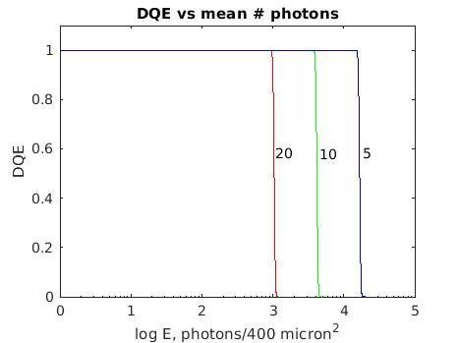 | 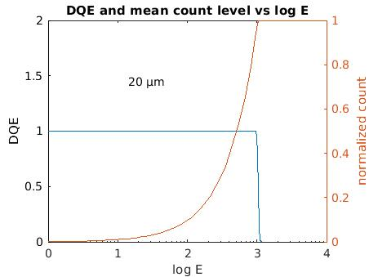

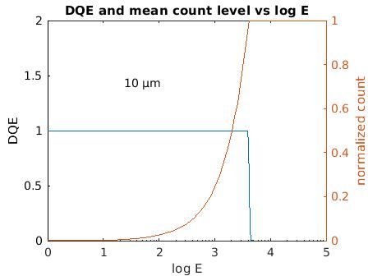 | 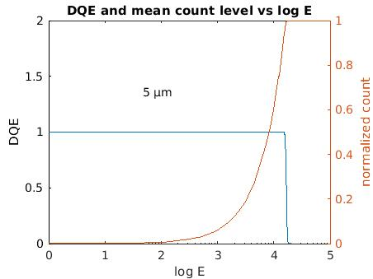

For Problem 5, Part 1, as the pixel size decreases, more photons are needed to saturate the pixels. The quantum efficiency in all cases is unitary.

For Problem 5, Part 2, the 20 µm pixel becomes saturated at E = 1024, since this is the given saturation level. The DQE becomes 0, and the normalized count becomes 1. The 10 µm pixel becomes saturated at E = 4096, and the 5 µm pixel becomes saturated at E = 16384, since more pixels are need to achieve the same amount of saturation.

Discussion

Many aspects of electronic imaging devices were simulated and discussed in the project. To plot the DQE, I needed to find the values of f₁, f₂, and f₃, then combine them into the DQE equation for simplicity. The actual effectiveness of a detector is dependent on its quantum efficiency, the read noise, and the A-D bit noise. The quantum efficiency affects both the maximum DQE and the amount of photons needed to cause saturation. The read noise primarily affects the DQE at low photon values, with greater read noise causing a lower DQE. A-D noise has a far greater effect at low bit values, as there is a far greater margin for error.

The effects of pixel area size and variance were also studied. Pixels with a smaller area take more time to saturate, since they have less room. However, small area pixels also have less noise variance. Due to Poisson statistics, variance linearly increases with respect to the mean count level, then drops towards zero as the maximum mean count level is reached. Compared to the average amount of photons, variance exponentially increases, then decreases to zero as the saturation threshold is reached. Another result from this is that pixels with a smaller area have a DQE that can withstand more photons, proportional to the saturation level.

It was easy for me to produce similar graphs to the provided graphs, as I carefully structured the MATLAB programs component by component. The biggest challenge at the beginning was trying to remove vertical gray lines that showed up at discontinuity points, until I learned how to not plot any values at those points.

However, I sometimes was not sure what the results actually meant until I carefully analyzed the equations to see what the patterns were. This especially applied to Problem 4, Part 1, until I had a better grasp of Poisson statistics. I was not sure why the graphs were proportionally scaled, and why there was a linear slope at first.

Conclusions

In conclusion, many aspects of the behavior of photon detectors were analyzed and discussed. The equation for the DQE was derived and studied with respect to quantum efficiency and noise. Additionally, the effects of different kinds of noise were also studied. Pixel size was shown to also play an important role in how photon detectors behave. The distribution of photons is also important in understanding its properties.

Appendix

Problem 1, Part 1

L = 1024; %The number of electrons
mcount = 1; %The initial plot marker, 'd'
Markers = ['s','x','o','d']; %list of markers
for n = [1, 0.5, 0.25, 0.125] %The values of n/eta

f1 = @(q) sum((1/L)*poisscdf(0:L-1,(q*n)));
%The value of f1 in the equation, using the poisscdf function, the
% scaled value of q, and the sum of the array values from 0:L-1

f2 = @(q) sum((1/L)*poisscdf(L-1,(q*n)));
%The value of f1 in the equation, using the poisscdf function and the
% scaled value of q

f3 = @(q) sum([(1:2:2*L-1)].*[(1/(L^2))*poisscdf(0:L-1,(q*n))]);
%The value of f3 in the equation, using the poisscdf function, the
% scaled value of q, the dot product with the coefficients [(1:2:2*L-1)],
% and the sum of the array values from 0:L-1

DQE = @(q) (q*(n^2))*(f2(q)^2)/((1-f3(q))-(1-f1(q))^2); %The final DQE equation

fplot(DQE,[1,1250/n],strcat('-',Markers(mcount)))
%Plot functions with markers, and at a range so that discontinuity
%lines do not show up

hold on;

mcount = mcount + 1;
end

ylim([0 1.2]) %change y limits on graph

xlabel('q, photons')
ylabel('DQE')
title('DQE vs mean # photons')

legend('η = 1.0','η = 0.5','η = 0.25','η = 0.125')

Problem 1, Part 2

L = 1024; %The number of electrons
mcount = 1; %The initial plot marker, 'd'
Markers = ['s','x','o','d']; %list of markers
for n = [1, 0.5, 0.25, 0.125] %The values of n/eta

f1 = @(q) sum((1/L)*poisscdf(0:L-1,(q*n)));
%The value of f1 in the equation, using the poisscdf function, the
% scaled value of q, and the sum of the array values from 0:L-1

f2 = @(q) sum((1/L)*poisscdf(L-1,(q*n)));
%The value of f1 in the equation, using the poisscdf function and the
% scaled value of q

f3 = @(q) sum([(1:2:2*L-1)].*[(1/(L^2))*poisscdf(0:L-1,(q*n))]);
%The value of f3 in the equation, using the poisscdf function, the
% scaled value of q, the dot product with the coefficients [(1:2:2*L-1)],
% and the sum of the array values from 0:L-1

DQE = @(q) (q*(n^2))*(f2(q)^2)/[((1-f3(q))-(1-f1(q))^2) + (1/(12*2^(2*4))) + 100/(L^2)]; %The final DQE equation

fplot(DQE,[1,1250/n],strcat('-',Markers(mcount)))
%Plot functions with markers, and at a range so that discontinuity
%lines do not show up

hold on;

mcount = mcount + 1;
end

ylim([0 1.2]) %change y limits on graph

xlabel('q, photons')
ylabel('DQE')
title('DQE vs mean # photons')

legend('η = 1.0','η = 0.5','η = 0.25','η = 0.125')

Problem 2, Part 1

L = 1024; %The number of electrons
mcount = 1; %The initial plot marker, 'd'
Markers = ['d','o','x']; %list of markers
for read = [1,3,10] %The values read noise at eta = 0.5

f1 = @(q) sum((1/L)*poisscdf(0:L-1,(q*0.5)));
%The value of f1 in the equation, using the poisscdf function, the
% scaled value of q, and the sum of the array values from 0:L-1

f2 = @(q) sum((1/L)*poisscdf(L-1,(q*0.5)));
%The value of f1 in the equation, using the poisscdf function and the
% scaled value of q

f3 = @(q) sum([(1:2:2*L-1)].*[(1/(L^2))*poisscdf(0:L-1,(q*0.5))]);
%The value of f3 in the equation, using the poisscdf function, the
% scaled value of q, the dot product with the coefficients [(1:2:2*L-1)],
% and the sum of the array values from 0:L-1

DQE = @(q) (q*(0.5^2))*(f2(q)^2)/[((1-f3(q))-(1-f1(q))^2) + (read^2)/(L^2)]; %The final DQE equation

fplot(DQE,[1,1250/0.5],strcat('-',Markers(mcount)))
%Plot functions with markers, and at a range so that discontinuity
%lines do not show up

hold on;

mcount = mcount + 1;
end

ylim([0 0.6]) %change y limits on graph

xlabel('q, photons')
ylabel('DQE')
title('DQE vs mean # photons')

legend('σ_r_e_a_d = 1','σ_r_e_a_d = 3','σ_r_e_a_d = 10')

Problem 2, Part 2

L = 1024; %The number of electrons
mcount = 1; %The initial plot marker, 'd'
Markers = ['d','o','x']; %list of markers
for bits = [2,4,8] %The values A-D converter bits at eta = 0.5

f1 = @(q) sum((1/L)*poisscdf(0:L-1,(q*0.5)));
%The value of f1 in the equation, using the poisscdf function, the
% scaled value of q, and the sum of the array values from 0:L-1

f2 = @(q) sum((1/L)*poisscdf(L-1,(q*0.5)));
%The value of f1 in the equation, using the poisscdf function and the
% scaled value of q

f3 = @(q) sum([(1:2:2*L-1)].*[(1/(L^2))*poisscdf(0:L-1,(q*0.5))]);
%The value of f3 in the equation, using the poisscdf function, the
% scaled value of q, the dot product with the coefficients [(1:2:2*L-1)],
% and the sum of the array values from 0:L-1

DQE = @(q) (q*(0.5^2))*(f2(q)^2)/[((1-f3(q))-(1-f1(q))^2) + (1/(12*2^(2*bits)))]; %The final DQE equation

fplot(DQE,[1,1250/0.5],strcat('-',Markers(mcount)))
%Plot functions with markers, and at a range so that discontinuity
%lines do not show up

hold on;

mcount = mcount + 1;
end

ylim([0 0.6]) %change y limits on graph

xlabel('q, photons')
ylabel('DQE')
title('DQE vs mean # photons')

legend('2 bits','4 bits','8 bits')

Problem 3

L = 1024; %The number of electrons
l = @(q) 1 - sum((1/L)*poisscdf(0:L-1,q/16)); %for 5 micron
fplot(l,[1,100000],'Color','r')
set(gca, 'XScale','log')
hold on;

L = 1024;
l = @(q) 1 - sum((1/L)*poisscdf(0:L-1,q/4)); %for 10 micron
fplot(l,[1,100000],'Color','g')

L = 1024;
l = @(q) 1 - sum((1/L)*poisscdf(0:L-1,q)); %for 20 micron
fplot(l,[1,100000],'Color','b')

xlabel('log E, photons/400 micron^2')
ylabel('L, normalized')
title('normalized pix val vs mean # photons')

Problem 4, Part 1

L = 1024; %The number of electrons

f1 = @(q) sum((1/L)*poisscdf(0:L-1,q));

f3 = @(q) sum([(1:2:2*L-1)].*[(1/(L^2))*poisscdf(0:L-1,q)]);

var = @(q) (L^2)*[(1-f3(q))-(1-f1(q))^2]; %equation for the variance

l = @(q) 1 - sum((1/L)*poisscdf(0:L-1,q)); %normalized mean count level

fplot(l,var,[1,1000],strcat('-','d'))

hold on;

var = @(q) [(L^2)*[(1-f3(q))-(1-f1(q))^2]]/4;
fplot(l,var,[1,1000],strcat('-','o'))

var = @(q) [(L^2)*[(1-f3(q))-(1-f1(q))^2]]/16;
fplot(l,var,[1,1000],strcat('-','x'))

ylim([0 1000])

xlabel('normalized mean count level')
ylabel('variance')
title('variance vs normalized mean count level')

legend('20','10','5')

Problem 4, Part 2

L = 1024; %The number of electrons
f1 = @(q) sum((1/L)*poisscdf(0:L-1,q));
f3 = @(q) sum([(1:2:2*L-1)].*[(1/(L^2))*poisscdf(0:L-1,q)]);
var = @(q) (L^2)*[(1-f3(q))-(1-f1(q))^2]; %variance equation for 20 microns
fplot(var,[1,100000],'Color','r')
set(gca, 'XScale','log')
hold on;

L = 1024;
var = @(q) [(L^2)*[(1-f3(q/4))-(1-f1(q/4))^2]]/4; %variance equation for 10 microns
fplot(var,[1,100000],'Color','g')

L = 1024;
var = @(q) [(L^2)*[(1-f3(q/16))-(1-f1(q/16))^2]]/16; %variance equation for 5 microns
fplot(var,[1,100000],'Color','b')

xlabel('log E, photons/400 micron^2')
ylabel('variance')
title('variance vs mean # photons')

ylim([0 1000])
Problem 5, Part 1

L = 1024; %The number of electrons
f1 = @(q) sum((1/L)*poisscdf(0:L-1,q));
f2 = @(q) sum((1/L)*poisscdf(L-1,q));
f3 = @(q) sum([(1:2:2*L-1)].*[(1/(L^2))*poisscdf(0:L-1,q)]);
DQE = @(q) q*(f2(q)^2)/((1-f3(q))-(1-f1(q))^2); %DQE equation for 20 microns
fplot(DQE,[1,1200],'Color','r')
set(gca, 'XScale','log')
hold on;

L = 1024;
DQE = @(q) (q/4)*(f2(q/4)^2)/((1-f3(q/4))-(1-f1(q/4))^2); %DQE equation for 10 microns
fplot(DQE,[1,5000],'Color','g')

L = 1024;
DQE = @(q) (q/16)*(f2(q/16)^2)/((1-f3(q/16))-(1-f1(q/16))^2); %DQE equation for 5 microns
fplot(DQE,[1,20000],'Color','b')

ylim([0 1.1])
xlim([0 100000])

xlabel('log E, photons/400 micron^2')
ylabel('DQE')
title('DQE vs mean # photons')

Problem 5, Part 2

L = 1024; %The number of electrons
f1 = @(q) sum((1/L)*poisscdf(0:L-1,q));
f2 = @(q) sum((1/L)*poisscdf(L-1,q));
f3 = @(q) sum([(1:2:2*L-1)].*[(1/(L^2))*poisscdf(0:L-1,q)]);
DQE = @(q) q*(f2(q)^2)/((1-f3(q))-(1-f1(q))^2); %DQE equation for 20 microns
fplot(DQE,[1,1200])
set(gca, 'XScale','log')
hold on;

ylim([0 2]);
ylabel('DQE')
yyaxis right

L = 1024;
l = @(q) 1 - sum((1/L)*poisscdf(0:L-1,q)); %for 20 micron
fplot(l,[1,10000])

xlabel('log E')
ylabel('normalized count')
title('DQE and mean count level vs log E')

L = 1024; %The number of electrons
f1 = @(q) sum((1/L)*poisscdf(0:L-1,q));
f2 = @(q) sum((1/L)*poisscdf(L-1,q));
f3 = @(q) sum([(1:2:2*L-1)].*[(1/(L^2))*poisscdf(0:L-1,q)]);
DQE = @(q) (q/4)*(f2(q/4)^2)/((1-f3(q/4))-(1-f1(q/4))^2); %DQE equation for 10 microns
fplot(DQE,[1,5000])
set(gca, 'XScale','log')
hold on;

ylim([0 2]);
ylabel('DQE')
yyaxis right

L = 1024;
l = @(q) 1 - sum((1/L)*poisscdf(0:L-1,q/4)); %for 10 micron
fplot(l,[1,100000])

xlabel('log E')
ylabel('normalized count')
title('DQE and mean count level vs log E')

L = 1024; %The number of electrons
f1 = @(q) sum((1/L)*poisscdf(0:L-1,q));
f2 = @(q) sum((1/L)*poisscdf(L-1,q));
f3 = @(q) sum([(1:2:2*L-1)].*[(1/(L^2))*poisscdf(0:L-1,q)]);
DQE = @(q) (q/16)*(f2(q/16)^2)/((1-f3(q/16))-(1-f1(q/16))^2); %DQE equation for 5 microns
fplot(DQE,[1,20000])
set(gca, 'XScale','log')
hold on;

ylim([0 2]);
ylabel('DQE')
yyaxis right

L = 1024;
l = @(q) 1 - sum((1/L)*poisscdf(0:L-1,q/16)); %for 5 micron
fplot(l,[1,100000])

xlabel('log E')
ylabel('normalized count')
title('DQE and mean count level vs log E')

