Tugas Kecil III IF2211 Strategi Algoritma

Semester II Tahun 2020/2021

**Implementasi Algoritma A* untuk Menentukan Lintasan Terpendek**



Disusun oleh:

1. Karlsen Adiyasa Bachtiar (13519001)
2. Yudi Alfayat (13519051)

PROGRAM STUDI TEKNIK INFORMATIKA

SEKOLAH TEKNIK ELEKTRO DAN INFORMATIKA

INSTITUT TEKNOLOGI BANDUNG

2021

kode program

app.py

from tkinter import filedialog

from tkinter import ttk

from tkinter import *

from Graph import *

from File import *

from Astar import findPath

SCREEN_WIDTH = 720

SCREEN_HEIGHT = 720

SCREEN_SIZE = f"{SCREEN_WIDTH}x{SCREEN_HEIGHT}"

graph = Graph(0, [], [], [])

# Graph visualization

def showGraphVisualization(graph, path):

    if (graph.getNumOfNode() == 0):

        print("Graph is empty!!")

        return

    edges = []

    if (len(path) > 1):

        for i in range(0, len(path)-1):

            edge = []

            edge.append(path[i])

            edge.append(path[i+1])

            edges.append(edge)

    for i in range(graph.getNumOfNode()):

        friend = graph.getListConnectedNode(i)

        for j in range(len(friend)):

            idx = friend[j]

            if (idx > i):

                node1 = graph.getNode(i)

                node2 = graph.getNode(idx)

                distance = graph.getDistance(i, idx)

                xPos1 = getPosXRelative(graph, node1.x)

                yPos1 = getPosYRelative(graph, node1.y)

                xPos2 = getPosXRelative(graph, node2.x)

                yPos2 = getPosYRelative(graph, node2.y)

                color = "red"

                if (len(edges) > 0):

                    e1 = [i, idx]

                    e2 = [idx, i]

                    if (e1 in edges or e2 in edges):

                        color = "black"

                drawLine(distance, xPos1, yPos1, xPos2, yPos2, color)

    for i in range(graph.getNumOfNode()):

        node = graph.getNode(i)

        xPos = getPosXRelative(graph, node.x)

        yPos = getPosYRelative(graph, node.y)

        color = "cyan"

        if (len(path) > 0):

            if (i in path):

                color = "orange"

        createNode(node.name, xPos, yPos, color)

def getPosXRelative(graph, x):

    pad = 100

    xPanelCenter = (graphVisualPanel.winfo_reqwidth()-4-pad)/2

    xCenterPos = (graph.getMaxX() + graph.getMinX())/2

    xMaxDisCenter = graph.getMaxDistanceX()/2

    dis = x - xCenterPos

    if (xMaxDisCenter == 0):

        return xPanelCenter + pad/2

    else:

        return dis/xMaxDisCenter * xPanelCenter + xPanelCenter + pad/2

def getPosYRelative(graph, y):

    pad = 100

    yPanelCenter = (graphVisualPanel.winfo_reqheight()-4-pad)/2

    yCenterPos = (graph.getMaxY() + graph.getMinY())/2

    yMaxDisCenter = graph.getMaxDistanceY()/2

    dis = y - yCenterPos

    if (yMaxDisCenter == 0):

        return yPanelCenter + pad/2

    else:

        return dis/yMaxDisCenter * yPanelCenter + yPanelCenter + pad/2

def createNode(name, xPos, yPos, color):

    radius = 20

    graphVisualPanel.create_oval(xPos-radius, yPos-radius, xPos+radius, yPos+radius, fill=color)

    graphVisualPanel.create_text(xPos, yPos, fill="darkblue", text=name)

def drawLine(dis, xPos1, yPos1, xPos2, yPos2, color):

    graphVisualPanel.create_line(xPos1, yPos1, xPos2, yPos2, fill=color, width=2)

    xTextPos = (xPos2 + xPos1)/2

    yTextPos = (yPos2 + yPos1)/2

    graphVisualPanel.create_text(xTextPos, yTextPos, text=round(dis, 2), fill="black")

def showMinimumPath(graph, path):

    print("Show minimum path")

    if (len(path) > 0):

        resetGraphVisualizationPanel()

        s = getStringPath(path)

        pathLabel['text'] = s

        showGraphVisualization(graph, path)

def showDistanceHeuristic(graph, heu):

    heuLabel.delete("1.0", "end")

    row = 1

    val = ""

    for i in range(len(heu)):

        temp = ""

        name = graph.getNode(i).name

        temp += name

        temp += " : " + str(round(heu[i], 2)) + "; "

        if (len(val + temp) >= 74*row):

            row += 1

            val += '\n' + temp

        else:

            val += temp

    heuLabel.insert(END, val)

# End of Graph Visualization

def searchPath():

    print("A Star")

    global graph

    if (graph.getNumOfNode() > 0):

        if (nodeFromDropdown.current() < 0 or nodeToDropdown.current() < 0):

            print("Node is not selected!!")

        else:

            pathAndHeu = findPath(graph, nodeFromDropdown.current(), nodeToDropdown.current())

            path = pathAndHeu[0]

            showDistanceHeuristic(graph, pathAndHeu[1])

            if (len(path) <= 0):

                print("Path is not found!!")

            else:

                showMinimumPath(graph, path)

    else:

        print("Graph is not ready!!")

def browse():

    print("browse!!")

    filePath = filedialog.askopenfilename(initialdir="/", title="Select Graph File", filetypes=(('text files', 'txt'),))

    # print(filePath)

    if (len(filePath) > 0):

        filePathText.delete(0, END)

        filePathText.insert(0, filePath)

        resetGraphVisualizationPanel()

        resetDropdown()

        heuLabel.delete("1.0", "end")

        pathLabel['text'] = " "

        global graph

        graph = convertTextToGraph(filePath)

        if (graph.getNumOfNode() > 0):

            showGraphVisualization(graph, [])

            setDrowdownMenu(graph.getListNode())

def getStringPath(path):

    s = ""

    for i in range(len(path)):

        name = graph.getNode(path[i]).name

        s += name

        if (i != len(path)-1):

            s += " -> "

    return s

def resetGraphVisualizationPanel():

    graphVisualPanel.delete("all")

def resetDropdown():

    print("Reset Dropdown")

    nodeFromDropdown.set('')

    nodeToDropdown.set('')

    nodeFromDropdown["values"] = []

    nodeToDropdown["values"] = []

    nodeFromDropdown.select_clear()

    nodeToDropdown.select_clear()

def setDrowdownMenu(nodes):

    val = []

    for i in range(len(nodes)):

        val.append(nodes[i].name)

    nodeFromDropdown["values"] = val

    nodeToDropdown["values"] = val

app = Tk()

app.title("A Start Path Planning")

# =========================================================

frame1 = Frame(app)

frame1.grid(row=0, padx=10, pady=10)

browseButton = Button(frame1, text="Browse", command=browse)

browseButton.grid(row=0, column=0)

filePathText = Entry(frame1, width=100)

filePathText.grid(row=0, column=1, columnspan=3, padx=10)

# =========================================================

frame2 = Frame(app)

frame2.grid(row=1, padx=10, pady=10)

labelTextFrom = Label(frame2, text="From : ")

labelTextFrom.grid(row=0, column=0)

nodeFromDropdown = ttk.Combobox(frame2, values=(), state="readonly")

nodeFromDropdown.grid(row=0, column=1)

fillLabel = Label(frame2, text=" ")

fillLabel.grid(row=0, column=2, padx=20)

labelTextTo = Label(frame2, text="To : ")

labelTextTo.grid(row=0, column=3)

nodeToDropdown = ttk.Combobox(frame2, values=(), state="readonly")

nodeToDropdown.grid(row=0, column=4)

searchButton = Button(frame2, text="Search", width=10, height=2, command=searchPath)

searchButton.grid(row=0, column=7, padx=40)

# =========================================================

frame3 = Frame(app)

frame3.grid(row=2, padx=10, pady=10)

pathTextLabel = Label(frame3, text="Path : ")

pathTextLabel.grid(row=0, column=0)

pathLabel = Label(frame3, text=" ")

pathLabel.grid(row=0, column=1)

# =========================================================

frame4 = Frame(app)

frame4.grid(row=3, padx=10, pady=10)

heuTextLabel = Label(frame4, text="Heuristic : ")

heuTextLabel.grid(row=0, column=0)

heuLabel = Text(frame4, height=3, width=74)

heuLabel.grid(row=1, column=0)

# =========================================================

frame5 = Frame(app, width=610, height=610)

frame5.grid(row=4, padx=10, pady=10)

graphVisualPanel = Canvas(frame5, width=600, height=600, bg="light grey")

graphVisualPanel.grid(row=0, pady=5, padx=5)

app.mainloop()

file.py

from Graph import *

def convertTextToGraph(filePath):

    try:

        if (len(filePath) < 4):

            dummy = Graph()

            return dummy

        dirNode = filePath

        dirAdj = filePath[:len(filePath)-4] + "_adj.txt"

        fileNode = open(dirNode, "r")

        fileAdj = open(dirAdj, "r")

        numOfNode = int(fileNode.readline().split(",")[0])

        graph = Graph(0, [], [], [])

        for line in fileNode:

            data = line.split(",")

            if (len(data) < 3+1):

                dummy = Graph()

                return dummy

            x = float(data[0])

            y = float(data[1])

            name = data[2]

            node = Node(name, x, y)

            graph.addNode(node)

        for i in range(numOfNode):

            line = fileAdj.readline()

            data = line.split(",")

            if (len(data) < numOfNode+1):

                dummy = Graph()

                return dummy

            for j in range(numOfNode):

                if (data[j] == '1'):

                    graph.addConnectedNode(i, j)

        return graph

    except IOError:

        print("Graph cannot be converted!!!")

        dummy = Graph()

        return dummy

Graph.py

class Node:

    def __init__(self, name, x, y):

        self.name = name

        self.x = x

        self.y = y

    def printNode(self):

        print(self.name + " : " + str(self.x) + ", " + str(self.y))

class Graph:

    # def __init__(self):

        # self.numOfNode = 0

        # self.nodes = []                 # array of node

        # self.numOfConnectedNode = []    # array of integer

        # self.connectedNode = []         # array of array of integer

    def __init__(self, numOfNodeTemp = 0, nodesTemp = [], numOfConnectedNodeTemp = [], connectedNodeTemp = []):

        self.numOfNode = numOfNodeTemp

        self.nodes = nodesTemp

        self.numOfConnectedNode = numOfConnectedNodeTemp

        self.connectedNode = connectedNodeTemp

    def getListNode(self):

        return self.nodes

    def getNode(self, idxNode):

        return self.nodes[idxNode]

    def getListConnectedNode(self, idxNode):

        return self.connectedNode[idxNode]

    def getListListConnected(self):

        return self.connectedNode

    def getListNumOfConnectedNode(self):

        return self.numOfConnectedNode

    def getNumOfConnectedNode(self, idxNode):

        return self.numOfConnectedNode[idxNode]

    def getNumOfNode(self):

        return self.numOfNode

    def getIdxConnectedNode(self, idxNode, idx):

        return self.connectedNode[idxNode][idx]

    def getConnectedNode(self, idxNode, idxConnect):

        return self.nodes[self.getIdxConnectedNode(idxNode, idxConnect)]

    def getIdxNode(self, node):

        count = 0

        for x in self.nodes:

            if x.name == node:

                return count

            else:

                count = count + 1

    def addNode(self, newNode):

        self.numOfNode += 1

        self.nodes.append(newNode)

        self.numOfConnectedNode.append(0)

        self.connectedNode.append([])

    def addConnectedNode(self, idxNode, idxConnect):

        self.numOfConnectedNode[idxNode] += 1

        self.connectedNode[idxNode].append(idxConnect)

    def addEdge(self, idx1, idx2):

        self.addConnectedNode(idx1, idx2)

        self.addConnectedNode(idx2, idx1)

    def isExistEdge(self, idx1, idx2):

        for x in self.connectedNode[idx1]:

            if x == idx2:

                return True

        return False

    def getDistance(self, idx1, idx2):

        x1 = self.nodes[idx1].x

        y1 = self.nodes[idx1].y

        x2 = self.nodes[idx2].x

        y2 = self.nodes[idx2].y

        # Sementara pakau eucludian

        return ((x2-x1)**2 + (y2-y1)**2)**(1/2)

    def getMinX(self):

        if (self.numOfNode <= 0):

            return -999

        else:

            minX = self.nodes[0].x

            for i in range(1, self.numOfNode):

                if (minX > self.nodes[i].x):

                    minX = self.nodes[i].x

            return minX

    def getMaxX(self):

        if (self.numOfNode <= 0):

            return -999

        else:

            maxX = self.nodes[0].x

            for i in range(1, self.numOfNode):

                if (maxX < self.nodes[i].x):

                    maxX = self.nodes[i].x

            return maxX

    def getMinY(self):

        if (self.numOfNode <= 0):

            return -999

        else:

            minY = self.nodes[0].y

            for i in range(1, self.numOfNode):

                if (minY > self.nodes[i].y):

                    minY = self.nodes[i].y

            return minY

    def getMaxY(self):

        if (self.numOfNode <= 0):

            return -999

        else:

            maxY = self.nodes[0].y

            for i in range(1, self.numOfNode):

                if (maxY < self.nodes[i].y):

                    maxY = self.nodes[i].y

            return maxY

    def getMaxDistanceX(self):

        return self.getMaxX() - self.getMinX()

    def getMaxDistanceY(self):

        return self.getMaxY() - self.getMinY()

    def printGraph(self):

        for i in range(self.numOfNode):

            name = self.nodes[i].name

            x = self.nodes[i].x

            y = self.nodes[i].y

            numOfconnect = self.numOfConnectedNode[i]

            # print(numOfconnect)

            data = name + "[" + str(x) + "," + str(y) + "]" + str(numOfconnect)

            print(data, end=", ")

        print()

        for i in range(self.numOfNode):

            print(self.connectedNode[i])

Astar.py

from Graph import *

def getHeuristic(graph, destination):

    heu = []

    for i in range(graph.getNumOfNode()):

        dis = graph.getDistance(i, destination)

        heu.append(dis)

    return heu

def getMinDistance(dis):

    if (len(dis) <= 0):

        return -1

    else:

        idxMin = 0

        for i in range(1, len(dis)):

            tup = dis[i]

            tupMin = dis[idxMin]

            if (tup[1] < tupMin[1]):

                idxMin = i

        return idxMin

def astar(graph, idxDestinastion, heu, distance, stack, blacklist):

    if (stack[-1] == idxDestinastion):

        return stack

    idxFrom = stack[-1]

    friend = graph.getListConnectedNode(idxFrom)

    count = 0

    for i in range(len(friend)):

        idxFriend = friend[i]

        if (idxFriend not in stack):

            gn = graph.getDistance(idxFrom, idxFriend)

            hn = heu[idxFriend]

            fn = gn + hn

            tempStack = [e for e in stack]

            tempStack.append(idxFriend)

            tempDistance = [tempStack, fn]

            if (tempDistance not in distance and tempStack not in blacklist):

                distance.append(tempDistance)

                count += 1

    if (count == 0 and len(distance) != 0):

        idxMinDistance = getMinDistance(distance)

        blacklist.append(distance[idxMinDistance][0])

        distance.pop(idxMinDistance)

    if (len(distance) == 0):

        return []

    idxMinDistance = getMinDistance(distance)

    tup = distance[idxMinDistance]

    stack = tup[0]

    if (stack[-1] == idxDestinastion):

        return stack

    return astar(graph, idxDestinastion, heu, distance, stack, blacklist)

def findPath(graph, idxFrom, idxTo):

    if (graph.getNumOfNode() > 0):

        heu = getHeuristic(graph, idxTo)

        path = astar(graph, idxTo, heu, [], [idxFrom], [])

        if (len(path) <= 0):

            return [[], heu]

        else:

            return [path, heu]

    else:

        return [[], []]

bonus

map.py

import folium

from folium import plugins

from Astar import *

from Graph import *

from file import *

def printPath(path):

    for x in path:

        print(x+1)

def inputRouteAstar(path, route_Astar):

    for idxNode in path:

        node = g1.nodes[idxNode]

        route_Astar.append([node.x, node.y])

def createMarkers(graph):

    # Create Markers

    i = 1

    heu = getHeuristic(graph, idxTo)

    for coor in graph.nodes:

        num = str(i)

        koordinat = str(coor.x) + " " + str(coor.y)

        folium.Marker([coor.x, coor.y],

                    popup=heu[i-1],

                    tooltip="Click for more info",

                    icon=plugins.BeautifyIcon(number=i,

                                                border_color='blue',

                                                border_width=2,

                                                text_color='red',

                                                inner_icon_style='margin-top:0px;')).add_to(map1)

        i = i + 1

# Create map object

map1 = folium.Map(location=[-6.8915, 107.6107], zoom_start=20)

print("Masukkan satu angka diantara 1 sampai 10")

idxFrom = int(input("Masukkan simpul mulai (dalam integer) : "))

idxTo = int(input("Masukkan simpul tujuan (dalam integer) : "))

while idxFrom < 1 or idxFrom > 10 or idxTo < 1 or idxTo > 10:

    print("\nMasukkan tidak valid. Coba lagi\n")

    print("Masukkan satu angka diantara 1 sampai 10")

    idxFrom = int(input("Masukkan simpul mulai (dalam integer) : "))

    idxTo = int(input("Masukkan simpul tujuan (dalam integer) : "))

g1 = convertTextToGraph("../test/04.txt")

createMarkers(g1)

route_Graph = [

    [-6.892650, 107.610433],  # 1

    [-6.892650, 107.608763],  # 2

    [-6.891056, 107.608712],  # 3

    [-6.891057, 107.609713],  # 4

    [-6.891037, 107.611024],  # 6

    [-6.891057, 107.609713],  # 4

    [-6.891934, 107.610388],  # 5

    [-6.891362, 107.611052],  # 8

    [-6.891037, 107.611024],  # 6

    [-6.890978, 107.612087],  # 7

    [-6.891355, 107.612193],  # 9

    [-6.891362, 107.611052],  # 8

    [-6.891355, 107.612193],  # 9

    [-6.892427, 107.612027],  # 10

    [-6.892650, 107.610433],  # 1

    [-6.891934, 107.610388]   # 5

]

pathAndHeu = findPath(g1, idxFrom-1, idxTo-1)

path = pathAndHeu[0]

printPath(path)

route_Astar = []

inputRouteAstar(path, route_Astar)

# add route to map

folium.PolyLine(route_Graph).add_to(map1)

# add ant path route to map

plugins.AntPath(route_Astar).add_to(map1)

# Generate map

map1.save('map.html')

peta/graf input

01.txt

8,

5,5,A,

20,7,B,

15,20,C,

5,18,D,

25,15,E,

25,25,F,

7,23,G,

30,21,H,

01_adj.txt

0,1,1,1,0,0,0,0,

1,0,1,0,1,1,0,0,

1,1,0,0,0,1,1,0,

1,0,0,0,0,1,1,0,

0,1,0,0,0,1,0,1,

0,1,1,1,1,0,0,1,

0,0,1,1,0,0,0,0,

0,0,0,0,1,1,0,0,

02.txt

8,

5,5,A,

20,7,B,

15,20,C,

5,18,D,

25,15,E,

25,25,F,

7,23,G,

30,21,H,

02_adj.txt

0,1,1,1,0,0,0,0,

1,0,1,0,1,1,0,0,

1,1,0,0,0,1,1,0,

1,0,0,0,0,1,1,0,

0,1,0,0,0,0,0,0,

0,1,1,1,0,0,0,1,

0,0,1,1,0,0,0,0,

0,0,0,0,0,1,0,0,

03.txt

8,

5,5,A,

20,7,B,

15,20,C,

5,18,D,

25,15,E,

25,25,F,

7,23,G,

30,21,H,

03_adj.txt

0,1,1,1,0,0,0,0,

1,0,1,0,1,1,0,0,

1,1,0,0,0,1,1,0,

1,0,0,0,0,1,1,0,

0,1,0,0,0,0,0,0,

0,1,1,1,0,0,0,0,

0,0,1,1,0,0,0,0,

0,0,0,0,0,0,0,0,

04.txt merupakan peta ITB jalan ganesha

04.txt

10,

-6.892650, 107.610433,A,

-6.892650, 107.608763,B,

-6.891056, 107.608712,C,

-6.891057, 107.609713,D,

-6.891934, 107.610388,E,

-6.891037, 107.611024,F,

-6.890978, 107.612087,G,

-6.891362, 107.611052,H,

-6.891355, 107.612193,I,

-6.892427, 107.612027,J,

04_adj.txt

0,1,0,0,1,0,0,0,0,0,

1,0,1,0,0,0,0,0,0,0,

0,1,0,1,0,0,0,0,0,0,

0,0,1,0,1,0,0,0,0,0,

1,0,0,1,0,0,0,1,0,0,

0,0,0,0,0,0,0,1,0,0,

0,0,0,0,0,0,0,1,0,0,

0,0,0,0,1,1,1,0,1,0,

0,0,0,0,0,0,0,1,0,1,

0,0,0,0,0,0,0,0,1,0,

Screenshot

Wajib

Bonus

Setiap node jika diklik akan menampilkan nilai heuristik terhadap node tujuan

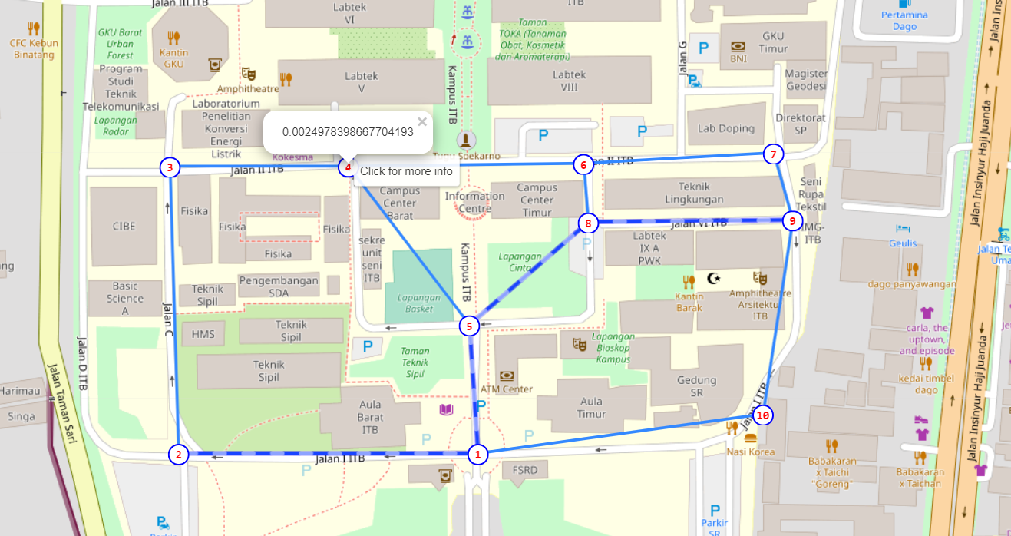

Node awal =2

Node tujuan = 9

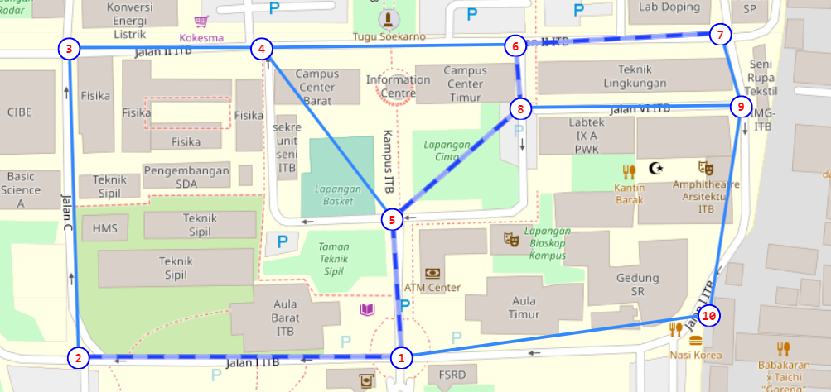

Node awal =2

Node tujuan = 7

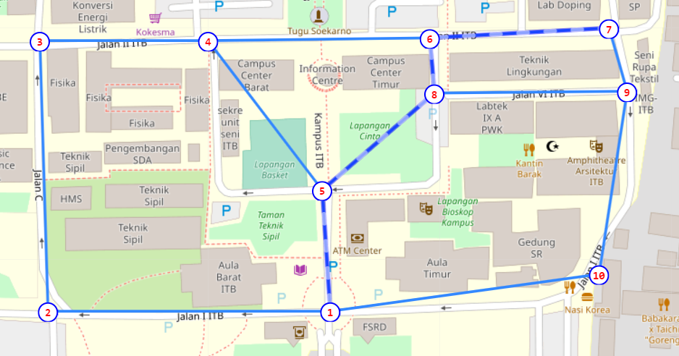

Node awal = 7

Node tujuan = 1

Link github

<https://github.com/yudialfayat/A-Star_Path_Planning.git>

Centang (√) jika ya

|  |  |  |
| --- | --- | --- |
| 1 | Program dapat menerima input graf | √ |
| 2 | Program dapat menghitung lintasan terpendek | √ |
| 3 | Program dapat menampilkan lintasan terpendek serta jaraknya | √ |
| 4 | Bonus: Program dapat menerima input peta dengan Google Map API dan menampilkan peta | √ |