Trust Fund Financial Information Summary for fiscal years ended June 30, 2024 and 2023 All amounts in USD millions, unless otherwise noted
Trust Fund Operations
Financial Information Summary
Fiscal years ended June 30, 2024 and 2023

1
1

Trust Fund Financial Information Summary for fiscal years ended June 30, 2024 and 2023 All amounts in USD millions, unless otherwise noted
Trust Fund Operations – Financial Information Summary for the Fiscal years ended June 30, 2024 and 2023
Introduction 1
Trust Funds1 are financial and administrative arrangements made between Development Partners (DPs) and one or more World Bank Group entities to meet diverse development needs including project preparation, technical assistance, advisory services, debt relief, post conflict transition, disaster recovery, climate change, and co-financing of lending projects. Trust funds contribute to the Bank Group’s mission of poverty reduction on a livable planet by supporting the design and implementation of development projects.
This report provides aggregate financial information on trust fund operations administered individually or jointly by the International Bank for Reconstruction and Development (IBRD), the International Development Association (IDA), the International Finance Corporation (IFC) and the Multilateral Investment Guarantee Agency (MIGA). These four entities are collectively referred to as the “Bank Group.” This report is unaudited, and is not intended to represent the combined financial position of trust funds and programs administered by the Bank Group. Numbers presented for previous periods have been regrouped to conform to the current period presentation.
Questions or comments on the report should be addressed to Christopher R. Vallyeason, Manager, Trust Funds and Accounting Department at cvallyeason@worldbank.org.
1This report uses the Trust Fund typology of IBRD/IDA Trust Funds, Financial Intermediary Funds (FIFs) and IFC Trust Funds. The following are not included in this report: (1) the Advance Market Commitment (AMC), which is a FIF but not a trust fund, and (2) trust funds that are managed separately by IFC (trust funds which support IFC's Special Initiatives and Investment Programs) which do not form part of the investment portfolio maintained by IBRD for trust funds.
2
1

Trust Fund Financial Information Summary for fiscal years ended June 30, 2024 and 2023 All amounts in USD millions, unless otherwise noted
Abbreviations and Acronyms
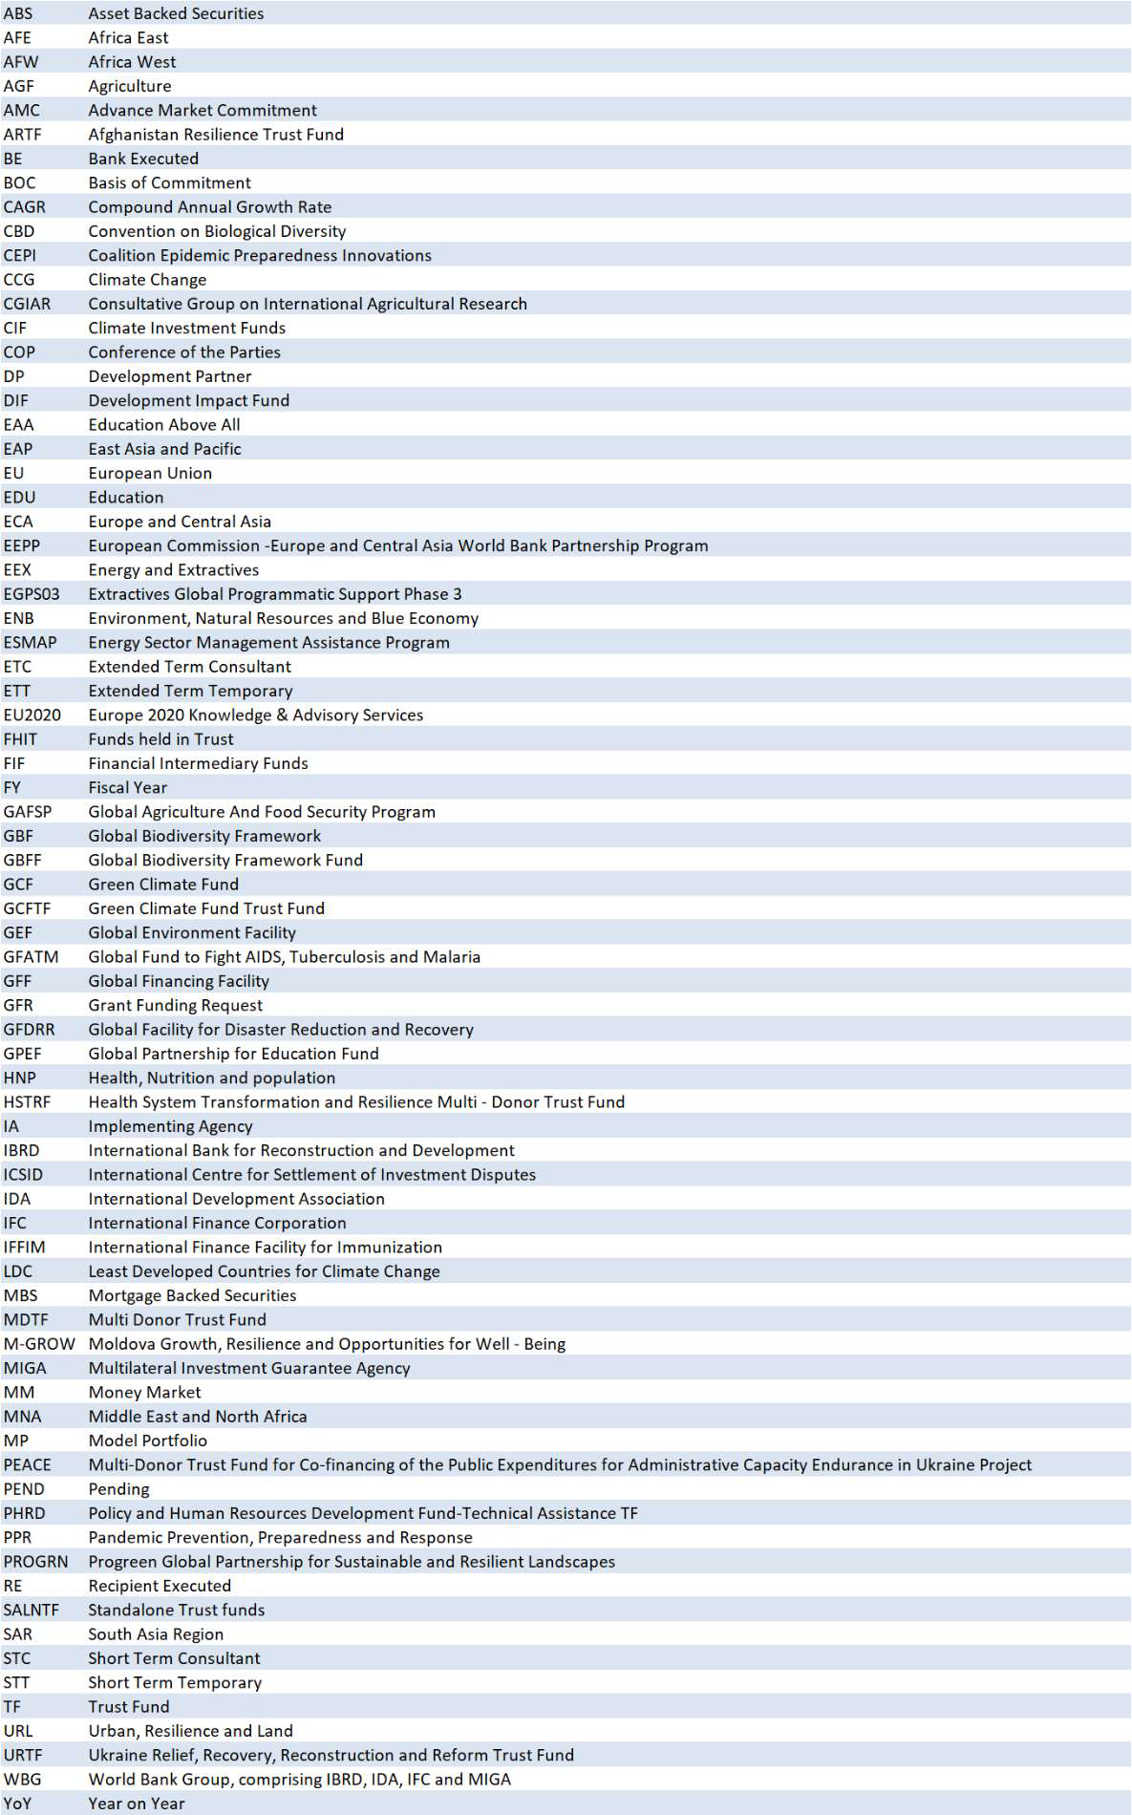
3
1

Trust Fund Financial Information Summary for fiscal years ended June 30, 2024 and 2023 All amounts in USD millions, unless otherwise noted
Contents and Summary of Financial Data
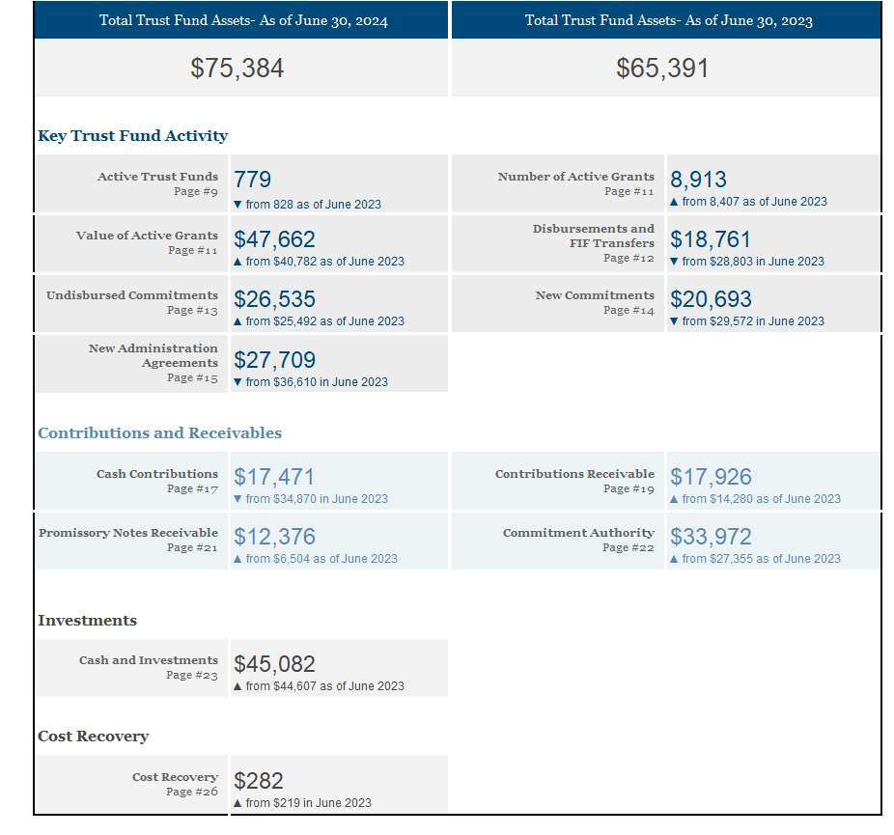
4
1

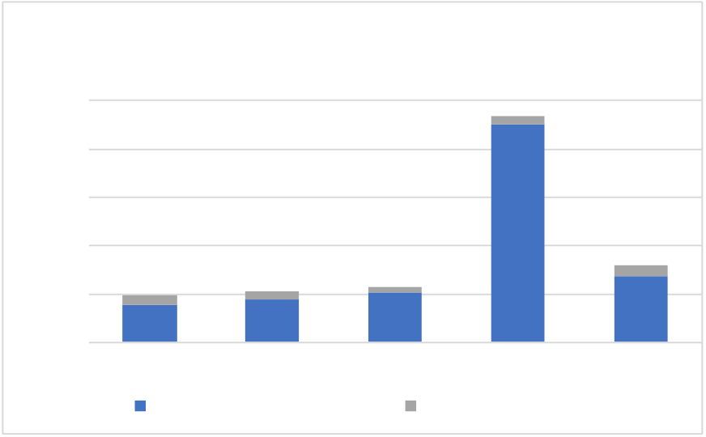
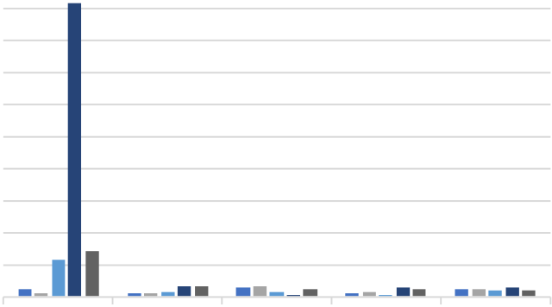
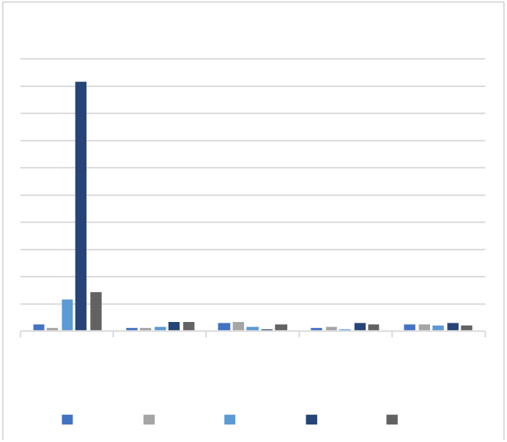
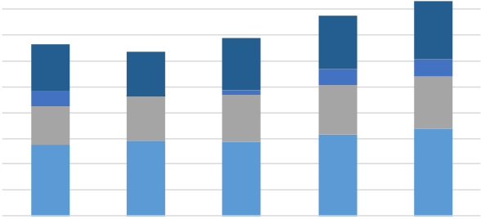

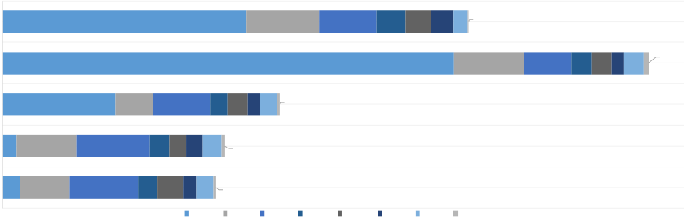
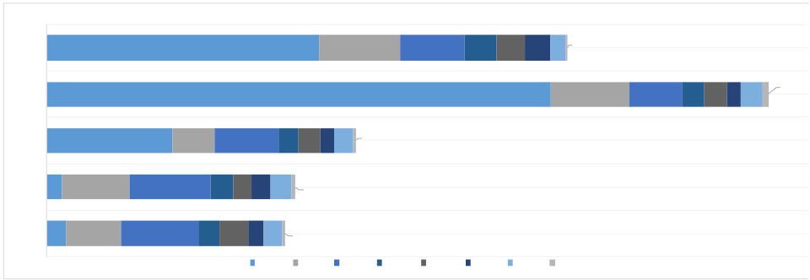
Trust Fund Financial Information Summary for fiscal years ended June 30, 2024 and 2023 All amounts in USD millions, unless otherwise noted
Portfolio at a Glance - IBRD/IDA/IFC Trust Funds
 | Contributions | Investment Income Disbursements Fund Balance
2024 | $6,890 $851 $9,797 $13,626
YoY change %
69% | 48% | 53% | 10%

Key Metrices
Cash contributions  Total Contribution Receipts of IBRD/IDA/IFC TF, $m  25,000 4%, 932  20,000  15,000  10,000 96%, 14%,  18%, 16%, 11%, 22,543 1,092  5,000 877 858 638 86%,  82%, 84%, 89%,  - 3,938 4,400 5,158 6,890  FY20 FY21 FY22 FY23 FY24  Direct Donor Contributions Transfers from FIFs |  | IBRD/IDA/IFC Top DPs Contributions $m  18,326  2,850  2,315  672  672  656  617  620  543  530  471  463  463  450  386  378  314  332  298  247  236  217  185  175  170  United Japan United Norway Germany  States FY21 Kingdom FY23 FY24  FY20 FY22
• On an average, 13% of overall contributions received by IBRD/IDA/IFC TFs are from FIFs, where IBRD/IDA/IFC play an implementing agency (IA) role. FIFs therefore, indirectly contribute to the IBRD/IDA/IFC trust fund activities.
•  •  • | Around 89% of the FIF transfers to IBRD/IDA/IFC TFs in FY24 were from 5 FIFs and these accounted for 82% over the past 5 years.  Top 10 donors accounted for 85% of the total IBRD/IDA/IFC TF contributions in FY24 with the top 5 accounting for 70% of the contributions.  There has been a steep decrease in contributions from United States (↓$15,476m) in FY24 as compared to
FY23 as the majority of contributions towards trust funds supporting Ukraine through SALNTF* have been paid by the donor during FY23 in accordance with the administration agreements.
 | Cash Disbursements |  | Disbursements for BE activities by Expense Categories, $m 1,800  1,600  1,400 417 445  1,200 366 343 398 123 141  1000  1000 110 6 35 382 395  800 301 346 366  600  554 580 575 633 681  400  200  -  FY20 FY21 FY22 FY23 Others FY24  Staff Costs Consultant Fees Travel
 | Disbursements for RE activities by Region, $m
 | 17
 | FY24 5,587 833 655 329 299 255 160
 | FY 140 61
 | FY 17,250 803 540 232 228 228
135
31
 | FY22 2,578 431 660 201 229 196
 | FY21
 | 152 694 837 225 191 196 221 29
 | FY20
 | 193 573 788 215 292 165 186 29
 | ECA AFE SAR AFW MNA EAP LCR OTH
• In FY24, disbursements from ECA region decreased significantly by 68% (↓$11,663m), primarily due to lower disbursements of PEACE MDTF supporting Ukraine through SALNTF program. In RE Activities, disbursements of ECA and AFE regions accounts for 79% of disbursements in FY24, and on an average of 78% in the last 5 years.
• | Staff costs increased by $48m equivalent to 8% increase compared to FY23 and continues to be the largest expense category with CAGR of 5% over the last 5 years. Consultant fees increased by $13m which is 3% higher than FY23, with CAGR of 7%. Travel costs increased by $18m equivalent to 15% increase compared to
FY23.
* Standalone trust fund program make up a diverse portfolio of typically smaller trust funds (non-umbrella programs). These TFs are established to finance activities that cannot be accommodated in an existing Global, Regional or country Umbrella.
5
1

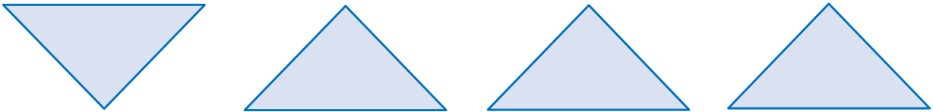
Trust Fund Financial Information Summary for fiscal years ended June 30, 2024 and 2023 All amounts in USD millions, unless otherwise noted
Portfolio at a Glance - FIFs
 | Contributions | Investment Income Disbursements Fund Balance
2024 | $10,581 $1,635 $8,964 $30,127
YoY change %
 | 14% | 76% | 15% | 6%

Key Metrices
Contribution and Disbursements  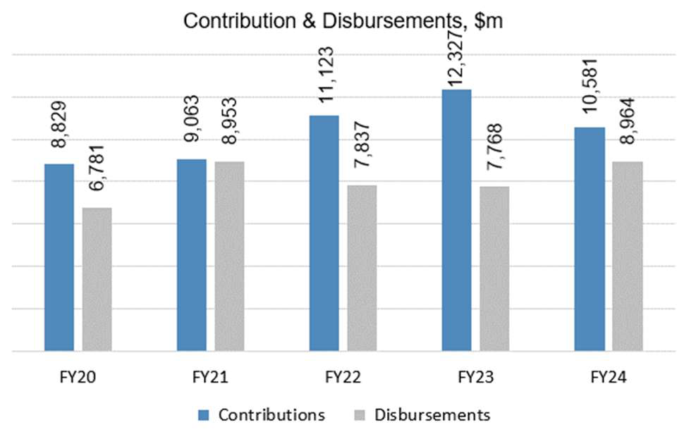 | Contributions  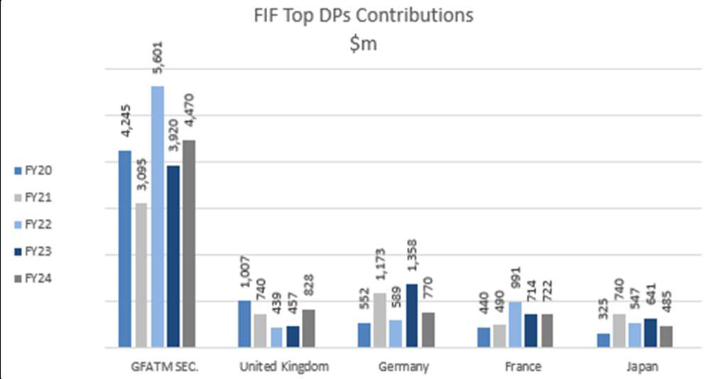
•  • | In FY24, contributions from top donors have decreased towards PPR and agriculture programs (GAFSP and CGIAR); while increased towards CIF, GEF and GBFF.  Top 2 donors GFATM and United Kingdom accounted for 50% of the total contributions in FY24 and an
average of 48% over the past 5 years.
•  • | Disbursements from GFATM, GCF and GEF programs accounted for 74% of total disbursement in FY24 and on an average 70% over the past 5 years.  GFATM has been the leading FIF constituting 41% of the total FIF contributions and 50% of total FIF
disbursements over the past 5 years.
6
1

Trust Fund Financial Information Summary for fiscal years ended June 30, 2024 and 2023 All amounts in USD millions, unless otherwise noted
Trust Fund FY24 Key Highlights
•In April 2024, the President announced new financial instruments including the Livable Planet Fund totaling $11,000m that will enable governments, philanthropies and other partner contributions to incentivize cooperation across borders and tackle shared challenges. Japan committed to providing the first contribution to the new Livable Planet Fund.
•Ukraine continues to receive support from the international community. New administration agreements have been signed in FY24 for various trust funds supporting Ukraine through SALNTF ($10,167m) and URTF ($661m) programs. Japan and United States were the major donors with expected funding of $7,673m and $2,655m respectively.
•During FY24, a new FIF, Global Biodiversity Framework Fund (GBFF) was established. The Trust Fund has been established following the decision of the Conference of the Parties to the Convention on Biological Diversity (“CBD”) at its Fifteenth Session (“COP 15”) to invite GEF to operate the Trust Fund. GBFF aims to support the Kunming-Montreal Global Biodiversity Framework. Five donors have contributed to-date to this FIF of which, majority of the funding was received from Canada ($55m) and Germany ($44m). •TF reforms continued in FY24 with an aim to reduce fragmentation, increase strategic alignment and improve efficiencies of the trust fund portfolio by using fewer and larger Umbrella 2.0 Programs. As of June 30, 2024, 70 Umbrella programs (140 active trust funds) have been established. Four new umbrella programs - EGPS03, DIF, M - GROW and HSTRF have been initiated and activated in FY24.
Top 3 trust funds activated during the fiscal year ended June 30, 2024, on the basis of Expected Funding
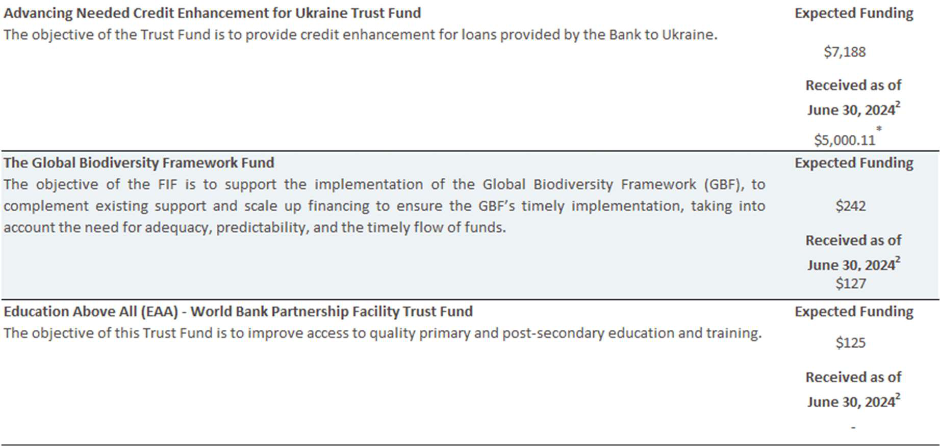
2DP’s contributions to the trust funds are based on installment schedules agreed per administration agreements. Hence, the total funding for the trust funds is not expected to be fully received as of June 30,2024.
*Promissory note of USD 5,000 was received and yet to be encashed.
7
1

Trust Fund Financial Information Summary for fiscal years ended June 30, 2024 and 2023 All amounts in USD millions, unless otherwise noted
Key Trust Fund Activity
Trust Fund Asset Summary
The Trust fund assets comprise funds held in trust (cash and investments, and promissory notes receivable) and
contributions receivable. Trust fund assets increased by $9,993m as of June 30, 2024 when compared to
June 30, 2023.
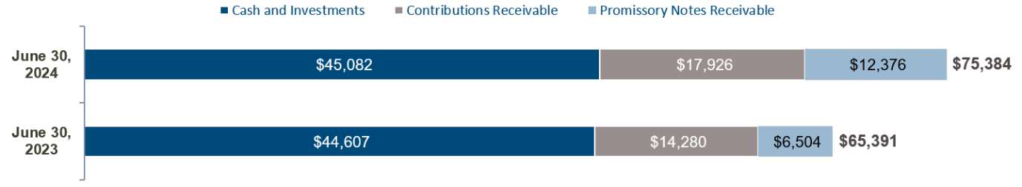
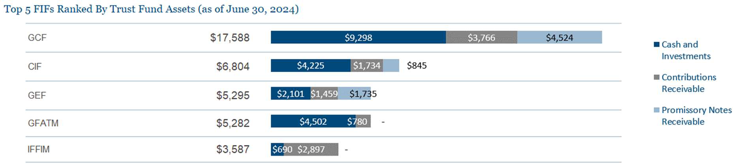
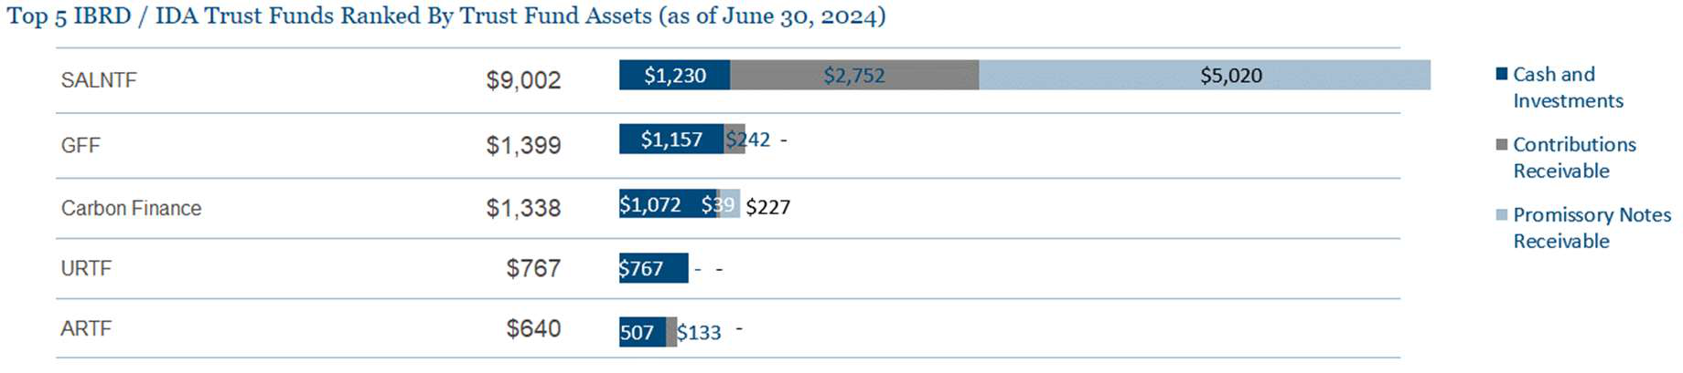
Of the total $75,384m of trust fund assets, assets held by IFC trust funds comprise $1,166m (including balances in Deferred fee & holding funds) of cash and investments and $232m of contribution receivable as of June 30, 2024.
8
1

Trust Fund Financial Information Summary for fiscal years ended June 30, 2024 and 2023 All amounts in USD millions, unless otherwise noted
Key Trust Fund Activity
Composition of Active Trust Funds32
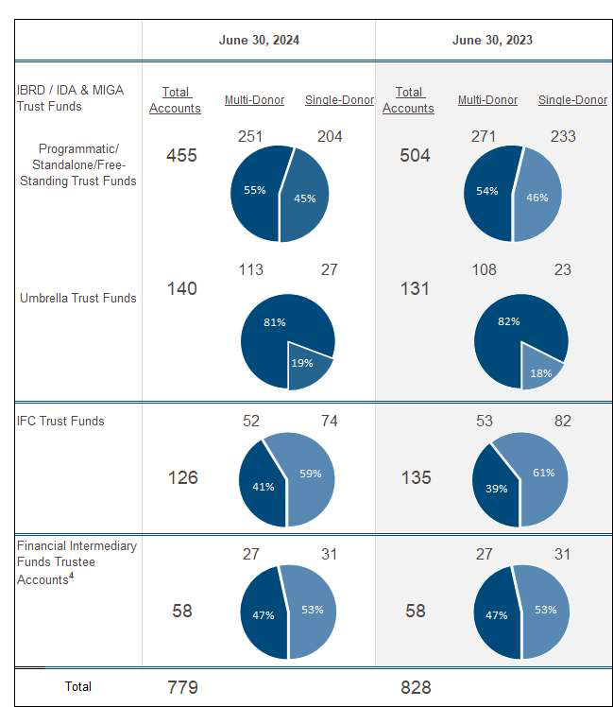
The FIF portfolio has continued to grow, from a base of 9 programs in 2008 to 26 in 2024. The major sectors in FIF are Environment and Climate change (12 FIF programs), Health (4 FIF programs) and Agriculture (3 FIF programs).
3The count is based on number of trust funds established as trustees under program types - Umbrella, Programmatic, Standalone and Free-standing. Apart from the active trust funds above there are DP balance accounts established to hold unused funds from closed trust funds, investment income earned on active trust fund balances, or to hold DP contributions temporarily awaiting establishment of a project trust fund. The total number of such active DP balance accounts as of June 30, 2024, is 343 and June 30, 2023 is 312.
4FIF Programs may be administered through the use of multiple accounts. There are 26 FIF programs (June 2023: 26) comprising multiple FIF trustee accounts.
9 1

Trust Fund Financial Information Summary for fiscal years ended June 30, 2024 and 2023 All amounts in USD millions, unless otherwise noted
Key Trust Fund Activity
Composition of Active Umbrella Trust Funds3
As of June 30, 2024, 70 umbrella programs comprising of 140 TFs have Funds-Held in Trust (FHIT) of $5,481m. Cash contributions and Disbursements of these programs during FY24 were $1,936m and $2,576m.
Description | As of June 2024 |  | FY24
 | FHIT | No of  Programs | Cash Contribution | Disbursement
Global Practices | 3,423 | 49 | 947 | 813
Regions | 2,058 | 21 | 989 | 1,763
Total | $5,481 | 70 | $1,936 | $2,576

Global Practices | As of June 2024 |  | FY24
 | FHIT | No of  Programs | Cash  Contribution | Disbursement
GP-Health, Nutrition and Population (HNP) | 1,405 | 4 | 263 | 265
GP-Environment, Natural Resources and Blue Economy (ENB) | 415 | 3 | 102 | 63
GP-Energy and Extractives (EEX) | 388 | 2 | 95 | 90
GP-Agriculture (AGF) | 210 | 1 | 52 | 26
GT- Climate (CCG) | 202 | 3 | 68 | 53
GP-Urban, Resilience and Land (URL) | 158 | 4 | 60 | 52
GP-Education (EDU) | 93 | 2 | 43 | 29
Others | 552 | 30 | 264 | 235
Total | $3,423 | 49 | $947 | $813

Regions | As of June 2024 |  | FY24
 | FHIT | No of  Programs | Cash  Contribution | Disbursement
Europe and Central Asia (ECA) | 791 | 2 | 683 | 1024
South Asia (SAR) | 547 | 4 | 175 | 549
Africa East (AFE) | 525 | 6 | 44 | 67
Middle East and North Africa (MNA) | 95 | 6 | 62 | 73
East Asia and Pacific (EAP) | 73 | 2 | 15 | 43
Africa West (AFW) | 27 | 1 | 10 | 7
Total | $2,058 | 21 | $989 | $1,763
10
1

Trust Fund Financial Information Summary for fiscal years ended June 30, 2024 and 2023 All amounts in USD millions, unless otherwise noted
Key Trust Fund Activity
Active Grants4
Grants represents funds which are provided from a trust fund to the Bank or a recipient to implement the trust
fund activities.
Total Number of Active Grants
BE Activities RE Activities  1,087 | 8,913
 | 8,407
Total Value of Active Grants
June 30 | BE Activities | RE Activities | $39,872 | $47,662
2024
 |  |  | $33,305 | $40,782
June 30
2023
Top 5 Trust Funds by Grant Amount (as of June 30 2024)
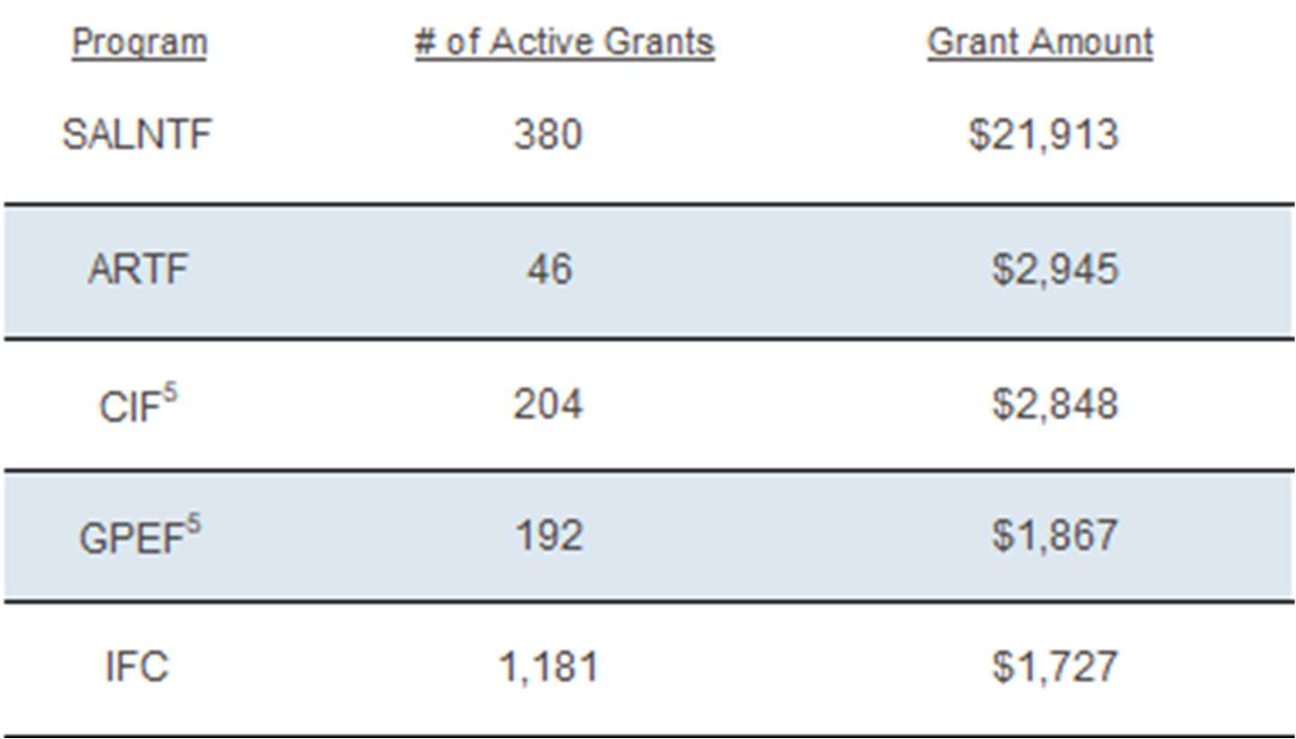
5 Grants shown under GPEF and CIF represent projects under their implementing agency/secretariat trust funds.
11
1

Trust Fund Financial Information Summary for fiscal years ended June 30, 2024 and 2023 All amounts in USD millions, unless otherwise noted
Key Trust Fund Activity
Disbursements and FIF Transfers 6
2024 |  | 2023
$18,761 |  | $28,803
There has been an overall decrease in disbursements and FIF transfers by $10,042m (35%) during FY24 as compared to FY23. FIF transfers increased by $1,196m (mostly due to GFATM and CEPI), disbursements from IBRD/IDA and IFC trust funds have decreased by $11,264m and increased by $26m respectively.
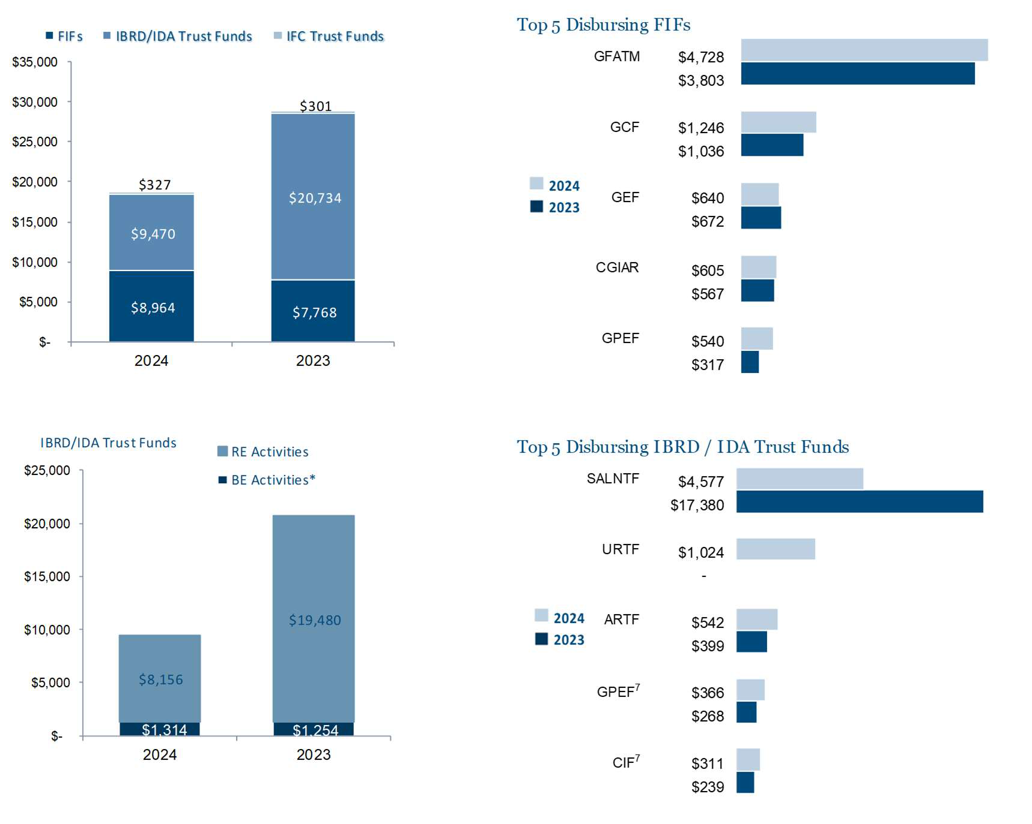
*includes Indirects costs of $88m for FY23 ($92m for FY23).
In FIF programs, the top 3 FIFs constituted 74% of the total FIF disbursements (FY23 71%) of which GFATM constituted about 53% (FY23 49%). FIF disbursements increased by $ 1,196m primarily due to increase in disbursements for GFATM ($925m) and CEPI ($465m).
In IBRD/IDA TF, disbursements for RE activities were $ 8,156m (FY23 $19,480m) and 79% of these were in ECA and AFE regions (FY23 93%). SALNTF and URTF were the leading programs in these regions in which $5,266m (FY23 17,074m) disbursements are related to Ukraine. Disbursements for RE activities are generally affected by the prevailing country environment, including capacity constraints, political environment, etc.
Disbursements for BE activities increased by $60m (5%) in FY24 when compared to FY23 due to increase in travel and media workshops related to in-person meetings/consultations and associated travels, and other costs primarily due to increase in advisory management expenses. Staff costs also contributed to the overall increase by $26m while STC and ETC costs increased by $10m.
________________
6FIF transfers exclude transfers made from FIFs to (i) IBRD/IDA/IFC as implementing Agency (IA) (ii) IBRD/IDA for administrative expenses as trustee and the expenses of in-house secretariats which are included in disbursements from IBRD/IDA trust funds. 7Includes disbursements by IBRD/IFC as Implementing Agency and Secretariat costs.
12
1

Trust Fund Financial Information Summary for fiscal years ended June 30, 2024 and 2023 All amounts in USD millions, unless otherwise noted
Key Trust Fund Activity
Undisbursed Commitments5
Commitments refer to the amount of financing approved for project(s) or activity(ies) at the grant level. Undisbursed commitments refer to balance of commitments pending disbursement or transfers.
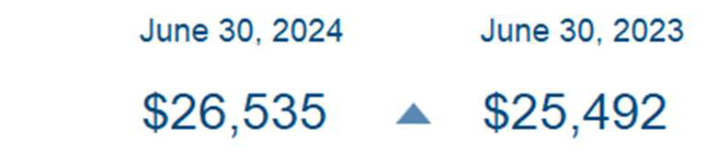
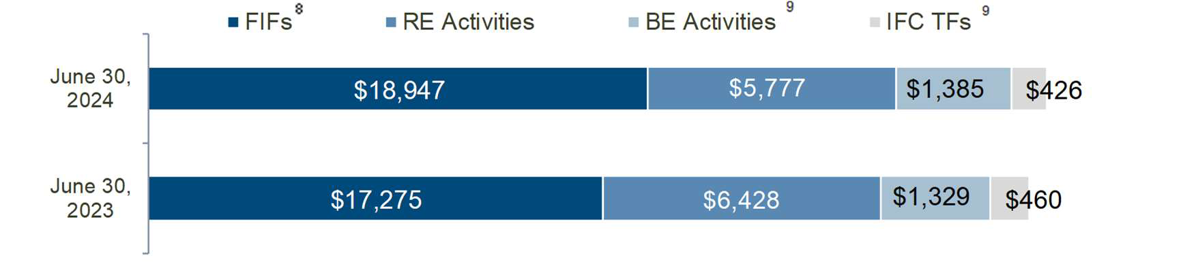
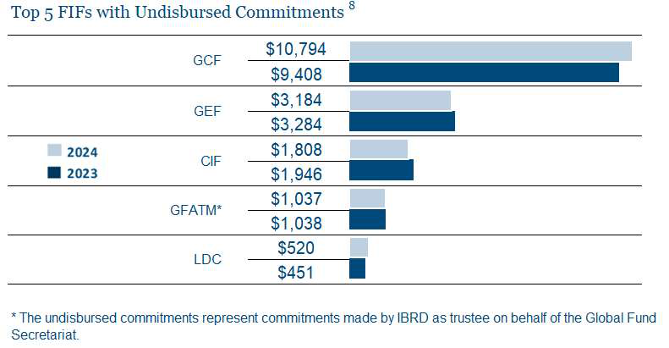
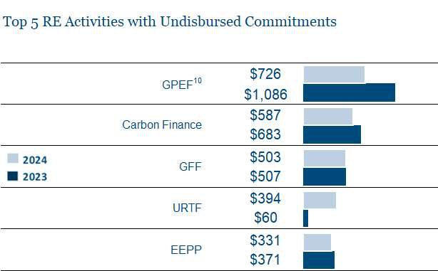 | 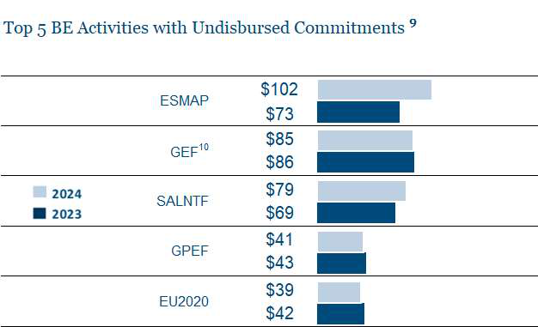
8 For FIFs, liabilities to implementing agencies for projects, fees and administrative budgets are considered as undisbursed commitments.
9 The available fund balances in disbursing funds are considered as undisbursed commitments for BE activities and IFC trust funds. 10 Includes undisbursed commitments of trust funds where IBRD/IFC is an Implementing Agency/Secretariat.
13
1

Trust Fund Financial Information Summary for fiscal years ended June 30, 2024 and 2023 All amounts in USD millions, unless otherwise noted
Key Trust Fund Activity
New Commitments
New commitments for BE activities and IFC trust funds represents the balance after netting out cancellations of unused commitments when trust funds are closed.
6 | 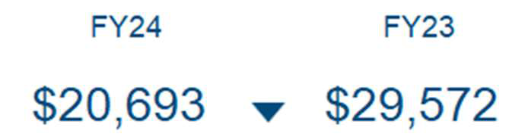
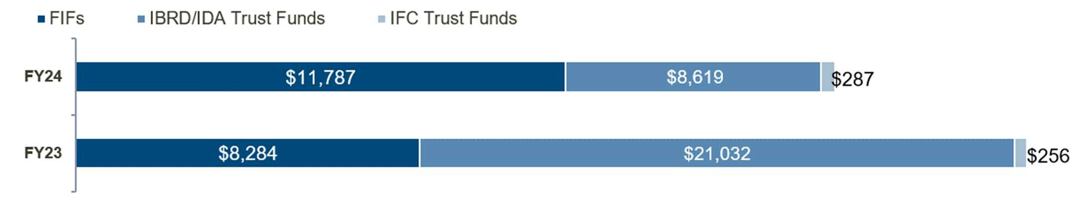
7
In FIF programs, commitments towards GFATM, GCF and GPEF have increased significantly by $926m, $743m
and $486m respectively.
In IBRD/IDA TFs, new commitments have decreased due to lower commitments towards SALNTF (↓$12,856m) primarily of which are for TFs supporting Ukraine. This was partially offset by increase in new commitments for URTF (↑$1,300m), GAFSP (↑$85m) and ESMAP (↑$82m).
14
1

Trust Fund Financial Information Summary for fiscal years ended June 30, 2024 and 2023 All amounts in USD millions, unless otherwise noted
Trust Fund Activity
New Administration Agreements
New administration agreements signed between the Bank Group and DPs represents contributions made to new trust funds and additional contributions made to existing trust funds. These are presented net of cancellations. The negative amounts are where the current period cancellations are greater than additional contributions.
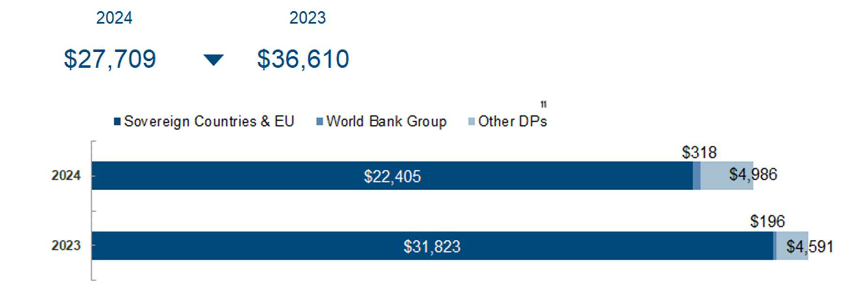
Top 10 Sovereign Countries and EU
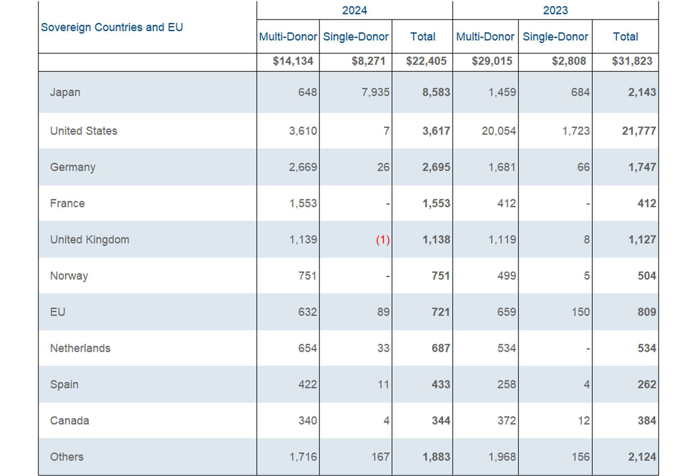
11 Other DPs includes multilateral development banks, United Nations agencies, and public and private institutions. Out of the total $5,707m
in Other DPs, $4,470m pertains to GFATM Secretariat.
15
1

Trust Fund Financial Information Summary for fiscal years ended June 30, 2024 and 2023 All amounts in USD millions, unless otherwise noted
Key Trust Fund Activity
New Administration Agreements (Cont’d)
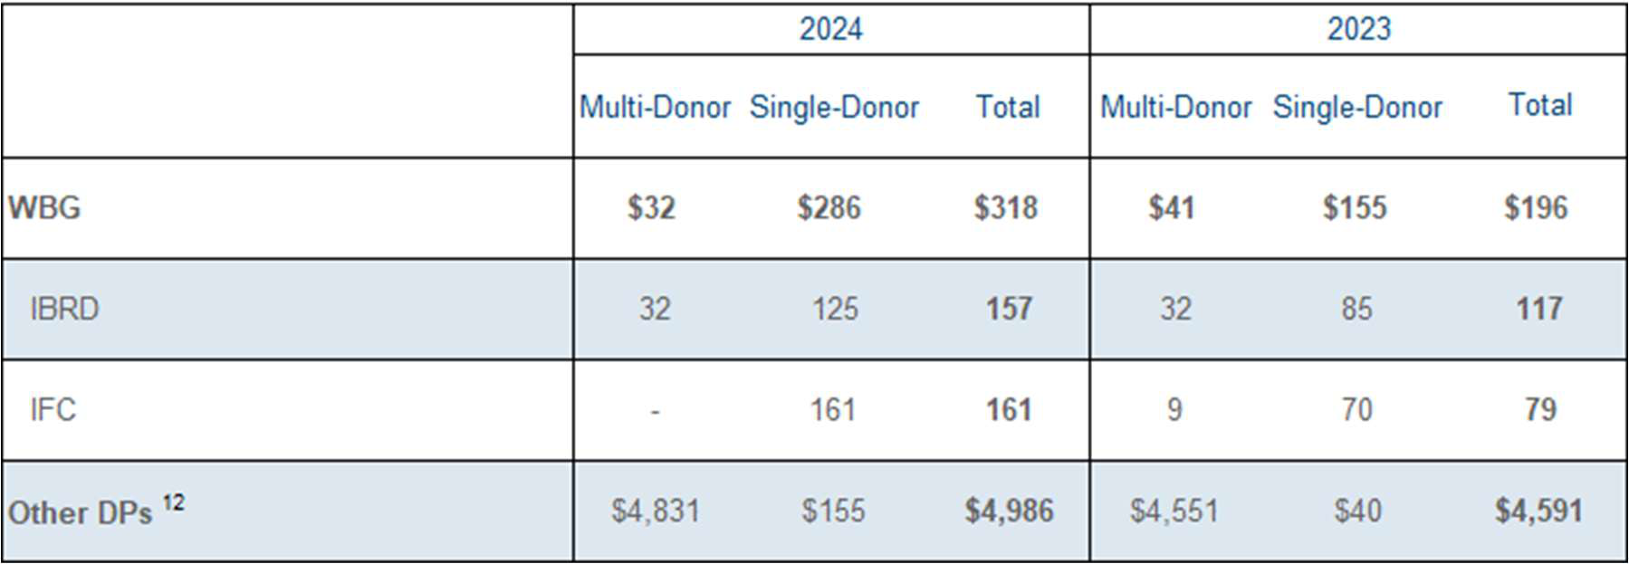
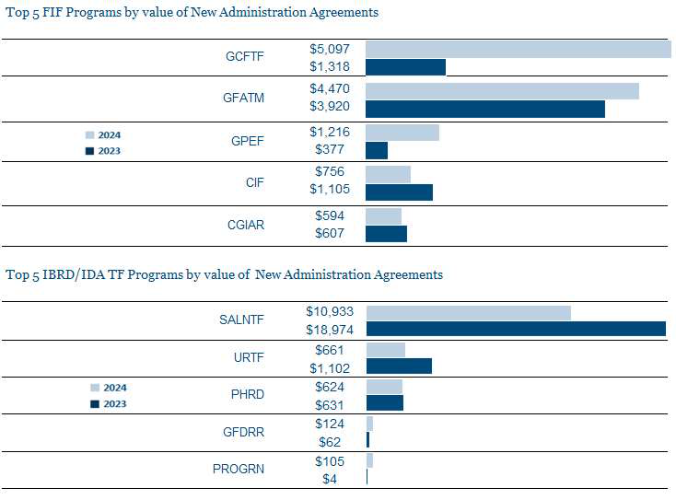
In FIF programs, new agreements were signed during FY24 towards GCFTF and GFATM for $9,567m constituting 72% of total FIF contributions. For FY24, Germany and France are the top donors for GCFTF.
In IBRD/IDA TFs, new agreements have been signed in FY24 primarily towards SALNTF for trust funds supporting Ukraine’s credit enhancement ($7,188m), co-financing of the public expenditures for administrative capacity endurance ($2,892m) and reconstruction and economy support ($87m). New agreements have also been signed for URTF and PHRD amounting to $661m and $624m, respectively. There was an overall decrease in new administration agreements signed in FY24 as compared to FY23.
______________________
12 Other DPs includes multilateral development banks, United Nations agencies, and public and private institutions. Out of the total $4,986m in Other DPs, $4,470m pertains to GFATM Secretariat.
16
1

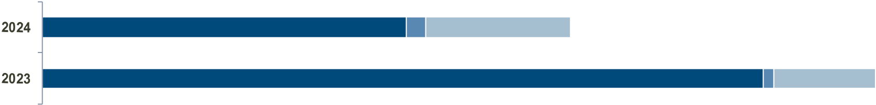
Trust Fund Financial Information Summary for fiscal years ended June 30, 2024 and 2023 All amounts in USD millions, unless otherwise noted
Contribution and Receivables
Cash Contributions
2024 | 2023 |  | World Bank Group | Other DPs | 13
$17,471 |  | $34,870
Sovereign Countries & EU
$318
$12,269 | $4,884
$187
$30,357 | $4,326
Top 10 Sovereign Countries and EU
Sovereign Countries and EU | 2024 |  |  | 2023
 | Multi-Donor | Single-Donor | Total | Multi-Donor | Single-Donor | Total
 | 11,058 | 1,211 | $12,269 | $27,443 | $2,914 | $30,357
United States  United Kingdom  Japan  Germany  France  EU  Norway  Canada  Netherlands  Sweden  Other sovereign countries | 3,317  1,274  517  1,119  739  543  627  514  482  410  1,516 | 6  24  639  29  1  173  13  4  28  1  293 | 6 3,323  1,298  1,156  1,148  1 740  716  640  518  510  411  1,809 | 18,844  615  687  1,912  750  433  869  721  636  416  1,560 | 1,720  18  627  65  1  270  20  4  30  5  154 | 20,564  633  1,314  1,977  751  703  889  4 725  666  421  1,714
__________________
13 Other DPs includes multilateral development banks, United Nations agencies, and public and private institutions. Out of the total $4,884m in
other DPs, $4,470m pertains to GFATM Secretariat
17
1

Trust Fund Financial Information Summary for fiscal years ended June 30, 2024 and 2023 All amounts in USD millions, unless otherwise noted
Contribution and Receivables
Cash Contributions (cont’d)
Contributions received from WBG and Other DPs9
 | 2024 | 2023
 | Multi-Donor Single Donor Total | Multi-DonorSingle-Donor Total
WBG | $32 $286 $318 | $32 $155 $187
IBRD  IFC | 32 125 157  - 161 161 | 32 85 117  - 70 70
Other DPs 14 | $4,813 $71 $4,884 | $4,262 $64 $4,326
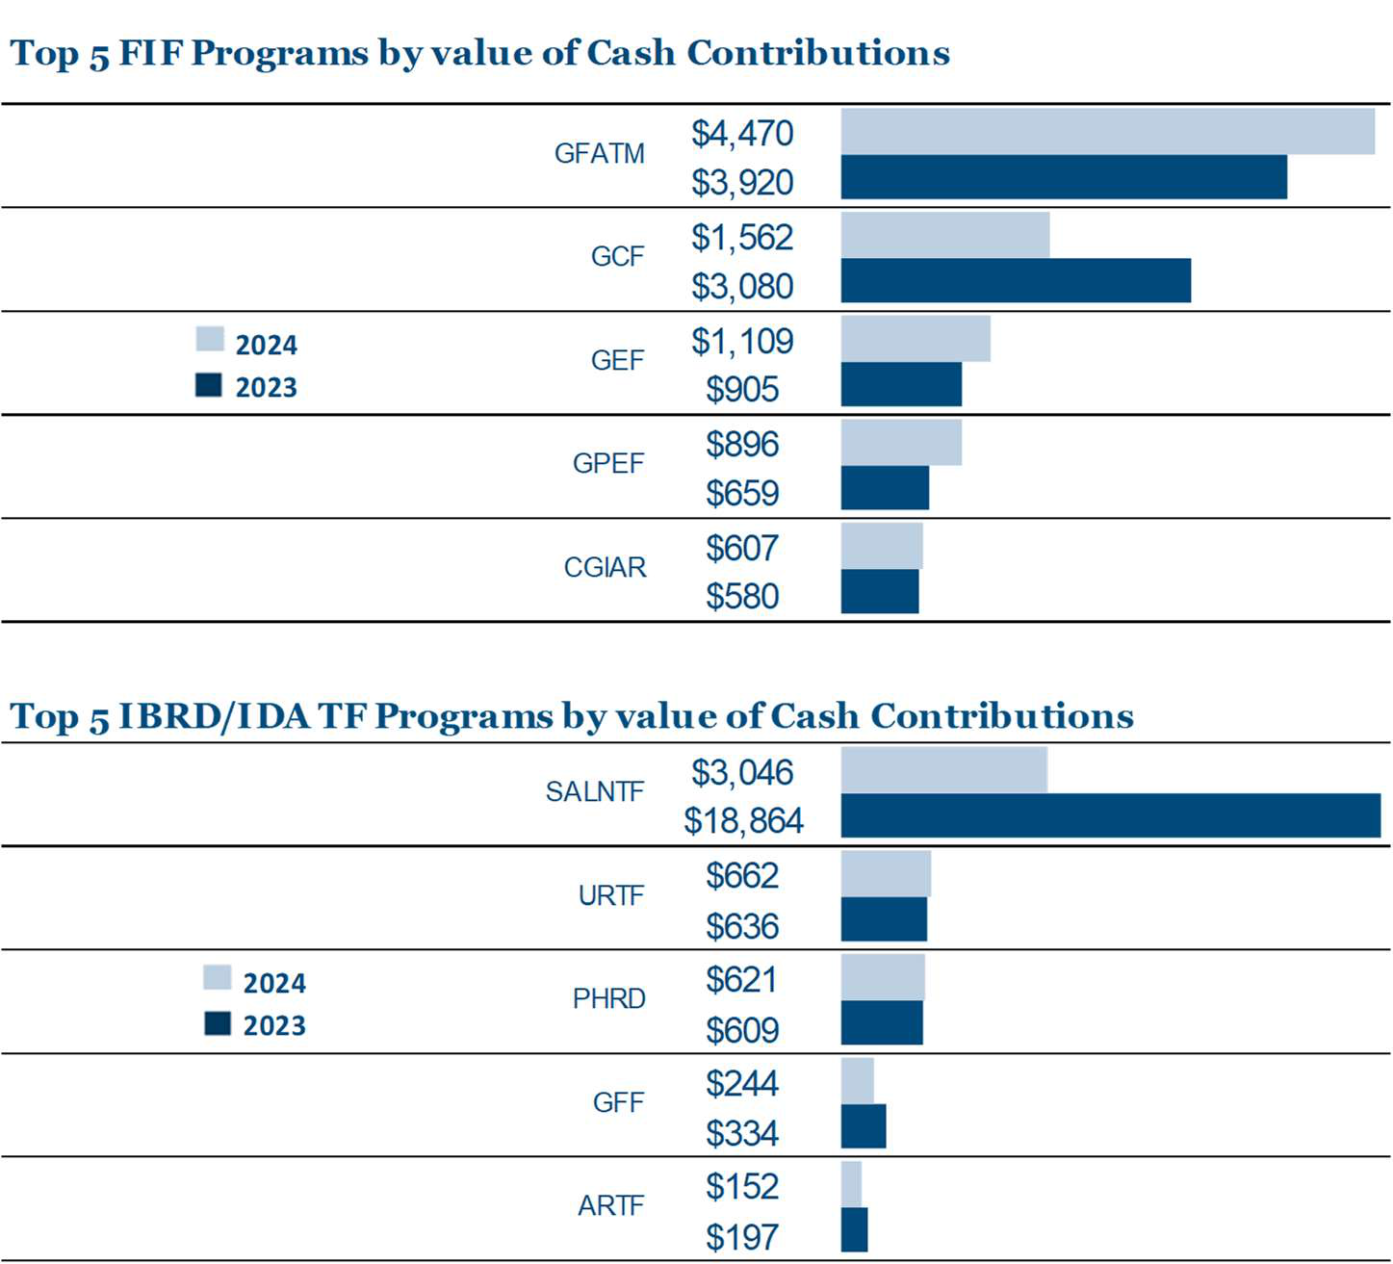
In FIF programs, GFATM has been the leading FIF constituting 42% of the total FIF contributions in FY24 (32% in FY23). Health sector accounts for 51% (47% in FY23) of the total FIF contributions mainly due to GFATM followed by IFFIM. Further, Climate sector accounts for 35% in FY24 (38% in FY23) primarily represented by GCF and GEF.
In IBRD/IDA TFs, contributions have significantly decreased in FY24 due to majority of contributions being fully paid in FY23 for TFs supporting Ukraine. United States have contributed additional $2,630m in FY24 to TFs supporting Ukraine through URTF and SALNTF. The contributions to these programs are largely influenced by the prevailing country environment, including capacity constraints, political environment, donor appropriations, etc.
14Other DPs includes multilateral development banks, United Nations agencies, and public and private institutions. Out of the total $4,884m in other DPs, $4,470m pertains to GFATM Secretariat.
18
1

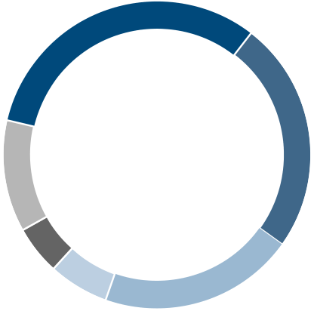
Trust Fund Financial Information Summary for fiscal years ended June 30, 2024 and 2023 All amounts in USD millions, unless otherwise noted
Contribution and Receivables
Contributions Receivable (Cont’d)10
Contributions Receivable by Currency
Euro | 37% June 30, 2024 |  | 32% | June 30, 2023
US Dollar
Pound Sterling
Norwegian Kroner
 | 7% |  |  | 24%
Canadian Dollar
Others | 3% 34%  14% | 12% | 6% | 21%
 |  | 5%
Top 5 Sovereign Countries, EU and Other DPs
 | June 30, 2024 | June 30, 2023
Sovereign Countries and EU | $16,603 | $12,935
Japan  United Kingdom  Germany  France  United States  Other sovereign countries | 2,632  2,516  2,446  1,542  1,430  6,037 | 695  2,956  1,777  746  990  5,771
Other DPs 16 | $1,308 | $1,330
16Other DPs includes multilateral development banks, United Nations agencies, and public and private institutions but does not include
receivables from entities of WBG amounting to $14m as of June 30,2024 ($15m as of June 30, 2023).
20
1

Trust Fund Financial Information Summary for fiscal years ended June 30, 2024 and 2023 All amounts in USD millions, unless otherwise noted
Contributions and Receivables
Promissory Notes Receivable11
June 30, 2024 |  | June 30, 2023 | In certain programs, contributions receivable are settled
 |  |  | through deposit of promissory notes, which are
$12,376 |  | $6,504 | subsequently encashed based on schedules agreed with
 |  |  | the DPs, and are recorded as cash contributions upon
encashment.
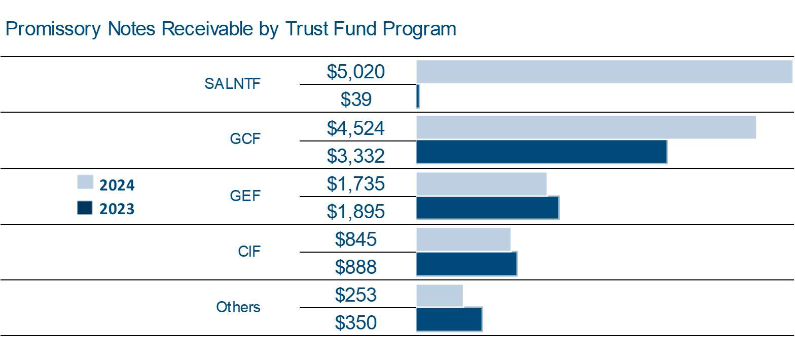
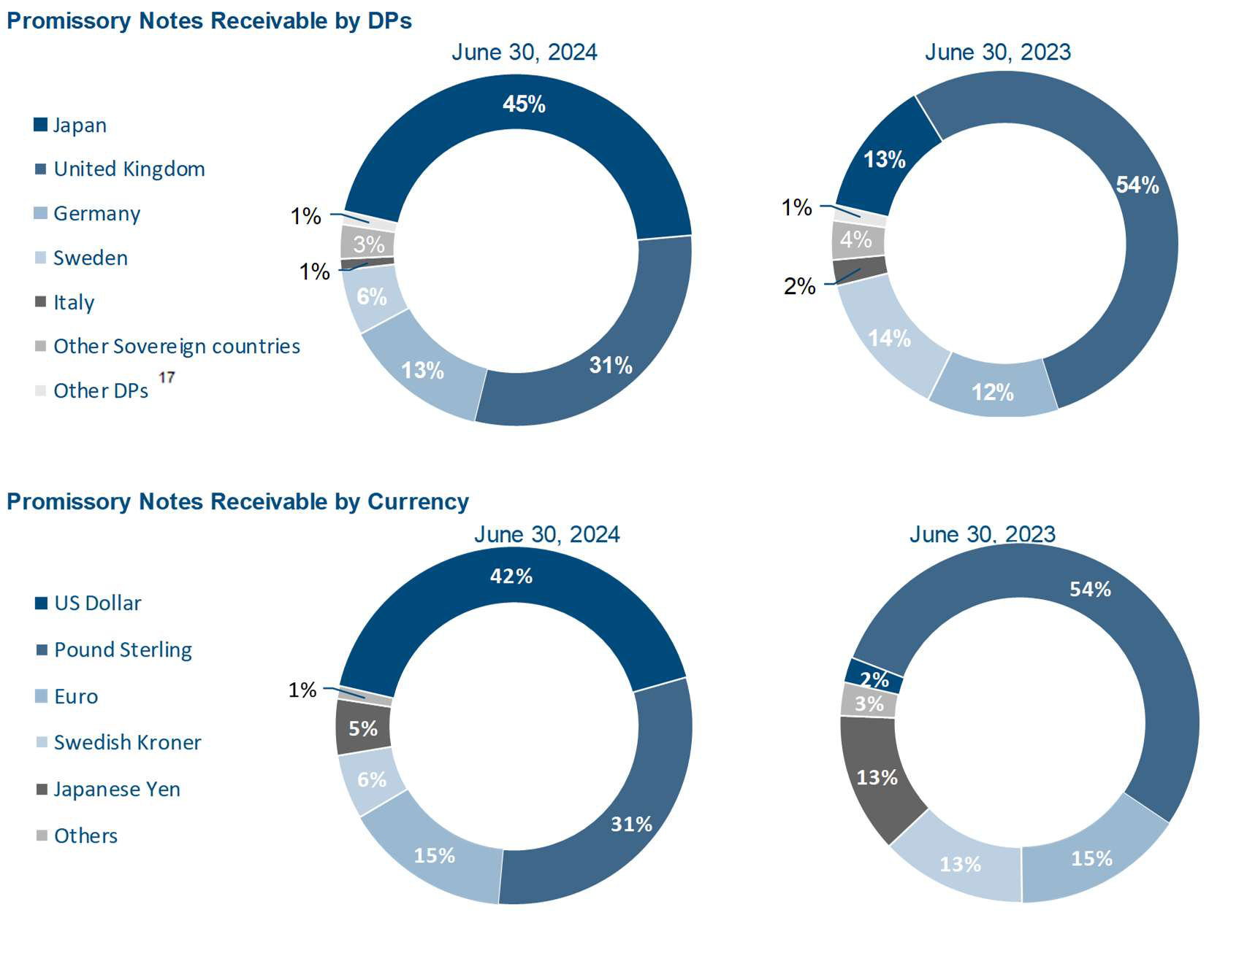
In FY24, promissory note receivable increased significantly for SALNTF program primarily due to Japan’s contribution ($5,000m) for trust fund supporting advancing needed credit enhancement for Ukraine.
17 Other DPs includes multilateral development banks, United Nations agencies, and public and private institutions.
21
1

Trust Fund Financial Information Summary for fiscal years ended June 30, 2024 and 2023 All amounts in USD millions, unless otherwise noted
Contributions and Receivables
Commitment Authority
Commitment authority represents an upper limit up to which task teams can commit future disbursements at the individual TF level. The classes of assets that a trust fund could commit upon form the trust fund’s Basis of Commitment (BoC). The asset classes that can be committed against are either (i) cash, (ii) cash plus promissory notes, or (iii) cash plus promissory notes and contributions receivable. The default BoC for a trust fund is cash, but may be modified to include promissory notes receivable and/or contributions receivable with the approval of Director(s) in the unit managing the trust fund. The trust funds grouped by BoC types and the funds available for commitments is presented in the table below:
Trust funds with Basis of Commitment as | Contribution Receivable | Promissory Notes  Receivable | Cash 18 | Total TF Assets | Outstanding Commitments | Balance  Available to Commit  as of  June 30, 2024
 | A | B | C | D=A+B+C | E | F
Cash (63% of TFs )  Cash and Promissory Notes Receivable  (4% of TFs)  Cash, Promissory Notes Receivable, and  Contributions Receivable (33% of TFs) | 5,416  6,370  6,140 | 1,761  5,421 | 16,490  22,608  4,655 | 23,667  34,399  15,989 | 8,401  16,000  2,134 | 8,089  12,029  13,855 | (C-E)  (B+C-E)  (D-E)
 |  | 5,194
TOTAL | $17,926 | $12,376 | $43,753 | $74,055 | $26,535 | $33,973
___________________________________________________________
18 Excludes cash in DP Balance Accounts, funds held in escrow on behalf of ICSID and DPs contributions to be applied to trust funds pending receipt of signed agreements, and balances in administration accounts (IBRD/IFC), totally amounting to $1,329m. RE Activities in Pend status and RE Activities GFRs in pipeline (including corresponding fee) are not considered.
22
1

Trust Fund Financial Information Summary for fiscal years ended June 30, 2024 and 2023 All amounts in USD millions, unless otherwise noted
Investments
Cash and Investments
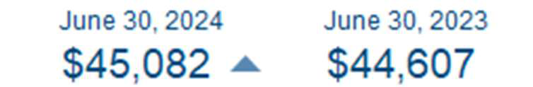
Cash received from DPs contributions, loans from DPs and proceeds from the issuance of bonds (for IFFIM) are managed by IBRD’s Treasury, which manages a commingled investment portfolio (the Pool) for all funds that are administered by the Bank Group entities. The Pool also includes funds held in ICSID's escrow accounts. IBRD maintains all assets underlying the trust funds’ fund balances separate and apart from the assets of the World Bank Group. IBRD, on behalf of the World Bank Group, invests the funds in liquid financial instruments such as government and agency obligations, time deposits, money-market securities and asset-backed securities, as well as swaps and a range of other derivative instruments. Additionally, the pool may also include equity securities. The investment composition within the pool is based on the investment horizons and cash flow profiles of the trust fund programs. Net investment income earned by the Pool is allocated to each trust fund based on its share of cash and investments in the Pool.
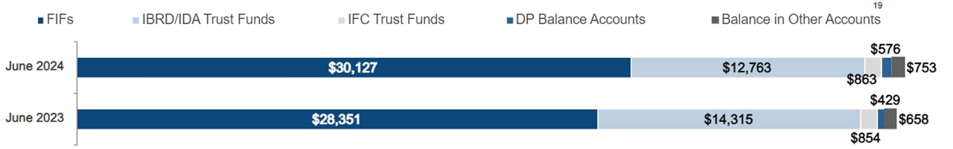
Cash and Investments in DP Balance Accounts
DP balance accounts are established to hold unused funds from closed trust funds, investment income earned on active trust fund balances, or on a temporary basis, subject to separate agreement, funds pending the establishment of another trust fund. The funds in a DP balance accounts may only be returned to the DPs or transferred to other trust funds as a contribution from DPs.
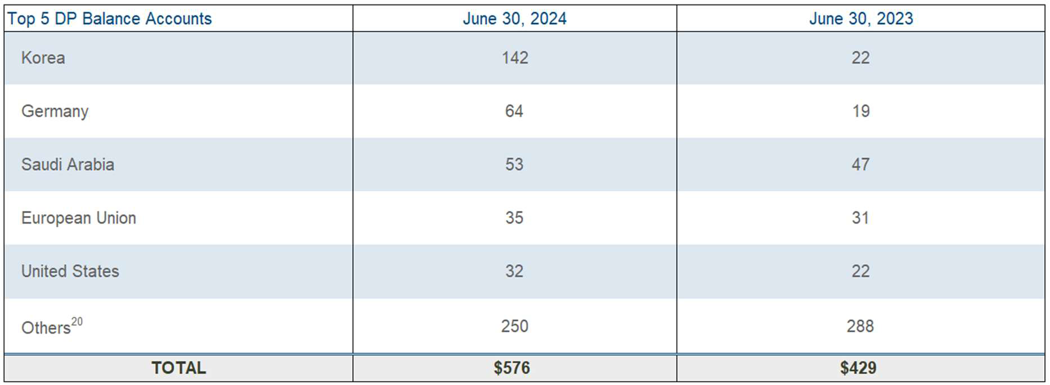
___________________________________________________________
19Primarily represents funds held in escrow on behalf of ICSID and DPs contributions to be applied to trust funds pending receipt of signed agreements, and balances on administration accounts (IBRD/IFC).
20 Others includes balance accounts for Sovereign countries other than the top 5, WBG, multilateral development banks, United Nations agencies, and public and private institutions. Multi-donor holding accounts have also been grouped under others.
23
1

Trust Fund Financial Information Summary for fiscal years ended June 30, 2024 and 2023 All amounts in USD millions, unless otherwise noted
Investments
Cash and Investments (cont’d)
Investment Income
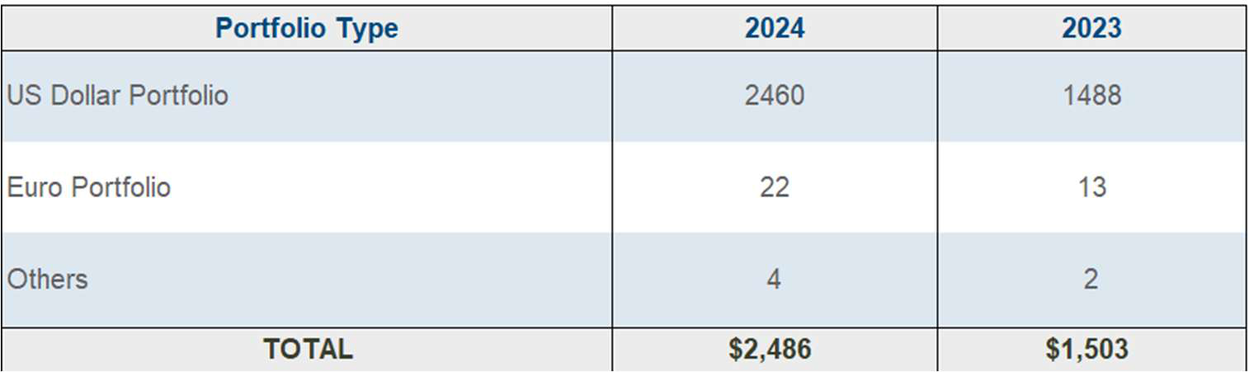
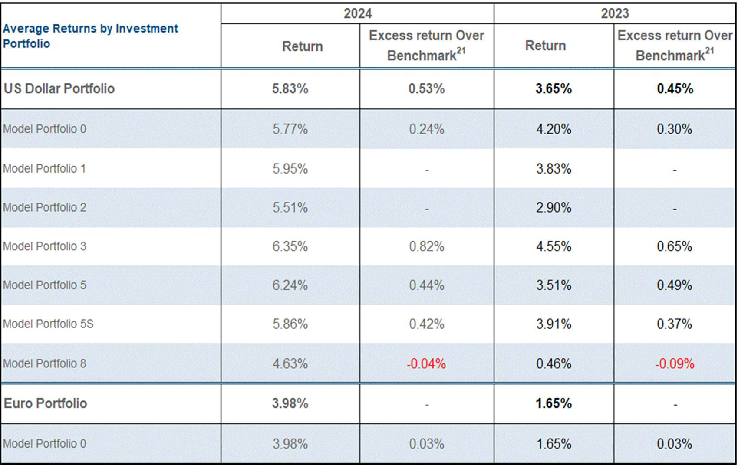
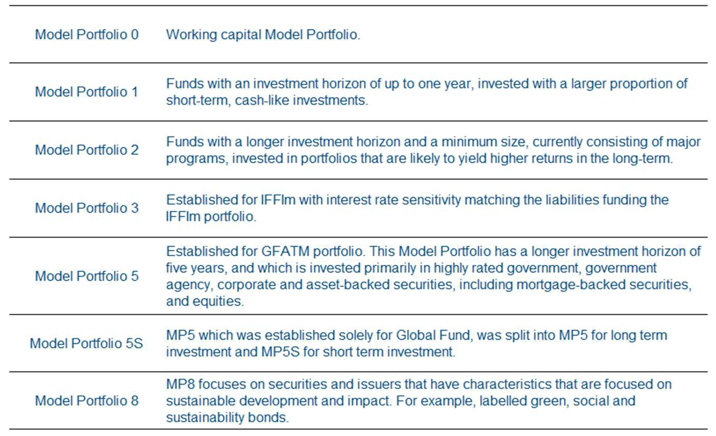
21Refers to the return in excess of the benchmarks determined by the WBG Treasury before deducting any investment management fee.
24
1

Trust Fund Financial Information Summary for fiscal years ended June 30, 2024 and 2023 All amounts in USD millions, unless otherwise noted
Investments
Cash and Investments (cont’d)
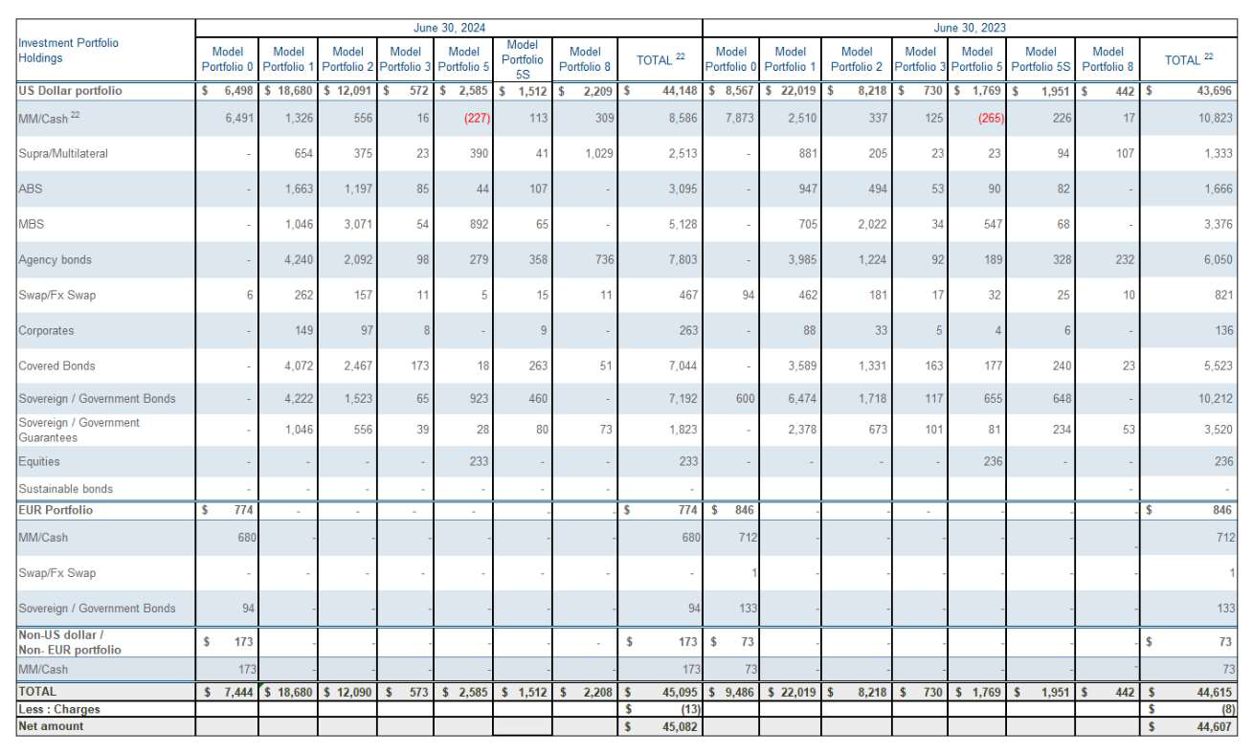
Investment Composition
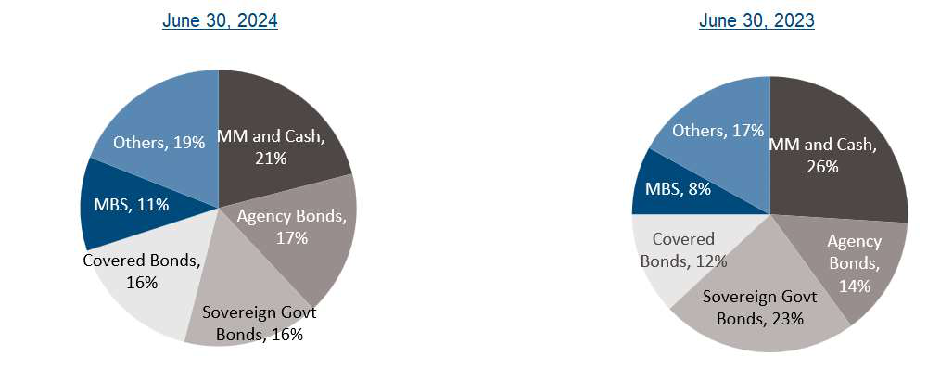
___________________________________________
22 Negative amounts in MM/Cash are due to excess payable position over receivable position as of June 30, 2024 and June 30, 2023.
25
1

Trust Fund Financial Information Summary for fiscal years ended June 30, 2024 and 2023 All amounts in USD millions, unless otherwise noted
Cost Recovery
Cost Recovery
WBG charges administrative fees, pursuant to administrative agreements with DPs to assist in the defrayment
of the costs incurred for the administration of trust funds.
2024 |  | 2023
$282 |  | $219

Description | 2024 | 2023
Administrative Fees and Expenses | 194 | 127
Indirects charges on Personnel Cost | 88 | 92
Total Cost Recovery | $282 | $219
Administrative Fee & Expenses Composition:
Description | 2024 | 2023
Fees charged as a percentage of grant commitments | 102 | 63
Financial Intermediary funds - Billing | 23 | 19
Fee charged as a percentage of contributions received from donors | 25 | 18
FIF Secretariat fees | 21 | 13
Fee charged as a percentage on disbursements of BE activities | 17 | 8
Other fees 23 | 6 | 6
Total Administrative Fees and Expenses | $194 | $127
Indirect charges on Personnel Cost Composition:
For BE activities, the computation of personnel costs (Staff costs, Short-Term Consultants/ Temporary Costs (STC/STT) and Extended Term Consultants/Temporary costs (ETC/ETT) includes an allocation of indirect costs, charged in accordance with Bank policies and procedures.
Description | 2024 | 2023
Staff costs | 53 | 55
Short Term Consultants/Temporary | 31 | 33
Extended Term Consultants/Temporary | 4 | 4
Total Indirects charges on Personnel Cost | $88 | $92
__________________________________________
23 Other fees include any special arrangements and manual fee recovery.
26
1

