Trust Fund Operations
Financial Information Summary
Six months ended December 31, 2025 and 2024


Trust Fund Financial Information Summary for the six months ended December 31, 2025 and 2024 All amounts in USD millions, unless otherwise noted
Trust Fund Operations – Financial Information Summary for the six months ended December 31, 2025 and 2024
Introduction
Trust Funds1 are financial and administrative arrangements made between Development Partners (DPs) and one or more World Bank Group entities to meet diverse development needs including project preparation, technical assistance, advisory services, debt relief, post conflict transition, disaster recovery, climate change, and co-financing of lending projects. Trust funds contribute to the Bank Group’s mission of poverty reduction on a livable planet by supporting the design and implementation of development projects.
This report provides aggregate financial information on trust fund operations administered individually or jointly by the International Bank for Reconstruction and Development (IBRD), the International Development Association (IDA), the International Finance Corporation (IFC) and the Multilateral Investment Guarantee Agency (MIGA). These four entities are collectively referred to as the “Bank Group.” This report is unaudited, and is not intended to represent the combined financial position of trust funds and programs administered by the Bank Group. Numbers presented for previous periods have been regrouped to conform to the current period presentation.
Questions or comments on the report should be addressed to Christopher R. Vallyeason, Manager, Trust Funds Accounting and Reporting at cvallyeason@worldbank.org.
______________________________________
1This report uses the Trust Fund typology of IBRD/IDA Trust Funds, Financial Intermediary Funds (FIFs) and IFC Trust Funds. The following are not included in this report: (1) the Advance Market Commitment (AMC), which is a FIF but not a trust fund, and (2) trust funds that are managed separately by IFC (trust funds which support IFC's Special Initiatives and Investment Programs) which do not form part of the investment portfolio maintained by IBRD for trust funds.
2
1

Trust Fund Financial Information Summary for the six months ended December 31, 2025 and 2024 All amounts in USD millions, unless otherwise noted
Abbreviations and Acronyms

ABS | Asset Backed Securities
AFE | Africa East
AFW | Africa West
AGF | Agriculture
ARTF | Afghanistan Resilience Trust Fund
BE | Bank Executed
BoC | Basis of Commitment
CAGR | Compound Annual Growth Rate
CCG | Climate Change
CGIAR | Consultative Group on International Agricultural Research
CIF | Climate Investment Funds
CRO | Chief Risk Officer Vice Presidency
CTR | Controllers
CU-DFI | Central Unit for Development Finance
CWA | Compact with Africa 2.0
DDP | Digital Development Partnership
DFTFPR | Development Finance,Trust Funds & Partner Relations
DP | Development Partner
DPI | Digital Public Infrastructure & Services
EAP | East Asia and Pacific
EC/EU | European Commission/ European Union
ECA | Europe and Central Asia
EDU | Education
EEX | Energy and Extractives
ENB | Environment, Natural Resources and Blue Economy
ESMAP | Energy Sector Management Assistance Program
ETC | Extended Term Consultant
ETT | Extended Term Temporary
FCV | Fragility, Conflict and Violence
FHIT | Funds Held In Trust
FIF | Financial Intermediary Funds
FORTIE | F.O.R.T.I.S. Ukraine FIF - IBRD as Implementing Entity Trust Fund
FORTIS | Facilitation of Resources to Invest in Strengthening Ukraine FIF
FS | Free Standing
FS-CFP | Free - Standing Tfs For Cfp
FY | Fiscal Year
GCF | Green Climate Fund
GEF | Global Environment Facility
GFATM | Global Fund For Aids, Tuberculosis And Malaria
GFDRR | Global Facility for Disaster Reduction and Recovery
GFF | Global Financing Facility
GFR | Grant Funding Request
GP | Global Practices

HNP | Health, Nutrition and Population
IA | Implementing Agency
IBRD | International Bank for Reconstruction and Development
ICSID | International Centre for Settlement of Investment Disputes
IDA | International Development Association
IDASTF | IDA Crisis Facility Special Transfer Fund
IFC | International Finance Corporation
IFFIM | International Finance Facility for Immunization
LCR | Latin America and the Caribbean
LDC | Least Developed Countries for Climate Change
LEG | Legal Vice Presidency
LPF | Livable Planet Fund
MBS | Mortgage Backed Securities
MDTF | Multi-donor Trust fund
MIGA | Multilateral Investment Guarantee Agency
MM | Money Market
MNA | Middle East and North Africa
MP | Model Portfolio
OTH | Others
PEND | Pending
PPR | Pandemic Prevention, Preparedness and Response
PSNP | Productive Safety Net Project
RE | Recipient Executed
SALNTF | Standalone Trust funds
SAR | South Asia Region
SCALE | Scaling Climate Action by Lowering Emissions
SDTF | Single Donor Trust Fund
STC | Short Term Consultant
STT | Short Term Temporary
TF | Trust Fund
TFFF | Tropical Forest Forever Facility
TRE | Treasury Vice Presidency
UFT2.0 | TRTA - Umbrella Facility for Trade
UK | United Kingdom
URL | Urban, Resilience and Land
URTF | Ukraine Relief, Recovery, Reconstruction and Reform Trust Fund
US | United States
VPU | Vice Presidential Unit
WBG | World Bank Group, comprising IBRD, IDA, IFC and MIGA
WBGBK | West Bank & Gaza - IBRD Funded
WGPGTF | IBRD Fund for Innovative GPG Solutions
WSP | Water And Sanitation Program (WSP)
YoY | Year on Year

GPEF | Global Partnership for Education Fund | YTD | Year to Date
3
1

Trust Fund Financial Information Summary for the six months ended December 31, 2025 and 2024 All amounts in USD millions, unless otherwise noted
Contents and Summary of Financial Data
Total Trust Fund Assets- As of December 31, 2025 | Total Trust Fund Assets- As of December 31, 2024
$95,208 | $101,597
Key Trust Fund Activity
A ctiv e Trust Funds | 712 | Num ber of Activ e Gran ts | 9,233
Page #1 0 |  | Page #1 2
 | ▼ from 757 as of December 2024 |  | ▲ from 8,848 as of December 2024

V alu e of Activ e Gran ts Page #1 2 | $42,697  ▼ from $56,103 as of December 2024 | Disbu rsem ent s an d FIF Transfers Page #1 3 | $14,485  ▼ from $15,640 in December 2024
Undisbursed Com m itm ents Page #1 4 | $38,491  ▼ from $51,532 as of December 2024 | New Com m itm ents Page #1 5 | $10,014  ▼ from $49,414 in December 2024
New A dm inistra tion A greem ents Page #1 6  Contributions and Rece  Cash Contribu tion s  Page #1 8 | $4,629  ▼ from $40,290 in December 2024 | Cont ributions Receiv able Page #2 0 $20,011 ▼ from $21,137 as of December 2024
ivables
$8,144
▼ from $36,663 in December 2024
Prom issory Notes Receiv able
Page #2 2
Investments
Cash and Inv estm ents

Page #2 4
Cost Recovery
Cost Recov ery

Page #2 7

$13,409
▲ from $12,119 as of December 2024
$61,788
▼ from $68,341 as of December 2024
$122
▲ from $118 in December 2024
Com m itm ent Au th ority Page #2 3
$39,160
▲ from $32,920 as of December 2024
4
1

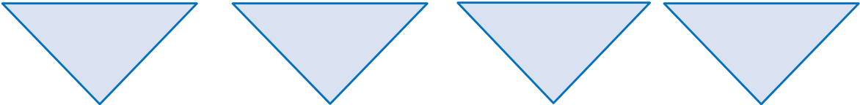

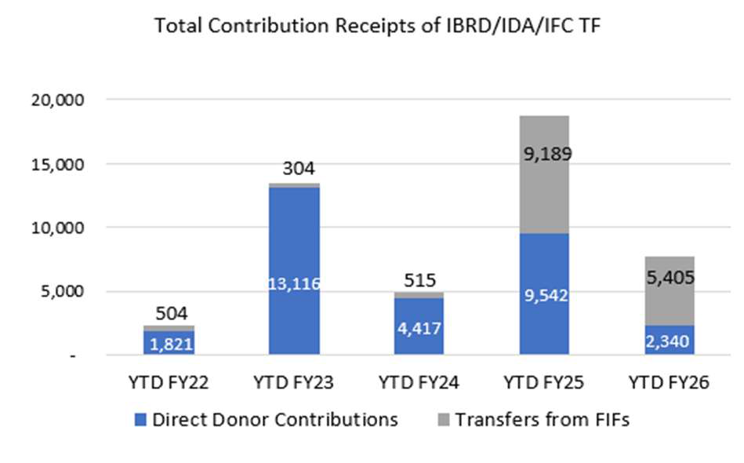

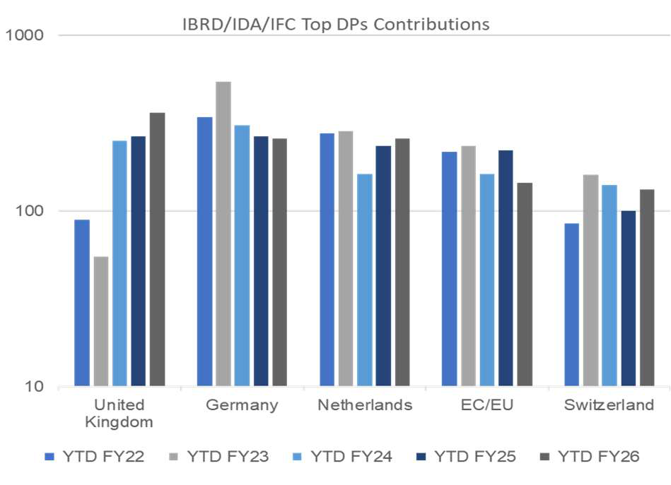
Trust Fund Financial Information Summary for the six months ended December 31, 2025 and 2024 All amounts in USD millions, unless otherwise noted
Portfolio at a Glance - IBRD/IDA/IFC Trust Funds
 | Contributions | Investment Income Disbursements Fund Balance
YTD FY26 | $2,340 $434 $9,770 $14,885
YoY change %
75% | 4% | 10% | 32%

Key Metrices
Cash contributions | On an average, 31% of overall contributions
received by IBRD/IDA/IFC TFs are from FIFs,
where IBRD/IDA/IFC play an implementing
agency (IA) role. FIFs therefore, indirectly
contribute to the IBRD/IDA/IFC trust funds
activity.
Around 99% (YTD FY25 98%) of the FIF transfers
to IBRD/IDA/IFC TFs during YTD FY26 were from
5 FIFs and these accounted for 98% (YTD FY25
96%) from YTD FY22 to YTD FY26. The decrease
in YTD FY26 is mainly due to lower FIF transfers
to FORTIE by $3,500m compared to YTD FY25.
Top 10 donors accounted for 66% of the total
IBRD/IDA/IFC TFs contributions during YTD FY26
with the top 5 accounting for 49% of the
contributions.
There has been an increase in contributions from
United Kingdom in YTD FY26 ($97m) compared
to YTD FY25 largely due to contributions received
towards GFF and SCALE, partially offset by lower
contributions in ARTF.
5
1

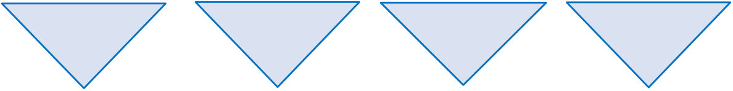
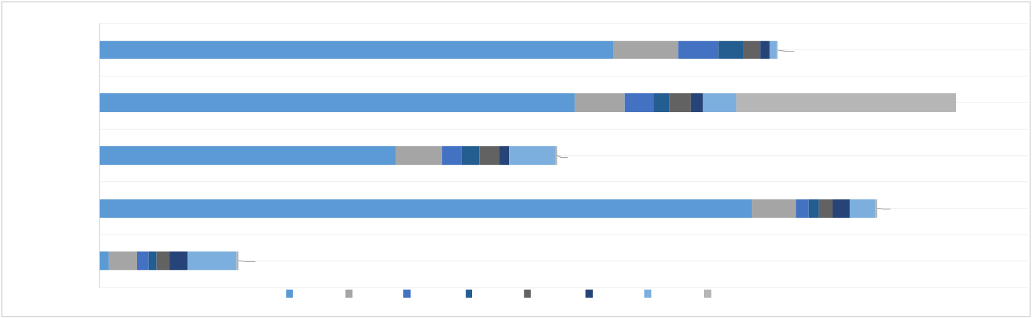
Trust Fund Financial Information Summary for the six months ended December 31, 2025 and 2024 All amounts in USD millions, unless otherwise noted
Portfolio at a Glance - IBRD/IDA/IFC Trust Funds
 | Contributions | Investment Income Disbursements Fund Balance
YTD FY26 | $2,340 $434 $9,770 $14,885
YoY change %
75% | 4% | 10% | 32%

Key Metrices
Cash Disbursements
YTD FY26 | 71 | 56 |  | 139 | 370 | 4,471 | Disbursements for RE Activities by Region |  |  |  |  |  |  |  |  |  |  |  |  |  |  | 73 |  | 6 |  |  |  | 12
 |  |  |  |  |  |  | 7,755 |  |  |  | 486 |  |  |  |  |  |  | 305 |  | 191 | 123 |  | 54
YTD FY25 |  |  |  |  |  |  | 7,169 |  |  |  | 374 |  |  |  |  | 118 94  219 162 251 |  |  |  |  |  |  |  | 1,658
YTD FY24 |  |  |  |  |  |  | 349 |  |  | 136 |  | 80 | 350 | 7 |  |  |  |  |  |  |  |  |  | 77 |  | 128
 |  |  |  |  |  |  |  |  |  | 144 | 147
YTD FY23 |  |  |  |  |  |  | 9,837 |  |  |  | 333
 |  |  |  |  |  |  |  |  |  |  |  |  |  |  |  |  |  |  |  |  |  |  |  | 94 | 106 |  | 197
YTD FY22 | 214 | 90 | 95 |  |  | 16 | ECA | AFE | MNA |  | EAP |  | AFW |  | LCR |  | SAR |  | OTH
Disbursements from ECA region increased in YTD FY26 (↑$586m) primarily due to higher disbursements for TFs supporting Ukraine under FORTIE and URTF.
In disbursements for RE activities, ECA and AFE regions accounts for 92% of disbursements in YTD FY26, and on an average of 85% in the last 5 years.
In YTD FY26, disbursements significantly decreased in OTH regions due to $1,600m transferred to IDA through IDASTF in FY25.
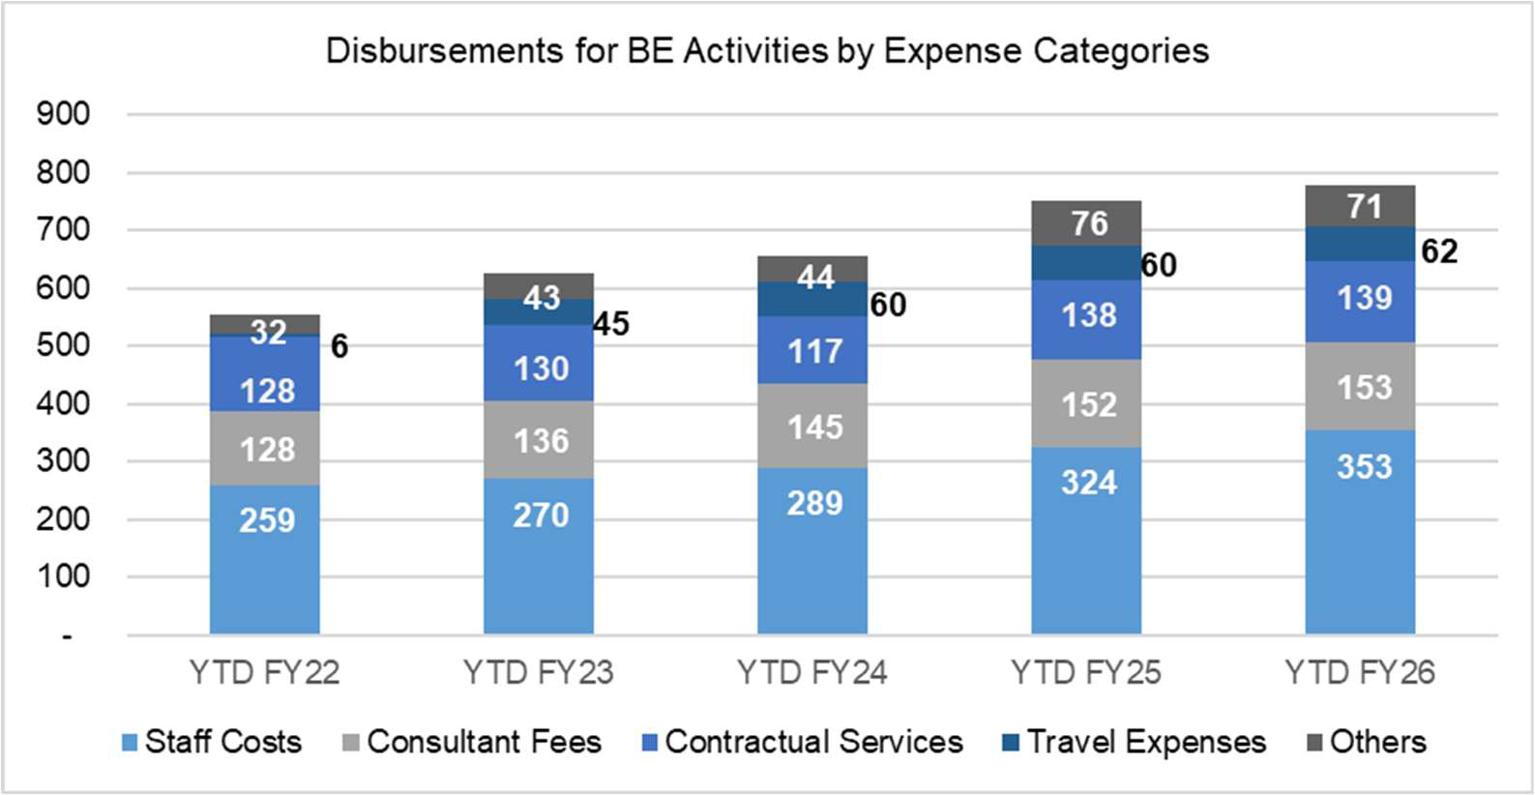
− Staff costs continued to be the largest expense category over the past 5 periods with the CAGR of 8%. CAGR of consultant fee category is at 5%.  
6
1

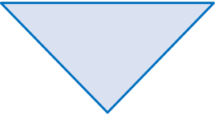
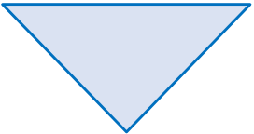
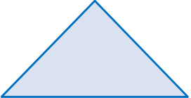
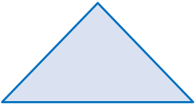
Trust Fund Financial Information Summary for the six months ended December 31, 2025 and 2024 All amounts in USD millions, unless otherwise noted
Portfolio at a Glance - FIFs
Contributions Investment Income Disbursements Fund Balance
YTD FY26 | $5,804 $1,208 $4,715 $45,640
YoY change % | 79% | 37% | 3% | 1%

Key Metrices
Contribution and Disbursements  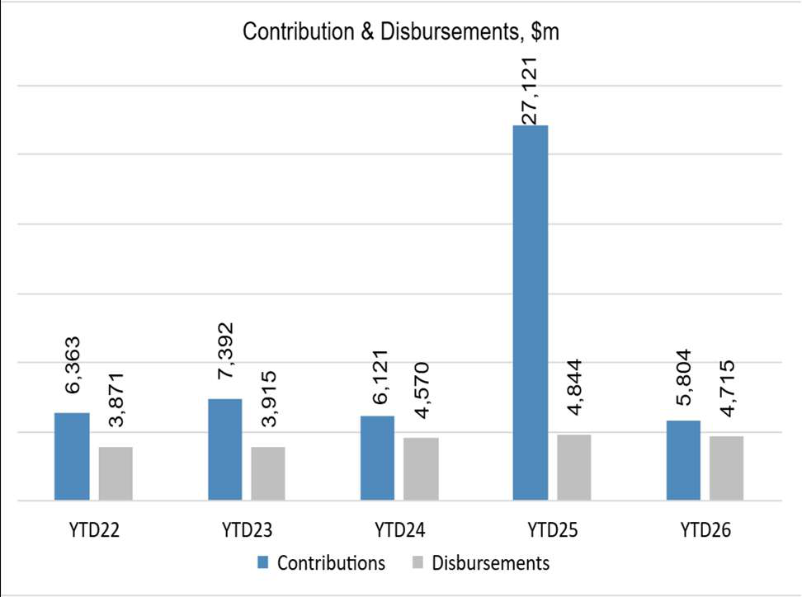 | Cash contributions  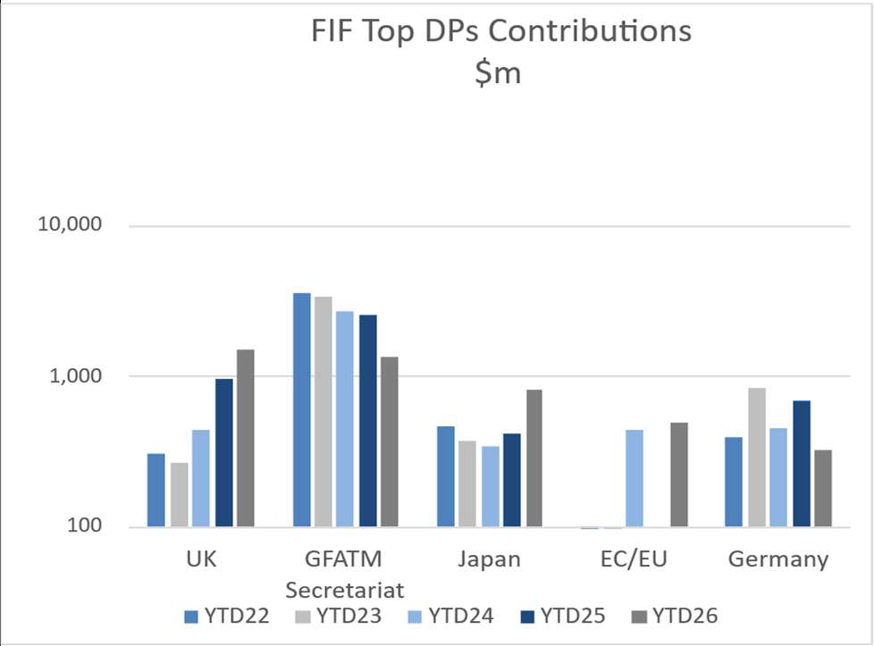
•  •  •  •  • | In YTD 26, United Kingdom and GFATM Secretariat has been the top donor constituting 49% of the total contributions received.  Significant decline in contribution in YTD 26 compared to YTD 25, due to funding of $20,000m received towards the FORTIS in YTD 25.  In YTD 26, United Kingdom have increased their contributions towards CIF and GCF, Japan towards FORTIS and EU towards GPEF and PPPR.  Top 3 donors United Kingdom, GFATM Secretariat and Japan accounted for 63% of the total contributions in YTD 26 and an average of 51% from YTD 22 to YTD 26.  Disbursements from GFATM, GCF and IFFIM programs accounted for 64% of total disbursement during YTD 26 and on an average 68% from YTD 22 to YTD 26.

7
1

Trust Fund Financial Information Summary for the six months ended December 31, 2025 and 2024 All amounts in USD millions, unless otherwise noted
Trust Fund YTD FY26 Key Highlights
•Ukraine continues to receive support from the international community. In YTD FY26, contribution receivables from Japan, through the Japan International Cooperation Agency (JICA), have reached $2,470m. This contribution is being provided in installments over several years. Further, Ukraine disbursements with IBRD as Implementing Entity reached $7,372m ($1,000m in YTD FY25), equivalent to a 637% increase compared to the previous year. Disbursement amounts vary depending on the timing and verification of eligible expenditures submitted by the Ukrainian government.
•The Bank will serve as the Trustee for the Tropical Forest Forever Facility (TFFF) FIF that is designed to become the largest-ever global forest fund, aims to ensure continuous and performance-based financing to countries and communities that successfully conserve tropical forests, recognizing their essential role in regulating the climate, preserving biodiversity, and supporting sustainable development.
•Following the adoption of the UN Security Council resolution, Gaza Reconstruction and Development Fund (GRAD) has been established as a FIF, with the World Bank serving as limited trustee. The GRAD Fund will receive donor contributions to fund recovery, reconstruction, and development activities in Gaza. The
• | Bank, as limited Trustee, will transfer the Fund's resources to the Board of Peace which has been authorized by United Nations Security Council to undertake the activities  In September 2025, IBRD authorized an immediate transfer of $300 million from IBRD’s surplus, by way of
grant, to replenish the Trust Fund for Gaza and the West Bank (WBGBK). This transfer is to be drawn down by IDA.
•TF reforms continued in YTD FY26 with an aim to reduce fragmentation, increase strategic alignment and improve efficiencies of the trust fund portfolio by using fewer and larger Umbrella 2.0 Programs. As of December 31, 2025, 75 Umbrella programs (146 active trust funds) have been established. CWA and DPI TF are new programs established in YTD FY26. CWA will support African countries in promoting regulatory reforms and is an increasingly urgent priority given the scale of the jobs challenge across the continent.
DPI-TF aims to increase the adoption and productive use of safe and inclusive Digital Public Infrastructure (DPI) and digitally enabled services by individuals, businesses, and governments.
Top 3 trust funds activated during the fiscal year ended December 31, 2025, on the basis of Expected Funding
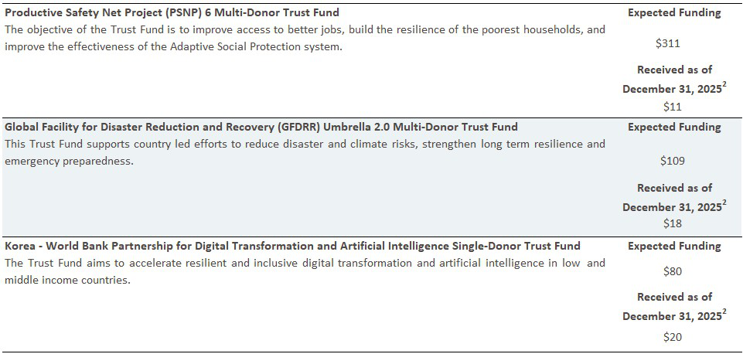
2DP’s contributions to the trust funds are based on installment schedules agreed per administration agreements. Hence, the total funding
for the trust funds is not expected to be fully received as of December 31,2025.
8
1

Trust Fund Financial Information Summary for the six months ended December 31, 2025 and 2024 All amounts in USD millions, unless otherwise noted
Key Trust Fund Activity
Composition of Active Trust Funds31
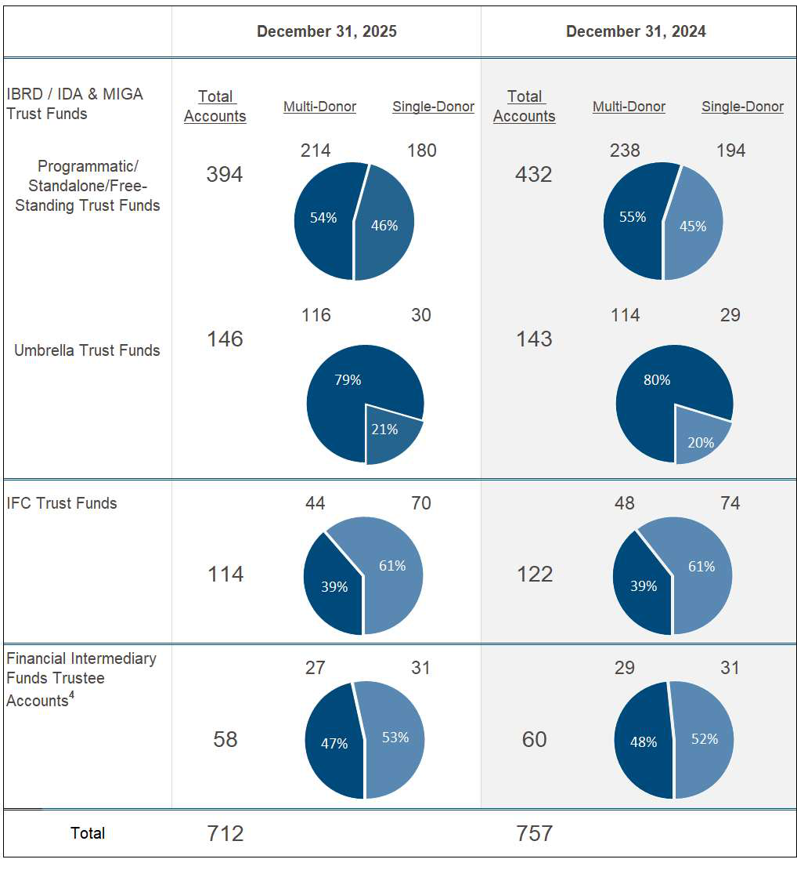
The FIF portfolio has continued to grow, from a base of 9 programs in 2008 to 26 active programs as of December 2025. The major sectors in FIF are Environment and Climate change (12 FIF programs), Health (4 FIF programs) and Agriculture (3 FIF programs).
3The count is based on number of trust funds established as trustees under program types - Umbrella, Programmatic, Standalone and Free-standing. Apart from the active trust funds above there are DP balance accounts established to hold unused funds from closed trust funds, investment income earned on active trust fund balances, or to hold DP contributions temporarily awaiting establishment of a project trust fund. The total number of such active DP balance accounts as of December 31, 2025, is 361 and December 31, 2024, is 352.
4 FIF Programs may be administered through the use of multiple accounts. There are 26 FIF programs (December 2024: 28) comprising multiple FIF trustee accounts.
10
1

Trust Fund Financial Information Summary for the six months ended December 31, 2025 and 2024 All amounts in USD millions, unless otherwise noted
Key Trust Fund Activity
Composition of Active Umbrella Programs2
As of December 31, 2025, 75 umbrella programs comprising of 146 TFs have Funds-Held in Trust (FHIT) of $6,426m. Cash contributions and disbursements of these programs during YTD FY26 were $1,165m and $763m.
Description | As of December 2025 |  | YTD FY26
 | FHIT | No of  Programs | Cash  Contribution | Disbursement
Global Practices | 4,060 | 52 | 731 | 391
Regions | 2,011 | 22 | 389 | 372
Institutional Services | 355 | 1 | 45 | -
Total | $6,426 | 75 | $1,165 | $763

Global Practices | As of December 2025 |  | YTD FY26
 | FHIT | No of  Programs | Cash  Contribution | Disbursement
GP-Health, Nutrition and Population (HNP) | 1,548 | 4 | 207 | 96
GP-Energy and Extractives (EEX) | 464 | 2 | 69 | 62
GP-Environment, Natural Resources and Blue Economy (ENB) | 444 | 3 | 49 | 34
GT- Climate (CCG) | 316 | 3 | 109 | 24
GP-Urban, Resilience and Land (URL) | 233 | 4 | 54 | 25
GP-Agriculture (AGF) | 208 | 1 | 8 | 21
GP-Education (EDU) | 115 | 2 | 32 | 18
Others | 732 | 33 | 203 | 111
Total | $4,060 | 52 | $731 | $391

Regions | As of December 2025 |  | YTD FY26
 | FHIT | No of  Programs | Cash  Contribution | Disbursement
Europe and Central Asia (ECA) | 960 | 2 | 203 | 236
Africa East (AFE) | 461 | 7 | 42 | 66
Middle East and North Africa (MNA) | 386 | 8 | 73 | 52
Africa West (AFW) | 111 | 2 | 54 | 6
East Asia and Pacific (EAP) | 60 | 1 | - | 11
South Asia (SAR) | 33 | 2 | 17 | 1
Total | $2,011 | 22 | $389 | $372
The LPF program initiated within CU-DFI business unit has been classified under Institutional Services.
11
1

Trust Fund Financial Information Summary for the six months ended December 31, 2025 and 2024
All amounts in USD millions, unless otherwise noted
Key Trust Fund Activity
Active Grants3
Grants represent funds which are provided from a trust fund to the Bank or a recipient to implement the trust fund activities.
Total Number of Active Grants
1,153 | 9,233
1,073 | 8,848
Total Value of Active Grants
Dec 31 2025 | BE Activities | RE Activities | $34,582 |  | $42,697
Dec 31 2024 |  |  |  | $48,311 | $56,103
Top 5 Trust Funds by Grant Amount (as of December 31, 2025)
Program | # of Active Grants | Grant Amount
FORTIE5 | 5 | $16,002

ARTF | 48 | $3,113

GPEF5 | 206 | $2,646

IFC | 1,222 | $1,805

CIF5 | 142 | $1,803
As of December 2025, Ukraine has 30 active grants for RE activities totaling $17,865m and 104 grants for BE activities amounting to $191m. The majority of RE grants in Ukraine are implemented through the FORTIE and URTF programs.
5 Grants shown under FORTIE, GPEF and CIF represent projects under their implementing agency/secretariat trust funds.
12 1

Trust Fund Financial Information Summary for the six months ended December 31, 2025 and 2024

Key Trust Fund Activity

All amounts in USD millions, unless otherwise noted

Disbursements and FIF Transfers 6
YTD 2026 YTD 2025
$14,485 $15,640
There has been a decrease in disbursements and FIF transfers by $1,155m ( 7%) during YTD FY26 as compared to
YTD FY25. Of these, FIF transfers decreased by $129m, disbursements from IBRD/IDA trust funds decreased by
$1,038m and IFC trust funds increased by $12m.
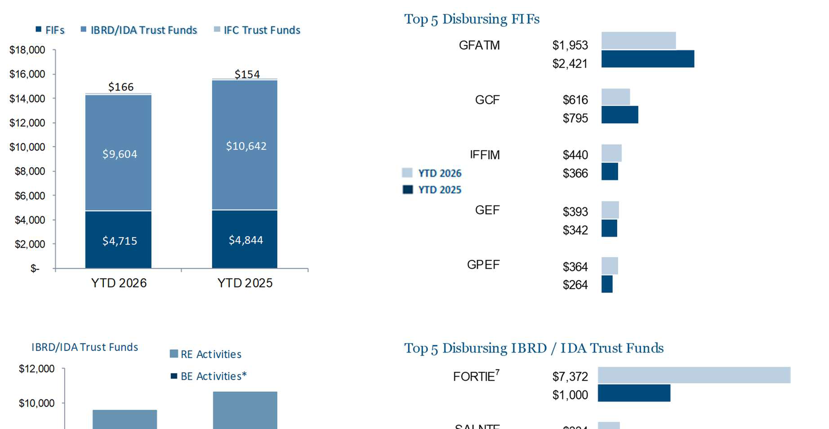
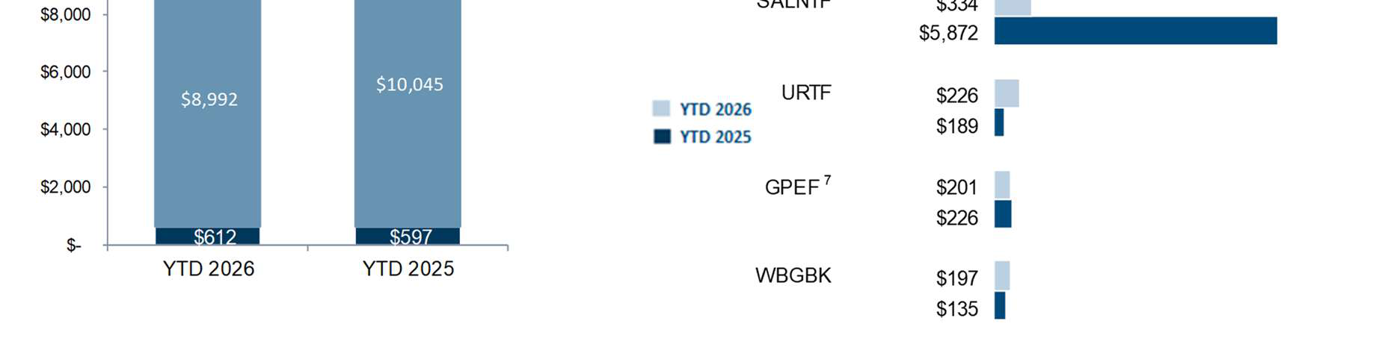
*Includes indirects costs of $33m for YTD FY26 ($37m for YTD FY25).
In FIF programs, the top 3 FIFs constituted 64% of the total FIF disbursements (YTD FY25 74%) of which GFATM constituted about 41% (YTD FY25 50%).
In the IBRD/IDA TFs, disbursements for RE activities amounted to $8,992m (YTD FY25 $10,045m), with 86% of these disbursements occurring in the ECA region (YTD FY25 71%). The decrease in RE disbursements in YTD FY26 is attributed to lower disbursements of trust funds supporting Ukraine through the SALNTF and Free Standing TF programs by $7,295m, partially offset by increase in Disbursements through FORTIE programs by $6,371m. Disbursements for RE activities are generally affected by the prevailing country environment, including capacity constraints, political environment, and other factors.
Disbursements for BE activities increased by $15m (3%) in YTD FY26 when compared to YTD FY25 primarily due to increase in staff costs and advisory management expenses by $9m each.
________________
6FIF transfers exclude transfers made from FIFs to (i) IBRD/IDA/IFC as implementing Agency (IA) (ii) IBRD/IDA for administrative expenses
as trustee and the expenses of in-house secretariats which are included in disbursements from IBRD/IDA trust funds.
7Includes disbursements by IBRD/IFC as Implementing Agency and Secretariat costs.
13
1

Trust Fund Financial Information Summary for the six months ended December 31, 2025 and 2024
Key Trust Fund Activity | All amounts in USD millions, unless otherwise noted
Undisbursed Commitments4
Commitments refer to the amount of financing approved for project(s) or activity(ies) at the grant level. Undisbursed commitments refer to balance of commitments pending disbursement or transfers.
December 31, 2025 |  | December 31, 2024  $51,532
$38,491
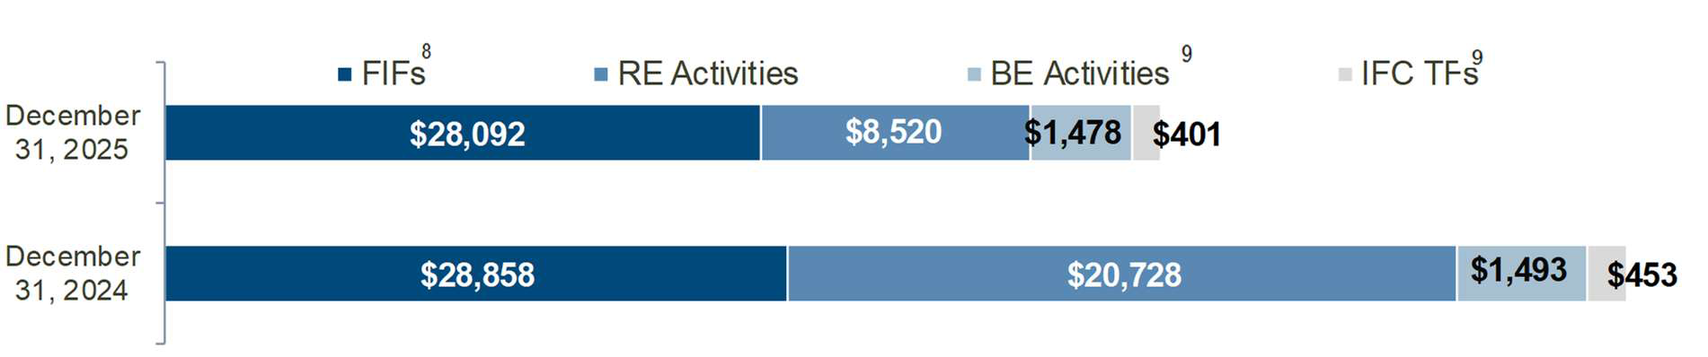
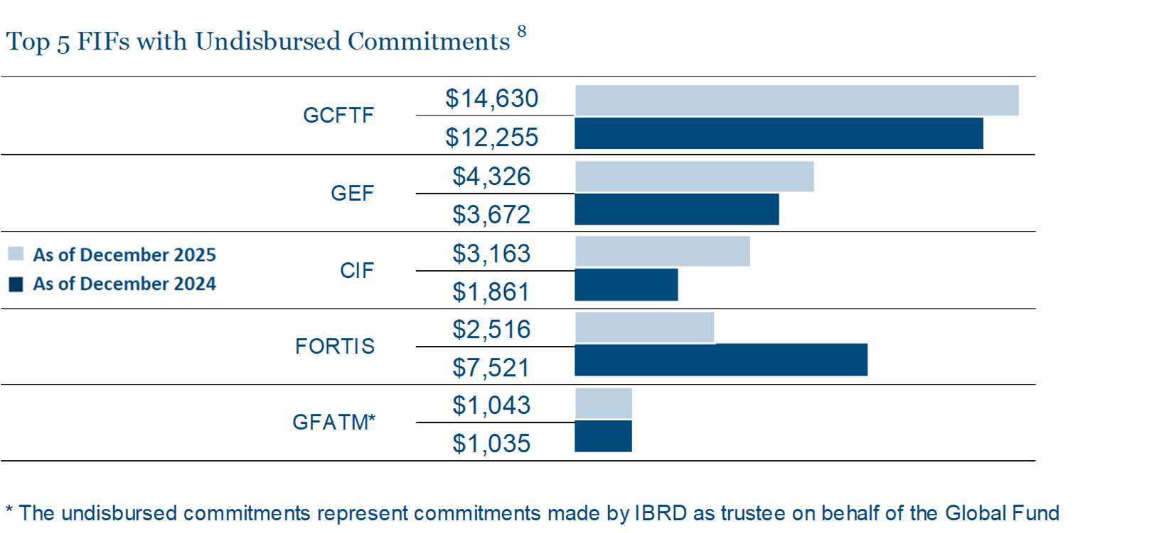
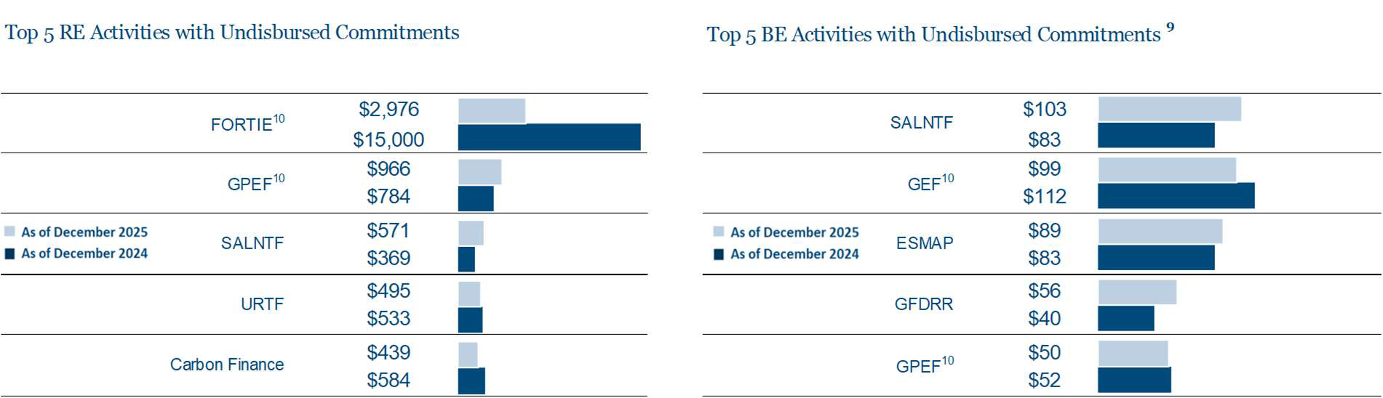
8 For FIFs, liabilities to implementing agencies for projects, fees and administrative budgets are considered as undisbursed commitments. 9 The available fund balances in disbursing funds are considered as undisbursed commitments for BE activities and IFC trust funds. 10 Includes undisbursed commitments of trust funds where IBRD/IFC is an Implementing Agency/Secretariat.
14 1

Key Trust Fund Activity | Trust Fund Financial Information Summary for the six months ended December 31, 2025 and 2024 All amounts in USD millions, unless otherwise noted
New Commitments
New commitments for BE activities and IFC trust funds represents the balance of unused commitments, netting off cancellations when trust funds are closed.
5 | 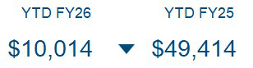
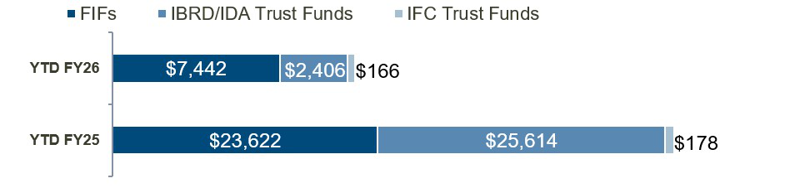
In FIF programs, commitments have decreased by 68% primarily towards FORTIS ($16,023m), PPR ($555m) and GFATM ($467m). New commitments have increased for GCFTF ($420m), LDC ($178m) and GEF ($154m).
In IBRD/IDA TFs, commitments have decreased by 91% mainly towards FORTIE ($16,000m), SALNTF ($5,421m) and IDASTF ($1,650m). For SALNTF, commitments have decreased primarily due to decline in commitments for two TFs supporting Ukraine which had significant increase during previous YTD FY25. These decreases in new commitments have been marginally offset by increase in GPEF ($90m), WBGBK($78m) and GFF ($57m).
15
1

Trust Fund Financial Information Summary for the six months ended December 31, 2025 and 2024 All amounts in USD millions, unless otherwise noted
Key Trust Fund Activity
New Administration Agreements
New administration agreements signed between the Bank Group and DPs represents contributions made to new trust funds and additional contributions made to existing trust funds. These are presented net of cancellations. Negative amounts represent cancellations in excess of additional contributions during the period.
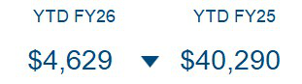
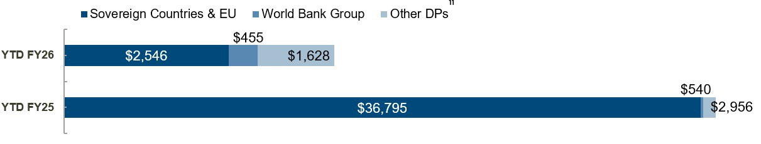
Top 10 Sovereign Countries and EU
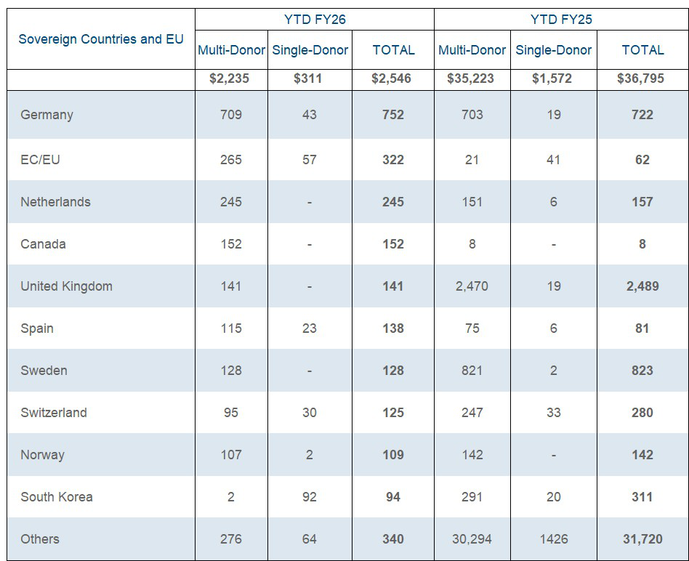
__________________
11Other DPs includes multilateral development banks, United Nations agencies, and public and private institutions. Out of the total 1,628m
in Other DPs (YTD FY25 $2,956m), $1,278m pertains to GFATM Secretariat (YTD FY25 $2,555m).
16
1

Trust Fund Financial Information Summary for the six months ended December 31, 2025 and 2024 All amounts in USD millions, unless otherwise noted
Key Trust Fund Activity
New Administration Agreements (Cont’d)
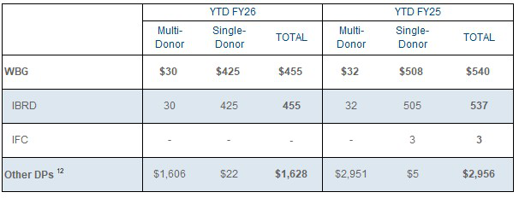
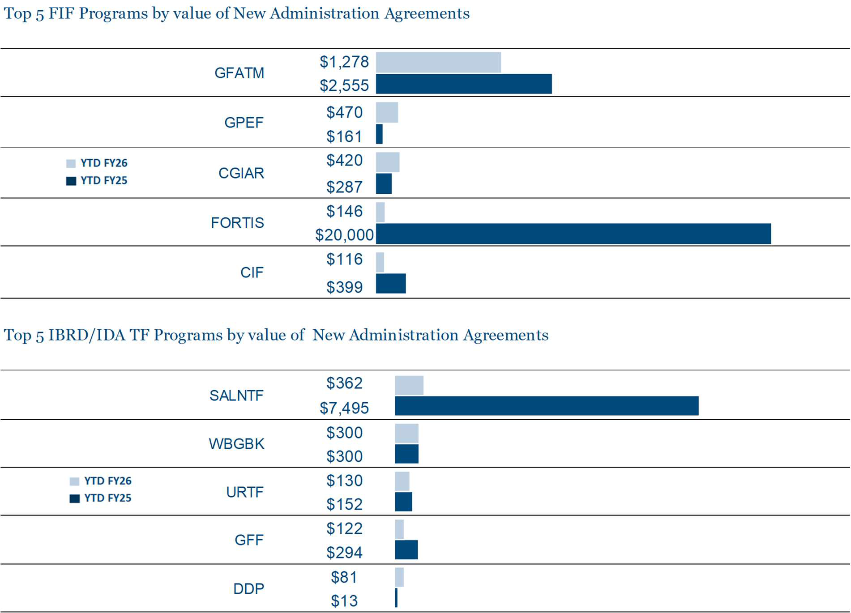
In FIF programs, during YTD FY26, new agreements were signed by Germany and EC towards GPEF for $457m and Canada towards FORTIS for $146m, constituting 22% of the total FIF agreements for YTD FY26. Decline in new agreements during YTD FY26 was due to $20,000m signed by United States towards FORTIS during YTD FY25. New agreements have also declined in YTD FY26 for GCFTF by $4,646m and GFATM by $1,277m.
In IBRD/IDA TFs, the decrease during YTD FY26 was due to decline in SALNTF new agreements by $7,133m mainly towards trust funds supporting Ukraine, such as the Co-financing of the public expenditures for administrative capacity endurance MDTF, and Advancing needed credit enhancement SDTF. There has also been a decrease in new agreements for IDASTF during YTD FY26 by $1,594m.
__________________
12 Other DPs include multilateral development banks, United Nations agencies, and public and private institutions. Out of the total 1,628m in
Other DPs (YTD FY25 $2,956m), $1,278m pertains to GFATM Secretariat (YTD FY25 $2,555m).
17
1

Trust Fund Financial Information Summary for the six months ended December 31, 2025 and 2024 All amounts in USD millions, unless otherwise noted
Contribution and Receivables
Cash Contributions
YTD FY26 |  | YTD FY25
$8,144 |  | $36,663
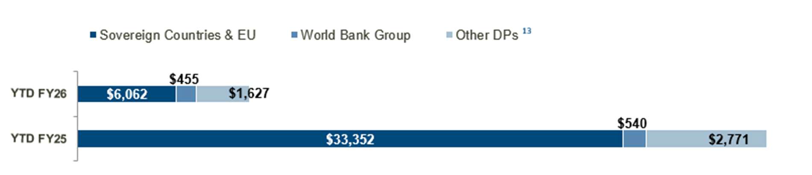
Top 10 Sovereign Countries and EU
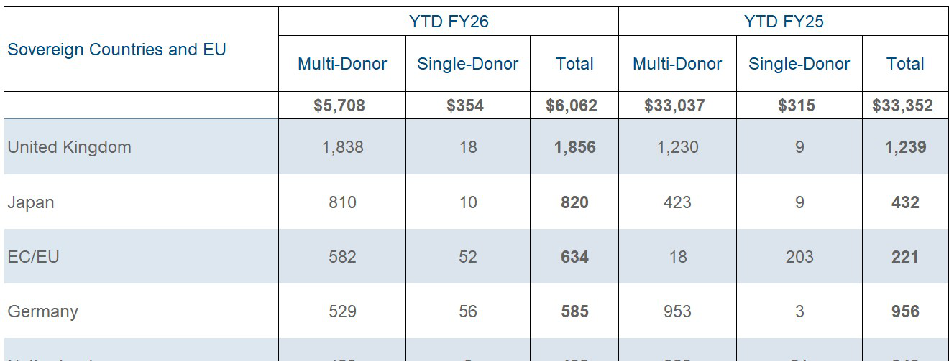
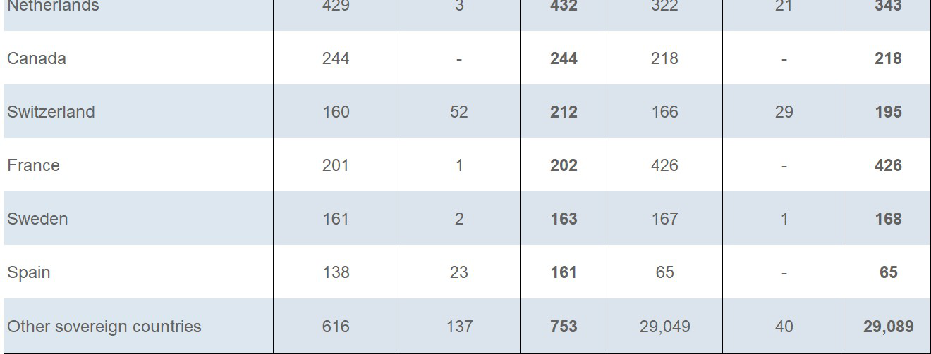
__________________
13 Other DPs include multilateral development banks, United Nations agencies, and public and private institutions. Out of the total $1,627m in Other DPs (YTD FY25 $2,771 m), $1,336m pertains to GFATM Secretariat (YTD FY25 $2,555m).
18
1

Trust Fund Financial Information Summary for the six months ended December 31, 2025 and 2024
Contribution and Receivables | All amounts in USD millions, unless otherwise noted
Cash Contributions (cont’d)
Contributions received from WBG and Other DPs6
 | YTD FY26 | YTD FY25
 | Multi-Donor Single Donor Total | Multi-Donor Single-Donor Total
WBG | $30 $425 $455 | $32 $508 $540
IBRD  IFC | 30 425 455  - - - | 32 505 537  - 3 3
Other DPs 14 | $1,604 $23 $1,627 | $2,759 $12 $2,771
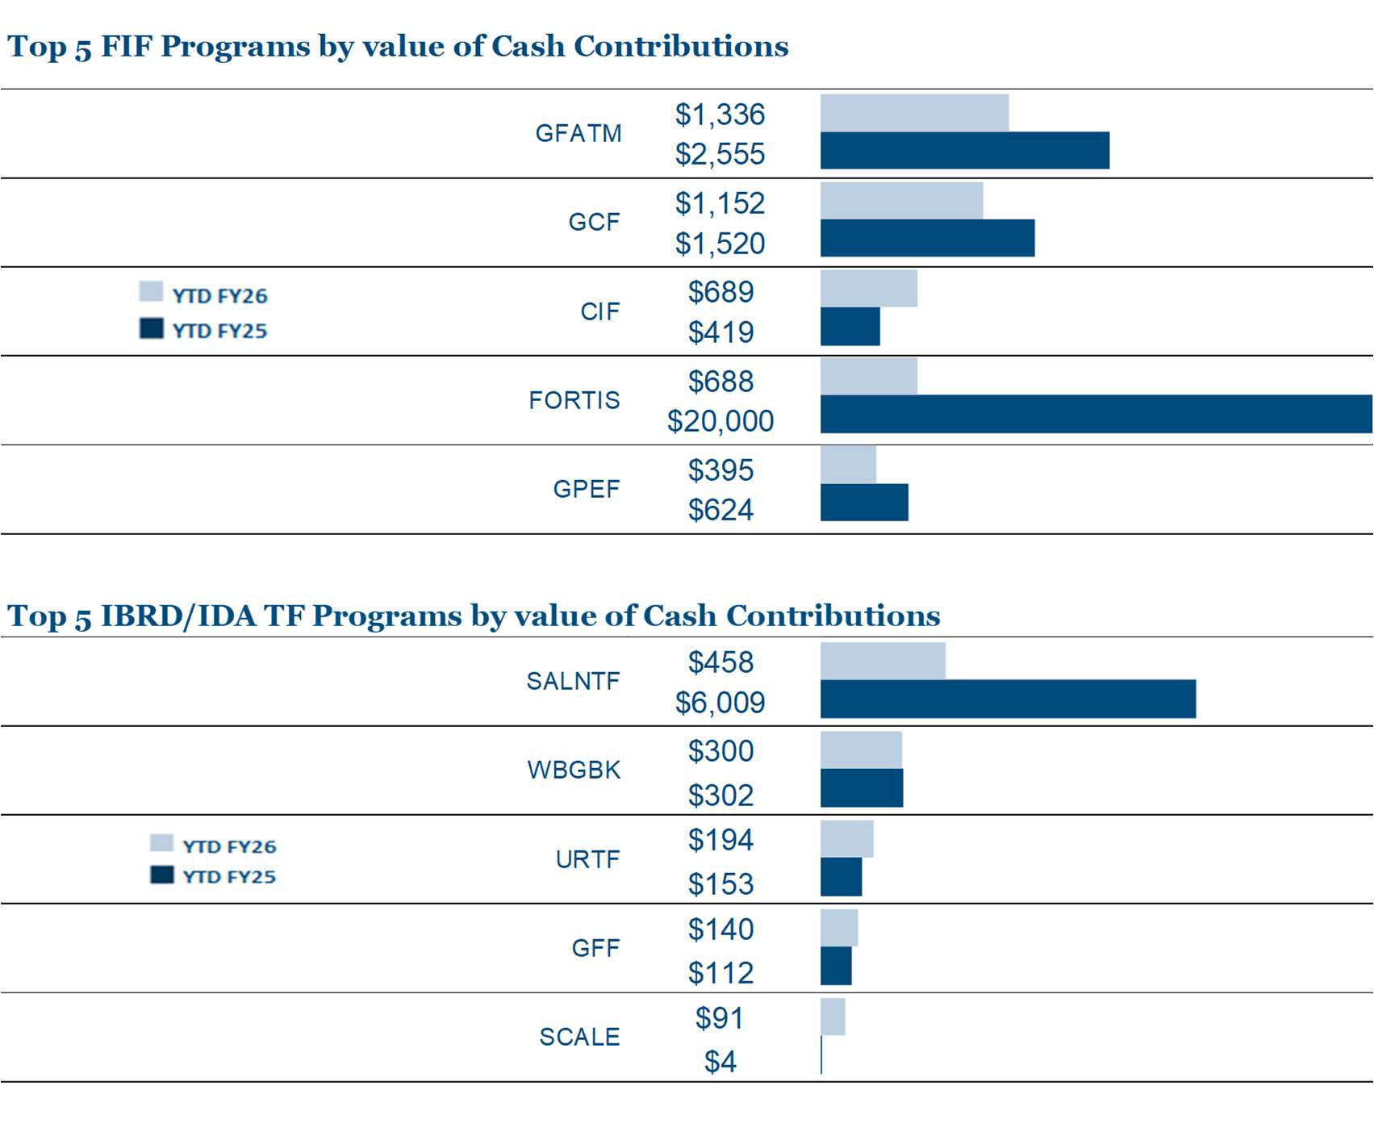
Health sector accounts for 31% (12% in YTD FY25) of the total FIF contributions primarily represented by GFATM. Further, Climate sector accounts for 44% (10% in YTD FY25) primarily represented by GCF and CIF.
In IBRD/IDA TFs, contributions have decreased as a result of lower contributions to TFs supporting Ukraine (Europe and Central Asia region) through SALNTF and FS-CFP programs where United States has made significant contribution in YTD FY25. IBRD has also transferred $300 from surplus, by way of grant, to WBGBK during YTD FY26.
14 Other DPs include multilateral development banks, United Nations agencies, and public and private institutions. Out of the total $1,627m in Other DPs (YTD FY25 $2,771 m), $1,336m pertains to GFATM Secretariat (YTD FY25 $2,555m).
19
1

Trust Fund Financial Information Summary for the six months ended December 31, 2025 and 2024
Contribution and Receivables | All amounts in USD millions, unless otherwise noted
Contributions Receivable (Cont’d)7
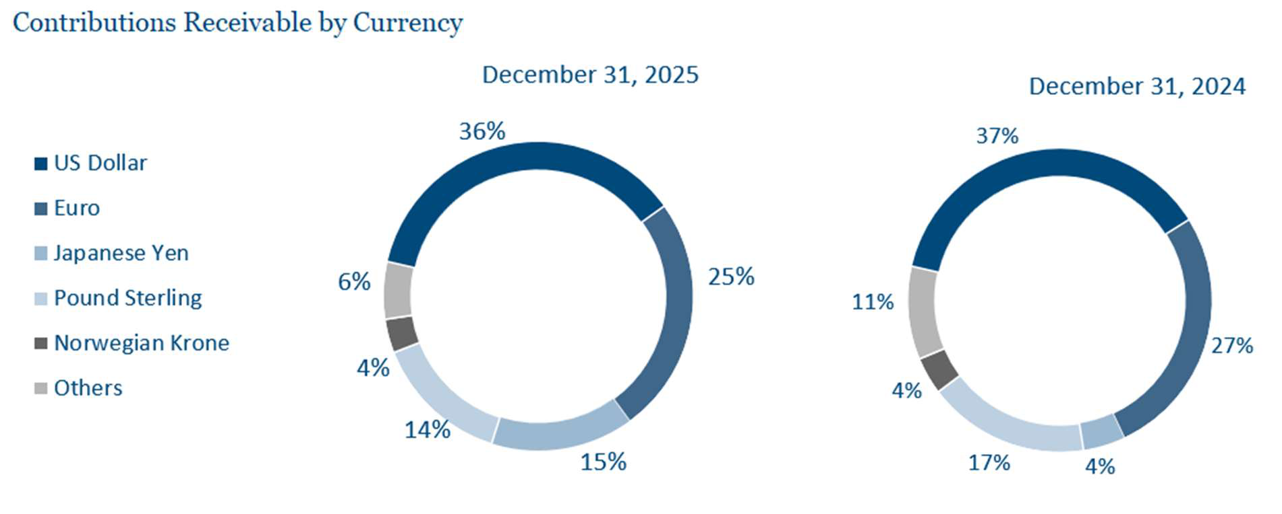
Top 5 Sovereign Countries, EU and Other DPs
 | December 31, 2025 | December 31, 2024
Sovereign Countries and EU | $18,689 | $19,691
Japan  United Kingdom  Germany  United States  France  Other sovereign countries | 6,623  2,877  2,536  1,149  926  4,578 | 4,575  3,658  2,309  1,622  1,227  6,300
Other DPs 16 | $1,308 | $1,432
16 Other DPs includes multilateral development banks, United Nations agencies, and public and private institutions but does not include receivables from WBG entities amounting to $14m as of December 31,2025 ($14m as of December 31, 2024).
21 1

Trust Fund Financial Information Summary for the six months ended December 31, 2025 and 2024 All amounts in USD millions, unless otherwise noted Contributions and Receivables
Promissory Notes Receivable8
December 31, 2025 |  | December 31, 2024 | In certain programs, contributions receivable are settled
 |  |  | through deposit of promissory notes, which are
$13,409 |  | $12,119 | subsequently encashed based on schedules agreed with
 |  |  | the DPs, and are recorded as cash contributions upon
encashment.
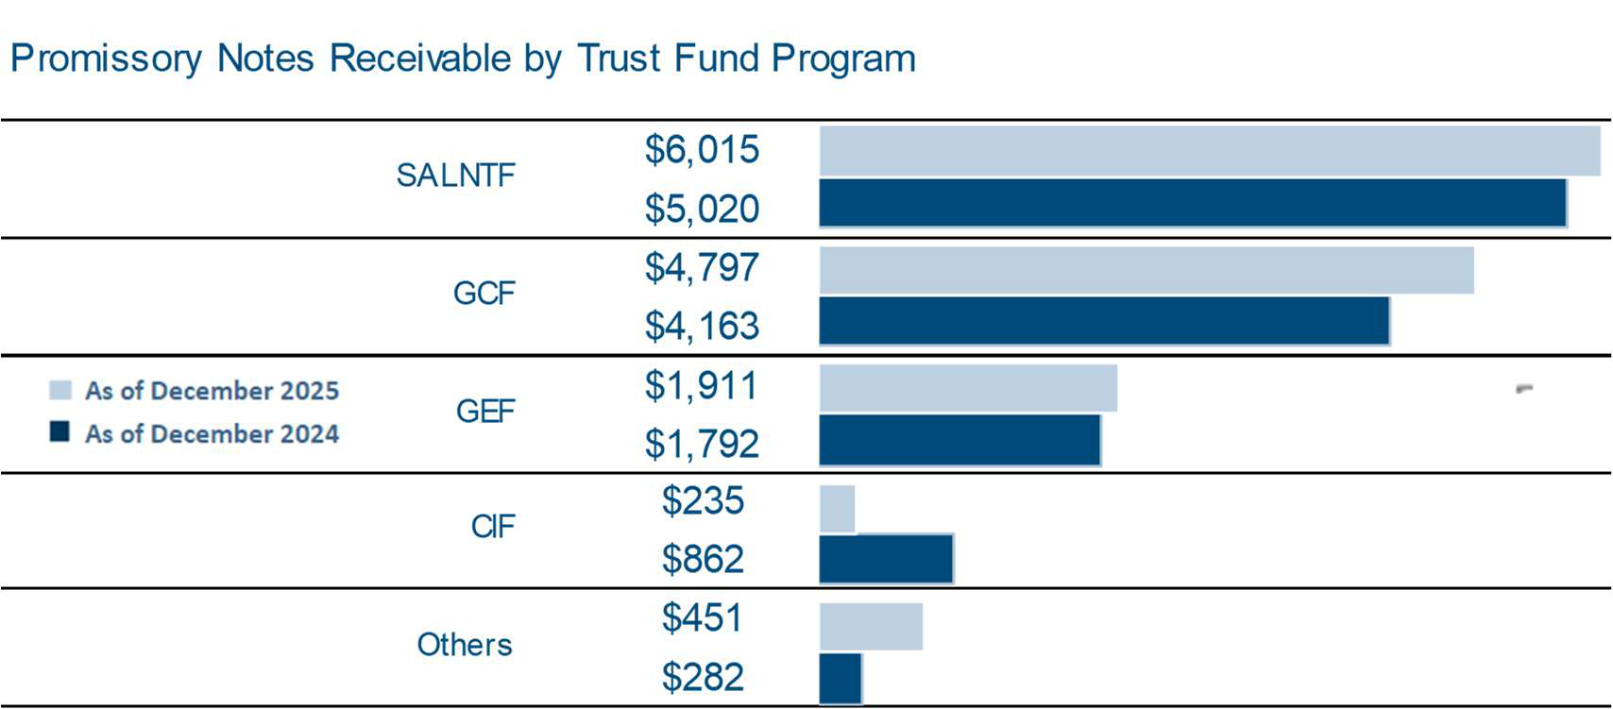
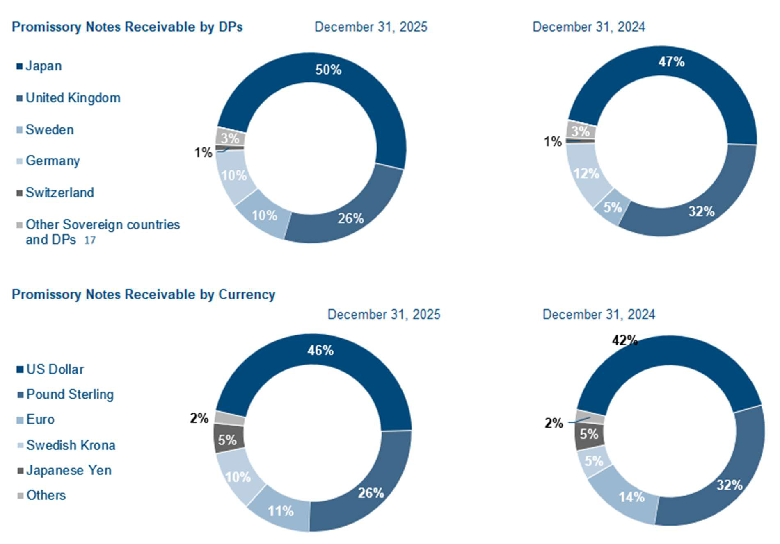
The promissory note receivable ($5,000m) from Japan as contribution to the trust fund for advancing credit enhancement for Ukraine through SALNTF remains outstanding as of December 2025.
17 Other DPs include multilateral development banks, United Nations agencies, and public and private institutions.
22
1

Contributions and Receivables | Trust Fund Financial Information Summary for the six months ended December 31, 2025 and 2024 All amounts in USD millions, unless otherwise noted
Commitment Authority
Commitment authority represents an upper limit up to which task teams can commit future disbursements at the individual TF level. The classes of assets that a trust fund could commit upon form the trust fund’s Basis of Commitment (BoC). The asset classes that can be committed against are either (i) cash, (ii) cash plus promissory notes, or (iii) cash plus promissory notes and contributions receivable. The default BoC for a trust fund is cash, but may be modified to include promissory notes receivable and/or contributions receivable with the approval of Director(s) in the unit managing the trust fund. The trust funds grouped by BoC types and the funds available for commitments are presented in the table below:
Trust funds with Basis of Commitment as | Contribution Receivable | Promissory Notes  Receivable | Cash 18 | Total TF Assets | Outstanding Commitments | Balance Available to Commit  as of  December 31, 2025
 | A | B | C | D=A+B+C | E | F
Cash (65% of TFs )  Cash and Promissory Notes Receivable (4% of TFs)  Cash, Promissory Notes Receivable, and Contributions Receivable (31% of TFs) | 6,229  7,073  6,709 | 2,992  5,101  5,316 | 31,221  23,504  5,800 | 40,442  35,678  17,825 | 15,258  18,451  4,782 | 15,963  10,154  13,043 | (C-E)  (B+C-E)  (D-E)
TOTAL | $20,011 | $13,409 | $60,525 | $93,945 | $38,491 | $39,160
___________________________________________________________
18 Excludes cash in DP Balance Accounts, funds held in escrow on behalf of ICSID and DPs contributions to be applied to trust funds pending receipt of signed agreements, and balances in administration accounts (IBRD/IFC), totally amounting to $1,263m. RE activities in PEND status and GFRs for RE activities in pipeline (including corresponding fee) are not considered.
23
1

Trust Fund Financial Information Summary for the six months ended December 31, 2025 and 2024
Investments | All amounts in USD millions, unless otherwise noted
Cash and Investments
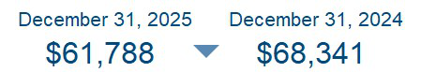
Cash received from DPs contributions, loans from DPs and proceeds from the issuance of bonds (for IFFIM) are managed by IBRD’s Treasury, which manages a commingled investment portfolio (the Pool) for all funds that are administered by the Bank Group entities. The Pool also includes funds held in ICSID's escrow accounts. IBRD maintains all assets underlying the trust funds’ fund balances separate and apart from the assets of the World Bank Group. IBRD, on behalf of the World Bank Group, invests the funds in liquid financial instruments such as government and agency obligations, time deposits, money-market securities and asset-backed securities, as well as swaps and a range of other derivative instruments. Additionally, the pool also include equity securities. The investment composition within the pool is based on the investment horizons and cash flow profiles of the trust fund programs. Net investment income earned by the Pool is allocated to each trust fund based on its share of cash and investments in the Pool.
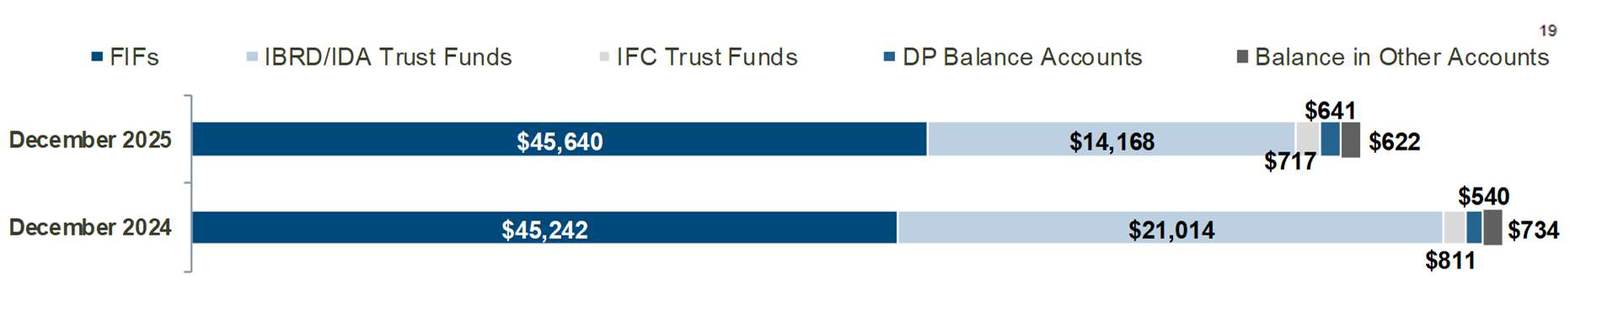
Cash and Investments in DP Balance Accounts
DP balance accounts are established to hold unused funds from closed trust funds, investment income earned on active trust fund balances, or on a temporary basis, subject to separate agreement, funds pending the establishment of another trust fund. The funds in a DP balance accounts may only be returned to the DPs or transferred to other trust funds as a contribution from DPs.
Top 5 DP Balance Accounts | December 31, 2025 | December 31, 2024
Korea  Germany  Saudi Arabia  EC/EU  United States  Others20 | 83  77  45  42  39  355 | 77  48  55  63  32  265
TOTAL | $641 | $540
__________________________________________________
19Primarily represents funds held in escrow on behalf of ICSID and DPs contributions to be applied to trust funds pending receipt of signed agreements, and balances on administration accounts (IBRD/IFC).
20 Others includes balance accounts of Sovereign countries other than the top 5, WBG, multilateral development banks, United Nations agencies, and public and private institutions. Multi-donor holding accounts have also been grouped under others.
24
1

Investments | Trust Fund Financial Information Summary for the six months ended December 31, 2025 and 2024 All amounts in USD millions, unless otherwise noted
Cash and Investments (cont’d)
Investment Income
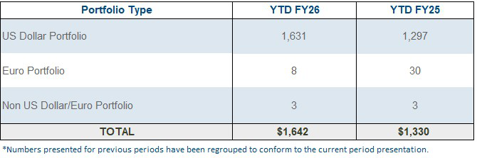
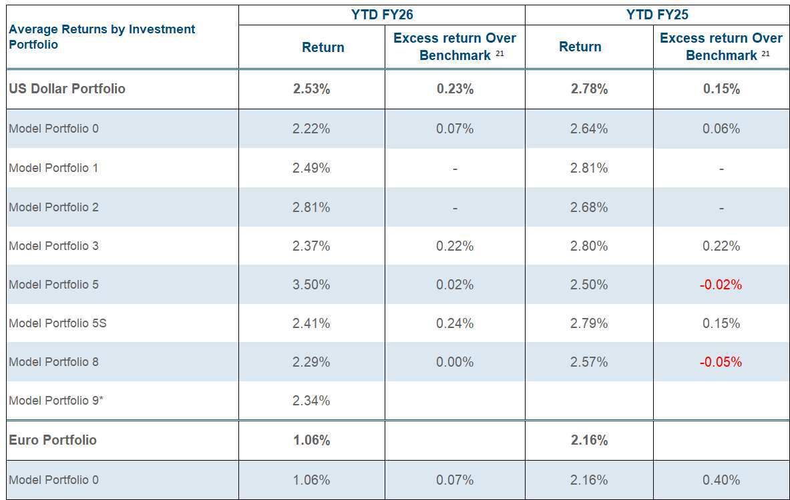
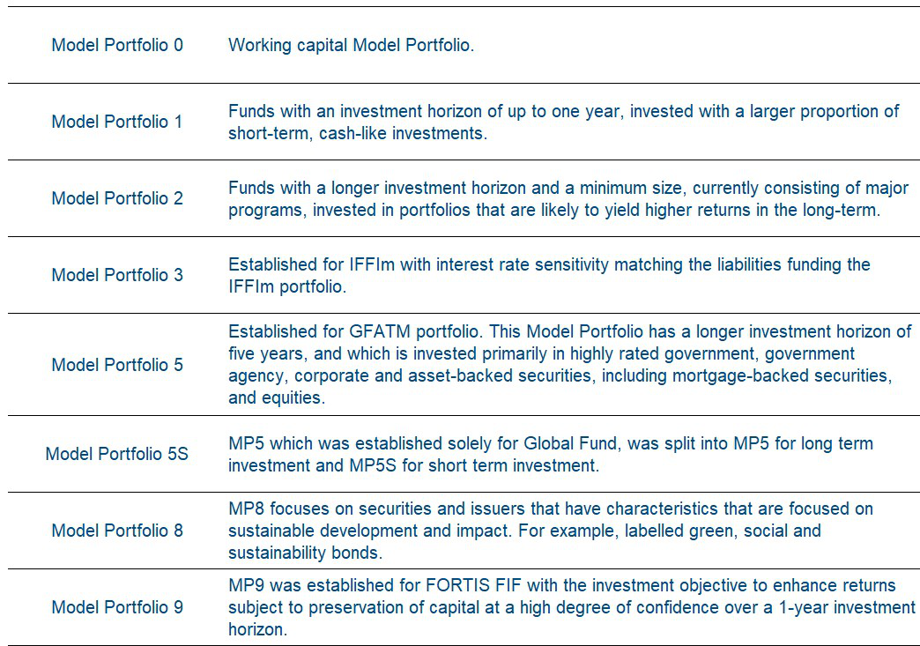
_____________________________________________
21Refers to the return in excess of the benchmarks determined by the WBG Treasury before deducting any investment management fee. * MP9 was newly included in December 2024 hence the average returns are not available in December 2024 MIR.
25
1

Trust Fund Financial Information Summary for the six months ended December 31, 2025 and 2024 All amounts in USD millions, unless otherwise noted Investments
Cash and Investments (cont’d)
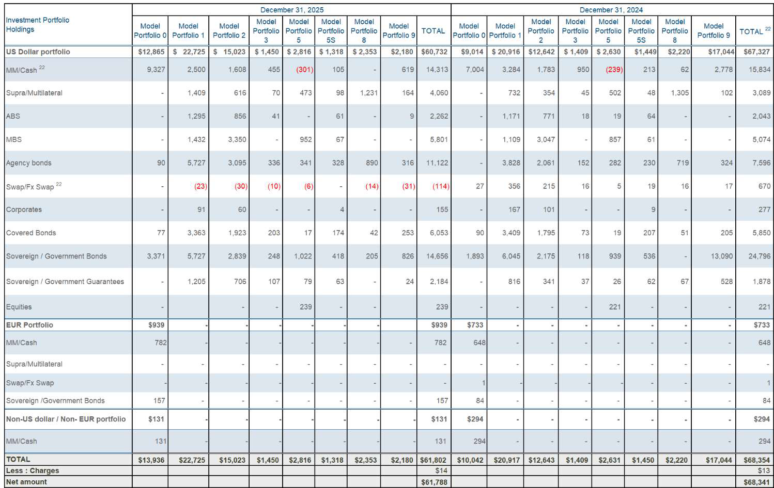
Investment Composition
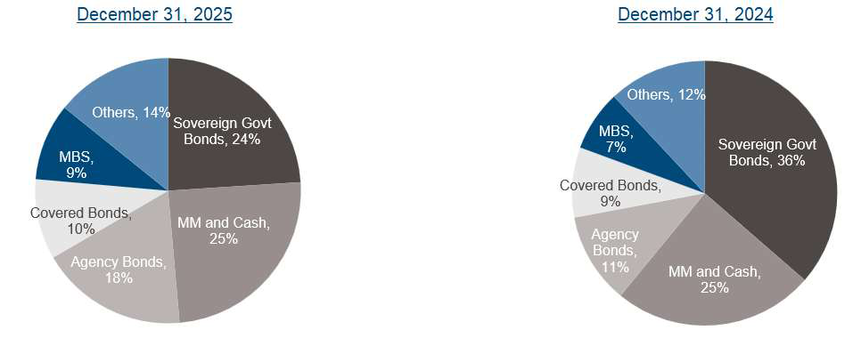
___________________________________________
22 Negative amounts in MM/Cash and Swaps are due to excess payable position over receivable position as of December 31, 2025 and as of
December 31, 2024.
26 1

Trust Fund Financial Information Summary for the six months ended December 31, 2025 and 2024 All amounts in USD millions, unless otherwise noted
Cost Recovery
Cost Recovery
WBG charges administrative fees, pursuant to administrative agreements with DPs to assist in the defrayment
of the costs incurred for the administration, supervision and oversight of trust funds.
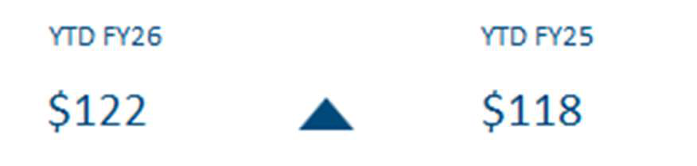
Description | YTD FY26 | YTD FY25
Administrative Fees and Expenses | 89 | 81
Indirects charges on Personnel Cost | 33 | 37
Total Cost Recovery | $122 | $118
Administrative Fee & Expenses Composition:
Description | YTD FY26 | YTD FY25
Fees charged as a percentage of grant commitments | 38 | 29
Fee charged as a percentage of contributions received from donors | 7 | 14
FIF Secretariat fees | 13 | 13
Financial Intermediary funds - Billing | 13 | 11
Fee charged as a percentage on disbursements of BE activities | 16 | 11
Other fees 23 | 2 | 3
Total Administrative Fees and Expenses | $89 | $81
Indirects charges on Personnel Cost Composition:
For BE activities, the computation of personnel costs (Staff costs, Short-Term Consultants/ Temporary Costs (STC/STT) and Extended Term Consultants/Temporary costs (ETC/ETT) includes indirect costs, charged in accordance with Bank policies and procedures.
Description | YTD FY26 | YTD FY25
Staff costs | 22 | 25
Short Term Consultants/Temporary | 9 | 10
Extended Term Consultants/Temporary | 2 | 2
Total Indirects charges on Personnel Cost | $33 | $37
___________________________________________
23 Other fees include any special arrangements, manual fee recovery
27
1

Trust Fund Financial Information Summary for the six months ended December 31, 2025 and 2024 All amounts in USD millions, unless otherwise noted
Cost Recovery
Cost Recovery
Administrative Fees through FIF Billings:
Fees are charged by the respective business units to recover administration costs for providing trustee services
to the FIFs.
Unit | YTD FY26 | YTD FY25
TRE | 5 | 4
DFTFPR | 3 | 3
CRO and Non-Core Units | 3 | 2
CTR | 1 | 1
LEG | 1 | 1
Total FIF Billing Admin Fees per Business Unit | $13 | $11
28
1

