LecturesonStatisticsinTheory: PreludetoStatisticsinPractice
arXiv:1807.05996v4 [physics.data-an] 26 Jun 2024 | RobertD.Cousins∗  Dept.ofPhysicsandAstronomy  UniversityofCalifornia,LosAngeles  LosAngeles,California90095  June26,2024  Abstract  Thisisawriteupoflectureson“statistics”thathaveevolvedfromtheinitialver-sionforthe2009HadronColliderPhysicsSummerSchoolatCERNtoversionsfor othervenuesand,mostrecently,fortheAfricanSchoolofFundamentalPhysicsand Applicationsin2024.Theemphasisisonfoundations,usingsimpleexamplestoil-lustratethepointsthatarestilldebatedintheprofessionalstatisticsliterature.The three main approaches to interval estimation (Neyman confidence, Bayesian, likelihood ratio)arediscussedandcomparedindetail,withandwithoutnuisanceparameters. Hypothesis testing is discussed mainly from the frequentist point of view, with pointers totheBayesianliterature.Variousfoundationalissuesareemphasized,includingthe conditionalityprincipleandthelikelihoodprinciple.
∗cousins@physics.ucla.edu
1

Contents
1 | Introduction |  |  |  |  |  |  |  |  |  | 6
2 | Preliminaries |  |  |  |  |  |  |  |  |  | 7
3 | 2.1 | Whyfoundationsmatter............................. |  |  |  |  |  |  |  |  | 7
 | 2.2 | Definitionsareimportant............................. |  |  |  |  |  |  |  |  | 7
 | 2.3 | Keytasks:Importanttodistinguish....................... |  |  |  |  |  |  |  |  | 8
 | Probability |  |  |  |  |  |  |  |  |  | 9
4 | 3.1 | Definitions,Bayes’stheorem........................... |  |  |  |  |  |  |  |  | 9
 | 3.2 | ExampleofBayes’stheoremusingfrequentistP................ |  |  |  |  |  |  |  |  | 11
 | 3.3 | ExampleofBayes’stheoremusingBayesianP................. |  |  |  |  |  |  |  |  | 12
 | 3.4 | AnotereDecisions................................ |  |  |  |  |  |  |  |  | 13
 | 3.5 | Aside:Whatisthe“wholespace”? |  |  | ....................... |  |  |  |  |  | 13
 | Probability,probabilitydensity,likelihood |  |  |  |  |  |  |  |  |  | 14
5 | 4.1 | Changeofobservablevariable(“metric”)xinpdfp(x|µ)........... |  |  |  |  |  |  |  |  | 15
 | 4.2 | Changeofparameterµinpdfp(x|µ)...................... |  |  |  |  |  |  |  |  | 16
 | 4.3 | Probabilityintegraltransform.......................... |  |  |  |  |  |  |  |  | 16
 | 4.4 | Bayes’stheoremgeneralizedtoprobabilitydensities.............. |  |  |  |  |  |  |  |  | 16
 | Bayesiananalysis |  |  |  |  |  |  |  |  |  | 17
6 | 5.1 | Can“subjective”betakenoutof“degreeofbelief”?.............. |  |  |  |  |  |  |  |  | 18
 | 5.2 | “Uniformprior”requiresachoiceofmetric................... |  |  |  |  |  |  |  |  | 18
 | 5.3 | Jeffreys’schoiceofmetricinwhichpriorisuniform |  |  |  |  | .............. |  |  |  | 19
 | 5.3.1 |  | ReferencepriorsofBernardoandBerger................ |  |  |  |  |  |  |  | 19
 | 5.4 | Whattocallsuchnon-subjectivepriors?.................... |  |  |  |  |  |  |  |  | 20
 | 5.5 | Whateveryoucallthem,non-subjectivepriorscannotrepresentignorance! |  |  |  |  |  |  |  | . | 20
 | 5.6 | Priorsinhighdimensions ............................. |  |  |  |  |  |  |  |  | 21
 | 5.7 | TypesofBayesians................................ |  |  |  |  |  |  |  |  | 21
 | 5.8 | Do“Bayesians”careaboutfrequentistpropertiesoftheirresults? |  |  |  |  |  |  | ...... |  | 22
 | 5.9 | Analysisofsensitivitytotheprior........................ |  |  |  |  |  |  |  |  | 22
 | 5.10Bayesianmust-readlistforHEP/Astro/Cosmo(includingdiscussion!).... |  |  |  |  |  |  |  |  |  | 23
 | 5.11Pseudo-Bayesiananalyses |  |  | ............................ |  |  |  |  |  |  | 23
 | Frequentistestimation:confidenceintervals |  |  |  |  |  |  |  |  |  | 24
 | 6.1 | Notation...................................... |  |  |  |  |  |  |  |  | 25
 | 6.2 | Theconceptualideaofconfidenceintervalsintwosentences |  |  |  |  |  | ......... |  |  | 25
 | 6.2.1 |  | Orderingprincipleisrequiredforpossiblevaluesofx......... |  |  |  |  |  |  |  | 26
 | 6.2.2 |  | A“confidencelevel”mustbespecified |  |  | ................. |  |  |  |  | 26
 | 6.2.3 |  | One-sentencesummary.......................... |  |  |  |  |  |  |  | 26
 | 6.3 | Correspondencebetweenupper/lowerlimitsandcentralconfidenceintervals |  |  |  |  |  |  |  |  | 26
 | 6.4 | Gaussianpdfp(x|µ, σ)withσafunctionofµ:σ= 0.2µ............ |  |  |  |  |  |  |  |  | 27
 | 6.4.1 |  | Whatisthecentralconfidenceintervalforµ? |  |  |  | ............. |  |  |  | 28
 | 6.4.2 |  | ContrastWilsonreasoningwith“Waldinterval”reasoning...... |  |  |  |  |  |  |  | 28
2

6.5 Confidenceintervalsforbinomialparameterρ ................. 30
6.5.1 Whatcentralconfidenceintervalshouldwereportforρ? ....... 30
6.5.2 Gaussian approximation for binomial confidence intervals:Wilson score
intervalof1927.............................. 32
6.5.3 Gaussianapproximationforbinomialconfidenceintervals:potentially
disastrousWaldintervaltoavoid .................... 33
6.5.4 HEPapplicationsofconfidenceintervalsforbinomialparameter... 33
6.6 Perceivedproblemswithupper/lowerlimitsandhenceforcentralconfidence
intervals...................................... 33
6.7 Beyondupper/lowerlimitsandcentralconfidenceintervals.......... 34
6.8 Neyman’sConstructionofConfidenceIntervals ................. 34
6.9 FamousconfusionreGaussianp(x|µ)whereµismass≥0 .......... 35
6.10Confidencebelts.................................. 37
6.11Confidenceintervalsandcoverage........................ 37
6.11.1Over-coveragewhenobservablexisdiscrete .............. 38
7 Frequentist(classical)hypothesistesting 38
7.1 Hypothesistestingjargon,ROCcurves..................... 39
7.1.1 JargoninHEP .............................. 40
7.1.2 Jargonformedicaltests ......................... 41
7.2 ThechoiceofTypeIerrorprobabilityα.................... 41
7.3 Frequentisthypothesistesting:Simplehypotheses............... 42
7.3.1 TestingSimplehypotheses:Neyman–Pearsonlemma ......... 42
7.4 Nestedhypothesistesting ............................ 42
7.5 Nestedhypothesistesting:Dualitywithintervals ............... 43
7.6 Feldman-Cousins................................. 43
7.7 Post-datap-valuesandZ-values......................... 44
7.7.1 Interpretingp-valuesandZ-values .................... 44
7.7.2 EarlyCMSHiggsbosonspin-paritytestof0+vs.0− ......... 45
7.7.3 Post-datachoiceoftheC.L........................ 46
7.8 Classicalfrequentistgoodnessoffit(g.o.f.)................... 46
8 Likelihood(ratio)intervalsfor1parameter 47
8.1 LRintervalexample:Gaussianpdfp(x|µ, σ)withσ= 0.2µ.......... 48
8.2 Binomiallikelihood-ratiointervalexample ................... 48
8.3 Poissonlikelihood-ratiointervalexample.................... 48
9 Likelihoodprinciple 48
9.1 Likelihoodprincipleexample#1:the“Karmenproblem”........... 50
9.2 Likelihoodprincipleexample#2:binomialstoppingrule........... 50
9.3 Stoppingruleprinciple.............................. 51
9.4 Likelihoodprinciplediscussion.......................... 51
10Summaryofthreewaystomakeintervals 52
3

111Dparameterspace,2Dobservationspace 53 11.1Conditioning:Restrictingthesamplespaceused
byfrequentists ................................... 53 11.1.1ExampleofB.L.Welch(1939)...................... 54 11.1.2EfronexamplethatisstructurallysimilartoWelchexample
..... 58 11.1.3Coxtwo-measuringdeviceexample(1957) ............... 58 11.2ConditioninginHEP............................... 59 11.3Conditioningandthelikelihoodprinciple.................... 59
122Dparameterspace,multi-Dobservationspace 60 12.1Likelihoodregionsin≥2Dparameterspace.................. 60 12.2Nuisanceparameters............................... 61 12.2.1Systematicuncertaintiesasnuisanceparameters............ 61 12.3NuisanceparametersI:Bayesiancredibleintervals............... 62 12.3.1Priorsfornuisanceparameters...................... 63 12.4NuisanceparametersII:Neymanconstruction................. 63 12.5NuisanceparametersIII:Likelihoodratiointervals............... 63 12.5.1Profilelikelihoodfunction ........................ 63 12.5.2Aside:Profilelikelihoodratio(PLR)teststatistic........... 65 12.6Noteliminatinganuisanceparameter:the“rasterscan” ........... 66
13EvaluationofcoveragewithtoyMCsimulation 66 13.1ConstructingtheintervalswithtoyMC:Theparametricbootstrap ..... 67 13.2Hybridtechniques:Introductiontopragmatism................ 67 13.3Afewlooksattheliteratureonnuisanceparameters,andstudiesofcoverage 68 13.4“Stateoftheart”fordealingwithnuisanceparameters............ 68
14Downwardfluctuationsinsearchesforexcesses 69 14.1CLs ........................................ 69
15ATLASandCMSConventions 71
16Myadvocacyfor>15years 72
17Unsoundstatementsyoucannowavoid 73
ADetailsofspindiscriminationexampleofsimple-vs-simplehypothesistest73
BFurtherdiscussionofgoodnessoffit 76 B.1RelevanceofNeyman–PearsonLemmatog.o.f.tests.............. 78 B.2Prototypeproblem:testofuniformdensityon(0,1).............. 78 B.2.1 Testsbasedontheempiricaldistributionfunction........... 79 B.2.2 Otherfamiliesoftestsofuniformityon(0,1).............. 80 B.3Chisquareg.o.f.andvariants........................... 80 B.3.1 Gaussianchisquareg.o.f.isalikelihoodratiousingthesaturatedmodel81 B.3.2 Pearson’schisquareforbinnedhistograms ............... 81
4

B.3.3 Use of saturated model to construct improved chisquare g.o.f. for binned
histograms................................. 82
B.3.4 Testscomplementarytothechisquareg.o.f.test............ 82
B.4Cautionagainstabsolutelikelihoodasg.o.f.teststatistic........... 82
B.5Discussion..................................... 83
CLook-elsewhereeffect 83
DBayesianhypothesistesting(modelselection) 84
EPointestimation 84
E.0.1 Pointestimation:Traditionaldesiderata ................ 85
E.0.2 Alternativestothearithmeticmeanwhenmodelisnon-Gaussian .. 85
5

1 Introduction
This is a writeup of slides that I first prepared for two hours of lectures at the Hadron Collider PhysicsSummerSchool(HCPSS)atCERNin2009(andagainin2018atFermilab),and which eventually grew to about four hours of lectures in various venues, most recently for the 8thAfricanSchoolofFundamentalPhysicsandApplicationsin2024[1].Unlikecommonly availablelecturesbymanyofmycolleaguesonpracticalstatisticsfordataanalysis,my lectures focus on discussion of the foundational aspects, for which there is much less secondary literaturewrittenbyphysicists.
Ifirstgotinterestedinthefoundationsofstatisticsinthelate1980’s,whenIlearned thatdeepissuesofgreatimportancetoscience,suchas“Isthereastatisticallysignificant departurefromexpectationsinmydata?”werenotatallsettled.Theissueisnotmerely,“Howmanysigmaisadiscovery?”,butrather,“Isthe(equivalent)numberofsigmaeven therightfigureofmeritforinferringthepresenceofadiscovery?”ThemoreIreadabout theBayesian–frequentistdebatesintheprimarystatisticsliterature(whichhasthewonder-fulpracticeofincludingcommentaryandarejoinderinmanymajorpapers),themoreit becamea“hobby”tobrowsethisliteratureand(thankstothePhyStatseriesorganizedby LouisLyonsandcolleagues)todiscusstheseissueswithpreeminentstatisticiansandother interestedphysicists.
The style here is rather terse,reflecting the origin in the slides [2],with each subsection drawing attention to a point of interest or controversy, including pointers to more literature. Idonotassumemuchadvancedstatisticsknowledge,butthereadermayfindthesubject tobesurprisinglydifficult.Thatiscorrect(!),andisoneofthemainpointsofmylectures. Ofcourse,afamiliaritywithexamplesofplotsfromvariousHEPanalyseswillbehelpful.
Byconcentratingonthe“theoretical”underpinnings,Ihopetoprovidethereaderwith whatonemustknowinordertochooseappropriatemethodsfromthemanypossibilities. This includes the hope that by studying these topics, one will learn to avoid common pitfalls (andevensillystatements)thatcantripupprofessionalsinthefield.
This is a dense writeup, and I do not expect one to pick it all up in a quick read-through. It should however be extremely useful to study the topics,referring to the references.I have alsotriedtoputinenoughsub-headingssothatonecanuseitasareferenceonspecific topics.Aftersomepreliminaries,IbeginwithdefinitionsandtheBayesianapproach.That shouldhelptounderstandwhatthefrequentistapproach(describednext)isnot! The frequentist discussion includes interval estimation, hypothesis testing, conditional frequentist estimation,andthemuch-debatedissueofdownwardfluctuationsinasearchforanexcess. Afterdiscussinglikelihood-ratiointervals,Icomparethethreeapproaches,includingmajor foundationalissuessuchasthelikelihoodprinciple(Sections9,10).Finally,Iaddnuisance parametersinthecontextofeachoftheapproaches.Iconcludewithawordaboutcurrent practiceattheLHC.
Theappendiceshaveadetailedworkedexampleofahypothesistestfortwosimplehy-potheses;furtherdiscussionofgoodness of fit;a brief discussion of the look-elsewhere effect; somefurthernotesonBayesianmodelselection;andsomeremarksonpointestimation.All oftheseareimportanttopicsthatdidnotgetsufficientcoverageinmylectures.
6

2 Preliminaries
2.1 Whyfoundationsmatter
Inthe“finalanalysis”,weoftenmakeapproximations,takeapragmaticapproach,orfollow aconvention. Toinformsuchactions,itisimportanttounderstandsomefoundational aspectsofstatisticalinference.InQuantumMechanics,weareusedtothefactthatfor allofourpracticalwork,one’sphilosophicalinterpretation(e.g.,ofcollapseofthewave function)doesnotmatter.Instatisticalinference,however,foundationaldifferencesresult indifferentanswers:onecannotignorethem!
The professional statistics community went through the topics of many of our discussions startinginthe1920’s,andrevisitedthemintheresurgenceofBayesianmethodsinrecent decades.Iattempttosummarizesomeofthethingsthatweshouldunderstandfromthat debate.Most importantly:One needs to understand both frequentist and Bayesian methods!
2.2 Definitionsareimportant
Asinphysics,muchconfusioncanbeavoidedbybeingpreciseaboutdefinitions,andmuch confusioncanbegeneratedbybeingimprecise,or(especially)byassumingeverydaydefini-tionsinatechnicalcontext.Youhavelearnedinphysicstoseeconfusioninthestatement,“Ididalotofworktodaybycarryingthisbigstonearoundthebuildingandthenputting itbackinitsoriginalplace.”Bytheendoftheselectures,youshouldseejustasmuch confusioninthesetwostatements:
1.“Theconfidenceleveltellsyouhowmuchconfidenceonehasthatthetruevalueisin theconfidenceinterval,”
2.“Anoninformativepriorprobabilitydensitycontainsnoinformation.”
Confusionisalsopossiblebecausethestatisticsliteratureusessomewordsdifferently thandoestheHEPliterature.AfewexamplesareinTable1,adaptedfromJames[3]. HereItendtousewordsfrombothcolumns,withnearlyexclusiveuseofthestatisticians’definitionof“estimation”,asdiscussedbelow.
Table1:Potentialforconfusion
Physicistssay. . . | Statisticianssay. . .
Determine,Measure  Estimate  Gaussian  Breit-Wigner,Lorentzian | Estimate  (Informed)Guess Normal  Cauchy
7

2.3 Keytasks:Importanttodistinguish
Themostcommontaskstobeperformedinstatisticalinferencearetypicallyclassifiedas follows.
•Pointestimation:What single “measured” value of a parameter do you report?While muchiswrittenaboutpointestimation,intheenditisnotclearwhatthecriteria arefora“best”estimator.DecisionTheorycanbeusedtospecifycriteriaandchoose amongpointestimators. However,inHEPthisisonlyimplicitlydone,andpoint estimation is usually not a contentious issue:typically the maximum-likelihood (point) estimator(MLE)servesourneedsratherwell,sometimeswithasmallcorrectionfor biasifdesired.(SeeAppendixE.)Wegenerallyputa“hat”(accentcircumflex)over avariabletodenoteapointestimate,e.g.,ˆµ.
•Intervalestimation:Whatinterval(givingameasureofuncertaintyoftheparam-eterinference)doyoureport?ThisiscrucialinHEP(andinintroductoryphysics laboratorycourses),andasdiscussedbelow,isdeeplyconnectedtofrequentisthy-pothesistesting.InHEPitisfairlymandatorythatthereisaconfidencelevelthat givesthefrequentistcoverageprobability(Section6.11)ofamethod,evenifitisa Bayesian-inspiredrecipe.
Pointestimationandintervalestimationcanbeapproachedconsistentlybyinsisting thattheintervalestimatecontainthepointestimate;inthatcase,onecanconstruct thepointestimatebytakingthelimitofintervalestimatesasintervalsgetsmaller (limitofconfidencelevelgoingtozero).
FormanyproblemsinHEP,thereisreasonablehopeofapproximatereconciliation between Bayesian and frequentist methods for point and interval estimation, especially withlargesamplesizes.
•Hypothesistesting:Therearemanyspecialcases,includingatestof:
(a)Agivenfunctionalform(“model”)vsanotherfunctionalform.Alsoknownas “modelselection”;
(b)Asinglevalueofaparameter(say0or1)vsallothervalues;
(c) Goodness of Fit:A given functional form against all other (unspecified) functional forms(alsoknownas“modelchecking”)
Bayesian methods for hypothesis testing generally attempt to calculate the probability that a hypothesis is true.Frequentist methods cannot do this, and often lead to results expressedasp-values(Section7.7).Thereisalargeliteraturebashingp-values,but theyarestilldeemedessentialinHEP.
•Decisionmaking:What action should I take (tell no one, issue press release, propose a new experiment, . . . )based on the observed data?Decision making is rarely performed formally in HEP, but it is important to understand the outline of the formal theory, in ordertoavoidconfusionwithstatisticalinferencethatstopsshortofadecision,and toinforminformalapplication.
8

Infrequentiststatistics,theabovehypothesistestingcase(b)mapsidenticallyonto intervalestimation. Thisiscalledthedualityof“inversionofahypothesistesttoget confidenceintervals”,andviceversa.IdiscussthisinmoredetailinSection7.5.
Incontrast,inBayesianstatistics,hypothesistestingcase(b)isanespeciallycontro-versialformofcase(a),modelselection.Themodelwithfixedvalueoftheparameteris consideredtobealower-dimensionalmodelinparameterspace(onefewerparameter)than themodelwithparameternotfixed.Ijustmentionthisheretoforeshadowaverydeep issue.Becauseofthecompletelydifferentstructureoftheapproachestotesting,therecan bedramaticdifferencesbetweenfrequentistandBayesianhypothesistestingmethods,with
conclusionsthatapparentlydisagree,eveninthelimitoflargedatasets. | Beware! | See
AppendixDandmypaperontheJeffreys-Lindleyparadox[4].
3 Probability
3.1 Definitions,Bayes’stheorem
AbstractmathematicalprobabilityPcanbedefinedintermsofsetsandaxiomsthatP obeys,asoutlinedinRef.[5](Chapter1)anddiscussedinmuchmoredetailinRef.[6] (Chapter5).ConditionalprobabilitiesP(B|A)(read“PofBgivenA”)andP(A|B)are relatedbyBayes’sTheorem(or“Bayes’sRule”):
P(B|A) = P(A|B)P(B)/P(A). (1)
Acartoonillustrationofconditionalprobabilitiesanda“derivation”ofBayes’stheoremis inFig.1.
TwoestablishedincarnationsofP(stillarguedabout,buttolesspracticaleffect)are:
•Frequentist P:the limiting frequency in an ensemble of imagined repeated samples (as usuallytaughtinQ.M.).P(constantofnature)andP(SUSYistrue)donotexist(in ausefulway)forthisdefinitionofP(atleastinoneuniverse).
•(Subjective)BayesianP:subjective (personalistic) degreeofbelief (as advocated by de Finetti[7],Savage[8],andothers).P(constantofnature)andP(SUSYistrue)exist forYou.(Intheliterature,“You”isoftencapitalizedtoemphasizethepersonalistic aspect.)Thishasbeenarguedtobeabasisforcoherentpersonaldecision-making (where“coherent”hasatechnicalmeaning).
ItisimportanttobeabletoworkwitheitherdefinitionofP,andtoknowwhichone youareusing!
The descriptive word “Bayesian” applies to the use of the above definition of probability asdegreeofbelief!Theadjective“Bayesian”thusalsonormallyappliestotheuseofa probability density for any parameter (such as a constant of nature) whose true value is fixed butunknown,eveninacontextwherethepractitionerisnotreallyawareofthedegree-of-beliefdefinition.
Incontrast,Bayes’stheoremappliestoanydefinitionofprobabilitythatobeysthe axiomsandforwhichtheprobabilitiesaredefinedintherelevantcontext!Thedistinction
9

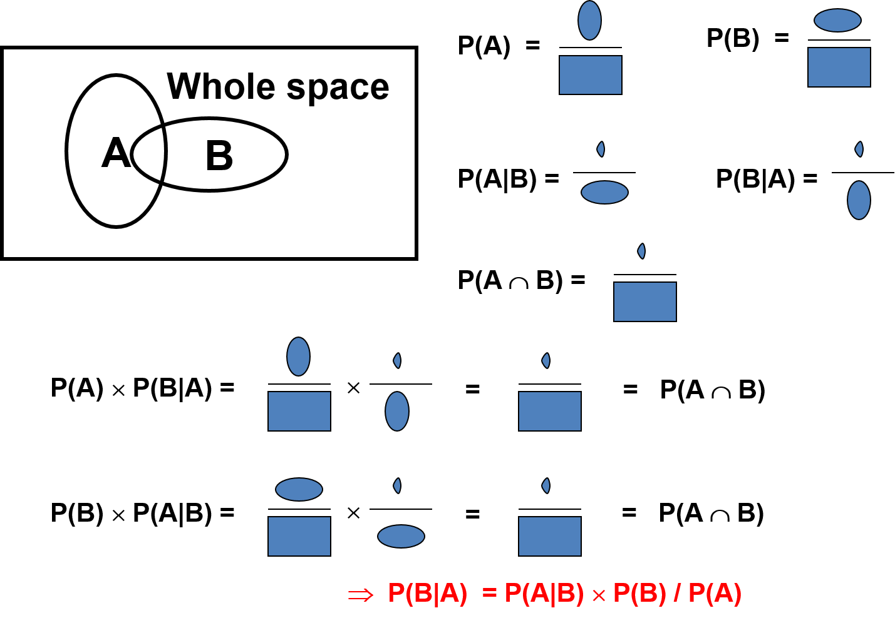
Figure 1:A cartoon explanation of probability, conditional probability, and Bayes’s Theorem, usingpicturearithmetic.
10

wasnotedbystatisticianBradleyEfroninhiskeynotetalkatthe2003PhyStatmeetingat SLAC[9]:
“Bayes’ruleissatisfying,convincing,andfuntouse.ButusingBayes’ruledoesnotmake oneaBayesian;alwaysusingitdoes,andthat’swheredifficultiesbegin.”(Emphasis inoriginal.)
Clearly,Bayes’stheoremhasmoreapplicationsforBayesianPthanforfrequentistP, sinceBayesianPcanbeusedinmorecontexts.Butoneofthesillierthingsonesome-timesseesinHEPistheuseofafrequentistexampleofBayes’sTheoremasafoundational argumentfor“Bayesian”statistics!BelowIgiveasimpleexampleforeachdefinitionofP.
3.2 ExampleofBayes’stheoremusingfrequentistP
Ab-taggingmethodisdeveloped,andonemeasures:
P(b-tag|b-jet),i.e.,efficiencyfortaggingb-jets
P(b-tag|notab-jet),i.e.,efficiencyforbackground
P(nob-tag|b-jet) = 1 −P(b-tag|b-jet)
P(nob-tag|notab-jet) = 1 −P(b-tag|notab-jet).
Question:Givenaselectionofjetstaggedasb-jets,whatfractionofthemisb-jets?I.e., whatisP(b-jet|b-tag)?
Answer:Cannotbedeterminedfromthegiveninformation!
Oneneedsinaddition:P(b-jet),thetruefractionofalljetsthatareb-jets.ThenBayes’s Theoreminvertstheconditionality:
P(b-jet|b-tag) ∝P(b-tag|b-jet)P(b-jet), (2)
(whereIsuppressthenormalizationdenominator).
Asnoted,inHEPP(b-tag|b-jet)iscalledtheefficiencyfortaggingb-jets.Meanwhile P(b-jet|b-tag)isoftencalledthepurityofasampleofb-taggedjets.Asthisshouldbea conceptuallyeasydistinctionforexperienceddataanalystsinHEP,itishelpfultokeepit inmindwhenoneencounterscaseswhereitisperhapstemptingtomakethelogicalerror ofequatingP(A|B)andP(B|A).
Note:Lookingahead,whenwetalkaboutfrequentisthypothesistestinglaterinthe lectures,wewillmentionnamesforanalogousprobabilitiesinotherfieldsofscience.E.g., inmedicine,P(Covidtestispositive|patienthasCovid)iscalledthe“sensitivity”ofthe Covidtest,or(unfortunatelyinmyopinion),the“truepositiverate”.
11

3.3 ExampleofBayes’stheoremusingBayesianP
Inabackground-freeexperiment,atheoristusesa“model”topredictasignalwithPoisson meanof3.0events.FromthePoissonformula(Eqn.9)weknow:
P(0events|modeltrue) = 3.00e−3.0/0! = 0.05
P(0events|modelfalse) = 1.0
P(> 0events|modeltrue) = 0.95
P(> 0events|modelfalse) = 0.0.
Theexperimentisperformed,andzeroeventsareobserved.
Question:Giventheresultoftheexperiment,whatistheprobabilitythatthemodelis true?I.e.,WhatisP(modeltrue|0events)?
Answer:Cannotbedeterminedfromthegiveninformation!
Oneneedsinaddition:P(modeltrue),thedegreeofbeliefinthemodelpriortotheexperi-ment.ThenBayes’sTheoreminvertstheconditionality:
P(modeltrue|0events) ∝P(0events|modeltrue)P(modeltrue) (3)
(againsuppressingthenormalization).ItisinstructivetoapplyBayes’sTheoreminalittle moredetail,withthenormalization.InEqn.1,let“A”correspondto“0events”and“B”correspondto“modeltrue”.Similarly,withP(notB)=1 −P(B),wecanwriteaversion ofBayes’sTheorem(replacingBwith“notB”)as
P(notB|A) = P(A|notB) × P(notB)/P(A). (4)
(As a check, we can add Eqns. 1 and 4 and get unity, confirming that P(A) is the correct nor-malization.)SolvingEqn.4forP(A)andsubstitutingintoEqn.1,andinsertingnumerical valuesfromabove,yieldsP(B|A) = 0.05P(B)/(1 −0.95P(B)),i.e.,
P(modeltrue|0events) = | 0.05 × P(modeltrue) (1 −0.95P(modeltrue)). | (5)
We can examine the limiting cases of strong prior belief in the model and very low prior belief.Ifweletthe“model”betheStandardModel(SM),thenwecouldexpressourhigh priorbeliefasP(modeltrue) = 1 −ϵ1,whereϵ1≪1.Pluggingingives,tolowestorder,
P(modeltrue|0events) ≈1 −20ϵ1. (6)
This is still very high degree of belief in the SM. Unfortunately, one still finds (in the press and even among scientists) the fallacy that is analogous to people saying, “P(0 events|model true) = 5%,with0eventsobserved,meansthereis5%chancetheSMistrue.”(UGH!)
Incontrast,letthe“model”belargeextradimensions,sothatforaskeptic,theprior belief can be expressed as P(model true) = ϵ2, for some other small ϵ2.Then to lowest order wehave,
P(modeltrue|0events) ≈0.05ϵ. (7)
Lowpriorbeliefbecomesevenlower.
Morerealisticexamplesareofcoursemorecomplex.Butthisexampleisgoodprepara-tionforavoidingmisinterpretationofp-valuesinSection7.7.
12

3.4 AnotereDecisions
Supposethatasaresultofthepreviousexperiment,yourdegreeofbeliefinthemodelis P(modeltrue|0events)=1%,andyouneedtodecideonanaction,e.g.,announcingina pressreleasethatthemodelisfalse,ormakingnoannouncementwhiletakingmoredata.
Question:Whatshouldyoudecide?
Answer:Cannotbedeterminedfromthegiveninformation!
Oneneedsinaddition:Theutilityfunction(oritsnegative,thelossfunction),whichquan-tifiestherelativecosts(toYou)of
TypeIerror:announcingthatthemodelisfalse,whenitistrue(thuseventuallyharming yourreputation);andof
TypeIIerror:notannouncingthatthemodelisfalsewhenitisfalse,thuspotentially allowinganotherexperimenttomaketheannouncementfirst.
Thus, Your decision requires two subjective inputs:Your prior probabilities, and the relative costs(orbenefits)toYouofoutcomes.
Statisticiansoftenfocusondecision-making.InHEP,thetraditionthusfaristocom-municate experimental results (well) short of formal decision calculations.It is important to realize that frequentist (classical) “hypothesis testing” as discussed in Section 7 below (espe-cially with conventions like 95% C.L. or 5σ) is not a complete theory of decision-making!One mustalwayskeepthisinmind,sincethetraditional“accept/reject”languageoffrequentist hypothesistestingistoosimplisticfor“deciding”.
3.5 Aside:Whatisthe“wholespace”?
Forprobabilitiestobewell-defined,the“wholespace”needstobedefined.Thiscanbe difficultorimpossibleforbothfrequentistsandBayesians.Forfrequentists,specification ofthewholespacemayrequirelistingtheexperimentalprotocolindetail,includingthe experimenters’ reaction to potentially unexpected results that did not occur!For Bayesians, normalization of probabilities of hypotheses requires enumerating all possible hypotheses and assigningdegreeofbelieftothem,includinghypothesesnotyetformulated!
Thus,the“wholespace”itselfismoreproperlythoughtofasaconditionalspace,con-ditionalontheassumptionsgoingintothemodel(Poissonprocess,whetherornotthetotal numberofeventswasfixed,etc.),andsimplifyingassumptionsorapproximations.
Furthermore, it is widely accepted that restricting the “whole space” to a relevant (“con-ditional”) subspace can sometimes improve the quality of statistical inference.The important topicofsuch“conditioning”infrequentistinferenceisdiscussedindetailinSection11.1.
In general, I do not clutter the notation with explicit mention of the assumptions defining the“wholespace”,butsomeprefertodoso.Inanycase,itisimportanttokeepthemin mindandtobeawareoftheireffectontheresultsobtained.
13

4 Probability,probabilitydensity,likelihood
These are key building blocks in both frequentist and Bayesian statistics,and it is crucial to distinguishamongthem.Inthefollowing,weletxbeanobservedquantity;sometimeswe useniftheobservationisinteger-valuedandwewanttoemphasizethat(toagingFortran programmers).A “(statistical) model” is an expression specifying probabilities or probability densitiesforobservingx.Hereweuseµforparameters(sometimesvector-valued)inthe model.(Inthestatisticalliterature,θismorecommon.)
InBayesianstatistics,theparametersthemselvesareconsideredtobe“randomvari-ables”.The notation for such a general model is p(x|µ), where the vertical line (read “given”) means conditional probability, conditional on a particular value of µ.In frequentist statistics, typically the dependence on µ is not a proper conditional probability, and thus many experts advocate using notation with a semi-colon:p(x; µ).The modern text by George Casella and RogerBerger[10](p.86)howeverusestheverticallinefor“given”inthecontextwherethe parameterisnotarandomvariablebeingconditionedon.Idonotknowofanyexamples wherethiscausestrouble,soattheriskofoffendingsome,Iuseaverticallinethroughout forbothBayesianandfrequentistmodels.ThenthemostcommonexamplesinHEPare:
•Binomialprobabilityfornonsuccessesoutofntottrials(Section6.5):
Bi(non|ntot, ρ) = | ntot!  non!(ntot −non)!ρnon (1 −ρ)(ntot−non) | (8)
•Poissonprobabilityforneventstobeobserved:
P(n|µ) =µne−µ  n! | (9)
•Gaussianprobabilitydensityfunction(pdf):
p(x|µ, σ) = | 1  √2πσ2e−(x−µ)2/2σ2, | (10)
sothatp(x|µ, σ)dxisadifferentialofprobabilitydP.
Atypicalcourseinstatisticalphysicsshowshowthelattertwocanbeviewedaslimiting casesofthefirst.ThebinomialandPoissonformulasaresometimescalledprobabilitymass functionsinthestatisticsliterature.
InthePoissoncase,supposethatn=3isobserved.Substitutingthisobservedvalue n = 3intoP(n|µ)yieldsthelikelihoodfunction,L(µ) = µ3exp(−µ)/3!,plottedinFig.2.
It is tempting to consider the area under L as meaningful,but L(µ) is not a probability densityinµ.TheareaunderL(orpartsofit)ismeaningless!ThePoissonexamplemakes this particularly clear, since the definition of L(µ) starts with a probability (not a probability density);itmakesnosensetomultiplyL(µ)bydµandintegrate.
Asweshallsee,likelihoodratiosL(µ1)/L(µ2)areusefulandfrequentlyused.Infact, inthestatisticsliterature,thelikelihoodisonlydefineduptoanoverallconstantfactor.
14

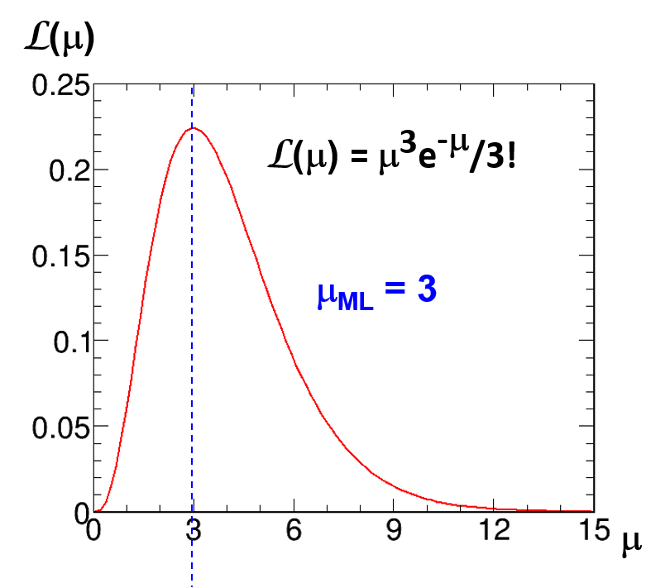
Figure 2:The likelihood function L(µ) after observing n = 3 in the Poisson model of Eqn. 9. Thelikelihoodobtainsitsmaximum(ML)atµ = 3.
4.1 Changeofobservablevariable(“metric”)xinpdfp(x|µ)
Forpdfp(x|µ)anda1-to-1changeofvariable(metric)from(vector)xto(vector)y(x),the volumeelementismodifiedbytheJacobian.Fora1Dfunctiony(x),wehavep(y)|dy|= p(x)|dx|,sothat
p(y(x)|µ) = p(x|µ)/|dy/dx|. (11)
TheJacobianmodifiestheprobabilitydensityinsuchawaytoguaranteethat
P(y(x1) < y< y(x2)) = P(x1< x < x2), (12)
(orequivalentwithdecreasingy(x)).Thatis,theJacobianguaranteesthatprobabilitiesare invariantunderchangeofvariablex.
BecauseoftheJacobianinEqn.11,themodeofprobabilitydensityisingeneralnot invariantunderchangeofmetric.Thatis,thevalueofyforwhichp(y(x))isamaximumis nottriviallyrelatedtothevalueofxforwhichp(x)isamaximum.
Another consequence of the Jacobian in Eqn. 11 is that the likelihood function L(µ) dif-fers for different choices of the data variable.However, likelihood ratios such as L(µ1)/L(µ2) areinvariantunderchangeofvariablextoy(x).TheJacobianinthedenominatorcancels thatinthenumerator.Thus,forexample,thevalueofµthatmaximizesL(µ)willbeinde-pendentofthechoiceofdatavariable,butthevalueofL(µ)atthatmaximumisdifferent. ThelatterpointalsoexplainswhythevalueofL(µ)atitsmaximumisnotanappropriate teststatisticforgoodnessoffit;usefultestsbasedonthelikelihoodfunctionuselikelihood ratios,asdiscussedinAppendixB.
15

4.2 Changeofparameterµinpdfp(x|µ)
Thepdfforxgivenparameterµ = 3isthesameasthepdfforxgiven1/µ = 1/3,orgivenµ2= 9,or given any specified function of µ.They all imply the same µ,and hence the same pdfforx.
Inslightlyconfusingnotation,thatiswhatwemeanbychangingtheparameterfrom µtof(µ),andsayingthat
p(x|f(µ)) = p(x|µ). (13)
Inserting an observed value of x, we see the important result that the likelihood function L(µ)isinvariant(!)underreparameterizationfromparameterµtof(µ):L(f(µ)) = L(µ). TheabsenceofaJacobianreinforcesthefactthatL(µ)isnotapdfinµ.Furthermore, themodeofL(µ)isthusalsoinvariant:ifweletˆµbethevalueofµforwhichL(µ)isa maximum,andifweletˆfbethevalueoff(µ)forwhichL(f)isamaximum,then
ˆf= f(ˆµ). (14)
ThisisanimportantpropertyofthepopularMLtechniqueofpointestimation.(Seedis-cussioninRef.[11],Section5.3.1.)
4.3 Probabilityintegraltransform
In1938EgonPearsoncommentedonapaperofhisfatherKarl(ofχ2fame),notingthat theprobabilityintegraltransform“. . . seemslikelytobeoneofthemostfruitfulconceptions introducedintostatisticaltheoryinthelastfewyears”[12].Indeedthissimpletransforma-tion makes many issues more clear (or trivial).Given continuous x ∈(a, b), and its pdf p(x),
onetransformstoygivenby | y(x) = | Zx | p(x′)dx′. | (15)
a
Thentriviallyy∈(0, 1),andwiththechainruleandthefundamentaltheoremofcalculus, itfollowsthatthepdfforyisp(y)=1(uniform)forally!(Ifxisdiscrete,thereare complications.)
So,forcontinuousvariables,therealwaysexistsametricyinwhichthepdfisuniform. As an aside, the inverse transformation can provide for efficient Monte Carlo (MC) generation ofp(x)startingfromapseudo-randomnumbergeneratoruniformon(0,1).SeeSection 42.2 inRef.[13].
LookingaheadtoSection5,ImentionherethatthespecificationofaBayesianprior pdf p(µ) for parameter µ is thus equivalent to the choice of the metric g(µ) in which the pdf isuniform.Thisisadeepissue,notalwaysrecognizedbyusersofuniformpriorpdf’sin HEP!
4.4 Bayes’stheoremgeneralizedtoprobabilitydensities
Recall(Eqn.1)thatP(B|A) ∝P(A|B)P(B).ForBayesianP,continuousparameterssuch asµarerandomvariableswithpdf’s.
16

Letpdfp(µ|x)betheconditionalpdfforparameterµ,givendatax.Asusual,p(x|µ) istheconditionalpdffordatax,givenparameterµ. ThenBayes’sTheorembecomes p(µ|x) ∝p(x|µ)p(µ).Substituting in a particular set of observed data x0, we have p(µ|x0) ∝p(x0|µ)p(µ).
Recognizingthelikelihood(variouslywrittenasL(x0|µ),L(µ),orunfortunatelyeven L(µ|x0)),then
p(µ|x0) ∝L(x0|µ)p(µ), | (16)
where:
p(µ|x0) =theposteriorpdfforµ,giventheresultsofthisexperiment, L(x0|µ) =thelikelihoodfunctionofµfromthisexperiment,
p(µ) =thepriorpdfforµ,beforeapplyingtheresultsofthisexperiment.
Notethatthereisone(andonlyone)probabilitydensityinµoneachsideoftheequation, consistentwithL(x0|µ)notbeingadensityinµ!
(Aside:occasionallysomeoneinHEPreferstothepriorpdfas“apriori”. Thisis incorrect,asisobviouswhenoneconsidersthattheposteriorpdffromoneexperimentcan serveasthepriorpdfforthenextexperiment.)
5 Bayesiananalysis
All equations up until now are true for any definition of probability Pthat obeys the axioms, includingfrequentistP,aslongastheprobabilitiesexist.Forexample,ifµissampledfrom an ensemble with known “prior” pdf, then it has a frequentist interpretation.(This is however unusual.)Theword“Bayesian”refersnottotheseequations,buttothechoiceofdefinition ofPaspersonalsubjectivedegreeofbelief.Forexample,ifµisaconstantofnature,its Bayesianpdfexpressesone’srelativebeliefindifferentvalues.
BayesianPappliestohypothesesandconstantsofnature(whilefrequentistPdoes not),sotherearemanyBayesian-onlyapplicationsofBayes’sTheorem.Bayesiananalysis isbasedontheBayesianposteriorpdfp(µ|x0),assketchedhere.
•Point estimation:Some Bayesians use the posterior mode (maximum posterior density) as the point estimate of µ.This has the problem that it is metric dependent:the point estimateofthemeanlifetimeτwillnotbetheinverseofthepointestimateofthe decayrateΓ.ThisisbecausetheJacobianmovesthemodearoundunderchangeof parameterfromlifetimeτtodecayrateΓ=1/τ.(RecallSection4.1.)Theposterior mediancanbeusedin1Dandismetric-independent.TherearealsoBayesians(as wellasfrequentists)whothinkthatemphasisonpointestimationismisguided.
•Intervalestimation:The credibility of µ being in any interval [µ1, µ2] can be calculated by integrating p(µ|x0) over the interval.For reporting a default interval with, say, 68% credibility,oneneedsinadditionaconventionforwhich68%touse(lower,upper,or centralquantilesarecommonchoices).Itispreferabletorefertosuchintervalsas“credibleintervals”,asopposedto“confidenceintervals”,unlesstheBayesianmachin-eryisusedjustasatechnicaldevicetoobtainvalid(atleastapproximate)frequentist confidenceintervals(asisoftenthecaseinHEP).
17

•Hypothesistesting:Unlikefrequentiststatistics,testingcredibilityofwhetherornotµequalsaparticularvalueµ0isnotperformedbyexaminingintervalestimates(atleast assumingaregularposteriorpdf).OnestartsoverwithBayesianmodelselection, asdiscussedinAppendixD.(Diracδ-functionsinthepriorandposteriorpdfscan howeverconnectintervalestimationtomodelselection,withitsissues.)
•Decisionmaking:All decisions about µ require not only p(µ|x0) but also further input: theutilityfunction(oritsnegative,thelossfunction).See,e.g.,Ref.[3](Chapter6) andRef.[14](Chapter2).
SinceBayesiananalysisrequiresapriorpdf,bigissuesinBayesianestimationinclude:
•Whatpriorpdftouse,andhowsensitiveistheresulttotheprior?
•HowtointerpretposteriorprobabilityifthepriorpdfisnotYourpersonalsubjective belief?
Frequentisttoolscanbehighlyrelevanttobothquestions!
5.1 Can“subjective”betakenoutof“degreeofbelief”?
Therearecompellingarguments(Savage[8],DeFinetti[7]andothers)thatBayesianrea-soningwithpersonalsubjectivePistheuniquely“coherent”way(withtechnicaldefinition ofcoherent)ofupdatingpersonalbeliefsuponobtainingnewdataandmakingdecisions basedonthem.However,thesefoundationalworkscanbeveryheavygoing.Foramore accessiblereviewbyanoutspokensubjectivist,withmorecompletereferences,seeLindley’s 2000review[15].A2018bookbyDiaconisandSkyrms[6]isalsoverydetailedandata deeplevelthatseemsmostlycomprehensibletophysicists.
Ahugequestionis:CantheBayesianformalismbeusedbyscientiststoreportthe resultsoftheirexperimentsinan“objective”way(howeveronedefines“objective”),and doesanyoftheglowofcoherenceremainwhensubjectivePisreplacedbysomethingelse?
An idea vigorously pursued by physicist Harold Jeffreys [16] in the mid-20th century is: Canonedefineapriorp(µ)thatcontainsaslittleinformationaspossible?
Thereallyreallythoughtlessidea(despitehavingafancyname,“Laplace’sPrincipleof InsufficientReason”),recognizedbyJeffreysassuch,butdismayinglycommonhistorically inHEPis:justchoosepriorp(µ)uniforminwhatevermetricyouhappentobeusing!
5.2 “Uniformprior”requiresachoiceofmetric
Recall that the probability integral transform always allows one to find a metric in which p is uniform(forcontinuousµ).Thusthequestion,“Whatisthepriorpdfp(µ)?”isequivalent tothequestion,“Forwhatfunctiong(µ)isp(g)uniform?”Thereisusuallynoreasonto choosegarbitrarilyasg(µ) = µ(!).
18

5.3 Jeffreys’schoiceofmetricinwhichpriorisuniform
Themodernfoundationofthevastliteratureonpriorpdfsthatonemayhope(invain) tobeuninformativeisthemonographbyHaroldJeffreys[16].Heproposesmorethanone approach,buttheonethatiscommonlyreferredtoasthe“Jeffreysprior”(andconsidered thedefault“noninformative”priorbystatisticiansforestimationin1-parameterproblems) isderivedfromthestatisticalmodelp(x|µ).
Thismeansthatthepriorpdfdependsonthemeasurementapparatus!Forexample, ifthemeasurementapparatushasaresolutionfunctionthatisGaussianformassm(withσindependentofm),thentheJeffreyspriorpdfp(m)forthemassisuniforminm.Ifa different measurement apparatus has a resolution function that is Gaussian for m2, then the Jeffreyspriorpdfp(m2)isuniforminm2.Inthelattercase,bytherulesofprobability (Eqn.11),thepriorpdfp(m)isnotuniform,butratherproportionaltom(!).
Jeffreys’sderivationofhiseponymouspriorisbasedontheideathatthepriorshould beuniforminametricrelatedtotheFisherinformation,calculatedfromthecurvatureof thelog-likelihoodfunctionaveragedoversamplespace.Someexamplesare:
Poissonsignalmeanµ,nobackground:p(µ) = 1/√µ
Poissonsignalmeanµ,knownmeanbackgroundb:p(µ) = 1/√µ + b
MeanµofGaussianwithfixedσ(unboundedorboundedµ):p(µ) = 1
rmsdeviationσofaGaussianwhenmeanfixed:p(σ) = 1/σ
Binomialparameterρ,0 ≤ρ ≤1:p(ρ) = ρ−1/2(1 −ρ)−1/2= Beta(1/2, 1/2).
Ifparameterµischangedtof(µ),therecipeforobtainingtheJeffreyspriorforf(µ) yieldsadifferent-lookingpriorthatcorrespondstothesamechoiceofuniformmetric.So ifyouuseJeffreys’srecipetoobtainapriorpdfforµ,andyourfriendusesJeffreys’srecipe toobtainapriorpdfforf(µ),thenthosepdfswillbecorrectlyrelatedbytheappropriate Jacobian.(Thisisnottrueforsomeotherrules,inparticularifeachofyoutakesauniform priorinthemetricyouareusing.) Thusprobabilities(integralsofpdfsoverequivalent endpoints)usingJeffreyspriorareinvariantunderchoicesofdifferentparameterizations.
ForadetailedmodernreviewofJeffreys’sentirebook,includinghisprior,withdiscus-sion by six prominent statisticians (including outspoken subjectivist Lindley), and rejoinder, seeRef.[17].
5.3.1 ReferencepriorsofBernardoandBerger
AsJeffreysnoted,hisrecipeencountersdifficultieswithmodelshavingmorethanonepa-rameter.Jos´eBernardo[18]andJ.O.Berger[19,20]advocateanapproachthattheyargue works well in higher dimensions, with the crucial observation that one must choose an order-ing of the parameters in order to well-define the multi-dimensional prior pdf.Their so-called“Referenceprior”reducestotheJeffreyspriorin1D,withadifferentrationale,namelythe priorthatleadstoaposteriorpdfthatismostdominatedbythelikelihood.Earlierthis year, Berger and Bernardo (with Donchu Sun) published a new book [21] discussing in detail theseissuesofestimation(thoughnothypothesistesting).
19

Therearemanysubtleties.Beware!SeealsoBernardo’stalkatPhyStat-2011,which includeshypothesistesting,anddiscussionfollowing[22]. Demortier,Jain,andProsper pioneered the use of Bernardo/Berger reference priors in a case of interest in HEP [23],with about40citationsthusfar(mid-2024)atinspirehep.net.
5.4 Whattocallsuchnon-subjectivepriors?
•“Noninformative priors”?Traditional among statisticians, even though theyknowitis amisnomer.(Youshouldtoo!)
•“Vaguepriors”?
•“Ignorancepriors”?
•“Defaultpriors”?
•“Referencepriors”?(UnfortunatelyalsoreferstothespecificrecipeofBernardoand Berger)
•“Objectivepriors”?Despitethehighlyquestionableuseoftheword,Jeffreysprior and its generalization by Bernardo and Berger are now widely referred to as “objective priors”.
KassandWasserman[24]givethebest(neutral)nameinmyopinion:Priorsselected by“formalrules”.TheirarticleisrequiredreadingforanyoneusingBayesianmethods!
Whateverthename,thepriorpdfinonemetricdeterminesitinallothermetrics:be carefulinthechoiceofmetricinwhichitisuniform!
For one-parameter models, the “Jeffreys prior” is the most common choice among statis-ticiansforanon-subjective“default”prior—socommonthatstatisticianscanbereferring totheJeffreyspriorwhentheysay“flatprior”(e.g.,D.R.CoxindiscussionatPhyStat 2005[25],p.297).
Akeypoint:priorssuchastheJeffreyspriorarebasedonthelikelihoodfunctionand thusinherentlyderivedfromthemeasurementapparatusandprocedure,notfromthinking abouttheparameter!Thismayseemstrange,butdoesgiveadvantages,particularlyfor frequentist(!)coverage(Section6.11),asmentionedinSection13.2andemphasizedtous byJimBergerattheConfidenceLimitsWorkshopatFermilabin2000[26].
5.5 Whateveryoucallthem,non-subjectivepriorscannotrepre-
sentignorance!
Althoughsomeauthorshaveclaimedthatvariousinvarianceprinciplescanbeinvokedto yieldpriorsthatrepresentcomplete“ignorance”,Idonotknowofanymodernstatistician whothinksthatthisispossible.Onthecontrary,(subjectivist)DennisLindleywrote,[27],“themistakeistothinkofthem[JeffreyspriorsorBernardo/Berger’sreferencepriors]as representingignorance.”ThisLindleyquoteisemphasizedinthemonographbyprominent BayesianChristianRobert[28](p.29).
20

ObjectivistJoseBernardosays,regardinghisreferencepriors,“[Withnon-subjective priors,]Thecontributionofthedatainconstructingtheposteriorofinterestshouldbe‘dominant’.Notethatthisdoesnotmeanthatanon-subjectivepriorisamathematical descriptionof‘ignorance’.Anypriorreflectssomeformofknowledge.”
Nonetheless, Berger [14] (p. 90) argues that Bayesian analysis with noninformative priors (older name for objective priors), such as those of Jeffreys and Bernardo/Berger, “is the single mostpowerfulmethodofstatisticalanalysis,inthesenseofbeingtheadhocmethodmost likelytoyieldasensibleanswerforagiveninvestmentofeffort.”[emphasisinoriginal].
5.6 Priorsinhighdimensions
Is there a sort of informational “phase space” that can lead us to a sort of probability Dalitz plot?I.e., the desire is that structure in the posterior pdf represents information in the data, nottheeffectofJacobiansinthepriors.Thisisanotoriouslyhardproblem!
Becareful:Uniformpriorspushtheprobabilityawayfromtheorigintotheboundary! (Thevolumeelementgoesasr2dr.)Thestateoftheartfor“objective”priorsmaybethe“referencepriors”ofBernardoandBerger,butmulti-Dtoolshavebeenlacking.Subjective priorsarealsoverydifficulttoconstructinhighdimensions:humanintuitionispoor.
SubjectiveBayesianMichaelGoldstein[29]toldusin2002atDurham,“. . . meaningful priorspecificationofbeliefsinprobabilisticformoververylargepossibilityspacesisvery difficultandmayleadtoalotofarbitrarinessinthespecification. . . ”.
BradleyEfronatPhyStat-2003[9]concluded:“Perhapsthemostimportantgeneral lesson is that the facile use of what appear to be uninformative priors is a dangerous practice inhighdimensions.”
Sir David Cox [30], p. 46:“With multi-dimensional parameters. . . naive use of flat priors canleadtoproceduresthatareverypoorfromallperspectives. . . ”.Also,onp.83:“. . . the notionofaflatorindifferentpriorinamany-dimensionalproblemisuntenable.”
5.7 TypesofBayesians
ThebroaddistinctionbetweenthesubjectiveandobjectiveBayesiansisfarfromthecom-pletestory. AtPhyStat-LHCin2007,SirDavidCoxdescribed“FivefacesofBayesian statistics”[31]:
•empiricalBayes:numberofsimilarparameterswithafrequencydistribution
•neutral(reference)priors:Laplace,Jeffreys,Jaynes,BergerandBernardo
•information-insertingpriors(evidence-based)
•personalisticpriors
•technicaldeviceforgeneratingfrequentistinference
Currently in HEP, the main application is the last “face” on his list:we typically desire good frequentistpropertiesforpointorintervalestimationwhenusinganominally“Bayesian”recipe.In particular, for upper limits on a Poisson mean, we use a uniform prior (i.e., not what
21

objectivestatisticiansrecommend),forfrequentistreasons.(SeeSection10andRef.[32].) Cox’sthird“face”alsoarisesinHEPwhenlikelihoodsareincorporatedfromsubsidiary measurements and are used to provide evidence-based priors.Unfortunately, some people in HEPhaveineffectalsoaddedtoCox’slista6th“face”:
•Priorsuniforminarbitraryvariables,orin“theparameterofinterest”.
IknowofnojustificationforthisinmodernsubjectiveorobjectiveBayesiantheory.Itis an“ignorance”prioronlyinthesensethatitbetraysignoranceofthemodernBayesian literature!
5.8 Do“Bayesians”careaboutfrequentistpropertiesoftheirre-
sults?
Anotherclaimthatisdismayingtoseeamongsomephysicistsistheblanketstatement that“Bayesiansdonotcareaboutfrequentistproperties”.Whilethatmaybetrueforpure subjective Bayesians, most of the pragmatic Bayesians that we have met at PhyStat meetings do use frequentist methods to help calibrate Bayesian statements.That seems to be essential when using “objective” priors to obtain results that are used to communicate inferences from experiments.
Avarietyofopinionsonthistopicareinthepublishedcommentsintheinaugural issueofthejournalBayesianAnalysis,followingthepapersbyJimBerger[33]andMichael Goldstein[34]thatadvocatetheobjectiveandsubjectivepointsofview,respectively.In particular,RobertKass[35]providedalistofninequestionsforwhichanswers“maybe usedtoclassifyvariouskindsofBayesians”.
Thefirstquestionis,“IsitimportantforBayesianinferencestohavegoodfrequentist operatingcharacteristics?” Thequestions,theexplicitanswersfromKass,Berger,and Goldstein, and other commentary (from which answers can be gleaned) from other prominent statisticians,arepartofmylistof“requiredreading”forphysicists.Theyshouldgoalong waytowardbroadeningtheviewofanyphysicistswhohaveswallowedsomeoftheextreme polemicsaboutBayesiananalysis(asfoundforexampleinJaynes[36],whichunfortunately seemstohavebeenreaduncriticallybytoomanyscientists).
5.9 Analysisofsensitivitytotheprior
SinceaBayesianresultdependsonthepriorprobabilities,whichareeitherpersonalisticor withelementsofarbitrariness,itiswidelyrecommendedbyBayesianstatisticianstostudy thesensitivityoftheresulttovaryingtheprior.
•“Objective”BayesianJos´eBernardo,quotedinRef.[37]:“Non-subjectiveBayesian analysisisjustapart—animportantpart,Ibelieve—ofahealthysensitivityanalysis tothepriorchoice. . . ”.
•“Subjective”BayesianMichaelGoldstein,fromtheProceedings[29]:“. . . Again,dif-ferentindividualsmayreactdifferently,andthesensitivityanalysisfortheeffectof
22

thepriorontheposterioristheanalysisofthescientificcommunity. . . ”.Inhistrans-parenciesattheconference,heputitsimply:“SensitivityAnalysisisattheheartof scientificBayesianism.”
Ithinkthathistorically,toolittleemphasiswasgiventothisimportantpointbyBayesian advocatesinHEP.
5.10 Bayesianmust-readlistforHEP/Astro/Cosmo(including
discussion!)
Inmyexperience,somehighenergyphysicistsandastrophysicistsappeartobeoverlyinflu-enced by the polemical book by E.T. Jaynes [36], (which, for example, argues for the existence priors representing ignorance).I strongly urge anyone diving into Bayesian statistics to read aswellthefollowingminimalsetofpapersbyBayesiansubjectivistsandobjectivists,and theassociateddiscussion,andrejoinders.(IfthereisonethingthatHEPjournalscould learnfromstatisticians,itistopublishsuchdiscussionandrejoinderaccompanyingmajor papers and reviews!)As I made this list over ten years ago,I would welcome suggestions for morerecentadditions.
RobertE.KassandLarryWasserman,“TheSelectionofPriorDistributionsbyFormal Rules,”[24]
Telba Z. Irony and Nozer D. Singpurwalla, “Non-informative priors do not exist:A dialogue withJoseM.Bernardo,”[37]
JamesBerger,“TheCaseforObjectiveBayesianAnalysis,”[33]
MichaelGoldstein,“SubjectiveBayesianAnalysis:PrinciplesandPractice,”[34]
J.O.BergerandL.R.Pericchi,“ObjectiveBayesianMethodsforModelSelection:Intro-ductionandComparison,”[38]
5.11 Pseudo-Bayesiananalyses
JimBergerin2006[33]:
“OneofthemysteriesofmodernBayesianismisthelipservicethatisoftenpaidto subjectiveBayesiananalysisasopposedtoobjectiveBayesiananalysis,butthenthepracti-calanalysisactuallyusesaveryad-hocversionofobjectiveBayes,includinguseofconstant priors, vague proper priors, choosing priors to ‘span’ the range of the likelihood, and choosing priors with tuning parameters that are adjusted until the answer ‘looks nice.’I call such anal-ysespseudo-Bayesbecause,whiletheyutilizeBayesianmachinery,theydonotcarrywith them any of the guarantees of good performance that come with either true subjective analy-sis(withaveryextensiveelicitationeffort)or(well-studied)objectiveBayesiananalysis. . . I donotmeantodiscouragethisapproach.Itsimplymustberealizedthatpseudo-Bayes techniquesdonotcarrytheguaranteesofpropersubjectiveorobjectiveBayesiananalysis, andhencemustbevalidatedbysomeotherroute.”
23

Bergergoesontogiveexamplesofpseudo-Bayesanalyses,withthefirstbeing(what else?),“Useoftheconstantpriordensity”.
Pseudo-BayesanalysespopupfromtimetotimeinHEP,forexamplebythoseusing priors“uniformintheparameterofinterest”.HereImentionthreeexamplesof“pseudo-Bayes”inHEPthathavebeencriticizedbymeandothers.Ipreviouslydiscussedthemat thePhyStat-nuworkshopinTokyoin2016[39](slides62–68).
ThefirstexamplewasexposedinLucDemortier’stalkin2002atDurham[40].Ina methodofBayesianupperlimitcalculationthatwascommonattheTevatronatthetime, the use of a uniform prior for a Poisson mean, along with a Gaussian truncated at the origin forasystematicuncertaintyinefficiency,ledtoanintegralthatLucshowed“byhand”todiverge!Theintegralwastypicallyevaluatednumerically,withoutfirstcheckingthatit exists.Theanswerthusdependedonthechoiceofcutoffthatwasusedinthenumerical evaluation.AlternativestothetruncatedGaussianpriorarementionedinSection12.3.1.
ThesecondexamplecomesfromJoelHeinrichattheOxfordPhyStatin2005[41].It hadbeenknownforalongtimethatauniformpriorforaPoissonmeanofasignalyields goodfrequentistpropertiesforupperlimits(butnotlowerlimits).(SeeSection10.)Joel showedthedangersofnaivelyusinguniformpriorsforthemeansofseveralbackground processes.
ThethirdexampleisinthecategorythatIfindhassomeoftheworstpseudo-Bayes examples,namelyBayesianmodelselection(AppendixD),whichishowevernotattempted asoftenasBayesianestimationinHEP.Practitionersaresometimesunawarethat:
1.In model selection, unlike estimation, the dependence on some prior pdfs for parameters doesnotbecomenegligibleastheamountofdataincreaseswithoutbound(evenfor so-calledBayesfactorsthatattempttoseparateoutthepriorprobabilitiesofthe hypotheses).
2.Improper priors (such as uniform over a line or half-line) are a disaster, and if they are made proper by adding a cutoff, then the model selection answer is directly proportional tothe(oftenarbitrary)cutoff.Using“1”forthepriorjusthidestheproblem.
3.Infact,Jeffreysandfollowersusepriorsformodelselectionthataredifferentfrom thoseusedforestimation(!).
Thus,Bayesianmodelselectionshouldnotbeapproachednaively.ForanexampleinPRL thatIcriticized,seemyCommentinRef.[42].
HarrisonProsper(anearlyandsustainedadvocateofBayesianmethodsinHEP)has providedanexcellentdiscussionofthecareneededinBayesiananalysesinChapter12of DataAnalysisinHighEnergyPhysics,editedbyO.Behnkeetal.[43].
6 Frequentistestimation:confidenceintervals
Whatcanbecomputedwithoutusingaprior,withonlythefrequentistdefinitionofP?
•NotP(constantofnatureisinsomespecificinterval | data)
24

•NotP(SUSYistrue | data)
•NotP(StandardModelisfalse | data)
Rather,withoutaprior,wecancompute:
1.ConfidenceIntervalsforconstantsofnatureorotherparametervalues,asdefinedin the 1930’s by Jerzy Neyman.Statements are made about probabilities in ensembles of intervals(fractioncontainingunknowntruevalue).Confidenceintervalshavefurther applicationsinfrequentisthypothesistesting.
2.Likelihoodsandthuslikelihoodratios,thebasisforalargesetoftechniquesforpoint estimation,intervalestimation,andhypothesistesting.
BothcanbeconstructedusingthefrequentistdefinitionofP.Inthissection,weintroduce confidenceintervals,andinSection8,introducelikelihoodratiosforintervalestimation.
“Confidenceintervals”,andthisphrasetodescribethem,wereinventedbyJerzyNey-manin1934-37[44].StatisticianstypicallymeanNeyman’sintervals(oranapproximation thereof)whentheysay“confidenceinterval”.InHEPthelanguageisalittleloose.Ihighly recommend using “confidence interval” (and “confidence regions” when multi-D) only to de-scribe intervals and regions corresponding to Neyman’s construction,described below,or by recipesofotherorigins(includingBayesianrecipes)onlyiftheyyieldgoodapproximations thereof.
Thefollowingsubsectionsuseupper/lowerlimitsandcloselyrelatedcentralconfidence intervalstointroduceandillustratethebasicnotions,andthendiscussNeyman’smore general construction (used e.g.by Feldman and Cousins).Then, after introducing frequentist hypothesis testing (Section 7), we return to make the connection between confidence intervals andhypothesistestingofaparticularvalueofparametervsothervalues(Section7.5).
6.1 Notation
xdenotesobservable(s). Moregenerally,xisanyconvenientorusefulfunctionofthe observable(s),andiscalleda“statistic”or“teststatistic”.
µdenotesparameter(s).(Statisticiansoftenuseθ.)
p(x|µ)istheprobabilityorpdf(fromcontext)characterizingeverythingthatdetermines theprobabilities/densitiesoftheobservations,fromlawsofphysicstoexperimental setupandprotocol.Thefunctionp(x|µ)iscalled“thestatisticalmodel”,orsimply“themodel”,bystatisticians.
6.2 Theconceptualideaofconfidenceintervalsintwosentences
Giventhemodelp(x|µ)andtheobservedvaluex0,weask:Forwhatvaluesofµisx0an“extreme”valueofx?Thenweincludeintheconfidenceinterval[µ1, µ2]thosevaluesofµforwhichx0isnot“extreme”.
(Notethatthisbasicideasticksstrictlytothefrequentistprobabilityofobtainingx, andmakesnomentionofprobability(ordensity)forµ.)
25

6.2.1 Orderingprincipleisrequiredforpossiblevaluesofx
In order to define “extreme”, one needs to choose an ordering principle that ranks the possible valuesofxapplicabletoeachµ.Byconventionhighrankmeansnotextreme.
Somecommonorderingchoicesin1D(when p(x|µ)issuchthathigher µimplieshigher averagex)are:
•Order x from largest to smallest:the smallest values of x are the most extreme.Given x0,theconfidenceintervalthatcontainsµforwhichx0isnotextremewilltypically notcontainthelargestvaluesofµ.Thisleadstoconfidenceintervalsknownasupper limitsonµ.
•Orderxfromsmallesttolargest.Thisleadstolowerlimitsonµ.
•Orderxusingcentralquantilesofp(x|µ),withthequantilesshorterinx(leastinte-gratedprobabilityofx)containinghigher-rankedx,withlower-rankedxaddedasthe centralquantilegetslonger(containsmoreintegratedprobabilityofx).Thisleadsto centralconfidenceintervalsforµ.
Thesethreeorderingsapplyonlywhenxis1D.Afourthordering,usingaparticular likelihoodratioadvocatedbyFeldmanandCousins,isstilltocome(Section6.7);itis applicableinboth1Dandmulti-D.
6.2.2 A“confidencelevel”mustbespecified
Given model p(x|µ) and an ordering of x, one chooses a particular fraction of highest-ranked valuesofxthatarenotconsideredas“extreme”.Thisfractioniscalledtheconfidencelevel (C.L.),say68%or95%.
(In this discussion, 68% is more precisely 68.27%; 84% is 84.13%; etc.Also, in the statis-ticsliteraturethereisafinedistinctionbetweenconfidencelevelandconfidencecoefficient, whichweignorehere.)
Wealsodefineα = 1−C.L.,i.e.,thefractionthatisthelower-ranked,“extreme”setof values.
6.2.3 One-sentencesummary
Then the confidence interval [µ1, µ2] contains those values of µ for which x0is not “extreme”at the chosen C.L.,giventhechosenorderingofx.E.g.,at 68% C.L.,[µ1, µ2] contains thoseµforwhichx0isinthehighest-ranked(leastextreme)68%valuesofxforeachrespectiveµ,accordingprobabilitiesobtainedfromthemodelp(x|µ).
6.3 Correspondencebetweenupper/lowerlimitsandcentralcon-
fidenceintervals
AsillustratedinFig.3,the84%C.L.upperlimit µ2excludesµforwhichx0isinthelowest 16%valuesofx.The84%C.L.lowerlimitµ1excludesµforwhichx0isinthehighest16%
26

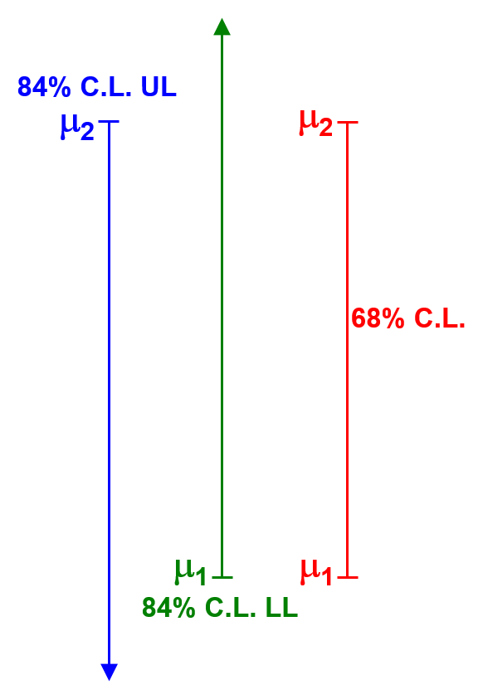
Figure 3:Sketch to illustrate the relationship among 84% C.L. upper limits,84% C.L. lower limits,and68%C.L.centralconfidenceinterval.Thetwoone-sidedtailsof16%compose thetwo-sidedtailstotaling32%.
valuesofx.Then,theinterval[µ1, µ2]includesµforwhichx0isinthecentral68%quantile ofxvalues.Itisa68%C.L.centralconfidenceinterval(!).
For general C.L., the endpoints of central confidence intervals are, by the same reasoning, the same as upper/lower limits with confidence level given by 1−(1−C.L.)/2 = (1+C.L.)/2.
Examplesfollowforacoupleofillustrativemodels,firstwithcontinuousx,thenwith discretex.
6.4 Gaussianpdfp(x|µ, σ)withσafunctionofµ:σ=0.2µ
ItiscommoninHEPtoexpressuncertaintiesasapercentageofameanµ(eventhough situationsinwhichthisisrigorouslymotivatedarerare).Thus,insteadofthemosttrivial exampleofGaussianwithunknownmeanµandknownrmsσ,let’sassumethatσis20%of theunknowntruevalueµ:
p(x|µ, σ) = | 1  √2πσ2e−(x−µ)2/2σ2= p(x|µ) = | 1  p 2π(0.2µ)2e−(x−µ)2/2(0.2µ)2, | (17)
asillustratedinFig.4.
Withµ(andhenceσ)unknown,supposex0=10.0isobserved.Whatcanonesay aboutµ?Regardlessofwhatelseisdone,itisalwaysusefultoplotthelikelihoodfunction,
27

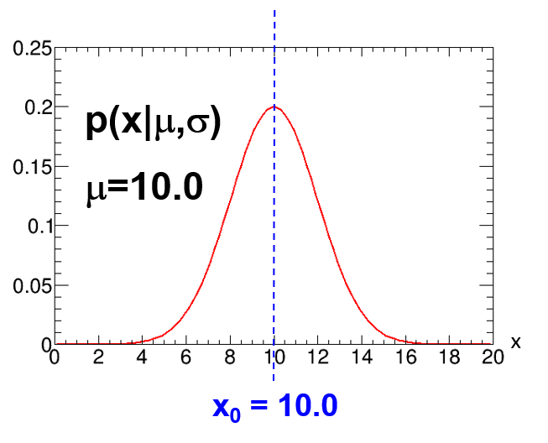
Figure4:Plotofp(x|µ, σ),withµ=10.0,σ=0.2µ,asinEqn.17.Inthesubsequent discussion,wesupposethattheobservedvalueisx0= 10.0.
inthiscaseobtainedbypluggingx0intoEqn.17:
L(µ) = | 1  p 2π(0.2µ)2e−(10.0−µ)2/2(0.2µ)2, | (18)
asillustratedinFig.5.Thefirstthingonenoticesisthatthelikelihoodisasymmetricand obtainsitsmaximumatµlessthanthex0.(Thereisfoodforthoughthere,butwemove on.)
6.4.1 Whatisthecentralconfidenceintervalforµ?
First we find µ1 such that 84% of p(x|µ1, σ= 0.2µ1) is below x0= 10.0; 16% of the probability isabove.Solve:µ1= 8.33,asinFig.6(left).So[µ1, ∞]isan84%C.L.confidenceinterval, andµ1is84%C.L.lowerlimitforµ.
Thenwefindµ2suchthat84%ofp(x|µ2, σ=0.2µ2)isabovex0=10.0;16%ofthe probabilityisbelow.Solve:µ2=12.52,asinFig.6(right).So[−∞, µ2]isan84%C.L. confidenceinterval,andµ2is84%C.L.upperlimitforµ.
Then the 68% C.L. central confidence interval is [µ1, µ2] = [8.33, 12.52].This is “exact”. Infact,thereasoningusedherewasalreadylaidoutbyE.B.Wilsonin1927[45]inhis discussionofintervalsintheGaussianapproximationofthebinomialmodel(Section6.5.2).
6.4.2 ContrastWilsonreasoningwith“Waldinterval”reasoning
The Wilson-inspired reasoning is crucial.Note the difference from the superficially attractive reasoningthatproceedsasfollows,leadingtoso-calledWaldintervals:
1.Forx0=10.0,the“obvious”pointestimateˆµ(perhapsthoughttobejustifiedby minimum-χ2)isˆµ=10.0.(Thismakesthemistakeofinterpretingthesampledvalue ofxasbeingthe“measuredvalueofµ”,andhenceasthepointestimateofµ,ˆµ.)
28

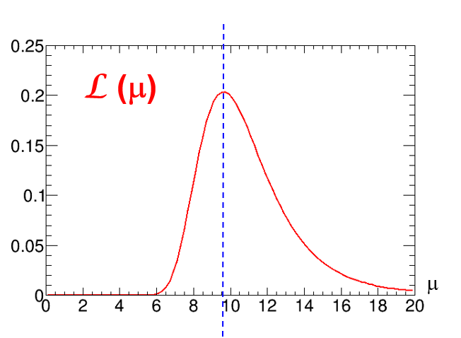
Figure5:PlotofL(µ)forobservedx0= 10.,forthemodelinEqn.17.ThemaximumisatµML= 9.63

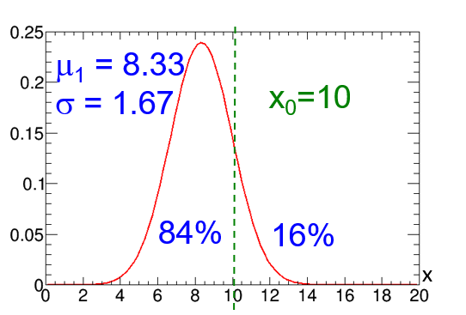

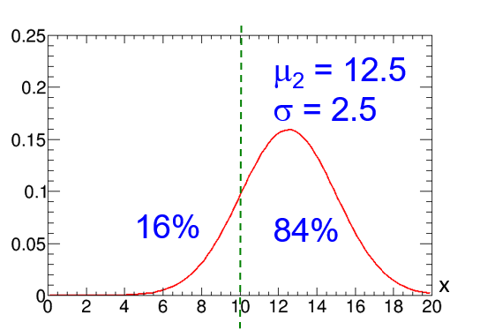

Figure 6:(left) The model in Eqn. 17, with µ chosen such that 84% of the probability is below x0= 10.0.(right)ThemodelinEqn.17,withµchosensuchthat84%oftheprobabilityis abovex0= 10.0.
29

2.Thenoneestimatesσbyˆσ=0.2 ×ˆµ=2.0.(Thisispotentiallydangeroussinceit estimatesoneparameterbypluggingthepointestimateofanotherparameterintoa relationshipbetweentruevaluesofparameters.)
3.Thenˆµ±ˆσyieldstheinterval[8.0, 12.0].(Againthisispotentiallydangerous,asit evaluates tail probabilities of a model having true parameters via plugging in estimates oftheparameters.)
Such“Waldintervals”areatbestonlyapproximationstoexactintervals. For(“exact”) confidenceintervals,thereasoningmustalwaysinvolveprobabilitiesforxcalculatedcon-sideringparticularpossibletruevaluesofparameters,asintheWilsonreasoning!Clearly, the validity of the approximate Wald-interval reasoning (i.e., how dangerous the “potentially dangerous” steps are) depends on how much σ(µ) changes for µ relevant to problem at hand. TheimportantpointisthattheWaldreasoningisnotthecorrectreasoningforconfidence intervals.Beware!
6.5 Confidenceintervalsforbinomialparameterρ
ThebinomialmodelisdirectlyrelevanttoefficiencycalculationsinHEP,aswellasother contexts.RecallthebinomialdistributionBi(non|ntot, ρ)fromEqn.8fortheprobabilityof nonsuccesses in ntottrials, each with binomial parameter ρ.In repeated trials, nonhas mean
ntot ρ (19)
andrmsdeviation
p ntot ρ (1 −ρ) . | (20)
Forasymptoticallylargentot,Bi(non|ntot, ρ)canbeapproximatedbyanormaldistribution withthismeanandrmsdeviation.
With observed number of successes non, the likelihood function L(ρ) follows from reading Eqn.8asafunctionofρ.Themaximumisat
ˆρ = non/ntot. (21)
Suppose one observes non= 3 successes in ntot= 10 trials.The likelihood function L(ρ) isplottedinFig.7.
6.5.1 Whatcentralconfidenceintervalshouldwereportforρ?
Wehavenon=3,ntot=10.Letusfindthe“exact”68%C.L.centralconfidenceinterval [ρ1, ρ2].RecalltheshortcutinSection6.4.1forcentralintervals:Findthelowerlimitρ1 withC.L.=(1 + 0.68)/2=84%;andfindupperlimitρ2withC.L.=84%.Then[ρ1, ρ2]is a68%C.L.centralconfidenceinterval.
1.Forlowerlimitat84%C.L.,findρ1suchthatBi(non<3|ρ1)=84%,i.e.,Bi(non≥ 3|ρ1) = 16%.Solve:ρ1= 0.142asinFig.8(left).
2.Forupperlimitat84%C.L.),findρ2suchthatBi(non>3|ρ2)=84%,i.e.,Bi(non≤ 3|ρ2) = 16%.Solve:ρ2= 0.508asinFig.8(right).
30

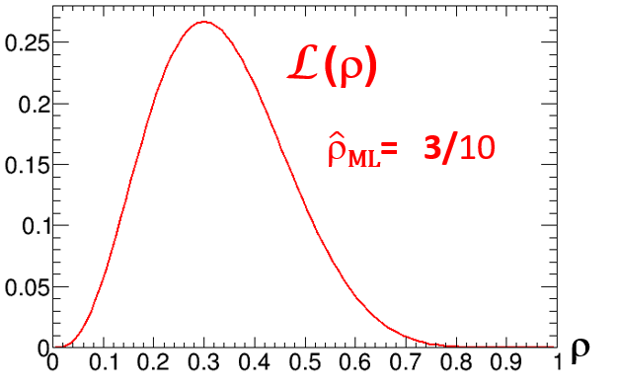

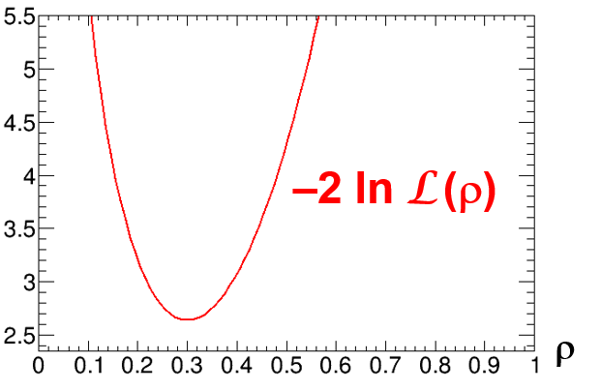

Figure7:(left)LikelihoodfunctionL(ρ)fornon=3successesinntot=10trialsinthe binomialmodelofEqn.8.(right)LookingaheadtoSection8,theplotof−2 ln L(ρ).

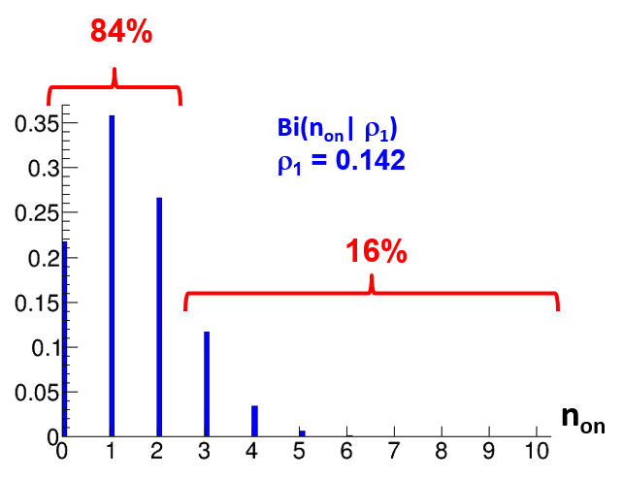

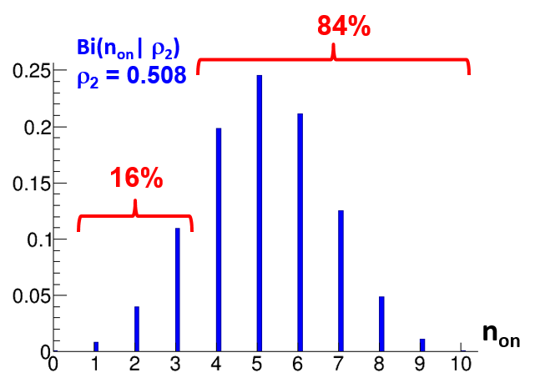

Figure8:(left)PlotofBi(non|ntot=10, ρ),withρchosensuchthat84%oftheprobability isbelownon=3.(right)PlotofBi(non|ntot=10, ρ),withρchosensuchthat84%ofthe probabilityisabovenon= 3.
31

3.Then[ρ1, ρ2] = [0.142, 0.508]isacentralconfidenceintervalwith68%C.L.
ThisisthesameresultasobtainedbyClopperandPearson(C-P)in1934[46],citing Fisher,Neyman,andNeyman’sstudents.InHEP,suchC-Pintervalsarethestandardfora binomialparameter;theyhavebeeninPDGRPPsince2002[13](althoughtheconnection ofthegivenformulawithC-Pisobscure).
ThesamemethodwasappliedtoconfidenceintervalsforaPoissonmeanbyGarwood inhis1934thesis,andpublishedin1936[47].(SeeRef.[32],andreferencestherein.)They are also the standard in HEP when there is no background.There is controversy when there isbackground;seePDGRPP(Section39.4.2.4).
ManytablesandonlinecalculatorsforC-PintervalsandGarwoodintervalsexist;I usuallyuseRef[48].
Theuseoftheword“exact”(datingtoFisher)forintervalssuchasC-Preferstothe constructionabove.Butthediscretenessofobservedx(noninthiscase)causesthefre-quentistcoverage(definedanddiscussedSection6.11below)nottobeexact,butrather generallygreaterthanthechosenC.L.C-Pintervalsarethuscriticizedbysomeas“waste-fullyconservative”.Foracomprehensivereviewofbothcentralandnon-centralconfidence intervalsforabinomialparameterandfortheratioofPoissonmeans,seeCousins,Hymes, andTucker[49].Manychoices,includingC-P,areimplementedinROOT[50].
For the closely related construction of upper/lower limits and central confidence intervals foraPoissonmean,seeRef.[32].
6.5.2 Gaussianapproximationforbinomialconfidenceintervals:Wilsonscore intervalof1927
Asmentionedabove,nonhasmeanandrmsdeviationgivenbyEqns.19and20,andfor
asymptoticallylargentot,Bi(non|ntot, ρ)convergestoaGaussianwithmeanµ(ρ)=ntotρ
andrmsσ(ρ) = | p ntotρ(1 −ρ).
We can thus compute approximate confidence intervals for ρ while invoking this Gaussian approximationtothebinomialdistribution.
TheideaisnottosubstituteˆρforρinEqns.19and20(potentiallybigmistake!),but rathertofollowthelogicalreadyusedabovefromE.B.Wilsonin1927[45].(Thisisinfact theexamplethathewasillustratinginthatpaper!)Thatis,weusetheaboverecipefor upperandlowerlimits:
1.Findρ1suchthatGauss(x ≥3|meanρ1, σ(ρ1)) = 0.16.
2.Findρ2suchthatGauss(x ≤3|meanρ2, σ(ρ2)) = 0.16.
Thisconsistentlyusesthe(different)valuesofσassociatedwitheachρ,notσ(ˆρ).It leadstoaquadraticequationthat,forourexample,hassolution[ρ1, ρ2]==[0.18, 0.46]. Thisistheapproximate68%C.L.confidenceintervalknownastheWilsonscoreinterval.
(SeeRef.[49]andreferencestherein.)
AlthoughthisWilsonscoreintervalneedsonlythequadraticformula,itisforsome reasonrelativelyunknown,asstudentsaretaughttheWaldinterval(UGH)ofthenext subsection.
32

6.5.3 Gaussian approximation for binomial confidence intervals:potentially dis-astrousWaldintervaltoavoid
Itistemptinginsteadtofollowtheso-called“Waldreasoning”mentionedinSection6.4.2,
andtosubstituteˆρ=ntotρforρintheexpressionforthermsdeviationinEqn.20.One
obtains:ˆσ= | p ntotˆρ(1 −ˆρ)anditseemsasimplesteptothepotentiallydisastrous“Wald
interval”ˆρ ± ˆσ,i.e.,[ρ1, ρ2] = [ˆρ −ˆσ, ˆρ + ˆσ].
TheWaldintervaldoesnotusethecorrectlogicforfrequentistconfidence!Infact,ˆσ= 0whennon= 0ornon= ntot.
Incredibly, the failure of the Wald interval when non= 0 (or non= ntot) has been used as afoundationalargumentinfavorofBayesianintervalsinatleastfourpublicHEPpostings (oneretracted)andonepublishedastrophysicspaper! Ofallthemisguidedthingsthat havebeenwrittenaboutstatistics(sometimesbyme)innominallyscholarlywritings,this isamongthemostuninformedthatIhaveseen.(Typicallytheauthorswerenotinformed about Bayesian statistics either, and thought that a prior uniform in ρ was obvious, without havingreadthevastBayesianliteratureonpriorsforabinomialparameter.)
Beware!AvoidtheWaldintervalexceptfor“hallwayestimates”—thereisnoreason touseit.AndcertainlydonotmakethesillyclaimthatproblemswiththeWaldinterval pointtofoundationalissueswithconfidenceintervals. TheWaldintervaldoesnotuse“confidence”reasoning,andwasalreadyobsoletein1927astheGaussianapproximation tobinomialconfidenceintervals;andby1934theexactintervalsusingconfidencereasoning werepublishedbyC-P!Theyhavenoproblemwiththecases“fatal”toWaldintervals, non= 0ornon= ntot,ascanbeeasilyverified.
6.5.4 HEPapplicationsofconfidenceintervalsforbinomialparameter
Asmentioned,thebinomialmodelisdirectlyrelevanttoefficiencycalculationsintheusual casewherenonisnotfixedbytheexperimentdesignbutrathersampled.
Usingafamousmathidentity,thebinomialmodelisalsodirectlyapplicabletocon-fidenceintervalsfortheratioofPoissonmeans[49,51]. Thus,itappliestostatistical significance(ZBi)ofanexcessinasignalbinwhenasidebandisusedtoestimatethemean background.(SeeCousins,Linnemann,andTucker[52].)Asdiscussedinourpaper,one canevenstretchtheuseofZBi(usinga“roughcorrespondence”)totheproblemofasignal binwhenaGaussianestimateofmeanbackgroundexists.
6.6 Perceivedproblemswithupper/lowerlimitsandhencefor
centralconfidenceintervals
For decades,issues with upper limits and central confidence intervals have been discussed in twoprototypeproblemsinHEP:
•Gaussian measurement resolution near a physical boundary (e.g., neutrino mass-squared ispositive,butthesamplexisnegative);
•Poissonsignalmeanmeasurementwhenobservednumberofeventsislessthanthe
33

meanexpectedbackground(sothatthenaive“background-subtracted”meanisnega-tive).
Manyideashavebeenputforward,andby2002thePDGRPPsettledonthree,which remains the case [13].I have described some of this interesting history in a “virtual talk” [53] andinanarXivpost[54].(SeeSection14inthispaper.)Inthissection,Idescribejustone ofthesethreeideas,namelyusingNeyman’sconfidenceintervalconstruction,goingbeyond the common orderings of x discussed thus far (Section 6.2.1),to that advocated by Feldman andCousins(F-C)[55].(TheothertwoideasintheRPPareBayesianupperlimitsand CLs(Section14.1.)
6.7 Beyondupper/lowerlimitsandcentralconfidenceintervals
Amongthemoregeneralchoicesfororderingxinp(x|µ),themostcommoninHEPisthat basedonalikelihoodratio(LR):
Foreachµ,orderx0usingthelikelihoodratioL(x0|µ)/L(x0|µbest-fit),whereµbest-fit respectsthephysicalboundariesofµ.ThiswasadvocatedinHEPbyFeldmanandCousins in 1998 [55].In fact, as learned by F-C while their paper was in proof, the dual hypothesis test (Section7.5)appearedinthehypothesistestsectionofthefrequentistclassicby“Kendall and Stuart” [56] long before and since.Unlike the orderings described above, the LR ordering isapplicableinboth1Dandmulti-Dforx.
RecallfromSection4.1thatlikelihoodratiosasinF-Careindependentofmetricinx sincetheJacobianscancel,sothereisnoissuethere.Incontrast,analternativethatmight cometomind,namelyorderingxbytheprobabilitydensityp(x|µ),isnotrecommended.A changeofmetricfromxtoy(x)leadstoaJacobian|dy/dx|inp(y|µ) = p(x|µ)/|dy/dx|(as inSection4.1).Soorderingbyp(y|µ)isdifferentthanorderingbyp(x|µ),andsoallthat wouldfollowfromorderingbyapdfwoulddependonthearbitrarychoiceofmetric.
Inordertoimplementthismoregeneralorderingbylikelihoodratios,wemustgo beyondfindingtheconfidenceintervalendpointsµ1andµ2independently,andperformthe constructionofthewholeintervalatthesametime,asinthenextsubsection.
6.8 Neyman’sConstructionofConfidenceIntervals
Thegeneralmethodforconstructing“confidenceintervals”,andthename,wereinvented byJerzyNeymanin1934-37.Ittakesabitoftimetosinkin—givenhowoftenconfidence intervalsaremisinterpreted,perhapstheargumentisabittooingenious!Inparticular,you shouldunderstandthattheconfidenceleveldoesnottellyou“howconfidentyouarethat theunknowntruevalueisinthespecificintervalyoureport”—onlyasubjectiveBayesian credibleintervalhasthatproperty!Rather,asstatedinSection6.2,theconfidenceinterval [µ1, µ2]containsthosevaluesofµforwhichtheobservedx0isnot“extreme”,accordingto theorderingprinciplechosen.Inthissection,wedescribethisconstructioninmoredetail andmoregenerality.Webeginwith1Ddataandoneparameterµ.
Given a statistical model p(x|µ):For each value of µ, one draws a horizontal acceptance interval[x1, x2]suchthat
p(x ∈[x1, x2]|µ) = C.L. = 1 −α, (22)
34

as in Fig. 9(left).The “ordering principle” that was chosen for x is used to well-define which valuesofxareincluded.
Uponobservingxandobtainingthevaluex0,onedrawsaverticallinethroughx0,as inFig.9(right).Theverticalconfidenceinterval[µ1, µ2]withconfidencelevelC.L.=1 −αistheunionofallvaluesofµforwhichthecorrespondingacceptanceintervalisintercepted bytheverticalline,asinFig.9(bottom).(Itneednotbesimplyconnected,asinhighly nonlinearapplicationssuchasneutrinooscillations.)
Importantnote:xandµneednothavethesamerange,units,or(ingeneralizationto higherdimensions)dimensionality!
In fact, I think it is much easier to avoid confusion if x and µ are qualitatively different. Louis Lyons gives the example where x is the flux of solar neutrinos and µ is the temperature at the center of the sun.I like examples where x and µ have different dimensions:Neyman’s original paper [44] has a 2D observation space and 1D parameter space; his figure was crucial formyownunderstandingoftheconstruction.
6.9 FamousconfusionreGaussianp(x|µ)whereµismass≥0
AprototypeproblemistheGaussianmodelp(x|µ, σ)inEqn.10inthecasewhereµcor-respondstoaquantitythatisphysicallynon-negative,e.g.,amass,amass-squared,oran interactioncrosssection.Notethatinthiscasenegativevaluesofµdonotexistinthe model !
Aparticle’smass-squaredmightbecomputedbymeasuringaparticle’senergy-squared (E2)withGaussianresolutionandalso(independently)itsmomentum-squared(p2)with Gaussianresolution.Thentheobservablexcorrespondingtomass-squaredcouldbecom-putedfromE2−p2,withGaussianresolution.Ifthetruem2iszeroorsmallcomparedto theresolution,thensuchaprocedurecaneasilyobtainavalueofxthatisnegative.There isnothinganomalousaboutnegativex.
AkeypointthatwasasourceofalotofconfusionhistoricallyinHEP,andwhichstill tripsuppeople,isthefollowing:Itiscrucialtodistinguishbetweentheobserveddatax, whichcanbenegative(noproblem),andthemodelparameterµ,forwhichnegativevalues donotexistinthemodel.Forparameterµ < 0,p(x|µ)doesnotexist:Youwouldnotknow howtosimulatethephysicsofyourdetectorresponsetonegativemass!
Theconstraintµ≥0thushasnothingtodowithaBayesianpriorpdfforµ(!!!)as sometimesmistakenlythought.Theconstraintisinthemodel,andhenceinthelikelihood L(µ),notinthepriorpdf.
The confusion is encouraged since we often refer to x as the “measured value of µ”, and say that x < 0 is “unphysical”.This is a bad habit!The value x is an observed sample from aGaussiancenteredonµ,withµbeing“physical”.
Thus,aproperNeymanconstructiongraphforthecaseathandhasxwithbotharith-metic signs but only non-negative µ ≥0.This is the case in the plot in Fig. 10(left), following thatinF-C[55].Therewasalotofconfusionintheearlydayswhentheverticalaxison thisplotwasextendedtonon-physicalvaluesofµ.Sincethemodeldoesnotexistthere,it isaconceptualmistaketodrawtheacceptanceintervalsthere(assomedid).
Foralternativemethodsfordealingwiththissituation,seeSection14.
35

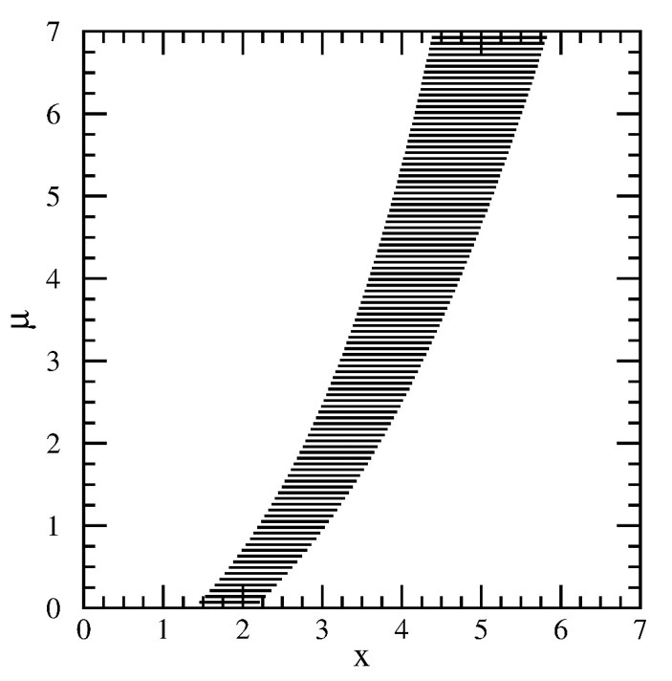

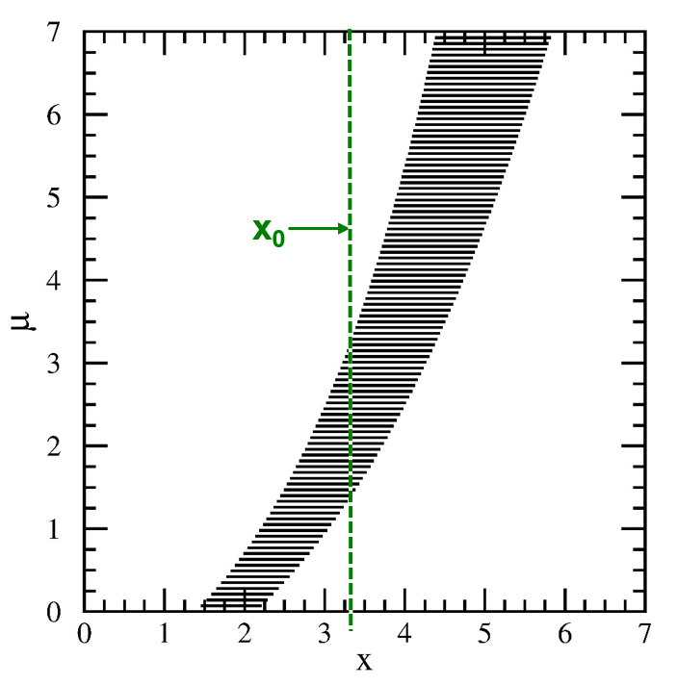

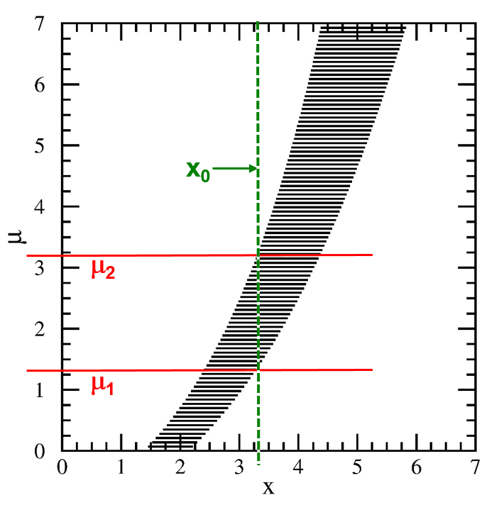
Figure9:StepsintheNeymanconstruction,asdescribedinthetext.FromRef.[55].
36

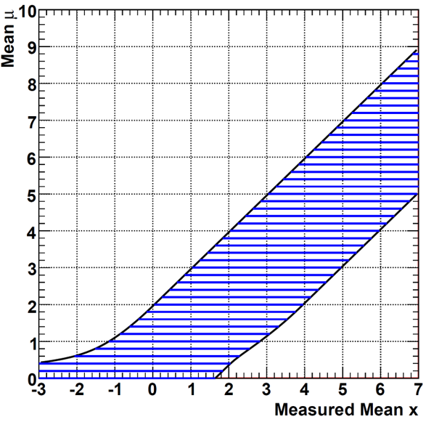

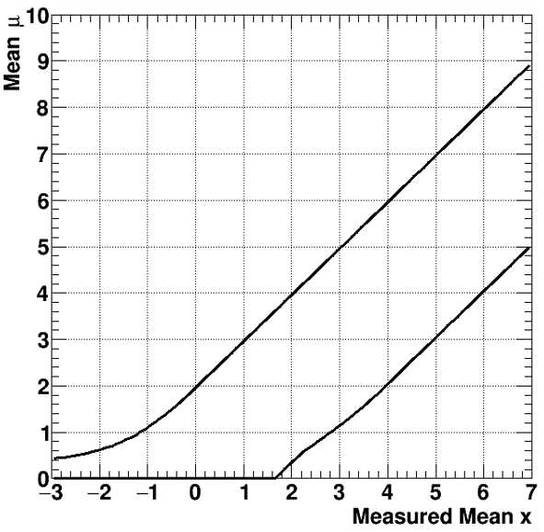

Figure10:(left)TheNeymanconstructionforthenonnegativemeanofaGaussianwith acceptanceintervalsshowninblue,asadvocatedinRef.[55].(right)The“confidencebelt”obtained from the construction on the left, showing the envelope of the acceptance intervals, whicharenotdrawn.
6.10 Confidencebelts
Fromtheearliestdays(asinthe1934Clopper-Pearsonpaper[46]),thehorizontalline segments of the acceptance intervals (such as in Fig. 10(left)) havebeensuppressed, and only theirenvelope,asintheblackcurvesinFig.10(right),havebeenplotted.Theblackcurves (andinterior)arecalledaconfidencebelt.
IaddedthelinesegmentsfordemonstratingtheconstructionintheF-Cpaperafter reading Neyman’s 1937 paper [44], in which his Fig. 1 has a couple of planes with acceptance regionsshown,anda1Dverticallineattheobserved2Dpointinterceptingthem.This practiceintheF-Cpaperisfortunatelyspreading.
Ihadfoundotherdescriptionsoftheconstruction,showingonlythebelt,tobetoo obscurewhenIwastryingtolearntheconstruction.TherewouldbestatementsthatI foundcryptic,suchas“Noticethattheconfidencebeltisconstructedhorizontallybutread vertically.”ThismadesensetomeonlyafterIhadunderstoodtheconstruction!
6.11 Confidenceintervalsandcoverage
Do you recall how a vector is defined in an abstract math class?In math, one defines a vector spaceasasetwithcertainproperties,andthenthedefinitionofavectoris“anelementof avectorspace”.Avectorisnotdefinedinisolation!
Similarly,whetherconstructedinpracticebyNeyman’sconstructionorsomeother technique,aconfidenceintervalisdefinedtobe“anelementofaconfidenceset”,wherethe confidencesetisasetofintervalsdefinedtohavethepropertyoffrequentistcoverageunder
37

repeatedsampling:
Let µt be the unknown true value of µ.In repeated experiments, confidence intervals will havedifferentendpoints[µ1, µ2],sincetheendpointsarefunctionsoftherandomlysampled x.
A little thought will convince you that a fraction C.L.= 1−α of intervals obtained from Neyman’sconstructionwillcontain(“cover”)thefixedbutunknownµt.I.e.,
P(µt∈[µ1, µ2]) = C.L. = 1 −α. (23)
Thisequationisthedefinitionoffrequentistcoverage.Inthis(frequentist!)equation,µt isfixedandunknown.Theendpointsµ1, µ2aretherandomvariables(!).Coverageisa propertyofthesetofconfidenceintervals,notofanyoneinterval.
[Here is the “little thought” that explains why Neyman’s construction leads to coverage: For the unknown true value µt, the probability that x0is in its acceptance interval is C.L., by construction.Whenthosex0’sareobtained,theverticallinewillinterceptµt’sacceptance region,andsoµtbewillbeputintotheconfidenceinterval.Thusthecoverageequationis satisfied.]
Oneofthecomplaintsaboutconfidenceintervalsisthattheconsumeroftenforgets(if heorsheeverknew)thattherandomvariablesinEqn.23areµ1andµ2,andnotµt;and that coverage is a property of the set, not of an individual interval!Please don’t forget!A lot ofconfusionmighthavebeenavoidedifNeymanhadchosenthenames“coverageintervals”and“coveragelevel ”!(Maybewecanhaveasummitmeetingtreatywherefrequentistsstop saying“confidence”andBayesiansstopsaying“noninformative”!)
Note:Itistrue(inpreciselythesensedefinedbytheorderingprincipleusedforxin the Neyman construction) that the confidence interval consists of those values of µ for which theobservedx0isamongtheC.L.leastextremevaluestobeobserved.
6.11.1 Over-coveragewhenobservablexisdiscrete
AproblemarisesinNeyman’sconstructionwhentheobservablex(ormoregenerally,the teststatistic)isdiscrete.ThiswasalreadythecaseintheClopper-Pearsonpaper.When constructinganacceptanceinterval,typicallyEqn.22cannotbesatisfiedexactly. The traditionalconvention(stilltypicallyobservedinHEP)istoincludeenoughvaluesofxso thattheequalitybecomes“≥”.Thismeansthatthecoverageequationincludesso-called over-coverage:
P(µt∈[µ1, µ2]) ≥C.L. = 1 −α. (24)
Foradiscussionofthisissueandvariousopinionsaboutit,seeRef.[49]andreferences therein.
7 Frequentist(classical)hypothesistesting
Atthispoint,wesetasideconfidenceintervalsforthemomentandconsiderfromthebe-ginningthenominallydifferenttopicofhypothesistesting.Infact,wewillsoonfindthat infrequentiststatistics,certainhypothesis tests will take us immediately back to confidence intervals.Butfirst,weconsiderthemoregeneralframework.
38

Frequentist hypothesis testing, often called “classical” hypothesis testing, was developed byJ.NeymanandE.Pearson(N-P)inunfriendlycompetitionwithR.A.Fisher.Modern testing has a mix of ideas from both “schools”.Following the N-P approach [3, 57], we frame the discussion in terms of a null hypothesis H0(e.g., the Standard Model), and an alternative H1(e.g.,someBeyond-SMmodel).
AsinSection6.1,xisateststatistic(functionoftheobserveddata)andµrepresents parameters.Thenthemodelp(x|µ)isdifferentforH0andH1,eitherbecauseparameterµ(oftencalledθbystatisticians)hasadifferentvalue,orbecausep(x|µ)itselfisadifferent functionalform,perhapswithadditionalparameters.
ForthenullhypothesisH0,weorderpossibleobservationsxfromleastextremeto mostextreme,usinganorderingprinciple(whichcandependonH1aswell).Wechoosea probabilityα(smallishnumber).
We then “reject” H0if the observed x0is in the most extreme fraction α of observations x(generatedunderH0).Byconstruction:
α = probability (with x generated according to H0) of rejecting H0when it is true, i.e., false discoveryclaim(TypeIerror).Itiscalledthesizeorsignificancelevelofthetest.
ToquantitytheperformanceofthistestifH1istrue,wefurtherdefine:
β= probability (with x generated according to H1) of not rejecting (“accepting”) H0when itisfalse,i.e.,notclaimingadiscoverywhenthereisone(TypeIIerror).
Thepowerofthetestisdefinedas1 −β.
Note:IfthealternativeH1isnotspecified,thenβisnotknownandoptimalitycannot be well-defined.The test is then called a goodness-of-fit test of H0, as discussed in Section 7.8.
ThereisatradeoffbetweenTypeIandTypeIIerrors. Typically,internaltothe dataanalysis,thereisathresholdonateststatisticxthatdeterminesthetradeoff.This tradeoff,aswellascompetinganalysisalgorithms(resultingindifferentteststatistics)can becomparedbylookingatgraphsofthepower1 −βvsαatvariousµ,asinFig.11,and atgraphsof1 −βvsµatvariousα(powerfunction).(See,e.g.,Ref.[3],pp.258,262.) TestingH0vsH1,includingthebinaryclassificationproblemofassigningitemstoone of two classes,is ubiquitous in science.There are several sets of words used instead of N-P’s Type I error probability α and Type II error probability β and their “power” 1−β.Typically, H0isthe“boring”hypothesis(backgroundevent,nodisease,nosignalofsomethingnew), andH1issomethingnew(signalfornewscience,presenceofdisease,etc.)RejectingH0is calleda“positive”resultofthetest(evenifnewsofadisease),whilenotrejectingH0isa“negative”testresult.Sotestresultsarecalledtrue+,true−,false+,orfalse−.
AppendixAillustratesthetradeoffbetweenαandβwithatoyexampleofspindis-criminationofanewresonance.
7.1 Hypothesistestingjargon,ROCcurves
TheacronymROC(for“receiveroperatingcharacteristic”)fromtheearlydaysofradaris commonlyusedinmanyfieldsofengineeringandscience.TheROCcurveisagraphof power1 −βvsType1errorprobabilityα,oftenwithnewnames:Truepositiveratevs.
39

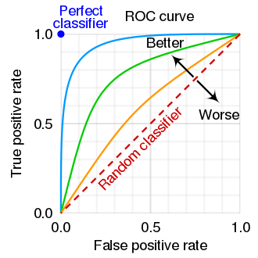
Figure11: | SketchofROCcurvesforthreedifferentclassifyingalgorithms, | from
Wikipedia[58].The“Truepositiverate”isanothernameforthepower1 −β,andthe“Falsepositiverate”isanothernamefortheTypeIerrorprobabilityα.
Falsepositiverate.ThisdefinitionofROC[58]uses“rate”asasynonymfor“probability”(UGH),asfollows:
Falsepositiverate=P(rejectH0 |H0true)
=α=N-PTypeIerrorprobability
=1−specificityinmedicaljargon,and
Truepositiverate=P(rejectH0 |H0false)
=1 −β=N-Ppoweroftest
=sensitivityinmedicaljargon.
Again,thereisinternallyathresholdofateststatisticxthatdeterminesthetradeoff betweenαand1 −β,andhencebetweenFPRandTPR.
Thecommonlyusedmachinelearningsoftwaresuitescikit-learn[59]providesROC curveswithTPRvsFPR.
7.1.1 JargoninHEP
•P(objectcalledsignal|bkgnd)=αisthe“mistag”probabilityforbackground.The objectis“tagged”assignaleventhoughitisbackground.
•P(objectcalledsignal|signal)=1 −βisthe“efficiency”forsignal(fractionoftrue signaleventsthataretaggedassignal)
•P(objectcalledbkgnd|signal)= βisthe“inefficiency”forsignal
40

Asthethresholdonateststatisticfortaggingsignalischanged,onemapsoutcurveswith axeslabeledwiththesetermsinsteadof1 −βvs.α,orTPRvs.FPR.
Note:The assignment of H0 and H1 is arbitrary and can be reversed, with corresponding reversalofαandβ.TypicallyH0isthesimplerhypothesis.
Warning:In the TMVA package in ROOT, there is a nonstandard convention for “ROC curves”; the axes are labeled “background rejection” vs “efficiency”, meaning 1−α vs 1−β. Bewareofthemanydefinitionsandconventions!
7.1.2 Jargonformedicaltests
Recall:resultsaretrue+,true−,false+,ortrue−.
•P(testis+|disease)=1 −βiscalledthe“sensitivity”ofthetest:theprobabilityof correctdiagnosisifactuallydiseased(true+).
•P(testis−|nodisease)=1 −αiscalledthe“specificity”ofthetest:theprobability ofcorrectdiagnosisifnodisease(true−).
Again,thechosenvalueofathresholdonateststatisticdeterminesthetradeoffbetween sensitivityandspecificity.
Question:Supposeweknowthesensitivityandspecificity.Considerpeoplewithpositive testresults.Whatfractionofthemhavethedisease?I.e.,whatisP(disease|testis+)? Thisiscalledthepositivepredictivevalue(PPV)inmedicine.
Answer:Cannotbedeterminedfromthegiveninformation!
One needs in addition:P(disease), the true fraction of all people that have the disease.Then Bayes’sTheoreminvertstheconditionality:
P(disease|testis+)∝P(testis+|disease)P(disease)
7.2 ThechoiceofTypeIerrorprobabilityα
Thechoiceofoperatingpointonthe1 −βvsαcurve(orROCcurve)isalongdiscussion. (ItisevenlongerwhenconsideredasthenumberNofeventsincreases,sothatbothαandβarereduced.)TheN-Planguageof“accept”or“reject”H0shouldnotbemistakenfor acompletetheoryofdecision-making:Adecisiononwhetherornottodeclarediscovery (falsifyingH0)requires2moreinputs:
•PriorbeliefinH0vsH1.(Canaffectchoiceofα)
•Cost of Type I error (false discovery claim) vs cost of Type II error (missed discovery). (Canalsoaffectchoiceofα)
Aone-size-fits-allcriterionofαcorrespondingto5σiswithoutfoundation!Foradiscussion ofthispoint,seeRefs.[4,60].
Considerationssuchastheseforthechoiceofαtypicallydependonthecontext.Using the result of an experiment for a single test of a physics hypothesis is a very different context than repeatedly selecting candidate b-jets with a b-tagging algorithm as in Section 3.2.In the latter case,the tradeoff between βvs αis usually determined by considerations downstream intheanalysis.
41

7.3 Frequentisthypothesistesting:Simplehypotheses
Inidealizedcasesthataresometimesreasonablywell-approximatedinHEP,ahypothesis mayhavenofloating(unfixed)parameters.N-Pcalledsuchhypothesessimple,incontrast tocompositehypothesesthathaveunfixedparameters.
Examples in HEP where both H0and H1are truly simple are rare, but we do have a few examples where the quantity of interest is simple in both hypotheses, and the role of unfixed nuisanceparametersdoesnotbadlyspoilthe“simplicity”.Forexample,thehypothesesH0 vsH1mightbe:
•“jetoriginatedfromaquark”vs“jetoriginatedfromagluon”,forajetreconstructed inthedetector
•spin-1vsspin-2foranewresonanceinµ+µ−
•JP= 0+vsJP= 0−fortheHiggs-likeboson
Asimplified,detailedillustrationofthespintestisinAppendixA,whileanexampleofthe JPtestpublishedbyCMSisinSection7.7.2.Ofcourse,framingthesetestsinthisway makesstrongassumptions(inparticularthatoneofthetwohypothesesistrue)thatneed toberevisitedoncedataareinhand.
7.3.1 TestingSimplehypotheses:Neyman–Pearsonlemma
IftheTypeIerrorprobability αisspecifiedina testofsimplehypothesisH0againstsimple hypothesisH1,thentheTypeIIerrorprobabilityβisminimizedbyorderingxaccordingto thelikelihoodratio[57],
λ = L(x|H0)/L(x|H1). (25)
Onefindsthecutoffλcut,αforthedesiredαandrejectsH0ifλ ≤λcut,α.Foranoutlineofa proof,seeRef.[56](p.176).Asmentioned,AppendixAhasanexample.
This “Neyman–Pearson lemma” applies only to a very special case:no fitted parameters, not even undetermined parameters of interest!However, it has inspired many generalizations, andlikelihoodratiosareanoft-usedcomponentofbothfrequentistandBayesianmethods.
7.4 Nestedhypothesistesting
In contrast to two disjoint simple hypotheses, it is common in HEP for H0to be nested in H1. For example, commonly H0corresponds to the parameter µ in H1being equal to a particular valueµ0.(Typicalvaluesofµ0are0or1.)Soweoftenconsider:
H0:µ = µ0(the“pointnull”,or“sharphypothesis”)vs
H1:µ̸ = µ0(the“continuousalternative”).
Commonexamples,includingadecayoftheHiggsbosonH0,are:
•Signalstrengthµofnewphysics:nullµ0= 0,alternativeµ > 0
42

•H0→γγbeforediscoveryofthisdecay,µ=signalstrength:nullµ0=0,alternative µ > 0
•H0→γγafterdiscoveryofthisdecay:µistheratioofthesignalstrengthtotheSM prediction;nullµ0= 1(i.e.,SMprediction),alternativeisanyotherµ̸ = µ0.
7.5 Nestedhypothesistesting:Dualitywithintervals
Intheclassicalfrequentistformalism(butnottheBayesianformalism),thetheoryofthese testsmapstothatofconfidenceintervals!Theargumentisasfollows.
1.Havingobserveddatax0,supposethe90%C.L.confidenceintervalforµis[µ1, µ2]. Thiscontainsallvaluesofµforwhichtheobservedx0isrankedintheleastextreme 90%ofpossibleoutcomesxaccordingtop(x|µ)andtheorderingprincipleinuse.
2.With the same data x0, suppose that we wish to test H0 vs H1 (as defined in Section 7.4) atTypeIerrorprobabilityα = 10%.WerejectH0ifx0isrankedinthemostextreme 10%ofxaccordingtop(x|µ)andtheorderingprincipleinuse.
Comparingthetwoprocedures,weseethatwerejectH0atα = 10%ifandonlyif µ0is outsidethe90%C.L.confidenceinterval[µ1, µ2].
(In this verbal description, I am implicitly assuming that x is continuous and that p(x|µ) isapdfthatputszeroprobabilityonapointxwithmeasurezero.ThusIignoreanyissues concerningendpointsofintervals.)
Weconclude:Givenanordering:atestofH0vsH1atsignificancelevelαisequivalent toasking:Isµ0outsidetheconfidenceintervalforµwithC.L.= 1 −α?
AsKendallandStuartputit,“Thereisthusnoneedtoderiveoptimumproperties separatelyfortestsandforintervals;thereisaone-to-onecorrespondencebetweenthe problemsasinthedictionaryinTable20.1”[56](p.175). Thetablementionedmaps theterminologythathistoricallydevelopedseparatelyforintervalsandfortesting,e.g.,
α↔1 −C.L.
Mostpowerful↔Uniformlymostaccurate
Equal-tailedtests↔centralconfidenceintervals
Use of this duality is referred to as “inverting a test” to obtain confidence intervals, and vice versa.
7.6 Feldman-Cousins
AsmentionedinSection6.7,the“new”likelihood-ratio(LR)orderingprinciplethatGary FeldmanandIadvocatedforconfidenceintervalsinRef.[55]turnedouttobeoneandthe same as the time-honored ordering (generalized to include nuisance parameters) described in Ref. [56] in the chapter of hypothesis testing using likelihood ratios.We had scoured statistics literature for precedents of “our” intervals without finding anything.But we over-looked the
43

factthatweshouldalsobescouringtheliteratureonhypothesistests,untilGaryrealized that,justintimetogetanoteaddedinproof.Infact,itwasallon11 4pagesof“Kendall and Stuart”, plus nuisance parameters!This led to rapid inclusion of the LR ordering in the PDGRPP,sincetheproposalsuddenlyhadtheweightofrealstatisticsliteraturebehindit.
7.7 Post-datap-valuesandZ-values
TheaboveN-Ptheoryisallapre-datacharacterizationofthehypothesistest.Adeepissue ishowtoapplyitafterx0isknown,i.e.,post-data.
InN-Ptheory,αisspecifiedinadvance.Supposeafterobtainingdata,younoticethat withα=0.05previouslyspecified,yourejectH0,butwithα=0.01previouslyspecified, youacceptH0.Infact,youdeterminethatwiththedatasetinhand,H0wouldberejected forα ≥0.023.
Thisinterestingvaluehasaname:Afterdataareobtained,thep-valueisthesmallest valueofαforwhichH0wouldberejected,hadthatvaluebeenspecifiedinadvance.
This is numerically (if not philosophically) the same as the definition used e.g.by Fisher and often taught:“The p-value is the probability under H0 of obtaining x as extreme or more extremethantheobservedx0.”[5](p.58).SeealsoRef.[3](p.299)andRef.[13](Section 40.3.2).
InHEP,ap-valueistypicallyconvertedtoaZ-value(unfortunatelysometimescalled“the significance S”), which is the equivalent number of Gaussian standard deviations.E.g., foraone-tailedtestinasearchforanexcess,p-value = 2.87 × 10−7correspondstoZ= 5.
NotethatGaussianityoftheteststatisticistypicallynotassumedwhenthep-valueis computed;thisconversiontoequivalentGaussian“numberofsigma”isjustforperceived easeofcommunication.ThisneedstobeemphasizedwhencommunicatingoutsideHEP,as IheartoooftenstatisticianswonderingaboutGaussianassumptions,ineffectmakingthe conversioncounter-productive(!).
Although these lectures are not “statistics in practice”, I mention ROOT commands for one-tailedconversions(improvedversioncourtesyofIgorVolobouev):
zvalue=-TMath::NormQuantile(pvalue)
pvalue=0.5*TMath::Erfc(zvalue/sqrt(2.0))
Inourusualone-tailedtestconvention,p-value>0.5correspondstoZ< 0.
7.7.1 Interpretingp-valuesandZ-values
Intheexampleabove,itiscrucialtorealizethatthatvalueofαequaltothep-value(0.023 intheexample)wastypicallynotspecifiedinadvance.Sop-valuesdonotcorrespondto TypeIerrorprobabilitiesofexperimentsreportingthem.
The interpretation of p-values (and hence Z-values) is a long, contentious story—beware! Theyarewidelybashed;IdiscusswhyinSection9.IalsodefendtheiruseinHEP.(Seefor examplemypaperontheJeffreys-LindleyParadox[4].)
Whatever they are, p-values are not the probability that H0is true!This misinterpreta-tion of p-values is unfortunately so common as to be used as an argument against frequentist statistics.Pleasekeepinmind:
44

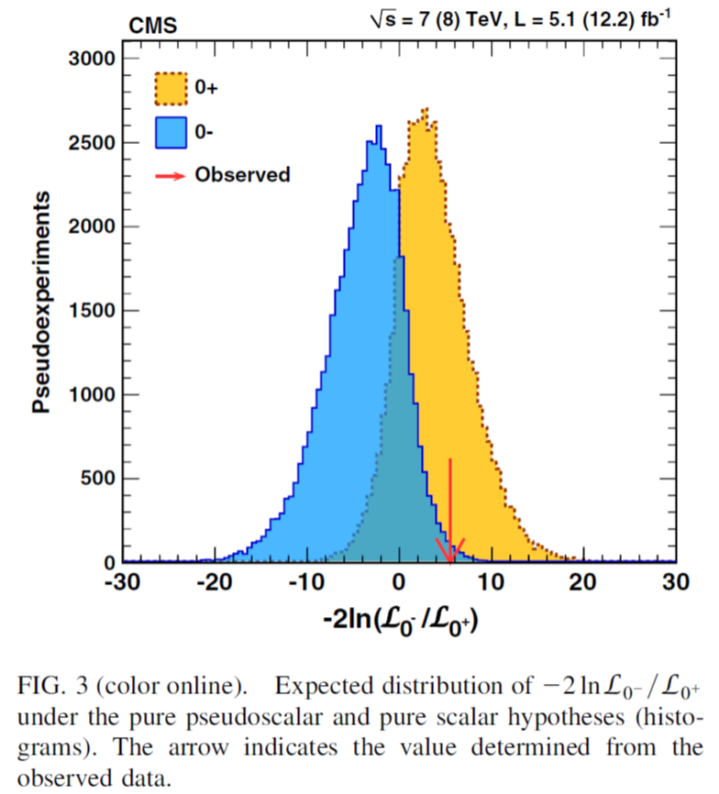
Figure12:FigureandcaptionfromtheearlyCMSpaperonatestofJP=0+vsJP=0−fortheHiggs-likeboson[61].
•Thatp-valuesarecalculatedassumingthatH0istrue,sotheycanhardlytellyouthe probabilitythatH0istrue!
•That thecalculationof the“probability that H0is true” requires prior(s) to invert the conditionalprobabilities,asinSection3.3.
Pleasehelpeducatepressofficersandjournalists!(andphysicists)!
7.7.2 EarlyCMSHiggsbosonspin-paritytestof0+vs.0−
AsnotedatthebeginningofSection7.3,thetestofH0:JP=0+vsH1:JP=0−for theHiggs-likebosonisacasewheretheparameterofinterest(parityP)hastwodiscrete values of interest, and the role of the (many) unfixed nuisance parameters do not badly spoil this“simplicity”inpractice.Thustheteststatisticusedis(twicethenegativelogof)the Neyman–Pearson likelihood ratio λ (with nuisance parameters separately optimized for each P). An early result from CMS [61] is shown in Fig. 12.The pdf of the test statistic, obtained bysimulation,isshownforeachhypothesis.
The similarity with the spin discrimination example in Appendix A is evident; the prin-ciples are the same, but in the Higgs boson case the likelihood functions are more complicated
45

andtherearenuisanceparameters.AssuchexamplesarefairlyrareinHEP(comparedto casesofacontinuousalternative),therewasafairamountofdiscussionwithinCMSabout howbesttopresenttheresultspost-data.CMSreported:
1.Theobservedvalueλ = −2 ln(L0−/L0+) = 5.5,favoring0+;
2.ForatestofH0:0−,thep-value= 0.0072;
3.ReversingtheroleofthetwohypothesesandtestingH0:0+,thep-value= 0.7;
4.CLs= (0.0072)/(1 −0.7) = 0.024,“amoreconservativevalueforjudgingwhetherthe observeddataarecompatiblewith0−.”(SeeSection14.1.)
Notethatforeachp-valuecalculation,therelevanttailprobabilityisforthetailinthe directionoftheotherhypothesis.TheBayesfactor(AppendixD)forthistestissimilarto the observed value of λ reported, as it differs only in the treatment of the nuisance parameters (marginalizationratherthanseparateoptimization).
DemortierandLyons[62]discussthetwop-valuesinsuchasimple-vs-simplecase, contrastingtailprobabilitieswiththelikelihoodratio.SeealsoFig.4ofRef.[63].
7.7.3 Post-datachoiceoftheC.L.
Section 7.5 describes how for a hypothesis test dual to intervals, the (pre-data) α corresponds to1 −C.L.TheninSection7.7,the(post-data)p-valueisthesmallestvalueofαforwhich H0: µ = µ0wouldberejected.Inlightoftheduality,thecorrespondingpost-dataquantity for intervals is “the largest value of the C.L. (or limiting value thereof) such that µ0is not in the confidence interval for µ.”This is clearly equal to one minus the p-value, but (remarkably to me) it seems not to have a standard name in the statistics literature.Thus I will call it the“criticalC.L.”Amorenaturalwaytothinkaboutthiscriticalvaluemaybe“thesmallest valueoftheC.L.suchthatµ0isintheconfidenceintervalforµ.”
For people focused more on the interval aspect of the duality, the critical C.L. may seem a naturalwayto expressa post-data result when a particular value µ0is of interest.In fact, shortly after the F-C paper, the CDF collaboration [64] measured a quantity called sin 2βfor whichakeyscientificquestionwaswhethersin 2β>0.Theyreportedthecriticalvalueof C.L.(0.93)for which0was(just) included in the F-C interval (so that 0 was an endpoint of the interval).I was in a couple of email exchanges regarding what this 0.93 number was, and how to interpret it (as people understood that it was not a pre-data coverage probability for theCDFinterval).Eventually,weallagreed(Ithink)thatithadexactlythesamestatus asapost-datap-value.GiventheLRorderingusedbyF-C,ap-valueassociatedwiththat orderingforthetestofsin 2β=0vssin 2β>0wassimply1 −0.93=0.07.Reportingthe criticalC.L.wasdualtoreportingthatcriticalα.
7.8 Classicalfrequentistgoodnessoffit(g.o.f.)
AmoreextendeddiscussionofgoodnessoffitisinAppendixB.
AsnotedinSection7,ifH0isspecifiedbutthealternativeH1isnot,thenonlythe TypeIerrorprobabilityαcanbecalculated,sincetheTypeIIerrorprobabilityβdepends
46

onH1.Atestwiththisfeatureiscalledatestforgoodness-of-fit(toH0).(Fishercalled themsignificancetests.Ileaveittoothers,e.g.,Ref.[65],totrytoexplainhisseemingly pathologicaloppositiontoexplicitformulationofalternativehypotheses.)Withnoalterna-tive specified, the question “Whichtest is best?”is thus ill-posed.Despite the popularity of testswithuniversalmapsfromteststatisticstoα(inparticularχ2andKolmogorovtests), theymaybeill-suitedformanyproblems(i.e.,theymayhavepoorpower(1 −β)against relevantalternativeH1’s).
In1D,thedifficultyoftheunbinnedg.o.f.testisexemplifiedbythefollowingsimple example:“Given3numbers(e.g.,neutrinomixingangles)in(0, 1),aretheyconsistentwith three calls to a random number generator that is uniform on (0, 1) ?”Have fun with that!A plethoraofpossibletestsin1DaredescribedinthebookbyD’AgostinoandStephens[66] (amust-readforthosewantingtoinventanewtest).
Asmulti-DunbinnedMLfitshaveproliferatedinrecentdecades,thereareincreasing needsformulti-Dunbinnedg.o.f.tests.E.g.,isitreasonablethat1000eventsscatteredina 5Dsamplespacehavebeendrawnfromaparticularpdf(whichmayhaveparametersthat werefitusinganunbinnedM.L.fittothose1000events)?Ofcourse,thisisanill-posed question,butwearelookingforgoodomnibustests.Thengettingthenulldistributionof theteststatisticfromsimulation(Section13)istypicallydoable,itseems.Onecanfollow anunbinnedMLfitwithabinnedg.o.f.testsuchasχ2,butthisbringsinitsownissues. Atalossofpowerbutincreaseintransparency,onecanalsoperformtestson1Dor2D distributionsofthemarginalizeddensities.
AppendixBhasfurtherdiscussionofg.o.f.,basedonmyinformalnote[67].
8 Likelihood(ratio)intervalsfor1parameter
RecallfromSection4.2:thelikelihoodfunctionL(µ)isinvariantunderreparameteriza-tionfromµtof(µ):L(µ)=L(f(µ)).SolikelihoodratiosL(µ1)/L(µ2)andlog-likelihood differencesln L(µ1) −ln L(µ2)arealsoinvariant.
Afterusingthemaximum-likelihoodmethodtoobtaintheestimateˆµthatmaximizes eitherL(µ)orL(f(µ)),onecanobtainalikelihoodinterval[µ1, µ2]astheunionofallµfor which
2 ln L(ˆµ) −2 ln L(µ) ≤Z2, (26)
forZreal.
Asthesamplesizeincreases(underimportantregularityconditions)thisintervalap-proachesacentralconfidenceintervalwithC.L.correspondingto±ZGaussianstandard deviations.ThisisaspecialcaseofanimportanttheorembyS.SWilks[68],discussedin Sections12.1and12.5.Section9.3.2ofRef.[3]hasaheuristicargumentwhythismight work;morerigorousdiscussionsareintheliteratureon“asymptotic”(largesamplesize) approximations.(SeeRef.[69];Chapter6inRef.[30];andthediscussionsinSeverini’s monographdevotedtolikelihoodmethods[70].)
But!Regularity conditions, in particular the requirement thatˆµ is not on the boundary (whichcanalsocausepracticalproblemsifitisclosetoaboundary),needstobecarefully checked.Ifµ≥0onphysicalgrounds,thenˆµ=0requirescare.(See,e.g.,Ref.[71]and referencestherein.)
47

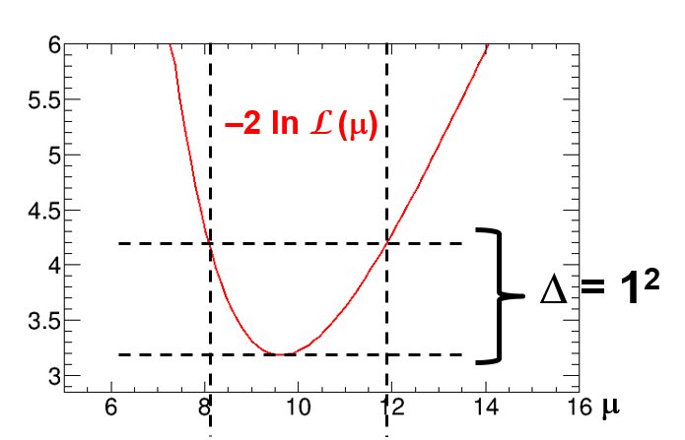
Figure13:Plotof−2 ln L(µ)correspondingtoFig.5,thecaseofGaussianpdfp(x|µ, σ) withσ=0.2µ.SuperimposedistheconstructionusingEqn.26withZ=1tofindthe approximate68%C.L.likelihoodratiointerval.
8.1 LRintervalexample:Gaussianpdfp(x|µ, σ)withσ=0.2µ
RecallfromSection6.4theGaussianpdfwithσ=0.2µ.ThelikelihoodfunctionL(µ)for observedx0=10.0isplottedinFig.5,withamaximumatµML=9.63.Fig.13isaplot of−2 ln L(µ),fromwhichthelikelihoodratiointervalforµatapproximate68%C.L.is [µ1, µ2] = [8.10, 11.9].Comparewiththeexactconfidenceinterval,[8.33,12.5].
8.2 Binomiallikelihood-ratiointervalexample
Recall(Section6.5)theexampleofnon=3successesinntot=10trials,withL(ρ)and−2 ln L(ρ)plottedinFig.7.Theminimumvalueofthelatteris2.64.Solvingforsolutions to −2 ln L(ρ) = 2.64+1 = 3.64, one obtains the likelihood-ratio interval [ρ1, ρ2] = [0.17, 0.45]. This can be compared to the Clopper-Pearson interval, [ρ1, ρ2] = [0.14, 0.51], and the Wilson interval,[ρ1, ρ2] = [0.18, 0.46].
8.3 Poissonlikelihood-ratiointervalexample
RecalltheplotofL(µ)inFig.2foraPoissonprocesswithn=3observed.Fig.14isa plotof−2 ln L(µ),fromwhichthelikelihoodratiointervalatapproximate68%C.L.canbe similarly extracted, yielding [µ1, µ2] = [1.58, 5.08].The central confidence interval (Garwood) is[µ1, µ2] = [1.37, 5.92].
9 Likelihoodprinciple
Recallthethreemethodsofintervalconstructionforbinomialparameterρuponobserving non= 3 out of ntot= 10 trials:Bayesian intervals as briefly outlined in Section 5,confidence
48

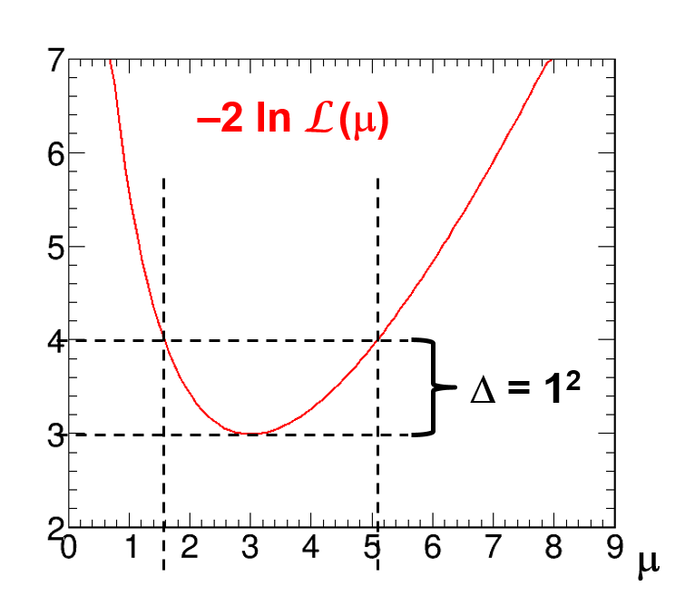
Figure14:Plotof−2 ln L(µ)correspondingtoFig.2,thecaseofPoissonprobabilityin Eqn.9withn = 3observed.SuperimposedistheconstructionusingEqn.26withZ= 1to findtheapproximate68%C.L.likelihoodratiointerval.SeealsoRef.[32]
intervalsinSection6.5,andLRintervalsinSection8.2.Wecannotethat:
•ForconstructingBayesianandlikelihoodintervals,Bi(non|ntot, ρ)isevaluatedonlyat theobservedvaluenon= 3.
•For constructing confidence intervals we use, in addition, probabilitiesforvaluesofnon notobserved.
Thisdistinctionturnsouttobeahugedeal!
In both Bayesian methods and likelihood-ratio-based methods, the probability (density) forobtainingthedataathandisused(viathelikelihoodfunction),butprobabilitiesfor obtainingotherdataarenotused!
Incontrast,intypicalfrequentistcalculations(confidenceintervals,p-values),onealso usesprobabilitiesofdatathatcouldhavebeenobservedbutthatwerenotobserved.
Theassertionthatonlytheformerisvalidiscapturedbythe
•LikelihoodPrinciple:Iftwoexperimentsyieldlikelihoodfunctionsthatarepropor- tional,thenYourinferencesfromthetwoexperimentsshouldbeidentical.
TherearevariousversionsoftheL.P.,strongandweakforms,etc.SeeRef.[56]and thebookbyBergerandWolpert[72].
TheL.P.isbuiltintoBayesianinference(excepte.g.,whenJeffreyspriorleadstovi-olation).TheL.P.isviolatedbyp-valuesandconfidenceintervals.Jeffreys[16](p.385) stillseemstobeunsurpassedinhisironiccriticismoftailprobabilities,whichincludeprob-abilitiesofdatamoreextremethanthatobserved:“Whattheuseof[thep-value]implies,
49

therefore,isthatahypothesisthatmaybetruemayberejectedbecauseithasnotpredicted observableresultsthathavenotoccurred.”
Although practical experience indicates that the L.P. may be too restrictive,it is useful tokeepinmind. Whenfrequentistresults“makenosense”or“areunphysical”,inmy experiencetheunderlyingreasoncanbetracedtoabadviolationoftheL.P.
9.1 Likelihoodprincipleexample#1:the“Karmenproblem”
YouexpectbackgroundeventssampledfromaPoissondistributionwithmeanb=2.8, assumedknownprecisely.Forsignalmeanµ,thetotalnumberofeventsnisthensampled fromaPoissondistributionwithmeanµ + b.SoP(n) = (µ + b)nexp(−µ −b)/n!.
Thensupposeyouobservenoeventsatall!I.e.,n=0.(Thenumbersaretakenfrom animportantneutrinoexperiment[73].)Pluggingin,
L(µ) = (µ + b)0exp(−µ −b)/0! = exp(−µ) exp(−b) (27)
Notethatchangingbfrom0to2.8changesL(µ)onlybytheconstantfactorexp(−b).This getsrenormalizedawayinanyBayesiancalculation,andisirrelevantforlikelihoodratios. Soforzeroeventsobserved,likelihood-basedinferenceaboutsignalmeanµisindependent ofexpectedbwhenzeroeventsareobserved.(Ifthepriordependsonb,asdoestheJeffreys prior for this example in Section 5.3,then there is potentially an issue.But I do not see this usedinHEP.)
Foressentiallyallfrequentistconfidenceintervalconstructions,thefactthatn=0is lesslikelyforb=2.8thanforb=0resultsinnarrowerconfidenceintervalsforµasb increases.ThisisaclearviolationoftheL.P.
9.2 Likelihoodprincipleexample#2:binomialstoppingrule
Thisisafamousexampleamongstatisticians,translatedtoHEP.Youwanttomeasurethe efficiencyϵofsometriggerselection.Youcountuntilreachingntot=100zero-biasevents, andnotethatofthese,m = 10passedtheselection.Theprobabilityformisbinomialwith binomialparameterϵ:
Bi(m|ntot, ϵ) = | ntot!  m!(ntot −m)!ϵm(1 −ϵ)(ntot−m) | (28)
Thepointestimateisˆϵ = 10/100,andwecancomputethebinomial confidenceinterval (Clopper-Pearson)forϵ.Also,pluggingintheobserveddata,thelikelihoodfunctionis
L(ϵ) =100! 10!90!ϵ10(1 −ϵ)90 | (29)
Suppose that your colleague inadifferentexperiment counts zero-bias events until m = 10havepassedhertriggerselection.Shenotesthatthisrequiredntot=100minimum-bias events (a coincidence).Intuitively, the fraction 10/100 over-estimates her trigger’s ϵ because shestoppedjustuponreaching10passedevents.Indeedanunbiasedestimateofϵand confidenceintervalwillbeslightlydifferentfromthebinomialcase.
50

Therelevantdistributionhereis(aversionof)thenegativebinomial:
NBi(ntot|m, ϵ) =ntot −1! (m −1)!ϵm(1 −ϵ)(ntot−m) (30)
Pluggingintheobserveddata,herlikelihoodfunctionis
L(ϵ) =99! 9!90!ϵ10(1 −ϵ)90. | (31)
Sobothyouandyourfriendobserved10successesoutof100trials,butwithdifferent stopping rules.Your likelihood function is based on the binomial distribution.Your friend’s is based on the negativebinomial distribution.The two likelihoods differ by (only!)a constant factor,sothe(strong)LPsaysthatinferencesshouldbeidentical.Incontrast,frequentist inferencesthatuseprobabilitiesofdatanotobtainedresultindifferentconfidenceintervals andp-valuesforthedifferentstoppingrules.
Amusingsidebar:TheJeffreyspriorisindeeddifferentforthetwodistributions,sothe useoftheJeffreyspriorviolatesthe(strong)L.P.
9.3 Stoppingruleprinciple
Thetwoefficiencymeasurementshavedifferentstoppingrules:onestopsafterntotevents, andtheotherstopsaftermeventspassthetrigger.Frequentistconfidenceintervalsdepend onthestoppingrule;thelikelihoodfunctiondoesnot,exceptforanoverallconstant.So Bayesianswillgetthesameanswerinbothcases,unlessthepriordependsonthestopping rule.
ThestrongL.P.implies,inthisexample,thattheinferenceisindependentofthestop-
pingrule! | Thisirrelevancehasbeenelevatedtothe“StoppingRulePrinciple”. | (Itis
sometimesamusingtoaskarecentBayesianconvertiftheyknowthattheyjustboughtthe StoppingRulePrinciple.)Conceptsthataverage/sumoverthesamplespace,suchasbias andtailprobabilities,donotexistinthepureBayesianframework.
A quote by L.J. (Jimmie) Savage (Ref. [74], p. 76), a prominent early subjective Bayesian advocate,iswidelymentioned(asseeninGooglehits,whichcanpointyoutoacopyofthe original“Savageforum”whereyoucanreadhisoriginalnote):
“. . . I learned the stopping-rule principle from Professor Barnard,in conversation in the summerof1952.Frankly,Ithenthoughtitascandalthatanyoneintheprofessioncould advanceanideasopatentlywrong,evenastodayIcanscarcelybelievethatsomepeople resistanideasopatentlyright.”
9.4 Likelihoodprinciplediscussion
Wewillnotresolvethisissue,butweshouldbeawareofit.Thereisalotmoretothe LikelihoodPrinciplethanIdiscusshere.SeethebookbyBergerandWolpert[72],but bepreparedfortheStoppingRulePrincipletosetyourheadspinning.Whenfrequentist confidenceintervalsfromaNeymanconstructionbadlyviolatetheL.P.,usegreatcaution! AndwhenBayesianinferencesbadlyviolatefrequentistcoverage,againusegreatcaution!
51

Table2:Summaryofthreewaystomakeintervals.Theasteriskremindsusthatthechoice ofpriormightviolatethelikelihoodprinciple.
 | Bayesian credible | Frequentist confidence | Likelihood ratio
Requirespriorpdf?  ObeysLikelihoodPrinciple?  Randomvariable(s)inP(µt∈[µ1, µ2]) = C.L. (Over)Coverageguaranteed?  ProvidesP(parameter|data)? | Yes  Yes*  µt  No  Yes | No  No  µ1, µ2  Yes  No | No  Yes  µ1, µ2  No  No
In these lectures, I omitted the important (frequentist) concept of a “sufficient statistic”, due to Fisher.This is a way to describe data reduction without loss of relevant information. E.g.,fortestingabinomialparameter,oneneedsonlythetotalnumbersofsuccessesand trials, and not the information on exactly which trials had successes.(See Ref. [56] for math definitions.) The“SufficiencyPrinciple”says(paraphrasing—therearestrongandweak forms)thatiftheobservedvaluesofthe sufficient statistic intwoexperimentsare the same, thentheyconstituteequivalentevidenceforuseininference.
Birnbaumfamouslyargued(1962)thattheConditionalityPrinciple(Section11.3)and theSufficiencyPrincipleimplytheLikelihoodPrinciple.Section11.3hasafewmorecom-mentsonthispoint.
Controversy continues.For a recent discussion and references, see Deborah Mayo’s 2014 detailed article [75] and references therein, with comments by six statisticians and rejoinder.
10 Summaryofthreewaystomakeintervals
Table 2 summarizes properties of the three ways discussed to make intervals.Only frequentist confidenceintervals(Neyman’sconstructionorequivalent)canguaranteecoverage.Only Bayesianandlikelihoodintervalsareguaranteedtosatisfythelikelihoodprinciple(except whenapriorsuchasJeffreys’spriorviolatesit).
Table3,inspiredbyRef.[32],givesillustrativeintervalsforaspecificPoissoncase.It isofgreathistoricalandpracticalimportanceinHEPthattherightendpointofBayesian centralintervalswithauniformpriorismathematicallyidenticaltothatofthefrequentist centralconfidenceinterval(5.92intheexampleofn=3,buttrueforanyn). Bythe reasoningofFig.3,thisidentityappliesto upperlimits.Incontrast,theprior1/µisneeded toobtaintheidentityoftheleftendpointofconfidenceintervals,andhenceoflowerlimits (1.37intheexample,buttrueforanyn).
The fact that our field is almost always concerned with upper (rather than lower) limits onPoissonmeansisresponsibleforthenearlyubiquitoususeoftheuniformprior(instead oftheJeffreysprior,forexample);asnotedinSection5.7,themainuseoftheBayesian machineryinHEPisasatechnicaldeviceforgeneratingfrequentistinference,i.e.,intervals thatare(atleastapproximately)confidenceintervals.
52

Table3:68%C.L.confidenceintervalsforthemeanofaPoissondistribution,basedonthe singleobservationn = 3,calculatedbyvariousmethods.
Method √ | Prior | Interval | Length | Coverage?
Wald,n ± n  Garwood,Frequentistcentral Bayesiancentral  Bayesiancentral  BayesiancentralJeffreys  Likelihoodratio | —  —  1  1/µ  1/√µ— | (1.27,4.73) (1.37,5.92) (2.09,5.92) (1.37,4.64) (1.72,5.27) (1.58,5.08) | 3.36  4.55  3.83  3.27  3.55  3.50 | no  yes  no  no  no  no
Whenaknown(fixed)backgroundisaddedtotheproblem,theBayesianintervals withuniformpriorforµbecomeconservative(over-cover),afeaturethatmanyarewilling toacceptinordertoobeythelikelihoodprinciple(orperhapsforlessexplicitlystated reasons).(Evenwithoutbackground,frequentistintervalsover-coverduetodiscretenessof n,asdiscussedinSection6.11.1.)
11 1Dparameterspace,2Dobservationspace
Untilnowwehaveconsidered1Dparameterspaceand1Dobservationspace.Addinga secondobservationaddssurprisingsubtleties.Asbefore,µisa1Dparameter(oftencalledθbystatisticians).Anexperimenthastwoobservations,theset{x1, x2}.Thesecouldbe:
•twosamplesfromthesamep(x|µ),or
•onesampleeachoftwodifferentquantitiessampledfromajointdensityp(x1, x2|µ).
For frequentist confidence intervals for µ, we proceed with a Neyman construction.Prior totheexperiment,foreachµ,oneusesanorderingprincipleonthesamplespace(x1, x2)to select an acceptance region A(µ) in the sample space (x1, x2) such that P((x1, x2) ∈A(µ)) = C.L.(AsmentionedinSection6.8,thiswastheillustrationinNeyman’soriginalpaper.) Uponperformingtheexperimentandobservingthevalues{x1,0, x2,0},theconfidence interval for µ at confidence level C.L. is the union of all values of µ for which the corresponding acceptanceregionA(µ)includestheobserveddata{x1,0, x2,0}.
The problem is thus reduced to choosing an ordering of the points (x1, x2) in the sample space,inordertowell-defineA(µ),givenaC.L.Thisturnsouttobesurprisinglysubtle, exposingafurtherfoundationalissue.
11.1 Conditioning:Restrictingthesamplespaceused
byfrequentists
WenowreturntothepointmentionedinSection3.5regardingthe“wholespace”ofpossi-bilitiesthatisconsideredwhencomputingprobabilities.
53

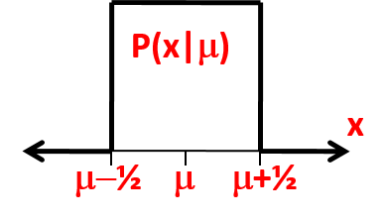
Figure15:Therectangularpdfp(x|µ)oftheWelchexample,centeredonµ.
In Neyman’s construction in the 2D sample space (x1, x2), the probabilities P((x1, x2) ∈A(µ))associatedwitheachacceptanceregionA(µ)areunconditionalprobabilitieswith respecttothe“whole”samplespaceofallpossiblevaluesof(x1, x2).Incontrast,Bayesian inferenceisbasedonasinglepointinthissamplespace,theobserved(x1,0, x2,0),perthe LikelihoodPrinciple.Therecanbeamiddlegroundinfrequentistinference,inwhichthe probabilitiesP((x1, x2)∈A(µ))areconditionalprobabilitiesconditionedonafunctionof (x1, x2),ineffectrestrictingthesamplespacetoa“recognizablesubset”dependingonthe observeddata.
Restrictingthesamplespaceinthiswayisknownasconditioning.HereIdiscusstwo famousexamples:
•AsomewhatartificialexampleofWelch[76]wheretheconditioningarisesfromthe mathematicalstructure;
•AmorephysicalexampleofCox[77]wheretheargumentforconditioningseems“ob- vious”.
11.1.1 ExampleofB.L.Welch(1939)
Inthisexample,x1andx2aretwosamplesfromsamep(x|µ),arectangularpdfgivenby (Fig.15)
p(x|µ) = | ( 1, | ifµ −1 2≤x ≤µ +1 | (32)
 | 0, | otherwise.
Theobserveddataisasetoftwovalues{x1, x2}sampledfromthispdf.Fromthesedata, thepointestimateforµisthesamplemean,ˆµ =¯x = (x1 + x2)/2.(Aside:ifmorethantwo samplesareobserved,thepointestimateisthemeanoftheoutermosttwo,notthewhole samplemean;seeSectionE.0.1.)
Whatisa68%C.L.centralconfidenceintervalforµ?ToperformaNeymanconstruc-tion, for each µ we must define an acceptance region A(µ) containing 68% of the unit square (x1, x2)centeredonµ,asinFig.16.Which68%shouldoneuse?Centralityimpliessym-metry,butweneedsomethingelsetorankpointsintheplane.TheN-PLemmasuggestsa likelihoodratio,butfirstlet’sthinkaboutsomeexamplesofpossiblepairs{x1, x2}.
54

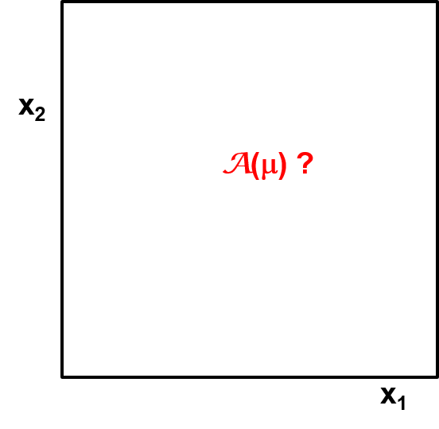
Figure 16:The starting point for constructing confidence intervals in the Welch example:in the2Ddataspacecenteredon(x1= µ, x2= µ)whatshouldbetheacceptanceregionA(µ) containing68%oftheunitsquare?Oneshouldimagineaµaxisperpendiculartotheplane ofthesquare,withsuchasquareateachµ.
A “lucky” sample with |x1−x2| close to 1 is shown in Fig. 17(left):L(µ) = L1(µ)×L2(µ) isverynarrow.Isitthusreasonabletoexpectsmalluncertaintyinˆµ?
An“unlucky”samplewith|x1 −x2|closeto0isshowninFig.17(right):L(µ)hasfull widthcloseto1,asthesecondobservationaddsalmostnousefulinformation.Shouldwe expecta68%C.L.confidenceintervalforµthatisthesameasforonlyoneobservation,i.e. withlength0.68?
Intuitionsuggeststhatareasonableanswermightbeaconfidenceintervalcenteredonˆµ,withalengththatis68%ofthewidthofL,i.e.,theintervalˆµ ± 0.34(1 −|x1 −x2|).
Fromthisargument,itseemsreasonableforthepost-datauncertaintytodependon |x1 −x2|,whichofcoursecannotbeknowninadvance.Thisquantity|x1 −x2|isaclassic exampleofanancillarystatisticA:ithasinformationontheuncertaintyintheestimate ofµ,butnoinformationonµitself,becausethedistributionofAdoesnotdependonµ.AnideadatingtoFisherandbeforeistodividethefull“unconditional”samplespace into“recognizablesubsets”(inthiscasehavingsameorsimilarvaluesofA),andcalculate probabilitiesusingthe“relevant”subsetratherthanthewholespace!
The(representative)diagonallinesinFig.18(left)showapartitionofthefullsample spaceviatheancillarystatisticA=|x1 −x2|.Withineachpartition,inFig.18(right),the shading shows a central 68% probability acceptance region (red fill).We are thus using con-ditionalprobabilities(stillfrequentist!)p(x|A, µ)inthisNeymanconstruction,withdesired probability68%withineachpartition.(Aside:Asetofmeasurezerohaszeroprobability evenifnon-zeropdf,soingeneral,careisneededinconditioningonanexactvalueofcon-tinuousAinp(x|A, µ).Thisisnotanissuehereinthisexample.)TheresultingA(µ)for
55

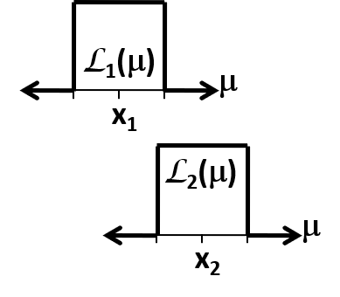

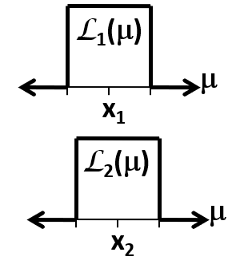

Figure 17:(left) A “lucky” set of observations {x1, x2} having small overlap of the likelihood functions,sothatpossibletrueµislocalized. (right)an“unlucky”setofobservations {x1, x2},forwhichthesecondobservationaddslittleadditionalinformation.

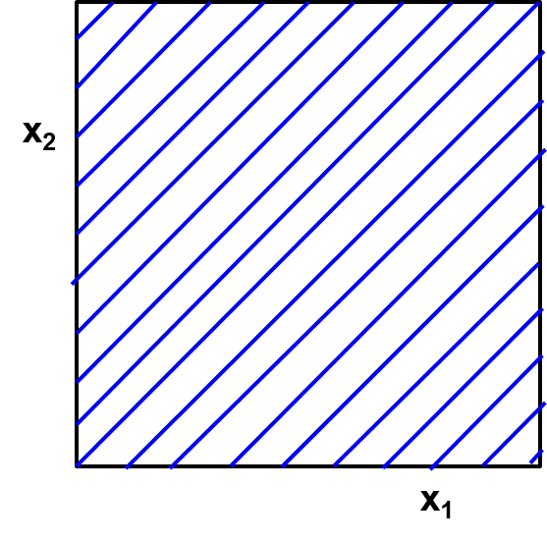

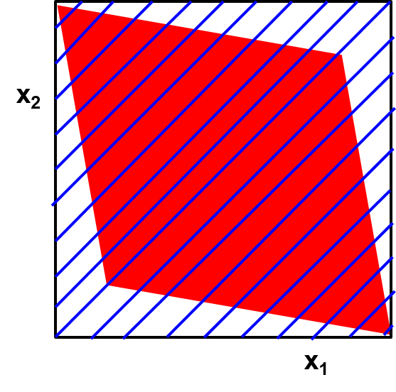

Figure18:(left)Dividingtheobservationspaceintosubsetsbasedontheancillarystatistic |x1 −x2|.(right),withineachsubset,acceptanceregionscontainingthe68%centralvalues of|x1 + x2|.
56

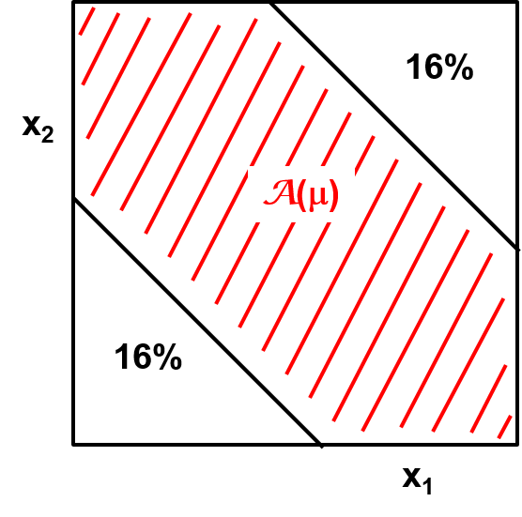

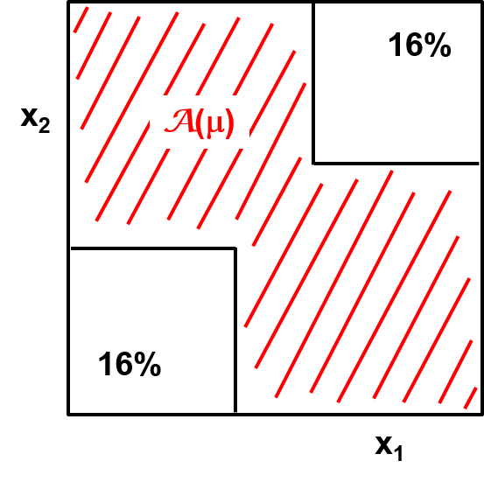

Figure19:AlternativeacceptanceregionshavingmorepowerthanthatinFig.18(right).
the whole square fills 68% of the square, so there is correct unconditional probability as well.
Imagineaplanesuchasthisforeveryµ,andthenobtainingthedata{x1, x2}.The confidenceintervalforµisthentheunionofallvaluesofµforwhichtheobserveddataare inA(µ).Amoment’sthoughtwillconfirmthatthisresultsinconfidenceintervalscentered on (x1+x2)/2, with a length that is 68% of |x1−x2|, i.e.,ˆµ±0.34(1−|x1−x2|), as intuitively thoughtreasonable!
This construction is known as “conditioning” on the ancillary statistic A.Operationally, itcanbesimplystated:post-data,ignoretheconstructioninthewholesamplespacefor valuesofAotherthanthatobserved,andproceedasifAhadbeenfixedinthedesignofthe experiment,ratherthanrandomlysampled!
Nowthecatch:onecanfindacceptanceregionsA(µ)thatcorrespondtohypothesis tests with morepower (lower Type 2 error probability β) in the unconditional sample space! AcoupleofexamplesfromtheliteratureareshowninFig.19.Theconstructionontheleft resultsin68%C.L.intervalswithlengthindependentof|x1 −x2|,namelyˆµ ± 0.22at68% C.L.Theyobtain68%coverageintheunconditionalsamplespacebyhaving100%coverage inthesubspacewhere|x1−x2|≈1(narrowlikelihood),whilebadlyundercoveringwhen |x1≈x2|.
Welch’s 1939 paper argued against conditioning because it is less powerful in the uncon-ditionalsamplespace!Neyman’spositionisnotcompletelyclearbuthealsoseemstohave beenagainstconditioningonancillaries(whichwasFisher’sidea)whenitmeantanoverall lossofpower[65,78].
MostmodernwritersuseWelch’sexampleasan“obvious”argumentinfavorofcondi-tioning, unless one is in an “industrial” setting where the unconditional ensemble is sampled repeatedlyandtheresultforanindividualsampleisnotofmuchinterest.
57

11.1.2 EfronexamplethatisstructurallysimilartoWelchexample
Brad Efron’s talk at PhyStat-2003 [9] included a similar example using the Cauchy distribu-tion,wheretheancillarystatisticisthecurvatureofL(µ).Hecalledtheconditionalanswer“correct”.
11.1.3 Coxtwo-measuringdeviceexample(1957)
FormeasuringameanµwithGaussianresolution,oneoftwodevicesisselectedrandomly withequalprobability:
Device#1withσ1
Device#2withσ2≪σ1.
Thenasinglemeasurementsampleismadewiththechosendevice.
Inmynotation,x1isanindex(1or2)chosenrandomlyandspecifyingthedevice,and x2isthesinglesamplefromtheselectedGaussianmeasurement.Thetotalobserveddata isthen,asbefore,{x1, x2}.Butinthisexample,x1andx2aresamplesoftwodifferent quantitiesfromthejointdensityp(x1, x2|µ).
InRef.[43](p.112)LucDemortiergivesaniceexampleinHEP:µisthemassofa decayingparticlewithprobabilityphtodecayhadronically(massresolutionσ1)andproba-bility1 −phtodecayleptonicallywithmassresolutionσ2).Thusthe“measuringmachine”chosenrandomlyisthedetectorusedtomeasurethedecaymodethatisrandomlychosen byquantummechanics.
Soˆµ = x2.Whatistheconfidenceinterval?Theindexx1isanancillarystatistic,and itisreasonable(obvious?)toconditiononit.I.e.,wereportaconfidenceintervalgiving correctcoverageinthesubspaceofmeasurementsthatusedthesamemeasuringdevicethat weused.Sothe68%C.L.confidenceintervalis:
ˆµ ± σ1ifDevice#1wasrandomlyselected
ˆµ ± σ2ifDevice#2wasrandomlyselected
Againitturnsoutthatmorepowerfultestscanbefound.Demortiergivesdetailson howtheaveragelengthofintervalsoptimizedintheunconditionalsamplespaceisshorter intheHEPexample.HereIgiveCox’sdiscussion.
Ifoneistestingµ = 0vsµ = µ1,withµ1roughlythesizeofσ1(thelargerσ),consider thefollowingintervals:ˆµ ± (0.48)σ1ifDevice#1used(coverstrueµin37%ofuses),andˆµ ± 5σ2ifDevice#2used(coverstrueµnearly100%ofuses).
Then the true µ is covered in (37/2 + 100/2)% = 68% of all intervals!The unconditional (full sample space) coverage is correct, but conditional coverage is not.Due to the smallness of σ2, the average length of all intervals whenaveragingovertheentireunconditionalsample space is smaller than for conditional intervals with independent coverage.One gives up power withDevice#1andusesitinDevice#2.
Cox asserts:“If, however, our object is to say ‘what can we learn from the data that we have’, the unconditional test is surely no good.” [77] (p. 361) (See also Ref. [30] (pp. 47-48).)
58

11.2 ConditioninginHEP
Aclassicexampleisameasurementofthebranchingfractionofaparticulardecaymode whenthetotalnumberofdecaysNcanfluctuatebecausetheexperimentaldesignistorun forafixedlengthoftime.ThenNisanancillarystatistic.Youperformanexperimentand obtainNtotaldecays,andthendoatoyMCsimulation(Section13)ofrepetitionsofthe experiment.DoyouletNfluctuate,ordoyoufixittothevalueobserved?Itmayseem thatthetoyMCshouldincludeyourcompleteprocedure,includingfluctuationsinN.
However,theaboveargumentswouldpointtowardconditioningonthevalueofthe ancillarystatisticactuallyobtained.Soyourbranchingfractionmeasurementisbinomial withtrialsN.ThiswasoriginallydiscussedinHEPbyF.JamesandM.Roos[51].Fora morecompletediscussion,seeRef.[49].
11.3 Conditioningandthelikelihoodprinciple
Insummary,conditioningonanancillarystatisticAmeans:EventhoughAwasrandomly sampledintheexperimentalprocedure,afterdataareobtained,proceedasifAhadbeen fixedtothevalueobserved.Ignoretherestofthesamplespacewithallthoseothervalues ofAthatyoucouldhaveobtained,butdidnot.
The Welch and Cox (and Efron) examples reveal a real conflict between N-P optimization forpowerandconditioningtooptimizerelevance.
TheassertionthatinferenceshouldbeconditionedonanancillaryintheWelchexam-ple(whereitcomesoutofthemath)isoftencalledthe“ConditionalityPrinciple”(CP). ConditioningintheCoxexample(a“mixtureexperiment”wheretheancillaryhasphysical meaningaboutwhichexperimentwasperformed)isthencalledthe“WeakConditionality Principle”(WCP).
Butnote:insufficientlycomplicatedcases(forexampleifthereismorethanonean-cillarystatistic),theprocedureislessclear.Inmanysituations,ancillarystatisticsdonot exist,anditisnotatallclearhowtorestrictthe“wholespace”totherelevantpartforfre-quentistcoverage.Foracomprehensivereviewofancillarystatisticsandtheirapplications, seeRef.[79].
ThepureBayesianansweristocollapsethewholesamplespacetothedataobserved, andreferonlytotheprobabilityofthedataobserved,i.e.,thelikelihoodprinciplediscussed inSection9.Thisisliterallytheultimateextremeinconditioning,conditioning(inthe continuouscase)onapointofmeasurezero!(Youcan’tgetanymore“relevant”.)Butthe priceisgivingupcoverage.
When there are “recognizable subsets” with varying coverage, Buehler [80] has discussed howa“conditionalfrequentist”canwinbetsagainstan“unconditionalfrequentist”.(See Refs.[53,54].)
I emphasize conditioning not only for the practical issues, but also to explain that there areintermediatepositionsbetweenthefullunconditionalfrequentistphilosophyandthe LikelihoodPrincipleofSection9.Akeypointisthatunconditionalfrequentistcoverageis apre-dataassessment:theentireconfidencebeltisconstructedindependentofwherethe observation lies.Thus a big argument is whether unconditional coverage remains appropriate post-data,afteroneknowswhereone’sobserveddataliesinthesamplespace.Whenthe
59

“measurementuncertainty”dependsstronglyonwhereone’sdatalies,thenthearguments forconditioningseemstrong.Whetherornotonetakesconditioningtotheextremeand considersonlythe(measure-zero)subsetofthesamplespacecorrespondingtothedata observedistheissueoftheLikelihoodPrinciple[72].
ItisnotsurprisingthatpureBayesiansarguefortheimportanceofrelevanceofthein-ference, and criticize frequentists for the danger of irrelevance (and the difficulty of diagnostic ofirrelevance).Anditisnotsurprisingthatpurefrequentistsarguefortheimportanceof ausefulmeasureof“errorrates”,inthesenseofType1andType2errors,coverage,etc., whichmayatbestbeestimatesiftheL.P.isobserved.
12 2Dparameterspace,multi-Dobservationspace
We (finally) generalize to two parameters µ1and µ2, with both true values unknown.(I hope that from context, there is no confusion from using the subscripts 1 and 2 to indicate different parameters, whereas in the 1D case above, they indicate the endpoints of a confidence interval on the single parameter µ.)Let data x be a multi-D vector, so the model is p(x|µ1, µ2).The observedvectorvalueisx0.
Firstconsiderthedesiretoobtaina2Dconfidence/credibleregionintheparameter space(µ1, µ2).Allthreemethodsdiscussedforintervalshandlethisinastraightforward(in principle)generalization.Wementionthefirsttwobrieflyanddevoteasubsectiontothe third:
Bayesian:Put the observed data vector x0into p(x|µ1, µ2) to obtain the likelihood func-tion L(µ1, µ2).Multiply by the prior pdf p(µ1, µ2) to obtain the 2D posterior pdf p(µ1, µ2|x0). Usetheposteriorpdftoobtaincredibleregions,etc.,in(µ1, µ2).
Confidence intervals:Perform a Neyman construction:Find acceptance regions A(µ1, µ2) for x as a function of (µ1, µ2).The 2D confidence region is the union of all (µ1, µ2) for which x0isinA(µ1, µ2).
12.1 Likelihoodregionsin≥2Dparameterspace
Recallthemethodfor1Dlikelihoodintervals,Eqn.26,notingthatthedifferencesinlog-likelihoodscorrespondtoratiosoflikelihoods.Forajoint2Dlikelihoodregion,firstfind theglobalmaximumofL(µ1, µ2),yieldingpointestimatesˆµ1, ˆµ2.Thenfindthe2Dcontour boundedby
2∆ln L = 2 ln L(ˆµ1, ˆµ2) −2 ln L(µ1, µ2) ≤C, (33)
whereCcomesfromWilks’sTheorem[68],tabulatedinthePDGRPP[13](Table40.2)for variousC.L.andforvariousvaluesofm,thedimensionalityoftheconfidenceregion.Here wehavethecasem = 2,forwhichC= 2.3for≈68%C.L.
Thisregionisanapproximateconfidenceregion,assketchedinFig.20. Asin1D, Wilks’sTheoremisanasymptotic(largeN)result,withvarious“regularityconditions”to besatisfied.(Againsee,e.g.,Ref.[71]andreferencestherein.)
60

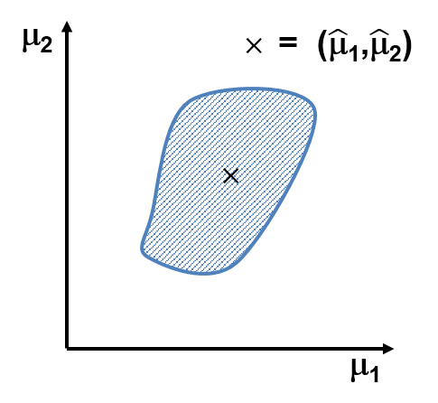
Figure 20:Sketch of a 2D joint ≈68% C.L. likelihood region for (µ1, µ2), obtained via Eqn. 33.
12.2 Nuisanceparameters
Frequently one is interested in considering one parameter at a time, irrespective of the value ofotherparameter(s). Theparameterunderconsiderationatthemomentiscalledthe“parameterofinterest”andtheotherparameters(atthatmoment)arecalled“nuisance parameters”.E.g.,ifµ1isofinterestandµ2isanuisanceparameter,thenideallyoneseeks a2Dconfidenceregionthatisavertical“stripe”inthe(µ1, µ2)planeasinFig.21(left); thisallowsthesame1Dintervaltobequotedforµ1,independentofµ2.Or,inadifferent moment,µ2maybeofinterestandµ1isanuisanceparameter;thenoneseeksahorizontal stripe,asinFig.21(right).Howcanoneconstructthosestripes?
Eachofthethreemainclassesofconstructingintervals(Bayesian,Neymanconfidence, likelihoodratio)hasa“native”waytoincorporatetheuncertaintyonthenuisanceparame-ters,describedinSections12.3–12.5.Butthisremainsatopicoffrontierstatisticsresearch.
12.2.1 Systematicuncertaintiesasnuisanceparameters
Ihavebegunwithjustoneparameterofinterestandonenuisanceparameter.Analysesin HEP can have hundreds or even thousands of nuisance parameters.Systematic uncertainties provideexamplesofparametersthatarefrequentlynuisanceparameters,soImentionthem briefly here.A typical measurement in HEP has many subsidiary measurements of quantities notofdirectphysicsinterest,butwhichenterintothecalculationofthephysicsquantityof particularinterest.E.g.,ifanabsolutecrosssectionismeasured,onewillhaveuncertainty intheintegratedluminosityL,inthebackgroundlevelb,theefficiencyeofdetectingthe signal,etc.InHEP,wecallthesesystematicuncertainties,butstatisticians(fortheobvious reason)refertoL,b,andeasnuisanceparameters.Fordiscussionofmanyoftheissues withsystematicuncertaintiesinHEP,seeRefs.[81,82,83].
However,it is important to keep in mind that whether or not a parameter is considered
61

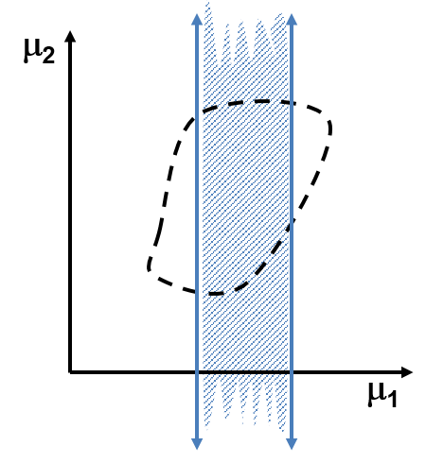

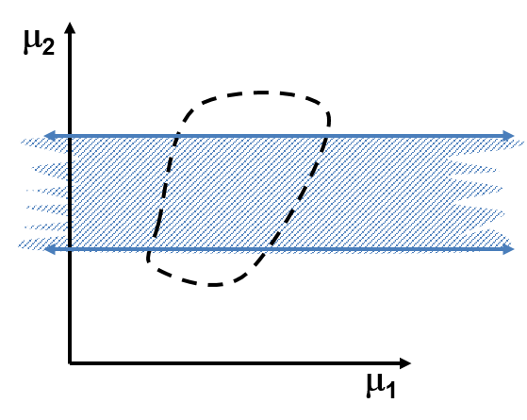

Figure 21:The dashed curve is the boundary of the 2D confidence region when both param-eters are of interest.The shaded stripes are (left) 2D region to get 1D ≈68% C.L. interval forµ1(µ2isnuisance).(right)2Dregiontoget1D≈68%C.L.intervalforµ2(µ1isnuisance)
tobeanuisanceparameterdependsoncontext.Forexample,inmeasurementsofHiggs bosoncouplings,themassoftheHiggsbosonistypicallyregardedasanuisanceparameter. Butclearly,themassoftheHiggsbosoncanitselfbetheprimaryobjectofameasurement, inwhichcasethecouplingsarethenuisanceparameters.
12.3 NuisanceparametersI:Bayesiancredibleintervals
Constructamulti-Dpriorpdfp(parameters)forthespacespannedbyallparameters.Mul-tiplyitbythelikelihoodfunctionL(data|parameters)forthedataobtainedtoyieldthe multi-D posterior pdf.Integrate over the full subspace of all nuisance parameters (marginal-ization).Thusobtainthe1Dposteriorpdffortheparameterofinterest.Furtheruseofthe posteriorpdfisthusreducedtothecaseofnonuisanceparameters.
Problems:Themulti-Dpriorpdfisaproblemforbothsubjectiveandnon-subjective priors.In HEP there has been little use of the favored non-subjective priors (reference priors ofBernardoandBerger).Thehigh-Dintegralcanbeatechnicalproblem,moreandmore overcomebyMarkovChainMonteCarlo.
As with all Bayesian analyses,how does one interpret probability if “default” priors are used,sothatcoherentsubjectiveprobabilityisnotapplicable?
62

12.3.1 Priorsfornuisanceparameters
It used to be (unfortunately) common practice to express, say, a 50% systematic uncertainty onapositivequantityasaGaussianwith50%rms.Thenone“truncated”theGaussianby notusingnon-positivevalues.
AsmentionedinSection5.11butworthrepeating,inBayesiancalculations,theinter-actionofauniformpriorforaPoissonmeananda“truncatedGaussian”forsystematic uncertaintyinefficiencyleadstoanintegralthatdivergesifthetruncationisatorigin[40]. Inevaluatingtheintegralnumerically,somepeopledidnotevennotice!
Recommendation:Use lognormal or (certain) Gamma distributions instead of truncated Gaussian.Recipesareinmynote[84].
12.4 NuisanceparametersII:Neymanconstruction
Foreachpointinthesubspaceofnuisanceparameters,treatthemasfixedtruevalues andperformaNeymanconstructionformulti-Dconfidenceregionsinthefullspaceofall parameters.Projecttheseregionsontothesubspaceoftheparameterofinterest.
Problems:Typically intractable and causes overcoverage, and therefore rarely attempted.
Tractabilitycansometimesberecoveredbydoingtheconstructioninthelowerdimen-sionalspaceoftheprofilelikelihoodfunction,obtainingapproximatecoverage.(Thisisone waytointerpretthepagesinKendallandStuartonthelikelihoodratiotestwithnuisance parameters[56].SeeRef.[85])forsomehistory.)
Typically “elimination” is done in a way technically feasible, including parametric boot-strap(Section13.1),andthecoverageisstudiedwithsimulation(Section13).
12.5 NuisanceparametersIII:Likelihoodratiointervals
ManyofusraisedonMINUITMINOSreadthearticlebyF.James,“Interpretationofthe ShapeoftheLikelihoodFunctionaroundItsMinimum,”[86].Whereasthe2Dregionin Section12.1hasm=2andhence2∆ln L≤2.3,for1Dintervalsonµ1,wefirstamake 2Dcontourwiththem=1value,2∆ln L=1,asshownbytheblackdashedcurvein Fig.22(right).Thentheextremainµ1ofthiscurvecorrespondtotheendpointsofthe approximateconfidenceintervalforµ1.
12.5.1 Profilelikelihoodfunction
At the Fermilab Confidence Limits Workshop in 2000, statistician Wolfgang Rolke expressed theconstructioninadifferent(butexactlyequivalent)way[87,88],asillustratedinFig.23 andparaphrasedasfollows:
•For each µ1, find the valueˆˆµ2that minimizes −2 ln L(µ1,ˆˆµ2), shown in red.Make a 1D plot vs µ1 of (twice the negative log of) this “profile likelihood function” −2 ln Lprofile(µ1). Usethem=1thresholdon−2 ln Lprofile(µ1),i.e.,Eqn.26,toobtainintervalsatthe desiredC.L.
TheintervaloneobtainsinFig.23istheexactsameintervalasobtainedby“MINOS”inFig.22(right).Canyouseewhy?Since2000,the“profile”statisticalterminologyhas
63

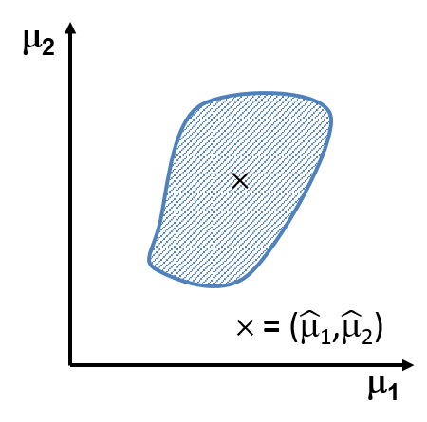

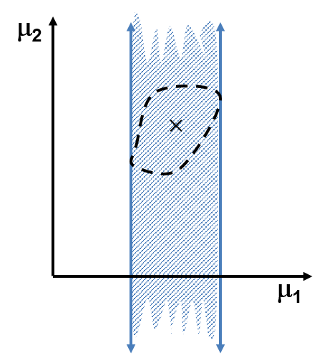

Figure 22:Sketches for likelihood ratio regions.(left) The 2D confidence region from Fig. 20, when both parameters are of interest.(right) On the same scale,the 2D confidence region ifµ1isofinterestandµ2isanuisanceparameter,sothateffectivelyoneobtainsaconfidence intervalforµ1thatisindependentofµ2.Thewidthofthestripeissmallerthanthewidth oftheextremaoftheregionontheleft,sinceasmallervalueofCisusedinEqn.33:the dashed contour on the right is inside the solid contour on the left.Both the left and the right shadedregionscorrespondtothesameC.L.;theleftregionisrelevantforjointinferenceon thepairofparameters,whiletherightregionisrelevantwhenonlyµ1isofinterest.
64

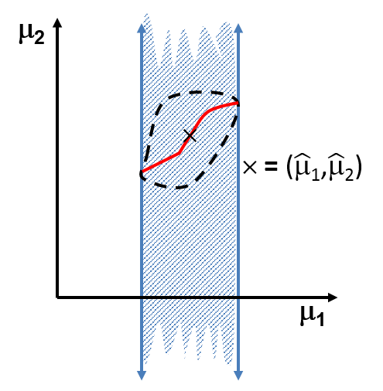
Figure23:Redcurveispath(µ1,ˆˆµ2)alongwhichprofileLisevaluated
permeatedHEP.The“hat-hat”notation(stackedcircumflexaccents)isalsoused,forex-ample,by“KendallandStuart”[56]inthegeneralizedhypothesistestthatisdualtothe intervalsofFeldmanandCousins.SeealsoRef.[71].
Warning:Combiningprofilelikelihoodsfromtwoexperimentsisunreliable. Apply profilingaftercombiningthefulllikelihoods[89].
Problemswithprofilelikelihood:
Coverageisnotguaranteed,particularlywithsmallsamplesize.Byusingthebest-fit valueofthenuisanceparameterscorrespondingtoeachvalueoftheparameterofinterest, thishasan(undeserved?)reputationforunderestimatingthetrueuncertainties.
InPoissonproblems,theprofilelikelihood(MINUITMINOS)givessurprisinglygood performanceinmanyproblems.SeeRolke,etal.[88].
In some cases (for example when there are spikes in L), marginalization may give better frequentistperformance,Ihaveheard.Forsmallsamplesizes,thereisnotheoremtotell uswhetherprofilingormarginalizationofnuisanceparameterswillgivebetterfrequentist coveragefortheparameterofinterest.
12.5.2 Aside:Profilelikelihoodratio(PLR)teststatistic
In more general notation, let µ be the parameter of interest and νbe a vector of nuisance pa-rameters, so the profile likelihood function of µ is L(µ,ˆˆν).This is also written as supν L(µ, ν). Ausefulquantityforhypothesistesting(andhenceforconfidenceintervalconstruction)is this profile likelihood function divided by the global maximum likelihood, thus obtaining the profilelikelihoodratioteststatistic,
Λ(µ) = L(µ,ˆˆν)/L(ˆµ, ˆν). (34)
65

Wefrequentlyuse−2ln Λasateststatistic.ABayesian-inspiredalternativetothe profile likelihood function, discussed below, is the “integrated” (or “marginalized”) likelihood function(alsoofonlyµ),
Z | L(µ, ν)π(ν)dν, | (35)
whereπ(ν)isaweightfunctioninthespiritofaBayesianpriorpdf.(Moregenerally,it couldbeπ(ν|µ).)
12.6 Noteliminatinganuisanceparameter:the“rasterscan”
Inthe2DexampleofFigure22,therightsideisanattemptto“eliminate”thenuisance parameterµ2byobtaininganintervalestimateforµ1thatisindependentofµ2.However, itmaybethatitispreferablesimplytoquotea1Dintervalestimateforµ1asafunctionof assumedtruevaluesforµ2.In a toy neutrino oscillation example, Feldman and Cousins [55] contrasted their unified approach with this method, which they referred to as a “raster scan”, inanalogywiththewayoldtelevisionsdrewlinesacrossthescreen.
Asanexample,Iamremindedthatbeforethetopquarkmasswasknown,othermea-surements(andtheoreticalpredictions)weretypicallygivenasafunctionoftheunknown topquarkmass,withnoattemptto“eliminate”it(forexamplebyputtingaBayesianprior pdfonitandintegratingitout).InthesearchfortheHiggsbosonandultimatelythe discovery,itsunknownmasswasanuisanceparameterthatwasalsotreatedbyrasterscan: alltheplotsofupperlimitsoncrosssection,aswellas p-valuestestingthebackground-only hypothesis,aregivenasafunctionofmass.
Whentousearasterscanisamatterofjudgment;forsomeusefulconsiderationsand detailedexplanations,seeRef.[90].
13 EvaluationofcoveragewithtoyMCsimulation
Forasingleparameterofinterestµ,onetypicallyreportstheconfidenceinterval[µ1, µ2] atsomeC.L.aftereliminationofnuisanceparametersbysomeapproximatemethodand constructionofintervals,perhapsinvolvingmoreapproximations.Itisimportanttocheck thattheapproximationsinthewholeprocedurehavenotmateriallyalteredtheclaimed coverage,definedinEqn.23.TypicallytheperformanceisevaluatedwithasimplifiedMC simulation,referredtoas“toyMonteCarlosimulation”.FirstIdescribethemostthorough evaluation(veryCPUintensive),andthensomeapproximations.
In frequentist statistics, the true values of all parameters are typically fixed but unknown. Acomplete,rigorouscheckofcoverageconsidersafinemulti-Dgridofallparameters,and foreachmulti-Dpointinthegrid,generatesanensembleoftoyMCpseudo-experiments, runs the full analysis procedure, and finds the fraction of intervals covering the µtof interest thatwasusedforthatensemble.I.e.,onecalculatesP(µt∈[µ1, µ2]),andcomparestoC.L.
Thusathoroughcheckoffrequentistcoverageincludes:
1.Fix all parameters (of interest and nuisance) to a single set of true values.For this set,
(a)Loopover“pseudo-experiments”
66

(b)Foreachpseudo-experiment,loopoverevents,generatingeacheventwithtoy datageneratedfromthestatisticalmodelwithparameterssetequaltothefixed set.
(c)Performthesameanalysisonthetoyeventsinthepseudo-experimentaswas donefortherealdata.
(d)Findthatfractionofthepseudo-experimentsforwhichparameter(s)ofinterest areincludedinstatedconfidenceintervalsorregions.
2.Repeatforvariousotherfixedsetsofallparameters,ideallyafinegrid.
But. . . the ideal of a fine grid is usually impractical.So the issue is what selection of “various otherfixedsets”isadequate. Obviously,oneshouldcheckcoverageforthesetoftrue valuessetequaltotheglobalbest-fitvalues.Justasobviously,thismaynotbeadequate. Someexplorationisneeded,particularlyindirectionswheretheuncertaintyinaparameter depends strongly on the parameter value.One can start by varying a few critical parameters byoneortwostandarddeviations,tryingparametersnearboundary/ies,andseeinghow stablecoverageis.
A Bayesian-inspired approach is to calculate a weighted average of coverage over a neigh-borhoodofparametersetsforthenuisanceparameters.Thisrequiresachoiceofmulti-D prior.Instead of fixing the true values of nuisance parameters during the toy MC simulation, onesamplesthetrueparametersfromtheposteriorpdfofthenuisanceparameters.
13.1 ConstructingtheintervalswithtoyMC:Theparametric
bootstrap
ThisapproachisverycommonattheLHC.Itgenerallyimprovesontheprofilelikelihood ratio intervals described above.I think that it is best explained using the nested-hypothesis-test view in the duality of hypothesis tests and confidence intervals.So, we consider the test ofaparticularvalueoftheparameterofinterestµ,andforthatfixedvalue(andusingthe dataobserved),wefindthebest-fitvaluesofallofthenuisanceparameters.Wegenerate toyMCwiththesefixedvalues,andconstructthedistributionoftheteststatistic(typically aprofilelikelihoodratio).ForagivenC.L.= 1 −α,weseeifµisrejectedornot.Bytrying variousvaluesofµ,weconstructtheconfidenceintervalforµ.
13.2 Hybridtechniques:Introductiontopragmatism
Giventhedifficultieswithallthreeclassesofintervalestimation,especiallywhenincorpo-ratingnuisanceparameters,itcanbeusefultorelaxfoundationalrigorand:
•TreatnuisanceparametersinaBayesianway(marginalization)whiletreatingthepa-rameterofinterestinafrequentistway.VirgilHighlandandIwereearlyadvocates ofthisfortheluminosityuncertaintyinupperlimitcalculation[91].AtPhyStat2005 atOxford,KyleCranmerrevealedproblemswhenusedforthebackgroundmeanin a5σdiscoverycontext[92].Forareviewofthebackgroundcaseandconnectionto GeorgeBox’ssemi-Bayesian“priorpredictivep-value”,seeCousins,Linnemann,and Tucker[52].
67

•Or,usetheBayesianframework(evenwithoutthepriorsrecommendedbystatisti-cians), but evaluate the frequentist performance [26].In effect (as in profile likelihood) onegetsapproximatecoveragewhilerespectingtheL.P.Infact,thestatisticslitera-turehasattemptstofindpriorpdfsthatleadtoposteriorpdfswithgoodfrequentist coverage:probabilitymatchingpriors.Atlowestorderin1D,thematchingprioristhe Jeffreysprior![93].
13.3 Afewlooksattheliteratureonnuisanceparameters,and
studiesofcoverage
Inthemid-2000s,LucDemortierandIbothlookedinthestatisticsliteratureregarding nuisanceparameters.IthoughtthatmynotewasfairlythoroughuntilIreadhis!Our writeups:
•R.D.Cousins,“TreatmentofNuisanceParametersinHighEnergyPhysics,andPos-sibleJustificationsandImprovementsintheStatisticsLiterature,”presentedatthe PhyStat2005atOxford[94]withresponsebystatisticianNancyReid[95].
•LucDemortier,“PValues:WhatTheyAreandHowtoUseThem,”[96].Seealso Luc’sscholarlyChapter4onintervalestimationinRef.[43].
Recently, statistician Larry Wasserman and I performed an “informal review” of marginal-izationversusprofilingatadedicatedPhyStatmeeting,andpostedourwriteupsonthe arxiv[85],includingadiscussionoftheparametricbootstrap.
Numerousstudieshavebeendoneforeliminationofnuisanceparametersinthetest statistic (typically a likelihood ratio),many concluding that results are relatively insensitive toprofilingvsmarginalization,sothatthechoicecanbemadebasedonCPUtime.Seefor exampleJohnConway’stalkandwriteupatPhyStat-2011[97].Itseemsthatthemethod for treating nuisance parameters in the toy MC generation of events may be more important than the treatment chosen in the test statistic:with poor treatment in the test statistic, one maylosestatisticalpowerbutstillcalculatecoveragecorrectly,whilepoortreatmentinthe toyMCgenerationmayleadtoincorrectcoveragecalculation.
13.4 “Stateoftheart”fordealingwithnuisanceparameters
In HEP, all three main classes of methods are used for the parameter of interest.In addition:
•Bothmarginalizationandprofilingareusedtotreatnuisanceparameters.Atpresent, Ithinkthatprofilingis(much)morecommonattheLHC.
•Manypeoplehavethegoodpracticeofcheckingcoverage.
•Theparametricbootstrapisincreasinglyusedtoimprovecoverage.
•Too little attention is given to priors, in my opinion.But the uniform prior for Poisson meanis“safe”(fromfrequentistpointofview)forupperlimits(only!).
68

Aseriousanalysisusinganyofthemainmethodsrequirescodingupthemodelp(x|µ). (It is needed at x = x0to obtain the likelihood function, and at other x as well for confidence intervals.)Doing this (once!)with the RooFit [98] modeling language gives access to RooSt-ats[99]techniquesforallthreeclassesofcalculations,andonecanmix/matchnuisance parametertreatments.SoftwaresuchastheCombinesuiteoftools[100]isavailable.
14 Downwardfluctuationsinsearchesforexcesses
AsmentionedinSection6.6anddiscussedinmoredetailinSection6.9,akeyproblemthat has been a driver of the development of special methods for upper limits in HEP is the situa-tion where there is Gaussian measurement resolution near a physical boundary.Specifically, intheGaussianmodelp(x|µ, σ)inEqn.10,µmaybeaquantitythatisphysicallynon-negative,e.g.,amass,amass-squared,oraninteractioncrosssection.Recall(Section6.9) thatinthiscasenegativevaluesoftheparameterµdonotexistinthemodel,butthat negativevaluesoftheobservationxdoexistinthesamplespace.
The traditional Neyman construction of frequentist one-sided 95% C.L. upper limits, forα = 1−C.L. = 5%, is shown in Fig. 24.As the observation x0becomes increasingly negative, thestandardfrequentistupperlimit(obtainedbydrawingaverticallineatobservedx0) becomessmall,andthenforx0< −1.64σ,theupperlimitisthenullset!
Somepeopleprefertoextendtheconstructiontonegativeµ,whichisabadideainmy opinion,sincethemodeldoesnotexistthere(!);thisleadstoadifferentdescriptionofthe issue,so-called“unphysical”upperlimits.
Inanycase,oneshouldreportenoughinformationsothattheconsumercanmake interval estimates by any desired method.This would include the observed x (not constrained topositivevalues)andthemodelp(x|µ).Suchinformationisalsoessentialforcombining resultsofdifferentexperiments.
This was an acute issue 20–30 years ago in experiments to measure the¯νemass (actually the mass-squared) in tritium βdecay:several observed x0< 0.(With neutrino mixing,¯νeis presumablynotamasseigenstate,butonestillspeakslooselyofitsmass,whichisactually anexpectationvalue.)Atthetime(andstilltoday,unfortunately),x0wasreferredtoas the“measuredvalue”,orpointestimateˆm2ν.Theresultingconfusionandresolutionsmake averylongstory;seemy“virtualtalk”,“Bayes,Fisher,Neyman,NeutrinoMasses,andthe LHC”[53]andarXivpost[54].(Thesealsocontainanintroductionto“Buehler’sbetting game”,relatedtoconditioning.)
TheconfidenceintervalsproposedbyF-CanddescribedinSection6.9arejustoneof thethreeproposedwaystodealwiththisissuethathavebeenwidelyadopted.Theother twoareBayesianwithauniformprior(forthequantitywithGaussianresolution),andthe CLscriterionofthenextsubsection.
14.1 CLs
TheunfortunatelynamedCLsisthetraditionalfrequentistone-tailedp-valueforupper limitsdividedbyanothertailprobability(associatedwiththealternativehypothesis),i.e.,
byanumberlessthan1. | Thelimitsarethus(intentionally)conservative. | Adefinition
69

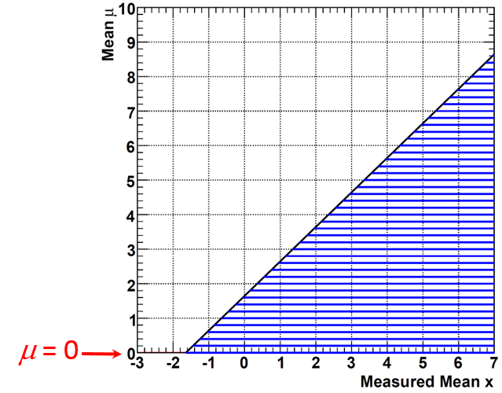
Figure24:Thetraditionalfrequentistconstructionforone-sidedupperlimitsat95%C.L., foraGaussianmeasurementwithunitrms.Averticallinedrawnthroughobservedx0, forx0<−1.64σ,intersectsnoacceptanceintervals,resultinginanempty-setconfidence interval.
anddiscussioningoodnotationisinthePDGRPP[13](Eqn.40.84,Section40.4.2.4). CLsisageneralizationofanearlierresultbyG¨unterZech[101]thatconsideredthecaseof Poissondistributionwithbackgroundandappliedanon-standardformofconditioningon an inequality.The rationale is further described by Alex Read in the early papers [102, 103]; animplementationwithfurthercommentaryisdescribedbyTomJunk[104].
Whatisnew(non-standardstatistics)inCLsiscombiningtwop-valuesintoonequan-tity.(Thisisreferredtoasa“modification”totheusualfrequentistp-value.)Thecom-bination(equivalenttoanon-standardformofconditioning)isdesignedtoavoidrejecting H0whenthedataaresimilarlyincompatiblewithH1.Thissituationcanarisewhenan experimenthaslittlesensitivityfordistinguishingH0fromH1.
There is no established foundation in the statistics literature for this as far as I know.In fact, the two uncombined p-values are considered to be the (irreducible) post-data “evidence”for simple-vs-simple hypothesis testing in a philosophical monograph by Bill Thompson [105] (p.108).Clearly,withbothp-valuesathand,aswiththeHiggsspin-parityexampleinSec-tion 7.7.2, the consumer has the complete information regarding post-data tail probabilities.
(OferVitellshasunearthedasuggestionina1961paperbyBirnbaum[106](p.434) thatcombinesthepre-dataTypeIandTypeIIerrorsratesαandβintoonequantityin theidenticalmanner,i.e.,α/(1 −β);Birnbaum’smotivationwasthatthisquantityequals thelikelihoodratioinaveryspecialcasewheretheteststatisticisthesinglebinarydigit“rejectH0”or“donotrejectH0”(ratherthanthefulllikelihoodratio).Butthisseemsto beobscuretomodernstatisticians,andBirnbaum’slastpaper[107]examinedbothαand 1 −β(theusual“power”),notjustthecombinationα/(1 −β),indefininghis“confidence
70

concept”.)
Inanycase,theCLsquantitydoeshavepropertiesthatmanyfindtobeattractive.In particular,forthetwosimpleprototypeproblems(Poissonwithknownmeanbackground, andtheboundedGaussianproblem),theresultsarenumericallyidenticaltotheBayesian answerswithuniformprior,andhencethelikelihoodprincipleisrespected.TheseBayesian intervalestimatesover-coverfromafrequentistpoint,whichisnotconsideredtobeasbad as under-coverage.(Regarding the uniform priors, for both these models negative µ doesnot existinthemodel,soitisincorrecttospeakofthepriorbeingzerofornegativeµ,asin Section6.9)
Thestepofcombiningthetwop-valuesintoonequantityiscalled“theCLscriterion”in(most)CMSpapers.Unfortunately,thecalculationofthep-valuesthemselves,typically usingalikelihood-ratioteststatistic,issometimescalledthe“CLsmethod”inHEP.But thesep-valuesthemselveshavelongexistedinthestatisticsliteratureandshouldbedesig-natedthatway(andnotdenotedwithequallyunfortunatenamesthattheoriginalpapers ofCLsuseforthem).
Themanyissuesofp-valuesareofcourseinheritedbyCLs,namely:
•Whatspecificlikelihoodratioisusedintheteststatistic;
•Hownuisanceparametersaretreated(marginalization,profiling);
•Whatensemblesareusedfor“toyMC”simulationusedtogetthedistributionofthe teststatisticunderH0(e.g.noHiggs)andH1(e.g.SMwithHiggs).
LEP,Tevatron,andLHCHiggsexperimentersdifferedinthechoicesmade(!).
15 ATLASandCMSConventions
For many years, ATLAS and CMS physicists have collaborated on statistics tools (the RooSt-ats[99]software),andattemptedtohavesomecoherenceinmethods,sothatresultscould becompared,and(whenworththeeffort)combined.
A key development was the paper by Cowan,Cranmer,Gross,and Vitells (CCGV) [71] thatextendsasymptoticformulastovariouscaseswhereWilks’stheoremisnotvalid.
AstheCCGVasymptoticformulascorrespondtothe“fullyfrequentist”treatmentof nuisance parameters, for consistency we tended to use that treatment in many cases at small Naswell.ToyMCsimulationisthusperformedinanapproximatefrequentistmanner inwhichtheunderlyingparametricdistributionofthedataisknownuptooneormore parameters,andsamplingisperformedfromthatdistributionaftersubstitutingestimates fortheparameter(s).(Thisisknownastheparametricbootstrap[108].)
Forupperlimits,therewasalotofdiscussionamongCMSandATLASphysicistsin theearlyLHCdayswithoutconvergence,withtheresultthatthetwoexperiments’physics coordinatorsin2010decreedthatCLs(Section14.1)beusedinmostcases.
TheATLAS/CMSHiggsbosonresultsfollowedthesetrends.Ajointlywrittendescrip-tionis,“ProcedurefortheLHCHiggsbosonsearchcombinationinSummer2011”[109].
71

ManyissueswerefurtherdiscussedanddescribedintheATLAS-CMScombination

papersformass[110]andcouplings[111]. correlations.

Inparticular,alotofattentionwaspaidto

Inthelastfewyears,Feldman-Cousins[55]startstobeusedinsomeanalyses,without my pushing.(Initially, some at the LHC were very opposed, evidently because it could return atwo-sidedintervalnotincludingzerowhentheyinsistedonastrictupperlimit.) TheCMSCollaborationmaintainsalargesuiteofsoftwarecalled“Combine”[100], buildingontechniquesdevelopedbytheCMSandATLASCollaborationsfortheHiggsbo-sonmeasurementsandcombinations,aswellasnumerousotherapplications.Thesetools continuetoevolverapidly.IndividualtoolscurrentlyusedbyATLAS(inadditiontoRoofit andRoostatsmentionedabove)include(pointerscourtesyKyleCranmer)HistFactory[112] forspecificmodellinginhistogrambasedanalyses);HistFitter[113],whichsitsontopof HistFactoryandofferstop-levelsteeringfunctionalitymorelikeCMS’sCombine);TRexFit-ter,thatislikeHistFitterandwidelyused,butnopaperyet;pyhf[114],aPython-based implementationofHistFactory,whichalsohasadifferentformatforsavingresults,which isbeingusedbyHEPData;andcabinetry[115],aPython-basedapproachtotoolslike HistFitter/TRexFitter.
16 Myadvocacyfor>15years
Haveinplacetoolstoallowcomputationofresultsusingavarietyofrecipes,forproblems uptointermediatecomplexity:
•Bayesianwithanalysisofsensitivitytoprior
•Profilelikelihoodratio(MINUITMINOS)
•Frequentistconstructionwithapproximatetreatmentofnuisanceparameters
•Other“favorites”suchasCLs(anHEPinvention).
The community can (and should) then demand that a result shown with one’s preferred methodalsobeshownwiththeothermethods,andsamplingpropertiesstudied.
Whenthemethodsallagree,weareinasymptoticNirvana(idyllicstate).Whenmeth-odsdisagree,weareremindedthattheresultsareanswerstodifferentquestions,andwe learnsomething!E.g.:
•Bayesianmethodscanhavepoorfrequentistproperties
•FrequentistmethodscanbadlyviolatetheLikelihoodPrinciple.
Infact,thecommunityreachedthepointofhavingthetoolsinplace(RooStats[99]) bythetimeoftheHiggsbosondiscovery,andtheyhavecontinuedtobeimproved.Whatis notasfaralongisthe“demands”ofthecommunity,inmyopinion.Iwouldpreferthatit bemorecommonforpaperstocompareexplicitlythechosenmethodwithothermethods, asissometimesdone.
72

17 Unsoundstatementsyoucannowavoid
•“Itmakesnosensetotalkabouttheprobabilitydensityofaconstantofnature.”•“Frequentist confidence intervals for efficiency measurements don’t work when all trials givesuccesses.”
•“Weusedauniformpriorbecausethisintroducestheleastbias.”
•“Weusedauniformpositivepriorasafunctionoftheparameterofinterest.”•“Anoninformativepriorprobabilitydensitydoesnotcontainanyinformation.”•“Thetotalnumberofeventscouldfluctuateinourexperiment,soobviouslyourtoy MonteCarlosimulationshouldletthenumberofeventsfluctuate.”
•“WeusedDelta-likelihoodcontourssotherewasnoGaussianapproximation.”•“Afive-sigmadeparturefromtheSMconstitutesadiscovery.”
•“Theconfidenceleveltellsyouhowmuchconfidenceonehasthatthetruevalueisin theconfidenceinterval.”
•“Weusedthetailareaunderthelikelihoodfunctiontomeasurethesignificance.”•“Statisticsisobvious,soIprefernottoreadtheliteratureandjustfigureitoutfor myself!”
A Detailsofspindiscriminationexampleofsimple-vs- simplehypothesistest
Ref.[116]describesanenlighteningtoyexamplewithsimplehypotheses.Thesetupisthe observation of a new resonance with a mass of 1.5 TeV in the dilepton final state at the LHC (unfortunately optimistic thus far).We consider here the case of just two simple hypotheses for the spin of the new resonance,either a spin-1 vector boson or a spin-2 graviton.In order to avoid confusion between subscripts and spin values, the hypotheses are called HAand HB.
Thedistinguishingobservableistheso-calledCollins-Soperangleθ∗CS,whichisauseful approximationtotheangleintheCMframebetweentheincomingquarkandtheoutgoingµ−.Figure25showsthesimulateddistributionsofcos θ∗CSforthetwospinhypotheses.The eventsinthedetector’sgeometricalacceptance(solidhistograms)areusedintheanalysis. Thehistogramsnumericallydefinethemodelsp(cos θ∗CS|HA)andp(cos θ∗CS|HB).
AsdictatedbytheNeyman–Pearsonlemma(Section7.3.1),theoptimalteststatistic fordistinguishingthetwohypothesesisthelikelihoodratio
λ = L(HA)/L(HB), (36)
73

2200
2000
1800
1600
1400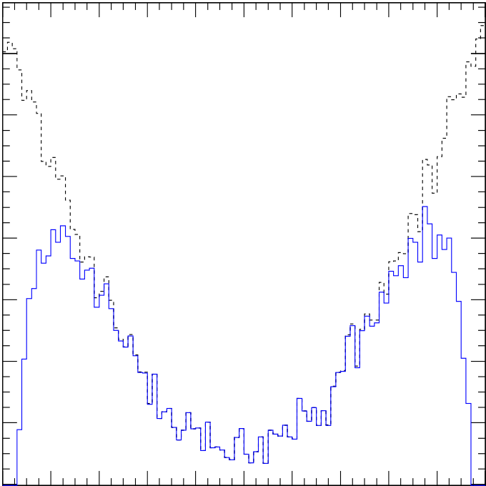 1800
1600
1400
1200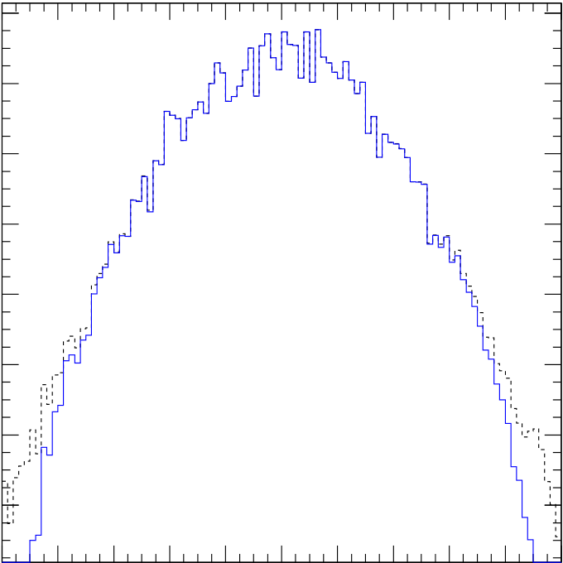
Entries/0.02
Entries/0.02
2600
2800
2400
2600
2200
2400
2000
-1 -0.8 -0.6 -0.4 -0.2 -0 0.2 0.4 0.6 0.8 1 -1 -0.8 -0.6 -0.4 -0.2-0 0.2 0.4 0.6 0.8 1
cos θCS cos θCS
Figure25:Histogramsofcos θ∗CSofindividualeventsfromthegenerated(dashed)andac-
cepted(solid)samplesofspin-1Z′(left)andspin-2G∗(right)for1.5TeVmass. From
Ref.[116].
fromwhichoneusuallyconsidersthemonotonicfunction−2 ln λ.ForadatasetwithN
eventsindexedbyi,λistheproductofeventlikelihoodratios,sothat−2 ln λisthesumof
theindividualeventquantities,
−2 ln λ = | N | −2 ln | p(cos θ∗CS,i|HA) | ! | . | (37)
 | X
 |  |  | p(cos θ∗CS,i|HB)
 | i
Figure 26(left) and right are histograms of the individual terms in the sum,with events
on the left simulated according to HAas in Figure 25(left), and events on the right simulated
accordingtoHB,asinFigure25(right).
Wethenconsiderdatasets(“experiments”)thateachcontainasampleofNevents
fromthedistributionsinFigure26,withthevaluessummedasinEqn.37.Figure27shows
ontheleftthedistributionfor10,000simulatedexperiments,eachwithN=50,andon
therightforN=200.Weseethedramaticeffectofthecentrallimittheorem,whichsays
that each histogram of sums tends to Gaussian despite the highly non-Gaussian distribution
oftheaddendsfromFig.26;andthatfurthermorethemeanandrmsofeacharecorrectly
relatedtothoseinFig.26.
RecallingtheprescriptionsinSections7and7.3.1,toperformaN-Phypothesistestof
HA,onefindsthecutoffλcut,αforthedesiredTypeIerrorprobabilityαandrejectsHAif
λ≤λcut,α.TheTypeIIerrorprobabilityβthenfollows.Bothoftheseerrorprobabilities
areeasilyobtainedfromthehistogramsinFig.27andplottedasafunctionof−2 ln λcut,α,
inFig.28(left),forN=50.OnecanalsoplotβvsαasinFig.28(right)forN=50.As
notedinSection7.2,thechoiceofoperatingpointontheβvsαcurve(orequivalentROC
curveofpower1 −βvsα)requiresmultipleconsiderations.
74

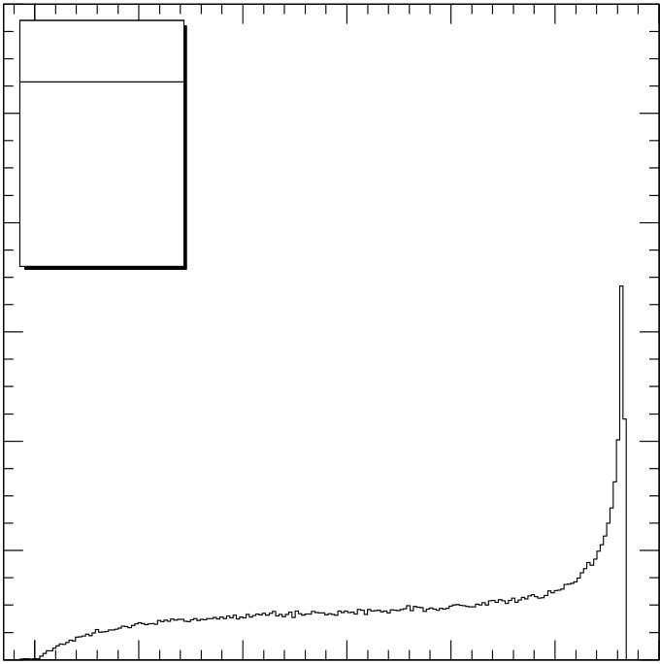
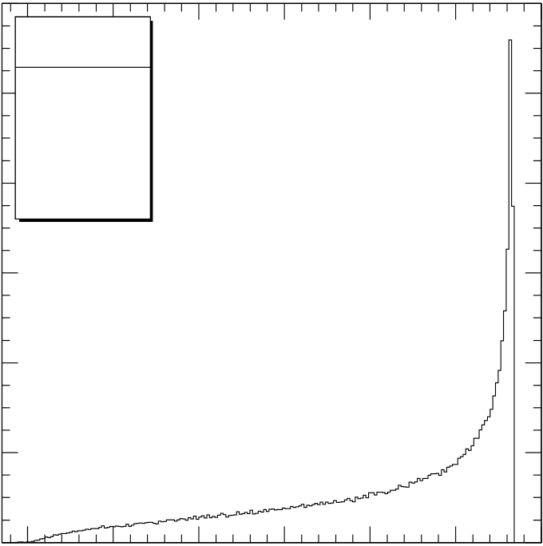
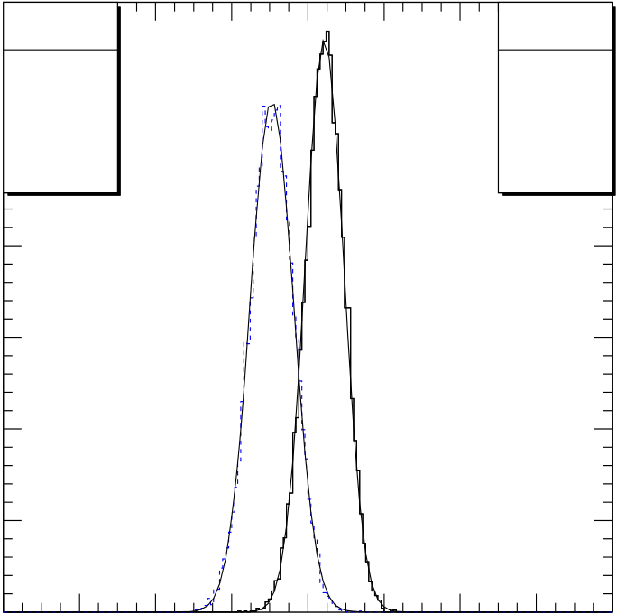
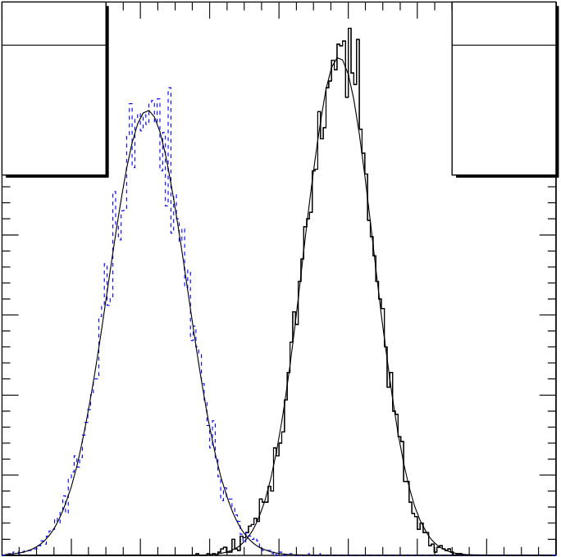
12000  Entries/0.02  10000 | Z’(1500) |  | -1 | -0.5 | 0 | 0.5 | 1 | 12000 Entries/0.02  10000 | G*(1500) |  | -1 | -0.5 | 0 | 0.5 | 1
 | Entries 175171 |  |  |  |  |  |  |  | Entries 189555
 | Mean -0.1899 |  |  |  |  |  |  |  | Mean 0.08654
8000 | RMS | 0.8051 |  |  |  |  |  | 8000 | RMS | 0.7197
6000 | -2 | -1.5 |  |  |  |  |  | 6000 | -2 | -1.5
4000 |  |  |  |  |  |  |  | 4000
2000 |  |  |  |  |  |  |  | 2000
0 |  |  |  |  |  |  |  | 0
 |  |  |  |  |  |  | -2 ln λ |  |  |  |  |  |  |  | -2 ln λ
Figure26:Histogramsof−2 ln λ=2 ln L(HA) −2 ln L(HB)forindividualeventsfromthe
accepted samples generated according to HA (spin-1) and HB (spin-2) for a 1.5 TeV resonance.
FromRef.[116].
Entries/0.80  600  500 | Z’(1500) |  | G*(1500) |  | Entries/0.80  300 | Z’(1500) |  | G*(1500)
 | Entries 10000 |  | Entries 10000 |  |  | Entries 10000 |  | Entries 10000
 | Mean -9.477 |  | Mean 4.393 |  |  | Mean -37.89 |  | Mean 17.26
 | RMS | 5.703 | RMS | 5.138 | 250 | RMS | 11.46 | RMS | 10.15

400 | -60 | -40 | -20 | 0 | 20 | 40 | 60 | 80 | 200 | -60 | -40 | -20 | 0 | 20 | 40 | 60 | 80
300 |  |  |  |  |  |  |  |  | 150
200 |  |  |  |  |  |  |  |  | 100
100
 |  |  |  |  |  |  |  |  | 50
0  -80 |  |  |  |  |  |  |  |  | 0  -80
 |  |  |  |  |  |  | -2 ln λ |  |  |  |  |  |  |  |  | -2 ln λ
Figure 27:Histograms of −2 ln λ for simulated experiments with 1.5 TeV dilepton mass, each
of which is a sum of Nvalues of −2 ln λ from spin-1 and spin-2 events in Fig. 26, for N= 50
(left)andN= 200(right)eventsperexperiment.ThesuperimposedGaussiancurveshave
meansfixedatafactorofNgreaterthanthatoftheeventsinFig.26,andrmsdeviations√
afactorof Ngreater.FromRef.[116].
75

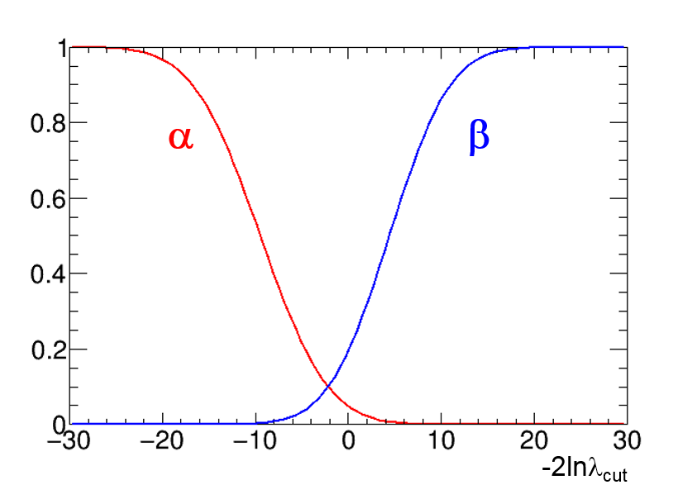

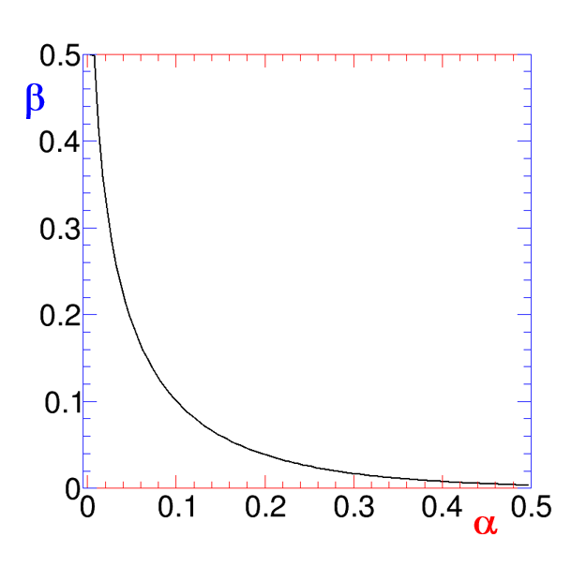

Figure 28:On the left are plots of α and βas a function of the cut −2 ln λcut,αthat is applied tothehistogramsinFig.27(left).Ontherightisaplotofβvsαderivedfromthecurves ontheleft.(ReversetheverticalaxistogettheROCcurveofpower1 −βvsα).
B Furtherdiscussionofgoodnessoffit
As introduced in Section 7.8, a goodness-of-fit (g.o.f.)test is generally defined as a test of the null hypothesis (typically composite, i.e., having adjustable parameters) when an alternative hypothesishasnotbeenexplicitlyspecified.Inatypicalexample,onehasobserveddata x,andthenullhypothesisH0isthat⃗xisarandomsamplefromaspecificprobability densityfunction(pdf)p0(⃗x;⃗µ);here⃗µindicatesparametersthataretypicallynotspecified inadvance,butrathersettotheir“best-fit”values.Ag.o.f.testisthenusedtotestH0. AsnotedinSection4,thegivenpdfp0isoftencalled“themodel”(shortfor“thestatistical model”).Despitetheissuesraisedinthisnote,g.o.f.testsconstituteanimportantstepin dataanalysis;infact,thediscussionhereindicatesthatusingmorethanoneg.o.f.testis advisable.
Themostcommong.o.f.testissurelythechisquareg.o.f.testusedinintroductorylab classes,eitherformeasurementsofdependentvariablesxiasafunctionofanindependent variable(saycurrentvs.voltage),orforbinneddata.Asanalyseswithunbinnedlikelihood functionshavebecomecommonplaceinHEP,theuseofunbinnedg.o.f.testshasincreased aswell.Forunbinnedmeasurementsinonedimension(1D),theKolmogorov-Smirnov(K-S)testiscommonlyused,probablybecauseithasbeenreadilyavailableinHEPsoftware packages (CERNLib and ROOT) for decades, and (like the chisquare test) the interpretation of the test statistic is asymptotically independent of the null hypothesis model p0.However, as this note emphasizes, other tests may be more appropriate than the K-S test (for example whenoneisinterestedindeparturesfromp0inthetails).
Forg.o.f.testsofunbinneddatainmorethanonedimension,therearenoconventions inHEP,despitesporadicworkinthelast25yearsormore.Anexampleofapotential applicationaroseintheZZ∗Higgsdiscoverychannel,inwhichtheeventswereexpectedto
76

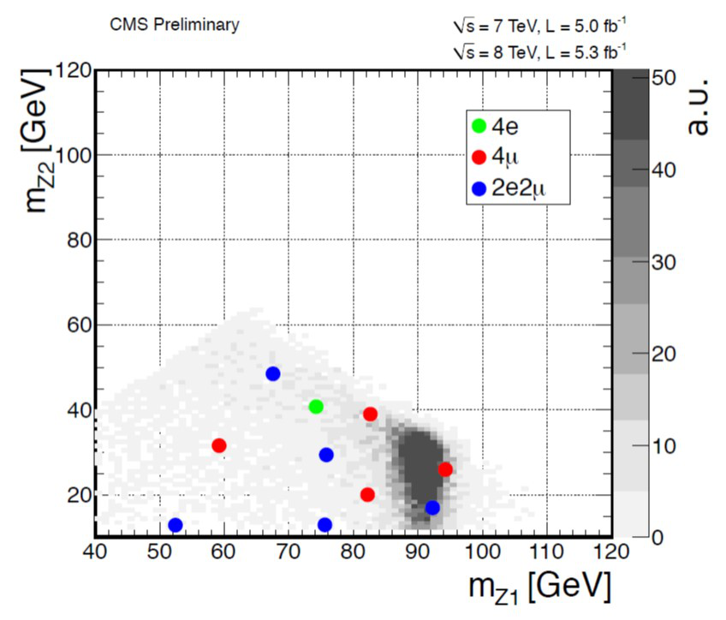
Figure29:ScatterplotshownbyJoeIncandelaattheCMStalkonthediscoveryofthe Higgs-likeboson[117]. ForHiggstoZZ∗candidatesinthefour-leptonfinalstate,the horizontalaxisisthemassofthehigher-masspair(Z1),whiletheverticalaxisisthemass ofthelower-masspair(Z2).Thelargedotsarethe10eventsindata.Thegrayshading, peakingintheregionaround(90GeV,30GeV),istheexpectedpdfforanSMHiggswith massof126GeV.
haveoneZnearlyonmassshellandtheotheroff-shell.TheCMSdatapresentedatthe discoverytalkon4July2012includedFigure29,ascatterplotoftheinvariantmassof thelower-masspairvsthehigher-masspair.Inthiscase,thenullhypothesisp0couldbe takenasSMHiggsproductionanddecay,forwhichthepdfisshowningrayshading.To theeye,thereseemedtobefeweron-shellZ’sthanexpected.Thiswasnotedandpresumed tobeastatisticalfluctuation(borneoutwhenmoredatawasobtained).AsfarasIknow, nounbinned2Dg.o.f.testofp0wasattempted.Onecanimaginethatsuchtestsmightbe usefulforfuturediscoveryplotsinlow-statisticsregions.
As noted above, in common g.o.f. tests the model p0has parameters that are adjusted to obtain the “best fit”,in which case the g.o.f. test is performed using the best-fit parameters. In such a case, it is important keep in mind that the g.o.f. test is a test of the complete model includingthebest-fitadjustableparameters.Thisisdistinctfromtheseparateinference problemsof“measuring”theparametersanduncertaintiesonthem(knowntostatisticians aspointestimationandintervalestimation,respectively).
77

B.1 RelevanceofNeyman–PearsonLemmatog.o.f.tests
Inapproachingthetheoryofg.o.f.tests,itisusefultorecalltheNeyman–Pearson(N-P) theory of hypothesis testing, as discussed in Section 7.The N-P theory provides the language inwhichthelimitationsofg.o.f.testsbecomeclear.Recallinginparticularthetestingof simple hypothesis H0vs simple hypothesis H1in Section 7.3.1, for a given α,βis minimized iftheteststatisticTisthelikelihoodratioλinEqn.25thatdependsexplicitlyonH1.By definition,inag.o.f.testH1hasnotbeenspecified.Thustheproblemofchoosinga“best”Tforag.o.f.testofH0isnotwell-posed!Theretypicallyexistmanypossiblechoicesfor Tinag.o.f.test.Somemaybeparticularlypopular(e.g.theubiquitouschi-squareg.o.f. test),butthatdoesnotmeanthattheyare“best”inanygeneralsense.
Infact,itfollowsfromtheNeyman–PearsonLemmathatforanychoiceof Tusedfora g.o.f. test, that choice will tend to have high power against some alternative H1if it happens thatTisapproximatelymonotonicwiththelikelihoodratioλ=L(H0)/L(H1),whilethe choice is vulnerable to having poor power against alternative hypotheses from which Tbears norelationshiptoλ.Thus,achoiceofg.o.f.teststatisticTpicksoutalternativestoH0 (sometimescalleddirectionsofdeviationsfromH0)forwhichThashigherdiscrimination power.Thisistruewhetherornotoneisawareofit!
AlthoughthestrictsuperiorityofλasteststatisticTnolongerholdswithcomposite hypotheses,thelessonremainsthatthechoiceofTdefinesdirectionsofhighdiscrimination power.
B.2 Prototypeproblem:testofuniformdensityon(0,1)
Aprototypeg.o.f.testisthefollowing:supposethat⃗yconsistsofasetofNnumbers{yi} between0and1,andyouwanttotestthehypothesisthattheywereobtainedbysampling Ntimes from a uniform density on (0,1).While this may seem to be an artificial special case (usefulfortestingthevalidityofapseudorandomnumbergenerator),infactmanymodels canbere-castintothisformwithoutlossofgeneralitybyusingtheprobabilityintegral transformofSection4.3.Thatis,wecanconsiderthemoregeneralnullhypothesisH0as themodelinwhicheachnumberxiinthesetofNnumbers{xi}isanindependentrandom samplefromageneralpdfp(x)definedinthedomaina<x<b,withxcontinuous.Then the probability integral transform of Eqn. 15 defines y(x) such that p(y) is uniform on (0,1). Thuswithoutlossofgenerality,theg.o.f.testofthenullhypothesisH0forthemodelp(x) is re-cast as the hypothesis that the set {yi} = {y(xi)} is a random sample from the uniform density on (0,1).(If x is discrete,there are complications which are discussed in some of the citedpapers.)
Since1−yisalsouniformon(0,1),typicallysomeotherconsideration(suchasthe distributionofxunderadifferentp)dictatesifoneendoftheintervalisofmoreinterest thantheother.
Overthelastcentury,aplethoraoftestshavebeeninventedtotestforuniformity of⃗yon(0,1),andhencetestfor⃗xdrawnfromanygivencontinuousp0(x).Thebookby D’AgostinoandStephens[66]containsacomprehensivediscussion.Themorerecentarticle byMarhuendaetal.[118]definesandcomparesaplethoraoftestsagainststandardsetsof parameterizedalternatives(higherorlowerdensitynear0or1,orboth,etc.).Subsetsof
78

testsincommonuseinHEParediscussedbyF.James[3],andafewareimplementedin ROOT.
B.2.1 Testsbasedontheempiricaldistributionfunction
ThemostwidelyusedmethodsinHEParebasedonthecumulativedistributionfunction (CDF)andempiricaldistributionfunction(EDF).Whileinscience“distribution”isoften usedsynonymouslywithprobabilitydensityfunction(pdf),instatistics“distributionfunc-tion”isoftenshortforcumulativedistributionfunction,whichisanintegralofapdf.Often f(x)isusedforapdf,anduppercaseF(x)isusedforitsCDF:
F(x) = | Zx | f(x′)dx′. | (38)
−∞
GivenNobservedvaluesxiasabove,theEDFis
FN(x) =numberofobservedvalues≤x N | . | (39)
ThusFN(x)isanincreasingpiecewise-constantfunction,startingfrom0forxlessthanthe smallestobservedxi,increasingby1/Nateveryobservedvalue,andobtainingunityabove thehighestobservedvalueofxi.
Iftheobserved⃗xisdrawnfromp0(x),thenweexpecttheEDFFN(x)tobesimilarto theCDFcalculatedfromp0(x),whichwecallF0(x).Avarietyofg.o.f.testsarethusbased onvariousdefinitionsofthe“distance”betweenF0(x)andFN(x).Thesetestsinclude,for example,theKolmogorov-Smirnovtest(basedontheextremumof|F0(x) −FN(x)|),and theCram´er-vonMisesfamilybasedonintegralsweightedbyafunctionw(x)ofthesquared
difference: | N | Z+∞ | (F0(x) −FN(x))2w(x)dF(x). | (40)
−∞
Theunweightedcase(i.e.w(x)=1)correspondstotheclassicCram´er-vonMisesstatistic. Theweightfunctionw(x)canbechosentogivemorepoweragainstcertaindeviations.For example, the Anderson-Darling (AD) test is designed to have more power against deviations atbothendsofthedistribution,withaweightfunction
w(x) = | 1  F(x)(1 −F(x). | (41)
SincedeparturesfromassumedGaussianityareofteninthetails,ADisreputedtobe usefulfortestingGaussianity,aswellasbeinggenerallyuseful.Therearealsoversionsthat emphasizeonlyonetail[66].Ontheotherhand,boththeKolmogorov-Smirnovfamilyand theCram´er-vonMisesfamilyhavevariationsthatmaketheendpointsnotspecialbyposing theproblemonacircle.
KeepinginmindtheprobabilityintegraltransformandthefactthatEqn.40isdefined intermsofdF(x)ratherthandx,onecanseethatthedistributionofsuchteststatistics under the null hypothesis does not depend on the specific form p0in the null.Such tests are calleddistribution-freeandarepopularsincestandardtablescanbecomputedandused. Nowadays,withtheabilitytosimulatedatasetsandobtainthenulldistributiondirectly,it canbeworthexploringtheuseofmorepowerfulteststhatdonothavethisproperty.
79

B.2.2 Otherfamiliesoftestsofuniformityon(0,1)
Refs. [66, 118] describe multiple classes of tests in addition to those based on the EDF. These include tests based on the “ordering statistics”, i.e., on the ordered set of the observed points yi(testing mean values of ith points,moments of differences yj −yi,etc.).Among the many tests,onecanattempttochoose“omnibus”teststhatperformreasonablywellagainsta numberofdifferentalternatives.TheconclusionofRef.[118]isthatamemberoftheclass oftestscalled“Neymansmoothtests”isuniqueinbeinginthetop-10mostpowerfultests forallthealternativesthattheyconsidered.
Neymansmoothtestsandmoregeneral“smooth”testsseemtohavehadlittleusein HEPthusfar,despitepopularityinthestatisticsliterature[119,120].Theyaretestswhere the alternative hypothesis is constructed by fitting the data to a sum of Legendre polynomi-als.(ThevariantthatRef.[118]studiesusesSchwarz’sBayesianinformationcriterion[121] tochoosethedegreeofpolynomials.)Thisspiritofusingthedatatoconstructthealter-nativehypothesisusedinalikelihoodratio(orasymptoticequivalent)issimilartothatof thesaturatedmodeldiscussedbelowforbinneddata.Recently,areal-worldexampleusing theNeymansmoothtestinX-rayastronomywaspublishedbyastrophysicistscollaborating withstatisticianAlgeriandherstudentZhang[122].Grossoetal.[123]haveinvestigateda furthergeneralizationthatusesmachinelearningtoconstructanalternativemodelthatis usedinalikelihoodratio.
B.3 Chisquareg.o.f.andvariants
Asnotedabove,NeymanandPearsontaughtusthat(evenforsimplehypotheses)thebest test of the null hypothesis depends on the alternative, and hence there is no universally best g.o.f.test.Nonetheless,theubiquityofthechisquareg.o.f.testatteststoitsutility,atleast forpickingupcertaindeparturesfromthenull.InitsusualformforuncorrelatedGaussian (normal)distributeddata,onehas
χ2= | X | (di −fi)2 | , | (42)
 |  | σ2 i
 | i
wheredi ± σiistheithmeasureddatapointwithrmsdeviationσi(eachassumedtobea knownconstant),andfiisthemodelprediction(perhapswithparameters)tobecompared withdi.(Ifσiisnotaknownconstantateachi,butdependsontheunknowntruevalueof the model at i, then there are subtleties beyond the scope of this note.)Since the test statisticχ2is a function of the random data, it is itself a random variable, and in unbounded Gaussian applicationsithasaprobabilitydensityfunction[13]whichisitselfalsofrequentlycalled chisquare.Thepotentiallyconfusingambiguityinmultiplemeaningsisusuallyresolvable bycontext.Thiscouldalsobeavoidedbyusinganothername,suchasS2orQ2fortheleft handsideofEqn.42,butIyieldtocommonpracticeinthisnote.
InHEP,wecanalsoencountersituationsinwhichtheso-called“regularityconditions”arenotmet,sothatthedistributionoftheteststatisticinEqn.42isnotachisquare function;twocommoncasesarewhenthetrueorbest-fitvaluesofparametersareonthe boundary (physical constraint such as non-negativity), and when there are issues with degrees offreedomnotbeingwell-defined.Again,theseissuesarebeyondthescopeofthisnote.
80

Moreinformationregardingthechisquaretest,includingthegeneralizationofEqn.42 toincludecorrelations,isinthePDGRPP[13].
B.3.1 Gaussianchisquareg.o.f.isalikelihoodratiousingthesaturatedmodel
Forthesamedataandmodelasabove,thelikelihoodforthenullhypothesisH0is:
L(H) = | Y | 1 | exp | −(d−f)2/2σ2 | . | (43)
 | Y
0 | i | p 2πσ2 i |  | ii
Itissometimessaidthat−2 ln Lisequaltoχ2;thisisclearlynotcorrectsincetheformer quantityhasextraconstantterms.Understandinghowtheextraterms“disappear”inthe g.o.f.test(fromthepointofviewofN-Ptesting)isenlightening.
Given only the null hypothesis and the data, one can use the data to invent an alternative hypothesisforwhichthemodelfiisequaltothedatadiateverymeasuredvalue!Such amodel,whichtypicallyneedsasmanyparametersaretherearedatapoints,iscalleda saturatedmodel[124].
FortheGaussiandataabove,thesaturatedmodelsets fi= di,sothatthelikelihoodof thealternativehypothesisH1(thesaturatedmodel)is(sinceexp(0) = 1)
L(H) = | Y | 1 | . | (44)
 | Y
1 | i | p 2πσ2 i
InspiredbyEqn.25,weconsidertheratioofthetwolikelihoodsabove,i.e,
λ = L(H0)/L(H1) = | Y | exp | −(di −fi)2/2σ2 | , | (45)
i
andthus
χ2= −2 ln λ. (46)
Fromthispointofview,theconstantsin−2 ln Lwerenotjustignored;theywerecanceled when a ratio was formed.(There are other paths to the chisquare expression not as relevant tothisnote.)Sincethesaturatedmodeldoesnotdependontheparametersoftheoriginal model, the maximum of λ is of course at those parameters that maximize the original L(H0).
B.3.2 Pearson’schisquareforbinnedhistograms
TheoriginalchisquarevariableisthatofKarlPearsonin1900,designedforhistograms (“frequencytables”)withmultinomial-distributedbincontents,anddefinedas
χ2= | X | (di −fi)2 | . | (47)
 |  | fi
 | i
(Inamultinomialhistogram,thetotalnumberofeventsisfixedbydesign,sothereisone fewerindependentbincontentthaninPoissondata.)ThisisverysimilartoEqn.42,since inmultinomialandPoissondata,ficanbeaproxyforσ2 i.
81

B.3.3 Useofsaturatedmodeltoconstructimprovedchisquareg.o.f.forbinned histograms
In1983,BakerandCousins[125]reviewedconstructionoflikelihoodratiosasinEqn.25 usingsaturatedmodelsfortestingg.o.f.forPoissonandmultinomialdatainhistograms. (Theydidnotcallthemsaturatedmodels,insteadcitinga1928paperbyNeymanand Pearson.)Bythattime,ithadbeenwidelynotedthatusingaPoissonlikelihoodmodelfor fittingtypicalHEPhistogramscuredadefectoffitsusingPearson’schisquare,namelythat theareaunderthefittedcurvewasnotequaltotheobservednumberofevents.Itwasless well known how to construct a g.o.f. test consistent with such a likelihood fit.For histograms withindependentPoisson-distributedbincontentsdi,theresultfortheg.o.f.teststatistic,
−2 ln λ = 2 | X | fi −di + di ln(di/fi), | (48)
i
was called χ2λ,psince asymptotically its pdf tends to the chisquare distribution.This Poisson formismentionedinthePDG’sReviewofParticleProperties[13];sometimeagoitwas decidedthatitisbestjusttodenoteitby−2 ln λassomefeltthatcallingitχ2might encouragepeopletoforgetthatitonlyasymptoticallyfollowstheχ2distribution(andonly ifconditionsaresatisfied).AsnotedintheBaker-Cousinspaper,probablythesafestthing todoistostudythedistributionbyMonteCarlo.
Heinrich[126]hasstudiedthedistributionandmomentsofλforsmallstatistics,and makesthepointthatfortheasymptoticformulastobevalid,thecontentsofallbinsmust eachbelarge.Moregenerally,howtobindataisanothercomplexproblemsincebinning discardsinformationonthelocationofeventswithinthebin,andsuppressestheabilityto observehigh-frequencycomponents.Thustherobustnessofresults(orlackthereof)tothe binningchosenshouldbeunderstoodandcommunicated.
B.3.4 Testscomplementarytothechisquareg.o.f.test
The tests based on chisquare or asymptotic equivalents discard all or most of the information on the ordering of the deviations as well as the signs of the deviations.Hence they can easily missatrendinthedeviationsthatisobvioustotheeye(e.g.,alldeviationsofthesame sign,oratrendduetoaslopenotpresentinthenullhypothesis).Thus,authorssuch James[3]suggestcomplementingthechisquaretestwitha“runstest”,oftencalledthe Wald-Wolfowitzrunstest.Performingmorethanoneg.o.f.testraisestheissueofwhether or not the results can be combined into one overall g.o.f. summary.Doing so might be useful insomecontexts,butoneshouldbeawarethatcombiningp-valuesisitselffraughtwith ambiguity,asdiscussedinRef.[127].
B.4 Cautionagainstabsolutelikelihoodasg.o.f.teststatistic
Occasionallyonefindstherecommendationtouseasag.o.f.teststatistictheabsolute likelihoodatitsmaximum,asopposedtoaratiooflikelihoodmaxima;typicallyMonte Carlo simulation is recommended as the way to get the null distribution of the test statistic. Although this might at first seem plausible, it is a flawed concept:unlike the likelihood ratio,
82

suchag.o.f.statisticiswithoutfoundation,andpowercanvaryarbitrarilywiththemetric. Simpleexamplescanmakeclearthatthevalueofthelikelihoodatitsmaximummustbe comparedtosomething.Forexample,forPoissoncounts,theprobabilityofobserving100 eventswhenµ = 100.0ismuchlessthantheprobabilityofobserving1eventwhenµ = 1.0, eventhoughinbothcasesthedataperfectlyfitthetheory.Forbinneddata,thesaturated model provides the reference of the largest value that the likelihood can be for that data (for anymodel),andhenceprovidesareasonable normalization for the maximum observed for a moreconstrainingmodel.
Heinrich[128]discussesthepitfallsofusingtheabsolutelikelihoodasag.o.f.statistic. For unbinned likelihoods, which are common in HEP, the problem is exacerbated.One might hope that one could just take binned g.o.f. in the limit of small bins, but the answer depends onthewaythelimitistaken,i.e.,inwhichmetricthebinboundariesareequallyspaced.
B.5 Discussion
Fromtheabove,itisclearthat,for“g.o.f.test”definedinitspurestformofnospecified alternative,thereisnounique“best”g.o.f.test.Thereforetryingseveralcangivesome indicationofhowwellthechosenstatisticsmodelapproximatesreality,andinwhichdirec-tionsdeparturesmightbesuspected(heaviertails,skewness,etc.).Itisthereforeusefulto beawareofdirectionsagainstwhichonewouldliketohavepower,andtochooseg.o.f.tests appropriately;simpletoyMCsimulations,suchasthoseinthecitedreferences,canhelpin thisregard.Forag.o.f.testforunbinneddatainonedimension,onehasavarietyoftests tochooseamong[66,118],dependingonroughlywhatsortofalternativesonewantspower against.A recent monograph is by Thas [120].If, on the other hand, there is a specific alter-nativeofinterest,thentypicallyoneleavestheworldofgenericg.o.f.testsandgainspower byconstructingalternative-specificlikelihoodratiotests(asintheHiggsbosonsearches).
Generalizationoftheseg.o.f.teststohigherdimensions,asinFig.29,remainsatopic ofresearch.SomecomparisonsweremadebyAslanandZechatDurhamin2002[129], including their proposed energytest [130].Williams [131] has provided a more recent review, includingworkbyCuadrasandFortiana(firstpointedouttomebyIlyaNarsky)thatis closelyrelatedtotheenergytest.Williamsalsodiscussesthecloserelationshipbetween g.o.f. tests and two-sample tests, which are beyond the scope of this note.One can of course resorttobinningthedataforg.o.f.testseveniftheparametersarefitwithanunbinned likelihood;inthiscaseasnotedabovetherobustnesswithrespecttothebinningchosen needstobeunderstood.
C Look-elsewhereeffect
In these lectures, I did not have time for the important (and increasingly mandatory) calcula-tion of the LEE. A starting point for self-study is the discussion by Louis Lyons, “Comments on‘LookElsewhereEffect’”[132].SeealsoSection9.2ofmypaperontheJeffreys-Lindley Paradox[4].
Animportantpaperforpracticalcalculations,andalsoforqualitativeinsight,isby EilamGrossandOferVitells,“Trialfactorsforthelookelsewhereeffectinhighenergy
83

physics,”[133].
D Bayesianhypothesistesting(modelselection)
As mentioned very briefly in Sections 5, 5.11, and 10, the duality used in frequentist hypothe-sis testing (Section 7.5) is not used in Bayesian statistics.The usual methods follow Chapter 5ofHaroldJeffreys’sbook[16]:Bayes’sTheoremisappliedtothemodelsthemselvesafter integratingoutallparameters,includingtheparameterofinterest!Thisistypicallypre-sentedbyBayesianadvocatesas“logical”andthereforesimpletouse,withgreatbenefits suchasautomatic“Occam’srazor”penalizinglesspredictivemodels,etc.
Infact,Bayesianmodelselectionisfullofsubtleties,andevenfortheexperts,itcan bea“canofworms”(JamesBerger[33],Rejoinder,p.459).Asjustoneindication,Jeffreys andfollowersusedifferentpriorsforintegratingoutparameter(s)inmodelselectionthan forthesameparameter(s)inparameterestimation.HereImainlyjustsay:Beware!There areposted/publishedapplicationsinHEPthatlackfoundation,inparticularbyBayesian standards.AsmentionedinSection5.11,apseudo-BayesexampleinPRLprovokedmeto writeaComment[42]thathassomereferencestousefulBayesianliterature.
Thedependenceonpriorprobabilitiesforthemodelsthemselvescanbefactoredout, leadingtoa“Bayesfactor”thatistheratioofposterioroddstopriorodds.However,the Bayes factor still depends on prior pdfs for parameters in the models, and this leads to direct sensitivitytothepriorpdfforaparameterthatisinonemodelbutnotintheother.For testingH0:µ = µ0vsH1:µ̸ = µ0,improperpriorsforµthatworkfineforestimationbecome adisaster. Addingacut-offtomakethemproperjustgives(typicallyarbitrary)cutoff dependence.
Intheasymptoticlimitoflotsofdata,youranswersinatestofapointnullvsa continuousalternative(eithertheprobabilityH0istrue,oralsotheBayesfactor)remain directlyproportionaltothepriorpdffortheparameterofinterest.Thisistotallydifferent behaviorcomparedtoBayesianintervalestimation,wheretheeffectofapriortypically becomesnegligibleasthelikelihoodfunctionbecomesnarrowlypeakedatlargeN.
Forareviewandcomparisontop-valuesinthediscoveryofHiggsboson,seemypaper,“TheJeffreys-LindleyParadoxandDiscoveryCriteriainHighEnergyPhysics”[4]. As mentionedinSection5.11,seealsoChapter12byHarrisonProsperinRef.[43].
E Pointestimation
Most of this paper is about intervals; I do not say much about what to quote as the “measured value”(typicallyusingtheMLEbydefault).Statisticianscallthisthe“pointestimate”.
Thereisahugeliteratureonpointestimation;seee.g.Chapters7and8inRef.[3].
Ifyouarewell-groundedinintervalestimation,oneapproachistousethatmachinery togetapointestimate.E.g.,onemighttakethemid-pointof(say)your68%C.L.central interval.But a better approach is probably to let the C.L. go to 0, so that your interval gets shorterandshorter,andusethelimitingpoint.ForboththeLRorderingforconfidence intervals(F-C),andforlikelihoodratiointervals,thisresultsinthemaximumlikelihood estimate.
84

Togiveanideaofhowrichthesubjectis,IshowafewinterestingthingsfromRef.[3].
E.0.1 Pointestimation:Traditionaldesiderata
•Consistency:EstimateconvergestowardtruevalueasnumberofobservationsNin- creases
•Unbiasedness:Expectationvalueofestimateisequaltothetruevalue.(Biasand consistencyareindependentproperties;seeFig.7.2inRef.[3].)
•Efficiency:Estimatehasminimumvariance
•Minimumlossofinformation:(technicaldefinition)
•Robustness:Insensitivitytodeparturesfromtheassumeddistribution
Onecanadd:
•Simplicity:transparentandunderstandable
•Minimumcomputertime:stillrelevantinonlineapplications,lessrelevantotherwise
•Minimumlossofphysicist’stime(howmuchweighttoputonthis?)
Thesedesiredpropertiescanbeimpossibletoachievesimultaneously.Howtochoose? Athoroughanalysisrequiresfurtherinput:whatarethecostsofnotincorporatingvarious desiderata?Thenformaldecisiontheorycanbeusedtochooseanestimator.
In practice in HEP, maximum likelihood estimates are often used (even though they are typically not unbiased).Typically the MLE is consistent and has other excellent asymptotic properties(e.g.,estimateisasymptoticallynormal).ForfiniteN,theMLEworkswellin theso-calledexponentialfamilythatincludesbinomial,Poisson,andGaussian.Asnoted inSection4.2,theMLEisinvariantunderreparameterization.(Thismeansthatifitis unbiasedinonemetric,itistypicallybiasedinothermetrics,asdiscussedinRef.[11], Section5.3.1.)
E.0.2 Alternativestothearithmeticmeanwhenmodelisnon-Gaussian
FredJames[3](pp.209ff)hasaveryilluminatingdiscussionoftheMLEsforadiverseset ofpdfs,representinglongtails,shorttails,andinbetween.Ifp(x|µ) = f(x −µ),wherefis somepdf,thenµiscalledalocationparameter.Somecommonexamplesofpdfswhereµis alocationparameterare:
Normal:p ∼exp(−(x −µ)2/2σ2)
Uniform:p=constantfor|x −µ| < a;p = 0otherwise
Cauchy:p ∼1/(a2+ (x −µ)2)
Doubleexponential:p ∼exp(−a|x −µ|)
85

Theseexamplesareallsymmetricaboutµ:p(µ + y) = p(µ −y)
Suppose you are given N=11 values of x randomly sampled from p(x|µ).What estimator (functionofthe11values)givesyouthe“best”estimateofµ?Ifby“best”youmean minimumvariance,itistheM.L.estimate,resultinginadifferentformulaforeachofthe abovecases!ThreeofthefourarespecialcasesofLp,theestimatorthatminimizesthesum over the observations of |xi−µ|p.Different values of p put different emphasis on observations inthetails.
OnlyforthenormalpdfistheMLEequaltothearithmeticmean,obtainedbythe familiarleast-squarestechnique(p=2).CanyouguesswhattheMLEisfortheuniform andtheexponentialcases?(FortheCauchypdf,withitslongtails,thearithmeticmeanis particularlyuseless;seealsothediscussionbyEfron[9]).
Ifthetruedistributiondepartsfromthatassumed,thentheestimateoflocationisno longeroptimal.Sensitivityisinthetails!See the nice discussion of asymptotic variance and robustnessinRef.[3](pp.211ff).
Acknowledgments
Thanks to many in HEP (Frederick James, Gary Feldman, Louis Lyons, Luc Demortier, and numerousothers)fromwhomIlearned. . . andtomanystatisticiansthatLouisinvitedto PhyStatmeetings.ForBayesianstatistics,thatwasespeciallyJimBerger(multipletimes) andMichaelGoldstein,andmorerecently,DavidvanDyk(multipletimes).Thanksalsoto theCMSStatisticsCommittee(OlafBehnkeetal.,includingIgorVolobouev,whopointed toRefs.[118,120])formanydiscussionsandcommentsonearlierversionsoftheslides andwriteup. . . andtotheauthorsofnumerouspapersfromwhichIlearned,includingearly (1980s)BayesianpapersbyHarrisonProsper. . . .ThanksalsotoDiegoTonellioftheLHCb experimentforencouragementtoupdatetheslidesin2017andforcommentsonanearlier version.
ThisworkwaspartiallysupportedbytheU.S.DepartmentofEnergyunderAward NumberDE–SC0009937.
References
[1]“The8thAfricanSchoolofFundamentalPhysicsandApplications,ASP2024”.
Marrakesh,Morocco,2024,
https://africanschoolofphysics.org/2023/06/28/asp2024/.
[2]R.Cousins,“StatisticsinTheory:PreludetoStatisticsinPractice”,2024. http://www.physics.ucla.edu/~cousins/stats/theoryslides.
[3]F.James,“StatisticalMethodsinExperimentalPhysics”.WorldScientific, Singapore,2ndedition,2006.
[4]R.D.Cousins,“TheJeffreys–Lindleyparadoxanddiscoverycriteriainhighenergy physics”,Synthese194(2017)395, arXiv:1310.3791.
doi:10.1007/s11229-014-0525-z,10.1007/s11229-015-0687-3.
86

[5]G.Cowan,“StatisticalDataAnalysis”.ClarendonPress,Oxford,1998.
[6]P.DiaconisandB.Skyrms,“TenGreatIdeasaboutChance”.PrincetonUniversity Press,Princeton,2018.
[7]B.deFinetti,“TheoryofProbability:ACriticalIntroductoryTreatment”.Wiley, U.K.,2017.ThefirsteditionwaspublishedinItalianin1970.
[8]L.J.Savage,“TheFoundationsofStatistics”.DoverBooksonMathematicsSeries. DoverPublications,NewYork,2ndedition,1972.Thefirsteditionwaspublishedby Wileyin1954.
[9]B.Efron,“Bayesians,Frequentists,andPhysicists”,inProceedingsofPHYSTAT 2003:Statisticalproblemsinparticlephysics,astrophysicsandcosmology,Stanford, USA,September8-11,2003,L.Lyons,R.Mount,andR.Reitmeyer,eds.,p.17. SLACeConfC030908,2003.
http://www.slac.stanford.edu/econf/C030908/papers/MOAT003.pdf.
[10]G.CasellaandR.L.Berger,“StatisticalInference”.Brooks/Cole,CengageLearning, Belmont,CA,2ndedition,2002.
[11]R.J.Barlow,“Statistics:AGuidetotheUseofStatisticalMethodsinthePhysical Sciences”.Wiley,Chichester,U.K,1989.
[12]E.S.Pearson,“TheProbabilityIntegralTransformationforTestingGoodnessofFit andCombiningIndependentTestsofSignificance”,Biometrika30(1938)134.and referencesthereintoR.FisherandK.Pearson.
http://www.jstor.org/stable/2332229.
[13]ParticleDataGroup,S.Navas,etal.,“ReviewofParticlePhysics”,Phys.Rev.D 110(2024)030001.http://pdg.lbl.gov/.
[14]J.O.Berger,“StatisticalDecisionTheoryandBayesianAnalysis”.SpringerSeriesin Statistics.Springer,NewYork,2ndedition,1985.
[15]D.V.Lindley,“ThePhilosophyofStatistics”,J.RoyalStat.Soc.SeriesD(The Statistician)49(2000)293.http://www.jstor.org/stable/2681060.
[16]H.Jeffreys,“TheoryofProbability”.OxfordUniversityPress,Oxford,3rdedition, 1961.
[17]C.P.Robert,N.Chopin,andJ.Rousseau,“HaroldJeffreys’sTheoryofProbability Revisited”,StatisticalScience24(2009)141.
http://www.jstor.org/stable/25681291,
https://projecteuclid.org/euclid.ss/1263478373.Seetherestoftheissuefor discussionandrejoinder,https://projecteuclid.org/euclid.ss/1263478370.
[18]J.M.Bernardo,“ReferencePosteriorDistributionsforBayesianInference”,J.Royal Stat.Soc.SeriesB(Methodological)41(1979)113.
http://www.jstor.org/stable/2985028.
87

[19]J.O.BergerandJ.M.Bernardo,“EstimatingaProductofMeans:Bayesian AnalysiswithReferencePriors”,J.Amer.Stat.Assoc.84(1989)200.
[20]J.O.BergerandJ.M.Bernardo,“OrderedGroupReferencePriorswithApplication totheMultinomialProblem”,Biometrika79(1992)25.
[21]J.O.Berger,J.M.Bernardo,andD.Sun,“ObjectiveBayesianInference”.World Scientific,Singapore,2024.
[22]J.M.Bernardo,“BayesandDiscovery:ObjectiveBayesianHypothesisTesting”,in ProceedingsofPHYSTAT2011WorkshoponStatisticalIssuesRelatedtoDiscovery ClaimsinSearchExperimentsandUnfolding,CERN,Geneva,Switzerland,17-20 January2011,H.B.ProsperandL.Lyons,eds.,pp.27–49.2011.
http://cdsweb.cern.ch/record/1306523.
[23]L.Demortier,S.Jain,andH.B.Prosper,“Referencepriorsforhighenergyphysics”, Phys.Rev.D82(2010)034002, arXiv:1002.1111.
doi:10.1103/PhysRevD.82.034002.
[24]R.E.KassandL.Wasserman,“TheSelectionofPriorDistributionsbyFormal Rules”,J.Amer.Stat.Assoc.91(1996)1343.
http://www.jstor.org/stable/2291752. doi:10.2307/2291752.
[25]D.Coxetal.,“PanelDiscussion”,inProceedingsofPHYSTAT05Statistical ProblemsinParticlePhysics,AstrophysicsandCosmology,Oxford,U.K,September 12-15,2005,L.LyonsandM.K.Unel,eds.,p.294.ImperialCollegePress,2005. http://www.physics.ox.ac.uk/phystat05/proceedings/.
[26]J.Berger,“ConvergenceofobjectiveBayesianandfrequentistmethodologyfor confidencelimits”,.TalkatWorkshoponConfidenceLimits,Fermilab,27-28March 2000.Thehand-writtenslidesarestillagoodread,concludingwith“Objective Bayesiananalysisisthebestfrequentisttoolaround.”
http://conferences.fnal.gov/cl2k/.
[27]D.V.Lindley,“[The1988WaldMemorialLectures:ThePresentPositionin BayesianStatistics]:Rejoinder”,Statist.Sci.5(1990)85.
http://www.jstor.org/stable/2245889. doi:10.1214/ss/1177012262.
[28]C.P.Robert,“TheBayesianChoice:FromDecision-TheoreticFoundationsto ComputationalImplementation”.Springer,NewYork,2ndedition,2007.
[29]M.Goldstein,“WhybeaBayesian?”,inAdvancedStatisticalTechniquesinParticle Physics.Proceedings,Conference,Durham,UK,March18-22,2002,p.300.2002.
http://www.ippp.dur.ac.uk/Workshops/02/statistics/proceedings/ /goldstein.pdf.
[30]D.R.Cox,“PrinciplesofStatisticalInference”.CambridgeUniversityPress, Cambridge,2006.
88

[31]D.Cox,“Thelast50yearsofstatisticalresearch:whichaspectsmightberelevantfor ParticlePhysics?”,(2007).TalkatPHYSTATLHCWorkshoponStatisticalIssues forLHCPhysics,CERN,Geneva,Switzerland,27-29June2007.
https://indico.cern.ch/event/17772/.
[32]R.D.Cousins,“Whyisn’teveryphysicistaBayesian?”,Amer.J.Phys.63(1995) 398. doi:10.1119/1.17901.
[33]J.Berger,“ThecaseforobjectiveBayesiananalysis”,BayesianAnal.1(2006)385. doi:10.1214/06-BA115.
[34]M.Goldstein,“SubjectiveBayesianAnalysis:PrinciplesandPractice”,Bayesian Anal.1(2006)403. doi:10.1214/06-BA116.
[35]R.E.Kass,“KindsofBayesians(commentonarticlesbyBergerandbyGoldstein)”, BayesianAnal.1(2006)437. doi:10.1214/06-BA116E.
[36]E.Jaynes,“ProbabilityTheory:TheLogicofScience”.CambridgeUniversityPress, Cambridge,U.K.,2003.EditedbyG.LarryBretthorst.
[37]T.Z.IronyandN.D.Singpurwalla,“Non-informativepriorsdonotexist:Adialogue withJos´eM.Bernardo”,J.StatisticalPlanningandInference65(1997)159. doi:10.1016/S0378-3758(97)00074-8.
[38]J.BergerandL.Pericchi,“ObjectiveBayesianMethodsforModelSelection: IntroductionandComparison”,inModelSelection,P.Lahiri,ed.,volume38of LectureNotes-MonographSeries,p.135.Inst.ofMathematicalStatistics, Beachwood,Ohio,2001.Articleanddiscussioninpdfat
https://projecteuclid.org/euclid.lnms/1215540957,\url{http:
//www.jstor.org/stable/4356165}.
[39]B.Cousins,“Physicist’sConferenceSummary”,.TalkatPhyStat-νWorkshopon StatisticalIssuesinExperimentalNeutrinoPhysics,KavliInst.,Kashiwa,Japan,30 May–1June(2016).https://indico.ipmu.jp/indico/event/82/,directlink http://indico.ipmu.jp/indico/event/82/session/9/contribution/16/ material/slides/0.pdf.
[40]L.Demortier,“BayesianTreatmentsofSystematicUncertainties”,inAdvanced StatisticalTechniquesinParticlePhysics.Proceedings,Conference,Durham,UK, March18-22,2002,p.145.2002.http:
//www.ippp.dur.ac.uk/Workshops/02/statistics/proceedings/demortier.pdf.
[41]J.Heinrich,“TheBayesianApproachtoSettingLimits:WhattoAvoid”,in
ProceedingsofPHYSTAT05StatisticalProblemsinParticlePhysics,Astrophysics andCosmology,Oxford,U.K,September12-15,2005,L.LyonsandM.K.Unel,eds., p.98.ImperialCollegePress,2005.
http://www.physics.ox.ac.uk/phystat05/proceedings/.
89

[42]R.D.Cousins,“Commenton‘BayesianAnalysisofPentaquarkSignalsfromCLAS Data”’,Phys.Rev.Lett.101(2008)029101, arXiv:0807.1330.ThearXivpost containsinadditionmyresponsetotheReplybyIrelandandProtopopsecu. doi:10.1103/PhysRevLett.101.029101.
[43]O.Behnke,K.Kr¨oninger,T.Sch¨orner-Sadeniusetal.,eds.,“Dataanalysisinhigh energyphysics”.Wiley-VCH,Weinheim,Germany,2013.
http://www.wiley-vch.de/publish/dt/books/ISBN3-527-41058-9.
[44]J.Neyman,“OutlineofaTheoryofStatisticalEstimationBasedontheClassical TheoryofProbability”,PhilosophicalTransactionsoftheRoyalSocietyofLondon. SeriesA,MathematicalandPhysicalSciences236(1937)333.
http://www.jstor.org/stable/91337.
[45]E.B.Wilson,“ProbableInference,theLawofSuccession,andStatisticalInference”, J.Amer.Stat.Assoc.22(1927)209.http://www.jstor.org/stable/2276774.
[46]C.J.ClopperandE.S.Pearson,“TheUseofConfidenceorFiducialLimits IllustratedintheCaseoftheBinomial”,Biometrika26(1934)404. http://www.jstor.org/stable/2331986.
[47]F.Garwood,“FiducialLimitsforthePoissonDistribution”,Biometrika28(1936) 437.http://www.jstor.org/stable/2333958.
[48]J.C.Pezzullo,“ExactBinomialandPoissonConfidenceIntervals”,(accessed2018). http://statpages.org/confint.html.
[49]R.D.Cousins,K.E.Hymes,andJ.Tucker,“Frequentistevaluationofintervals estimatedforabinomialparameterandfortheratioofPoissonmeans”,Nucl.

Instrum.Meth.A612(2010)388, http://arxiv.org/abs/0905.3831.

arXiv:0905.3831.
doi:10.1016/j.nima.2009.10.156.

[50]R.BrunandF.Rademakers,“ROOT:Anobjectorienteddataanalysisframework”, Nucl.Instrum.Meth.A389(1997)81.TheTEfficiencyclassisat
https://root.cern.ch/doc/master/classTEfficiency.html.
doi:10.1016/S0168-9002(97)00048-X.
[51]F.JamesandM.Roos,“ErrorsonRatiosofSmallNumbersofEvents”,Nucl.Phys.
B | 172(1980)475. | doi:10.1016/0550-3213(80)90179-0.
[52]R.D.Cousins,J.T.Linnemann,andJ.Tucker,“Evaluationofthreemethodsfor calculatingstatisticalsignificancewhenincorporatingasystematicuncertaintyintoa testofthebackground-onlyhypothesisforaPoissonprocess”,Nucl.Instrum.Meth.
A595(2008)480, | arXiv:physics/0702156. | doi:10.1016/j.nima.2008.07.086.
[53]R.D.Cousins,“Bayes,Fisher,Neyman,NeutrinoMasses,andtheLHC”,(2011). http://www.physics.ucla.edu/~cousins/stats/cousins_bounded_gaussian_ virtual_talk_12sep2011.pdf.
90

[54]R.D.Cousins,“NegativelyBiasedRelevantSubsetsInducedbytheMost-Powerful One-SidedUpperConfidenceLimitsforaBoundedPhysicalParameter”,(2011). arXiv:1109.2023[physics.data-an].
[55]G.J.FeldmanandR.D.Cousins,“UnifiedApproachtotheClassicalStatistical AnalysisofSmallSignals”,Phys.Rev.D57(1998)3873,
arXiv:physics/9711021. doi:10.1103/PhysRevD.57.3873.
[56]A.Stuart,K.Ord,andS.Arnold,“Kendall’sAdvancedTheoryofStatistics”, volume2A.Arnold,London,6thedition,1999.SeealsoearliereditionsbyKendall andStuart.ThehypothesistestthatisdualtotheconfidenceintervalsofFeldman andCousinsisdetailed(includingprofilelikelihoodfornuisanceparameters)inthe chapteron”LikelihoodRatioTestsandTestEfficiency,”pp.238-239.
[57]J.NeymanandE.S.Pearson,“OntheProblemoftheMostEfficientTestsof StatisticalHypotheses”,PhilosophicalTransactionsoftheRoyalSocietyofLondon. SeriesA,ContainingPapersofaMathematicalorPhysicalCharacter 231(1933) 289.http://www.jstor.org/stable/91247.ReprintedinBreakthroughsin Statistics,ed.byS.KotzandN.Johnson,Vol.1,(Springer-Verlag,1992).Seealso discussionsinG.Upton,I.Cook,OxfordDictionaryofStatistics(OxfordUniversity Press,2002)andRef.[56].
[58]“Receiveroperatingcharacteristic”.https://scikit-learn.org/stable/,Accessed on13June2024.
[59]“scikit-learn:MachineLearninginPython”.
https://en.wikipedia.org/wiki/Receiver_operating_characteristic, Accessedon13June2024.
[60]L.Lyons,“DiscoveringtheSignificanceof5sigma”,(2013). arXiv:1310.1284.
[61]CMSCollaboration,“StudyoftheMassandSpin-ParityoftheHiggsBoson CandidateviaItsDecaystoZBosonPairs”,Phys.Rev.Lett.110(2013)081803, arXiv:1212.6639.[ErratumPhys.Rev.Lett.110,189901(2013)].
doi:10.1103/PhysRevLett.110.081803,10.1103/PhysRevLett.110.189901.
[62]L.DemortierandL.Lyons,“TestingHypothesesinParticlePhysics:Plotsofp0 Versusp1”,(2014). arXiv:1408.6123[stat.ME].
[63]L.LyonsandN.Wardle,“StatisticalissuesinsearchesfornewphenomenainHigh EnergyPhysics”,JournalofPhysicsG:NuclearandParticlePhysics45(2018) 033001.http://stacks.iop.org/0954-3899/45/i=3/a=033001.
[64]CDFCollaboration,“Ameasurementofsin(2β)fromB→J/ψK0 SwiththeCDF

detector”,Phys.Rev.D61(2000)072005, doi:10.1103/PhysRevD.61.072005.
91

arXiv:hep-ex/9909003.

[65]E.L.Lehmann,“TheFisher,Neyman-PearsonTheoriesofTestingHypotheses:One TheoryorTwo?”,J.Amer.Stat.Assoc.88(1993)1242.
http://www.jstor.org/stable/2291263.
[66]R.B.D’AgostinoandM.A.Stephens,eds.,“Goodness-of-fitTechniques”.Marcel Dekker,Inc.,NewYork,1986.Vol.68ofStatistics:TextbooksandMonographs.
[67]R.D.Cousins,“OnGoodness-of-FitTests”,(2016).
http://cousins.web.cern.ch/cousins/ongoodness6march2016.pdf.
[68]S.S.Wilks,“TheLarge-SampleDistributionoftheLikelihoodRatioforTesting CompositeHypotheses”,Ann.Math.Stat.9(1938)60.
doi:10.1214/aoms/1177732360.
[69]I.VolobouevandA.A.Trindade,“Improvedinferenceforthesignalsignificance”,
JINST | 13(2018)P12011, | arXiv:1609.00752[physics.data-an].
doi:10.1088/1748-0221/13/12/P12011.
[70]T.Severini,“LikelihoodMethodsinStatistics”.Oxfordsciencepublications.Oxford UniversityPress,Oxford,2000.IthankIgorVolobouevforrelateddiscussionsand forintroducingmetothisbook.
[71]G.Cowan,K.Cranmer,E.Grossetal.,“Asymptoticformulaeforlikelihood-based
testsofnewphysics”,Eur.Phys.J.C | 71(2011)1554, | arXiv:1007.1727.
[Erratum:Eur.Phys.J.C73,2501(2013)].
doi:10.1140/epjc/s10052-011-1554-0,10.1140/epjc/s10052-013-2501-z.
[72]J.O.BergerandR.L.Wolpert,“TheLikelihoodPrinciple”,Instituteof
MathematicalStatisticsLectureNotes–MonographSeries6(1988)1.2ndedition, http://www.jstor.org/stable/4355509.
[73]KARMENCollaboration,“TheSearchforNeutrinoOscillations¯νµ→¯νewith KARMEN”,Nucl.Phys.Proc.Suppl.77(1999)212, arXiv:hep-ex/9809007. doi:10.1016/S0920-5632(99)00420-X.
[74]G.BarnardandD.Cox,“TheFoundationsofStatisticalInference:ADiscussion”. Methuen&Co.(alsoWiley),London(alsoNewYork),1962.Sub-subtitle:Opened byProfessorL.J.SavageatameetingoftheJointStatisticsSeminar,Birkbeckand ImperialColleges,intheUniversityofLondon.
[75]D.G.Mayo,“OntheBirnbaumArgumentfortheStrongLikelihoodPrinciple”, Statist.Sci.29(2014)227.http://www.jstor.org/stable/43288472. doi:10.1214/13-STS457.
[76]B.L.Welch,“OnConfidenceLimitsandSufficiency,withParticularReferenceto ParametersofLocation”,AnnalsMath.Stat.10(1939)58.
http://www.jstor.org/stable/2235987.
92

[77]D.R.Cox,“SomeProblemsConnectedwithStatisticalInference”,AnnalsMath. Stat.29(1958)357.http://www.jstor.org/stable/2237334.
[78]J.O.Berger,“CouldFisher,JeffreysandNeymanHaveAgreedonTesting?”, Statist.Sci.18(2003)1.https://projecteuclid.org/euclid.ss/1056397485. doi:10.1214/ss/1056397485.
[79]M.Ghosh,N.Reid,andD.A.S.Fraser,“Ancillarystatistics:Areview”,Statistica Sinica20(2010)1309.http://www.jstor.org/stable/24309506.
[80]R.J.Buehler,“SomeValidityCriteriaforStatisticalInferences”,AnnalsMath.Stat. 30(1959)845.http://www.jstor.org/stable/2237430.
[81]P.K.Sinervo,“DefinitionandTreatmentofSystematicUncertaintiesinHighEnergy PhysicsandAstrophysics”,inProceedingsofPHYSTAT2003:Statisticalproblems inparticlephysics,astrophysicsandcosmology,Stanford,USA,September8-11, 2003,L.Lyons,R.Mount,andR.Reitmeyer,eds.,p.122.SLACeConfC030908, 2003.https://www.slac.stanford.edu/econf/C030908/papers/TUAT004.pdf.
[82]J.HeinrichandL.Lyons,“SystematicErrors”,AnnualReviewofNuclearand ParticleScience57(2007)145.
https://doi.org/10.1146/annurev.nucl.57.090506.123052. doi:10.1146/annurev.nucl.57.090506.123052.
[83]R.Barlow,“Systematicerrors:Factsandfictions”,inAdvancedStatistical
TechniquesinParticlePhysics.Proceedings,Conference,Durham,UK,March18-22, 2002,p.134.2002. arXiv:hep-ex/0207026.http:
//www.ippp.dur.ac.uk/Workshops/02/statistics/proceedings//barlow.pdf.
[84]B.Cousins,“ProbabilityDensityFunctionsforPositiveNuisanceParameters”, (2010).
http://www.physics.ucla.edu/~cousins/stats/cousins_lognormal_prior.pdf.
[85]R.D.CousinsandL.Wasserman,“PHYSTATInformalReview:Marginalizing versusProfilingofNuisanceParameters”,(2024). arXiv:2404.17180.
[86]F.James,“InterpretationoftheShapeoftheLikelihoodFunctionaroundIts Minimum”,Comput.Phys.Commun.20(1980)29.
doi:10.1016/0010-4655(80)90103-4.
[87]W.Rolke,“Confidenceintervalsandupperboundsforsmallsignalsinthepresence ofnoise”,(2000).TalkatWorkshoponConfidenceLimits,Fermilab,27-28March 2000.http://conferences.fnal.gov/cl2k/.
[88]W.A.Rolke,A.M.Lopez,andJ.Conrad,“Limitsandconfidenceintervalsinthe presenceofnuisanceparameters”,Nucl.Instrum.Meth.A551(2005)493,

arXiv:physics/0403059.

doi:10.1016/j.nima.2005.05.068.
93

[89]L.LyonsandE.Chapon,“Combiningparametervaluesorp-values”,(2017). arXiv:1704.05540[physics.data-an].
[90]L.Lyons,“Rasterscanor2-Dapproach?”,(2014). arXiv:1404.7395[hep-ex].
[91]R.D.CousinsandV.L.Highland,“Incorporatingsystematicuncertaintiesintoan upperlimit”,Nucl.Instrum.Meth.A320(1992)331.
doi:10.1016/0168-9002(92)90794-5.
[92]K.Cranmer,“StatisticalchallengesforsearchesfornewphysicsattheLHC”,in ProceedingsofPHYSTAT05StatisticalProblemsinParticlePhysics,Astrophysics andCosmology,Oxford,U.K,September12-15,2005,L.LyonsandM.K.Unel,eds., p.112.ImperialCollegePress,2005.SeediscussionandresultsforZN.
http://www.physics.ox.ac.uk/phystat05/proceedings/.
[93]B.L.WelchandH.W.Peers,“OnFormulaeforConfidencePointsBasedon IntegralsofWeightedLikelihoods”,J.RoyalStat.Soc.SeriesB(Methodological) 25(1963)318.http://www.jstor.org/stable/2984298.
[94]R.D.Cousins,“Treatmentofnuisanceparametersinhighenergyphysics,and possiblejustificationsandimprovementsinthestatisticsliterature”,inProceedings ofPHYSTAT05StatisticalProblemsinParticlePhysics,Astrophysicsand Cosmology,Oxford,U.K,September12-15,2005,L.LyonsandM.K.Unel,eds., p.75.ImperialCollegePress,2005.
http://www.physics.ox.ac.uk/phystat05/proceedings/.
[95]N.Reid,“Response(toCousins)”,inProceedingsofPHYSTAT05Statistical ProblemsinParticlePhysics,AstrophysicsandCosmology,Oxford,U.K,September 12-15,2005,L.LyonsandM.K.Unel,eds.,p.86.ImperialCollegePress,2005. http://www.physics.ox.ac.uk/phystat05/proceedings/.
[96]L.Demortier,“PValues:WhatTheyAreandHowtoUseThem”,(2007).
CDF/MEMO/STATISTICS/PUBLIC/8662,
https://www-cdf.fnal.gov/~luc/statistics/cdf8662.pdf.
[97]J.S.Conway,“IncorporatingNuisanceParametersinLikelihoodsforMultisource Spectra”,(2011).TalkatPHYSTAT2011Workshop,CERN,Geneva,Switzerland, 17-20January2011.http://indico.cern.ch/event/phystat2011.
[98]W.VerkerkeandD.P.Kirkby,“TheRooFittoolkitfordatamodeling”,.
arXiv:physics/0306116.TalkatComputinginHighEnergyandNuclearPhysics (CHEP03),LaJolla,Ca,USA,March2003.
[99]L.Moneta,K.Belasco,K.S.Cranmeretal.,“TheRooStatsProject”,PoS ACAT2010(2010)057, arXiv:1009.1003.
[100]CMSCollaboration,“TheCMSStatisticalAnalysisandCombinationTool: COMBINE”,(2024). arXiv:2404.06614.
94

[101]G.Zech,“UpperLimitsinExperimentswithBackgroundorMeasurementErrors”, Nucl.Instrum.Meth.A277(1989)608. doi:10.1016/0168-9002(89)90795-X.
[102]A.L.Read,“Modifiedfrequentistanalysisofsearchresults(theCLsmethod)”,in WorkshoponConfidenceLimits,CERN,Geneva,Switzerland,17-18Jan2000: Proceedings,p.81.2000.CERNYellowReport2000-005,
http://weblib.cern.ch/abstract?CERN-OPEN-2000-205.Seealsoreferences therein,goingbacktothe1997DELPHInote97-158PHYS737byRead.
[103]A.L.Read,“Presentationofsearchresults:TheCLstechnique”,J.Phys.G28 (2002)2693. doi:10.1088/0954-3899/28/10/313.
[104]T.Junk,“Confidencelevelcomputationforcombiningsearcheswithsmallstatistics”,

Nucl.Instrum.Meth.A434(1999)435, doi:10.1016/S0168-9002(99)00498-2.

arXiv:hep-ex/9902006.

[105]B.Thompson,“TheNatureofStatisticalEvidence”.LectureNotesinStatistics. Springer,NewYork,2007.
[106]A.Birnbaum,“OntheFoundationsofStatisticalInference:BinaryExperiments”, AnnalsMath.Stat.32(1961)414.http://www.jstor.org/stable/2237753.
[107]A.Birnbaum,“TheNeyman-PearsonTheoryasDecisionTheory,andasInference Theory;WithaCriticismoftheLindley-SavageArgumentforBayesianTheory”, Synthese36(1977)19.
http://www.jstor.org/stable/20115212.
[108]L.Demortier,“TheParametricBootstrapandParticlePhysics”,2012.Talkat ProgressonStatisticalIssuesinSearches:AConferenceInvolvingStatisticalIssues inAstrophysics,ParticlePhysicsandPhotonScience,SLACNationalAccelerator Laboratory,June4-6,2012,http://www-conf.slac.stanford.edu/
statisticalissues2012/talks/luc.demortier.pdf.
[109]ATLASandCMSCollaborations,LHCHiggsCombinationGroup,“Procedurefor theLHCHiggsbosonsearchcombinationinSummer2011”,CMS/ATLASjointnote ATL-PHYS-PUB-2011-11,CMSNOTE2011/005,(2011).
http://cdsweb.cern.ch/record/1379837.
[110]ATLAS,CMSCollaboration,“CombinedMeasurementoftheHiggsBosonMassin ppCollisionsat√s = 7and8TeVwiththeATLASandCMSExperiments”,Phys. Rev.Lett.114(2015)191803, arXiv:1503.07589.
doi:10.1103/PhysRevLett.114.191803.
[111]ATLAS,CMSCollaboration,“MeasurementsoftheHiggsbosonproductionand decayratesandconstraintsonitscouplingsfromacombinedATLASandCMS analysisoftheLHCppcollisiondataat√s = 7and8TeV”,JHEP 08(2016)045, arXiv:1606.02266. doi:10.1007/JHEP08(2016)045.
95

[112]ROOTCollaboration,“HistFactory:Atoolforcreatingstatisticalmodelsforuse withRooFitandRooStats”,(2012).
[113]M.Baak,G.J.Besjes,D.Cˆoteetal.,“HistFittersoftwareframeworkforstatistical
dataanalysis”,Eur.Phys.J.C | 75(2015)153, | arXiv:1410.1280.
doi:10.1140/epjc/s10052-015-3327-7.
[114]L.Heinrich,M.Feickert,G.Starketal.,“pyhf:pure-Pythonimplementationof HistFactorystatisticalmodels”,J.OpenSourceSoftw.6(2021)2823. doi:10.21105/joss.02823.
[115]K.CranmerandA.Held,“Buildingandsteeringbinnedtemplatefitswith cabinetry”,EPJWebConf.251(2021)03067.
doi:10.1051/epjconf/202125103067.
[116]R.Cousins,J.Mumford,J.Tuckeretal.,“Spindiscriminationofnewheavy resonancesattheLHC”,JHEP 05(2005)046.
http://stacks.iop.org/1126-6708/2005/i=11/a=046. doi:10.1088/1126-6708/2005/11/046.
[117]J.IncandelaandF.Gianotti,“LatestupdateinthesearchfortheHiggsboson”, (2012).PublicseminaratCERN.Video:http://cds.cern.ch/record/1459565; slides:http://indico.cern.ch/conferenceDisplay.py?confId=197461.
[118]Y.Marhuenda,D.Morales,andM.Pardo,“Acomparisonofuniformitytests”, Statistics39(2005)315. doi:10.1080/02331880500178562.
[119]J.Rayner,O.Thas,andD.Best,“SmoothTestsofGoodnessofFit:UsingR”. Wiley,NewJersey,2ndedition,2009.
[120]O.Thas,“ComparingDistributions”.SpringerScience+BusinessMedia,NewYork, 2010.SpringerSeriesinStatistics.
[121]G.Schwarz,“EstimatingtheDimensionofaModel”,TheAnnalsofStatistics6 (1978)461.http://www.jstor.org/stable/2958889,http:
//projecteuclid.org/euclid.aos/1176344136.
[122]X.Zhang,S.Algeri,V.Kashyapetal.,“Anovelapproachtodetectlineemission underhighbackgroundinhigh-resolutionX-rayspectra”,MonthlyNoticesRoy. Astr.Soc.521(02,2023)969. doi:10.1093/mnras/stad398.
[123]G.Grosso,M.Letizia,M.Pierinietal.,“GoodnessoffitbyNeyman-Pearson testing”,(2023). arXiv:2305.14137.
[124]J.Lindsey,“ParametricStatisticalInference”.OxfordUniversityPress,NewYork, 1996.
[125]S.BakerandR.D.Cousins,“ClarificationoftheUseofChi-SquareandLikelihood FunctionsinFitstoHistograms”,Nucl.Instrum.Meth.221(1984)437.
doi:10.1016/0167-5087(84)90016-4.
96

[126]J.G.Heinrich,“TheLogLikelihoodRatioofthePoissonDistributionforSmallµ”, (2001).http:
//www-cdf.fnal.gov/physics/statistics/notes/cdf5718_loglikeratv2.ps.gz.
[127]R.D.Cousins,“AnnotatedBibliographyofSomePapersonCombiningSignificances orp-values”,(2007). arXiv:0705.2209.
[128]J.Heinrich,“PitfallsofGoodness-of-FitfromLikelihood”,inProceedingsof PHYSTAT2003:Statisticalproblemsinparticlephysics,astrophysicsandcosmology, Stanford,USA,September8-11,2003,L.Lyons,R.Mount,andR.Reitmeyer,eds., p.52.SLACeConfC030908,2003. arXiv:physics/0310167.
[129]B.AslanandG.Zech,“Comparisonofdifferentgoodness-of-fittests”,inAdvanced StatisticalTechniquesinParticlePhysics.Proceedings,Conference,Durham,UK, March18-22,2002,p.166.2002. arXiv:math/0207300.
[130]B.AslanandG.Zech,“Anewclassofbinningfree,multivariategoodness-of-fittests: theenergytests”,(2002). arXiv:hep-ex/0203010.
[131]M.Williams,“Howgoodareyourfits?Unbinnedmultivariategoodness-of-fittestsin
highenergyphysics”,JINST | 5(2010)P09004, | arXiv:1006.3019.
doi:10.1088/1748-0221/5/09/P09004.
[132]L.Lyons,“Commentson‘LookElsewhereEffect’”,2010.
http://www.physics.ox.ac.uk/Users/lyons/LEE_feb7_2010.pdf.
[133]E.GrossandO.Vitells,“Trialfactorsorthelookelsewhereeffectinhighenergy
physics”,Eur.Phys.J.C | 70(2010)525, | arXiv:1005.1891.
doi:10.1140/epjc/s10052-010-1470-8.
97

