LectureNotes
NumericalLinearAlgebra
LeastSquares,QRandSVD  arXiv:2412.19960v1 [math.HO] 28 Dec 2024  DavoudMirzaei  UppsalaUniversity  September1,2023  Contents  1 Leastsquaresproblem  1.1 Existenceanduniqueness ............................  1.2 Normalequations................................  1.3 Conditioningoftheleastsquaresproblem ..................  2 Projectors*  3 OrthogonalityandQRfactorization  3.1 Householdertransformations..........................  3.2 Planerotations.................................  3.3 QRfactorization ................................  3.4 QRfactorizationusingHouseholdertransformations.............  3.5 QRfactorizationusingGivensrotations .................... |  |  |  | 1  3  4  5  8  11  12  15  18  19  23  24  24  26  29  30  32  34  37  39  40  41
3.6 |  | Otheralgorithms................................
3.7 |  | QRfactorizationforsolvingtheleastsquaresproblem............
3.8 |  | QRfactorizationwithcolumnpivoting....................
4 | SingularValueDecomposition(SVD)
4.1 |  | Geometricinterpretation............................
4.2 |  | PropertiesofSVD | ...............................
4.3 |  | ComputationofSVD..............................
4.4 |  | SolvingtheleastsquaresproblemusingSVD.................
4.5 |  | Pseudoinverse..................................
4.6 |  | Low-rankapproximation............................
4.7 |  | SomeapplicationsofSVD...........................

2

Theselecturenotesfocusonsomenumericallinearalgebraalgorithmsinscientificcomput-ing.Weassumethatstudentsarefamiliarwithelementarylinearalgebraconceptssuchas vectorspaces,systemsofequations,matrices,norms,eigenvalues,andeigenvectors.Inthe numericalpart,wedonotpursueGaussianeliminationandotherLUfactorizationalgorithms forsquaresystems.Instead,wemainlyfocusonoverdeterminedsystems,leastsquaressolu-tions,orthogonalfactorizations,andsomeapplicationstodataanalysisandotherareas.The referencetextbooks[Datta:2010],[Heath:2018],and[Trefethen-Bau:1997]areourmain sourcesinthislecture.
1 Leastsquaresproblem
LetA ∈Rm×n,wherem > n.Thesystem
Ax = b
foragivenvectorb ∈Rmandsolutionx ∈Rnistermedoverdeterminedbecauseitcontains moreequationsthanunknowns.Thissystemessentiallyaskswhetherbcanbeexpressedasa linearcombinationofthecolumnsofA:
b = x1a·1 + x2a·2 + · · · + xna·n.
Forthesquaresystem(thecasem = n),theansweris“yes”providedthatthecolumnvectors {a·1, a·2, . . . , a·n}arelinearlyindependent(orequivalentlyforanonsingularmatrixA).How-ever,foroverdeterminedsystems(m>n),theanswerisusually“no”unlessbhappenstolie inthespanof{a·1, a·2, . . . , a·n}(oftendenotedspan(A)orrange(A)),whichishighlyunlikely inmostapplications.Therefore,ingeneral,suchasystemhasnosolution.
Toillustratethis,considerthecasewherem=3andn=2.Inthisscenario,a·1anda·2 representtwovectorsinR3.Ifa·1anda·2arelinearlyindependent,thentheirspanformsa plane(a2-dimensionalsubspace)inR3.ThesystemAx=bhasasolutionifbliesinthat plane;otherwise,thesystemhasnosolution.Theprobabilityofavectorb∈R3lyingina planeiszero.
Insuchsituations,oneobviousalternativeto“solvingthelinearsystemexactly”istomin-imizetheresidualvector
r= b −(x1a·1 + x2a·2 + · · · + xna·n) = b −Ax.
Thesolutiontotheproblemdependsonhowwemeasurethelengthoftheresidualvector.It ispreferredtousethe2-norm,althoughanynormcouldbeused.The2-normisinducedby theinnerproduct,thusisrelatedtothenotionoforthogonality,anditissmoothandstrictly convex.Thesepropertiesmakethetheoryandcomputationwiththisnormmucheasierthan withothernorms.Withtheuseofthe2-norm,thesolutionisthevectorxthatminimizesthe sumofsquaresofdifferencesbetweenthecomponentsofbandAx.Thismethodisknownas leastsquares.Intheleastsquaresmethod,weseektofindanoptimalvectorthatsolvesthe
1

minimizationproblem:
x∈Rn ∥Ax −b∥2. (1.1)
As we pointed out, the solution x of this problem (which always exists) may not exactly satisfy Ax = b.Toreflectthelackofexactequality,wemaywritethelinearleastsquaresproblemas
Ax∼= b,
andapproximationisunderstoodintheleastsquaresense.
Example1.1([Heath:2018]).A surveyor tries to measure the heights of three hills.Sight-ingfirst,his/herinitialmeasurementsarex1=1237ft,x2=1941ft,andx3=2417ft. Toconfirmthesemeasurements,thesurveyorclimbstothetopofthefirsthillandmea-
surestheheightsofthesecondandthirdhillsabovethefirstandobtainx2−x1=711 ftandx3 −x1=1177ft.Thenhe/sheclimbstothetopofthesecondhillandmeasures x3 −x2= 475 ft.It is obvious that there exists an inconsistency with measurements.These canbewritteninanoverdeterminedlinearsystemofequations:
Ax = |  | 1 | 0 | 0 | x1 |  | ∼= | 1237 | = b.
 | −1−1 0  0  0 |  | 1 | 0 1 10  1 |  |  |  | 1177 711  4751941  2417
 |  |  | 0 |  |  | 
x2
x3
 |  |  | 1
 |  |  | 0
 |  |  | −1
Theleastsquaressolutionofthissystem(aswewillseesoon)isx=[1236, 1943, 2416]T whichdiffersslightlyfromtheinitialmeasurements.Thelastthreeobservationshelpedto
obtainabettermeasurement.
Example1.2.Datafitting(orcurvefitting)isaprocedureforfindingthecurveofbest fittoagivensetofdatapoints.Tryingtofindthebestcurvebyminimizingthesumof
thesquaresoftheresidualsofthepointsfromthecurveleadstoalinearleastsquares
problemoftheform(1.1).Givendata(tk, yk),k=1, 2, . . . , m,wewishtofindafunction p∈span{ϕ1(t), ϕ2(t), . . . , ϕn(t)}suchthatpisthebestfittodatavaluesykinthesense
that | n | (yk −p(tk))2→min .
 | X
k=1
Byexpandingpintermsofbasisfunctionsϕjwithcoefficientscj,i.e.,
p(t) = c1ϕ1(t) + c2ϕ2(t) + · · · + cnϕn(t),
theproblemisequivalentwithfindingavectorc=(c1, . . . , cn)T∈Rnthatsolvesthe minimizationproblem
min  c∈Rn | m | yk −(c1ϕ1(tk) + · · · + cnϕn(tk)) | 2.
 | X
 | k=1
2

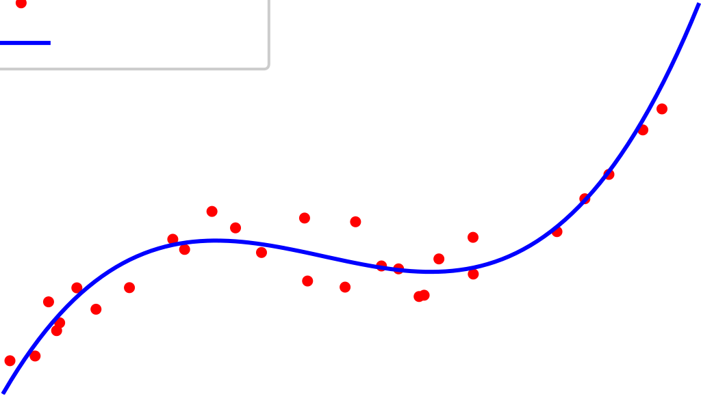

Ifwedefinethem × nmatrixAwithentriesakj=ϕj(tk)andm-vectorb=(y1, . . . , ym)T, thentheabovedata-fittingproblemtakestheform
c∈Rn ∥Ac −b∥2.
Inthecasewheretheapproximationspaceisthespaceofpolynomials(withbasis {1, t, . . . , tn−1},oranyotherbasis),theproblemisknownaspolynomialcurvefitting.A schematicofacubiccurvefitting(n = 4)isillustratedinFigure1.
y | data points  polynomial fit
t
Figure1:Aleastsquarespolynomialfittoagivendataset
The special case with basis {1, t} is refereed to as linear curve fitting or linear regression.As anexample,tofindacubicfitp3(t) = c1 + c2t + c3t2+ c4t3tosixpoints(t1, y1), . . . , (t6, y6) thematrixAis6 × 4andtheproblemhastheform
Ac = | 1 | t1 | t2 1 | t3 1 |  | c1 |  | ∼= | y1 |  | = b.
 | 1 1 1 1 1 | t2 |  |  |  |  |  |  | y4  y5 y2  y3  y6 | 
 |  |  | t2 2 | t3 2
 |  | t3 |  |  |  | c3 c2  c4 | 
 |  |  | t2 3 | t3 3
 |  | t4
 |  |  | t2 4 | t3 4
 |  | t5
 |  |  | t2 5 | t3 5
 |  | t6
 |  |  | t2 6 | t3 6
ThematrixAhereisaVandemondematrixwhichwillbeineffectivelyill-conditionedfor higherorderpolynomialcurvefittings.
1.1 Existenceanduniqueness
Assumethaty=Axsoy∈range(A).Thefunctionf(y)=∥b −y∥2iscontinuousand coerciveonRm,soithasatleastaminimumontheclosedandunboundedsetrange(A). Moreover,fisstrictlyconvexontheconvexsetrange(A),sotheminimumvectoryisunique. Itdoesnotmeanthatthesolutionxoftheleastsquareproblem(1.1)isuniqueingeneral. Supposexandexaretwosolutionsfortheleastsquareproblemandz=x −ex.ThenAz=0
3

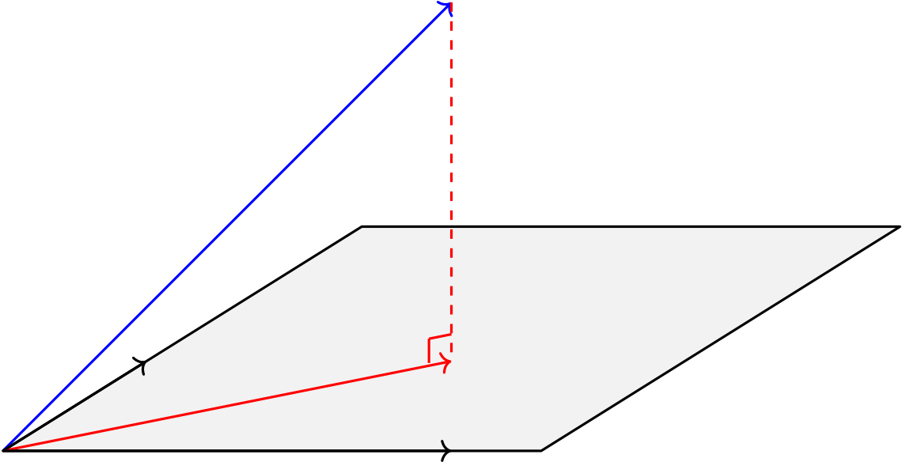
becauseAx=Aex.IfthecolumnsofAarelinearlyindependentthenz=0andx=ex.We concludethatifAhasfullcolumnrank,i.e.,rank(A)=nthenthesolutionofleastsquares problem is unique (the inverse is also true).If rank(A) < n, then A is said to be rank-deficient.
1.2 Normalequations
Tofindthesolutionoftheleastsquaresproblem(1.1),wedefinethen-variatefunction f: Rn→Rby
f(x) := ∥Ax −b∥2 2= (Ax −b)T(Ax −b) = xTATAx −2xTATb + bTb
andaimtominimizeitonRn.Thefunctionfisquadratic,andanecessaryconditionfora minimizerxisthat∇f(x) = 0,i.e.,2ATAx −2ATb = 0.Therefore,anyminimizeroffshould satisfy
ATAx = ATb. (1.2) TheHessianoffis2ATA,whichissemi-positivedefiniteingeneral.However,ifthecolumns ofAarelinearlyindependent(meaningAhasfullrank),thenATAispositivedefinite(you should prove this!).In this case, (1.2) becomes a sufficient condition as well.The linear system (1.2) is known as the system of normalequations and suggests a method for solving the least squaresproblem.However,itisadvisabletoavoiditinfavorofothercomputationallymore stablealgorithms,aswewilldescribelater.
b
a·2 Ax
a·1
Figure2:Geometricinterpretationoftheleastsquaresproblem.
Anotherapproach,equivalentwithonewederivedabove,isasbelow.ThevectorAx= x1a·1 + · · · + xna·noutofsubspacerange(A)closesttobintheEuclideannormoccurswhen the residual vector b−Ax is perpendicular to range(A).See Figure 2.Thus, the inner product ofb −AxandanycolumnofAshouldbezero,equivalently
AT(b −Ax) = 0
whichisthesamesystemofnormalequations(1.2).
4

Example1.3.ReturningtoExample1.1,sinceAhasfullrank,wecanobtaintheleast
squaressolutionbysolvingthenormalsystemATA = ATb.Wehave
ATA = |  | 3 | −1 | −1 | ATb = | −651
 | −1  −1 |  | 3 | −1 3, |  |  | 2177 | 
 |  |  | −1 |  |  |  | 4069
Since matrix ATA is positive definite, the solution of the normal system can be obtained by
theCholeskyfactorizationATA = LLTwhereLisalowertriangularmatrix.Wetherefore
needtosolvetwotriangularsystemsLz=ATb(lowertriangular)andLTx=z(upper
triangular)usingforwardandbackwardsubstitutionsforfinalsolutionx.InPythonwrite
importnumpyasnp

importscipyassp

A=np.array([[1,0,0],[0,1,0],[0,0,1],[-1,1,0],[-1,0,1],[0,-1,1]])

b=np.array([1237,1941,2417,711,1177,475])
L=np.linalg.cholesky(A.T@A) | #Choleskyfactorization

z=sp.linalg.solve_triangular(L,A.T@b,lower=True)#forward
x=sp.linalg.solve_triangular(L.T,z,lower=False) | #backward

print(’Hillheights=’,x)
Thefinalsolutionwillbex=[1236, 1943, 2416]T.Fromacomputationalpointofview,
thenormalequationiseffectiveforsolvingthissmall-sizedleastsquaressystem.However,
inpracticalscenariosandforlargermatrixsizes,solvingthroughthenormalequationis
stronglydiscouraged,aswewilldiscussitlater.
1.3 Conditioningoftheleastsquaresproblem
The conditioning of linear system Ax = b for a square and nonsingular matrix A is measured
bytheconditionnumber
cond(A) = ∥A∥∥A−1∥.
FortheoverdeterminedsystemAx∼=b,however,theinverseofAcannotbedefinedinthe
conventional sense, but it is possible to define a pseudoinverse or Moore–Penroseinverse,
denotedbyA+,thatbehaveslikeaninverseinmanyrespects1.ThepseudoinverseA+exists
foranymatrixA,inparticular,whenAhaslinearlyindependentcolumnsthen
A+= (ATA)−1AT
which is indeed a left inverse because A+A = I.On the other hand, P:= AA+is an orthogonal
projectorontorange(A),sothatthesolutionoftheleastsquaresproblemcanbewrittenas
1SuchdefinitionofinversematrixwasindependentlydescribedbyE.H.Moorein1920,ArneBjerhammar
in 1951,and Roger Penrose in 1955.Earlier,Erik Ivar Fredholm had introduced the concept of a pseudoinverse
ofintegraloperatorsin1903.
5

x = A+b.
InSection4,weexplorehowthepseudoinversecanbecomputedforanymatrixAusingthe SVD.Now,foramatrixA∈Rm×nwithm⩾nandrank(A)=n,theconditionnumberis definedas
cond2(A) := ∥A∥2∥A+∥2.
Thisdefinitionremainsvalidevenifrank(A) < n,providedthatwecancomputeA+.
WhiletheconditioningofasquaresystemdependssolelyonA,theconditioningofaleast squaresproblemAx∼= breliesonboththecoefficientmatrixAandtheright-handsidevector b.In fact, the closeness of b to range(A) will affect the conditioning.From Figure 2 we observe
∥Ax∥2 | = cos θ,
∥b∥2
where θ is the angle between Ax and b.To measure the sensitivity of the least squares solution to input perturbations, we consider perturbations in b and A separately.For the perturbed vector b+δthe least squares solution x+ε is given by the normal equation as ATA(x+ε) = AT(b+δ).
CombiningwithATAx = ATbyieldsATAε = ATδorε = A+δ.Thisgives
∥ε∥2⩽∥A+∥2∥δ∥2.
Dividingbothsidesby∥x∥thenyields
∥ε∥2 | ⩽∥A+∥ | ∥δ∥2
∥x∥2 | 2 | ∥x∥2
 | = cond(A) |  | ∥b∥2 |  |  | ∥δ∥2
 |  |  | ∥A∥2∥x∥2 |  |  | ∥b∥2
 | ⩽cond(A)∥b∥2∥Ax∥2 |  |  |  | ∥δ∥2
 |  |  |  |  | ∥b∥2
 | = cond(A) |  | 1 | ∥δ∥2 |  | .
 |  |  | cos θ | ∥b∥2
Weobservethattheconditionnumberfortheleastsquaressolutionxwithrespecttopertur-bationsinbdependsonbothcond(A)andtheangleθbetweenbandAx.Inparticular,the conditionnumberisapproximatelycond(A)whentheresidualissmall(cos θ≈1),however,it canbearbitrarilyworsethancond(A)whentheresidualislarge(cos θ≈0).
Workout1.1.Assumethattheperturbedleastsquaressolutionx + εisobtainedbyper-

turbingtheinputmatrixA + E,whiletheright-handsidevectorbremainsunchanged.
Showthat | ∥ε∥2 | ⩽ | [cond(A)]2tan θ + cond(A) | ϵ+ O(ϵ2 ) | (1.3)
 | ∥x∥2 |  |  | A A
whereϵA=∥E∥2∥A∥2.Concludethattheconditionnumberisapproximatelycond(A)whenthe

residualissmall.However,theconditionnumberissquaredforamoderateresidual,andit

becomesarbitrarilylargewhentheresidualislarge.
6

Themoststrikingfeatureof(1.3)isthat it depends on the square of cond(A).This implies that even if A is only mildly ill-conditioned, a small perturbation in A can cause a large change inx.Anexceptionoccursinproblemswheretheleastsquaressolutionfitsthedataverywell, i.e.,tan θ≈0,causingthefactor[cond(A)]2tocancelout.
Example1.4.LetusagainconsidertheheightmeasurementsofhillsinExample1.1with theleastsquaressolutionx = [1236, 1943, 2416]T.ThepseudoinverseofAisgivenby
A+= (ATA)−1AT=1 4 | 2 | 1 | 1 | −1 | −1 | 0 | 
 | 1  1 | 2 | 2 | 1 | 0 | −1 1.
 |  | 1 | 2 | 0 | 1
Wehave∥A∥2= 2and∥A+∥2= 1,sothat
cond(A) = ∥A∥2∥A+∥2= 2.
Ontheotherside,theratioiscomputedas
cos θ=∥Ax∥2 ∥b∥2 | .=3640.8761 3640.8809 | .= 0.99999868,
Hence,theanglebetweenAxandbisthesmallvalueθ=0.001625,indicatingthatthe normoftheresidualr=b −Axisverysmall.Giventhesmallconditionnumberandthe angleθ,wecanconcludethatthisparticularleastsquaresproblemiswell-conditioned.
Example1.5.Consideraleastsquaresproblemwithcoefficientmatrix
A = | 1 | 1 | 
 | 0ϵ | −ϵ0
and right-hand side vector b = [1, 0, ϵ]T, where ϵ > 0 is a small parameter.The pseudoinverse ofAiscomputedas
A+=1  2 |   1 1 | 1 | 0  0.  √  21  ϵ√2=1ϵ,
 |  | ϵ
 |  | −1ϵ
TheconditionnumberofAis
cond(A) = ∥A∥2∥A+∥2=
and the least squares solution is given by x = A+b = [1/2, 1/2]T.Assume a tiny perturbation
E= |  | 0 | 0
 | −ϵ0 |  | 0ϵ
formatrixA.Theperturbedsolutionthenisobtainedas
1 | 1 | 1 | −1 |  | 1 |  | 1 | 
x + ε = (A + E)+b = 2 | 1 | 2ϵ | 2ϵ |  | 0= |  | 4 | ,
 |  | −1 | 1 |  |  |  | 3
 |  | 2ϵ | 2ϵ |  |  ϵ  |  | 4
7

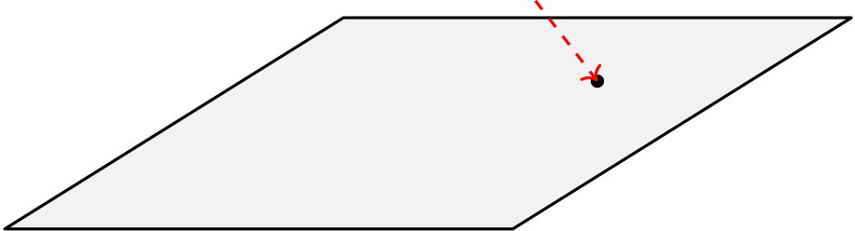
whichshowsthatε=[−1/4, 1/4]and ∥x∥2=1/2.Wecanobservethislargeerrorfrom ∥ε∥2
√
stabilitybound(1.3).Wehave∥E∥2∥A∥2=ϵ√2=ϵ,andθ=cos−1∥Ax∥2∥b∥2=cos−1√1+ϵ2≈0for 1
smallvaluesofϵ.Therefore,thetermwiththesquaredconditionnumberintheright-hand
sideof(1.3)becomesnegligible.Consequently,theboundontheoutputperturbation∥ε∥2∥x∥2
issolelydeterminedbycond(A)∥E∥2∥A∥2= 1,whichalignswiththeexactvalueof∥ε∥2∥x∥2.
Now,letuschangetheright-handsidetob = [1, 0, 1]T.Forthiscase,wehave
x = A+b = |  |  |  | 1 |  |  |  | −1 | 
 |  |  |  | 2 | , | x + ε = (A + E)+b = |  | 2 4ϵ | ,
 |  |  |  | 1 |  |  |  | +1
 |  |  |  | 2 |  |  |  | 2 4ϵ
and∥ε∥2∥x∥2= | 2ϵ.Therelativeperturbationinthesolutionisapproximately[cond(A)]2 ∥E∥2∥A∥2.
Inthiscase,θ=cos−1 |  | √1  2=π4,andtan θ=1,indicatingthatthecondition-squaredterm
intheperturbationboundisnotsuppressed.Asaresult,thesolutionishighlysensitiveto perturbations.
2 Projectors*
In Figure 2 we observed that the vector y= Ax ∈range(A) closest to b in the 2-norm is the orthogonal projection of b onto range(A).This observation leads to an algebraic characterization ofleastsquaressolutionsviathenotionofprojectors2.
Definition2.1.AprojectorisasquarematrixPthatsatisfies

P2= P.
v
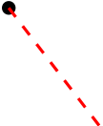
Pv
range(P)
Figure3:Anon-orthogonalprojector
Thisdefinitionincludesbothorthogonalandnonorthogonalprojectors.InFigure3,the vectorv∈R3isprojected(nonorthogonal)totwo-dimensionalsubspacerange(P).Inthis figure, Pv is the shadow projected by vector v if one shines a light from the north-west direction ontothesubspacerange(P).Itisclearthatifv∈range(P)thenPv=v(i.e.vliesexactly onitsownshadow).Infact,ifv∈range(P)thenthereexistsavectorxsuchthatv=Px andPv=P2x=Px=v.WealsoobservefromthefigurethatifPv̸=vthenthedirection inwhichthelightshinesisPv −v.ApplyingPonthelightdirectionweobtain
P(Pv −v) = P2v −Pv= Pv −Pv= 0
2Thereadercanskipthissection,asthefollowingsectionsareindependentofitscontent.
8

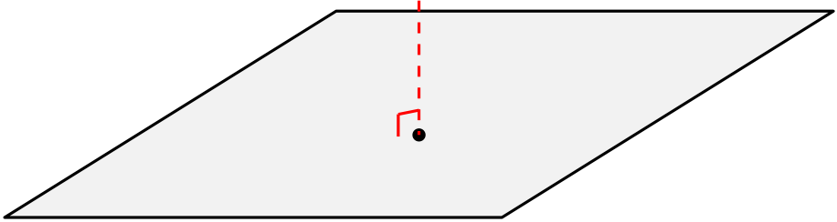

whichmeansPv−v∈null(P). describedbyavectorinnull(P).

Thedirectionofthelightdependsonvbutitisalways

IfPisaprojectorthen(I−P)2= I−2P+ P2= I−Pwhichmeansthat(I−P)isalso aprojector.ItiscalledthecomplementaryprojectortoP.ThematrixI−Pprojectsonto range(I−P)orequivalentlyontonull(P)because:
Lemma2.2.IfPisaprojectorthenrange(I−P) = null(P)andnull(I−P) = range(P).
Proof. | Ifv∈null(P)thenPv=0so(I−P)v=vwhichmeansv∈range(I−P).
Conversely,foranyv,wehave(I−P)v= v −Pv∈null(P).BywritingP= I−(I−P)we
derivethecomplementaryfactnull(I−P) = range(P). | ■

Lemma2.3.IfPisaprojectorthenrange(P) ∩null(P) = {0}.
Proof.Anyvectorvinbothsetsnull(I−P)andnull(P)satisfiesv −Pv= 0andPv= 0 whichgivesv= 0.So,null(I −P) ∩null(P) = {0}.ThentheresultfollowsbyLemma2.2.■
WeconcludethatanyprojectorP∈Rm×mseparatesRmintotwospacesrange(P)and null(P) in the sense that any vector v∈Rmcan be decomposed to v= x+y where x ∈range(P) and y∈null(P).Indeed x = Pvand y= (I −P)vbecause v= Pv +(I −P)v.In this scenario wemaywrite
Rm= range(P) + null(P).
Conversely,ifS1andS2aretwosubspacesofRmsuchthatS1 ∩S2={0}andRm=S1 + S2 thenthereisaprojectorPsuchthatrange(P)=S1andnull(P)=S2.WesaythatPisthe projectorontoS1alongS2.
Definition2.4.AprojectorPiscalledanorthogonalprojectorifitissymmetric,i.e.

P= PT.
InFigure4anorthogonalprojectionisillustrated.
range(P) |  | v
 |  | Pv
Figure4:Anorthogonalprojection
ForanorthogonalprojectorPthesubspacesrange(P)andnull(P)areorthogonalbecause theinnerproductbetweenavectorPx∈range(P)andavector(I−P)y∈range(I−P)= null(P)iszero:
(Px)T(I−P)y= xTPT(I−P)y= xTP(I−P)y= xT(P−P2)y= 0.
9

WeusethenotationsP⊥:=(I−P)andrange(P)⊥:=null(P).Anyvectorv∈Rmthencan beexpressedasthesum
v= (P+ (I−P))v= Pv + P⊥v
ofmutuallyorthogonalvectorsoneinrange(P)andtheotherinrange(P)⊥.Wealsohavethe Pythagoreanrelation(proveit!)
∥v∥2 2= ∥Pv∥2 2+ ∥P⊥v∥2 2.
Thisconceptcanbeappliedtofindthesolutionoftheleastsquareproblem(1.1).IfPis anorthogonalprojectortorange(A)(findPsuchthatrange(P) = range(A))thenwehave ∥b −Ax∥2 2= ∥P(b −Ax) + P⊥(b −Ax)∥2
= ∥P(b −Ax)∥2 2+ ∥P⊥(b −Ax)∥2 (2.1)
= ∥Pb −Ax∥2 2+ ∥P⊥b)∥2 2.
ThelastequalitysatisfiesbecausePA = AandP⊥A = 0.Sincethesecondnormontheright doesnotdependonx,theresidualisminimizedbyminimizingthefirstnorm.Butthefirst norm is minimized by the ideal solution x satisfying the overdetermined, but consistent system
Ax = Pb. (2.2)
Iffact,suchxexistsbecausePb∈range(P)=range(A).IfwemultiplybothsidesbyATwe haveATAx = ATPb = ATPTb = (PA)Tb = ATbgiving
ATAx = ATb,
whichisthenormalequationwealreadyderived.Thenorm∥P⊥b)∥2in(2.1)isthenormof residualoftheleastsquaressolution.
HowcanweconstructtheprojectionPexplicitly?IfAisafull-rankmatrixthenATAis nonsingularand
P:= A(ATA)−1AT
is an orthogonal projector to range(A).Because it is symmetric and idempotent and range(P) = range(A)(prove!).Thismeansthatthevectory∈range(A)closesttobis
˜b = Pb = A(ATA)−1AT= Ax
wherexisthesolutionofleastsquaresproblemgivenbythenormalequation.Wecanwrite basasum
b = Pb + P⊥b = Ax + (b −Ax) = ˜b + r
oftwomutualorthogonalvectors ˜b ∈range(A)andr∈range(A)⊥.
Example2.1.ConsiderExamples1.1and1.3.Forsolutionx=[1236, 1943, 2416]T,the reminderis
r= b −Ax = [1, −2, 1, 4, −3, 2]T
whichisorthogonaltoallcolumnsofA,i.e.,ATr=0.Theorthogonalprojectoronto
10

range(A)is
P= A(ATA)−1AT=1 4 |  | 2 | 1 | 1 | −1 | −1 | 0 | 
 | −1−1 0  1  1 |  | 2 | 1 | 1 | 0 | −1 1 2  −1  1
 |  |  | 1 | 2 | 0 | 1
 |  |  | 1 | 0 | 2 | 1
 |  |  | 0 | 1 | 1 | 2
 |  |  | −1 | 1 | −1 | 1
andtheorthogonalprojectorontorange(A)⊥is
P⊥= I−P=1 4 |  | 2 | −1 | −1 | 1 | 1 | 0 |  | ,
 | 1 1 0  −1−1 |  | 2 | −1 | −1 | 0 | −1 1  21  −1
 |  |  | −1 | 2 | 0 | −1
 |  |  | −1 | 0 | 2 | −1
 |  |  | 0 | −1 | −1 | 2
 |  |  | 1 | −1 | 1 | −1
sothatb = Pb + P⊥b = ˜b + r.
AnalternativewaytodefinePistoletQ∈Rm×nbeamatrixwhosecolumnsforman orthonormalbasis(i.e.,QTQ = I)forrange(A).Then
P:= QQT
issymmetricandidempotent,soitisanorthogonalprojectorontorange(Q)=range(A). Thenfrom(2.2)wehaveAx=QQTb.MultiplyingbothsidesbyQTgivesthesquaresystem QTAx = QTb.WewillseelaterhowtocomputethematrixQinsuchawaythatthissystem isuppertriangularandthereforeeasytosolve.
3 OrthogonalityandQRfactorization
Fromseveralpointsofview,itisadvantageoustouseorthogonalvectorsasbasisvectors
inavectorspace.Asanapplication,wewillobtainanstablealgorithmforsolvingtheleast
squaresproblemwhenaspecificorthogonalbasisisobtainedforthesubspacerange(A). WeremindthattwononzerovectorsxandyarecalledorthogonalifxTy= 0.
Workout3.1.If vectors qj, j= 1, 2, . . . , m are mutually orthogonal, i.e.qT jqk= 0 for j̸= k,

thentheyarelinearlyindependent.
Ifthesetoforthogonalvectorsqj∈Rm,j=1, 2, . . . , m,benormalizedby∥qj∥2=1then theyarecalledorthonormal,andformanorthonormalbasisforRm.
Definition3.2.Asquarematrixwhosecolumnsareorthonormaliscalledanorthogonal

matrix.
11

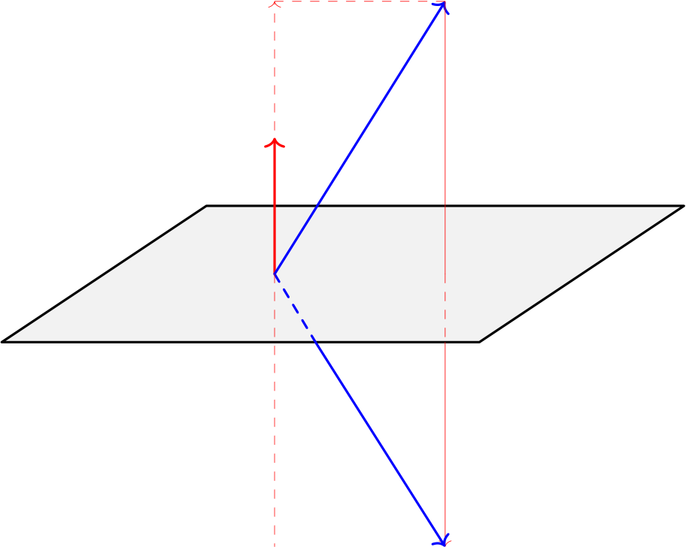
ItisclearthatanorthogonalmatrixQsatisfiesQTQ=I,itisfullrank,anditsinverseis equaltoQ−1= QT.Therowsofanorthogonalmatrixareorthogonal,i.e.,QQT= I.Itisnot difficulttoshowthattheproductoftwoorthogonalmatricesisorthogonal.
One of the most important properties of orthogonal matrices is that they preserve the length (Euclidiannorm)ofavector:
∥Qx∥2 2= (Qx)TQx = xTQTQx = xTx = ∥x∥2 2.
ThismeansthatQrotatesxbutdoesnotchangeitslength.Innumericalpointofview,this norm-preservingpropertymeansthatorthogonalmatricesdonotamplifyerrors.
Workout3.3.Showthatorthogonalmatricespreservethe2-normandtheFrobeniusnorm

ofmatrices.
Hereweintroducetwoclassesofelementaryorthogonalmatricesthatwillbeusedinthe sequeltotransferthecolumnsofanarbitrarymatrixAintoansetoforthonormalbases.
3.1 Householdertransformations
Inthissection,weconsiderHouseholdertransformationsasaclassoforthogonalmatrices, whichareparticularlyusefulforperformingreflectionsandorthogonalprojectionsinmatrix computations.ThewewillusethemtocomputetheQRfactorizationofamatrix.
Definition3.4.Amatrixoftheform
H= I− | 2  uTuuuT | (3.1)
where u is a non-zero vector in Rnis called a Householder matrix or a Householdertrans-

formationa.The vector u determining the Householder matrix His called the Householder

vector.

aAfterthecelebratednumericalanalystAlstonScottHouseholder(5May1904–4July1993)
x
u
U
w= x −2uuTx = Hx
Figure5:GeometricinterpretationofHouseholdertransformation
12

SeeFigure5forageometricinterpretationofaHouseholdertransformation.Inthefigure thevectoruisassumedtobeanormalvector(uTu=1)ofplaneU.Thevectorw=Hxis thereflectionofxwithrespecttoplaneU.Theplaneactsasamirror;thereasonwhythe Householdertransformationisalsoknownaselementaryreflector.
ThefollowingpropertiescanbesimplyprovedforaHouseholdertransformation.
Theorem3.5.LetH= I−2uuT/uTubeaHouseholdermatrixwithvectoru ∈Rn.Then

1.Hissymmetricandorthogonal.

2.H2= I

3.Hu = −u

4.Hv= vifuTv= 0

5.Ifx, y∈Rnaresuchthatx̸=yand∥x∥2=∥y∥2,anduischosenparalleltox −y

thenHx = y.
Proof.Weonlyproveitem(5)becauseotheritemsareeasytoprove.Letu = c(x −y)for aconstantc̸ = 0,andwritex =1 2(x + y) +1 2(x −y).Then
Hx =1 2H(x + y) +1 2H(x −y).
Byusingproperty(3)wehaveH(x −y) = −(x −y).Ontheotherhand(x + y)isorthogonal to x−ybecause (x+y)T(x−y) = xTx−xTy+yTx−yTy= ∥x∥2 −∥y∥2= 0.Thus by property (4)wehaveH(x + y) = x + y.AllthesetogethergiveHx = y. ■
Remark3.1.Properties(3)and(4)showthatHhasn −1eigenvalues1andasimple eigenvalue−1(correspondingtoeigenvectoru).
Theorem3.6.Givenanonzerovectorx̸=e·1:=[1, 0, . . . , 0]T,theHouseholdermatrixH

definebyu = x ± ∥x∥2e·1issuchthatHx = ∓∥x∥2e·1.(Takecareofsigns±and∓).
Proof.Thisisasimpleconsequenceofitem(5)ofTheorem3.5bylettingy= ∓∥x∥2e·1.■Hereisanillustration(α = ∓∥x∥2):
x = |  | x1 |  | =⇒ | Hx = | α
 |  |  |  |  |  |  | 0 |                   
x2
x3
...

xn
 |  |  |  |  |  |  | 0
 |  |  |  |  |  |  | ...
 |  |  |  |  |  |  | 0
Giventhevectorx,wefindareflectionmatrixH(themirror)suchthatHx = αe·1(reflect xonx1-axis).SeeFigure6below.
13

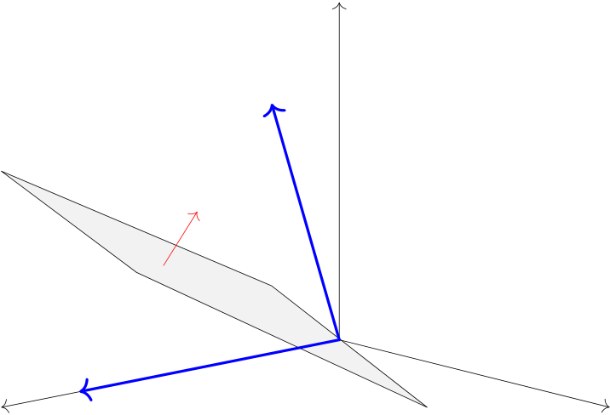
x
u
α
Hx = αe·1= |  | 0 | 
 |  | 0
Figure6:ThemirrorHreflectsxonx1-axis.Thenormalvectoruischosenparalleltox −αe·1.
Theorem3.6workswithbothnegativeandpositivesigns.However,toavoidcancelation
errorsincomputingthefirstcomponentofu,onecangetridofsubtractionatallbychoosing
sign(x1)inplaceof±.WealwaysformthematrixHviavector
u = x + sign(x1)∥x∥2e·1, withsign(0) = +.
Here we discuss how the computational costs of matrix-vector and matrix-matrix multiplica-
tions can be reduced when the matrix is a Householder reflection.The standard matrix-vector
multiplication Hx requires 2n2flops for a n×n matrix Hand a n-vector x.The matrix-matrix
multiplicationHAforn × mmatrixAcostsfor2mn2flops.However,ifHisaHouseholder
matrix it is not required forming Hexplicitly in favour of working with u directly.In this case,
lettingβ= 2/uTuonecanwrite
Hx = (I−βuuT)x = x −βu(uTx) = x −βγu, γ= uTx,
HA = (I−βuuT)A = A −βu(uTA) = A −βuwT, w= ATu,
AH= A(I−βuuT) = A −β(Au)uT= A −βwuT, w= Au.
Workout3.7.ForaHouseholdermatrixH∈Rn×nverifythattheflop-countsformatrix-

vectorproductHxisabout6n,andmatrix-matrixproductHAforA∈Rn×m(orAHfor

A ∈Rm×n)isabout4mn.Comparewithexplicitmultiplications.
ThefollowingPythoncodecomputesaHouseholdervectoruforagivenvectorx.
defHouseVec(x):

#HouseVec(x)computestheHouseholdervectorusuchthat

#(I-2uu’/u’u)x=|x|_2e_1

n=len(x);u=np.zeros(n)

u[1:]=x[1:]

s=np.sign(x[1])

ifs==0:s=1
14

u[0]=x[0]+s*np.linalg.norm(x,2)

returnu
MultiplicationbyaHouseholdertransformationisimplementedinthefollowingcode:
defHouseProd(u,A):

#HouseProd(u,A)computestheproductofHouseholdermatrix

#(I-2uu’/u’u)bymatrixA

b=2/np.dot(u,u);w=np.matmul(np.transpose(A),u)

HA=A-b*np.outer(u,w)

returnHA
Example3.1.Thefollowingscripttransformsthefirstcolumnofmatrix
A = | 2 | 3 | 5 | 
 | 2  1  1 | 2 | 3 0  −1
 |  | 5
 |  | −1
toamultipleofe·1.Wewrite
A=np.array([[2,3,5],[1,2,-1],[2,5,3],[1,-1,0]])

u=HouseVec(A[:,0])

A=HouseProd(u,A)  print("TransferredA=\n", | np.round(A,4))
andgetthefollowingoutput(roundedto4decimalsplaces):
TransferredA=
[[-3.1623-5.3759 |  |  | -4.7434]
[ | 0. | 0.3775 | -2.8874]
[ | 0. | 1.755 | -0.7749]
[ | 0. | -2.6225 | -1.8874]]
3.2 | Planerotations
Householder transformations are efficient for dense matrices because of a few flops they need.
Inthissectionweintroducetheplanerotationswhichareflexibleandcanbeusedefficiently
forsparsematricesbecausetheyproducezerosentrybyentry.
15

The2 × 2skewsymmetricmatrix
J= |   c−s | s |  | c2+ s2= 1 | (3.2)
 |  |  | ,
 |  | c
isanorthogonalmatrix.Ifc=cos θthenJxisaclockwiserotationofxbyangleθ.So thematrixJisarotationmatrixinthe(1, 2)-plane.SometimesJiscalledGivensrotation after Wallace Givens, who used them for eigenvalue computations around 1960.However, they hadbeenusedlongbeforethatbyJacobiforthesamereason.Letx=(x1, x2)T̸=0and c = x1/∥x∥2ands = x2/∥x∥2then
Jx = | 1 | x1 | x2 |  | x1 |  | ∥x∥2 | 
 |  |  |  |  |  | = |  | .
 | ∥x∥2 | −x2 | x1 |  |   x2 |  |  0 |  | zerositssecond
Inthiscase,therotationmatrixJrotatesxandputsitonx1-axis,i.e.
component.Byembeddinga2 × 2rotationinalargeridentitymatrix,onecanmanipulate vectorsandmatricesofarbitrarydimensions.
 | q x2 3+ x2 5̸=0.
Example3.2.Letx=(x1, x2, x3, x4, x5)Tbegivensuchthatα= |  | Let
c = x3/αands = x5/α.Thenwehave
1 | 0 | 0 | 0 | 0 | x1 |  | = | x1 |  | .
0 0 0  0 | 1 | 0 | 0 | 0  s  c0 | x3  x4 x2  x5 |  |  | x4α  0  x2 | 
 | 0 | c | 0
 | 0 | 0 | 1
 | 0 | −s | 0
Infactthismatrixisarotationmatrixin(3, 5)-planewhichchangesx5to0,x3toαand leavesothercomponentsunchanged.
Using this idea we can construct a sequence of plane rotations to transfer an arbitrary vector x∈Rmtoamultipleofunitvectore·1=[1, 0, . . . , 0]T∈Rm.Lettherotationmatrixinthe
(j, k)-planewhenapplyingonvectorxwithc=xj/αands=xk/αforα= | q x2 j+ x2 kbe
denotedbyJ(j, k).Thenitiseasytoshowthat
J(1, 2)J(1, 3) · · · J(1, m) |  |  | x = ∥x∥2e·1
| | {z G | }
WenotethatanyrotationmatrixJ(j, k)withj< kcanbeusedinsteadofJ(1, k)matrices.
Remark3.2.Possibleoverflowandunderflowincomputingc=x1/ q x2 1+ x2 2ands=
x2/ q x2 1+ x2 2canbeavoidedbyanappropriatescaling.If|x1| ≥|x2|weput
√
t = x2/x1, c = 1/ 1 + t2, s = c · t,
andif|x1| < |x2|, | t = x1/x2, | √  s = 1/ 1 + t2, | c = s · t.
Ineithercase,wecanavoidsquaringanymagnitudelargerthan1.
IfanelementaryplanerotationJ(j, k),withc=ajℓ/ q a2 jℓ+ a2 kℓands=akℓ/ q a2 jℓ+ a2 kℓis
16

appliedonamatrixAwithentriesajℓthenthe(k, ℓ)entryofAbecomeszeroifk>j.It
isimportanttonotethatonlytworowsjandkofthematrixarechanged.Thisshouldbe
takenintoaccountinprogramming.Insteadofexplicitlyembeddingthe2 × 2rotationmatrix
into a matrix of larger dimension,which would require unnecessary computations,we can save
operationsandstoragebyimplementingtherotationmoreefficiently.HerearetwoPython
functionsthatillustratehowtoimplementtherotationwhileminimizingcomputationalcosts.
IntheGivensProdfunctionweonlyoperateontworowsofmatrixA.
defGivensPar(x,y):

#GivensPar(x,y)computesGivensparameterstomakethesecond

#componentof[x,y]zero

ifabs(x)>abs(y):

t=y/x;c=1/np.sqrt(1+t**2);s=c*t

else:

t=x/y;s=1/np.sqrt(1+t**2);c=s*t

returnc,s

defGivensProd(c,s,j,k,A):

#GivensProd(c,s,j,k,A)appliesa(j,k)-planerotationtomatrixA

A[[j,k],:]=np.matmul([[c,s],[-s,c]],A[[j,k],:])

returnA
Example3.3.Thefollowingscripttransformsthefirstcolumnofmatrix
A = | 2 | 3 | 5 | 
 | 2  1  1 | 2 | 3 0  −1
 |  | 5
 |  | −1
toamultipleofe·1.ConsiderthematrixAinExample3.1.WeuseGivensrotationsto
transferAintoanewmatrixthatallthecomponentsofitsfirstcolumnexceptthefirstare
annihilated.
A=np.array([[2,3,5],[1,2,-1],[2,5,3],[1,-1,0]])

print("OriginalA=\n",A)

forkinrange(3,0,-1):

c,s=GivensPar(A[0,0],A[k,0])

A=GivensProd(c,s,0,k,A)
print("TransferredA=\n", | np.round(A,4))
Theoutputwithroundingtofourdecimalplaces:
17

OriginalA=
[[2. | 3. | 5.]
[1. | 2.-1.]
[2. | 5. | 3.]
[1.-1. |  | 0.]]

TransferredA=
[[3.16235.3759 |  | 4.7434]
[0. | 0.3162-2.6352]
[0. | 2.2361-0.7454]
[0. | -2.2361-2.2361]]
ComparingwiththeoutputoftheHouseholdertransformation(Example3.1),weobserve thatGAisnotnecessarilyidenticalwithHA.However,inbothcasesAistransferredtoa matrixwithzerosunderitsa11entry.
ForasinglecallthecostoffunctionGivensParis6flops,andforamatrixA∈Rm×nthe totalnumberofflopsinGivensProdis6n(multiplyinga2 × 2matrixbya2 × nmatrix.) Tozeroalloff-diagonalentriesofthefirstcolumnofamatrixA∈Rm×n,bothfunctions GivensParandGivensProdshouldbecalledinam −1foldsloop.Thetotalcostisthus (m −1)(6n + 6) ≈6mnflops.
3.3 QRfactorization
Matrixdecompositionsareessential,givingrisetofastandefficientalgorithmsinmatrix computations.StudentsaretypicallyfamiliarwithLUdecompositions(orGaussianelimina-tion),whichfactorizeamatrixAintoalowertriangularmatrixLmultipliedbyanupper triangular matrix U, or its other variant LLTfor positive definite matrices.Here, we introduce anotherusefulfactorizationwithnumerousapplicationsinefficientlinearalgebraalgorithms.
Theorem3.8.EverymatrixA ∈Rm×nwithm ⩾n(overdetermined)canbefactorizedas

A = QR

whereQisam × morthogonalmatrixandRisam × nuppertriangularmatrix.
× | × | × |  | × |  | × | × | × | × | × |  | × | ×
×    ×    ×    × | × | ×  × | = |  | ×  ×  ×  × | × | × | × | ×  ×  ×  × |  | 0 | × | ×    ×    0    0
 | × |  |  |  |  | × | × | × |  |  | 0 | 0
 | × | ×      × |  |  |  | × | × | × |  |  | 0 | 0
 | × |  |  |  |  | × | × | × |  |  | 0 | 0
A |  | Q |  |  |  |  |  | R
Hereisanillustrationforacasewithm = 5andn = 3.
18

Inthenextsectionwegivea“constructive”proofforthistheoremusingHouseholderre-flections.Byconstructivewemeanthattheproofalsosuggestsanalgorithmtocomputethe QandRfactors.
Asweobserve,thelastm −nrowsofRarezerossothelastm −ncolumnsofQhaveno contributiontotheproduct(butarestillimportant!).
× | × | × |  | × | × | × | × | × |  |  | × | × |  | × | 
×   | × | × |  |   × | × | × | × | × |  |  | 0 | × |  | × |     
×   | × | × | = |   × | × | × | × | × |  |  | 0 | 0 |  | × |     
×   | × | × |  |   × | × | × | × | × |  |  | 0 | 0 |  | 0 |     
× | × | × |  |   × | × | × | × | × |  |  | 0 | 0 |  | 0 | 
 | A |  | = | [ | Q1 |  | Q2] |  |  |  |  |   R1 0 | 
 |  |  |  |  |  |  |  |  |  |  |  |  | 
ThissuggeststhereducedQRfactorization
A = Q1R1
whichisoftensufficientformanyapplicationswheretheQ2portionisnotneeded.
3.4 QRfactorizationusingHouseholdertransformations
NowweshowhowtheideaofintroducingzerosinavectorusingaHouseholdermatrixcan beusedforcomputingafullQRfactorization
A = QR
ofamatrixA∈Rm×n,m⩾n,whereQ∈Rm×misorthogonalandR∈Rm×nisupper triangular(entriesbelowthemaindiagonalareallzero).Thisprocesswasfirstintroducedby Householderin1958.TheideaistoreduceAtoanuppertriangularmatrixRbysuccessively premultiplyingAwithaseriesoforthogonalHouseholdermatrices.TheproductsofHouse-holdermatricesthenconstitutetheorthogonalmatrixQ.Theprocessisillustratedform = 5 andn = 3:
Step1:
H1A= H1 | × | × | × | = | + |  | + | + | =: A(1)
 | ×  ×  ×  × | × | ×  ×  ×  × |  |  | 0  0  0  0 | + | +  +  +  +
 |  | × |  |  |  |  | +
 |  | × |  |  |  |  | +
 |  | × |  |  |  |  | +
19

Step2:
H2A(1)= H2 | + |  | + | + | = | + |  | + | + |  | =: A(2)
 |  | 0  0  0  0 | + | +  +  +  + |  |  | 0  0  0  0 | ∗ | ∗  ∗  ∗  ∗ | 
 |  |  | + |  |  |  |  | 0
 |  |  | + |  |  |  |  | 0
 |  |  | + |  |  |  |  | 0
Step3:
H3A(2)= H3 | + |  | + | + |  | = | + |  | + | + |  | =: A(3)=: R
 |  | 0  0  0  0 | ∗ | ∗  ∗  ∗  ∗ |  |  |  | 0  0  0  0 | ∗ | ∗  ⋆  0  0 | 
 |  |  | 0 |  |  |  |  |  | 0
 |  |  | 0 |  |  |  |  |  | 0
 |  |  | 0 |  |  |  |  |  | 0
WehaveR=A(3)=H3A(2)=H3H2A(1)=H3H2H1A.IfwedefineQT=H3H2H1then
R = QTA or A = QR where Q = H1H2H3.Remember that Hkare symmetric and orthogonal. ThegeneralcaseA∈Rm×ncanbetreatedsimilarly.LetA=(aij).Inthefirststep,the HouseholdermatrixH1∈Rm×misbuilduponthefirstcolumnofA,i.e.,
x = a= |  | a11 |  | ∈Rm, | u= a−sign(a)e, | H= I− | 2 | uuT .
 |  ...  a2,1  am,1 |  | 
·1 |  |  |  |  | 1·1 11·1 | 1 | uT 1u1 | 1 1
ThenH1Aannihilatesthecomponentsbelowa11.OtherentriesofAarechangedaswell.The
newmatrixisdenotedby
H1A =: A(1) withentriesa(1) ij.
Inthesecondstep,aHouseholdermatrixf H2∈R(m−1)×(m−1)isformedbasedontheentries
from2tomofthesecondcolumnofA(1),i.e.,
x = a(1) = |  | a(1) 22 |  | ∈Rm−1, | u= x −sign(x)e, | H= I− | 2 | uuT∈R(m−1)×(m−1)
 | a(1) 3,2a(1) m,2 ... |  | 
2:m,2 |  |  |  |  | 21·1 | f 2 | uT 2u2 | 2 2
ThentheHouseholdermatrixH2isdefinedby
H2= |   1 0 | 0 | 
 |  |  | ∈Rm×m.
 |  | H2 f
Inthenewmatrix
H2A(1)=: A(2)
theentriesbelowa(2) 22becomezero.FirstrowandfirstcolumnofA(2)areidenticalwiththat ofA(1)duetothespecialstructureofH2initsfirstrowandcolumn.Specially,thezeros
introducedintheperviousstep(inthefirstcolumn)arenotdestroyedinthecurrentstep.
20

Similarly,instepkaHouseholdermatrixf Hk∈R(m−k+1)×(m−k+1)isformedbasedonthe entriesfromktomofthek-thcolumnofA(k−1),i.e.,
x = |  | a(k−1) k,k |  | ∈Rm−k+1, | u= x −sign(x)e, | H= I− | 2 | uuT∈R(m−k+1)×(m−k+1).
 | a(k−1) k+1,ka(k−1) m,k ... |  | 
 |  |  |  |  | k1·1 | f k | uT kuk | k k
ThentheHouseholdermatrixHkisdefinedby
Hk= |   Ik−1 0 | 0 | 
 |  |  | ∈Rm×m,
 |  | Hk f
whereIk−1istheidentitymatrixofsizek −1.Inthenewmatrix
HkA(k−1)=: A(k)
theentriesbelowa(k) kkareallzero.ThefirstblockofHk(theidentityblock)ensuresthatthe firstk −1rowsandcolumnsofA(k−1)remainsunchangedinA(k).Thismeansthatthezeros introduced in all previous steps are not destroyed.For an economic implementation, the matrix-matrixmultiplicationshouldonlybedoneonasubmatrixofA(k−1)ofsize(m −k) × (n −k).
Thisprocessiscontinueduntilstepn.Inthelaststepwemakezerosbelowthediagonalin thelastcolumnofA(n−1)bymultiplyingtheHouseholdermatrixHn:
HnA(n−1)=: A(n).
TheresultingmatrixA(n)isanuppertriangularmatrixofsizem × n,letusdenoteitbyR. Wethushave
R = A(n)= HnA(n−1)= · · · = HnHn−1 · · · H2H1 |  |  | A = QTA
| | QT {z | }
whereQTisanorthogonalmatrixbecauseitistheproductofnorthogonalHouseholder matrices.Wesimplyhave
A = QR
whereQ = (Hn · · · H2H1)T= H1H2 · · · Hn.
Remark3.3(spacecomplexity).Tominimizethestorage,RisstoredoverAintheupper triangularpart.Householdermatricesarenotrequiredtobestoredatall.Insteadthe components2throughendofeachvectorukarestoredintherespectivepositionsofA (insteadofzeros),andthefirstcomponentsofallukvectorsarestoredinanauxiliaryone-dimensional array.The matrix Q, if it is needed explicitly, can be formed in a postprocessing calculationusingthestoredukvectorsinacheapway.SeeWorkout3.9.Wenotethat,in amajorityofpracticalapplications,itissufficienttohaveQinthisfactoredform,andin manyapplications,Qisnotneededatall.
Remark3.4.InstepkofthealgorithmtheentriesofthesubmatrixofAcontainingrowk throughmandcolumnskthroughn,denotedbyA(k:m, k:n),areupdatedandstored
21

overthecorrespondingentriesofAvia
A(k: m, k: n) = (I− | 2 | uuT )A(k: m, k: n)
 | uT kuk | k k | (3.3)
= A(k: m, k: n) −βukuT kA(k: m, k: n).
InaPythoncodeforQRfactorizationinstepkthesubroutineHouseProdcanbecalled
withinputargumentsukandA(k: m, k: n).
Workout3.9.Showthatitrequiresabout2n2(m −n/3)flopstocomputeRintheQR

factorizationofA∈Rm×n,m⩾nusingHouseholdertransformations.Thiscostdoesnot

include the explicit construction of Q.Show that it is required about4 3m3flops to compute

Qexplicitly.
Theprocedureisthesameform<nbutisfinishedafterm −1steps.Inthiscasethe
uppertriangularmatrixRisoftheform[R1R2]whereR1isam × muppertriangularand
R2isafullmatrixofsizem × (n −m).Hereisanillustrationform = 3andn = 5:
× | × | × | × | × | = | × | × | × | × |  | × | × | × | ×
×    × | × | × | × | ×  × |  | ×  × | × | ×  × |  | 0  0 | × | × | × | ×    ×
 | × | × | × |  |  |  | × |  |  |  | 0 | × | ×
 |  | A |  |  |  |  | Q |  |  |  |  | R
ThefollowingPythonfunctioncomputestheQRfactorizationofam × nmatrixA,either
m⩾norm<n.ThecodehandlescaseswhereonlyR,RandukvectorsandbothQand
Raredemanded.InthesecondcaseHouseholdervectorsukarestoredinthelowerdiagonal
partoftheoutputmatrixandinadditionalarrayu1.
defqrfac(A,mode=’Q&R’):

#qrfac(A,mode)computestheQRfactorizationofa(mxn)matrixA

#mode:’R’,’R&u’and’Q&R’.Thedefaultmodeis’Q&R’

m,n=np.shape(A)

s=min(m-1,n)

ifmode==’R’:

forkinrange(s):

u=HouseVec(A[k:,k])

A[k:,k:]=HouseProd(u,A[k:,k:])

returnnp.triu(A)

elifmode==’R&u’:

u1=np.zeros(s)
forkinrange(s):
22

u=HouseVec(A[k:,k])
A[k:,k:]=HouseProd(u,A[k:,k:])

A[(k+1):,k]=u[1:]

u1[k]=u[0];

returnA,u1

elifmode==’Q&R’:

A,u=qrfac(A,’R&u’)

Q=np.eye(m)

forkinrange(s):

Q[k:,:]=HouseProd(np.append(u[k],A[(k+1):,k]),Q[k:,:])

returnnp.transpose(Q),np.triu(A)

else:

3.5 | print("Inputmodetypes’R’,’R&u’or’Q&R’")  QRfactorizationusingGivensrotations
TheQRfactorizationofamatrixA∈Rm×ncanalsobesimplyobtainedusingGivens
rotationsins = min{m −1, n}stepsasbelow:
-Step1:formanorthogonalmatrixG1=J(1, m)J(1, m −1) · · · J(1, 2)suchthatA(1)=
G1Ahaszerosbelowits(1, 1)entryinthefirstcolumn.
-Step2:formanorthogonalmatrixG2=J(2, m)J(2, m −1) · · · J(2, 3)suchthatA(2)=
G2A(1)haszerosbelowits(2, 2)entryinthesecondcolumn.
...
-Stepk:formanorthogonalmatrixGk=J(k, m)J(k, m −1) · · · J(k, k+ 1)suchthat
A(k)= GkA(k−1)haszerosbelowits(k, k)entryinthek-thcolumn.
ThefinalmatrixA(s):= RisuppertriangularandthematrixQ = GT 1GT 2· · · GT sisorthogonal
and
A = QR.
Tooptimizethestorageused,thematrixRisstoredoverA,andQisformedimplicitlyoutof
Givensparameters(forexampleusingPythonfunctionGivensProd).
LabExercise3.10.ImplementaPythonfunctionforQRfactorizationusingGivensrota-

tions.Asktheuserfordifferentmodes.Callyourfunctionforsomematricesandprintthe

outputs.
Remark3.5.The QR factorization with Givens rotations requires 3n2(m−n/3) flops.This
doesnotincludethecomputationofQ. ComparedwiththeHouseholdermethod,this
23

algorithmisabout1.5timesmoreexpensive.HoweverwhenthematrixAissparseorhas aspecialstructurewithlotsofzerosinitslowertriangle,theGivensapproachischeaper. Forexampleinseveralapplications(forexampleineigenvaluecomputation)oneneedsto findtheQRfactorizationofanupperHessenbergmatrix.AnupperHessenbergmatrix issimilartoanuppertriangularmatrixwithadditionalnonzeroelementsonthediagonal rightbelowitsmaindiagonal.SinceanupperHessenbergmatrixA∈Rn×nhasatmost (n −1)nonzerosubdiagonalentries,theQRfactorizationofAcanbeobtainedbyonly (n −1)Givensrotations.Seethefollowingillustrationforn = 4:
× | × | × | × | J(1,2)  −−−→ | × |  | × | × | × | J(2,3)  −−−→ | × |  | × | × | × | J(3,4)  −−−→ | × |  | × | × | ×
×  0  0 | × | × | ×  ×  × |  |  | 0  0  0 | × | × | ×  ×  × |  |  | 0  0  0 | × | × | ×  ×  × |  |  | 0  0  0 | × | × | ×  ×  ×
 | × | × |  |  |  |  | × | × |  |  |  |  | 0 | × |  |  |  |  | 0 | ×
 | 0 | × |  |  |  |  | 0 | × |  |  |  |  | 0 | × |  |  |  |  | 0 | 0
Remark3.6.ItwasshownbyWilkinsonin1965thatthecomputedbQandbRwithGivens rotationssatisfy
bR =bQT(A + E)
wherethereexistsaconstantcindependentofmandnsuchthat
∥E∥F⩽c∥A∥F.
Thisshowsthatthealgorithmisbackwardstable.
3.6 Otheralgorithms
TheGram-Schmidtalgorithms(classicalandmodifiedversions)arealternativealgorithms forcomputingthethinQRfactorizationofA.See[Trefethen-Bau:1997,Heath:2018].
3.7 QRfactorizationforsolvingtheleastsquaresproblem
Solvingthelinearleastsquaresproblemsusingthenormalequationshastwosignificant drawbacks:(1)FormingATAcanleadtolossofinformation,(2)TheconditionnumberATA isthesquareofthatofA:
cond2(ATA) = [cond2(A)]2.
Weillustratethesepointsinacoupleofexamples.
Example3.4.Let
A = | 1 | 1
 | 0ϵ | 0ϵ
whereϵ > 0isasmallrealnumber.ClearlyAhasfullrankand
ATA = |   1 + ϵ2 1 | 1 | 
 |  | 1 + ϵ2 | 
24

Inthedoubleprecisionfloatingpointarithmeticifweletϵtobesmallerthat10−8then fl(1 + ϵ2) = 1andthecomputedmatrix
fl(ATA) = |   1 1 | 1
 |  | 1
isindeedsingular.
Example3.5.InthematrixAofExample3.4assumeϵ=10−4.Thenwecanshowthat √
cond2(A) = 2 × 104whilecond2(ATA) = 2 × 108.
Inviewofthepotentialnumericaldifficultieswiththenormalequationsapproach,weneed analternativethatdoesnotrequireformationofthenormalsystem.Inthissectionwewill explain the use of QR factorization for this purpose while in the sequel an alternative approach throughSVDwillbediscussed.
Consideragaintheleastsquaresproblem
x∈Rn ∥Ax −b∥2
withoverdeterminedmatrixA∈Rm×n.TheQRfactorizationtransformsthislinearleast squares problem into a triangular least squares problem having the same solution.First assume that A has full rank, i.e., rank(A) = n.Let A = QR be the QR factorization of A and partition
Q = [Q1Q2]whereQ1consistsoffirstncolumnsofQ,andR = |   R1 0 | 
 |  | whereR1∈Rn×nisan
uppertriangularmatrix.InthereducedformA=Q1R1.SinceAhasfullrankalldiagonal entriesofR1arenonzero,soitisnonsingular.Wecanwrite
∥Ax −b∥2 2= ∥QRx −b∥2 2= ∥Rx −QTb∥2 2= |   R1 0 |  |    QT QT 1b  2b   | 2
 |  | x − |  | 2
= ∥R1x −QT 1b∥2 2+ ∥QT 2b∥2 2.
Theminimumisobtainedifthefirstnormontheright-handsideisvanished,i.e.,
R1x = QT 1b.
Since R1is upper triangular and nonsingular, a simple backward substitution with O(n2) flops givestheleastsquaresolutionx.Thereminderthenis
r= ∥Ax −b∥2= ∥QT 2b∥2.
Ifthereminderisnotimportanttous,areducedQRfactorizationisenoughforobtainingthe leastsquaressolution.
Example3.6.ConsideragainExample1.1.Theleastsquaressolutiontoheightmeasure-mentscanbecomputedusingtheQRfactorizationasbelow.
25

importnumpyasnp

A=np.array([[1.,0,0],[0,1.,0],[0,0,1.],[-1.,1.,0],[-1.,0,1.],[0,-1.,1.]])

b=np.array([1237,1941,2417,711,1177,475])

Q,R=qrfac(A)

print(’Q=’,np.round(Q,4),’\nR=’,np.round(R,4))

x=BackSub(R[0:3,:],Q[:,0:3].T@b)

print(’x=’,np.round(x,4))
Notethatwealsocalledthebackwardsubstitutionalgorithmforsolvinguppertriangular
systems using the Python function BackSub.The code for this function is left as an exercise
forthereader.Theoutputsare
Q=[[-0.5774-0.2041-0.3536 |  |  | 0.5113 | 0.4878-0.0235]
[0. | -0.6124-0.3536-0.4878 |  |  | 0.0235 | 0.5113]
[0. | 0. | -0.7071-0.0235-0.5113-0.4878]
[0.5774-0.4082-0. |  |  | 0.6664-0.1786 |  | 0.1551]
[0.5774 | 0.2041-0.3536-0.1551 |  |  | 0.6664-0.1786]
[0. | 0.6124-0.3536 |  | 0.1786-0.1551 |  | 0.6664]]
R=[[-1.7321 | 0.5774 | 0.5774]
[0. | -1.633 | 0.8165]
[0. | 0. | -1.4142]
[0. | 0. | 0. | ]
[0. | 0. | 0. | ]
[0. | 0. | 0. | ]]

x=[1236.1943.2416.]
When A is rank-deficient, i.e., rank(A) < n, the solution of the least squares problem in not
unique;theproblemhasinfinitenumberofsolutions.Inthiscase,theQRfactorizationofA
stillexists,buttheuppertriangularfactorRissingular.Thissituationusuallyarisesfroma
poorly designed experiment, insufficient data, or an inadequate model.If one insists on forging
aheadasis,avariationofQRfactorizationwithcolumnpivoting(nextsection)canbeused
tofindallthesolutions.Seesection4.4foranalternativeapproachviaSVD.Dealingwith
rankdeficiencyalsoenablesustohandleunderdeterminedproblems,wherem<n,sincethe
columnsofAarenecessarilylinearlydependentinthatcase.
3.8 QRfactorizationwithcolumnpivoting
IncomputingtheQRfactorization,ineachsteponecaninterchangethecolumnhaving
themaximumEuclideannorminthesubmatrixwiththepivotcolumn.Thiskindofcolumn
26

pivotingmakescolumninterchangessothatthezeropivotsaremovedtothelowerrighthand corner of R.The resulting factorization then is suitable for solving rank-deficient least squares problems.Let’sdescribethealgorithmstepbystep.
Instep1,wecomputethe2-normofallcolumnsofA,andinterchangethecolumnhaving maximumnormwiththefirstcolumnbymultiplyingAwithapermutationmatrixP1from right.Then we apply the first step of basic QR factorization on AP1to transfer its first column totheform[α1, 0, . . . , 0]T.ByeitherHouseholderorGivenstransformationswehave
Q1AP1= |   α1 ˜a11 · · · ˜a1n  0 ... 0 ˜a22 · · · ˜a2n ... · · · ... ˜am2 ˜amn      | := A(1) | (3.4)
Instep2,wecomputethe2-normofallcolumnsofthesubmatrixobtainedbyignoring thefirstrowandcolumnofA(1)andinterchangethecolumnhavingmaximumnormwiththe secondcolumnbymultiplyingA(1)withapermutationmatrix P2fromright.(Note:whenthe columns are interchanged the full columns should be swapped,not just the portions that lie in thesubmatrix).ThenweapplythesecondstepofthebasicQRfactorizationonA(1)P2:
Q2A(1)P2= |   α1˜a11 0α2 ˜a12 · · · ˜a1n ˆa23 · · · ˆa2n  0 0 ... ... 0 0 ˆa33 · · · ˆa3n ... · · · ... ˆam2 ˆamn      | := A(2)
Wecontinueinasimilarwaytohighersteps.Ifthematrixhasfullrankn,thealgorithm terminatesafternstepswhereinthefinalstepwehave
R = A(n)= QnA(n−1)Pn= QnQn−1A(n−2)Pn−1Pn= · · · = QnQn−1 · · · Q1AP1 · · · Pn−1Pn=: QTAP orAP=QRwhereQ=QT 1· · · QT nandP=P1· · · Pn.HerePAisindeedamatrixobtained fromAbypermutingsomeofitscolumns.Risuppertriangularandnonsingular.
However,if A is rank-deficient there will come a step at which we are forced to take αk= 0. Inthisstepalloftheentriesoftheremainingsubmatrixarezero.Supposethisoccursafterr stepshavebeencompletedand
QrQr−1 · · · Q1AP1 · · · Pr−1Pr= |   α1 × · · · × 0 α2 · · · × ... ... ... 0 0 · · · αr × · · · × × · · · × ... · · · ... × ×  0 0 · · · 0 ... ... · · · ... 0 0 0 0 · · · 0 ... · · · ... 0 0    | =: |   R11 0 | R12 | 
 |  |  |  |  | = R
 |  |  |  | 0
whereR11∈Rr×risuppertriangularandnonsingular.Itsmaindiagonalentries α1, α2, . . . , αr
27

areallnonzero.AgainwehaveAP=QRwhereQ=QT 1· · · QT randP=P1· · · Pr.Since
rank(R) = rwehaverank(A) = r.Thisresultissummarizedinthefollowingtheorem.
Theorem3.11.GivenamatrixA ∈Rm×nwithm ⩾nandrank(A) = r⩽nthereexista

permutationmatrixP∈Rn×n,anorthogonalmatrixQ∈Rm×m,andanuppertriangular
matrixR ∈Rm×noftheformR = |   R11 0 | R12 | 
 |  |  | withR11∈Rr×randnonsingularsuchthat
 |  | 0

AP= QR.
Now, we address the question of how this factorization can be used to solve the least squares
problem.First,wenotethatthepermutationmatrixPisorthogonalasitisobtainedby
swappingthecolumnsoftheidentitymatrix.ItisclearthatP−1= PTifisappliedfromleft
onavectorxwillinterchangethecorrespondingrowsin x.Assumethatrank(A) = r< nand
AP= QR is the QR factorization of A with column pivoting.Partition Q = [Q1Q2] where Q1
consistsoffirstrcolumnsofQ.Usingthechangeofvariablesy= PTxandlettingy= [ey,by] forey∈Rr,wecanwrite
∥Ax −b∥2 2= ∥APP Tx −b∥2 2= ∥QRy −b∥2 2= ∥Ry −QTb∥2
= |   R11 0 | R12 |  |    ey−  by |    QT QT 1b  2b   | 2 | = ∥R11ey + R12by −QT 1b∥2 2+ ∥QT 2b∥2 2.
 |  | 0 |  |  |  | 2
Therearemanychoicesofy=[ey,by]forwhichthefirsttermintherighthandsideiszero. Thesecondtermisindependentofy(andthusx)anddeterminesthereminderoftheleast
squaressolutions.RecallthatR11isnonsingular.Foranychoiceofby∈Rn−rthereexistsa uniqueey∈Rrsuchthat
R11ey= QT 1b −R12by.
SinceR11isuppertriangular,eycanbecalculatedusingabackwardsubstitution.Finally,
x = Py
fory= [ey,by]isasolutiontotheleastsquaresproblem.Sincebyisarbitrary,weobtaininfinite numberofleastsquaressolutionsx.
Remark3.7.InpracticeweoftendonotknowtherankofAinadvance.Afterrsteps
oftheQRfactorizationwithcolumnpivoting,Awillhavebeentransformedtotheform
  R11 0 | R12 | 
 |  | whereR11isnonsingular.Ifrank(A)=r,theninprincipleR22=0andthe
 | R22
algorithmterminates.However,inthepresenceofroundofferrorsR22isnotexactlyzero.
InapracticalcomputationwemightassignanumericalrankrtoAifthenormofthe
largestcolumnofR11islessthanaprescribedtolerance.Thetoleranceshouldbeasmall
valuedependingonandtheaccuracyoftheentriesandthescaleoftheoriginalmatrix.It
isusuallysettobeδ=10−t∥A∥∞wheretheentriesofAarecorrecttotdecimaldigits.
This approach generally works well, but unfortunately it is not 100% reliable, because there
28

exists some nearly rank-deficient triangular matrix with relatively large on-diagonal entries. Searchforthewell-knownKahan’smatrixasanexample.Wewilladdressamorereliable approachtodetecttherankdeficiencyusingSVDinaforthcomingsection.
Remark 3.8.Another issue that is worth to be addressed is that if the norms of the columns arecomputedinthestraightforwardmannerateachstepthenthetotalcostisabout mn2−n3/3flops. Thiscostcanbereducedsubstantiallyforsteps2, 3, . . . , rbyusing informationfromprevioussteps.Forexampleletκ1, κ2, . . . , κndenotethesquaresofthe norms of columns of AP1 in the first step (thus κ1 the largest value).Computing all κjvalues counts2mnflops.Forthesecondstepoffactorizationrecall(3.4).SinceQ1isorthogonal, theEuclidiannormofcolumnsofA(1)areidenticalwiththatofAP1.Sothesquaresof normsofthesubmatrixcanbecalculatedas
κ(1) j | = κj−˜a2 1j, | j= 2, 3, . . . , n
using2(m −1) flopsinsteadofthe 2(m −1)(n −1) flops that isrequiredusing the straight-forwardcalculation.
Onecancontinuetootherstepssimilarly,butbeforestartingthenewstepk,thecorre-spondingcolumnswappingshouldbeappliedonκ(k−1)aswell.Thetotalcostthenis
2mn + 2 | r | (m −k) = 2mn + 2m(r −1) −r(r + 1) + 2 ≈2m(n + r) −r2.
 | X
k=2
Forcaser= nthetotalcostisabout4mn −n2whichshowsaremarkablereductioninthe costofthestraightforwardalgorithm.
Workout3.12.ShowthataftertheQRfactorizationwithcolumnpivoting,themaindiag-

onalentriesofR11satisfy|α1| ⩾|α2| ⩾· · · ⩾|αr|.

LabExercise3.13.DevelopaPythonfunctionforQRfactorizationwithcolumnpivoting.

Considers all the aspects described above.Then call your function to factorize some specific

matrices,andverifyyouroutputbycheckingtheequalityPA=QR.Finallyuseyour

functionforsolvingtheleastsquaresproblemAx∼= bforagivenmatrixAandright-hand

sidevectorb.Thecoefficientmatrixisassumedtobeofeitherfullrankorrank-deficient.

Assumethatthematrixrankisunknown,socomputeitnumericallybyconsideringthe

on-diagonalsoftheRfactor.
4 | SingularValueDecomposition(SVD)
Letuscontinuewithoneofthemostimportantandpracticalmatrixdecompositionsinnu-merical linear algebra.Our geometric presentation here is motivated by [Trefethen-Bau:1997].
29

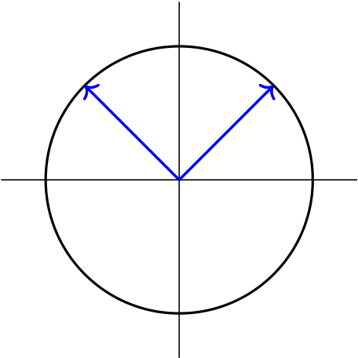
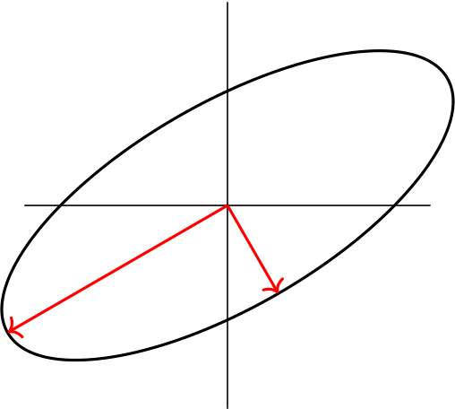
4.1 Geometricinterpretation
TheSVDofamatrixAcanbedescribedbythefollowinggeometricfact:
TheimageoftheunitsphereS={x∈Rn:∥x∥2=1}inRnunderanymatrix A ∈Rm×nisthehyperellipsoidE= {Ax : ∥x∥2= 1}inRm.
Hyperellipsoid is just the m-dimensional generalization of an ellipse, i.e., the surface obtained by stretching the unit sphere in Rmby some factors σ1, . . . , σm (possibly zero) in some orthonormal directionsu1, . . . , um∈Rm.Thevectors{σkuk}aretheprincipalsemiaxesofthehyperellipse, with lengths σ1, . . . , σm.If A has rank r, exactly r of the lengths ukwill turn out to be nonzero, andinparticular,ifm ⩾n,atmostnofthemwillbenonzero.
v2 v1
S | σ1u1 | σ2u2
 |  | AS
Figure7:SVDofa2 × 2matrixA
LetSbetheunitsphereinRnandA∈Rm×nwithm⩾n.ForsimplicityassumethatA hasfullrankn.TheimageASisahyperellipseinRm.WedefinensingularvaluesofAas thelengthofnprincipalsemiaxesofAS,i.e.,σ1, σ2, . . . , σn.Weassumethatsingularvalues arenumberedindegreasingorder,
σ1⩾σ2⩾· · · ⩾σn⩾0.
ThenwedefinetheleftsingularvectorsofAasthedirectionofprincipalsemiaxesofAS. Theseareorthonormalvectorsu1, u2, . . . , uncorrespondingtosingularvaluesσ1, . . . , σn.This meansthatthevectorσkukisthek-thlargestsemiaxisofAS.
TherightsingularvectorsofAaretheorthonormalvectorsv1, v2, . . . , vnthatarethe preimagesoftheprincipalsemiaxesofAS,numberedsothat
Avk= σkuk, | k= 1, 2, . . . , n. | (4.1)
Equations(4.1)inacompactformcanbewrittenasAV=U1Σ1whereV=[v1v2 · · · vn]∈Rn×n,U1= [u1u2 · · · un] ∈Rm×nandΣ1= diag(σ1, . . . , σn) ∈Rn×n.SinceVisanorthogonal matrix,wemaywrite
A = U1Σ1VT (4.2)
whichiscalledthereducedSVDofA.Hereisanillustrationforcasem = 5andn = 3:
30

× | × | × | = | × | × | × | σ1 |  | 0 | 0 |  | × | × | ×
×    ×    ×    × | × | ×  ×  ×  × |  | ×  ×  ×  × | × | ×  ×  ×  ×
 | × |  |  |  | × |  |  | 0  0 | σ2 | 0 |  | ×  × | × | ×      ×
 | × |  |  |  | × |  |  |  | 0 | σ3 |  |  | ×
 | × |  |  |  | × |  |  |  | Σ1 |  |  |  | VT
 | A |  |  |  | U1
ThetermreducedandtildesymbolsonΣandUareusedtodistinguishthefactorization(4.2)
from the more standard fullSVD. Since the column of U1are n orthonormal vectors in Rmand
m ⩾n then (unless when n = m) they do not form a basis for Rm.We can adjoin an additional
m −ncolumnstoU1toextendittoanorthonormalmatrixU∈Rm×m.Fortheproductto
remainunalteredthelastm −ncolumnsofUshouldmultiplybyzero.SoweextendΣ1by
m −nrowsofzerostogetthem × nmatrixΣ.NowwecanwritethefullSVDas
A = UΣVT (4.3)
whereU∈Rm×mandV∈Rn×nareorthonormalmatricesandΣ ∈Rm×nisadiagonalmatrix
thatcariesthenonnegativesingularvaluesσ1, . . . , σnonitsdiagonal. Theillustrationfor
m = 5andn = 3isshownbelow.
× | × | × | = | × | × | × | × | × | σ1 |  | 0 | 0 |  | × | × | ×
×    ×    ×    × | × | ×  ×  ×  × |  | ×  ×  ×  × | × | × | × | ×  ×  ×  × |  | 0  0  0  0 | σ2 | 0 | 
 | × |  |  |  | × | × | × |  |  |  |  | σ3 |  | ×  × | × | ×    ×
 |  |  |  |  |  |  |  |  |  |  | 0
 | × |  |  |  | × | × | × |  |  |  | 0 |  |  |  | ×
 |  |  |  |  |  |  |  |  |  |  |  | 0
 | × |  |  |  | × | × | × |  |  |  | 0 | 0 |  |  | VT
 | A |  |  |  |  | U |  |  |  |  | Σ
IfAisrankdeficient,rank(A) = r< nsay,thenthefactorization(4.3)isstillvalid.Theonly
differenceisthatnowσr+1=· · ·=σn=0andm −rcolumnsofUare‘silent’.Thismeans
thatrsingularvaluesandrleftsingularvectorsofAaredeterminedbythegeometryofthe
hyperellipse.ThelastrcolumnsofVhavenoeffectinfactorizationaswell.
LetusbringtheSVDinaformaldefinitionandproveitmathematically.Weprovethe
existenceanduniqueness(undersomeconditions)ofSVDforanycomplexmatrixA.
Theorem4.1.Let m and n be two arbitrary positive integers.Every matrix A ∈Cm×nhas

afullSVDoftheform

A = UΣV∗

where U∈Cm×mand V∈Cn×nare unitary matrices and Σ ∈Rm×nis a real diagonal matrix

thatcarriesthesingularvaluesσ1⩾σ2⩾· · ·⩾σn⩾0onitsdiagonal.Furthermore,the

singular values are uniquely determined and if A is square the left and right singular vectors

areuniquelydetermineduptocomplexsigns.
31

Proof.[Trefethen-Bau:1997]Forproofofexistence,letσ1:= ∥A∥2.Thereexistsvectors
v1∈Cnwith∥v1∥2=1suchthat∥Av1∥2=σ1.Letu1:=Av1∈Cm.Consideranyextension
of v1to an orthonormal basis {v1, v2, . . . , vn} for Cnand any extension of u1to an orthonormal
basis {u1, u2, . . . , um} for Cm.Suppose that V1 and U1 denote the unitary matrices with columns
vjanduj.Wecanwrite
U∗1AV1=  u∗
eU ∗ 
A h v1 eV1 i  σ1 0 eU ∗ u∗1A eV1
1A eV1

=:σ1 0
w∗
B

=: S,
where0iscolumnvectorofdimensionm −1,w∈Cn−1andB∈C(m−1)×(n−1).Nowweshow
wisindeedzero.Iffactwehave
  σ1 0 | w∗ |  |   σ1 w |  | 2 | = σ2 1+ w∗w⩾σ2 1+ w∗w= (σ2 1+ w∗w)1/2 |   σ1 w |  | 2
 | B |  |  |  |  |  |  | 
whichshowsthat∥S∥2⩾(σ2 1+ w∗w)1/2.SinceSandAareunitarilyequivalentweknowthat
∥S∥2= ∥A∥2= σ1.Thisshowsthatw= 0,and
U∗1AV1= |   σ1 0 | 0 | 
 |  |  | .
 |  | B
Theproofisnowcompletedbyinduction.Theproofforcasem=n=1isobvious.Let
B= U2Σ2V∗2isthefullSVDofB.Wecanwrite |  |  |  |  | 0 |  |   σ1 0 | 0 |  |   1 0 | 0 | 
U∗1AV1= |   σ1 0 | 0 |  |   1 0
 |  |  | =
 |  | U2Σ2V∗2 |  |  | U2 |  |  | Σ2 |  |  | V∗2 | 
whichgivesthefullSVDofAvia
A = U1 |   1 0 | 0 |  |   σ1 0 | 0 |  |   1 0 | 0 | 
 |  |  |  |  |  |  |  |  | V∗ | ,
 |  | U2 |  |  | Σ2 |  |  | V∗2
| | {z U |  | } | | | {zΣ | } | | | V∗{z | }
whichcompletestheproofofexistence.Ontheotherhandwehave
A∗AV= V ΣTΣ, or A∗Avk= σ2 kvk, k= 1, 2, . . . , n
which shows σ2 kare eigenvalues of Hermitian matrix A∗A.This proves the uniqueness of singular
values.■
Fortheremainderofthislecturewewillassume,withoutlossofgenerality,thatm⩾n,
becauseifm<nweconsidertheSVDofAT,andiftheSVDofATisUΣVT,thentheSVD
ofAisV ΣTUT.Besides,wewillassumeAisarealmatrixalthoughallresultscanbesimply
provedfortheacomplexSVD.
4.2 PropertiesofSVD
Several matrix properties including rank, norms and condition number can be extracted form
SVD.Inadditions,SVDprovidesorthonormalbasesforrange(A)andnull(A)andorthogonal
projectionsontorange(A)andnull(A).
32

Theorem4.2.Let σ1⩾σ2⩾· · · ⩾σn⩾0 be the singular values of A ∈Rm×nwith m ⩾n.

1.∥A∥2= σ1,
2.∥A∥F= | qσ2 1+ · · · + σ2 n,
3.∥A−1∥2= |  | 1  σnwhenm = nandAisnonsingular,
4.cond2(A) =σ1σnifAisnonsingular,

5.rank(A) =numberofnonzerossingularvalues.
Proof..Theproofisleftasanexercise.Usethefactsthatorthogonalmatricespreserve norm2andnormFrobeniusaswellastherankofmatrices.SeeWorkout4.3.
Workout4.3.ProveTheorem4.2.
TheconditionnumberofasquareandnonsingularmatrixAisdefinedbycond2(A)=∥A∥2∥A−1∥2.Weobservedthatitcanbeobtainedbydividingthelargestsingularvaluesby thesmallestone.Onecangeneralizethisnotiontorectangularmatricesbydefining
cond2(A) :=σ1  σn |  | , | A ∈Rm×n
providedthatAhasfullrank(σn̸=0). | Theconditionnumberbecomeslargefornearly
rank-deficientmatrices,i.e.,matriceswithverysmallσn.WhenAisrank-deficient,i.e.,whenσn=0,theconditionnumbercanbedefinedtobeinfinity.However,inpracticalapplication (forexampleinleastsquaressettings)thetruedefinitionofconditionnumberforarank-deficientmatrixA ∈Rm×n,m ⩾nis
cond2(A) :=σ1  σr | , | (4.4)
whererank(A)=r.(i.e.,σr+1=· · ·=σn=0).Thisgeneralizesthedefinitionofcondition numberforrank-deficientmatrices.
Remark4.1.In presence of nosy data and roundoff errors it is more practical to talk about numericalrankratherthanjusttherankofamatrix. Inthiscasesweshouldseta
criterion to accept a computed singular value to be ‘zero’.For example we may consider the
singularvaluesofordereps(machineepsilon)tobezero.However,thenormofthematrix andtheerrorsindata(entries)shouldalsobetakenintoaccount.Hereisapractical
criterion[Datta:2010,Golub-VanLoan:2010]:
Acomputedsingularvalueisacceptedtobezeroifitislessthanorequaltoδ= 10−t∥A∥∞wheretheentriesofAarecorrecttotdecimaldigits.
Usingthiscriterion,Ahasnumericalrankrifthecomputedsingularvaluesbσ1, . . . , bσn satisfy
bσ1⩾bσ2⩾· · · ⩾bσr> δ⩾bσr+1⩾· · · ⩾bσn.
Thismeansthattodetermineanumericalrankofamatrixoneneedstocountthelarge
singularvaluesonly.
33

Aspointedout,SVDprovidesorthogonalbasesforrange(A)andnull(A)aswellasprojec-tionstothesesubspaces.Thefollowingtheoremrevealsthis.
Theorem4.4.LetA = UΣVTbetheSVDofA ∈Rm×nwithm ⩾n,andletrank(A) = r.

Partition | U= [U1U2], | V= [V1V2]

whereU1andV1consistoffirstrcolumnsofUandV ,respectively.Then

1.ThecolumnsofU1formabasisforrange(A).

2.ThecolumnsofV2formabasisfornull(A).
3.U1UT 1isaprojectionontorange(A).
4.U2UT 2isaprojectionontonull(AT).
5.V1VT 1isaprojectionontorange(AT).
6.V2VT 2isaprojectionontonull(A).
Proof.Theproofsarestraightforward;however,wereferto[Datta:2010]orsimilarre-sources.Youmayskipitems3–6ifyouhavedecidedtoskipsection2.■
4.3 ComputationofSVD
SVDhasatightconnectiontothewell-knowneigendecompositionofsymmetricmatrices. Asweknow,ifB∈Rn×nisasymmetricmatrixthenallitseigenvaluesλkarerealandthe correspondingeigenvectorsvkareorthonormal.FromBvk=λkvkfork=1, . . . , n,wecan write
B= V DVT
whereV= [v1, v2, . . . , vn]isorthogonaland D= diag{λ1, λ2, . . . , λn}isdiagonal.Thisdecom-positioniscalledeigendecomposition,andhaslimitedapplicationsinpracticeasitisonly availableforsymmetricmatrices3.
TheconnectiontoSVDisobtainedbycomputingATAandAATasbelow:
ATA = (UΣVT)T(UΣVT) = V ΣTUTU | ΣVT= VΣTΣ | VT= V DVT
|{z} I | | {z } D
whereDisan × ndiagonalmatrix
D= ΣTΣ = | σ2 1 |  | ... | 0 | 
 |  | 0 |  | σ2 n | .
Since Vis orthogonal, V DVTis the eigendecomposition of symmetrix matrix ATA.This means thatσ2 1, . . . , σ2 nareeigenvaluesandcolumnsofVarecorrespondingeigenvectorsofATA.
3If A is not symmetric but has a set of independent eigenvectors then it can be decomposed to A = V DV−1 fornonsingularmatrixV .InthiscaseAiscalleddiagonalizable.
34

ThesamecomputationforAATshowsthat
AAT= UΣΣTUT= UDUT
whereDisam × mdiagonalmatrix
D= ΣΣT= | σ2 1 |  | ... | σ2 n | 0 | ... | 0
 |  | 0 |  |  |  |  | 0
ThecolumnsofUareeigenvectorsofAATcorrespondingtothesameeigenvaluesσ2 1, . . . , σ2 plusm −nzeroeigenvaluesσ2 n+1= · · · = σ2 m= 0.
WeconcludethatsingularvaluesofAaresquarerootsofeigenvaluesofATA.Columnsof
VareeigenvectorsofATA,andcolumnsofUareeigenvectorsofAAT.
Example4.1.TocomputetheSVDof
3 |  |  |  |  |  |  | 2 |  |  | √ | √
A = |  |  |  |  | 2  2 |  | −2 3
weform | ATA = |   17 8 |  | 8  17, λ1= 25,λ2= 9
andcomputeitseigenvaluesλ1=25andλ2=9.Thesegiveσ1= √ √  σ2= λ2= 9 = 3.WecanalsoshowthateigenvectorsofATAare |  |  |  |  |  |  |  |  |  | λ1= | 25=5and
v1=1  2 |  |  |    1 1,v2=1 2 |  |  |  |  |  |   1−1
whichresultin | V=1  2 |  |  |  |  |   1 1 | 1  −1.
Ontheotherside,columnsofUareeigenvectorsof
AAT= | 13 | 12 | 2 | 
 | 12  23 | 13 | −2 8.
 |  | −2
Withoutadditionalcomputationsweknowthateigenvaluesofthismatrixareλ1=25,
λ2=9andλ3=0(why?).However,theeigenvectorsofAATaredifferentfromthoseof
ATAandcanbecomputedas
u1=1  2 | 1 | 1√  18 | 1  −1  4,u3=1 |  | 2 | 
 | 1  0,u2= |  |  | −2  1
35

whichshowthat |  |  | √1 | √1  18 |  | 2 | 
 | U= |  | 2 |  |  | 3 | .
 |  |  | √1  2 | − | √1  18 | −2 3
 |  |  | 0 | √4  18 |  | −1 3
However,inpractice,adifferent,fasterandcomputationallymorestablealgorithmisused
tocomputetheSVDfactors.ThecommonlyusedalgorithmistheGolub-Kahan-Reinsch
algorithmwhichconsistsoftwophases. InthefirstphasethematrixAisreducedtoa
bidiagonalmatrixBusingHouseholdertransformations.Thisstepisusuallyknownasthe
Golub-Kahan bidiagonal procedure.Then in the second phase the matrix Bis further reduced
todiagonalmatrixΣusinganiterativemethodthatsuccessivelyconstructsasequenceof
bidiagonalmatricesBksuchthateachBkhaspossiblysmalleroff-diagonalentriesthanthe
previous one.The second procedure is known as the Golub-Reinsch iterative procedure.It thus
makessensetocallthecombinedtwo-stageproceduretheGolub-Kahan-Reinschalgorithm.
Wereferthereadertochapter10of[Datta:2010]fordetails.Thisalgorithmisprovedtobe
computationallystable.
InPythonthealgorithmisimplementedinnumpy.linalg(andalsoinscipy.linalg)
modulewhichprovidesbothreducedandfullSVDforeitherrealorcomplexmatrices.The
defaultcommandnumpy.linalg.svd(A)isequivalentwith
numpy.linalg.svd(A,full_matrices=True,compute_uv=True,hermitian=False)
Iffull_matrices=False,theoutputwillbethereducedSVD.Additionally,inthecaseof
compute_uv=False,theunitarymatricesUandVarenotcomputedandtheoutputisthe
vectorofsingularvaluesonly.Finally,byhermitian=True,AisassumedtobeHermitian
(symmetricifreal-valued),enablingamoreefficientmethodforfindingsingularvalues.Here
isanexample.
fromnumpy.linalgimportsvd

fromnumpyimportarray

A=array([[1,3,2],[4,0,-1],[0.5,2,1],[1,1,1],[2,1,-2]])

U,S,Vt=svd(A)

print(’FullSVD:’,’\nU=\n’,np.round(U,4),’\nVt=\n’,np.round(Vt,4),

’\nsigma=\n’,np.round(S,4))

U,S,Vt=svd(A,full_matrices=False)

print(’\nReducedSVD:’,’\nU=\n’,np.round(U,4),’\nVt=\n’,np.round(Vt,4),

’\nsigma=\n’,np.round(S,4))
Theoutputoftheabovescriptis(notethatPythongivesVTinsteadofV ):
36

FullSVD:
U=
[[-0.4575-0.6636-0.0238-0.4791 |  |  |  | 0.3468]
[-0.6711 | 0.4798 | 0.5011-0.1833-0.186]
[-0.2784-0.4014-0.2015 |  |  | 0.2431-0.8134]
[-0.2626-0.2225 |  | 0.2953 | 0.8113 | 0.3689]
[-0.4403 | 0.3446-0.7877 |  | 0.1398 | 0.2176]]
Vt=
[[-0.8593-0.5112 0.0186]
[0.3474-0.6099-0.7123]
[0.3755-0.6056 0.7016]]
sigma= [5.149 | 4.38041.5969]
ReducedSVD:
U=
[[-0.4575-0.6636-0.0238]
[-0.6711 0.4798 0.5011]
[-0.2784-0.4014-0.2015]
[-0.2626-0.2225 |  | 0.2953]
[-0.4403 | 0.3446-0.7877]]
Vt=
[[-0.8593-0.5112 0.0186]
[0.3474-0.6099-0.7123]
[0.3755-0.6056 0.7016]]
sigma= [5.149 | 4.38041.5969]
WenotethatforthereducedSVDthecommandU,S,Vt=svd(A,0)canbeusedinstead.
4.4 SolvingtheleastsquaresproblemusingSVD
TheSVDprovidesaparticularlyflexiblemethodforsolvinglinearleastsquaresproblems ofanyshapeorrank.Consideragaintheleastsquaresproblem
x∈Rn ∥Ax −b∥2
with overdetermined matrix A ∈Rm×n.First, we assume that A is full-rank, i.e., rank(A) = n. Let A = UΣVTbe the SVD of A and partition U= [U1U2] where U1consists of first n columns
37

ofU,andΣ= |   Σ1 0 | 
 |  | whereΣ1∈Rn×nisasquarediagonalmatrixwithσkonitsdiagonal.
SinceAisfull-rank,allsingularvaluesarepositiveandΣisnonsingular.Furthermore,weuse
thechangeofvariablesy= VTx.Then,wecanwrite
∥Ax −b∥2 2= ∥UΣVTx −b∥2 2= ∥ΣVTx −U Tb∥2 2= |   Σ1 0 |  |   U T UT 1b  2b |  | 2
 |  | y − |  |  | 2
= ∥Σ1y −UT 1b∥2 2+ ∥U T 2b∥2 2.
SinceVisnonsingular,theminimizationoverxisequivalenttominimizationovery.The
minimumisobtainedifthefirstnormontheright-handsideisvanished,i.e.y=Σ−1 1U T 1b.
Thisgivestheleastsquaressolution
x = V Σ−1 UT b = | n | uT jb | v, | (4.5)
 | X
1 1 |  | σj | j
andthereminderisr= ∥Ax −b∥2= ∥UT 2b∥2. | j=1
Now,letAbearank-deficientmatrix,rank(A)=r<n,say.PartitionU=[U1U2]now
withU1consistsoffirstrcolumnsofU,and
Σ = |   σ1 ... σr 0  0 0 ... 0  0 0    | = |   eΣ1 |  | 0
 |  |  |  | 0 | 0
whereeΣ1∈Rr×ristheupper-leftsquarematrixwithpositivesingularvaluesσ1, . . . , σronits
diagonal.Also,assumethat
y= VTx =: whereey∈Rr.Similartothefirstcase,wehave |    ey  by
∥Ax −b∥2 2= ∥UΣVTx −b∥2 2= ∥ΣVTx −U Tb∥2 2= |  |   eΣ1 |  | 0 |    ey−  by |   U T UT 1b  2b   | 2
 |  |  | 0 | 0 |  |  | 2
= ∥eΣ1ey −UT 1b∥2 2+ ∥U T 2b∥2 2.
Inthiscasetheleastsquaresolutionisnotunique.Solutionsareobtainedbyputtingey=
eΣ−1 1U T 1bandlettingbyarbitrary,andthen
x = V y= X r uT jb
vj+ X
n
yjvj. (4.6)
j=1 σj j=r+1
A least squares solution x with the minimum norm 2 among others is called the norm-minimal
38

solution.Since∥x∥2 2=∥y∥2 2=∥ey∥2 2+ ∥by∥2 2,thenorm-minimalsolutionoftherank-deficient leastsquaresproblemisobtainedbysettingby= 0,i.e.bydroppingthesecondsummationin (4.6).
LabExercise4.5.WriteaPythonfunctionforsolvingtheleastsquaresproblemforeither

full-rankorrank-deficientcaseusingSVD.Assumethattherankofthecoefficientmatrix

isunknowninadvance,socomputeitnumerically.
4.5 | Pseudoinverse
AssumingA ∈Rm×nhasrankrwithr⩽n,theSVDofAisrepresentedas
A = [U1U2] |   eΣ1 |  | 0  0[V1V2]T= U1eΣ1VT | (4.7)
 |  | 0
whereU1andV1consistofthefirstrcolumnsofUandV ,respectively,andeΣ1∈Rr×risa diagonalmatrixwithpositivesingularvaluesσ1, . . . , σronitsdiagonal.
Whenm=n(i.e.,Aissquare)andr=n(i.e.,Aisfull-rank),wehavethestandard representationA=UΣVTwithallmatricessquareandΣnonsingular. Inthiscase,the inverseofAiscomputedas
A−1= (UΣVT)−1= V−TΣ−1U−1= V Σ−1UT.
Thissuggestsanalgorithmtocomputetheinverseofsquareandnonsingularmatrices.How-ever,thisalgorithmismorecostlythantheusualalgorithmbasedonGaussianelimination, althoughitismorestableforill-conditionedmatrices.
When A is rectangular and even rank-deficient,we can generalize this approach to compute thepseudoinverseofA.Inthiscase,weusethefactorization(4.7)anddefine
A+:= V1eΣ−1UT
whichisindeedtheMoore–PenroseinverseofmatrixA.Asaresult,wecanseefrom(4.5) thattheleastsquaressolutionofafull-ranksystemAx∼= bisgivenby
x = A+b.
This is the counterpart of the exact solution x = A−1b for square and nonsingular linear system Ax=b.Additionally,from(4.5),weobservethatfortherank-deficientproblem,x=A+bis thenorm-minimalsolution.
Example4.2.TheSVDfactorsofamatrixAaregivenby  √1  2  √−1  2 0 0 02 √  3 0 0 0 |  | √  6 | 0 | 0 | √−1 | 
U=  0 0 0 1 0 0 10 ,Σ =  0 2 0 0 0 00 ,V=  0 0 −1 0 0 0 0  √1 2 √1 2 0 0 0 0 0  0 0 0 0 0 0 0 |  | 3 |  |  | 3 |  | .
 |  | 0 | 0 | 1
 |  |  |  |  | 0
 |  | √1  6 | √−1  2 | 0 | √1  3
 |  | √1  6 | √1  2 | 0 | √1  3 | 
39

ThepseudoinverseofAiscomputedas |  |  |  |  |  |  |  |  |  |  |  |  |  |  |  | 1 | 0 | 0 | 1 | 0
 |  | √  6 | 0 | 
 |  | 3 |  |  |  |  |  |  |  | √1 | 0 | 0 | √1 | 0 |  | 6 |  |  | 6
 |  | 0 | 0 |  |  | √1 |  |  |  |  |  |  |  |  |  | 0 | 0 | 0 | 0 | 0
A+= V1Σ−1 1U T 1= |  |  |  |  |  | 2 3 |  |  |  | 2 |  |  | 2 | 0= |  |  |  |  |  | 0 | .
 |  | √1 | √−1  2 |  |  |  | 1 |  |  | √−1 | 0 | 0 | √1 |  |  | 1 | 0 | 0 | 0
 |  | 6 |  |  |  | 0 | 2 |  |  | 2 |  |  | 2 |  |  |  |  |  |  | 0
 |  | √1  6 | √1  2 |  |  |  |  |  |  |  |  |  |  |  |  | 0 | 0 | 0 | 1
In addition, if we aim to solve the least square problem min ∥Ax−b∥2with b = [1, 1, 1, 1, 1]T forthenorm-minimalsolution,wewrite
 |  |  | 1 | 0 | 0 | 1 | 0 | 1 |  |  | 1 | 
4.6 | x = A+b = |  | 6 |  |  | 6 |  | 1 1 11 | = |  | 3 |  | .
 |  |  |  | 0 | 0 |  | 0 00
 |  |  | 0 |  |  | 0 |  |  |  |  | 0
 |  |  | 1 | 0 | 0 | 0 |  |  |  |  | 1
 |  |  | 0 | 0 | 0 | 1 |  |  |  |  | 1
 | Low-rankapproximation
Low-rankapproximationisafundamentalconceptinlinearalgebraandnumericalanalysis
thatplaysacrucialroleinvariousapplications.Inthisapproach,weseektorepresentagiven
matrix with a lower-rank approximation that captures its essential structure while reducing its
sizeandcomplexity.SVDenablesustoachievethiskindofapproximation.
Westartwiththefollowingtheoremwhihcaddressesthequestionofhowfarisarankr matrixfromamatrixofrankk<r.ThistheoremisgenerallyknownastheEckart-Yaung theorem.
Theorem4.6.LetA=UΣVTbetheSVDofA,andletk⩽r=rank(A). | Define

Ak=UΣkVTwhereΣk=diag{σ1, . . . , σk, 0, . . . , 0},whereσ1⩾σ2⩾· · ·⩾σk>0.Then

thefollowingsholdtrue:

1.Akhasrankk,

2.ThedistancebetweenAandAkis∥A −Ak∥2= σk+1.

3.Outofallrankkmatrices,AkistheclosettoA,thatis

rank(B)=k∥A −B∥2= ∥A −Ak∥2.
Proof.Theproofof1isobviousbecauserank(Ak)=rank(UΣkVT)=rank(Σk)=k.For theseconditemwehave
∥A −Ak∥2= ∥U(Σ −Σk)VT∥2= ∥Σ −Σk∥2= σk+1.
To prove item 3, we assume that B is another m×n matrix of rank k.So the null space of B has dimensionn −k.ConsiderthespaceS= span{v1, . . . vk+1}wherevjarerightsingularvectors ofA.Theintersectionofnull(B)andSmustbenonemptybecausebothspacesaresubspaces ofRnandthesumoftheirdimensionsisgreaterthann.Letzbeanormalvector(∥z∥2= 1)
40

lyinginthisintersection.Sincez∈Sthere existscalerscjsuch thatz= c1v1 + · · · + ck+1vk+1. Since {vj} are orthonormal we have |c1|2+· · ·+|ck+1|2= 1.On the other side, since z∈null(B) wehaveBz= 0.So
(A −B)z= Az= c1Av1 + · · · + ck+1Avk+1= c1σ1u1 + · · · + ck+1σk+1uk+1
andsince{uj}areorthonormalwehave
∥(A −B)z∥2 2= |c1σ1|2 + · · · + |ck+1σk+1|2⩾σ2 k+1(|c1|2 + · · · + |ck+1|2) = σ2 k+1.
Thisshowsthat
∥A −B∥2 2=max∥y∥2=1∥(A −B)y∥2 2⩾∥(A −B)z∥2 2⩾σ2 k+1= ∥A −Ak∥2
whichcompletestheproof. ■
AnotherrepresentationofSVDis
A = UΣVT= σ1E1 + σ2E2 + · · · + σnEn, Ek= ukvT k.
EachEkisarank1matrixwhichshowsthatSVDwritesAasasumofrank1matrices. Sinceσ1≥σ2≥· · ·≥σn,matrixAisexpressedasalistofits“ingredients”,orderedby“importance”.EachelementarymatrixEkcanbestoredusingonlym + nstoragelocations. Moreover, the matrix-vector product Ekx can be formed using only 2n+m flops.As was shown inTheorem4.6,
Ak= UΣkVT= σ1E1 + σ2E2 + · · · + σkEk
isk-rankapproximationof Awith2-normerrorσk+1.Suchanapproximationisusefulindata dimensionallyreduction,imageprocessing,informationretrieval,cryptography,andnumerous otherapplications.
4.7 SomeapplicationsofSVD
WehavealreadystudiedtheuseofSVDforcomputingsomenorms,conditionnumber, orthogonalbasesforsomesubspacesrelatedtoamatrix,andanapplicationforsolvingthe linearleastsquaresproblem.Inthissectionmoreconcreteexamplesaregivenfromdifferent applications.
Imagecompression
An image can be represented by an m×n matrix A whose (i, j)-th entry corresponds to the brightnessofthepixel(i, j).Thestorageofthismatrixrequiresmnlocations.SeeFigure8, Theideaofimagecompressionistocompresstheimagerepresentedbyaverylargematrix to the one which corresponds to a lower-order approximation of A.SVD provides a simple way ifonestores
σ1u1vT 1+ · · · + σkukvT k=: Ak
insteadin(m + n + 1)klocations(thefirstkcolumnsofUandVtogetherwiththefirstk singularvalues).Thisresultsaconsiderablesavingswhenkissmall.Ontheothersidek
41

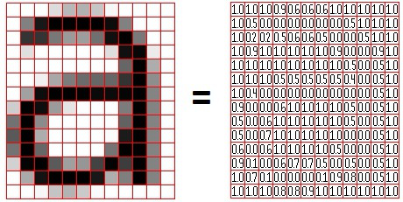
Figure8:Representationofanimagewithamatrix(formpippin.gimp.org/image_processing).
shouldbelargeenoughtokeepthequalityoftheimagestillacceptabletotheuser4. InFigure9differentlow-rankapproximationsofacatimageobtainedfromthefollowing Pythonscriptareshown.
importnumpyasnp
importmatplotlib.pyplotasplt
fromPILimportImage  A=Image.open(’cat.jpg’).convert(’L’) | #Grayscalereadpicture

sz=np.shape(A)  U,S,Vt=np.linalg.svd(A) | #GetsvdofA
k=[sz[1],100,50,20]
plt.figure(figsize=(7,7))
foriinrange(4):
Ak=U[:,:k[i]]@np.diag(S[:k[i]])@Vt[:k[i],:]
if(i==0):
plt.subplot(2,2,i+1),plt.imshow(Ak,cmap=’gray’),plt.axis(’off’), plt.title("OriginalImagewithk="+str(k[i]))
else:
plt.subplot(2,2,i+1),plt.imshow(Ak,cmap=’gray’),plt.axis(’off’), plt.title("k="+str(k[i]))
plt.savefig("cat1.jpg")
Imagerestoration
The aim in image restoration is to restor the original image from a blurry image contaminated bynoises.Itisknownthatnoisescorrespondtothesmallsingularvalues.Thusasimpleidea istocomputetheSVDofthenoisyimageandeliminateitslastn −ksmallsingularvalues
4Forimagecompression,moresophisticatedmethodslikeJPGthattakehumanperceptionintoaccount generallyoutperformcompressionusingSVD.
42

Original Image with k = 828    k = 50   | k = 100    k = 20  
Figure9:Originalcatimageandcompressedimageswithdifferentvaluesofk.
(smallerthanathreshold)andconsiderthelow-rankapproximation
Ak= UkΣkVT k
asanoise-freeimage.ItisleftasanexercisegivinganexamplewithaPythonscript. Note that, the literature contains a large number of more sophisticated denosing algorithms; someofthemarebasedonSVD.
Principalcomponentanalysis(PCA)
InPCAtheobjectiveistoreducethedimensionalityofadatasetinordertousethetrans-ferred data in applications that might not work well with high-dimensional data.The reduction isdonebyprojectingeachdatapointontoonlythefirstfewdirections(principalcomponents) toobtainlowerdimensionaldatawhilepreservingasmuchofthedata’svariationaspossible. The first principal component is a direction that maximizes the variance of the projected data. This direction captures most information of the data.The second principal component is then calculated with the condition that it is uncorrelated with (i.e.,perpendicular to) the first prin-cipalcomponentandthatitaccountsforthenexthighestvariance.Wemayproceedthrough othercomponents,similarly.SeeFigure10.
LetusoutlinethefundamentalprinciplesofPCAwithinamathematicalframework5.As-
5Forahistory,areviewandsomerecentdevelopmentsofPCAseethefollowingsources:
IanT.Jolliffe,JorgeCadima,Principalcomponentanalysis:areviewandrecentdevelopments,Phil.Trans. R.Soc.A374:20150202,(2016).
43

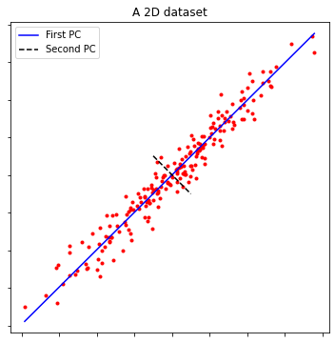
Figure10:ClusterofpointsinR2withprincipalcomponents(PCs).
sumethatwearegivenadatasetwithobservationsondvariables(dimensions),foreachofn entitiesorindividuals.Thesedatavaluesdefinenvectorsx·1, . . . , x·neachinRdor,equiva-
lently,ad × ndatamatrix
X= [x·1, x·2, . . . , x·n] ∈Rd×n.
We assume that Xis row-centred, i.e., the mean value of each row is zero.Otherwise, subtract eachrowbyitsmean.Wearelookingforaneworthonormalbasis{v·1, v·2, . . . , v·d},v·j∈Rn, forthecolumnspaceofXT(rowspaceofX)whichdeterminesthedirectionsofmaximum
variances in order of significance (a decreasing order).Any element of the new basis is a linear
combinationofcolumnsofXT.Suchlinearcombinationscanbewrittenas
σjv·j= | d | uℓjxℓ·= XTu·j, | j= 1, 2, . . . , d, | (4.8)
 | X
ℓ=1
whereu·j= [u1j, . . . , udj]Tareassumedtobeoftheunitnorm,i.e.∥u·j∥2= 1.Thenormaliza-
tionconstantsσjaremultipliedfromlefttomakethisassumptionmeaningful.Thevariance
ofanysuchlinearcombinationisgivenby
whereC= | var(XTu) = | 1  n −1(XTu)T(XTu) = uTCu,
 | n−1XXT∈Rd×disthesamplecovariancematrixassociatedwiththedataset.
Hence, identifying the linear combination with maximum variance is equivalent to obtaining a d-
dimensional vector u with uTu = 1 which maximizes the quadratic form uTCu.By introducing
aLagrangemultiplierλ,theproblemisequivalenttomaximizing
uTCu −λ(uTu −1).
Differentiatingwithrespecttou,andequatingtothenullvector,producestheequation
Cu = λu.
This means that u is an eigenvector and λ its corresponding eigenvalue of the covariance matrix
IanT.Jolliffe,Principalcomponentanalysis,2nded.NewYork,NY,Springer-Verlag,(2002).
44

C.Since Cis symmetric and semi-positive definite, all eigenvalues are real and nonnegative and eigenvectorsformanorthonormalbasisforRd.Theeigenvalueλcorrespondingtoeigenvector uofCisindeedthevarianceofthelinearcombinationdefinedbyu,i.e.XTu,because
var(XTu) = uTCu = uT(λu) = λuTu = λ.
LetusdenotethepairofeigenvaluesandeigenvectorsofCby(λj, u·j)forj=1, 2, . . . , dand sorteigenvaluesissuchwaythatλ1⩾λ2⩾· · · ⩾λd⩾0.Themaximumvarianceisattained atthedominantpair(λ1, u·1).Recalling(4.8),thisshowsthatthemaximumvarianceofthe datahappensacrossthedirectionu·1withvariance
λ1= var(XTu·1) = var(σ1v·1) = | σ2  n −1vT·1v·1= | σ2 1  n −1.  σ2  n−1isthehighestvariance
Thismeansthatu·1isthefirstprinciplecomponentofdataXand
inthedataalongthedirectionu1.
ALagrangemultipliersapproach,withtheaddedrestrictionsoforthogonalityofdifferent
vectorsu·jcanbeusedtoshowthatthefullset{u·1, . . . , u·d}arethesolutionstotheproblem ofobtaininguptodnewlinearcombinationsXTu·jwhichsuccessivelymaximizethevariance, subjecttouncorrelatednesswithpreviouslinearcombinations.Uncorrelatednessresultsfrom
thefactthatthecovariancebetweentwosuchlinearcombinationsiszero;
cov(XTu·j, XTu·k) = uT·jCu·k= λkuT·ju·k= 0, j̸= k.
Astheaboveformulationreveals,PCAisessentiallyconnectedtotheSVD.From(4.8)we
have
X= UΣVT (4.9) where U= [u·1u·2 . . . u·d] ∈Rd×dand V= [v·1v·2 . . . v·d] ∈Rd×nhave orthonormal columns andΣ = diag(σ1, σ2, . . . , σd).Consequently,thereducedSVD(4.9)givesallprincipalcomponents ascolumnsofthefactorU.Thevariancesineachdirectionarecalculatedasthesquaresof thesingularvaluesdividedby(n −1).

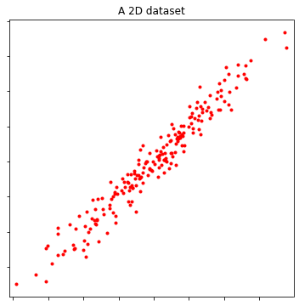

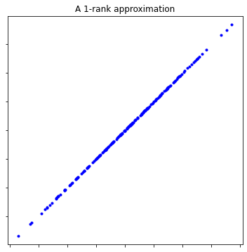

Figure11:AdatasetinR2(left)andits1-rankapproximationusingSVD.
Uptoherewehavefoundalltheprincipalcomponentsinorderofsignificance.Thenext
45

stepistochoosewhethertokeepallthesecomponentsordiscardthoseoflessersignificance andformwiththeremainingonesanewdatainalowerdimensionalsubspace.Assumethat wedecidetokeeponlyk< dprincipalcomponents.Ournewdatamatrixwillbe
Xk= UkΣkVT k= | k | σju·jvT·j
 | X
j=1
which is a k-rank approximation of the original data matrix X, and is called the feather matrix. Infact,thenewdatasetislocatedonak-dimensionalsubspaceofRdspannedbyorthonormal vectors{u·1, . . . , u·k}.ThisisadimensionalityreductionalgorithmbasedonSVD.See Figures11and12forillustrationsin2and3dimensions,respectively.
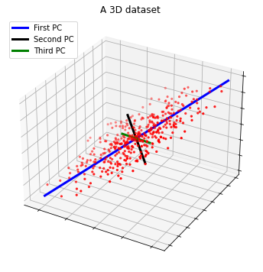
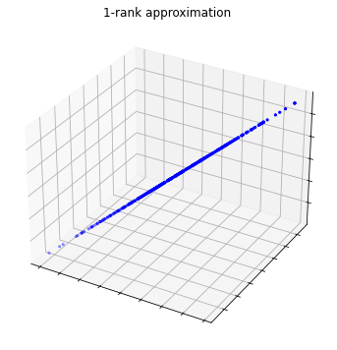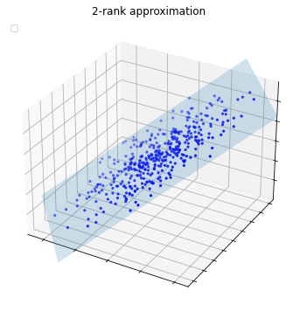
Figure 12:A dataset in R3(up) and its 1-rank approximation (down-left) and its 2-rank approximation (down-right)usingSVD.
Keywordsandkeysentencesextraction
Developmentofautomaticproceduresfortextsummarizationisimportantbecausepeople areoverwhelmedbythetremendousamountofonlineinformationanddocuments.
Thegoalofatextsummarizationalgorithmistoextractcontentfromatextdocumentand presentthemostimportantcontenttotheuserinacondensedform.
Wefollow[Elden:2019]andbrieflydiscussanalgorithmbasedonSVDforautomatically
46

extracting key words and key sentences from a text.Assume that we are given a text document, forexampleanarticleorachapterofabook.Assumethatthetextcontainsmwordsand nsentences6.Normallymismuchlargerthann.Weformam × nterm-sentencematrixA whereitsentryaijisdefinedasthefrequencyofterm(word)iinsentencej.Letusgivethe termithenonnegativescoreuiandthesentencejthenonnegativescorevj.Theassignment ofscoresismadebasedonthefollowingmutualreinforcementprinciple:
Atermshouldhaveahighscoreifitappearsinmanysentenceswithhighscores. Asentenceshouldhaveahighscoreifitcontainsmanywordswithhighscores.
Using this criterion the score of term i is proportional to the sum of the scores of the sentences, weightedbyfrequencies,whereitappears,
n
σui= | X | aijvj, | i = 1, 2, . . . , m,
j=1
whereσ> 0istheproportionalconstant.Similarly,thescoreofsentencejisproportionalto thesumofscoresofitswordsweightedbytheirfrequenciesinthesentence,
m
σvj= | X | aijui, | j= 1, 2, . . . , n.
i=1
Inmatrixformswehave
Av= σu, ATu = σv
foru=[u1, . . . , um]T(thescorevectorofwords)andv=[v1, . . . , vn]T(thescorevectorof sentences).Collectingbothequationswehave
AATu = σ2u, ATAv= σ2v
which show that u is an eigenvector of AATand vis an eigenvector of ATA both corresponding toeigenvalueσ2.Thismeansthatuisleftsingularvectorandvisarightsingularvalueof Acorrespondingtothesamesingularvalueσ.Ifwechoosethelargestsingularvalue,then weareguaranteedthatthecomponentsofuandvarenonnegativebecausethematrixAhas nonnegativeentries.Consequently,asimplealgorithmbasedonSVDconsistsofthefollowing steps:
•Step1:Applyastemmingandastopingwordalgorithmonthetext,
•Step2:Constructtheterm-sentencematrixA,
•Step3:ComputetheSVDofAandreporttheleadingvectorsuandv(firstcolumns ofUandV ,respectively)aswordandsentencescores.
ThefullSVDisnotnecessaryforthisalgorithmasthefirstsingularvectorsareonlyrequired. Moreover,theterm-sentencematrixissparse,soaSVDfunctionforsparsematricesisnumer-
6Usually a couple of preprocessing steps should perform before summarization which are known as stemming and stop words removing.In the stemming step the same word stem with different endings is represented by one token only.For example words {computation, computations, compute, computable, computing, computational} arerepresentedbystem“comput”.Stopwordssuchas {a,an,and,or,if,then,any,as,about,able,. . . }occur frequently in all texts and do not distinguish between different sentences.They should be removed.We assume thatspecialsymbols,e.g.,mathematicssymbolsarealsoremoved.
47

icallymoreefficient.
Classificationofhandwrittendigits
Classificationofhandwrittendigitsisastandardprobleminpatternrecognition.Atypical application is the automatic reading of zip codes on envelopes.Here we follow the presentation of[Elden:2019]andgiveaclassificationtechniqueusingSVD.
The problem is as follows:Givenasetofmanuallyclassifieddigitsasatrainingset,classify asetofunknowndigitsasthetestset.
InFigure13asampleofhandwrittendigits0, 1, . . . , 9isillustrated.Theimagesaredown-loadedfrom7.Eachimageisa28 × 28grayscaleimagebutwestackthecolumnsoftheimage aboveeachothersothateachimageisrepresentedbyavectorofsize784.
 |  |  |  | 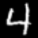
 |  |  |  | 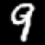
Figure13:Asampleofhandwrittendigits0, 1, . . . , 9.
Thetrainingsetofeachkindofdigits0, 1, . . . , 9canbeconsideredasamatrixAofsize m × nwithm=784andn=‘thenumberoftrainingdigitsofonekind’.Usually,n⩾m althoughthecasen<misalsopossible.So,wehaveatotalof10trainingmatrices,each correspondingtooneofthedigits0, 1, . . . , 9.AssumethatAisoneofthem.Thecolumnsof AspanalinearsubspaceofR784.However,thissubspacecannotbeexpectedtohavealarge dimension,becausecolumnsofArepresentthesamedigitwithdifferenthandwritings.One can use SVD A = UΣVTto obtain an orthogonal basis for the column space of A (or range(A)) via the columns of factor U.Then any test image of that kind can be well represented in terms oftheorthogonalbasis{u·1, u·2, . . . , u·m}.Letusdescribeitinmoredetail.Wehave
A = UΣVT= | m | σju·jvT·j,
 | X
j=1
thustheℓ-thcolumnofA(theℓ-thtrainingdigit)canberepresentedas m
a·ℓ= | X | (σjvjℓ)u·j
j=1
whichmeansthatthecoordinatesofimagea·ℓintermsoforthogonalbasis{u·1, u·2, . . . , u·m}
areσjvjℓ=: xj,i.e. | a·ℓ= | m | xju·j= Ux.
 |  | X
j=1
7https://www.nist.gov/itl/products-and-services/emnist-dataset
48

Thismeans,inanotherpointofview,thatsolvingtheleastsquaresproblem
min x∥Ux −a·ℓ∥2
resultsinanoptimalvectorx = [σ1v1ℓ, . . . , σmvmℓ]Twithresidual0.Aswepointedout,most columns of A are nearly linearly dependent as they represent different handwritten for the same digit.If we translate it to columns of U, this means that a few leading columns of Ushould well capturethesubspace.Forthisreasontheorthogonalvectorsu·1, u·2, . . . ,arecalledsingular images.Forexample,inFigure14thesingularvaluesandthefirstthreesingularimagesfor thetrainingset3’s(containingthefirst200imagesofthetrainingset)areillustrated.
k | 30000 | 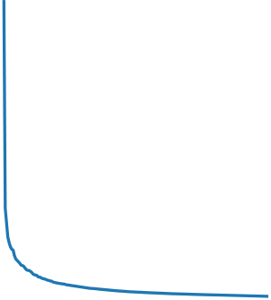 |  |  | Singular image u 1 | Singular image u 2 | Singular image u 3
 |  |  |  |  |  |  | 
 | 25000
 | 20000
 | 15000
σ
 | 10000
 | 5000
 | 0
 |  | 0 | 100  k | 200
Figure14:Rapiddecayofsingularvalues,andthefirstthreesingularimages.
Weobservethatthefirstsingularimagelookslikea3,andthefollowingsingularimages representthedominatingvariationsofthetrainingsetaroundthefirstsingularimage.Con-sequently,wecanuseak-rankapproximationofAwherek≪m.Inthiscaseeacha·ℓcan bewellrepresentedbyorthogonalbasis{u·1, u·2, . . . , u·k}inaleastsquaressensewithasmall residual.
Now,letd∈Rm,m=784,beadigitoutsidethetrainingset(whichiscalledatest digit).Itisreasonabletoassumethatdcanbewellrepresentedintermsofsingularimages {u·1, u·2, . . . , u·k} of its own type with a relatively small residual.We must compute how well d canberepresentedinthe10differentbases,eachcorrespondingtooneofthedigits0, 1, . . . , 9. Thiscanbedonebycomputingtheresidualvectorintheleastsquaresproblemsofthetype
min x∥Ukx −d∥2
wheredrepresentsatestdigitandUkisam × kmatrixconsistingofthefirstkcolumnsof U.SincethecolumnsofUkareorthonormal,thesolutionofthisproblemisx = UT kdandthe residualis
∥(I−UT kUk)d∥2.
(4.10) Altogether,aSVD-basedclassificationalgorithmofhandwrittendigitsconsistsoftwosteps:
•Step1(training):Forthetrainingsetofknowndigits,computetheSVDofeachset ofdigitsofonekind(ComputetenSVDsfordigits0, 1, . . . , 9).
•Step2(classification):Foragiventestdigitd,computeitsrelativeresidualinallten basesusingequation(4.10).Ifaresidualinaclassissmallerthanalltheothers,classify dinthatclass.
49

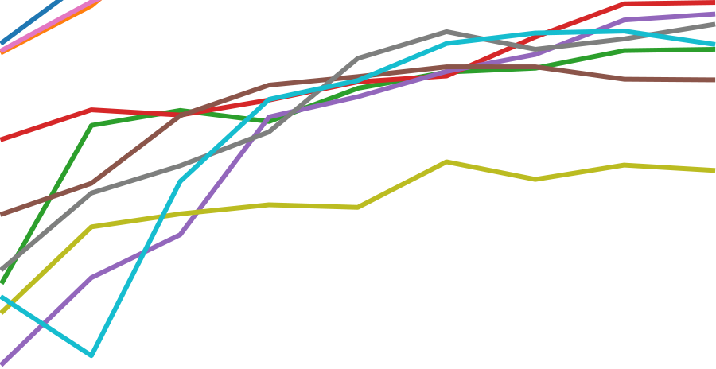

To test the algorithm, we download the training set consisting of 240000 images (24000 images peranydigit),andthetestsetconsistingof40000images(4000imagesperdigit)fromthe above-mentionedwebsite.Thedocumentalsocontainstwolabelfileswhicharemanualclassi-ficationsoftrainingandtestsets.Thetraininglabelswillbeusedtolearnandthetestlabels toverifythealgorithm.
Foreachdigitweconsiderusingonlytheinitial200imagesoutofthetotal24000training images(tenmatriceseachofsize784 × 200).However,wetestthealgorithmonall40000 testimagesandcompareourclassificationswiththeexacttestlabels.Thepercentagesof thesuccessofthisSVD-basedalgorithmforeachdigitwithdifferentvaluesk=3, 6, . . . , 10 (number of basis functions) are plotted in Figure 15.It is left to readers to discuss their insights basedontheobservationsfromthefigure.
Perceentage of success | 97.5 |  |  | 0  1  2  3  4  5  6  7  8  9
 | 95.0
 | 92.5
 | 90.0
 | 87.5
 | 85.0
 | 82.5
 | 80.0

2 | 4 | 6  k (columns of U) | 8 | 10
Figure15:Percentagesofsuccess(y-axis)intermsofnumberofbasisfunctions(x-axis)fordifferent digits0, 1, . . . , 9.
LabExercise4.7.Implementyourown Python code for the above classificationalgorithm.

Testyouralgorithmfordifferentnumberofbasisfunctions.Notethatinthestatement

above,the equations you need are formulated for a single test vector d (one “flattened” test

image).However, if you use that approach in your code, it will take a very long time to run.

Incontrast,matrix-matrixmultiplicationsaremuchmoreefficientonmoderncomputers.

Totakefulladvantageofthat,simplyreplacevectordinequation(4.10)withtheentire

testmatrix.
50

Additionalworkouts
Workout4.8(UniquenessofreducedQRfactorization).AssumethatA∈Rm×nhasafull
rank. | ProvethatApossessesauniquereducedQRfactorizationA=Q1R1withthe

diagonalentriesofR1positive.
Workout4.9.AssumethatA∈Rm×nhasrankr<min{n, m}. | Showthatforevery

ϵ>0(nomatterhowmuchsmall),thereexistsafull-rankmatrixAϵ∈Rm×nsuchthat

∥A −Aϵ∥2⩽ϵ.

Workout4.10.LetA∈Rn×nbeanarbitrarymatrix.Findtheclosetorthogonalmatrix

Q ∈Rn×ntoAinFrobeniusnorm,i.e.solvethefollowingproblem:

QTQ=I∥A −Q∥F.

Hint:useSVD.

Workout4.11([Trefethen-Bau:1997]).Let P∈Rn×nbe a nonzero projector.Show that

∥P∥2⩾1withequalityifandonlyifPisanorthogonalprojector.

Workout4.12([Trefethen-Bau:1997]).SupposethatasquarematrixAhasSVDA=

UΣVT.Findtheeigendecompositionofthesymmetricmatrix
B= |   0 A | AT | 
 |  |  | .
 |  | 0

Workout4.13([Trefethen-Bau:1997]).Suppose that A is a m × n matrix with m > n of
theform | A = |   B C | 
 |  |  | 

where Bis a nonsingular matrix of size n×n and Cis an arbitrary matrix of size (m−n)×n.

Provethat∥A+∥2⩽∥B−1∥2.

Workout4.14([Datta:2010]).LetAbeanm × nmatrixoffullrankr=min{m, n}.If

Bisanotherm × nmatrixsuchthat∥B −A∥2< σrthenshowBhasalsofullrank.

Workout4.15([Datta:2010]).ShowthattherelativedistanceofanonsingularmatrixA

tothenearestsingularmatrixBis | = | 1 .
∥A −B∥2
∥A∥2 |  | cond2(A)
51

References
[1]B. N. Datta, NumericalLienarAlgebraandApplications, 2nd edition, SIAM, Philadelphia, PA,2010.
[2]L.Eldén,MatrixMethodsinDataMiningandPatternRecognition,2ndedition,SIAM, Philadelphia,PA,2019.
[3]M.T.Heath,ScientificComputing,anIntroductorySurvey,revised2ndedition,SIAM, Philadelphia,PA,2018.
[4]L.N.Trefethen,D.BauIII,NumericalLinearAlgebra,SIAM,1997.
52

