00. Microsoft Visual Studio 2017 Installation Tutorial
Y. Liow (yliow@ccis.edu)

What is Visual Studio?

“Microsoft Visual Studio is a powerful IDE (Integrated Development Environment) that ensures quality code throughout the entire application lifecycle, from design to deployment. Whether you’re developing applications for SharePoint, the web, Windows, Windows Phone, and beyond, Visual Studio is your ultimate all-in-one solution.”
from http://www.microsoft.com/visualstudio/en-us

Downloading the setup file
Go to https://visualstudio.microsoft.com/vs/community/ and click on Download VS Community 2017.

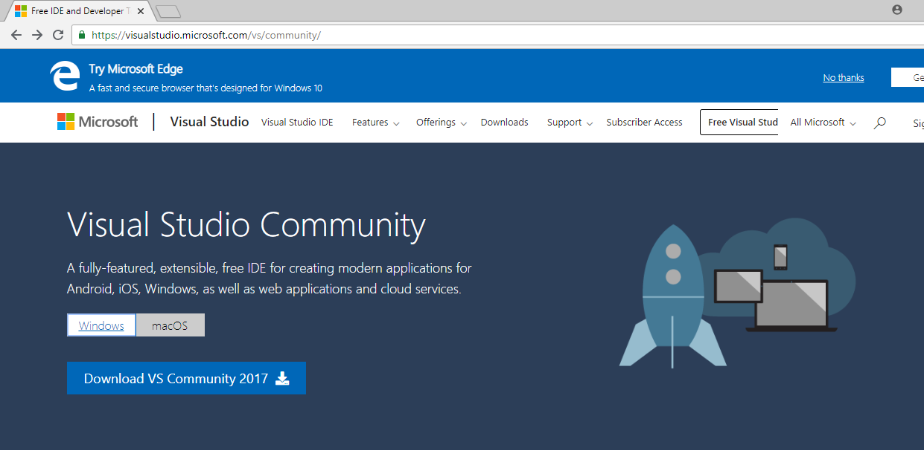

Installation
Click on the downloaded file and start installation process.
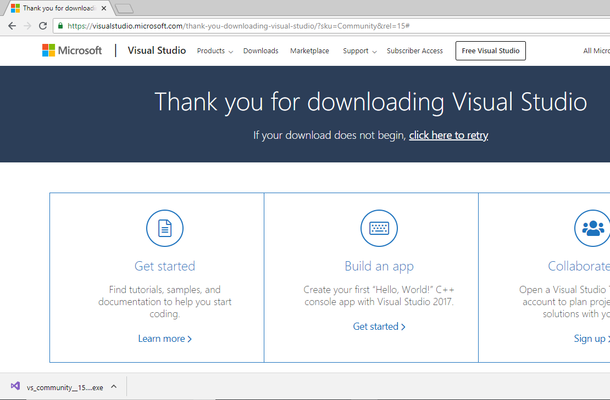
Click Continue.
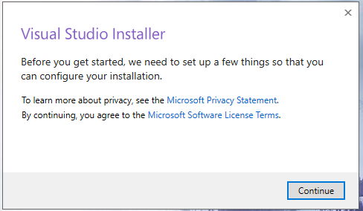

Now, wait for the installer to download files.
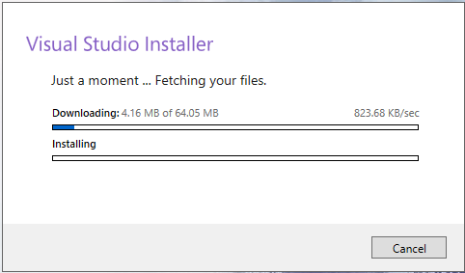
Choose Desktop development with C++ and click on Install. 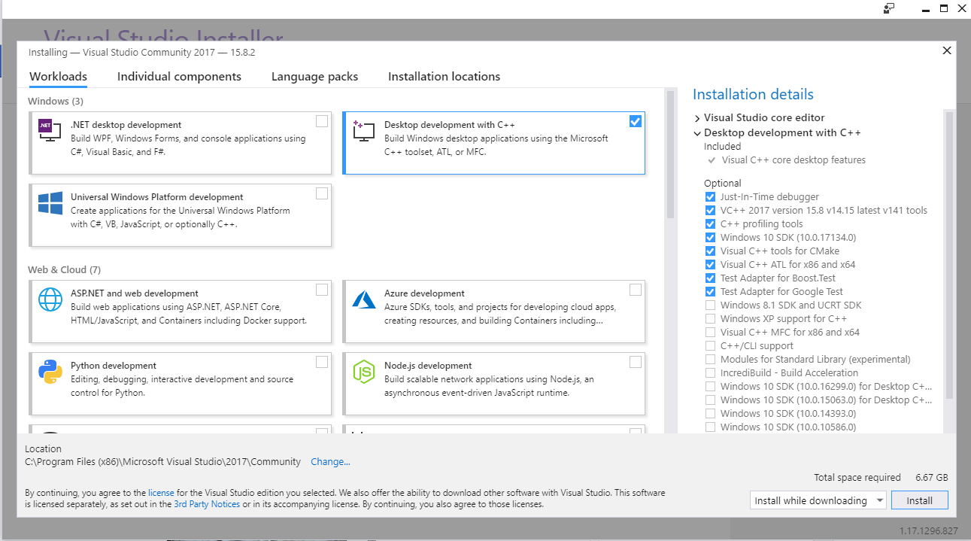

Wait for the installer to download files and install. (May take a while…. Coffee time!!..)
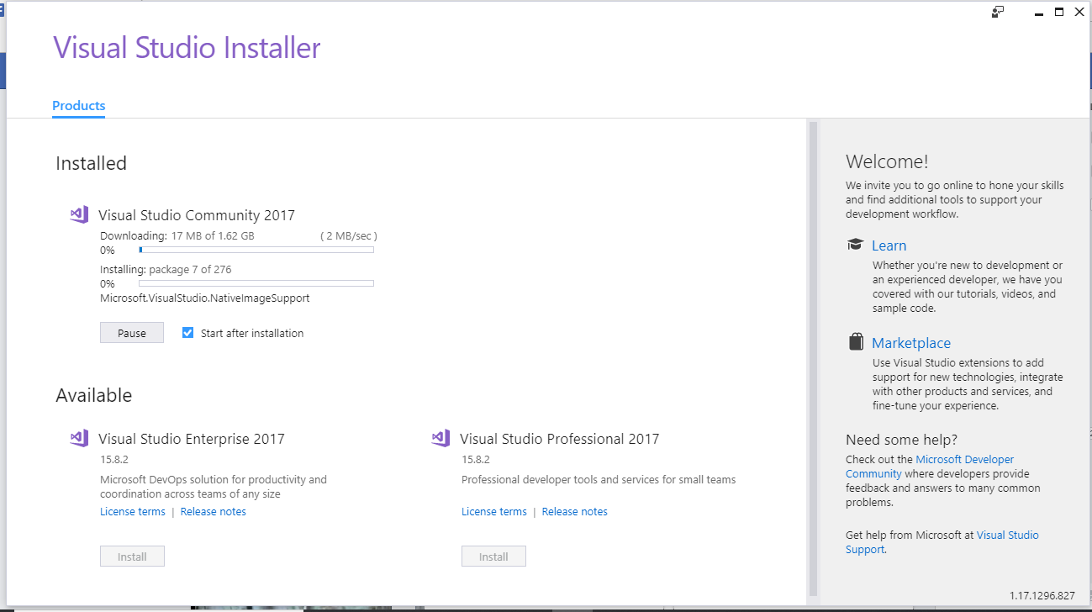

Once the installation is complete, click on Restart.
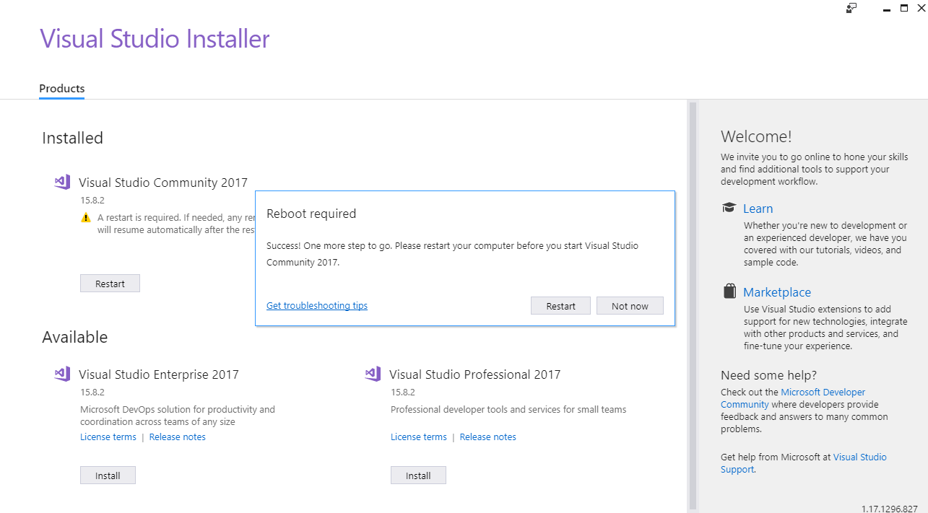

Click “Not now, maybe later.”
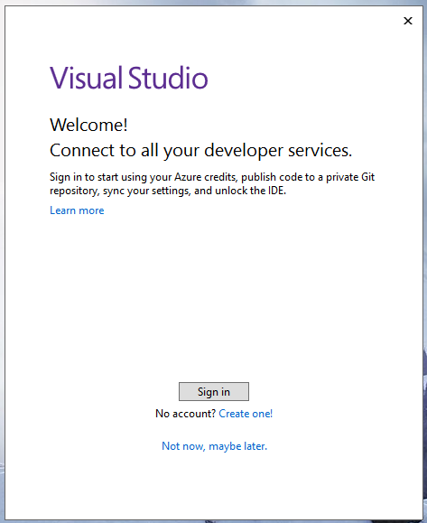

Choose the theme color you prefer and click on “Start Visual Studio”.
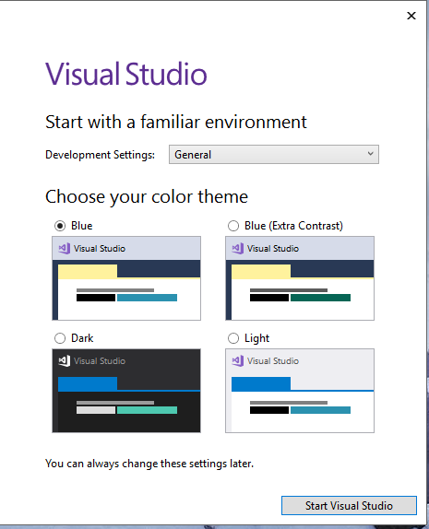

Voila!
