00. Microsoft Visual Studio 2010 Installation Tutorial
10/22/15: Y. Liow (yliow@ccis.edu)

What is Visual Studio?

“Microsoft Visual Studio is a powerful IDE (Integrated Development Environment) that ensures quality code throughout the entire application lifecycle, from design to deployment. Whether you’re developing applications for SharePoint, the web, Windows, Windows Phone, and beyond, Visual Studio is your ultimate all-in-one solution.”
from http://www.microsoft.com/visualstudio/en-us

Getting a copy of the Professional Edition

If you received a DVD with Visual Studio 2010, skip this and the following few sections and go to installation.

Visual Studio is a rather expensive professional software but students can get their hands on a copy of the professional edition by participating in DreamSpark. You'll get an ISO image of the DVD containing the software. You can think of that as a virtual copy of the DVD. You'll need an image mounting software in order to install the program using the ISO image. I will be using Daemon Tools (Google it or visit http://www.daemon-tools.cc/eng/downloads and download the lite version for free) to mount the image file. You can skip ahead to the section describing usage of Daemon Tools once you have the image file containing Visual Studio 2010 Professional Edition.

For this and almost all of my tutorials, I will be using Mozilla Firefox as the browser.

Downloading the ISO image file

To get yourself a copy of Visual Studio 2010 Professional Edition, create an account in http://www.DreamSpark.com. DreamSpark is an initiative by Microsoft to provide students with access to professional developer tools. You'll also need to verify that you are indeed a student.

The DreamSpark homepage looks like this:
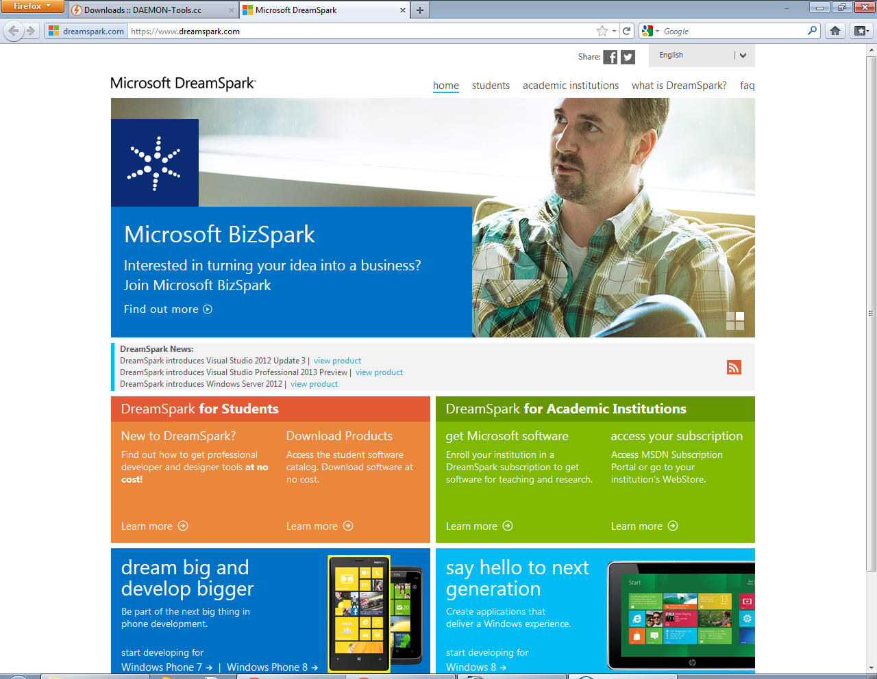

You can go to the products available for students by clicking on “Download Products” under “DreamSpark for Students”. We are interested in Visual Studio 2010 Professional. The product page for Visual Studio 2010 is located here: https://www.DreamSpark.com/Product/Product.aspx?productid=4. Go to that link or find and click on “Visual Studio 2010 Professional edition” from DreamSpark homepage.

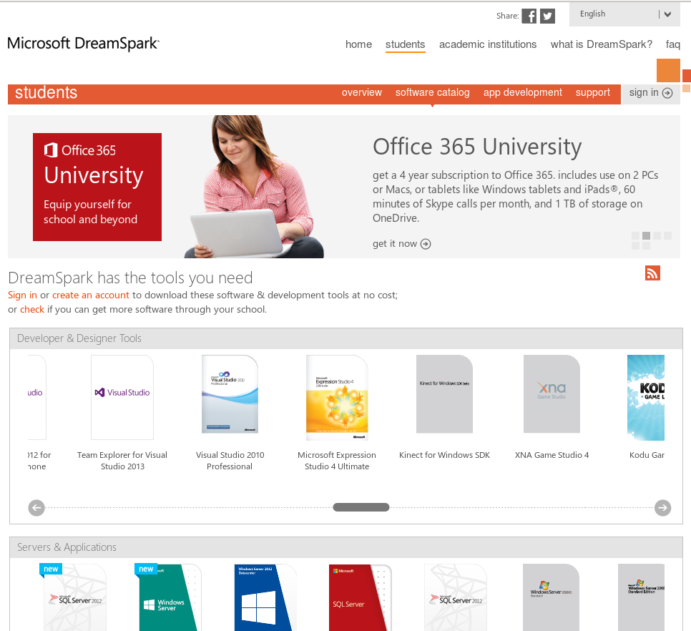

Click the “Get verified” button in the next page.

It will take you to the following page. If you already have an account with DreamSpark, log in. Else click on “Create an Account”. Click on “Continue” when the dialog box pops up.
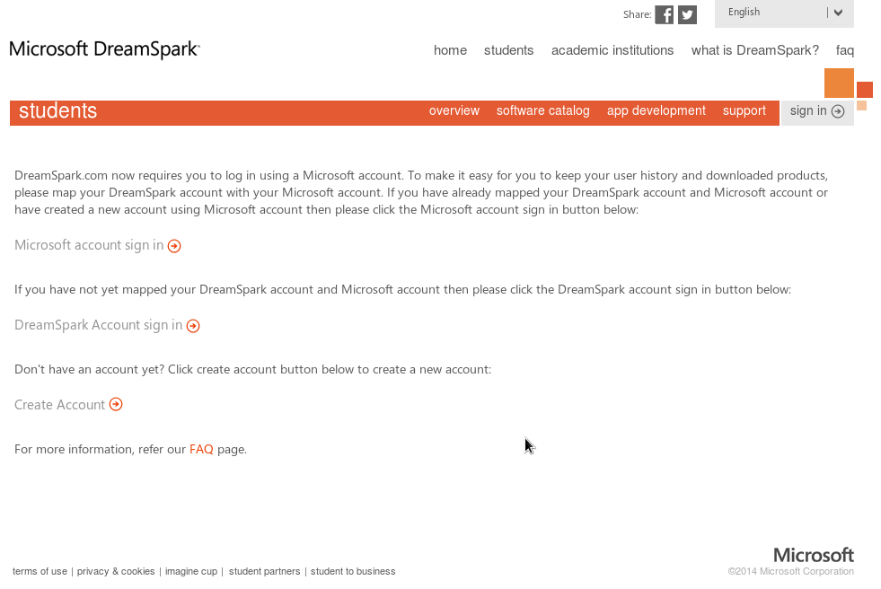

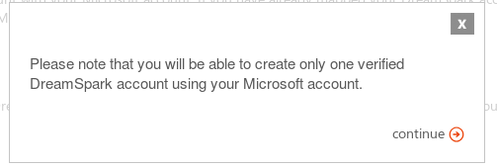

Note that you will need a Microsoft Live account to create a DreamSpark account. You can sign up for one on the Live website that you get linked to if you don't already have an account there. If you already have a Live account, just log in.



Fill in the required information in the sign up page. You must use your cougars email address. Click on “continue to verify” to move on.

In the next screen, click “I have a school email account” then enter your college email. Make sure you provide your “yourusername@cougars.ccis.edu” e-mail address. Click “Verify” to continue.

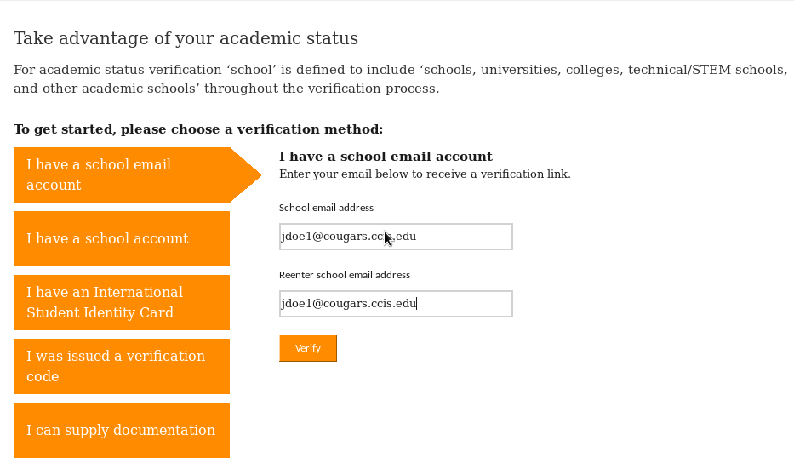
You should receive a confirmation message like this one:

You will then receive an activation email from DreamSpark with a link that you will need to click in order to activate.

You should see a confirmation page like this one:
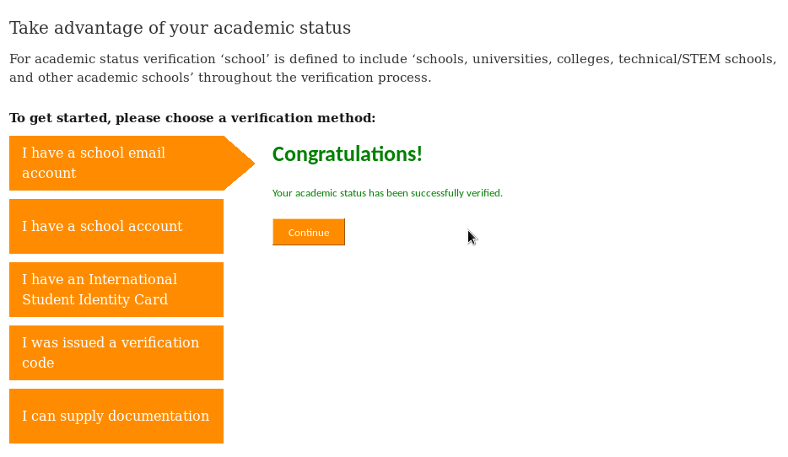
Click on “continue”. It should take you to the Microsoft Visual Studio 2010 Professional download page that you were at a bit earlier.

Alternatively, you can also go to the DreamSpark home page (http://www.DreamSpark.com). You should be signed in. Sign in if you aren't. Find the Visual Studio 2010 from the products and click to go its page or just go to https://www.DreamSpark.com/Product/Product.aspx?productid=4.

Choose the language you prefer and click “Download” in the download page. You should also generate the key by clicking on the “Get Key” button. Email the key to yourself for future reference.

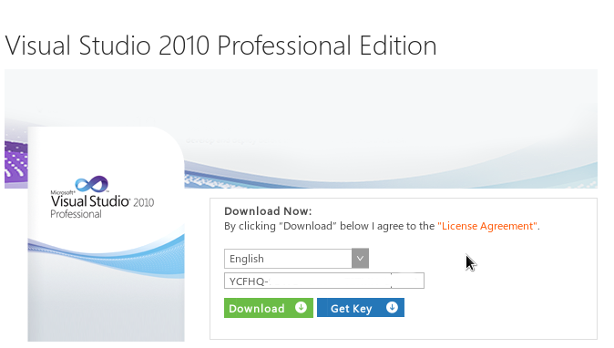

This will open a pop-up. You will need to let that pop-up open. Most modern browsers notify you that a pop-up was blocked and you can choose to open the pop-up from that notification. The notification differs for different browsers but it should look like this:

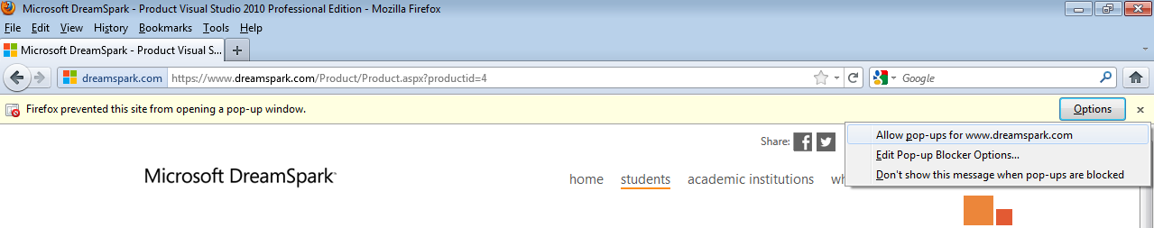

The pop-up looks like this:

Click on “Download SDM”. It will download a MSI package. Open that.

Run the package accepting any security warnings.

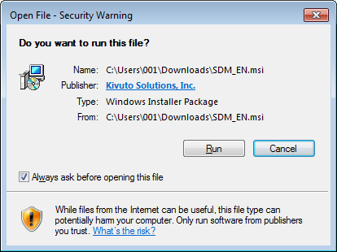

It will take you to the installation for the Secure Download Manager that DreamSpark uses.

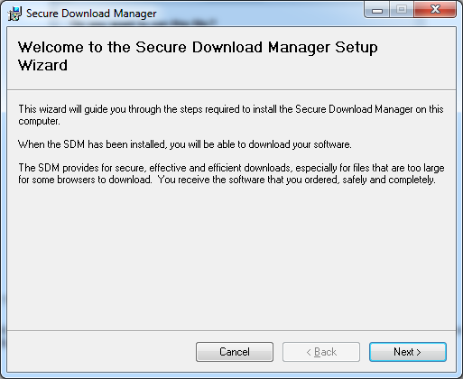

Install the Secure Download Manager by following through with the next few series of dialogue boxes.

Once you're done installing that, go back to the pop-up from the DreamSpark download page. Choose to download the .SDX file this time. That's step 3 in the instructions provided by the pop-up.

Next, open that .sdx file.

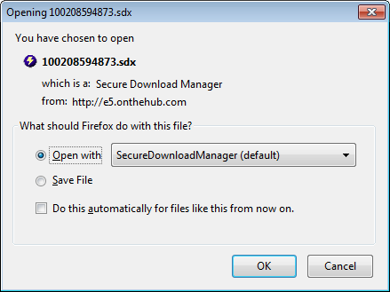

Secure Download Manager should start up and you should see something like this:

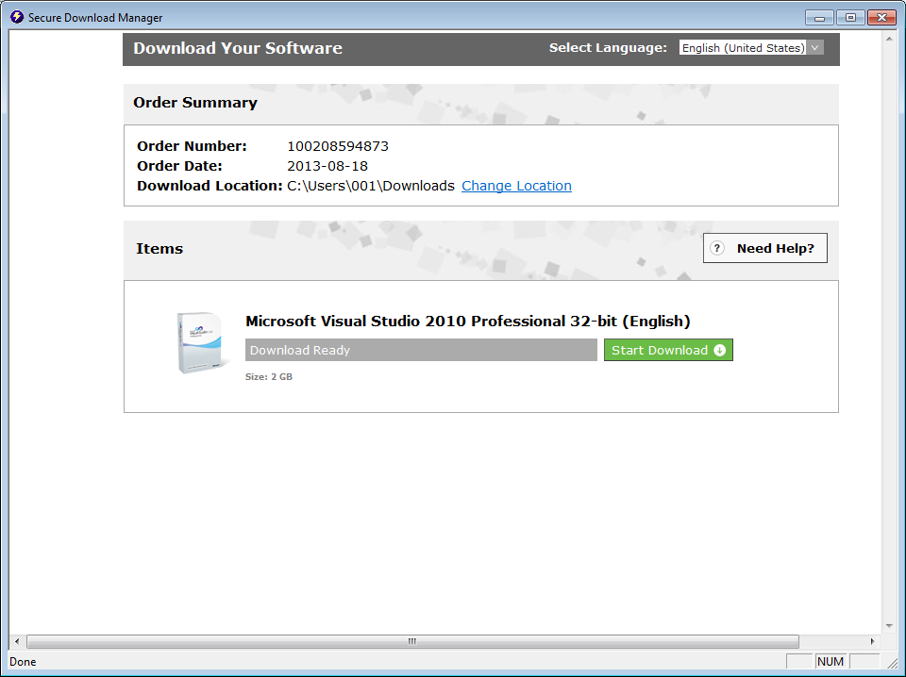

Choose the location that you want to download the file to then click on “Start Download.” I have noticed that it starts the download really slowly so don't panic if it doesn't start immediately. Resume is supported so you don't worry about having to download all of 2 GB in one sitting. You can just reopen the .sdx file in order to resume. The resume option should also be available when you rerun the “Secure Download Manager”.

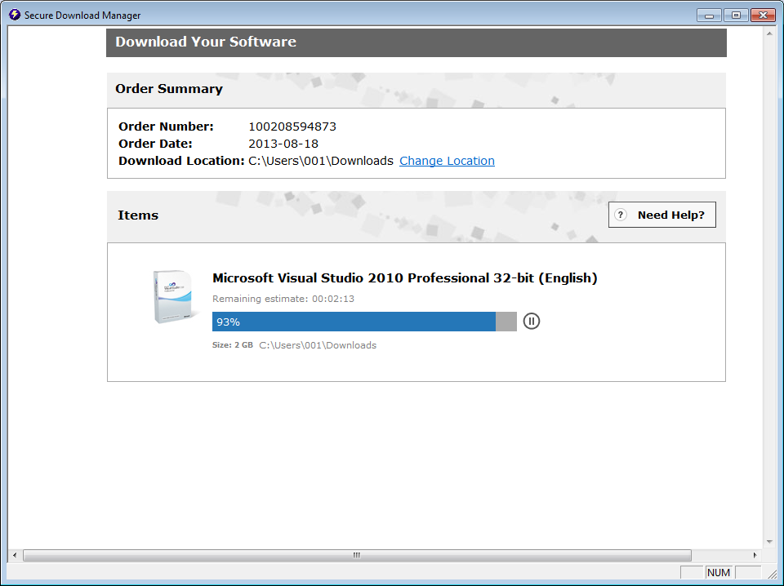

Once you are done downloading, you should see an ISO file at the location you saved the download.

Next, you will need to mount the ISO file and run the Visual Studio 2010 installation from the mounted disk. Refer to the “Mounting the ISO file” section of this tutorial.

Getting Daemon Tools

Important note: If you already have daemon tools or some other software (like alcohol 120%) to mount ISO files, skip this step.

To get Daemon Tools, either Google it and download then install a version or go to http://www.daemon-tools.cc/eng/downloads and download the Lite version for free.

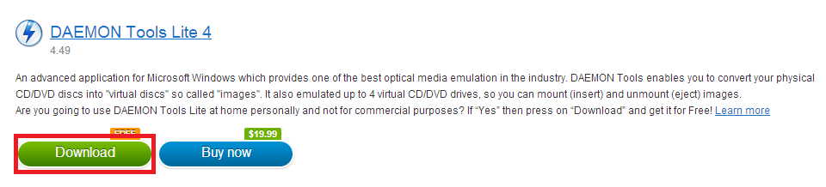
You should get a page that looks like this. Click on download again.

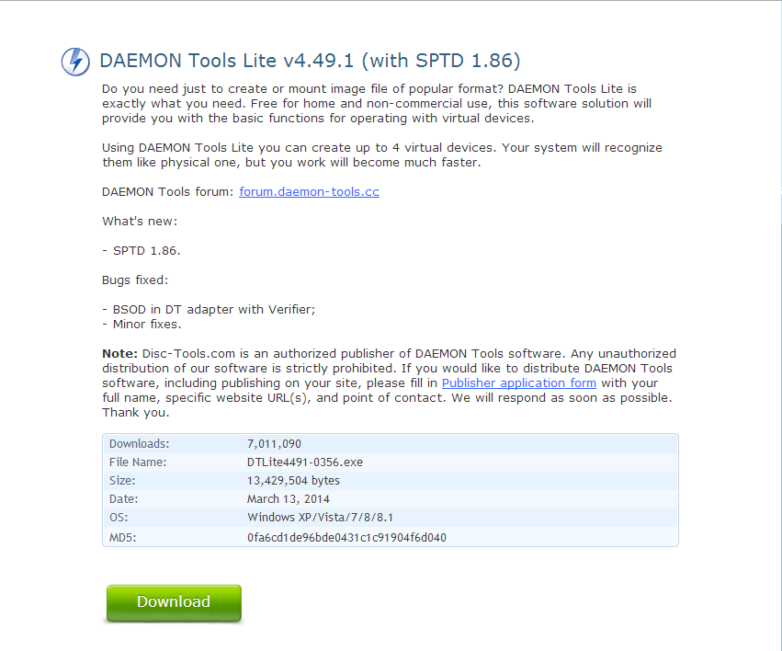

You will get a dialogue box asking you to save the file. Choose to do so.

Next, go to the folder you downloaded the file onto. Right click the file and run the file as an administrator. You will need to provide the administrator password.

You should see the following dialog box after the setup checks your system.

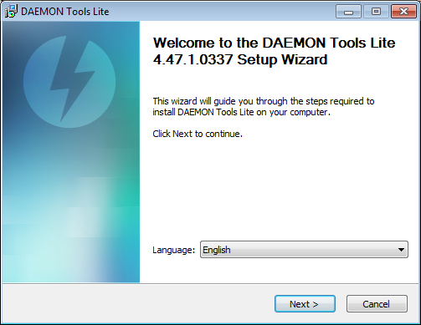
Install the software by going through the setup. If you don't already have SPTD installed on your computer, choose to include that in the installation as well. It will install the software then ask for a reboot. Choose to do so.

BEWARE that like nearly every other installer nowadays, the installer may ask you install extra software that isn't needed during the setup. You don't need to install anything but Daemon Tools and SPTD. Say no to any other offers.

Mounting the ISO file

Once you have successfully installed Daemon Tools and downloaded the “Visual_Studio2010_Professional_x86_x16-81637.img” file, run Daemon Tools Lite. You can double-click the icon in the Desktop or run it from the Start menu.

If it's your first run, you'll need to add a drive. Click on the “DT +” icon to do so. It will add one in a minute or so. Note that some versions of Daemon Tools already add a drive for you.

Right click the Device with No media mounted that is listed (The letter can differ depending on how many drives you have) then click on mount.

You should get a file browser. Locate the “Visual_Studio2010_Professional_x86_x16-81637.img” file and then click on open. You will have to switch the locator to “All files” in order to see the file.

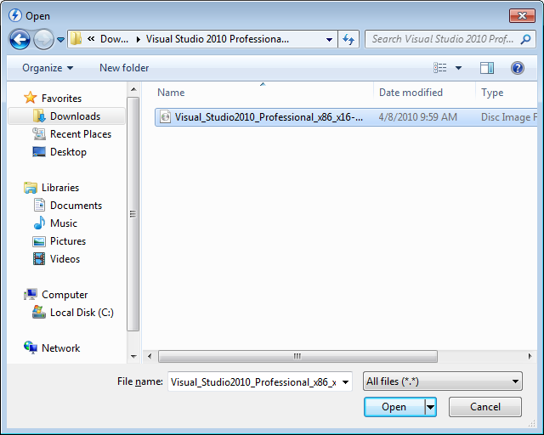
Note that the name of the file may differ for you. But as long as it's a file with the extension “.iso” or “.img” that you downloaded earlier from DreamSpark website, you are good.

Move on to installing Visual Studio 2010 itself.

INSTALLING VISUAL STUDIO 2010

Now load your Computer and go to the drive that just got mounted. Or, if you received a DVD, locate it. Then open it.

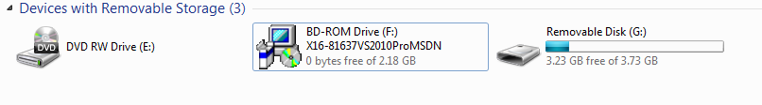
Run setup.exe. You will need administrator privileges to run it.

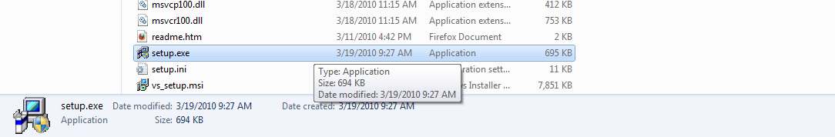

Click on install Microsoft Visual Studio 2010 on the screen that shows up.

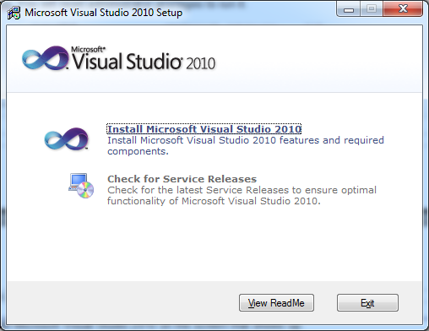

Wait while it loads up then click on next.

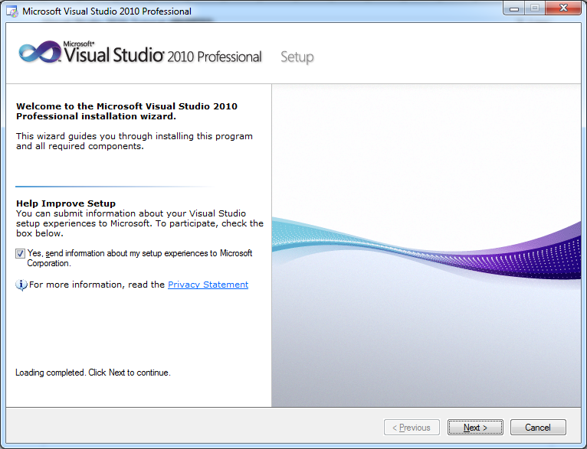

Accept the terms and click on next.
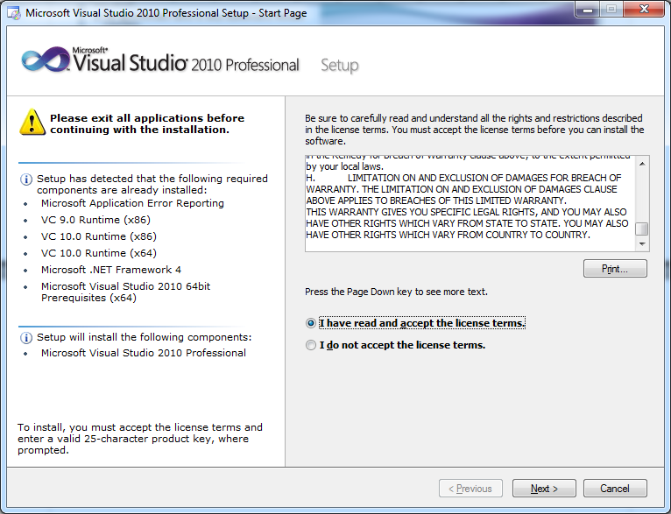
Choose Full and click on Install. You can change the install location if you want.

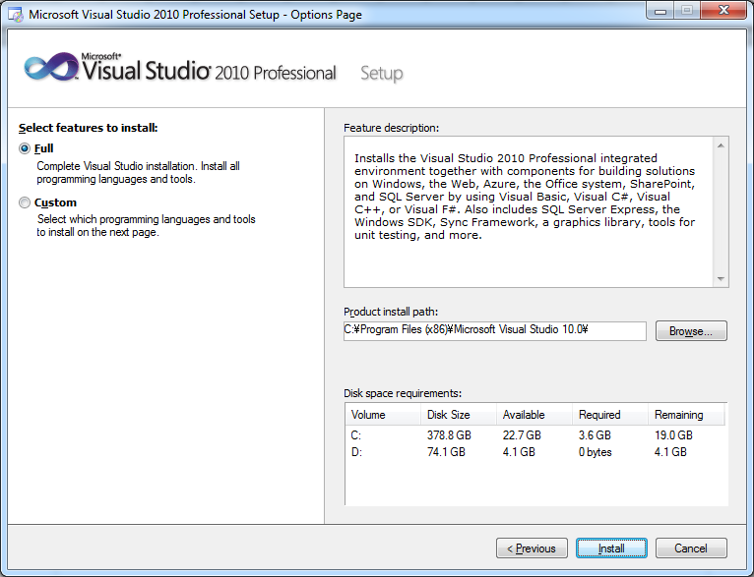

Wait for it to finish installing then click on finish.

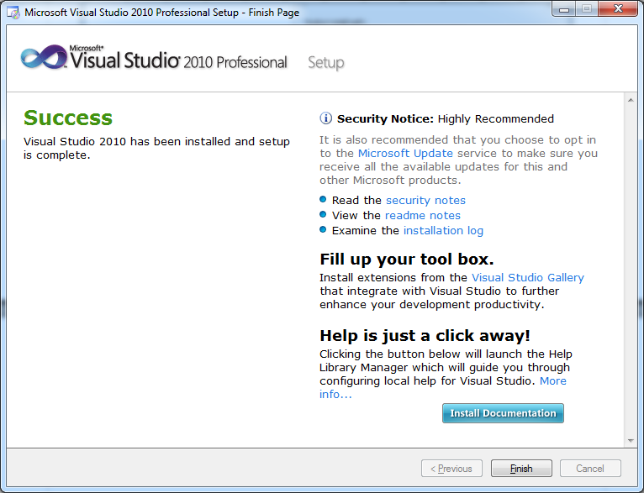
It will load the setup GUI again, you can exit out of it.

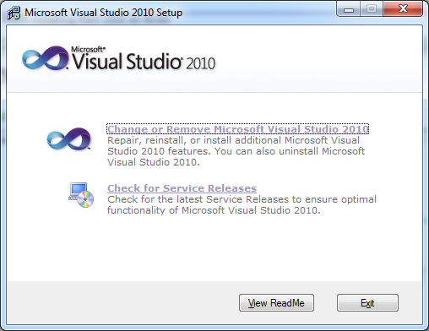

To load Visual Studio 2010, click on start button then All Programs.

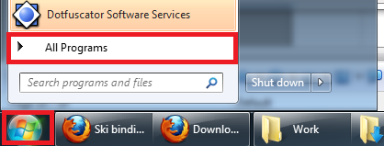
Then select Microsoft Visual Studio 2010 and click on Microsoft Visual Studio 2010.

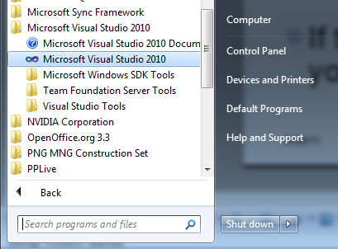

You should see the following Screen.

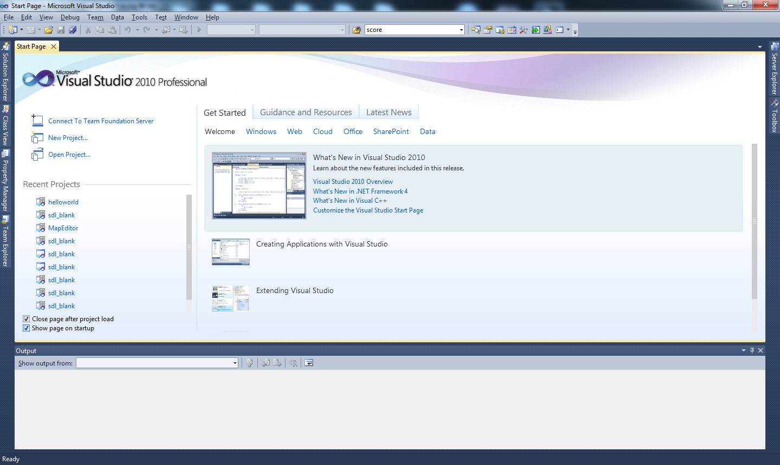
Congratulations! That's all for Visual Studio 2010 Installation. Read up on how to use Visual Studio 2010 through Google. There is also a tutorial to teach you the very basics that you will be given in class.

