Software Installation (DIY)

Objectives
- Install Firefox (optional)
- Install Python software
- Install Pygame
- Install Vpython
What is your machine drinking?

Before we being, let's just say that we're assuming you're using a 32-bit Windows XP machine (or a 64-bit machine running 32-bit Windows XP).

If you don't know what I'm talking about, then I'm 99% sure you are using a Windows XP machine ... and you're in luck!

For the rest of you Mac and Linux/FC folks ... you're on your own!

... just kidding. We'll try to help.
Installation of Firefox

This section is optional.

My favorite browsers are Firefox (FF) and Mozilla (Moz). You may use Internet Explorer (IE) from Microsoft. The only reason why I'm bring this up is because if I do a screen shot of the browser you will very likely see FF:
Why am I not telling you
the URL of Firefox's home
page? Because you should
learn to hunt for things
on your own.

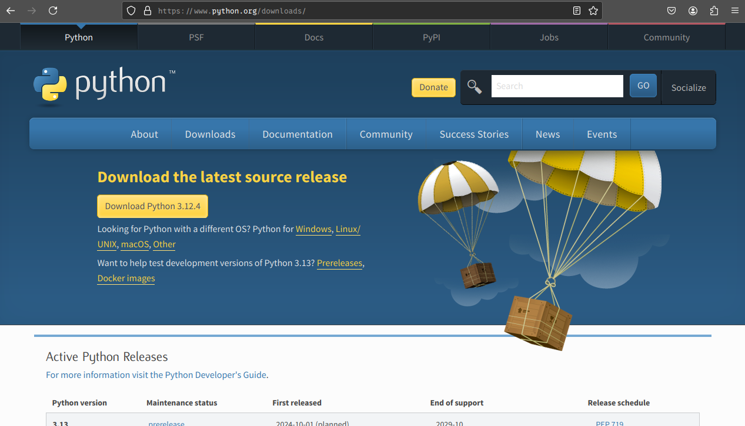
If you wish to try out FF follow the given instructions ... (I'll assume you have IE) ...

If you're comfortable looking for and installing software, all I need to tell you is to look for FF and install it. If you feel uncomfortable about that, please read on.

First open your IE. Go to “www.google.com”. Search for “Firefox”. Click on the link that gives you the home page of FF (it should be the first). FF's home should look like this:
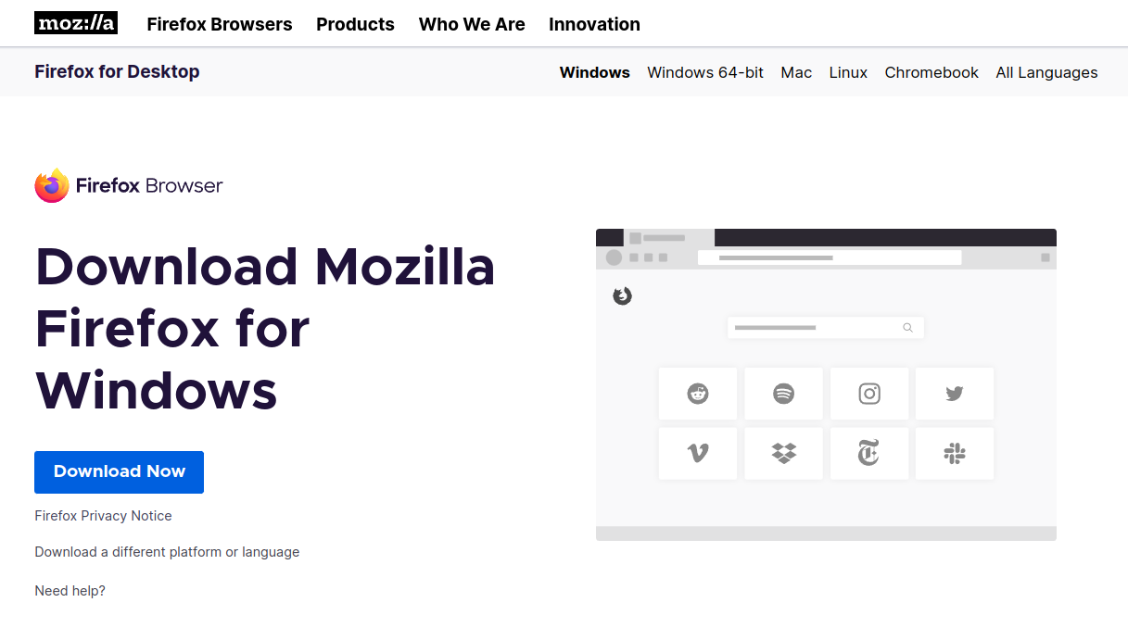
Click on “Download Firefox” and you should see this:
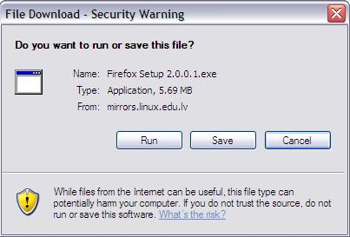
You can either click on “Run” or “Save”. If you click on “Run”, IE will download and run the FF installation program. If you click on “Save”, IE will save the FF installation program onto your hard drive.

If you click on “Run” you only need to answer a few questions to have FF installed.

If you click on “Save”, then IE asks you where you want to save the installation program. It doesn't matter where you save it ... as long as you remember the location. Let's say you choose to save it on the Desktop. Select the Desktop and click on OK. After the installation program is downloaded you will see this:

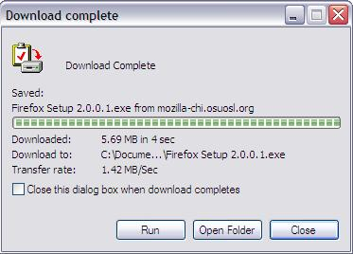
Click on “Run” to run the installation program (duh). However if you click on “Close”, then FF is not installed. You can still run the installation program. On your Desktop you will see

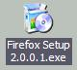
To run the installation program manually, you need to double-click on this icon.

In general, during the installation process you accept the default choices. You usually do that by clicking on “Next”. You might need to agree with some license agreement. When you're done you probably have to click on “Finish”.

Of course after you're done installing FF, you can get rid of the installation program.
Installation of Python
Google knows everything
The Python software does not come with your PC or notebook by default if you're using the Windows operating system. Here's how you make your PC understand Python.

First you need to find the home page of Python. Google for “python” and find it. It should look like this:

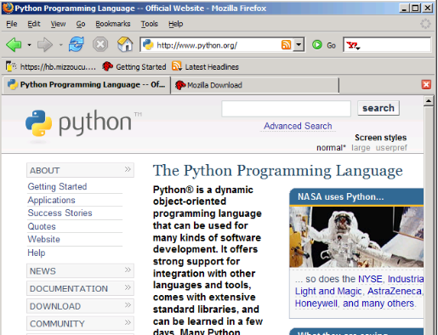
Click on “DOWNLOAD” in the left side-bar. Once in the download page, click on Releases on the left side-bar and then click on 2.5.5 (left side-bar) and then look for Python 2.5.4. From there you should be able to download Python 2.5.4 (you probably want to click on python-2.5.4.msi)

This will either save or run an installation program. If you saved it, you will need to double-click on it to run the installation. If you have chosen to run the installation it will run automatically. In either case when the installation program runs you will see this:
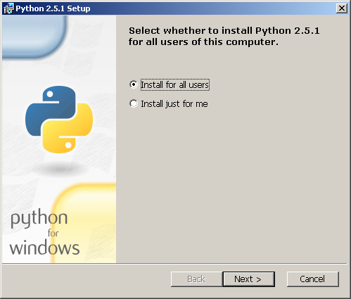
Click on “Next” and you will see this:
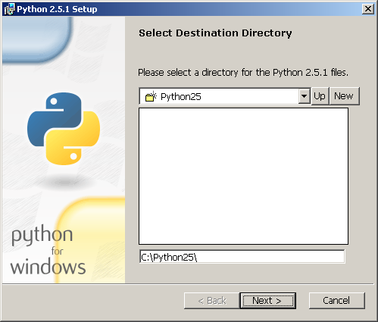

Click on “Next” and you see this:
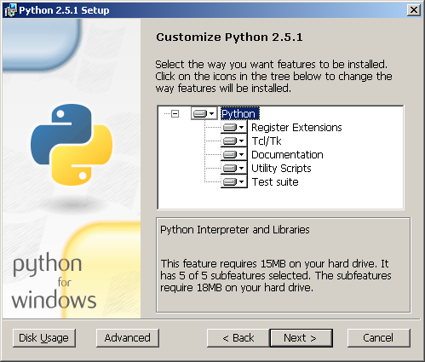
Click on “Next” again and you see this:
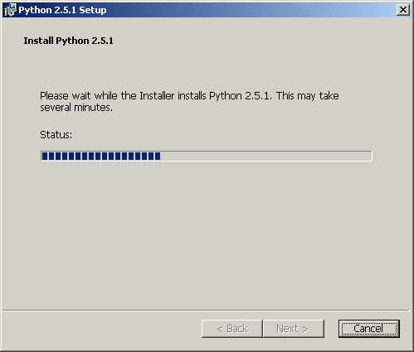
After a couple of seconds you will see this:
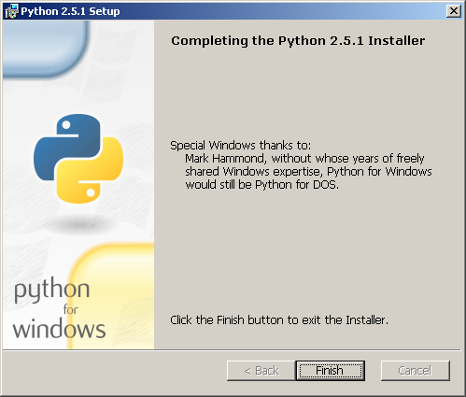
Click on “Finish” ... and you're done! You now have the Python software on your computer.
Installation of PyGame

PyGame is a Python library for game development. First Google for “pygame” to find PyGame's home page. Next, click on “Downloads” on the left side bar of the home page. The link you want to click on is labeled pygame-1.7.1release.win32-py2.5.exe. [NOTE ADDED 2011: The latest version is now 1.9.1.]

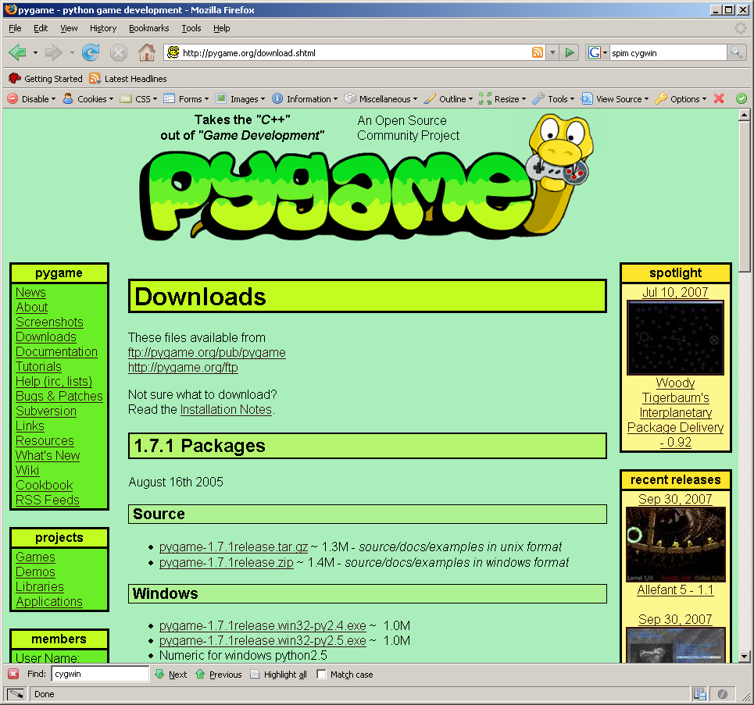
(The win32 tells you that it's for a 32-bit Windows system and the py2.5 tells you that it works with Python 2.5.x)

The rest should be easy.

Keep pressing “Next” to proceed to the next stage; you might have to do this several times. When the installation is complete, you will be prompted to press “Finish”.
Installing VPython

OK. You should be able to do this with minimal help by now ...

Install VPython!

