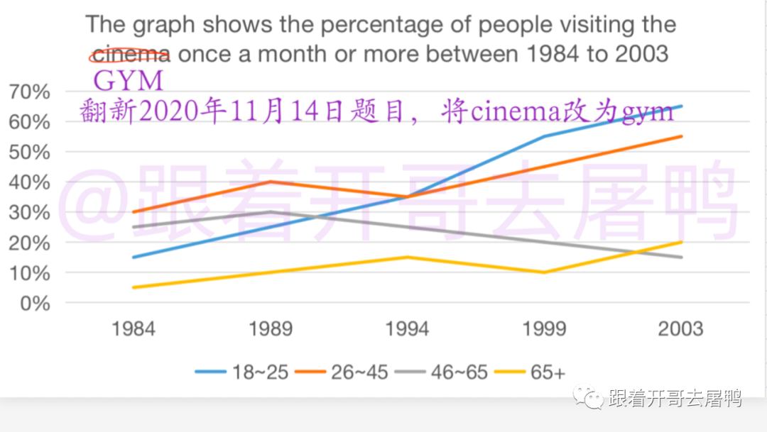The line chart illustrates the proportion of people visiting the gym at least once a month in four different age groups from 1984 to 2003.

Overall, There are three upward trend of the percentage of people visiting the gym once a month or more during the period. Meanwhile, the figure for 46-65 age group decreased rapidly after rise.

The proportion of people under 25 age went to gym every month increased significantly, moving from around 15 percent to almost 60 percent, it maintain the highest since 1994 by overtaking those of 26-45 age and 46-65 group. It can also be seen that the figure for 26-45 age group showed more variation from 1984 to 1994, then sharply went up and peaked at approximately 55 percent in 2003.

The percentage of above 65 age people monthly went to gym climbed gradually with a fluctuation, moving from 5 percent to 20 percent between 1984 and 2003. Furthermore, before the figure for 46-65 age group saw a dramatically decline, reaching ~~into~~ the lowest (15%) in 2003, it peaked at about 30 perent in 1989.

Nowadays, more and more people read electronic book rather than printed book. ~~especially young people.~~ However, whether printed book will continue to play its vital role in digital era is a controversial issue. I agree ~~with~~ that book with paper material is not essential with the development of electronic technology.

It is obvious that e-book is more convenient for people to read than printed book. It is a easier method for people to choose a book that they want to read with just one iPad or mobile phone everywhere, they do not carry a lot of printed book any more. For example, people have to carry three printed books during their journey if they want to read all of them, but they can read more then three e-books with only one iPad.

Moreover, it can also be argue that e-book is friendly to our natural environment than paper book. Producing a printed book require a lot of paper from harvesting trees, it is really waste of the natural resources. It is hard for us to maintain the health of our living environment. But procedure for creating digital book without any natural resources is more friendly to our environment, it is important for us to develop technology sustainable.

Although printed book with unique layout of image and text in each of them could provide a special reading experience, e-book could offer the same or even better with the improvement of technology. We can read e-book with their own layout in file format of pdf or epub.

In conclusion, the e-book is more convenient and environment-friendly for people to read than printed book. Therefore, I argue that printed book is not necessary in digital era.