Title:Machine Learning Techniques for Biometric and Behavioral Authentication

Name: Yilake Mengstie

Bowie State University

CTEC402

Date: September 8, 2024

### In this assignment, you will explore the Create Digital Certificates either /Linux or Window **Step-by-Step Guide Using XCA**

#### **1. Download and Install XCA**

**Part1: (5 points)**

**You need download Software to create Digital Certificates and make sure create step-by-step documentation how did**

1. **Download XCA:**
   * Go to the XCA download page.
   * Download the installer for your operating system (Windows).

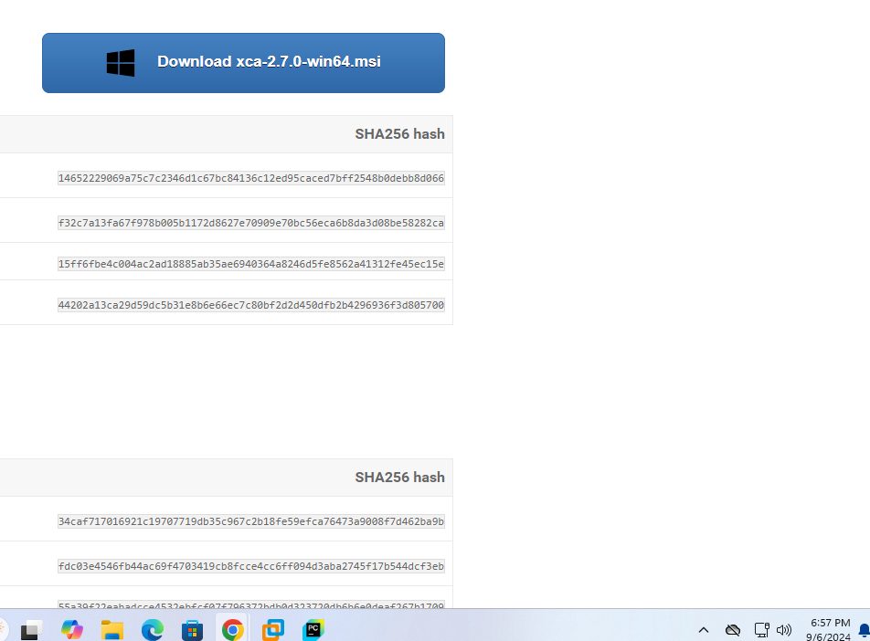

**Welcome window** 

User license and agreement 

**Install XCA:**

**Installation completed** 

#### **Generate a Certificate Authority (CA)**

1. **Create a New CA:**

Click New Certificate tab, fill the Source tab, make sure Create a self-signed certificate



**Fill out the subject** 

**Click extension tab and set the validity date** 

**KEY Created successfully**  

**Part 2: (10 points): Using ChatGPT to write research for paper.**

You need to use ChatGPT on the project1 topic to write report and power point.

Topic: Machine Learning Techniques for Biometric and Behavioral Authentication

1. **Introduction**

Machine learning (ML) has emerged as a pivotal technology in biometric and behavioral authentication, where individuals are identified and verified based on their unique physical or behavioral traits. Traditional authentication methods, such as passwords and personal identification numbers (PINs), are becoming increasingly vulnerable to security breaches. In contrast, biometric authentication leverages intrinsic human characteristics, such as fingerprints, facial recognition, and voice patterns, while behavioral authentication monitors patterns like keystroke dynamics, gait, and usage behaviors.

Integrating machine learning algorithms in these fields offers significant accuracy, adaptability, and security advancements. By learning from data, ML models can identify subtle and complex patterns that distinguish individuals, providing robust and continuous authentication solutions. This research explores the various machine learning techniques applied in biometric and behavioral authentication, examining their effectiveness, challenges, and future potential in enhancing secure and user-friendly authentication systems. The paper will also delve into the role of deep learning, anomaly detection, and real-time monitoring in developing more resilient systems against fraud and unauthorized access.

1. **Problem of The Statement**

As traditional authentication methods become increasingly vulnerable to sophisticated cyberattacks, there is a growing need for more secure and reliable alternatives. Biometric and behavioral authentication offer promising solutions by utilizing individuals' unique physiological and behavioral traits. However, these methods face challenges in ensuring accuracy, security, and adaptability across diverse environments and user behaviors. The primary problem is the limited effectiveness of conventional algorithms in handling complex biometric and behavioral data, leading to potential vulnerabilities and higher false rejection or acceptance rates. This research addresses these issues by investigating how machine-learning techniques can enhance biometric and behavioral authentication systems' precision, robustness, and real-time capabilities.

3**. Research Questions**

1. How can machine learning techniques improve the accuracy and reliability of biometric and behavioral authentication systems?
2. What are the key challenges in applying machine learning to biometric and behavioral data, and how can they be addressed?
3. How can deep learning models enhance real-time anomaly detection in biometric and behavioral authentication systems?
4. Which machine learning algorithms are most effective in reducing false acceptance and rejection rates in biometric and behavioral authentication?
5. What are the security implications of using machine learning for biometric and behavioral authentication, and how can potential vulnerabilities be mitigated?
6. How can machine learning-based authentication systems adapt to evolving user behaviors and environmental conditions?
7. How can data quality, diversity, and feature engineering impact the performance of machine learning models in biometric and behavioral authentication?
8. What are the ethical concerns surrounding using machine learning for biometric and behavioral authentication, particularly regarding privacy and data security?
9. How do different biometric and behavioral traits contribute to the effectiveness of machine learning models in authentication?
10. How can hybrid models combining multiple machine learning techniques improve overall system resilience and performance?

**4.Research Objective**

This research's main objective is to explore and evaluate the application of machine learning techniques to enhance the accuracy, reliability, and security of biometric and behavioral authentication systems. Specifically, the study aims to:

* 1. Identify the most effective biometric and behavioral authentication machine learning algorithms.
  2. Investigate methods for improving real-time anomaly detection using deep learning models in authentication processes.
  3. Address key challenges, such as false acceptance and rejection rates, by optimizing machine learning models.
  4. Examine how adaptive machine learning systems can evolve with changing user behaviors and environmental conditions.
  5. Ensure the security and privacy of biometric data in machine learning-driven authentication systems, mitigating potential vulnerabilities.

5. **Significant of the Research**

This research on machine learning techniques for biometric and behavioral authentication holds significant value in several key areas:

1. **Enhanced Security**: By exploring advanced machine learning methods, this research contributes to the development of more secure authentication systems that are resistant to common threats such as identity theft, spoofing, and hacking. It aims to strengthen security in various industries, including banking, healthcare, and government.
2. **Improved Accuracy**: The study focuses on reducing false acceptance and rejection rates and improving the reliability of authentication systems. This will make biometric and behavioral authentication more dependable in real-world applications.
3. **Scalability and Adaptability**: The research addresses how machine learning algorithms can adapt to user behaviors and environment changes, making authentication systems more scalable for diverse populations and adaptable to evolving conditions.
4. **Real-Time Anomaly Detection**: The investigation into real-time monitoring and anomaly detection using machine learning techniques will enhance the ability to detect suspicious or unauthorized activities during authentication processes.
5. **Data Privacy and Ethics**: By identifying vulnerabilities and ethical considerations, such as data privacy concerns, this research will inform best practices for ensuring that biometric and behavioral data are handled securely and ethically.
6. **Technological Advancements**: This research will contribute to the broader field of machine learning and its application in cybersecurity, fostering innovations that can benefit both academia and industry.

The findings from this research can guide the development of next-generation authentication systems that are secure but also efficient and user-friendly, addressing the growing demand for robust identity verification solutions in the digital age.

6. Literature Review

The literature review for this research will cover key themes and developments in biometric and behavioral authentication and the integration of machine learning techniques in these domains. The review will be organized around the following major areas:

1. **Biometric Authentication Systems**
   * **Overview of Biometric Modalities**: This section will cover various biometric traits such as fingerprints, facial recognition, iris scans, and voice recognition, exploring their strengths and weaknesses in authentication systems. It will review each modality's accuracy, reliability, and security challenges.
   * **Technological Advancements**: Studies on the evolution of biometric technologies, particularly the use of sensors and data collection techniques, will be explored. Research on multimodal biometric systems (systems using more than one biometric trait) will be emphasized.
2. **Behavioral Authentication Systems**
   * **Types of Behavioral Biometrics**: The focus will be on behavioral characteristics such as typing patterns, gait analysis, mouse movement, and smartphone usage patterns. These features are increasingly used in continuous authentication systems.
   * **Challenges and Opportunities**: Key studies will address issues related to behavioral variation over time and how it affects authentication accuracy. Research will also explore the potential of behavioral traits to supplement biometric traits in hybrid systems.
3. **Machine Learning in Authentication Systems**
   * **Supervised Learning for Biometric and Behavioral Data**: A detailed exploration of how supervised learning techniques (e.g., support vector machines, decision trees) are applied to classify biometric and behavioral data. Studies comparing traditional statistical models with machine learning approaches will be reviewed.
   * **Deep Learning in Biometric Authentication**: Recent developments in deep learning, particularly convolutional neural networks (CNNs) and recurrent neural networks (RNNs), will be analyzed. This section will highlight their facial recognition, fingerprint analysis, and voice authentication applications.
   * **Anomaly Detection**: Literature on machine learning techniques for detecting anomalies or abnormal behaviors during authentication processes will be examined, focusing on models like autoencoders and one-class SVMs.
4. **Hybrid and Multimodal Systems**
   * **Combination of Biometrics and Behavioral Traits**: Research on systems integrating biometric and behavioral data will be reviewed. The potential advantages of multimodal systems in improving accuracy and reducing false positives/negatives will be explored.
   * **Fusion Methods**: Studies focusing on different fusion techniques (early, late, and hybrid fusion) used to combine multiple data sources in authentication systems will be reviewed.
5. **Security and Privacy Concerns**
   * **Vulnerabilities in Biometric Systems**: This section will cover literature on security issues, including spoofing attacks, presentation attacks, and replay attacks. Research on adversarial attacks on machine learning-based systems will also be included.
   * **Privacy Issues in Data Handling**: The ethical concerns surrounding the collection, storage, and use of biometric and behavioral data will be discussed, focusing on regulations like GDPR. Studies will be reviewed proposing methods to protect user privacy, such as homomorphic encryption and differential privacy.
6. **Current Gaps and Challenges**
   * **Accuracy and Reliability Issues**: Many studies highlight the challenges of achieving high accuracy in diverse environments and with varying population groups. This section will identify gaps in the literature concerning accuracy and usability in real-world applications.
   * **Scalability**: Research will address how current systems struggle to scale effectively across large, diverse populations and evolving user behaviors.
   * **Ethical and Legal Frameworks**: Finally, the review will consider the ethical frameworks proposed for biometric and behavioral authentication, especially about privacy, consent, and data security.

By reviewing these areas, the literature review will provide a comprehensive understanding of the current state of biometric and behavioral authentication technologies and the role of machine learning in enhancing these systems. This will help identify gaps in the literature and inform the research direction.

**7. Methodology**

1. **Data Collection**

* Gather biometric data (fingerprints, facial recognition, voice, etc.) and behavioral data (keystroke dynamics, gait, etc.) from public and generated datasets.
* Preprocess and clean the data for feature extraction.

1. **Model Selection**

* Use machine learning algorithms like SVM, Random Forest, and Logistic Regression for classification.
* Implement deep learning models (CNNs for biometrics, RNNs/LSTMs for behavioral data).
* Apply anomaly detection techniques like Autoencoders for real-time monitoring.

1. **Model Training and Evaluation**

* Split data into training/testing sets and use k-fold cross-validation.
* Evaluate models with accuracy, FAR, FRR, precision, and recall metrics.
* Compare traditional machine learning models to deep learning approaches.

1. **Real-Time Authentication and Anomaly Detection**

* Simulate real-time authentication and monitor for abnormal patterns.
* Test the system's response to attacks and behavior changes.

1. **Security and Privacy**

* Implement encryption and privacy-preserving techniques (e.g., homomorphic encryption, differential privacy) to secure biometric data.

1. **Adaptability and Scalability Testing**

* Test model adaptability with changing user behaviors and environmental conditions.
* Evaluate the system's scalability for larger datasets and diverse users.

1. **Ethical Considerations**

* Ensure data privacy, informed consent, and bias mitigation during model development.

F. **Result Analysis**

* Analyze model performance, visualize results, and provide recommendations for enhancing biometric and behavioral authentication using machine learning.

8. **Conclusion**:

This research explores the application of machine learning techniques to enhance biometric and behavioral authentication systems. Starting with understanding the limitations of traditional authentication methods, the study investigates how machine learning can improve accuracy, security, and real-time anomaly detection. Through data collection and preprocessing of biometric and behavioral traits, a range of supervised and deep learning models were implemented and evaluated using relevant metrics. The research also addresses the challenges of false acceptance/rejection rates and ensures user data security through encryption and privacy-preserving methods.

Key findings demonstrate the potential of machine learning to create adaptive, scalable authentication systems that are more robust to security threats. The study’s significance lies in advancing the accuracy and reliability of authentication methods while maintaining high ethical standards in data privacy and bias mitigation. This research paves the way for more secure, user-friendly, and scalable authentication technologies in an increasingly digital world.