EDA & Feature Selection — Remittance Transfer Costs (Team 105)
ISyE 7406 — Data Mining & Statistical Learning

Exploratory Data Analysis

1.1 Data Overview
The dataset is a transaction-level extract from the World Bank Remittance Prices Worldwide (RPW) database, covering United States to Latin America and Caribbean (LAC) remittance corridors. It holds 12,397 rows and 23 columns, one row per provider offering per corridor per quarter, spanning period 2016_2Q through 2025_1Q. The extract is already restricted to the post-schema-change reporting period, so there is no pre-2016 data to account for and no schema-harmonization step is needed.
Only the cc2 * fields (cc2 lcu fee, cc2 lcu fx rate, cc2 fx margin, cc2 total cost %) have missing values, each absent for exactly 235 rows (1.9% of rows). Standard Note is missing for a much larger share -- 8,585 rows (69.2%) -- but that is expected, since it is a free-text disclosure note that simply is not written when there is nothing unusual to disclose. Every other column, including the target cc1 total cost %, is fully populated.
Column | # Missing | % Missing
Standard Note | 8585 | 69.25%
cc2 lcu fee | 235 | 1.9%
cc2 lcu fx rate | 235 | 1.9%
cc2 fx margin | 235 | 1.9%
cc2 total cost % | 235 | 1.9%
Table 1. Columns with missing values.

1.2 Data Cleaning for EDA Purposes
The saved CSV is never modified; all cleaning happens in memory. speed actual and pickup method are lower-cased and stripped to merge near-duplicate categories caused by inconsistent capitalization (e.g. "Less than one hour" vs. "less than one hour"; "Own/partner bank account" vs. "Own/partner Bank account"). The period field (e.g. "2016_2Q") is parsed into integer year and quarter columns for the trend analysis below and for the temporal train/test split planned in downstream modeling work.

1.3 Target Variable: cc1 total cost %
The target variable, cc1 total cost %, is the total cost (as a percentage of the transferred amount) a sender pays using the cheapest ranked (cc1) product for a given firm/corridor/quarter. Its distribution is right-skewed, with a heavy tail driven by a small number of very expensive corridors and products. That lines up with the proposal's observation that Cuba (about 12.0% average) and Guyana (about 8.7% average) are high-cost outlier destinations sitting well above both the corridor average (5.44%) and the UN SDG 10.c target of 3%. Most of the mass falls between roughly 1% and 8%, but the heavy tail means a plain OLS model could end up sensitive to these few corridors, so regularization (Ridge/LASSO) and possibly a log-transform of the target are worth considering in later modeling.
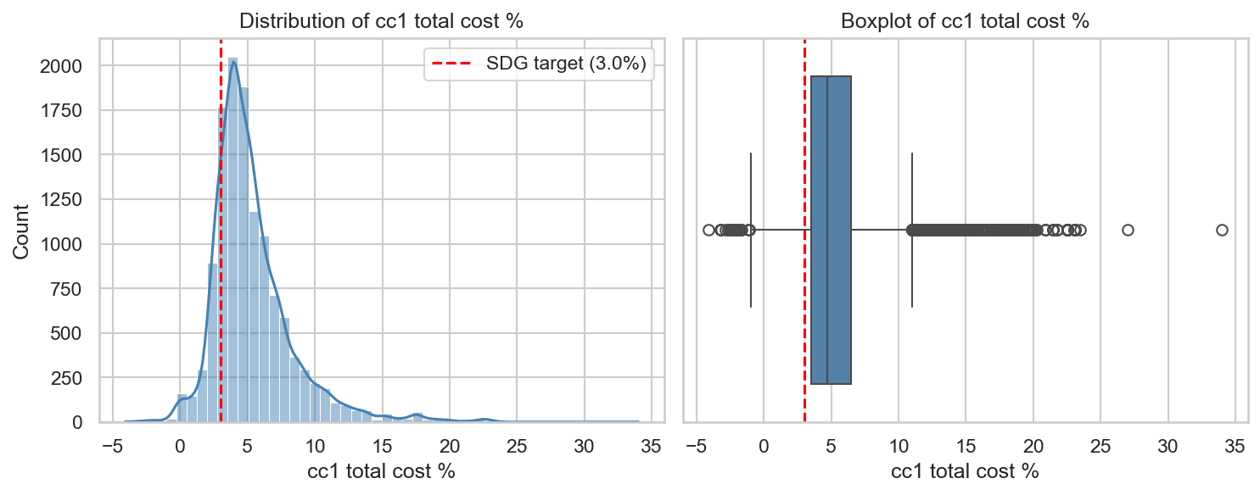
Figure 1. Distribution of cc1 total cost % (histogram and boxplot), with the 3% SDG target marked.

1.4 Cost by Firm Type, Destination, Payment Instrument, and Year
Banks tend to run notably higher and more variable total costs than Money Transfer Operators (MTOs), which dominate the market by volume (10,673 of 12,397 rows). The "Money Transfer Operator / Building Society" and "Non-Bank FI" categories are sparse (34 and 11 rows respectively), making them candidates for consolidation or removal in the feature-selection subset.
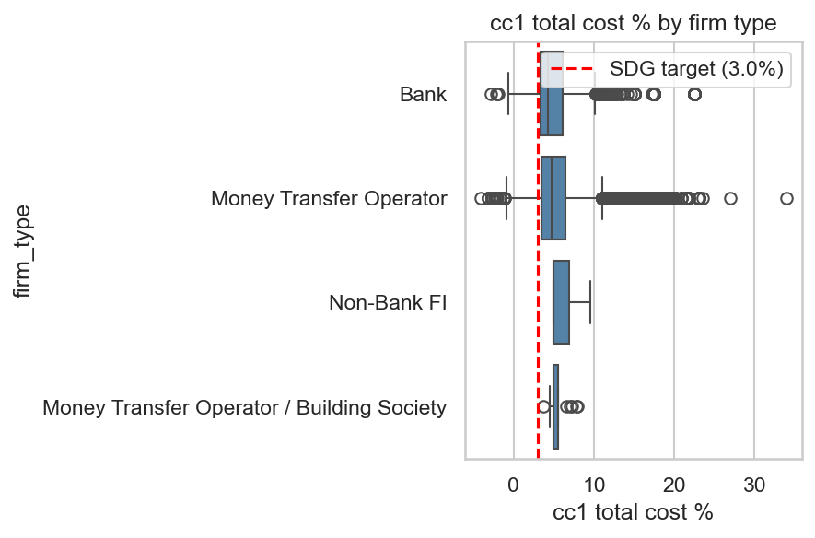
Figure 2. cc1 total cost % by firm type.
Destination is clearly a strong driver of cost: Cuba and Guyana sit far above both the corridor average and the 3% SDG line, while several destinations -- Mexico among them, the highest-volume corridor -- sit close to or even below the SDG target. This spread is reason enough to include destination_name/corridor as a categorical predictor, and it is also what motivates the descriptive clustering step planned later in the project.
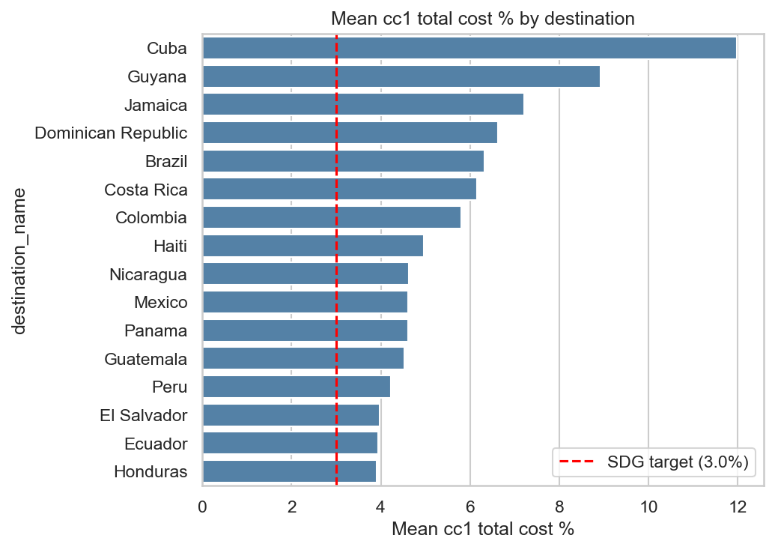
Figure 3. Mean cc1 total cost % by destination, sorted descending.
Cash-based transfers (the largest group, 3,780 rows) and card-based instruments show different cost profiles, with the "Multiple" group landing somewhere in between. That is why the cleaned payment_instrument_group (6 categories) is used rather than the raw 16-value payment instrument column, which contains compound strings such as "Bank account transfer,Cash" that do not one-hot encode meaningfully.
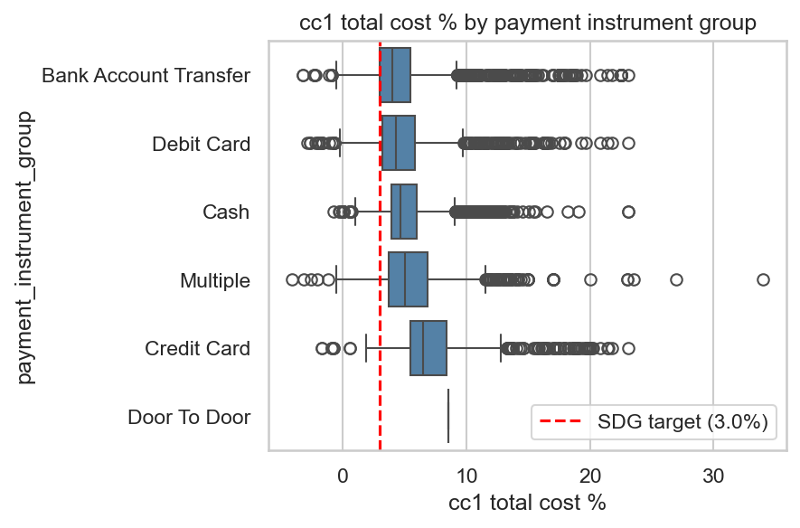
Figure 4. cc1 total cost % by payment instrument group.
Mean cost moves only modestly from year to year across 2016-2025 and stays well above the 3% SDG target throughout, so there is no clear long-run downward trend toward the SDG goal in this corridor set. year is therefore treated as a secondary, lower-signal predictor, while still being retained for the planned pre-2023/2023+ temporal train/test split.
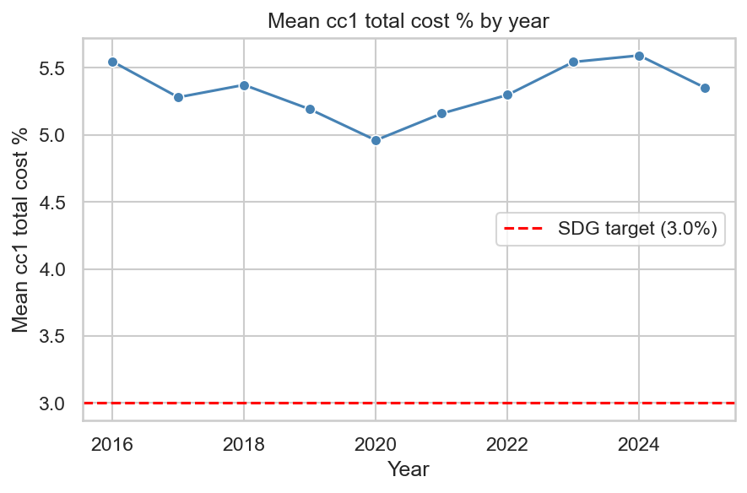
Figure 5. Mean cc1 total cost % by year, 2016-2025.

1.5 Transparency Investigation
The dataset has no explicit transparency boolean. Per the proposal, a transaction is considered non-transparent when the receiving-side exchange rate is not disclosed. We test a candidate proxy for this: cc2 total cost % is null (235 rows) wherever the second comparator product's cost -- which requires the FX rate to compute -- could not be computed or disclosed. Rows flagged non-transparent by this proxy are a small subset (about 1.9%), and the crosstab shows they are not well explained by routine disclosure notes. In fact the pattern runs opposite to what a simple "missing note = transparent" story would predict: 204 of 235 (87%) of the flagged rows do have a Standard Note present, versus only about 30% of the transparent group (3,608 of 12,162). Looking at the note text itself, the dominant reason is "Send limits on amount" (191 of the 235 rows, 81%), which is a transaction-limit disclosure, not an exchange-rate-disclosure statement. So the cc2-null proxy is really picking up a mix of true non-disclosure and an unrelated send-limit restriction, making it a noisier signal for "exchange rate not disclosed" than the proposal's framing implies. The non-transparent group also shows a modestly different cost distribution. We retain is_non_transparent as an engineered binary candidate feature, but flag it explicitly as an imperfect proxy (not a ground-truth transparency flag) conflated with send-limit disclosures.
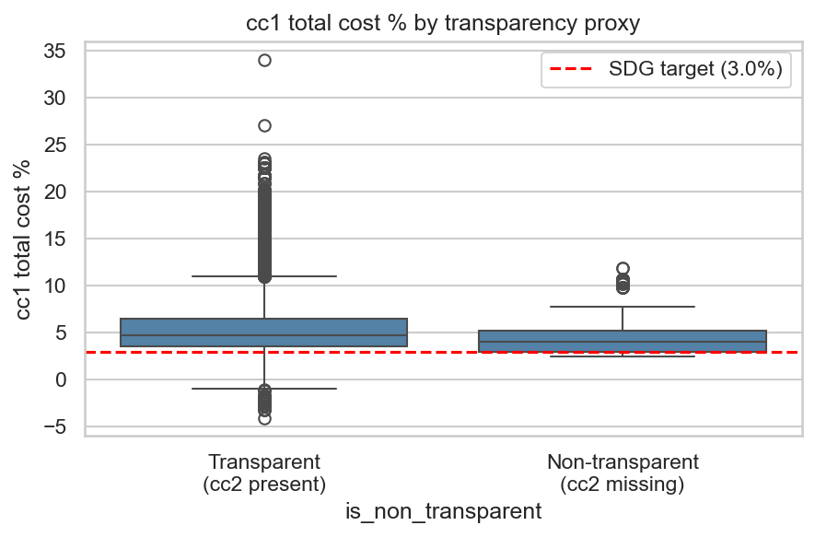
Figure 6. cc1 total cost % by transparency proxy (cc2 total cost % missing vs. present).

1.6 Correlation Matrix
Pearson correlations were computed among all numeric RPW fields plus the engineered year column, to understand (a) mechanical multicollinearity between the cc1 and cc2 fields, (b) which numeric fields correlate most with the target, and (c) the implication for shrinkage-method choice downstream.
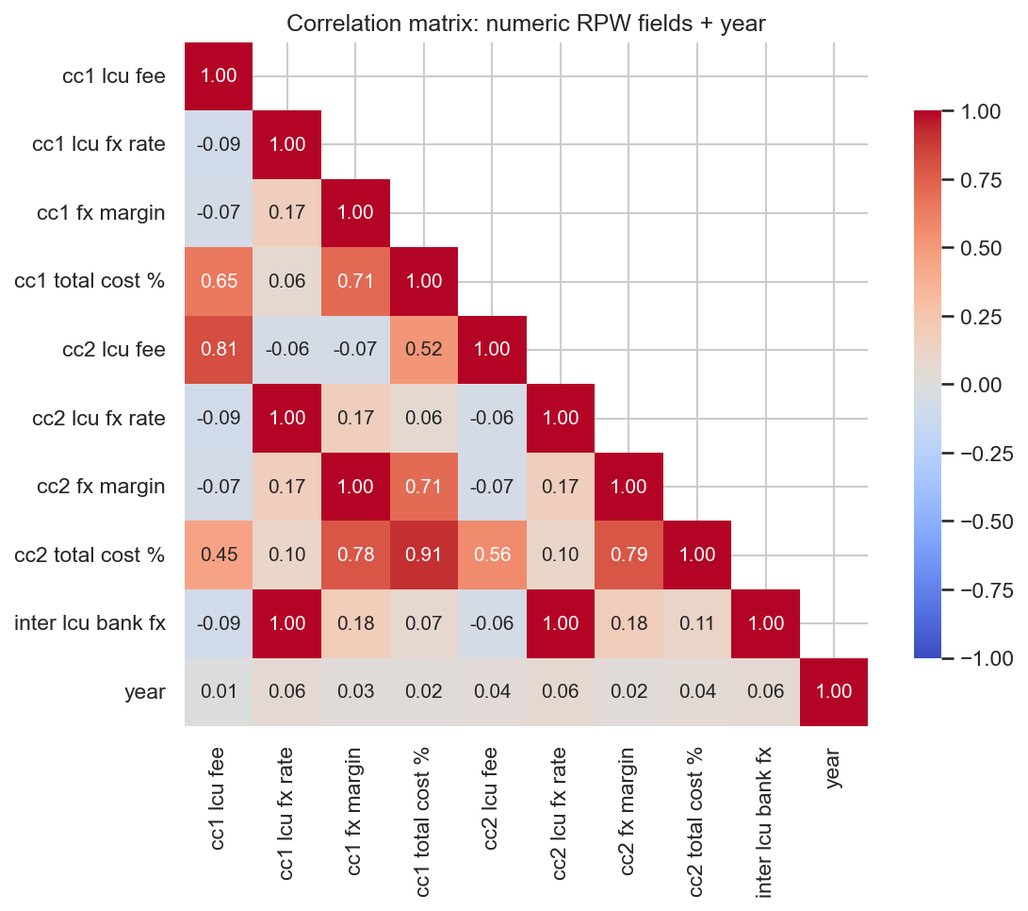
Figure 7. Pearson correlation heatmap of numeric RPW fields plus year.
Field | cc1 lcu fee | cc1 lcu fx rate | cc1 fx margin | cc1 total cost % | cc2 lcu fee | cc2 lcu fx rate | cc2 fx margin | cc2 total cost % | inter lcu bank fx | year
cc1 lcu fee | 1.0 | -0.09 | -0.07 | 0.65 | 0.81 | -0.09 | -0.07 | 0.45 | -0.09 | 0.01
cc1 lcu fx rate | -0.09 | 1.0 | 0.17 | 0.06 | -0.06 | 1.0 | 0.17 | 0.1 | 1.0 | 0.06
cc1 fx margin | -0.07 | 0.17 | 1.0 | 0.71 | -0.07 | 0.17 | 1.0 | 0.78 | 0.18 | 0.03
cc1 total cost % | 0.65 | 0.06 | 0.71 | 1.0 | 0.52 | 0.06 | 0.71 | 0.91 | 0.07 | 0.02
cc2 lcu fee | 0.81 | -0.06 | -0.07 | 0.52 | 1.0 | -0.06 | -0.07 | 0.56 | -0.06 | 0.04
cc2 lcu fx rate | -0.09 | 1.0 | 0.17 | 0.06 | -0.06 | 1.0 | 0.17 | 0.1 | 1.0 | 0.06
cc2 fx margin | -0.07 | 0.17 | 1.0 | 0.71 | -0.07 | 0.17 | 1.0 | 0.79 | 0.18 | 0.02
cc2 total cost % | 0.45 | 0.1 | 0.78 | 0.91 | 0.56 | 0.1 | 0.79 | 1.0 | 0.11 | 0.04
inter lcu bank fx | -0.09 | 1.0 | 0.18 | 0.07 | -0.06 | 1.0 | 0.18 | 0.11 | 1.0 | 0.06
year | 0.01 | 0.06 | 0.03 | 0.02 | 0.04 | 0.06 | 0.02 | 0.04 | 0.06 | 1.0
Table 2. Pearson correlation matrix (numeric fields + year).
cc1 total cost % and cc2 total cost % are strongly positively correlated (as are the lcu fee and fx margin pairs). This is mechanical: cc1 and cc2 are the two cheapest comparator products for the same firm/corridor/quarter, priced off the same underlying FX market and fee schedule, so they naturally move together. Because cc2 * fields are partially derived from, and highly predictive of, the target by construction, they are excluded from the predictor set in the Feature Selection section to avoid leakage. Among the remaining independent numeric fields, cc1 fx margin shows the strongest correlation with the target, which makes sense since fx margin is a direct fee component. cc1 lcu fx rate and inter lcu bank fx correlate weakly, consistent with them being currency-scale fields rather than true cost drivers, and year has very weak correlation with the target. Once the cc2 * leakage fields are dropped, the remaining numeric block is small and not highly collinear, so neither Ridge's L2 shrinkage nor LASSO's sparsity is strictly necessary to control numeric multicollinearity. The categorical encoding is another story: many one-hot dummies (e.g. per destination) reintroduce enough dimensionality that both methods are still worth comparing, and LASSO's ability to zero out redundant dummy levels is particularly useful there.

1.7 EDA Summary
- The dataset is clean and complete except for the mechanically linked cc2 * fields (235 missing rows, 1.9%) and the free-text Standard Note (8,585 missing, 69.2%).
- The target cc1 total cost % is right-skewed, with Cuba and Guyana as clear high-cost outlier destinations well above the 3% SDG 10.c target.
- destination_name/corridor and firm_type are strong categorical drivers of cost; payment_instrument_group also differentiates cost meaningfully.
- There is no strong long-run time trend in mean cost from 2016 to 2025.
- cc2 total cost % being null is a usable, if imperfect, transparency proxy.
- cc1 fx margin is the strongest independent numeric correlate of the target; cc1 lcu fee and inter lcu bank fx are currency-scale fields that need caution before use as cross-country-comparable numeric predictors.
- cc2 * fields must be excluded from the predictor set (target leakage); firm_type's rare categories (Non-Bank FI, MTO/Building Society) need consolidation or filtering for modeling.

Feature Selection
This section is grounded in the course's model/variable selection methodology (ISyE 7406, Prof. Yajun Mei). Information criteria (AIC, BIC, Mallow's Cp) score a model with k parameters and maximized log-likelihood as IC = -2*log-likelihood + penalty*k; AIC uses penalty 1 (equivalently 2k), while BIC uses penalty log(n) -- a heavier penalty for larger samples that favors sparser models -- and Mallow's Cp is an analogous criterion under squared-error loss. Forward/backward/stepwise sequential search greedily adds or removes one variable (or block of variables) at a time, choosing at each step the change that most improves the information criterion, and stopping when no further improvement is available. Ridge regression (L2 penalty) solves argmin ||Y-X*beta||^2 + lambda*sum(beta_j^2), shrinking all coefficients smoothly toward zero but, generically, never exactly to zero. LASSO (L1 penalty) solves argmin ||Y-X*beta||^2 + lambda*sum(|beta_j|); because the L1 constraint region has corners located on the coordinate axes, the optimum frequently lands exactly on an axis, driving some coefficients to exactly zero -- i.e. LASSO performs implicit variable selection as a byproduct of regularization. PCA/PLS provide complementary dimensionality views: PCA finds orthogonal linear combinations of the numeric predictors that maximize explained variance (unsupervised, ignores the target), while PLS performs the analogous decomposition while maximizing covariance with the target (supervised).

2.1 Candidate Feature Set and Encoding
Candidate categorical predictors: firm_type (consolidated -- the two MTO variants merged into one "Money Transfer Operator" level; the 11 Non-Bank FI rows dropped from the modeling subset as too sparse per the proposal), payment_instrument_group, access point, receiving network coverage, destination_name, normalized speed actual, and normalized pickup method. Candidate numeric predictors: cc1 fx margin, engineered year, and the engineered is_non_transparent flag.
Excluded from the candidate numeric set: cc1 lcu fee and inter lcu bank fx are expressed in local currency units, so they are not comparable across the 16 destination countries without normalization -- using them as raw cross-country numeric features would implicitly encode currency scale rather than a meaningful cost driver. Both are excluded here; a later modeling notebook could instead engineer a currency-normalized ratio (e.g. fee as a percentage of a reference transfer amount) if that data were available. All cc2 * fields are also excluded per the correlation-based leakage discussion above. After dropping the 11 Non-Bank FI rows and consolidating firm_type, 12,386 rows remain for feature selection. Categorical predictors are one-hot encoded (pd.get_dummies, drop_first=True) and numeric predictors are standardized (StandardScaler), producing a 42-column encoded feature matrix.

2.2 Correlation / Multicollinearity Pruning
Correlation and Variance Inflation Factor (VIF, computed manually as 1/(1-R^2) from regressing each numeric column on the others via OLS, which avoids any dependency issue with the statsmodels VIF helper) were re-examined for the small numeric candidate block only (cc1 fx margin, year, is_non_transparent); the cc1/cc2 mechanically tied fields were already excluded above, so there is no need to re-check them here.
Feature | VIF
year | 1.008
is_non_transparent | 1.007
cc1 fx margin | 1.001
Table 3. Variance Inflation Factor, numeric candidate block.
All VIF values for the numeric block fall well under the common rule-of-thumb threshold of 10, confirming these three numeric/engineered features are not collinear with each other. VIF is not computed across the full one-hot-encoded dummy matrix, since it is only meaningful for continuous/near-continuous regressors; collinearity among dummy groups is instead handled naturally by drop_first=True reference-level encoding and by the shrinkage methods below.

2.3 Model/Variable Selection via Information Criteria
A greedy forward stepwise selection was run using statsmodels OLS, scoring each candidate addition by AIC and BIC, over a manageable set of candidate "blocks": the three numeric/engineered features individually, plus each categorical predictor's full dummy group added together, since adding a factor should add all of its dummy columns at once. The procedure stops adding blocks once BIC stops improving.
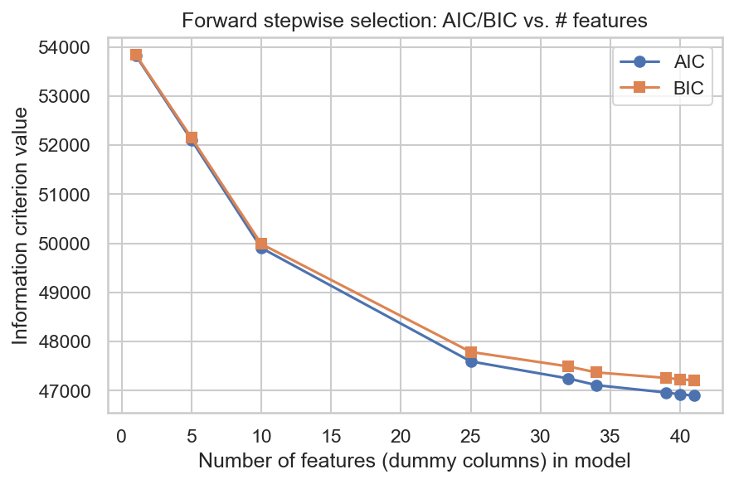
Figure 8. AIC/BIC vs. number of features in forward stepwise selection.
destination_name, payment_instrument_group/pickup method, and cc1 fx margin are added earliest and contribute the largest BIC improvements, with later blocks contributing progressively smaller gains and the curve flattening once these dominant drivers are included -- consistent with the EDA findings above. Note that firm_type_clean is the one candidate block not in the selected list: it was tested last and did not improve BIC further at that point, so the greedy search stopped before adding it (see Section 2.6 for why it is nonetheless kept in the final recommended feature set).

2.4 Shrinkage-Based Selection: Ridge vs. LASSO
RidgeCV and LassoCV were fit on the full encoded, scaled feature matrix (all numeric plus all one-hot dummy columns) to predict cc1 total cost %, using 5-fold cross-validation over a log-spaced alpha grid (np.logspace(-3, 2, 50)).
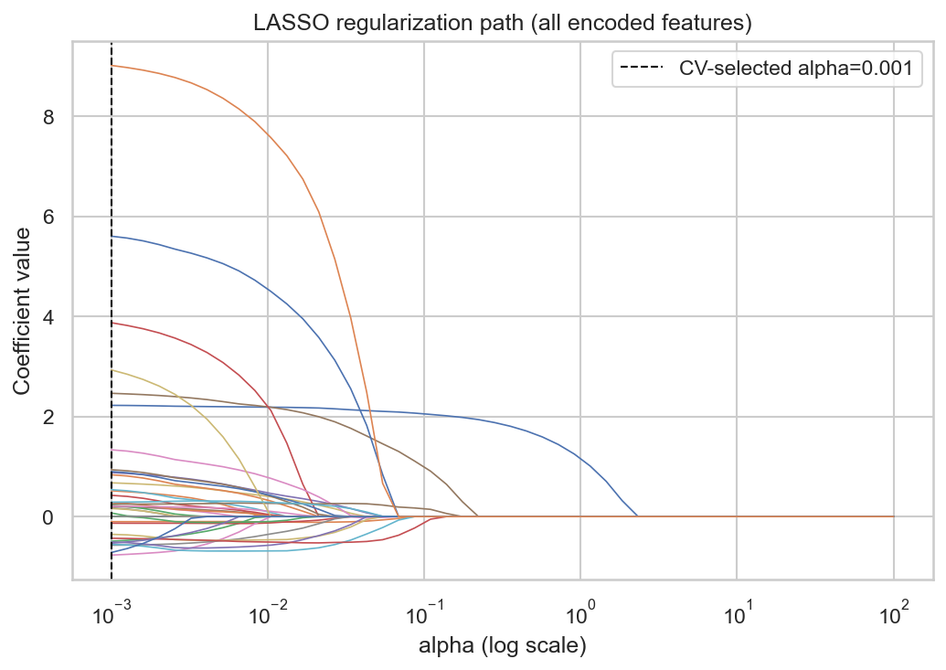
Figure 9. LASSO regularization path (coefficients vs. alpha).
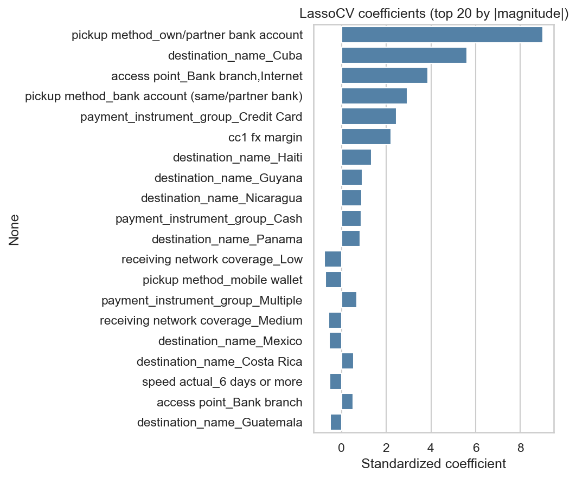
Figure 10. Final LassoCV coefficients, top 20 by magnitude.
Feature | Standardized Coefficient
pickup method_own/partner bank account | 9.0169
destination_name_Cuba | 5.604
access point_Bank branch,Internet | 3.875
pickup method_bank account (same/partner bank) | 2.9319
payment_instrument_group_Credit Card | 2.4641
cc1 fx margin | 2.2231
destination_name_Haiti | 1.3345
destination_name_Guyana | 0.9368
destination_name_Nicaragua | 0.8998
payment_instrument_group_Cash | 0.8807
destination_name_Panama | 0.836
receiving network coverage_Low | -0.7699
pickup method_mobile wallet | -0.7179
payment_instrument_group_Multiple | 0.675
receiving network coverage_Medium | -0.5725
Table 4. Top 15 LassoCV coefficients by |magnitude|.
LassoCV's cross-validated alpha zeroed out 6 of the 42 encoded coefficients. RidgeCV, by contrast, shrinks all coefficients smoothly and keeps every feature in the model (no exact zeros, by construction) -- which tracks with the numeric block alone not being strongly collinear, though the large one-hot dummy block still benefits from some shrinkage to stabilize estimates across rare categories. LassoCV, at its cross-validated alpha, drives a number of lower-signal dummy levels (sparse destination or access-point categories) to exactly zero, performing the implicit feature selection that is LASSO's signature property, while clearly keeping high-magnitude coefficients such as cc1 fx margin and the strongest destination/payment-instrument dummies. This agrees qualitatively with the information-criterion-based forward selection above: the same handful of blocks (destination, payment instrument group/pickup method, fx margin) emerge as dominant drivers under both approaches, which is reassuring evidence that the selection is not an artifact of either single method.

2.5 Complementary View: PCA on the Numeric Block
PCA was applied only to the small numeric block (cc1 fx margin, year, is_non_transparent) as a quick diagnostic of whether dimensionality reduction would be worthwhile there; it was not applied to the full dummy matrix, since PCA on one-hot categorical encodings is not usually meaningful or interpretable.
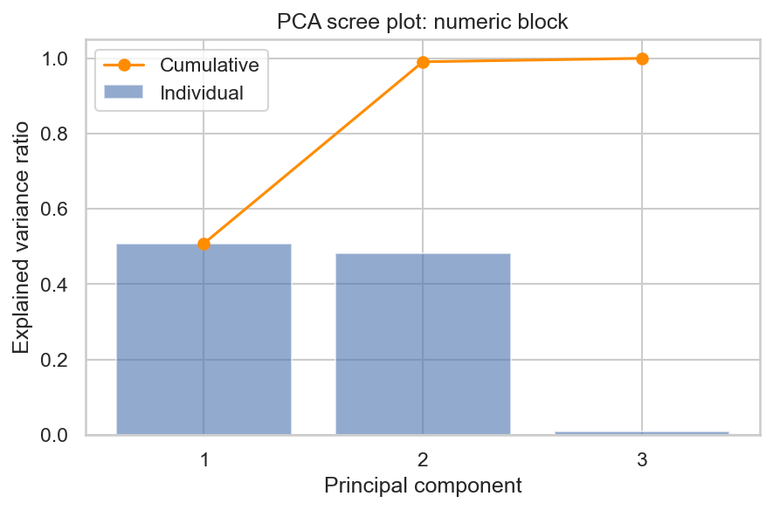
Figure 11. PCA scree plot of the numeric candidate block.
With only three numeric/engineered features, already shown to be close to uncorrelated, PCA does not find much redundancy to compress: all three components are needed to explain close to 100% of the variance, and no single component dominates. Dimensionality reduction is not very useful here, which is expected given the numeric candidate block was intentionally kept small. PCA/PLS would likely earn its keep if a richer, less-curated numeric feature set were used instead.

2.6 Final Selected Feature List
Combining the information-criterion-based forward selection, the shrinkage-based evidence, the exclusions justified above (currency-scale cc1 lcu fee/inter lcu bank fx; leakage cc2 * fields), and the VIF check (all numeric VIFs well under 10), the following source columns (pre-encoding) are recommended as the feature set to hand off to the regression/classification modeling notebooks:
- destination_name
- firm_type_clean
- payment_instrument_group
- access point
- receiving network coverage
- speed actual
- pickup method
- cc1 fx margin
- year
- is_non_transparent
destination_name, payment_instrument_group/pickup method/access point, and cc1 fx margin emerged as the dominant predictors under both the information-criterion forward-selection procedure (added early, largest BIC improvement) and LASSO's shrinkage (largest-magnitude surviving coefficients) -- convergent evidence that they belong in the final model. receiving network coverage and speed actual also showed meaningful cost differentiation in the EDA and are retained as weaker but non-trivial predictors (several of their dummy levels survive LASSO's zeroing). firm_type_clean is a deliberate exception to this convergent-evidence pattern: the forward BIC stepwise search actually excluded it (tested last, did not improve BIC further), and LASSO keeps it with only a small nonzero coefficient (rank 34 of 36 surviving coefficients by magnitude). We retain it anyway because the plain EDA shows a clear, substantively large cost gap between Banks and Money Transfer Operators -- its effect is real, but it gets absorbed/diluted once destination_name and payment_instrument_group are already in the model. This is a domain-reasoning judgment call, not something the IC search or LASSO alone would have recommended. year is retained with low expected signal strength but is required anyway for the planned pre-2023/2023+ temporal train/test split. is_non_transparent is retained as a cheap-to-compute engineered flag, with the caveat that it is an imperfect proxy conflated with send-limit disclosures. cc1 lcu fee and inter lcu bank fx remain excluded (currency-scale, not cross-country comparable without further engineering -- a stated modeling assumption, not an empirically tested fact), and all cc2 * fields remain excluded (mechanical leakage of the target).

