**FIND YOUR NANNY**

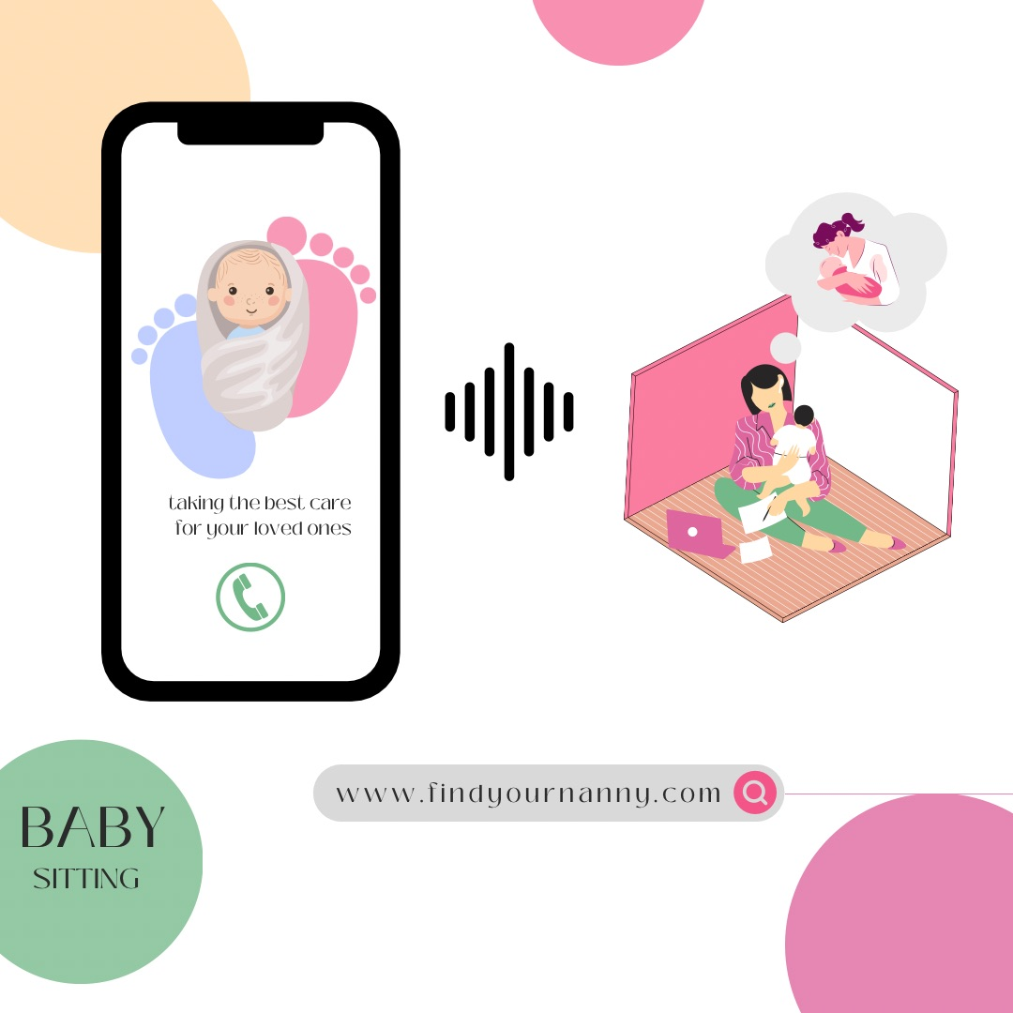

## *Even Supermoms need a Supernanny*

**Introduction**: Welcome to our presentation on "Nanny" an application designed to solve the problem of finding a reliable and trustworthy nanny or babysitter. In this presentation, we will discuss the problem we are trying to solve, our solution, product/service description, executive summary, management team, and market analysis.

**Problem Statement**: Finding a reliable and trustworthy nanny or babysitter can be a challenge for busy parents. It can be time-consuming and stressful to find someone who meets your requirements and fits your family's needs. Additionally, there are safety concerns when it comes to leaving your children with a stranger.

**Solution**: Our solution is to create a mobile application called "Nanny" that connects parents with a pool of pre-screened, background-checked nannies and babysitters in their area. The app will use an algorithm to match parents with the best candidates based on their needs, location, and availability. Parents can view candidate profiles, ratings, and reviews before making a selection. The app will also provide real-time tracking and monitoring of the nanny's location and activities during the job.

**Product/Service Description**: "Nanny" is a mobile application available for both iOS and Android devices. The app requires parents to create a profile with their family's needs, such as the number of children, preferred nanny or babysitter qualities, schedule, and location. The app will then provide a list of potential candidates that match the family's needs. Parents can view candidate profiles, ratings, and reviews before booking a nanny or babysitter. The app also offers real-time tracking and monitoring of the nanny's location and activities during the job. The app will have a rating system, where parents can rate the nanny's performance after the job is complete.

**Executive Summary**: Our business plan is to create a mobile application that solves the problem of finding a reliable and trustworthy nanny or babysitter. The app will provide pre-screened, background-checked nannies and babysitters to parents based on their needs, location, and availability. Our revenue model will be a commission-based fee for each booking made through the app.

**Management Team**: Our management team consists of four individuals with diverse backgrounds and expertise. Merjeme Bajrami, Yllza Kryeziu, Etrit Hasolli and Erisa Matoshi. We will lead the development and technical aspects of the app.

**Market Analysis**: Our target market is busy parents with young children who need a reliable and trustworthy nanny. According to the U.S. Bureau of Labor Statistics, the demand for nannies and babysitters is expected to grow by 5% from 2020 to 2030. Our main competition includes traditional nanny and babysitting agencies and other mobile applications that offer similar services. However, "Find your Nanny" differentiates itself by providing pre-screened, background-checked nannies and real-time tracking and monitoring of the nanny's location and activities during the job.

## Prototype

**Find Your Nanny** will consist of some basic features, we will be talking briefly about each one of those.

**User Authentication**: Secure login and registration for both parents and babysitters, possibly utilizing email, phone numbers, or social media accounts. **Profile Creation**: Both parents and babysitters can create detailed profiles with personal information, experience, qualifications, certifications, and background checks. **Search and Matchmaking**: Functionality to search for available babysitters based on criteria such as location, availability, experience, reviews, and ratings. The app could provide a matching algorithm to connect parents with suitable babysitters. **Messaging and Communication**: In-app messaging to facilitate communication between parents and babysitters. It could also include features like scheduling, notifications, and reminders for upcoming bookings. **Booking and Scheduling**: A calendar or scheduling tool allowing parents to book babysitting services, specify dates, times, and duration, as well as allowing babysitters to set their availability. **Reviews and Ratings**: A system for both parents and babysitters to leave feedback, ratings, and reviews after each childcare session to maintain accountability and build trust within the community. **Payment Integration**: Secure payment processing for parents to compensate babysitters directly through the app, including options for different payment methods and possibly automatic payments based on completed sessions. **Emergency Contact and Information**: Access to emergency contact information, medical details, and other critical information about the child(ren) being cared for, accessible to authorized users in case of an emergency. **Notifications and Alerts**: Push notifications or alerts to inform parents about upcoming bookings, changes in schedules, or new messages from babysitters. **Help and Support**: Access to customer support, FAQs, or help center for troubleshooting, assistance, or reporting issues within the app. **Privacy and Security Measures**: Implementation of robust security measures to protect user data, including encryption, secure connections, and privacy settings. **Additional Features**: Depending on the app's focus and target audience, additional features like video calls for interviews, GPS tracking during babysitting sessions, or additional services like tutoring or housekeeping might be included.

When we are at the babysitter, we will be asking them a couple of (personal) questions and see if they agree with our policies, such as:

**Age and Personal Information**: During the signup process, the app can request basic personal information from the babysitter, including age, name, address, and contact details. This helps in creating a comprehensive profile. **Status in Life and Work Preferences**: Provide options for the babysitter to specify their status in life (e.g., student, professional, stay-at-home parent) and their work preferences (part-time, full-time, occasional, specific hours/days). **Payment Expectations**: Allow the babysitter to input their desired pay rate or range for their services. This information can help parents and babysitters negotiate terms before confirming a booking. **Upload Documents for Background Check**: Implement a secure document upload feature that allows babysitters to upload documents such as a recent police background check. This document should confirm the absence of any criminal history for at least a specified period, as required by your app's policies. **Verification Process**: Ensure a verification process for uploaded documents to maintain the reliability and authenticity of the information provided. This could involve manual review by the app administrators or an automated verification system. **Privacy and Data Security**: Emphasize the importance of data security and privacy to reassure users that their personal information and documents are safe and only accessible by authorized parties. **Information Accessibility**: Make sure that parents have access to the relevant verified information (such as background checks) of the babysitters they're considering hiring, ensuring transparency and peace of mind. **Policy Compliance**: Ensure compliance with relevant laws and regulations regarding background checks and the handling of personal information and documents.

And now the parents, we will be asking them a couple of (personal) questions some of them about their kids but we will keep it simple like preferences and what the child likes, and see if they agree with our policies, such as:

**Childcare Needs and Preferences**: Understand the parents' childcare needs such as specific hours/days, services required (e.g., tutoring, housekeeping), and any particular preferences for a babysitter (e.g., language proficiency, specific skills). **Safety and Security Preferences**: Inquire about safety preferences, such as whether they prefer a babysitter with a verified background check or specific certifications (e.g., CPR training). **Child's Medical and Allergy Information**: Request details about the child's medical history, allergies, medications, and emergency contact information. This information is crucial for the babysitter to handle any health-related situations appropriately. **Communication Preferences**: Ask about preferred communication channels and frequency of updates during the babysitting session (e.g., regular text messages, video calls). **Budget and Payment Method**: Inquire about their budget for babysitting services and preferred payment methods to ensure seamless transactions within the app. **Feedback and Review Expectations**: Discuss expectations regarding feedback after each session and their willingness to provide reviews to help other parents within the app community.  **Any Additional Requirements or Expectations**: Provide a space for parents to specify any other essential requirements or expectations they have from the babysitter or the app's services. **Legal Compliance and Consent**: Ensure that parents are aware of and consent to the background checks or verification processes used to maintain safety within the app.  **Privacy and Data Security Measures**: Reassure parents about the app's commitment to privacy and data security, explaining how their information will be handled and protected. **Emergency Contact and Procedures**: Collect emergency contact information and discuss emergency procedures or protocols that need to be followed during a babysitting session.